sedos
Audition Information

Shakespeare in the City
A Midsummer Night’s Dream
By William Shakespeare

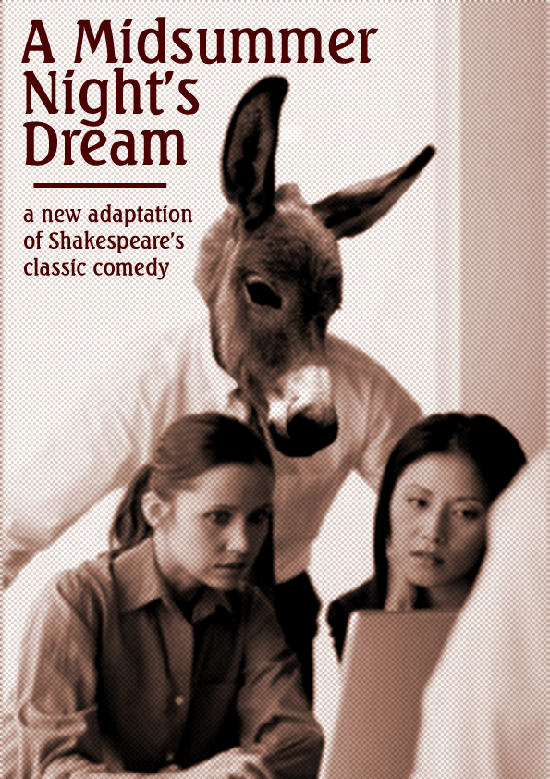

The Shakespeare in the City programme
Currently in its fourth year, the Shakespeare in the City programme tours various city institutions each summer, raising money for a variety of charities. If you are a member of an organisation that you think would be interested in raising funds for a charity of their choice as part of this programme then please contact the Executive Producer Juliette Chrisman (contact details at bottom).

Venue & dates
The show’s venues and dates are in the process of being confirmed, however potential performance dates are weeknights of weeks commencing 8th, 15th & 22nd September (dates so far confirmed are 10-12, 17, 24-25 September). If you have concerns about your availability on other dates in September, please discuss them with the director at the audition.

Audition Dates:
Workshop –Tuesday 17th June – BPP Liverpool Street
Auditions – Saturday 21st June – BPP Waterloo
Call backs – Sunday 22nd June – BPP Waterloo

Synopsis of Production:

A Midsummer Night’s Dream is one of Shakespeare's most well-known and best-loved comedies.
It is the night of the departmental office party; Hermia, the daughter of the CEO, rejects the advances of high-powered yuppie Demetrius (her father's favourite) and sneaks back up to the deserted offices with her sweetheart Lysander. Their escape is betrayed by her friend Helena who has a crush on Demetrius and tells him where Hermia has gone.
At night, though, in the dark offices the spirits are awake; call them fairies, call them the mischief-makers, call them gremlins, call them what you will. They are the ones that crash your computer just before you save, that move your coffee cup so you knock it over your work, that hide your security card and readjust your chair! Oberon, the lord of the mainframe, and Titania, the lady of paper, are having a spat and the mortals are going to be caught in between.
Finally, into this realm stumble a group of IT support staff (the 'Rude Electricals') who, in order to shake off their antisocial image, have offered to perform a play as the highlight of the party. If only they could find somewhere to rehearse!
As ever with the Shakespeare in the City programme, the play has been cut and adapted to the modern setting. Intended running time is to be between 75 to 90 minutes.

Workshop:

There will be a pre audition workshop (dates above) where you can get the opportunity to hear more about the show and ask questions. This is not compulsory if you want to audition, and is not part of the auditioning process.

Auditions:

Auditions will include some improvisational games and also prepared scenes from the play. The scenes will be available on the day and time will be given as part of the audition to prepare them.

Audition sessions will be approx. 90 mins long and will begin at predetermined times during the day (e.g. 12pm, 2pm, 4pm). Auditionees need only, and may only, attend a single session. Please bring to the audition a list of any dates for which you are unavailable in the rehearsal period.

There is a £5 audition fee if you are not already a member. To register for these auditions please email Emma.Knott@sainsburys.co.uk. Please state in your email if you are not able to make any times on the audition day. Prior to the day you will receive an email with the start time for your audition. Please also advise in your email if you wish to audition for a particular part(s), and if those are the only parts you are interested in auditioning for.

Audition restrictions:

Due to the extent of overlapping rehearsals, cast members in Don Carlos will not able to audition for A Midsummer Night’s Dream. Cast members from other shows, including Rosencrantz & Guildenstern Are Dead, are free to audition.

Additionally, if you are cast in A Midsummer Night’s Dream, you will not be able to audition for the two subsequent shows: Stepping Out and the SEDOS autumn musical.

Rehearsals:

Rehearsals will take place on Tuesday & Thursday evenings and Sundays in the afternoon in central London locations. Not everyone will be called to all rehearsals.

There is a £20 participation fee plus all cast members will be expected to join SEDOS. Current membership is £30 for the year. If you were not a member when auditioning your £5 audition fee will be refunded when you join.

Casting notes:
The roles of Hermia, Helena, Lysander, Demetrius, Theseus and Titania will all be cast along the set gender lines. All other roles can be played by men or women.
The Lovers & Theseus
Hermia, Lysander, Demetrius & Helena are young white-collar workers, falling in and out of love at a drop of a hat. Theseus is the CEO of the company for whom they all work. The role of Egeus has been cut, and Theseus replaces him as the father of Hermia. The roles of Hippolyta and Philostrate have been cut and their lines given to the lovers where necessary. Depending on casting and availability, the actor playing Theseus may double as Oberon, alternatively Oberon may be played by characters playing spirit roles.
We will be looking for actors who have chemistry with each other, who can deliver Shakespearean language in a naturalistic manner and can convey the meaning behind the words effectively to an audience which will have varying familiarity with Shakespeare.
The Mechanicals
become the Electricals, IT support staff who aspire to popularity and are way out of their depth. All the Mechanicals from the original script are included in this adaptation, there are therefore 6 roles which can be played by either men or women. For Bottom we will be looking for an actor with great stage presence and excellent comic timing. The roles of Quince, Snug, Flute, Snout and Starveling are more self-contained and will have a lighter rehearsal schedule. They are ideal for actors looking for less time-consuming roles and who may have other commitments over the rehearsal period. Comic potential and the ability to draw the audience into the fun will be the key casting criteria.
Oberon, Titania and the Spirits
Oberon is the Lord of the Mainframe, an entity created from and with power over all the electronic equipment in the office. If you think the Master Control Program from Tron with a bit more of a heart then you won’t be far off. As mentioned above, depending on casting and availability, the actor playing Theseus may double as Oberon, alternatively Oberon may be played by characters playing spirit roles.
Titania is the Lady of Paper: striking, imperious and not to be trifled with unless you want a really nasty cut. She’s a classic Shakespearean character, but the role is quite self-contained and will have a lighter rehearsal schedule than the other spirits, so is suitable for female actors with other commitments over the rehearsal period. The challenge in this role will be to make such an impact on the audience in her scenes that Titania holds her own against the omnipresent Oberon and Puck.
Puck will be played by four actors concurrently, either male or female. These actors will also be used for the other ‘fairy’ roles including Peaseblossom, Cobweb, Moth and Mustardseed and will be collectively referred to as ‘the Spirits’. As mentioned above, depending on casting and availability, the actor playing Theseus may double as Oberon, alternatively Oberon may be played by characters playing spirit roles. The spirits will be on stage for the entire play and will also portraying most of the set (walls, cupboards, drawers, faxes, photocopiers, coffee makers, biscuit tins etc.). Whilst other roles are self-contained these are all pervasive. They are the most challenging roles of this production and will require the heaviest commitment from the actors for, as well as their own scenes, they will be integrated into the other scenes of the play. We will be looking for actors with good control over their physicality; the ability to be engaged and detached, visible and invisible, at will; creativity; stamina, and bladder control.
Contacts:

Richard Williams (Director) richard@richard-williams.com
Emma Knott (Producer) Emma.Knott@sainsburys.co.uk
Juliette Chrisman (Executive Producer) juliette_chrisman@ml.com

