 Audition Notice


two linked plays
by Alan Ayckbourn

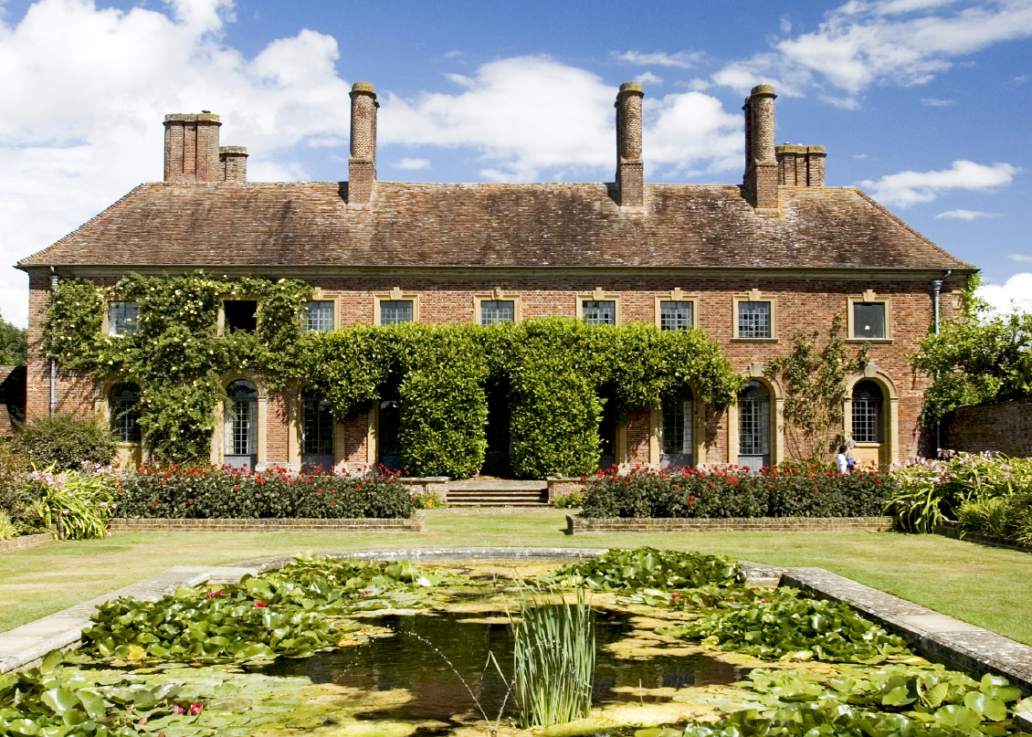

24th October – 3rd November 2012
Bridewell Theatre and Bridewell Hall

Director: Matt Gould
Producer: Alex Dorlandt

Workshops: Monday 25th June, 7.00pm & Tuesday 26th June, 7.00pm
(Note, attendance is strictly optional and both workshops will take the same format, so no need to attend both)

Auditions: Thursday 28th, Friday 29th and Saturday 30th June.
Recalls: Sunday 1st July

To book an audition slot, please e-mail: handgsedos@gmail.com
Two plays, two audiences, two theatres, one cast!

House and Garden are two plays written to be performed simultaneously by one cast in two separate auditoriums. One cast – two audiences!

Garden will be performed in the Bridewell Theatre, and simultaneously, House will be performed in the Bridewell Hall. The actors leave one stage to join the action in the other.

The plays are set in the present day in the country manor house of the Platt Family. The action in House takes place in principal ground floor sitting room, which backs onto the garden of the house. The action in Garden takes place simultaneously in the lower meadow, which is behind the “formal” garden. All the cast perform in both plays; their characters remain the same throughout!

The two plays are “standalone” comedies. There is no need to see both, however the audience is encouraged to do so because it is on seeing the second play that the “full picture” is revealed – and that is where the real magic lies. The plays can be viewed in either order.

Note, unusually for a play, we will be running for two weeks.

This is an incredibly exciting project, with great parts for actors of all ages. As well as having to deliver the two individual plays to create the humour and absurdity of the situations, the actors will also have to cope with the technical demands of playing two plays simultaneously – it should be an experience unlike any other!!

House
Up at the house, Teddy Platt (a wealthy businessman whose marriage is spectacularly on the rocks) has dreams of a bright political future as the new local MP. The only thing barring his path is an urgent need to clean up his messy private life before the Prime Minister's special envoy arrives...

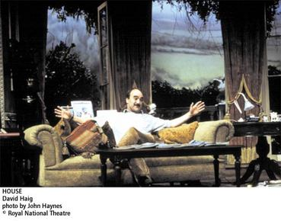
David Haig as Teddy in House

Garden
Down in the garden, Teddy’s jilted mistress threatens suicide as frenzied preparations are underway for the annual village fête. Will the maypole dancers pull it off? Is there someone sinister lurking in the bushes? And exactly what does go on in the fortune teller's tent?

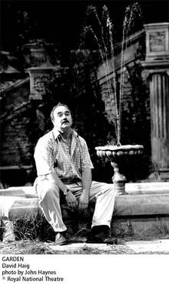

David Haig as Teddy in Garden

“The matter of the plays is deeply serious; nothing less than modern morality. But Ayckbourn’s treatment is wildly comic”
Guardian

“A mind-boggling technical feat... these extraordinary plays do something unparalleled in the history of drama”
Guardian

“There are scenes…..that leave you almost helpless with laughter”
Daily Telegraph

Dates:
Workshops: Monday 25th June 7pm
Tuesday 26th June 7pm
Auditions: Thursday 28th June, from 7pm
Friday 29th June, from 7pm,
Saturday 30th June at 10.30am, 1pm & 3.30pm
Recalls: Sunday 1st July.

Workshops:
The workshops will be an opportunity to learn more about the play, the roles and the audition process, as well as read extracts from the script. No preparation is required, and both workshops will follow the same format, so there is no need to attend both, or indeed either!

Auditions / Recalls:
Individual auditions will be held on Thursday 28th June, Friday 29th June, and in three slots on Saturday 30th June at 10.30am, 1pm and 3.30pm. When you apply for an audition, you will be allocated a slot. We will try and accommodate first preferences as much as possible. Recalls will take place as required on Sunday 1st July. If you are unable to attend the auditions, please let us know and we will try and make alternative arrangements. Hopefully there are sufficient alternative slots to enable those taking part in the Summer Festival and who wish to audition to find a slot that suits them.

Audition Extracts and to book a slot
Audition pieces will be made available shortly.

To arrange an audition slot, please e-mail:
handgsedos@gmail.com

Please specify your preferred audition date/time slot.

Notification
We will aim to inform you as quickly as possible after the auditions whether you have been shortlisted/cast. Whilst we would prefer to phone everyone individually we may notify you by e-mail. If you are unsuccessful, we will do our best to provide feedback when time permits if you request it.

Rehearsals:
Rehearsals will commence on Saturday 28th July with a read through of both plays. Rehearsals will generally be on Tuesdays and Thursday evenings and all-day Saturdays, but we may alternate between Saturdays and Sundays depending on the preferences of the cast.

Venue:
Workshops, Auditions, Recalls and Rehearsals will take place at:

Ocean House
10 Little Trinity Lane
London, EC4V 2AR
Nearest tubes: Mansion House and St Paul’s

Cast:
Teddy Platt A businessman
Trish Platt His wife, a designer and daughter of an admiral
Sally Platt Their daughter, a schoolgirl, (16-18)
Giles Mace A doctor
Joanna Mace His wife, a teacher
Jake Mace Their son, a student reporter (late teens, early 20s)
Gavin Ryng-Mayne A novelist and political fixer
Barry Love A local shopkeeper
Lindy Love His wife, also a shopkeeper
Lucille Cadeau A French Film-star (slightly faded)
Fran Briggs Her driver
Warn Coucher A gardener
Izzie Truce A housekeeper
Pearl Truce Izzie’s daughter - An occasional cleaner (mid 20s)
Ensemble (4-6) Venture Scouts/Girl Guides/Bandsmen

Playing Ages
I have generally not specified ages, because it is about getting a balance of actors that look credible together. I may cast the younger parts a bit older, provided that the look is sensible – it is about creating realistic family groupings!

Synopsis:
A detailed synopsis is contained in the Appendix.

Sedos: Audition, participation and membership fees
Sedos is one of London’s pre-eminent amateur theatre societies, with the aim of producing quality amateur shows to the best artistic quality possible. Please note that performers are not paid - not even expenses. To perform in House/Garden you must be a member of Sedos (membership is currently £30 per year) and pay a participation fee of £30. There is a £5 audition fee for non-Sedos members. If you are cast in the show, your audition fee will be deducted from your participation fee.

To book an audition slot, obtain a copy of the script or for further information, please contact:
handgsedos@gmail.com

Alternatively, please contact me directly at:
matt@mjgould.co.uk

I look forward to seeing you at the auditions!

Matt

APPENDIX
Detailed Synopsis

House
Teddy Platt is a well-known local businessman whose forefathers were eminent local politicians. His wife Trish is vehemently ignoring him, so he takes the dog out for a walk. His daughter Sally is also ignoring him, whom Trish asks to stop using the lovestruck Jake, son of the local doctor Giles, and to attend the lunch for a visiting French film-star, Lucille Cadeau, and the novelist Gavin Ryng-Mayne. Sally meets Jake, who reveals Trish and Teddy are not speaking as Teddy is having an affair with his mother, Joanna, unknown to his father.
Teddy promptly asks Giles if he understands why Trish is not talking to him, who suggests it may be lack of sex. Teddy is desperate to clear this up as Gavin is actually coming to ask Teddy to run for MP. Giles reveals Joanna is acting strangely, has never enjoyed sex and he’s afraid he is losing her. Teddy hypocritically reassures Giles. Trish enters, ignoring Teddy, and sends Giles to see Joanna. From the garden, we hear an enraged Giles shouting Teddy’s name.
A stricken Giles now ignores Teddy and Trish is immune to Teddy’s plea for a united front. Gavin arrives just after Teddy has sat on a plate of canapés left by Izzie, the housekeeper. Gavin asks Teddy to be the new candidate, which he accepts despite Gavin’s insistence the candidate must be above moral reproach. Everyone goes to meet Lucille, leaving Teddy alone and the first to meet Lucille as she steps through the French windows. He is smitten, but discovers when everyone else returns and starts speaking French, he is unable to communicate with her.
Teddy and Lucille bond, despite their lack of communication, over whisky and go to open the garden fete. Sally, besotted with Gavin, heavily flirts with him, who brutally manipulates her affections. Jake confronts him over this and is punched by Gavin. More chaos erupts as Izzie’s daughter Pearl shuts herself in the dining room to escape her knife-wielding mother. The gardener, Warn, appears and calms things down by promising to be a real father to Pearl. Trish and Jake have a heart-to-heat and Lucille appears with a trouser-less Teddy.
Later in the afternoon, Gavin decides to leave having confirmed the party won’t actually be requiring Teddy’s services. Trish finally speaks to Teddy to tell him she is leaving. Lucille heads off to the rehabilitation clinic she was heading to. Jakes finally gains the confidence to express his feelings for Sally, who promptly runs away, leaving the poor boy confused as Trish leaves the house, noting “That’s life, I suppose.”

Garden
In the garden, Joanna hides in a bush when Warn enters, followed by Izzie whose lengthy gossip is met only by Warn’s grunts. Teddy meets Joanna about their affair, which he says must stop. Joanna breaks down and is found by Pearl, who suggests she should stick with Giles. He appears, but is only interested in his Morris Dancing at the afternoon fete. Pearl also talks to Warn – hinting something happened between him and her in the past. Jake tells Sally he hopes his father doesn’t discover his mother’s affair. Joanna has decided to confess though, but Trish bluntly tells her to end the affair, tell Giles and not to dare ruin the lunch party. Joanna, alone, rehearses her confession, alongside increasingly improbably suicide methods only for Warn to run her over with a lawn mower. Giles comes to help and Joanna reveals the truth. An enraged Giles shouts Teddy’s name.
Barry and Lindy Love are responsible for the fete and she is very much belittled by him. Gavin arrives lost as Warn has removed all the sign posts for the fete. Jake and Giles have a heart-to-heart, but Giles breaks down when discussing Joanna and Jake gets into an argument with Sally over a poem. Lucille arrives, not unnoticed by Barry and Lindy runs off upset, just as a storm threatens to break.

Joanna is having a break-down and believes Giles, Jake and Teddy have been replaced by aliens with improbable names, such as Harold. Giles has been abandoned by his morris dancing troupe and Lucille is interviewed by Jake, revealing she is an alcoholic on her way to rehab. The storm starts just as the fete opens leaving a drunk Teddy and Lucille to paddle in the long-broken fountain and pour out their woes to each other in different languages. Lucille drags Teddy into the fortune-teller’s tent and the fountain unexpectedly erupts into life. Izzie hears noises from the tent and believing it to be Warn and Pearl, cuts the tent ropes. Pearl appears and flees to the house, chased by a knife-wielding Izzie. Barry puts the blame of the tent on Lindy and Joanna gets into a fight with Lucille over Teddy, who has to concoct a lame excuse for why he is trouserless. As Gavin judges the fancy-dress, Lindy asks if she can get a lift with him to London.
Jake and Giles discuss their problems with women and Pearl persuades Giles to do a Morris dance with her. Gavin leaves with Lindy in tow. Teddy and Lucille say goodbye and he finds a note from Trish saying goodbye. Giles goes off with Pearl, leaving Teddy to note, as he fruitlessly calls for his dog and the fountain fails. “That’s life, I suppose.”

MG
5.6.12

