Sedos Summer Season Audition Notice
The Bridewell Theatre

A weekend workshop of a Pulitzer Prize winning play
12th July 2015
Director: Zoe Thomas-Webb



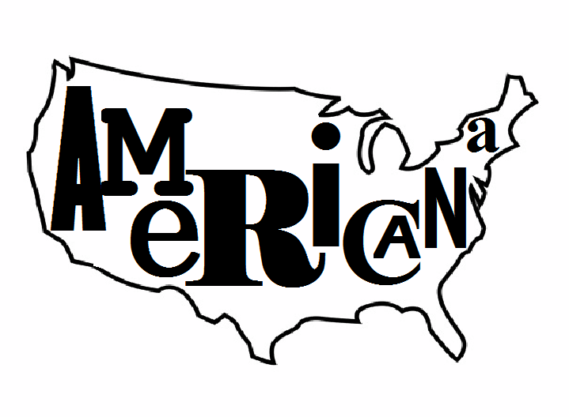
An evening of six plays showcasing the history of American drama.
15th July 2015
Director: Alex Magliaro

A live reading of the film script
16th July 2015
Director: Lorenzo Peter Mason

Auditions: 16th May
10.30 - 4.30
To sign up for the audition day please email zoe.thomaswebb@gmail.com
This year sedos is staging it’s first ever Summer season, where each night a different event will be taking place. On the 16th of May we are holding joint auditions for three of those events, so if you like the sound of all three or only one of them takes your fancy please do come along and audition.

What

‘Clybourne Park’: A weekend workshop

In 1959 Russ and Bev are selling their desirable two-bed at a knock-down price. This enables the first Black (Did you want to captialise ‘Black’?) family to move into the neighborhood, creating ripples of discontent amongst the cosy white urbanites of Clybourne Park. In 2009, the same property is being bought by Lindsey and Steve whose plans to raze the house and start again is met with a similar response. Are the issues festering beneath the floorboards actually the same fifty years on?

An intensive weekend of working on a text culminating in a performance. The performance will be semi staged and although all the actors would be working off scripts, with rehearsal it would be slicker than a sit down reading. A weekend workshop is a great place to get people who are new to Sedos involved and also a wonderful opportunity to get involved with a show without the time commitment of a full production.

Zoe has directed 3 plays for Sedos, the last being ‘Government Inspector’ which toured to Edinburgh Fringe. This is her first directing project after having a baby girl in December, so she is super excited about talking to adults!

Americana: An evening of six plays showcasing the history of American drama

Love. Dreams. Loss. Pain. Strength. Freedom. Scene nights (What are ‘scene nights’?)can often be disjointed and overdone leaving the audience with a series of high intensity scenes one after the other. Alex has chosen a group of plays and taken a pivotal scene from the first and second acts in order to show the arcs of character and story. So the first act will be a collection of scenes from the first acts and the second act will be the continuation of those plays with scenes from each of their second and in some cases third acts.

This should be a great chance for each actor to showcase themselves. Each scene has 2/3 people and each actor will portray at least 2 roles in the show. It will be challenging but a great opportunity. The plays Alex has chosen are Our Town, Sweet Bird of Youth, Bus Stop, The Odd Couple, Steel Magnolias, and Take Me Out.

Alex has acted in 4 Sedos shows and this is his first foray into directing. He plans on having as much fun as possible whilst trying his hardest to transfer the truths of the page to the stage.

Reservoir Dogs: A live reading

In the style of Jason Reitman’s live readings of screenplays as LACMA Los Angeles, for one night only eight actors will perform the legendary roles of the director’s master debut. This project is meant to not only to give performers a chance to do amazing film roles but to examine character creation and spontaneity, as such there will be no rehearsals beforehand aside from a production meeting with the cast. Instead the actors, in costume, will read the roles from music stands as images from the movie and projected behind them.

It’s important to point out that the performances shouldn’t be mimicry, imitations, parodies or suchlike of the original movie actors but the performer’s own interpretation of the role. Cast actors will receive the script upon getting the role to read through and familiarize themselves with its contents.

This is Lorenzo's first project with Sedos having previously directed The Apple Cart for KDC and How He Lied to Her Husband for the Shaw Society, both by George Bernard Shaw. By the same author he is also preparing On The Rocks for the National Trust at Shaw's Corner.

Who We’re Looking For

All shows need actors who feel comfortable doing an American accent (a general American is fine we’re not going to test you on how many states or regions you can do). Clybourne Park and Reservoir Dogs need actors who are comfortable with sight reading. But apart from that we’re happy to see anyone and everyone. Below is a very rough cast breakdown for each show, if you would like a more detailed cast breakdown please email zoe.thomaswebb@gmail.com and we will send you one.

Clybourne Park Character Breakdowns:

Bev
Female, white, 40s, a brave faced housewife.
Lindsay
Female, white, 20s/30s, a liberal pregnant lady.
Lena
Female, black, 30s, a no-nonsense member of the Owners Association.
Betsy
Female, white, 20s, a deaf pregnant lady.
Franciene
Female, black, 20s/30s, a proud maid.
Kathy
Female, white, any age, a relaxed lawyer.

Karl
Male, white, 20s/30s, a bigoted busybody.
Russ
Male, white, 40s, a grieving father.
Jim
Male, white, any age, a softly spoken vicar.
Steve
Male, white, 20s/30s, a dogmatic homeowner
Kevin
Male, black, 20s/30s, a friendly member of the Owners Association.
Tom
Male, white, any age, a bored surveyor.
Albert
Male, black, 20s/30s, a helpful husband.

Americana Character Breakdowns:

George (Our Town) and Bo (Bus Stop)
Male, 20s, youthful, innocent and ignorant
Chance (Sweet Bird of Youth) and Darren (Take Me Out)
Male, 30s, charismatic, talented and lucky.
Felix (The Odd Couple) and Marz (Take Me Out).
Male, 30s/40s, somewhere between a camp straight man and a straight acting gay.
Oscar (The Odd Couple) and Dr Lyman (Bus Stop).
Male, 40s, selfish and flawed

Emily (Our Town), Shelby (Steel Magnolias), and Sister (The Odd Couple)
Female, 20s, a good girl.
Cherie (Bus Stop), Annelle (Steel Magnolias), and Sister (The Odd Couple)
Female, 20s, the girl from the other side of the tracks.
Alexandra (Sweet Bird of Youth) Truvy (Steel Magnolias)
Female, 30s/40s, a movie star.
Mrs Webb (Our Town) M’Lynn (Steel Magnolias)
Female, 40s, motherly, kind and wise.
Ouiser (Steel Magnolias)
Female, age open, eccentric woman.

Reservoir Dogs Character Breakdown:

N.B. This is an all male cast.

Mr White
30s-50s, cool, calm and collected.
Mr Orange
20s - 30s, a bright young thing.
Mr Blonde
25-40s, a bone fide psychopath.
Mr Pink
25-35, laid back and irritating.
Joe Cabot
50-70, gruff and no-nonsense.
‘Nice Guy’ Eddie Cabot
any age, affable and loyal.
Mr Brown/Marvin Nash
20s - 30s, getaway driver / policeman
Mr Blue / Officer Holdaway / K-Billy DJ and others
any age, a veteran / policeman / radio host

When

On the 16th May we’ll be holding an audition day with games, scene work and speech work. At the audition day you will be spilt up into groups and throughout the day you will be seen by the different directors. Because we are asking for so much of your time we want to make the day as rewarding, challenging and fun for you as we can. If you can only make the morning or the afternoon please do let us know and we will try and accommodate you.

Below are the key dates for each of the productions.

Clybourne Park

Friday 10th July (evening) - Read-through
Saturday 11th July (all day) - Rehearsals
Sunday 12th July (all day) - Rehearsals
Sunday 12th July (evening) - Performance

Americana
From the 8th June (Mainly Wednesday & Saturday) - Rehearsals
Wednesday 15th July - Performance

Reservoir Dogs
Sunday 12th July - Rehearsal
Thursday 16th July - Performance

How

To sign up for the audition day please email zoe.thomaswebb@gmail.com with your name and which shows you are interested in auditioning for. Or you can email with any questions you have about the day.

Sedos Membership Fees
Sedos is one of London’s pre-eminent amateur theatre societies, with the aim of producing quality amateur shows to the best artistic quality possible. Please note that performers are not paid - not even expenses. To perform in any of the Summer Festival shows you must be a member of Sedos (membership is currently £30 per year).

After-note
If these don’t take your fancy or your looking for something a bit jazzier. Check out the auditions for the musical ‘On the Night’ on the 21st & 22nd May and the short play ‘Shakers’ which is holding auditions on the 22nd & 23rd May.

We look forward to hearing from you and hope you are as excited about our one off events as we are.

Alex, Lorenzo & Zoe

