**Sink the Belgrano!**

**By Stephen Berkoff**

**Bridewell Theatre**

**17th-21st July 2012**

Director: Matt Hudson

Producer: Mia Bennett

Assistant Director: Tracie Laurinaitis

GOTCHA read the headlines that reported the start of the Falkland's War in 1982. A war, that killed around 900 lives over the land rights of the Falklands, had begun. The war involved many tragic incidents , however the catalyst was the decision made by the Thatcher administration to take offensive action. The Argentinean warship the General Belgrano was sunk by British forces on May 2nd 1982.

*Sink the Belgrano!* is a satirical take on the British military decision to torpedo an Argentinean Ship. It is a rarely performed play within Berkoff's canon of work. The piece packs a serious punch against Thatcherism, but also raises the bigger question of political decision making against the individual survival of military personnel. However, this is not a play of just dreary and depressing themes, it is a satirical comedy that uses a comical style to paint this political, and individual picture

*Sink the Belgrano!* is a visceral, linguistic and physical piece of theatre written mainly in verse. So we are looking for 10 actors who fancy a challenge and are up for a lot of fun. This is a completely ensemble production that will demand a strong group approach.

**Auditions:**

The Auditions will be a split into two parts. First round will be a workshop where you will be given parts to rehearse and then perform back to the panel and the wider group. We run things this way so you get a better idea of the play, especially when we get to recalls. This first session will include an exercise with the text, and an exercise based in physicality and movement so please wear something comfortable (no need to crack out the jazz boots and leg warmers don't worry). See the Character Breakdowns at the end for more info about characters.

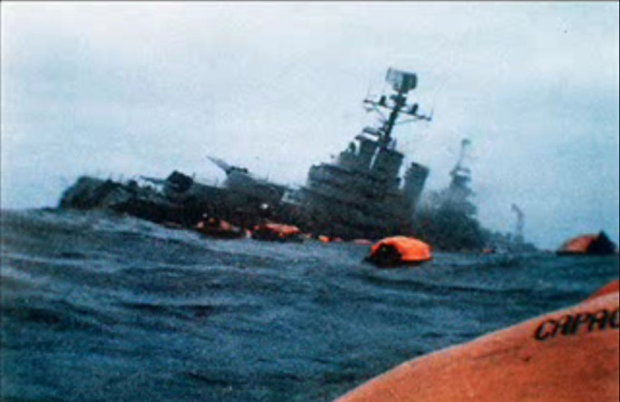**Recalls:** These will be a blend of workshop/rehearsing scenes and you will also get a speech before the day to perform individually to the panel. This is so we see something prepared and something fresh you create with others.

There are 3 available slots to audition with limited places in each so book your slot early.

**First Round**

Slot 1: Monday 23rd April 7-8:30

Slot 2: Monday 23rd April 8:30 - 10

Slot 3: Friday 27th April 7-8:30

If you cannot make these please still get in touch, and we will see if we can see you another time.

**Recalls**

Sunday 29th April

Please keep the full day free for recalls if you are auditioning, or let us know early on if you can't make the recalls

**How to register:**

To register for auditions please email Mia on miabennett@btinternet.com and please make the subject title SINK THE BELGRANO AUDITIONS, and state which slot you would prefer. If for any reason you cannot make these times please get in touch with us and we will try and re-arrange.

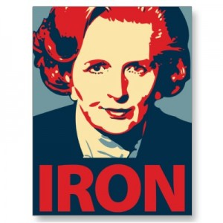**Need to Knows:**

**Rehearsals:**

Main Rehearsal Period from May 23rd. **Each Monday and Wednesday evenings 7-9:30 and Saturday 11-5**. We will try to work through peoples availability, but in this flexibility we ask for yours also to help accommodate the needs of the production.

We will also have a preliminary rehearsal on **13th May to** meet the team and read through the script etc

During the start of the process we will be working on the style of the piece, I will be inviting guests to run workshops in movement, improvisation techniques and voice work so we are all equipped with skills to tackle the script with. This will also be a lot of fun!

**Show week**

The production will run in conjunction with Man of Destiny from **17th - 20th July nightly (times TBC) with a Matinee on Saturday 21st July**. The two plays are part of Sedos' exciting summer festival that will include lots of exciting events from the 3rd July - 21st July.

**And Finally**

We are looking to create an exciting and ambitious bit of theatre and cannot wait to get going on the project. We are looking for people to get their teeth into this great project, and into the whole festival in many capacities not just acting. If you have any questions or would like to get involved, please get in touch directly to Matt (mattkhudson@gmail.com) or Mia ([miabennett@btinternet.com](mailto:miabennett@btinternet.com)).

If you have any questions do get in touch!

**Character List:**

**Maggot Scratcher -** F 20+  
A parody of Margaret Thatcher. We are not looking to be a spitting image (or like *Spitting Image)* physically or vocally. What we are looking for is someone to embody the persona of Margaret Thatcher. Someone who wants to bring out the extremes and play with them and craft something full of wit, charm, malevolence, and the list goes on! At the time of the play Margret would have been in her late 50's, however this is not a naturalistic play so any age will be considered if the persona is correct. I advise doing some research on Youtube to watch Maggie before auditioning, just so you don't come in blind.

**Pimp** - M 20+   
Based on Francis Pym. Foreign Secretary 1982-3. In the play a lack boy to Maggot, but someone who does try and see the route for peace. However, usually gets shot down and does as he is told.

**Nit** - M 30+  
Based on John Nott, Defence Secretary 1981-1983. More militarised and pompous in the play than other politicians. A booming presence but we know he lacks intelligence, and Maggot knows this too.

**Choru -** M/F Any Age  
Is read by one person. A master of ceremonies who runs the proceedings and will be very active across the play linking scenes with their monologues. This part is open it either male or female actors of any age. What is required is a tough presence and a strong story telling style.

**Ensemble:**The 6 Members of the ensemble will multi role Sailors, Politicians, Farmers, Presidents etc. Because of this there will be a blend of male and females, I hope 3f/3m, but we may decide to split it differently whilst casting. We are looking for strong physical performers who will throw themselves at trying things. Bring some regional British accents (lots of fun to hear, some of mine are dreadful so don't feel threatened), and have a flexible approach. There is plenty to do across the show, the whole cast is an ensemble really but if I list all the parts we will be here forever! Any questions then get in touch.

**Sedos - Audition, participation and membership fees**

Sedos is one of London’s pre-eminent amateur theatre societies, with the aim of producing quality amateur shows to the best artistic quality possible. Please note that performers are not paid - not even expenses. To perform in the production you must be a member of Sedos (membership is currently £30 per year) and pay a participation fee of £30. There is a £5 audition fee for non-Sedos members. If you are cast in the show, your audition fee will be deducted from your participation fee. There is only one £5 fee payable if you wish to audition for both Man of Destiny & Sink the Belgrano.

You can of course pay your £30 membership fee at your audition, the fee will then be waived and not only can you then audition for free for the next 12 months but you’ll benefit from discounted ticket prices for all our shows and other member benefits.