Gormenghast

**By Mervyn Peake**

**Adapted for the stage by John Constable**

**Show – 26th February to 2nd March 2013**

**Auditions - w/c 19th Nov 2012**

**Character Description**

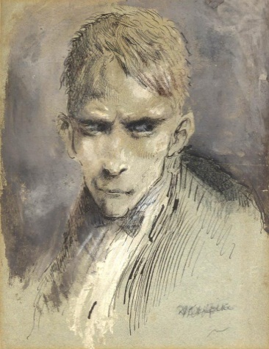**STEERPIKE**

*“If ever he had harboured a conscience in his tough narrow breast he had by now dug out and flung away the awkward thing - flung it so far away that were he ever to need it again he could never find it.”*

Steerpike is protagonist, antagonist, terrorist, revolutionary, anti-hero and utter villain. He is a highly intelligent schemer, a seductive and ruthless youth of 17. Following his escape from the kitchens of Gormenghast, he swiftly and effortlessly works his way up through the social circles of the castle.

*“Limb by limb, it appeared that he was sound enough, but the sum of these several members accrued to an unexpectedly twisted total. His face was pale like clay and save for his eyes, mask-like. These eyes were set very close together, and were small, dark red, and of startling concentration”*

**GERTRUDE**

*“…half asleep and half aware: with the awareness of anger, the detachment of trance. A furlong of white cats trails after her. A bullfinch has a nest in her red hair. She is the Countess Gertrude of huge clay.”*

The large, terrifyingly intimidating redheaded Countess. She gives the impression of a total lack of interest in anything except her cats and birds. However she assumes a role of leadership naturally and shows a keener intelligence and interest in the tradition and welfare of her home that she would prefer to be known. Various methods will be explored for the birds and cats, primarily puppetry with the ensemble.

*“Like something far larger than life, her dark dress shot with the red of the fire, she ploughed her way upwards to the window… and yet for all the contortions of her great frame, for all the ungainliness of her egress, a slow dignity pervaded her which gave, even to the penultimate view – that of her rear disappearing hugely into the night - a feeling rather of the awesome than the ludicrous.”*

**DOCTOR PRUNESQUALLOR**

Utterly bonkers, but insightful too. He is eccentric , verbose and has a maniacal cackle. He has a shock of hair and is quite aware of the problems of someone so clearly driven and capable of Steerpike around. Proves to be something of a hero.

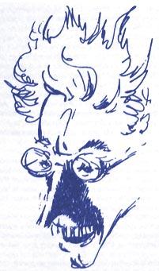

*“Doctor Prunesquallor, with his hyena laugh, his bizarre and elegant body, his celluloid face. His main defects? The insufferable pitch of his voice; his maddening laughter and his affected gestures. His cardinal virtue? An undamaged brain.”*

**FUCHSIA**

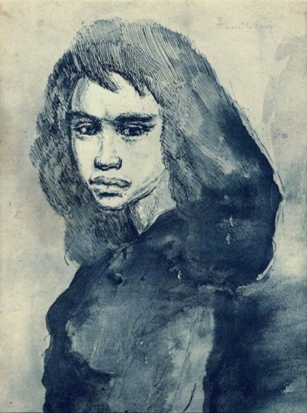*"A girl of about fifteen with long, rather wild black hair. She was gauche in movement and in a sense ugly of face, but with how small a twist might she not suddenly have become beautiful. Her sullen mouth was full and rich -- her eyes smoldered."*

If there was a love interest in this play, this would be it. But Fuchsia is so much more. She is a girl turning into a woman and still has a LOT of childishness in her. She has a very “coming of age” narrative in the story and will require auditionees to go back to their Dolls House mentalities.

*FUN FACT – The Cure have a song called The Drowning Man about Fuchsia.

**TITUS GROAN**

*“What do I care for the symbolism of it all? What do I care if the castle's heart is sound or not? I don't want to be sound anyway! Anybody can be sound if they're always doing what they're told. I want to live! Can't you see? Oh, can't you see? I want to be myself, and become what I make myself, a person, a real live person and not a symbol anymore.”*

The Eponymous character of 2 of the three books, Titus comes to the forefront in the second half of the play. Independently minded and tired of the fixed rituals of Gormenghast, he begins to threaten the very essence of the castle by standing against it’s ideology of “No Change”

**FLAY**

Flay is a servant/retainer in the castle and attendant to Lord Sepulchrave. He is fiercely loyal, barely speaking, and then in broken sentences. He has a violent rivalry with the chef Swelter and an immediate distaste for Steerpike. Towards the later part of the play he looks out for the young Earl, Titus.

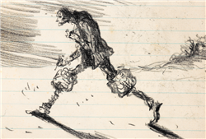

*“It did not look as though such a bony face as this could give normal utterance, but rather that instead of sounds, something more brittle, more ancient, something drier would emerge, something more in the nature of a splinter or a fragment of stone. Nevertheless, the harsh lips parted. "It's me," he said, and took a step forward, his joints cracking as he did so. His passage across a room -- in fact his passage through life -- was accomplished by these cracking sounds, one per step, which might be likened to the breaking of dry twigs.”*

*FUN FACT – Even though I will be encouraging people to stay clear of the BBC Adaptation, Mister Flay was played by the Legend Christopher Lee! The Lord of Misrule himself!

**SMALLER ROLES**

**SEPULCHRAVE**

The 76th Earl of Groan. Melancholic and quiet, he obediently follows the daily bizarre rituals set down for him. The only things that appear to matter to him are his legacy and his library. His mind is destroyed by actions in the first half of the play

**CORA & CLARICE**

*“She and her sister were dressed in purple, with gold buckles at their throats by way of brooches, and another gold buckle each at the end of hatpins which they wore through their grey hair in order apparently to match their brooches. Their faces, identical to the point of indecency, were quite expressionless, as though they were the preliminary lay-outs for faces and were waiting for sentience to be injected.”*

Twins and sisters to Sepulchrave, these odd creatures live a life of isolated outrage at not having power, but in a truly childish way. The roles require two actors who can really clown childishly and mirror each other. This can be a hilarious and terrifying performance opportunity.

**SWELTER**

*“Abiatha Swelter, who wades in a slug-like illness of fat through the humid ground mists of the Great Kitchen. From bowls as big as baths, there rises and drifts like a miasmic tide the all but palpable odor of the day's bellytimber. The arrogance of this fat head exudes itself like an evil sweat.”*

Huge and monstrous. The chef of Gormenghast and the stuff of nightmares. Drunken, crude and lecherous. Swelter is mass. Mass and nastiness. A fight scene WILL be present!

**BARQUENTINE**

*“The lynch-pin son of the dead Sourdust, by name Barquentine, Master of Ritual, is a stunted, cantankerous pedant of seventy, who stepped into his father's shoes (or, to be exact, his shoe, for this Barquentine is a one-legged thing who smites his way through ill-lit corridors on grim and echoing crutch.)”*

Master of Ritual. In the novel, Barquentine is introduced after his father, Sourdust, has died. In the play, both characters are melded. Barquentine is a great physical opportunity for an actor as he is hunched, gnome like and one legged. And he is rather sweary.

**THE THING**

A very physical but mute performance. The Thing is a savage, outcast girl, and represents a wild, free, unpredictability that haunts and seduces the impressionable Titus.

*“Titus was heavily if sparsely built. This creature was exquisitely slender. It floated through the golden air like a feather, the slender arms along the side of the gracile body, the head turned slightly away and inclined a little as though on a pillow of air.”*

**IMPORTANT NOTE**

**All roles will be open to all actors. You may be a young pretty five foot nothing dancer, but be the perfect person for the fat, oozing chef. Or you may be the seasoned heroic dramatic lead and end up as the Countess if that hat fits you best. Don’t be afraid of being constrained by the gender, physicality or attitude of the characters!**

We strongly encourage you to look at the novels before the audition, although it is not essential. A FREE COPY will be given to all those cast because I want you to be familiar with the source.

Please don’t look at the BBC version as any kind of influence. It’s what introduced me to the world of Gormenghast, it has a cracking cast, and it looks great, but it’s not right for this show and I will be staying well clear. Thanks! And we hope we have enticed you to get involved!