

Audition Notice

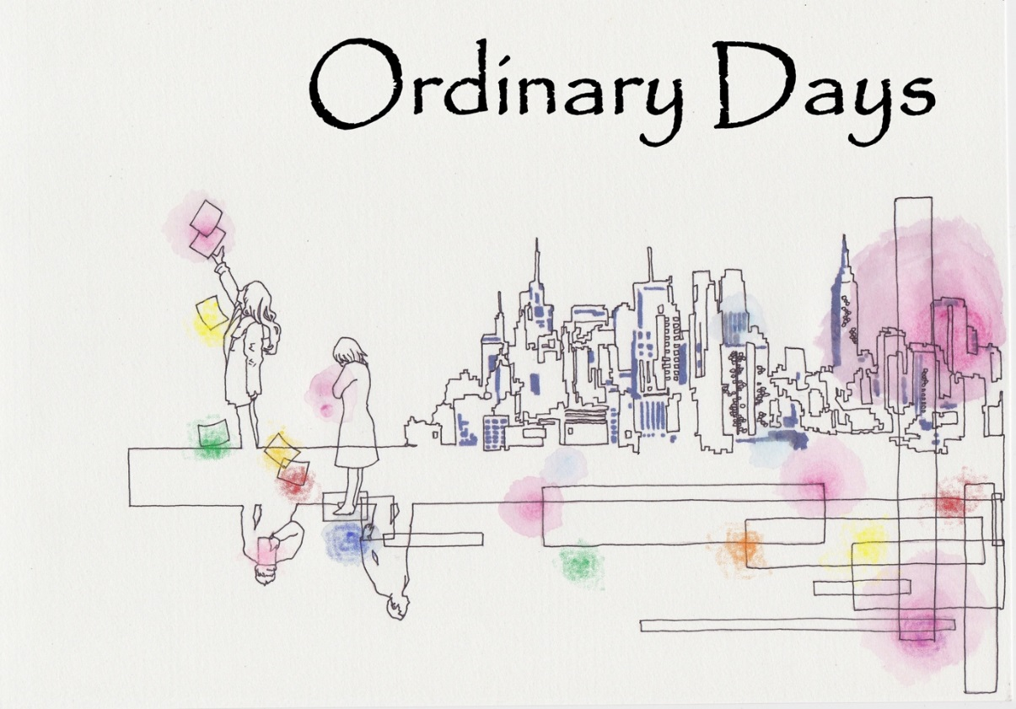

**27 - 30 September, Bridewell Theatre**

PLEASE NOTE: Ordinary Days is being performed as a 'late night' show, and the Weds – Fri night performances will start at 9pm after performances of The Nether.

**Production Team**

Director: Yojiro Ichikawa

Musical Director: Ed Curry

Producer: Vaughan-Alicia Watts

**Workshop**

26 June, 7:00pm

**Auditions**

8 July, 12:00pm-7:00pm

Recalls: 9 July, 10:00am-5:00pm

**Location**

1 Brewers’ Hall Garden, London EC2V 5DX.

**To book an audition please e-mail: ordinarydays@sedos.co.uk.**

If you have any questions that are not answered in this audition notice, please email ordinarydays@sedos.co.uk and we will get back to you as soon as possible.

# The Show

***“[Ordinary Days] captures with stinging clarity that uneasy moment in youth when doubts begin to cloud hopes for a future of unlimited possibility."***

***— Charles Isherwood, The New York Times***

From one of musical theatre's most exciting new composers comes Ordinary Days, a refreshingly honest and funny musical about making real connections in the city that never sleeps (but probably should at some point).

Ordinary Days tells the story of four young New Yorkers whose lives intersect as they search for fulfillment, happiness, love and cabs. Through a score of vibrant and memorable songs, their experiences ring startlingly true to life.

Ordinary Days is an original musical for anyone who's ever struggled to appreciate the simple things in a complex place. With equal doses of humor and poignancy, it celebrates how 8.3 million individual stories combine in unexpected ways to make New York City such a unique and extraordinary home.

For Ordinary Days, Adam Gwon won the 2008 Fred Ebb Award for excellence in musical theatre songwriting and the 2011 Kleban Award in the Lyricist category.

Some video materials you can watch:

Kate Wetherhead (Deb, Original Broadway Cast) sings "Don't Wanna Be Here"

<https://youtu.be/vx33e6nkyrE>

Hunter Foster (Jason, Original Broadway Cast) sings "Favorite Places"

<https://youtu.be/z_n56LL0sFM?list=PL3B54D1AE6D306A26>

Jared Gertner & Kate Wetherhead (Warren & Deb, Original Broadway Cast) sing "Beautiful"

<https://youtu.be/VBz-WAf2HMk?list=PL3B54D1AE6D306A26>

Hunter Foster & Lisa Brescia (Jason & Claire, Original Broadway Cast) sing "Fine"

<https://youtu.be/UXzI-QD56PI?list=PL3B54D1AE6D306A26>

Julie Atherton (Claire, Original London Cast) sings ‘I’ll Be Here’

<https://youtu.be/RV40lh6amlM>

# The Vision

The production will be staged with the aesthetics of simplicity. We focus on the chemistry between the characters and expect the strong story line to stand out by just using a limited number of furniture and props. In addition to this, we are going to have some projections on to the pure white floor and back wall to help the narrative to be more easily understood.

# The Team

#### Yojiro Ichikawa, Director

#### Yojiro, a graduate of MA Directing in Musical Theatre in Arts Educational Schools London, worked with the Shiki Theatre Company in his native Japan where he directed, assisted and translated numerous productions including “Once on This Island,” “Songs for A New World” and the Japanese premiere of Tony award winning musical “Spring Awakening”.

#### In 2010 he won a fellowship with the prestigious Overseas Study Programme for Artists that offered him the opportunity to learn about theatres both in London and NY a year each. In the UK Yojiro participated in projects and workshops at The National Theatre, Young Vic, Complicite, Drama Centre London and Arts Ed. His work in the US included fellowships at the New York Theatre Workshop and The Play Co. and participation in the Lincoln Center Directors Lab in 2012 and 2013.

#### He recently directed “Tell Me On A Sunday” at the New National Theatre Tokyo, which won a prestige drama award in Japan, and “The Red Candle – Mermaids in the East” which premiered at the Grand Entrance Hall of Brunel Museum and got 5 star reviews. There was also a special performance for Prince Edward, Earl of Wessex. Additionally, he has collaborated with many international artists including David Leveaux (“Eternal Chikamatsu”), Harold Prince, Susan Stroman (“Prince of Broadway”) and Thom Southerland (“TITANIC” and “Grand Hotel”).

#### Yojiro’s aim is to bridge many borders including those between musical, physical and straight theatres, western and eastern cultures, and other contexts where our differences might enhance our creative expressions. He is the artistic director of Théatre Lapis, and all of his activities can be found at theatrelapis.org, Facebook and twitter.

#### Ed Curry, Music Director

Ed originally got involved in the world of theatre playing violin and guitar, before becoming musical director for a number of productions including: Alice in Wonderland, Songs for a New World, Great Expectations (all at ADC Theatre, Cambridge); Iolanthe (Church Hill Theatre, Edinburgh); Hot Mikado, One Man Two Guvnors (both at Bridewell Theatre, London). He also knows what it's like to be on the other side, with past on-stage roles at the Bridewell including Billy in 42nd Street (Geoids), Arab in West Side Story (Sedos) and Joe in 9 to 5 (Centre Stage).

#### Vaughan-Alicia Watts, Producer

Vaughan has been with Sedos for 7 years and has performed in and choreographed a number of shows (including *The Drowsy Chaperone, Legally Blonde, Hot Mikado, Guys and Dolls, West Side Story)* as well as being a member of the Sedos committee for 4 years. This is her first foray into producing for Sedos however she has co-produced at university and for PwC Pantomime previously.

# Key Dates

Rehearsals will be starting on Monday 17th July. We will rehearse on Monday and Wednesday evenings and during the day on Saturdays (with the exception of Saturday 5th August and Saturday 12th August where we will be rehearsing on Sunday 6th August and Sunday 13th August respectively). Evening rehearsals will generally start at 6.30pm, weekend rehearsals, 11am – 5pm.

Rehearsals will usually be at 1 Brewers’ Hall Garden (formerly known as City Business Library) London EC2V 5DX, however a small number of rehearsals may be at another venue in central London.

Everyone in the cast must make themselves available for the following dates leading up to the performances:

* Sat 23rd September 10am-6pm
* **Get in / tech**: Sun 24th September 10am-6pm
* **Dress rehearsal / Tech**: Mon 25th September 6-11pm
* **Dress rehearsal / Tech**: Tue 26th September 6-11pm

And of course, everyone **must be available for all shows**. Evening show calls will be at 7.30pm for a 9pm curtain, Saturday matinee call will be at 1pm for a 2:30pm curtain.

Show dates/times: Weds 27th – Fri 29th Sept at 9pm, Sat 30th Sept at 2.30pm and 7.30pm.

## Note on Availability

Though there are four roles in the show, the cast mainly work in pairs. Therefore, you are expected to be released from some of the rehearsal dates.

# Workshop

**When**: Monday 26th July, 7pm

**Where**: 1 Brewers’ Hall Garden (formerly known as City Business Library)

London EC2V 5DX

**Sign up**: if you plan to attend, please email ordinarydays@sedos.co.uk so that we have an idea of numbers.

The workshop will be an opportunity to learn more about the musical, our vision, the roles and the audition process. There will be opportunities to sing through some music from the show and explore some character work. No preparation is required prior to the workshop and attendance is strictly optional.

Attendance will not affect your chances of being successfully cast.

# Audition Format

**When**: Saturday 8th, 10 minute slots, 10am-5pm

**Where**: 1 Brewers’ Hall Garden (formerly known as City Business Library)

London EC2V 5DX

**Sign up**: please email [ordinarydays@sedos.co.uk](mailto:ordinarydays@sedos.co.uk) to sign up. Please include any timing preference when asking for a slot.

**Alternative dates**: If you are unable to audition on Saturday 8th July, we may be able to see some people on the morning of Sunday 9th July. Please let us know if this applies to you and we will try our best to accommodate. Unfortunately, it is unlikely that we will be able to audition at any time other than the weekend of 8th/9th July.

#### Format

You will be allocated a specific 10 minute slot, auditionees will be seen individually in this time slot and will not be required to stay beyond this time.

Please come prepared with a song of your own choice. The song must demonstrate your technical singing ability and should be in a modern musical theatre style. We are particularly looking for people who can tell a story through song.

If you are called back for a specific role, you will be asked to sing a song from the show that that role sings.

#### Audition Form

When you register to audition, you will be sent the audition form, please complete this and bring with you to the audition. This is so we have full details about you, your experience and what part(s) you are auditioning for. If you are only interested in one particular part, then do indicate this.

### Recalls

**When**: Sunday 9th July, throughout the day

**Where**: 1 Brewers’ Hall Garden (formerly known as City Business Library)

London EC2V 5DX

More details of the recalls will be given if you are recalled.

### Notification

We will aim to inform you as quickly as possible after the auditions whether you have been recalled/cast. While we will try to take your preferred method of communication into account, we may have to notify you by another method due to time constraints etc. In the event that you are unsuccessful, we will be very willing to provide feedback when time permits.

# Conflicts for Casts in Existing Shows

Because of overlapping rehearsal periods, it will not be possible to be in Ordinary Days and any of these Sedos shows: The Rivals, The Nether, Frankenstein and Priscilla Queen of the Desert. We are aware that we are auditioning at the same time as Priscilla Queen of the Desert and The Nether. You are welcome to audition for all three shows, although you can only be cast in one — the production teams will discuss casting if they both want to shortlist/cast the same person. Auditionee preferences will be taken into account.

# Minimum Age

We are sorry, but we cannot accept performers in this show who are under 16.

# Backstage help

If you are not interested in auditioning, but are interested in helping out backstage, in any capacity (from stage crew, to building scenery to sewing costumes to providing front of house assistance) then please let us know by e-mailing candide@sedos.co.uk. We would be delighted to hear from you.

There will also be a slot on the Audition Form to indicate if you would like to be involved backstage if you are unsuccessful at being cast in the show – all assistance gratefully received!

# Sedos: audition, participation and membership fees

Sedos is one of London’s pre-eminent amateur theatre societies, with the aim of producing quality amateur shows to the best artistic quality possible. Please note that performers are not paid - not even expenses. To perform in Ordinary Days you must be a member of Sedos (membership is currently £35 per year – or £30 if you pay by direct debit) and pay a participation fee of £40. There is a £5 (non-refundable) audition fee for non-Sedos members. For more information about Sedos, please visit our website, sedos.co.uk.

# Cast breakdown

We have four roles in the show: two females and two males. As it is a sung-through show, it is required for the successful candidates to be highly skilled in storytelling through singing. The show does not involve any dancing, however, it is ideal that the actors have some experience in movement.

**Roles**

**Claire**

In her 30's-40’s and is embarking on a new stage of her life with boyfriend Jason. The decision to share an apartment is the catalyst for Claire to face her past. Her cathartic "I'll Be Here" provides the audience the final clue to her arc.

Required vocal range: Soprano, E3 – E5

## Jason

## Jason is in his 30's-40’s and is the boyfriend of Claire. A romantic at heart, he spends the bulk of the musical attempting to further his relationship, at first by moving in ("The Spaces Between") and then by proposing. Claire consistently resists his attempts leading to the central conflict of their story arc ("Fine").

## Required vocal range: Tenor, E2 – G#4

## Note: Many of the low notes occur during the spoken sections of the music.  For example, Jason does not necessarily need a really strong low E.

## Deb

## In her mid-twenties, Deb is a cynical and defensive grad student who is struggling to find focus in her life. She meets struggling artist Warren when he finds her thesis notes in the street.

## Required vocal range: Mezzo, F#3 – E5

## Warren

## In his 20’s. The cheerful and sometimes annoyingly optimistic Warren sees beauty in the simple things in life, delivering the musical's message and final number ("Beautiful").

## Required vocal range: Tenor, G#2 - G#4

If you have any questions regarding the show, rehearsals or the audition process as well as to book an audition slot, please contact us via ordinarydays@sedos.co.uk.

We look forward to seeing you at the auditions!