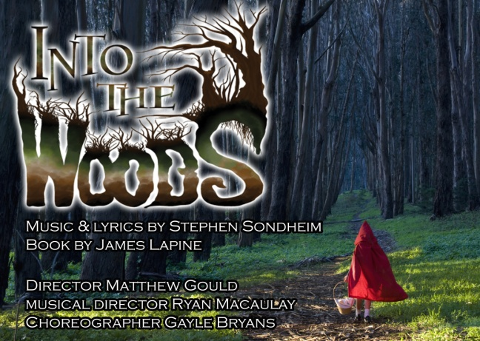

**INFORMATION SHEET**

**SHOW DATES**: Weds 2nd - Sat 12th April 2014

**WORKSHOP / AUDITION DATES**

Workshop:  Weds 20th Nov, 7pm

Auditions - 1st Round: Fri 6th / Sat 7th / Sun 8th Dec (individual slots to be allocated)

Recalls:  Sat 14th Dec (and Sun 15th Dec if necessary)

Note: First round auditions are the final weekend of Hot Mikado – additional times will be made available as necessary to accommodate HM folk.

**FIRST REHEARSAL AND GET-TOGETHER**:  Sat 4th Jan

**REHEARSAL DAYS**: Tuesdays, Wednesdays and alternate Sat / Sun

(first week is Sat 11th, then Sun 19th etc)

**CHARACTERS**: Note: Doubling to be confirmed

We will probably do the “two wolf” version; One or both princes will also therefore play a wolf☺

*Male* *Female*

Narrator   
 Witch

Baker Baker’s Wife  
Jack Jack’s Mother  
Cinderella’s Prince Cinderella

Rapunzel’s Prince Rapunzel

Little Red Riding Hood

Cinderella's Father Cinderella's Stepmother

Florinda (Cinderella’s stepsister)

Lucinda (Cinderella’s stepsister)

Mysterious Man Grandmother / Cinderella’s Mother / Giant  
Prince's Steward

Sleeping Beauty  
Snow White

Two wolves

**FURTHER INFORMATION**

For further information or to book an audition slot, please contact: [**SedosITW@gmail.com**](mailto:SedosITW@gmail.com)

**FULL AUDITION NOTICE AND FURTHER INFORMATION INCLUDING AUDITION FORMAT ETC**

Will be issued shortly and available on the Sedos website: **Sedos.co.uk**

 31/10/13