**AUDITION PACK**



Presents…

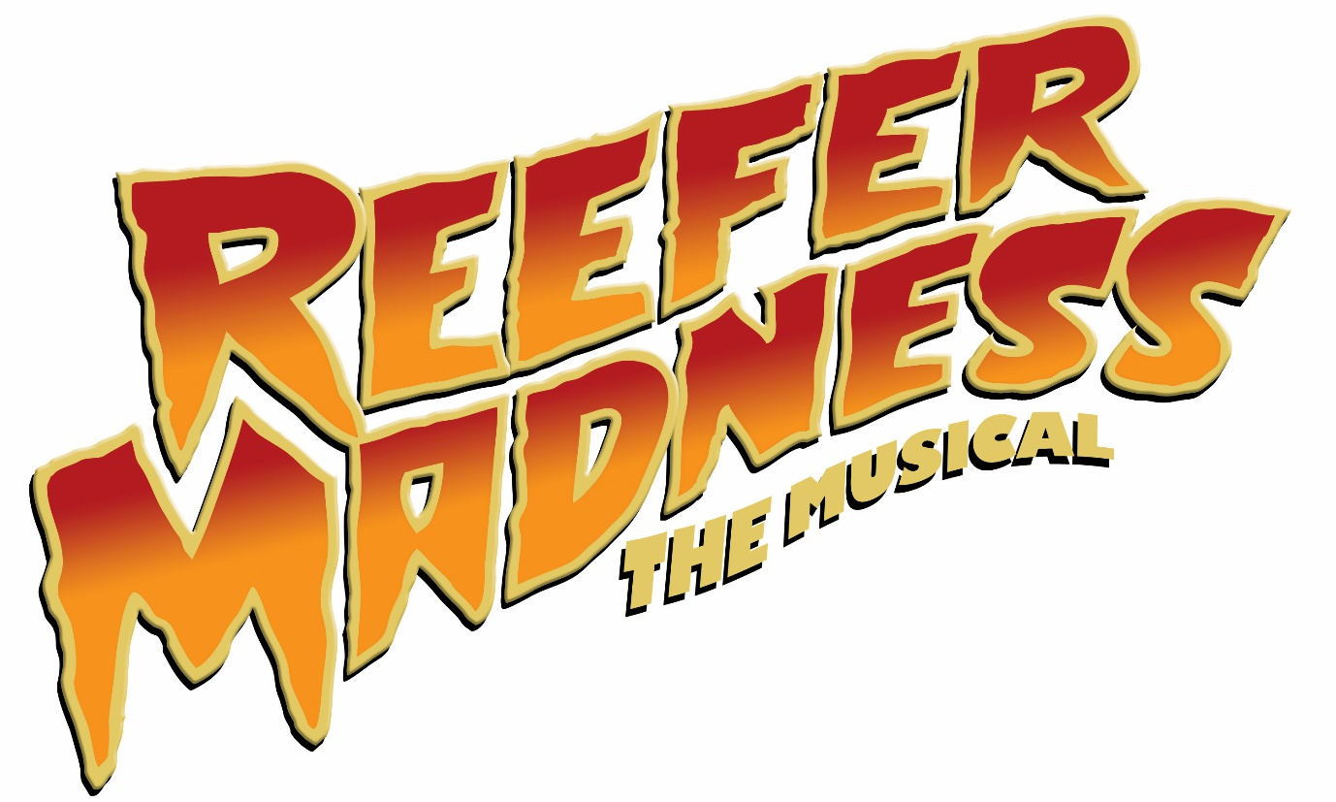

By Kevin Murphy and Dan Studney

|  |  |
| --- | --- |
| Director | Matt Bentley |
| Musical Director | Hayden Taylor |
| Choreographer | Alice Bendall |
| Producer | Nicola Gledhill |
| Assistant Producer | Blake Klein |
|  |  |

**Synopsis**

Inspired by the original 1936 film of the same name, this raucous musical comedy takes a tongue-in-cheek look at the hysteria caused when clean-cut kids fall prey to marijuana, leading them on a hysterical downward spiral filled with evil jazz music, sex and violence.

A lecturer presents to a school hall on the Harper Affair, in which young Jimmy Harper finds his life of promise turning into a life of debauchery and murder thanks to the new drug menace, marijuana. Along the way he receives help from his girlfriend Mary and Jesus himself, but always finds himself in the arms of the Reefer Man and the rest of the denizens of the Reefer Den.

The full 2005 film of Reefer Madness, starring Alan Cumming, Kristen Bell and Neve Campbell, is available to watch free of charge on YouTube. Our version will more closely resemble the film than the earlier original LA cast recording, with the retention of some older songs, including the Act 1 finale and Jimmy on the Lam. Also, Mrs Poppy has been restored to the original Mr Poppy, and is played by the Lecturer (as Jesus is played by Jack).

**Content**

Reefer Madness is not about marijuana.

Let me clarify that: Reefer Madness uses marijuana as a subject, but it is really about the lies and misinformation that are regularly used as scare tactics to stir up paranoia. This technique has been used for centuries to whip people up into a frenzy over such ‘terrors’ as jazz music, alcohol, homosexuality, and even The Beatles. More recently we’ve seen paranoid social media campaigns against vaccines and GMO crops that have no basis in science.

The show doesn’t put forward an opinion on whether marijuana is ‘good’ or ‘bad’. It satirises those who use it as well as those who spread horror stories about it. So don’t worry if you are pro-pot, anti-pot, or know very little about pot – this show may still be for you!

However, it is not for the faint of heart. Reefer Madness is a highly stylized and satirical political commentary. It contains adult humour, religious parody, and drug use, as well as suggested violence and sexual explicitness. It’s no more risqué than The Book of Mormon, but if that show troubled you morally, this could be one to think twice about.

**Style**

The tone of Reefer Madness is energetic from start to finish, with very little down time. Its dialogue and characters are intentionally ridiculous to emphasise the silliness of the paranoia the Lecturer is trying to create. The production will reflect this by aiming to be as close to a living cartoon as possible. Many aspects of the set and props will be two-dimensional pen-and-ink cutouts, and the performances will be bordering on the extreme. However, it is important that these extreme performances are committed to by the cast to avoid descending into incoherence and losing the humour.

**Music**

Reefer Madness features a wide variety of song styles, from rock and swing to Bollywood and Tom-Jones-cheesy pop. Consequently, the vocal demands on most of the named roles are significant – every character has at least one major song, with the exception of the Placard Girl. Similarly, the many varied production numbers require all members of the ensemble to hold their own (or at least be able to sing in tune).

**Dance**

This show has some big dance numbers. This mostly affects the ensemble, but some of the named roles will ideally be able to move, particularly Jack and Sally. Jack’s ability to dance is a plot point, and Sally’s character calls for a seductive quality to her movement. It would also be very useful if Mary, Jimmy and the Lecturer could move as well, but this isn’t as essential.

The focus of the ensemble, however, will be on dancing. This doesn’t mean they will all be trained dancers, but they need to be willing to put the work in to make the dance numbers look impressive. That being said, don’t let this put you off auditioning if you’re not strictly a ‘dancer’. We will be looking for people we can work with to get the effect we’re after.

**What are we looking for?**

The cast will comprise 15-20 performers, but will most likely be closer to 17, depending on the range of people who audition. These will be 7 named characters, 7-12 ensemble members, and the Placard Girl (who is a bit of both).

The named characters are all specific ‘types’ that will each need a certain mix of abilities. Looks are less important, but we will be looking for people who ‘fit’ the role and will work well opposite each other.

The ensemble will need to sing and dance, as discussed above, but our priority is for strong personalities which the performers will bring to their roles. As each character the ensemble plays is only on stage for one or two numbers, the overall personalities of the ensemble members (real or developed) will take the place of any consistent character.

There are some numbers (the Orgy and/or Little Mary Sunshine) that require performers to be scantily clad, in underwear or sexy/seductive costumes. Please keep this in mind before auditioning as we want all cast to be comfortable with this. The cast must also be unafraid of some fast costume changes.

Although Reefer Madness is set in the 1930s, when specific racial assumptions were still in place, the production team thinks this is rubbish and encourages auditionees from all backgrounds.

**Characters**

|  |  |
| --- | --- |
| **Jimmy Harper** | Male. Aged 16, but will likely be cast 18-30. The perfect image of a typical 1930s American teenager until he succumbs to the lure of the deathly marijuana, at which point he becomes sex-crazed and manic. On stage in the bulk of the show, so needs to have great energy. Key songs are Romeo and Juliet, Mary Jane/Mary Lane, Murder, and The Truth. Needs to be an excellent actor and a good singer. Movement ability isn’t essential, but if the actor can dance, there are opportunities to work this into the production. |
| **Mary Lane** | Female. Aged 16, but will likely be cast 18-30. Also the perfect image of a typical 1930s American teenager, who spends much of the show concerned for Jimmy, but is eventually lured into sampling marijuana with startling results. Key songs are Rome and Juliet, Lonely Pew, Mary Jane/Mary Lane, and Murder. Ideally leads the Five and Dime dancers, and will need a strong singing voice. |
| **Mae** | Female. Late 20s-40s. The ‘mother’ of the reefer den. In an abusive relationship with Jack, but stays with him due to her dependency on the drugs he provides. A faded beauty and the show’s unexpected hero. Key songs are The Stuff and The Truth. Must be a strong actress and singer, but doesn’t need to dance much. |
| **The Lecturer** | Male. Any age, with a distinctive presence. A ‘community leader’ who is at the Benjamin Harrison High School to deliver a presentation about the evils of marijuana to parents and other community members. He is mainly interested in spreading paranoia and misinformation, but with a sincere belief he is doing the right thing. He acts as the narrator of the show and also plays many minor roles including Mr Poppy, Goat-Man, Irish Priest, Old Man, Radio Announcer, Ticket-Taker, Policeman, and FDR. Key songs are Reefer Madness and The Truth, with a distinctive cameo in The Orgy. Requires a versatile actor with a strong singing voice and ideally will be able to move. |
| **Jack Stone** | Male. Late 20s-40s. The reefer den’s handsome and ruthless proprieter; a shady and violent 30s gangster movie type. Full of slick old-school charisma but with a brutally dark nature underneath. Key songs are Listen to Jesus Jimmy, and Murder. Also plays Jesus and George Washington. The script specifically requires him to be a strong dancer and he has some demanding vocal moments. |
| **Sally** | Female. 20s. The reefer den’s resident floozy. Unabashedly sexual and responsible for seducing many a young man into the world of marijuana. Key song is The Orgy, with a distinctive cameo in The Truth. Also plays Lady Liberty. Must be a good mover and a strong singer, but more importantly must ooze the libidinous soul of Mae West combined with the rat-a-tat moxie of vintage Barbara Stanwyck. |
| **Ralph Wiley** | Male. 20s-30s. A denizen of the reefer den, formally a fraternity man, his college days ended long ago due to his reefer habit. Key songs are Lullabye and Murder. Also plays Sally’s Baby, Switch-Puller, and Uncle Sam. Must be a very strong comic actor who can hold a tune, but doesn’t need to dance much. |
| **Placard Girl** | Female. 18-30s. Throughout the show she reinforces the warnings of the Lecturer by holding large signs that clearly reinforce the moral of what we’ve just seen. Also plays a Police Officer and most of the ensemble roles. Doesn’t have any vocal solos, but must meet the requirements of the ensemble. Ideally she will also be a strong lead dancer for solos in Down at the Ol’ Five and Dime, and The Orgy. |
| **Ensemble** | 7-12 performers with strong personalities and no particular look to play Reefer Zombies, Kids at the Five and Dime, Jungle Orgy dancers, Angels, and patriotic background chorus in the star-spangled finale. Will ideally be good dancers who can hold a tune and commit to the ridiculousness of the characters and the overall show. |

**Key Dates**

Pre-Audition Workshops Wednesday 20 & Sunday 24 January

Auditions Saturday 6, Sunday 7 & Monday 8 February

Recalls Wednesday 10 February

Initial Read-Through Sunday 28 February

First Rehearsal Tuesday 1 March

Rehearsals will be on Tuesday and Thursday evenings, and Sunday afternoons.

Get-in/Tech Sunday 15 May

Final Dress Rehearsal Monday 16 May

Performance Dates at the Bridewell Theatre:

Tuesday 17 – Saturday 21 May, 7:30pm

Saturday 21 May, 2:30pm

**Workshops**

**Wednesday 20 January, 7:30pm – 9pm.**

**Sunday 24 January, 6pm – 7:30pm.**

**1 Brewers Hall Gardens, Moorgate, EC2V 5DX.**

The workshops will include:

* Meet and greet with the production team
* Introduction to the show
* Teaching the dance audition routine
* Group improvisation activities
* A look at some scenes
* Adjourn to the pub

Note that while the dance audition routine will be taught at the workshops, a filmed version will also be available on the Sedos website following the workshops, and there will be some opportunity to recap it at the audition itself. Attendance at the workshops is therefore recommended but not compulsory for all auditionees.

Please email [sedos.reefermadness@gmail.com](mailto:sedos.reefermadness@gmail.com) to register your attendance (note registration is not mandatory, but it would be useful to give us an idea of numbers).

**Auditions**

**Saturday 6, Sunday 7 & Monday 8 February. 1 Brewers Hall Gardens, Moorgate, EC2V 5DX.**

Initial auditions will focus on dance and singing, with a small amount of acting. Auditionees will be called in groups of approximately 10-12. At the beginning of the session, we will recap/teach the dance routine and then it will be performed in smaller groups for the panel. As there are many different styles of music in the show, the audition piece will be a mix of them all, but the focus will be on the lines and showmanship. Note that the audition piece will be 4 bars longer than that taught in the workshop, just to check how quickly auditionees pick things up.

Each auditionee will then have a 10 minute slot to perform a prepared song and read a monologue from the script. The order of these auditions will be set on the day, on a first-come-first-served basis.

Audition sessions will be held at 11am, 2:30pm and 6pm on Saturday and Sunday, and 7pm on Monday. Participants are requested to arrive in advance of their set time, and will be able to leave when their singing audition has finished.

Please prepare a modern musical theatre song. Choose something that you feel comfortable singing and that showcases what you can do – both your vocal range and your acting ability. Due to time constraints unfortunately we may not be able to hear your whole song, so please consider selecting the bit that will best showcase your abilities. We would prefer that songs from Reefer Madness were avoided at this stage. We will provide a pianist and a speaker with a headphone jack cable, so please either bring legible sheet music or a backing track on a device with a headphone socket. Please do not sing a capella or request to accompany yourself.

A selection of short monologues will be made available when you sign up for an audition slot. Hard copies will also be available on the day. We will not require you to read for a specific part, but want to get a rough idea of your comfort with dialogue, so select any monologue regardless of character, or even gender. Have fun with it, and there is no need to learn it by heart. Note that the show requires all cast members with dialogue to use an American accent, so using one at this stage will be a distinct advantage.

Please note all auditions will be filmed so the Musical Director can review them from overseas.

**Recall (invitation only)**

**Wednesday 10 February. 1 Brewers Hall Gardens, Moorgate, EC2V 5DX. 7pm – 10pm.**

Recalls will focus on group scenes, and we may also request that you sing something specific. Further information will be sent if you are asked to attend. Please note we won’t necessarily be recalling people for every role.

**Booking an Audition**

To book an audition, please email Nicola at [sedos.reefermadness@gmail.com](mailto:sedos.serialkillers@gmail.com) and include the following:

* Name
* Contact number
* Preferred audition date and any time restrictions
* Role preference, if you have one
* Availability on Wednesday 10 February in case we want to recall you

Please be aware that there is a slight overlap between the rehearsal period for Reefer Madness and the production dates of I Love You, You’re Perfect, Now Change. We are happy to work around this, but if you are involved with I Love you, You’re Perfect, Now Change and would like to audition for Reefer Madness, please inform us when booking your audition.

Unfortunately those cast in Such Stuff As Dreams Are Made On will not be able to audition for Reefer Madness due to heavy overlap between the rehearsal periods of both shows. Involvement in Reefer Madness may also limit the extent to which you can participate in Whose Life Is It Anyway and, potentially, London Road.

**Fees**

Sedos is one of London’s pre-eminent amateur theatre societies with the aim of producing quality  
amateur theatre to the best artistic quality possible. In the nature of amateur theatre performers are not paid – not even expenses. To perform in Reefer Madness you must pay a participation fee and be a member of Sedos. The participation fee is £30. Membership of Sedos is £30 per year if you pay by direct debit or £35 otherwise. There is a £5 audition fee for non-Sedos members. (Note, this is non-refundable, even if you are cast in the show).

**Backstage**

Sedos is always looking for volunteers to help with set building, sewing costumes, working Front of House or backstage. If you are interested in getting involved, please contact Nicola at [sedos.reefermadness@gmail.com](mailto:sedos.serialkillers@gmail.com).

**Rehearsals**

Rehearsals will be held at 1 Brewers Hall Garden, Moorgate, EC2V 5DX on Tuesdays and Thursdays from 7pm – 9:30pm, and on Sundays from 2pm – 6pm. We will try to schedule rehearsals around cast availability as much as possible, but please indicate on your audition form any dates you are unavailable. Please be honest – it will not necessarily stop you from being cast, but will help us plan.

Thank you for your interest, and we look forward to meeting you at the workshops and auditions!

Matt, Hayden, Ali, Nic, and Blake.