1. To run KalahGame application: Right click application and select Run As->Run Configuration

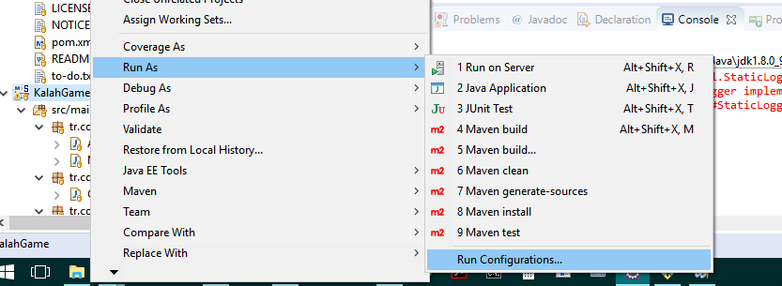

1. Then configure as blow. Click “Apply” and “Run”

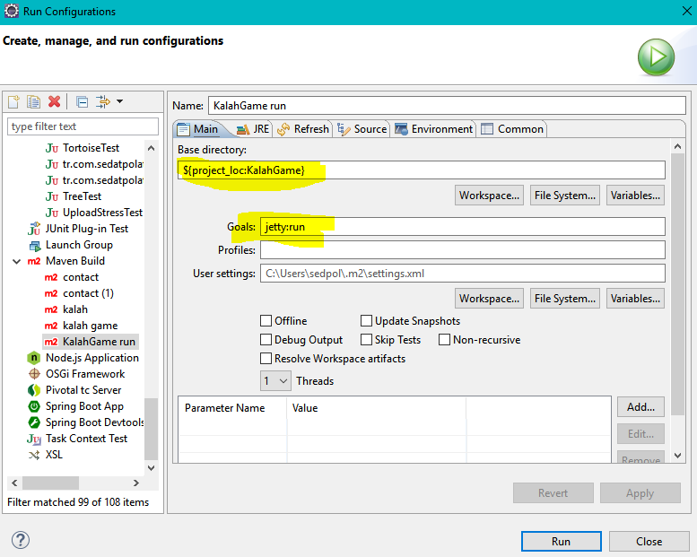

1. After run application click <http://localhost:8080/index.xhtml>

New Game-> creates new game and clears players’ scors.

Start Game-> creates new game without clearing scors.

At the end of the game, if both players have same number of stones in their Kalah, none gains any score.

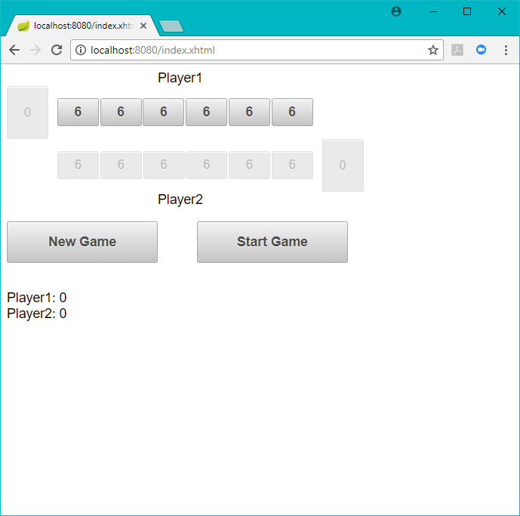

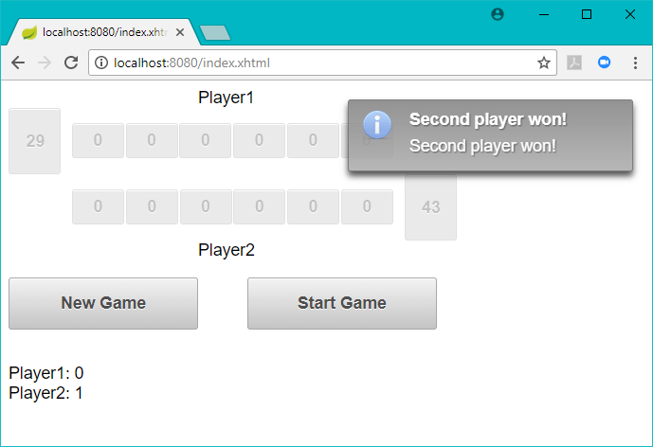

After game finished click “Start Game” to play another game.

