Intelligent Robotics Assignment 1 Report
Motion Model Parameters
The values for the odometry rotation noise, translation noise and drift noise were chosen as 0.65, 0.4 and 0.4 respectively. This was done purely through trial and error; higher values were found to cause the cloud to be too large, decreasing accuracy in the estimation of the robot’s position, whereas lower values were found to be insufficient to keep the cloud focussed on the robot; the cloud would easily lose the robot on sharp turns and drift away.

Initialising the particle cloud
This function uses a for loop to append 750 poses into a blank array. Each of these poses represents one particle. Ideally more particles would have been used but numbers greater than 750 began to produce a large amount of lag, impairing the program’s ability to keep up with the robot. The poses were each generated by adding a gaussian random number to the each of the initialpose’s x and y position values, as well as rotating it’s orientation quaternion by a third gaussian value. The standard deviation for each of the position gaussian values was chosen as 0.8. For the rotation value, a gaussian number was chosen using standard deviation 1.3. Again these values were chosen through trial and error; they were found to initialise a cloud of a suitable size for localising the robot.

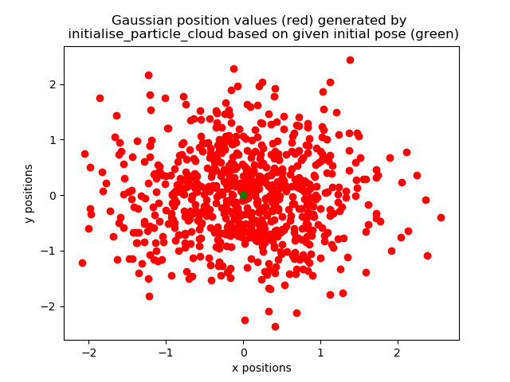
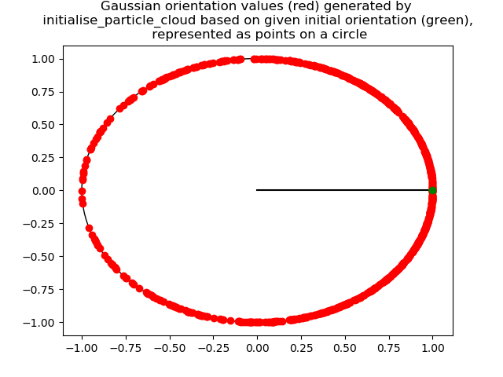
Figure 1 Figure 2

Note: In Figure 2, each point represents the angle extended between the horizontal radius (shown in black) and the line connecting the center of the circle and the point.

Updating the particle cloud
This method begins by checking all of the values in scan.ranges are valid numbers. This is included to avoid an error found when running the real bag files; some range values are returned as nan, which causes a crash when sensor_model attempts to predict the probability of finding these readings. These values are replaced with -1.0, allowing the program to continue.
Next, a for loop is used to find each of the particle’s weights using sensor_model’s get_weight function. The weights are then squared; this was tried as a way of choosing high weight particles even more often than they are naturally, and low weight particles less often. For example, if the only two particles were of weight 2 and 10 respectively, the lower weight one would be chosen only 1 in 26 times, as opposed to 1 in 6 without squaring these values. Experimenting with this was found to affect the localisation positively, so the choice was kept.
Two if statements then check to see if the robot has been kidnapped; the condition for the first is the average (squared) weight being less than 28 and the maximum being less than 31. The second has slightly looser conditions; the values 36 and 42 are used in place of 28 and 31 respectively.
These values were again found through repeated trial and error and fine tuning; the first of these conditions will usually return a positive result when the robot has been kidnapped and negative when not. The second runs when the robot is possibly kidnapped, but there is more uncertainty. In either event, all particles of low (squared) weight are dispersed in an attempt to find the robot. These particles are given a position chosen from the last estimated pose with large gaussian random numbers added, and a completely random orientation. The only difference between the two situations is the requirement for a particle to be considered low enough weight to be dispersed.
The starting standard deviation for the calculation of the position gaussians is 7; this increases by 1 each time the robot is found to still be kidnapped after the previous attempt at finding it.
In the event neither of these if statements run, the robot is not believed to be kidnapped. A new, empty, particle cloud is created. A for loop then adds a new particle to replace each previous particle. The new particle is given the position and orientation of a previous particle plus a small amount of noise. The previous particle is chosen at random in accordance with it’s (squared) weight. This is done by stochastic universal sampling; a random number is chosen between 0 and the sum of the (squared) weights, and a dummy variable starts at 0 and adds each particles (squared) weight in turn until it exceeds the random number. The particle whose ‘region’ contained the random number is the one that is chosen. Finally the new particle cloud replaces the old one.
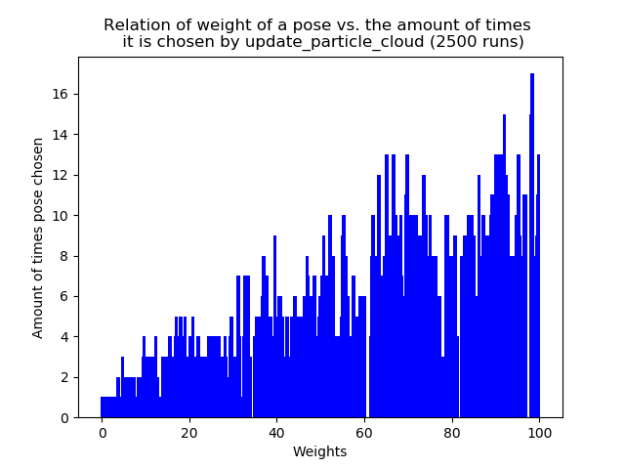
Figure 3

Estimating the pose
This is a very simple function which discards any particles whose x or y position lies in the top or bottom quartile, then calculates an average location and orientation based solely on the remaining values. This is a quite straightforward calculation for the average location, but the average orientation required a little more work, since the values cannot simply be added and divided by the total amount. Fortunately python’s atan2 function can be used to find the average of a set of angles through the use of the formula
avg(d_{i}) = atan2(sum(sin(d_{i})),sum(cos(d_{i}))). The sin and cos sums are easily found from the quaternion values as the quaternion z and w values for an angle d are simply sin(d/2) and cos(d/2) respectively. Then the double angle formulas can be applied to find:
sin(d) = sin(2*d/2) = 2sin(d/2)cos(d/2) = 2zw, and
cos(d) = cos(2*d/2) = cos²(d/2) – sin²(d/2) = w² – z²
The rotateQuaternion function is subsequently called to set the orientation of the new estimated pose to this average.
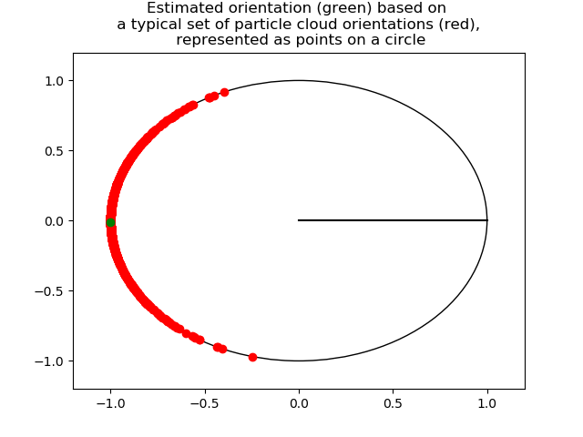
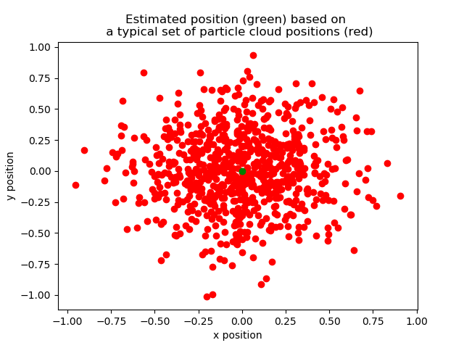
Figure 4 Figure 5
Performance
The particle cloud quickly localises to the correct position if a relatively good initial pose is given. As the robot moves, it follows it with a fair degree of accuracy, although there is noticably more variation in the cloud than in the AMCL implementation, especially when the robot is rotating. If a bad initial pose is given, the cloud is usually able to find the robot fairly quickly, depending heavily on how far away the pose was from the true position of the robot.

Difficulties faced
- When initialising position it proved difficult to choose noise values to be added in order to create an appropriate cloud. This was solved through simple trial and error.
- When updating the cloud, low weight particles seemeed to be being chosen a higher proportion of the time than was deemed appropriate; this caused a little too much variation in the cloud. As mentioned above, we experimented with squaring the weights of all particles and experienced positive results.
- When testing the code on the provided bag files containing real data, several crashes were experienced. The cause of this was tracked down to be the inclusions of ‘nan’ values in the laser scan ranges. To solve this, a few lines of code were added to alter these values to -1.0, allowing the program to continue.
- The if statement for checking if the robot has been kidnapped was often found to give both false positive and negative results; the code would believe the robot to be kidnapped when it was not, and not always detect when it actually was. Both of these remain problems but by fine tweaking of the conditions for the if statement to run and the addition of a second, similar if statement with looser conditions that disperses less of the particles they have been reduced to occur as small a proportion of the time as we have been able to acheive. The code is now usually fairly quick to detect the robot has been kidnapped, and rarely falsely assumes that it has.
- When estimating pose it proved hard to find an effective way to filter out outliers. Initially we attempted to discard the top and bottom quarter by distance, but this quickly led to an issue in which all particles are discarded as outliers. Instead we implemented a method which sorts all x and y values, then only considers particles whose x and y values both lie in the middle half of all particles.

Flaws
- If given a very wrong initial pose, or if the robot is kidnapped and moved a large distance, the particle cloud struggles to quickly relocate the robot. This is due to the low standard deviation used when dispersing particles to find the robot. Higher standard deviations were experimented with, but it was found that this made it more difficult to locate the robot when it is kidnapped and moved shorter distances, ultimately making the algorithm less effective.It occasionally spends periods of time believing it has located the robot when it has not.
- False positives still occasionally occur when checking if the robot has been kidnapped.
- The estimated pose does not adjust for the case in which the particle cloud has divided into two or more clusters tracking several hypotheses. In this situation ideally the biggest cluster should be selected and the estimated pose should be calculated from it. However the algorithm naively takes the average of all particles in the middle half of the dataset; this can lead to an estimated pose in the middle of two clusters, seperated from both.
- There is still some noticeable lag in the program, even with as few as 750 particles. This is caused mainly by the large amount of time it takes to calculate the weights of the particles.
- In estimate_pose, it is still technically possible for the algorithm to discard all particles as outliers, though this has never been observed while testing.
- Particles are only disregarded as outliers based on their position; no filtering is done with regards to their orientation

