Predict Earthquake Magnitude and Identify High-risk Regions Based On Historical Earthquake Data

Project Report

- Objective:
The objective of this project is to apply data mining techniques to analyze historical earthquake data, uncover patterns, and predict earthquake magnitudes. The analysis aims to identify high-risk regions based on historical trends, providing data-driven insights and recommendations for disaster preparedness. The deliverables include an executive report and a presentation showcasing the methods used and the actionable findings derived from the dataset.

- Introduction:

- Problem Statement:
- Earthquakes are unpredictable natural disasters that can have devastating effects on human lives, infrastructure, and the environment. While predicting the exact timing of earthquakes remains difficult, analyzing historical earthquake data can provide insights into the likelihood of future seismic events. This project aims to predict earthquake magnitudes and identify high-risk regions by clustering historical earthquake occurrences.

- Research Questions:
- Can historical earthquake data be used to reliably predict the magnitude of future earthquakes?
- What are the geographical regions most prone to high-magnitude earthquakes?
- How do various factors like depth, tsunami indicator, and alert levels correlate with the magnitude and significance of earthquakes?
- How can clustering techniques be applied to categorize regions based on earthquake risk?

- Expected Outcomes:
- A predictive model capable of estimating earthquake magnitudes with reasonable accuracy.
- A clear identification of high-risk regions for disaster preparedness and resource allocation.
- Insights into significant factors contributing to earthquake severity.
- Interactive visual tools for stakeholders to understand and interpret the analysis results.

- Background Information on the Dataset:
- The dataset includes historical earthquake records from 1/1/2001 to 1/1/2023
- Rows: 1001
- Columns: 19
- Dataset-link : https://www.kaggle.com/datasets/warcoder/earthquake-dataset?select=earthquake_1995-2023.csv

- Column descriptions:
- magnitude: The magnitude of the earthquake
- date_time: date and time
- cdi: The maximum reported intensity for the event range
- mmi: The maximum estimated instrumental intensity
- alert: The alert level - “green”, “yellow”, “orange”, and “red”
- tsunami: "1" for events in oceanic regions and "0" otherwise
- sig: A number that describes the size of the event. A higher number means a larger event. This value is determined from a number of parameters including magnitude, maximum MMI, felt reports, and estimated impact
- net: The ID that Identifies the network - source of information for this event.
- nst: The total number of seismic stations used to determine earthquake location.
- dmin: Horizontal distance from the epicenter to the nearest station
- gap: The largest azimuthal gap between azimuthally adjacent stations (in degrees). In general, the smaller this number, the more reliable is the calculated horizontal position of the earthquake. Earthquake locations in which the azimuthal gap exceeds 180 degrees typically have large location and depth uncertainties
- magType: The method or algorithm used to calculate the preferred magnitude for the event
- depth: The depth where the earthquake begins to rupture
- latitude / longitude: coordinate system by means of which the position or location of any place on Earth's surface can be determined and described
- location: location within the country
- continent: continent of the earthquake hit country
- country: affected country

- Data Collection and Exploration:

- Process of Data Collection:
The dataset represents a comprehensive compilation of historical earthquake records spanning from January 1, 2001, to January 1, 2023, covering a 22-year period. The collection process involved gathering data from reputable seismic monitoring organizations and scientific networks.

- Steps in the Data Collection Process:
- Primary Data Sources:
The data was likely obtained from reliable sources such as:
  - United States Geological Survey (USGS): A globally recognized authority for earthquake monitoring.
  - Seismic Networks: Local and regional seismic monitoring systems contributing data on earthquake occurrences (e.g., IRIS, European-Mediterranean Seismological Centre).
  - Instrumental Records: Earthquake intensity and magnitude data collected via seismographs.
- Timeframe Selection:
The dataset focuses on a specific timeframe (2001–2023), allowing for a meaningful analysis of trends and patterns in earthquake occurrences over two decades.
- Data Standardization:
  - Information was curated to ensure consistency across records, particularly for fields such as magnitude, depth, and location.
  - Parameters like mmi, cdi, and sig were standardized using widely accepted algorithms to ensure comparability.
- Geographic Scope:
Data includes global earthquake events, capturing their latitude, longitude, and associated countries/continents.
- Incorporation of Secondary Indicators:
  - Fields like tsunami (indicating tsunami risk), alert (severity levels), and sig (significance of the event) were derived based on seismic activity characteristics and impact assessments.
  - Additional data such as dmin (distance to the nearest station) and gap (azimuthal gap) were integrated to provide context on the quality and reliability of earthquake measurements.
- Quality Assurance:
Data was filtered to remove anomalies and duplicates, ensuring the final dataset contains accurate, validated records. Outliers in critical fields like magnitude, depth, or sig were carefully reviewed.

- EDA (Exploratory Data Analysis)
- Pie chart
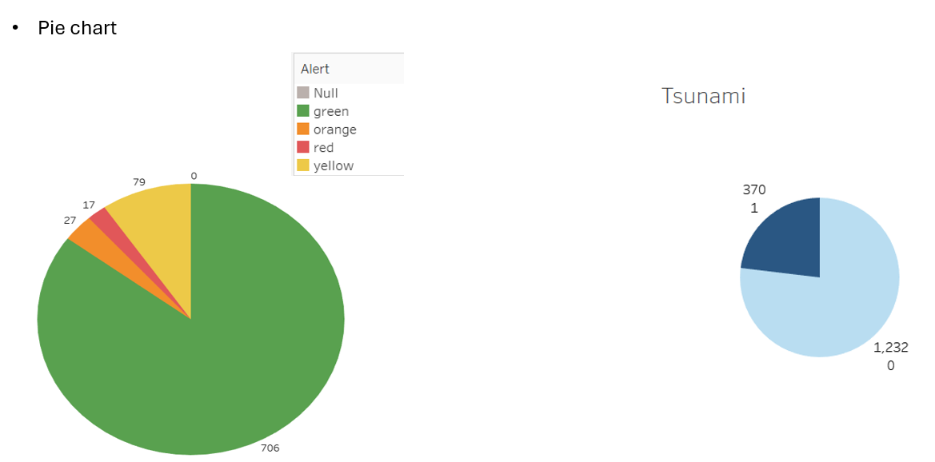
- Left Pie Chart (Alert Levels):
The chart appears to show different alert levels represented by colors:
  - Green (706 instances) - dominant segment, representing ~85% of the total
  - Yellow (79 instances) - ~9.5%
  - Orange (27 instances) - ~3.2%
  - Red (17 instances) - ~2%
- Right Pie Chart (Tsunami):
Shows a binary distribution with two segments:
  - Light blue segment (1,232) - approximately 77%
  - Dark blue segment (370) - approximately 23%

- Histogram
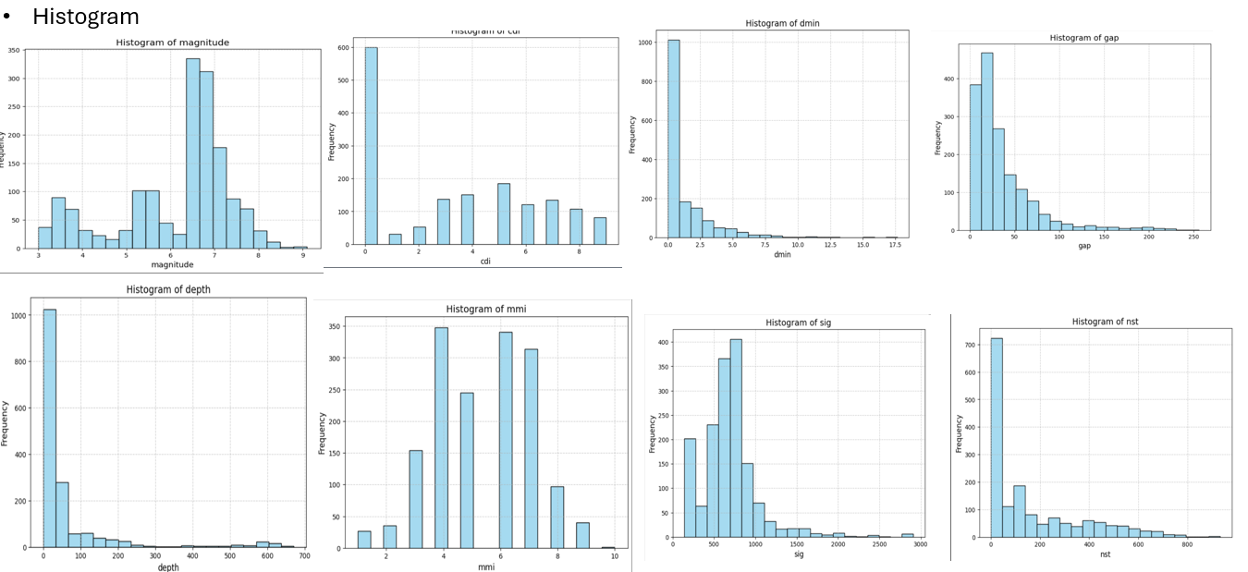
- Histogram of magnitude:
- There appears to be a smaller secondary peak around magnitude 5.5-6
- The frequency drops off sharply after magnitude 7.5
- The data suggests that moderate-to-strong earthquakes (magnitude 6-7.5) are most common in this dataset
- Histogram of cdi:
- After the initial peak at 0, there's a sharp drop to very low frequencies at CDI = 1-2
- The distribution shows multiple smaller peaks rather than a smooth decline
- The frequency gradually decreases for higher CDI values (7-9)
- Values between 3-9 show a somewhat more even distribution compared to the dramatic spike at 0
- Histogram of dmin:
- The vast majority of observations are concentrated in the shortest distance range (0-2.5)
- Sharp drop in frequency between first and second bin (from ~1000 to ~200)
- After the initial steep decline, the frequency decreases more gradually
- Very few observations beyond dmin = 10
- Histogram of gap:
- Most observations have small azimuthal gaps (< 60 degrees)
- Steep decline in frequency between 40-100 degrees
- Very low but persistent frequency of observations with larger gaps (>100 degrees)
- The tail of the distribution extends to about 250 degrees but with very few occurrences

- Histogram of depth:
- The vast majority of earthquakes occur at shallow depths (<100 )
- Sharp drop in frequency after the first bin
- Long tail extending to deeper depths
- Interesting small secondary peak at very deep depths (~600)
- Histogram of mmi:
- Very few events at low intensities (MMI 1-2)
- Frequency increases sharply from MMI 3 to 4
- After the second peak at MMI 6, there's a steady decline
- Few events above MMI 8
- Almost no events at MMI 10
- Histogram of sig:
- Two main clusters of data: One cluster near zero , Main cluster centered around 700-800
- Rapid drop in frequency after the main peak
- Very few observations beyond 1500 units
- The tail becomes very thin but extends quite far
- Histogram of nst:
- The vast majority of events are recorded by relatively few stations (<100)
- Very rapid initial decline in frequency
- Long tail extending to higher station counts
- Almost no events recorded by more than 600 stations

- Frequency table
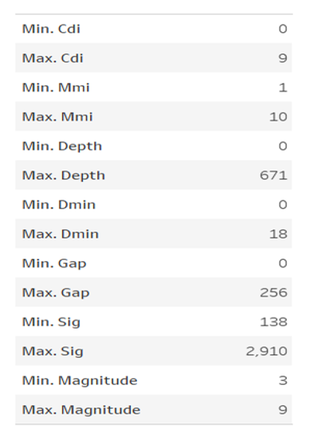
- Min. Cdi / Max. Cdi: Likely refers to the Community Internet Intensity (CDI), which measures the perceived intensity of an earthquake based on public reports. The range here is from 0 (no perception) to 9 (extreme perception).

- Min. Mmi / Max. Mmi: Refers to the Modified Mercalli Intensity (MMI) scale, which assesses the intensity of shaking and damage caused by an earthquake. The range goes from 1 (barely felt) to 10 (extreme destruction).

- Min. Depth / Max. Depth: The minimum and maximum depth of earthquakes recorded, measured in kilometers. The range here is from 0 km (surface) to 671 km (deep focus).

- Min. Dmin / Max. Dmin: Minimum and maximum distance to the nearest station (Dmin) from the earthquake source. The range is 0 to 18 units (likely in kilometers).

- Min. Gap / Max. Gap: The range of azimuthal gap values, representing the largest angle between seismic stations recording the earthquake. A higher gap might suggest lower data reliability. The range is 0 to 256 degrees.

- Min. Sig / Max. Sig: The minimum and maximum significance (Sig) of earthquakes, which combines magnitude, depth, and population density to indicate the potential impact. The range here is 138 to 2,910.

- Min. Magnitude / Max. Magnitude: Minimum and maximum earthquake magnitude, on a scale where 3 indicates minor earthquakes and 9 represents major earthquakes.

- Covariance
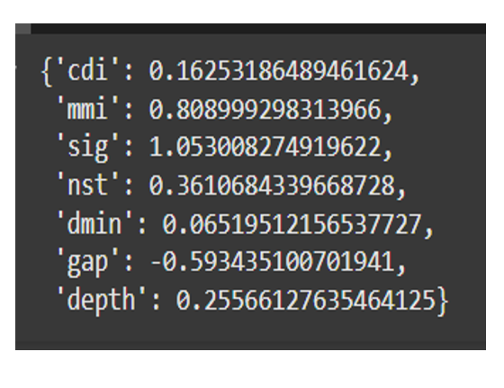
- 'cdi': Represents the Community Internet Intensity (CDI) value, normalized.
Example Value: 0.16253186489461624.
- 'mmi': Refers to the Modified Mercalli Intensity (MMI), also normalized.
Example Value: 0.808999298313966.
- 'sig': Indicates the significance score of an earthquake, normalized.
Example Value: 1.053008274919622.
- 'nst': Likely represents the number of seismic stations (nst) reporting the earthquake, normalized.
Example Value: 0.3610684339668728.
- 'dmin': Normalized minimum distance (dmin) from the earthquake to the nearest station.
Example Value: 0.06519512156537727.
- 'gap': Normalized azimuthal gap value, where the negative value suggests relative scaling.
Example Value: -0.593435100701941.
- 'depth': The normalized depth of the earthquake.
Example Value: 0.25566127635464125.

- Treemap
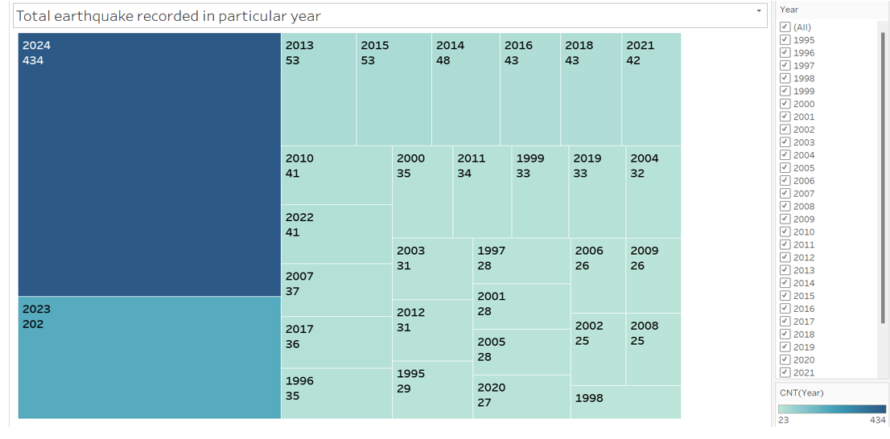

- treemap visualization representing the number of earthquakes recorded each year.
    - Size and Color:
  - The size of each block corresponds to the total number of earthquakes recorded in a specific year.
  - Darker colors indicate higher earthquake counts, while lighter colors indicate fewer.
    - Key Observations:
  - 2024 recorded the highest number of earthquakes (434), shown as the largest and darkest block.
  - 2023 had the second-highest count, with 202 earthquakes.
  - Other years have significantly fewer events, mostly ranging from 25 to 53 earthquakes annually.
    - Trends:
  - There is a visible increase in earthquake recordings in recent years (2023–2024).
  - Years prior to 2010 generally recorded fewer events, possibly due to limited technology or lower seismic activity.
    - Filter Panel:
  - On the right side, there’s a filter for selecting years to view earthquake counts dynamically.

- Text table
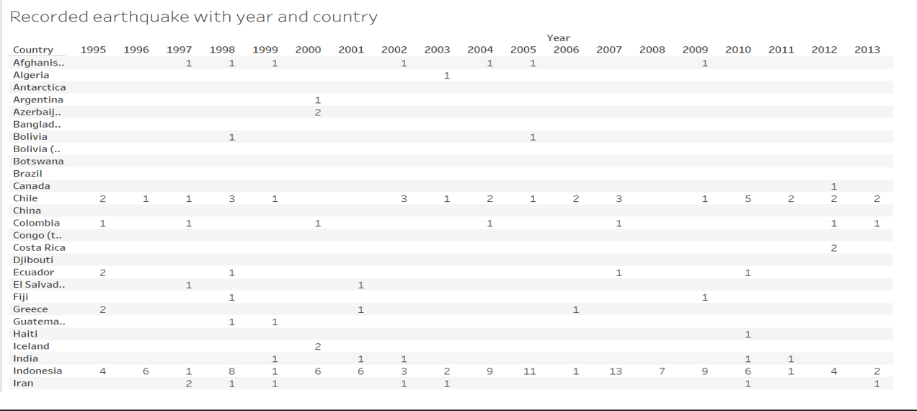

- Map view
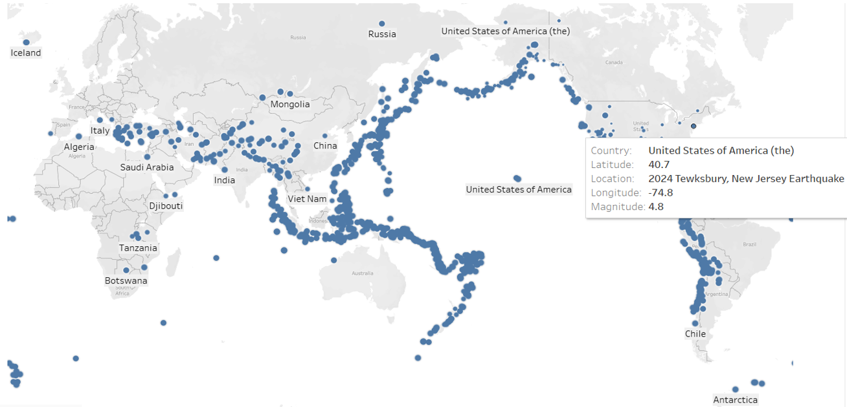

- Data Preprocessing:
- Handling missing values
Handling missing values for numeric data with Average
- Magnitude
- Cdi
- Mmi
- Sig
- Dmin
- Gap
- Depth
- Data transformation
Calculate z score for numeric data type attributes:
- Magnitude
- Cdi
- Mmi
- Sig
- Dmin
- Gap
- Depth
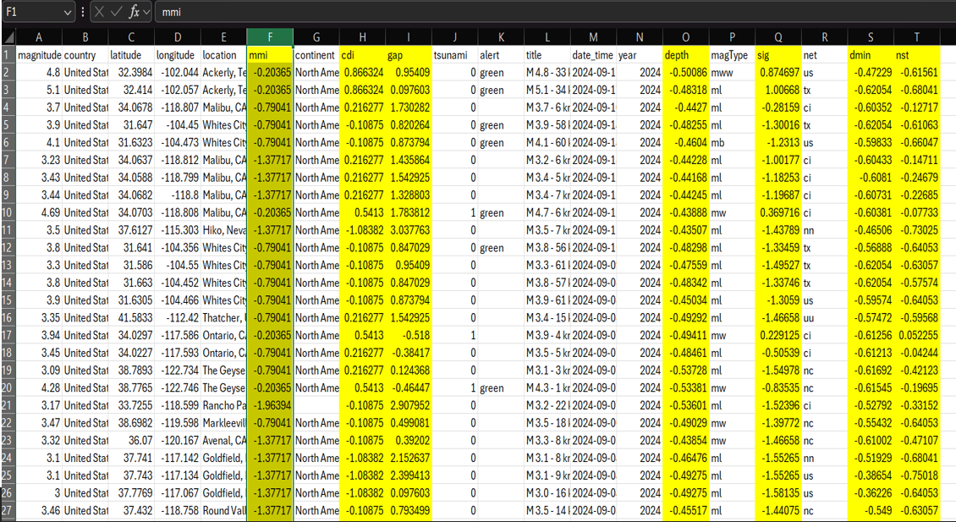

- Dealing with Outliers
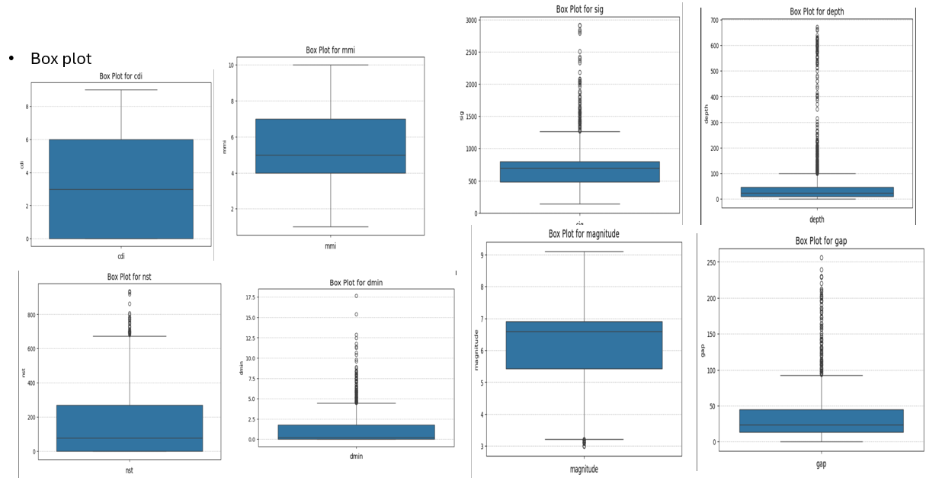

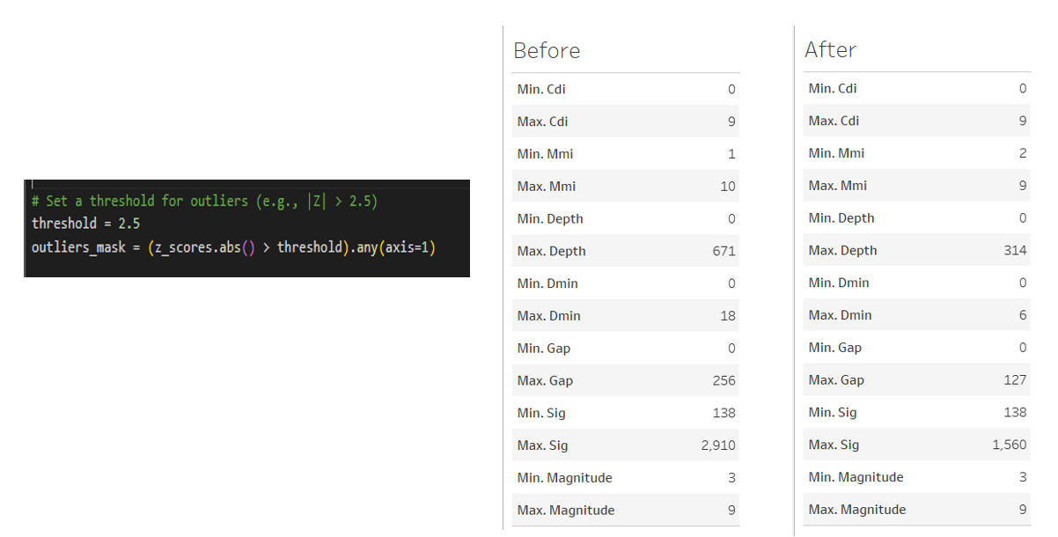
- It removes outliers from the dataset.
- The threshold is set at 2.5. This likely corresponds to a Z-score threshold, where any data point with a Z-score greater than 2.5 (absolute value) is considered an outlier.
- The outliers_mask is created using the Z-scores of the data. It identifies rows in the dataset where the absolute Z-score exceeds the threshold across any column (.any(axis=1)).
- "Before" Table: Shows the original dataset with extreme values (e.g., "Max. Depth" is 671, "Max. Gap" is 256, and "Max. Sig" is 2,910).
- "After" Table: Shows the same dataset after outlier removal. The extreme values are reduced to more reasonable ranges (e.g., "Max. Depth" is now 314, "Max. Gap" is 127, and "Max. Sig" is 1,560).

- Methodology:

- Here, Data mining technique uses two methodology.
    - Decision Tree & KNN which is predict Earthquake magnitude
    - Clustering which is identify high-risk regionsbased on historical earthquake data.

- . Decision Tree: Predict earthquake magnitude

- Process with steps:

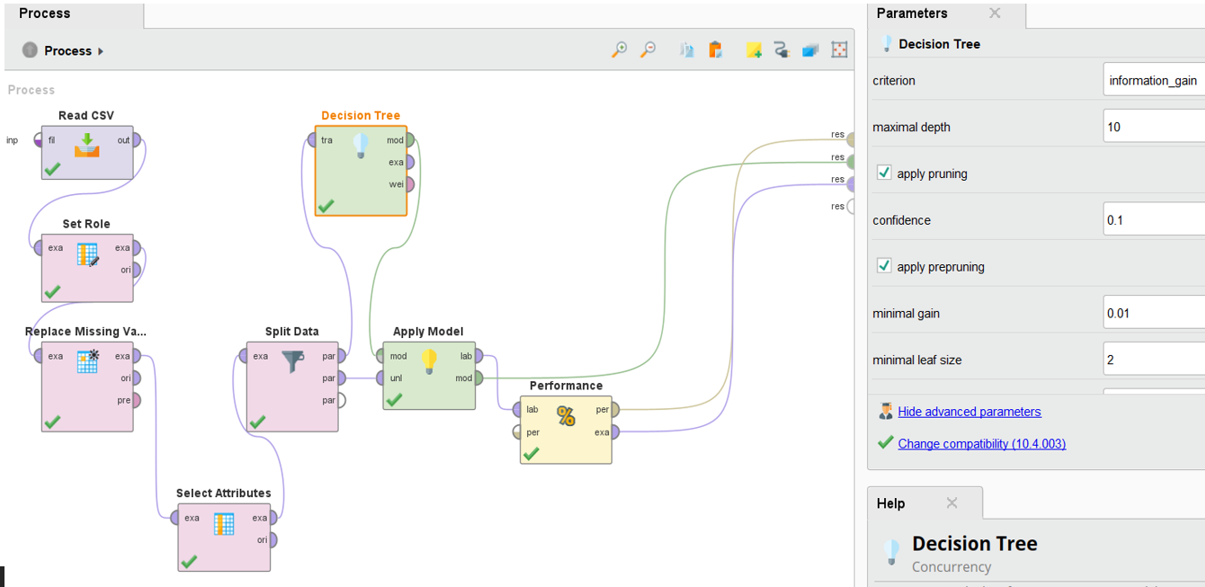

- Data Input and Preprocessing:
  - "Read CSV": Imports the initial dataset from a CSV file
  - "Set Role": Defines the roles of different variables (likely setting the target variable)
  - "Replace Missing Values": Handles missing data in the dataset
  - "Select Attributes": Chooses which features to include in the model
  - "Split Data": Divides the dataset into training and testing sets

- Model Building:
  - "Decision Tree": Creates a decision tree model with specific parameters visible in the right panel:
    - criterion: information_gain (measures the quality of splits)
    - maximal depth: 10 (limits tree depth)
    - apply pruning: checked (helps prevent overfitting)
    - confidence: 0.1 (affects pruning severity)
    - apply prepruning: checked
    - minimal gain: 0.01
    - minimal leaf size: 2

- Model Evaluation:
  - "Apply Model": Applies the trained model to the test data
  - "Performance": Evaluates the model's performance metrics

- Tree Structure with Performance matrix:
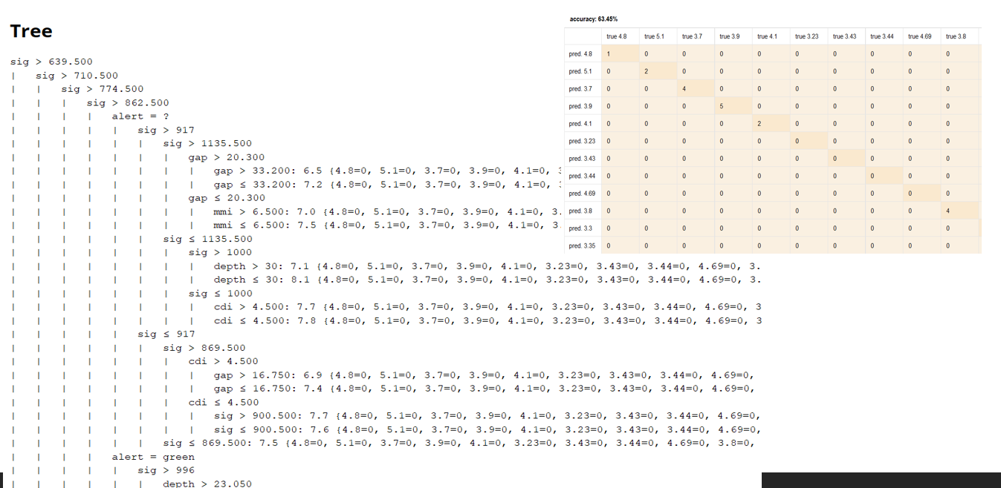

      - Decision Tree Structure:
- The data is structured as a nested decision tree, where each level represents a condition or threshold that must be met before moving to the next level. The conditions involve various parameters such as:
- sig: Signal strength or amplitude.
- gap: Gap in data or coverage.
- mmi: Modified Mercalli Intensity, a measure of earthquake intensity.
- depth: Depth of the earthquake.
- cdi: Cumulative Distance Index, which might relate to the distance from the epicenter.

      - Performance Matrix (top right):
- Shows a confusion matrix
- Accuracy is reported as 63.45%

      - Tree Characteristics:
- It's a multi-level decision tree with nested conditions
- Uses binary splits (greater than/less than comparisons)
- Contains an "alert" parameter with at least one "green" value
- Many leaf nodes contain multiple parameters in parentheses, suggesting this might be used for some kind of alert or monitoring system.

- The file describes a detailed decision-making process for classifying seismic events based on multiple parameters. It uses a hierarchical structure to narrow down the possible outcomes based on the values of these parameters, ultimately assigning a specific value or alert level to each event. This system is likely used in automated earthquake monitoring and alert systems to quickly and accurately classify seismic events.

- Decision Tree has low accuracy (63.45%) which suggest the improvement for model performance.

- . Decision Tree Cross Validation: Predict earthquake magnitude

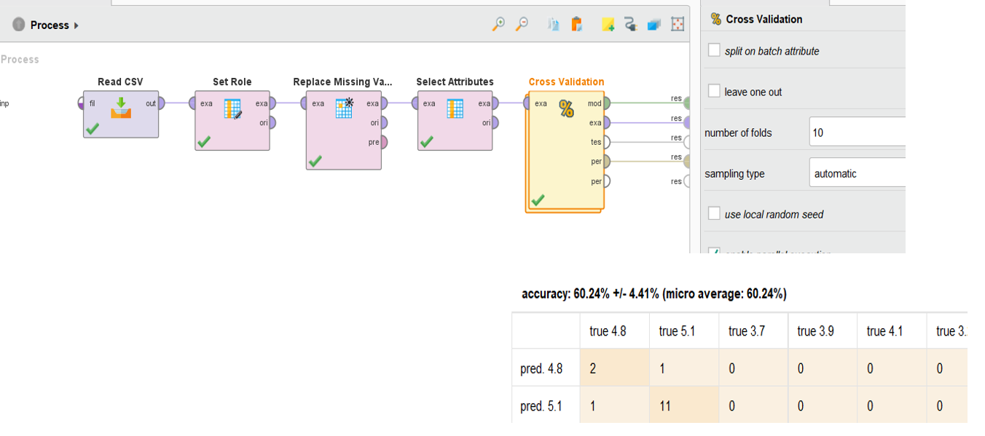

  - Process Workflow:
- Read CSV: Imports the earthquake data without outliers.
- Set Role: Defines target and feature variables
- Replace Missing Values: Handles missing data with average value.
- Select Attributes: Chooses relevant features (alerts, cdi, depth, dmin, gap, magnitude, mmi, sig)
- Cross Validation: Performs 10-fold cross validation

  - Cross Validation Settings (right panel):
- Number of folds: 10
- Sampling type: automatic
- No split on batch attribute
- No leave-one-out validation
- No local random seed used
- Enable parallel execution

  - Performance Results:
- Overall accuracy: 60.24% ± 4.41% (micro average: 60.24%)

- . KNN: Predict earthquake magnitude

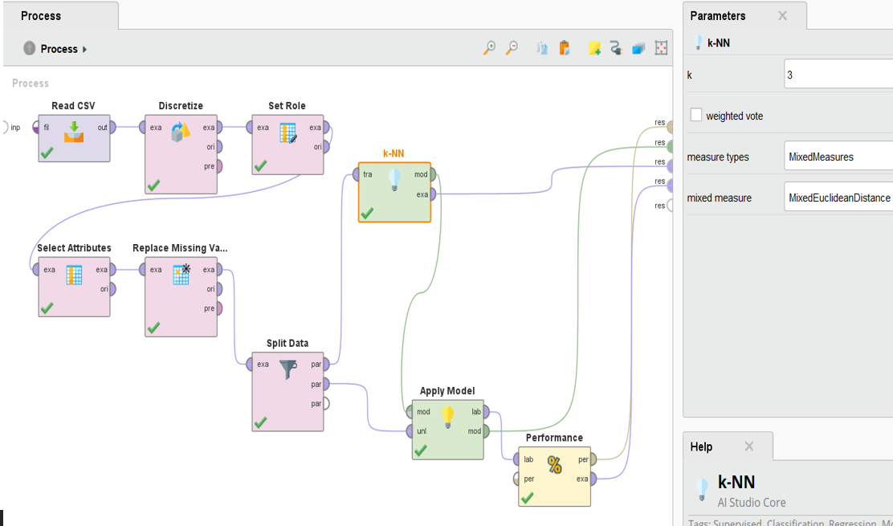
  - Data Preprocessing Pipeline:

- Read CSV: Loads the earthquake data
- Discretize: Converts continuous data into discrete categories
- Set Role: Defines target and feature variables
- Select Attributes: Chooses relevant features
- Replace Missing Values: Handles missing data
- Split Data: Divides data into training and test sets

  - Model Configuration (from Parameters panel):

- k = 3 (considers 3 nearest neighbors)
- MixedMeasures as measure types
- MixedEuclideanDistance for distance calculation
- No weighted voting enabled

  - Model Evaluation:

- Apply Model: Uses the trained k-NN model on test data
- Performance: Evaluates prediction accuracy
This workflow differs from the previous decision tree approach by:
- Using k-NN, which makes predictions based on the 3 most similar historical earthquakes
- Including a discretization step to handle continuous variables
- Using mixed measures to handle different types of features
- Using Euclidean distance to determine similarity between earthquake events
The k-NN approach might be valuable for earthquake prediction as it can capture complex patterns by looking at similar historical events, though the relatively low k value of 3 suggests the model might be sensitive to noise in the data.

  - Performance Result:

- Accuracy: 86.47% (much higher than the previous ~60%)

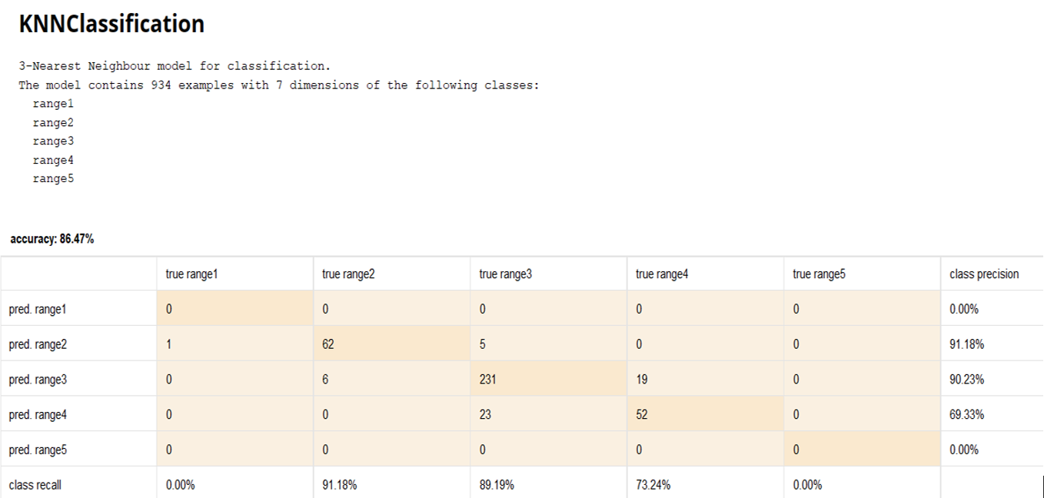

- The k-NN model performs particularly well for ranges 2 and 3, with over 90% precision, but struggles with extreme ranges (1 and 5). This could indicate either a class imbalance in the training data or that extreme magnitude earthquakes have more unique characteristics that make them harder to classify using nearest neighbors.

- Accuracy: The model correctly classified 85.24% of data points.
- Precision: The model is good at identifying true positives for each class.
- Recall: The model is good at finding all positive instances for each class.

- True Positives: The model correctly predicted the class for 75 range1, 269 range2, and 66 range3 data points.

- False Positives: The model incorrectly predicted range1 for 6 range2 and 1 range3 data points, and so on.

- Clustering – identifying High-risk Regions Based on Historical Earthquake Data

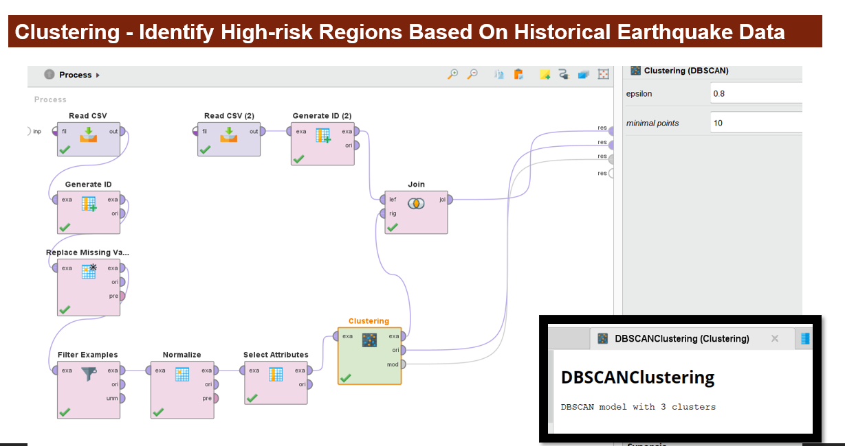

- Process:

      - Data Loading:
- Two CSV files are read as input.
- Unique IDs are generated for each record.

      - Data Preparation:
- Missing values are replaced.
- Examples are filtered.
Data is normalized.
Relevant attributes are selected.
      - Clustering:
- DBSCAN algorithm is applied with the following parameters:
  - epsilon: 0.8
  - minimal points: 10
- Interpretation
- Clustering: The DBSCAN algorithm groups similar earthquake data points into clusters.
- High-Risk Regions: Clusters with a high density of earthquake events are likely to be identified as high-risk regions.
- Overall Visualization
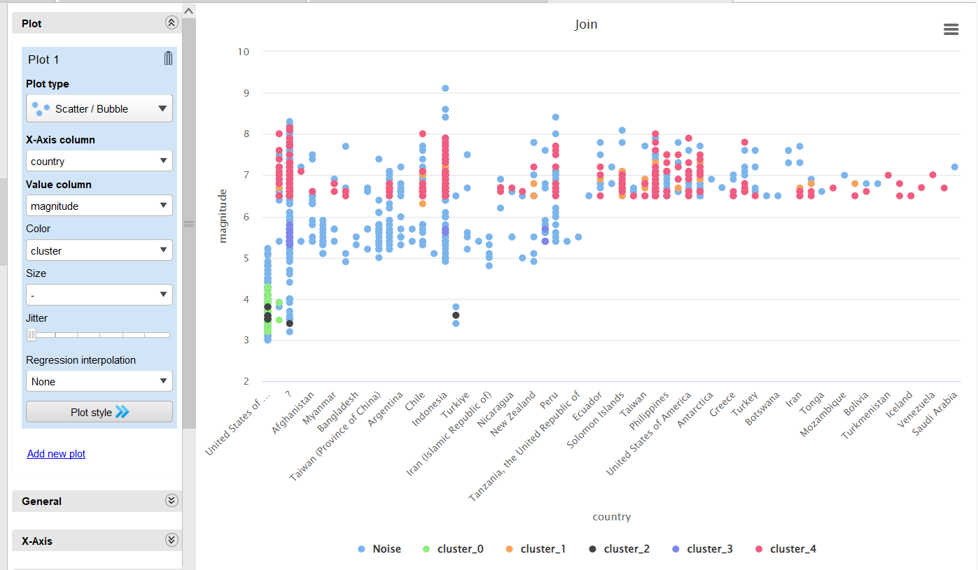
- Type: Scatter plot with color-coded clusters
- Purpose: Visualize the relationship between earthquake magnitude and country, grouped by clusters.
- Data
- X-Axis: Country name
- Y-Axis: Earthquake magnitude
- Color: Represents different clusters (0 to 4)
- Size: Possibly indicates the number of earthquakes or other relevant data points
- Interpretation
- Cluster Distribution: The data points are divided into 5 clusters based on their magnitude and country.
- Magnitude Range: The magnitude values range from approximately 2 to 10.
- Country Distribution: The plot includes a wide range of countries.
- Outliers: There are some outliers with very high magnitude values.
- Cluster Characteristics:
  - Cluster 0: Low magnitude earthquakes across multiple countries
  - Cluster 1: Medium magnitude earthquakes, mostly concentrated in a few countries
  - Cluster 2: High magnitude earthquakes, scattered across countries
  - Cluster 3: Very high magnitude earthquakes, concentrated in a few countries
  - Cluster 4: Extremely high magnitude earthquakes, concentrated in a few countries.

- Results:

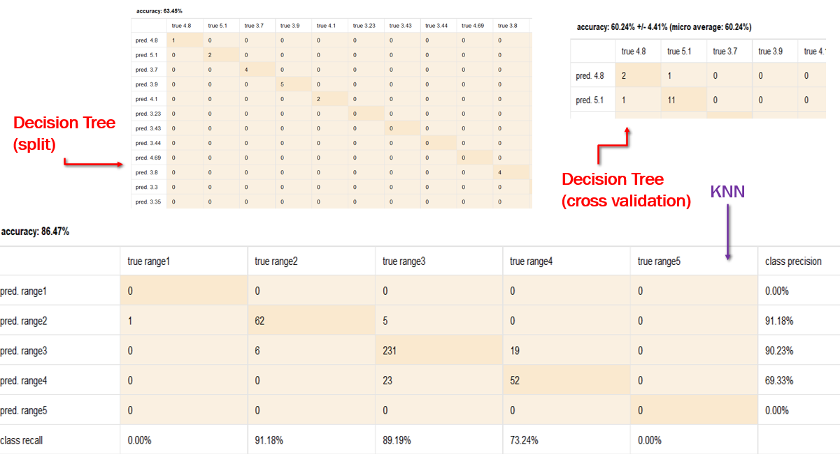

    - Decision Tree with Split (63.45% accuracy):
- Simple train/test split validation
- Performs well for specific magnitudes (4.8, 3.7, 3.9, 4.1)
- Shows some confusion between adjacent magnitude values
- The confusion matrix is sparse, with most predictions concentrated around a few magnitude values.

    - Decision Tree with Cross Validation (60.24% ± 4.41%):
- More robust evaluation using 10-fold cross-validation
- Slightly lower but more reliable accuracy estimate
- Strong performance for magnitude 5.1 (11 correct predictions)
- Shows consistent confusion pattern between 4.8 and 5.1 magnitudes
- The standard deviation indicates relatively stable performance across folds.

    - k-NN Classification (86.47% accuracy):
- Best performing model among the three
- Uses ranges instead of specific magnitude values
- Excellent performance for middle ranges:
  - Range2: 91.18% precision, 62 correct predictions
  - Range3: 90.23% precision, 231 correct predictions
- Moderate performance for Range4: 69.33% precision
- Poor performance for extreme ranges (Range1 and Range5)
- Shows some confusion between adjacent ranges, particularly Range3 and Range4.

- The results suggest that using k-NN with magnitude ranges is the most effective approach for this earthquake prediction task, though care should be taken with predictions for extreme magnitude ranges.

- Discussion:

- Analysis in Context:

- Magnitude Prediction:

- decision tree is around 63% accurate in predicting earthquake magnitudes based on historical data.
- For some data records decision tree is overestimating or underestimating certain magnitudes.
- Knn on other hand is more accurate in predicting earthquake than decision tree.

- Cluster Analysis:

- DBSCAN helps in highlighting the spatial patterns in the clustering results.
- Helps in Identify regions prone to high-magnitude earthquakes (e.g., clusters with higher average magnitude).
- It also Highlight noise points (outliers)

- Recommendations:

- Focus on disaster preparedness in high-risk regions identified through clustering.
- Use predictive models to issue early warnings for potential high-magnitude earthquakes.
- Improve data collection and preprocessing for more accurate predictions.

- Limitations and Challenges:

- Data Limitations:

  - Potential biases in historical earthquake records.
  - Incomplete or missing data affecting model accuracy.

- Model Trade-offs:

  - DBSCAN sensitivity to parameters (epsilon and min_samples).

- Conclusion:

- Summary of Findings:

- Decision tree is not effective, but KNN is effectively predicted earthquake magnitudes with a measurable accuracy, precision, and recall.
- DBSCAN clustering successfully identified high-risk regions, with some noise points indicating isolated events.
- Insights from the dataset can help improve disaster preparedness and resource allocation.

- Impact on Research or Practice:

- Encourages the adoption of machine learning techniques in seismology and disaster management.
- Provides a framework for identifying high-risk areas for future studies.

- Future Research:

- Experiment with other clustering algorithms (e.g., K-Means, Hierarchical Clustering) for comparison.
- Incorporate additional features (e.g., tectonic plate boundaries, population density) to enhance predictions and clustering.
- Develop real-time models to integrate new earthquake data dynamically.

