Energy: Guatemala: a country that runs on fuelwood

Renato Vargas

Table of Contents

Toggle navigation

[SEEA Guatemala](http://seeagt.github.io/)

* [Topics](index.html#)
  + [SEEA Overview](index.html)
  + [Agriculture, Forestry, and Fisheries](http://seeagt.github.io/report/aff)
  + [Forests](http://seeagt.github.io/report/forests)
  + [Water](http://seeagt.github.io/report/water)
  + [Land and Ecosystems](http://seeagt.github.io/report/ecosystems)
  + [Waste](http://seeagt.github.io/report/waste)
  + [Subsoil](http://seeagt.github.io/report/subsoil)
  + [Fisheries](http://seeagt.github.io/report/fisheries)
  + [Energy](http://seeagt.github.io/report/energy)
* [Credits](http://seeagt.github.io/credits)

# Energy

### Guatemala: a country that runs on fuelwood

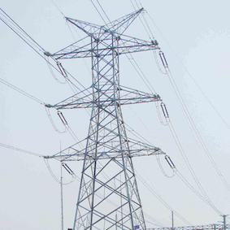

[Read Online](index.html#startarticle)

[PDF](http://seeagt.github.io/doc/energy.pdf)

#### [Institutional Credits](http://seeagt.github.io/credits)

## * * *

*Natural capital accounting showed that Guatemala is a country whose main source of energy is fuelwood, and it also made clear that the production of electricity is the largest individual user of energy of all kinds, taking up to 3.3 units of energy in other forms to produce one unit of electricity.*

## Energy, the environment, and the Guatemalan economy in a nutshell

Nature provides the Guatemalan economy with coal, wind, power derived from water and thermal sources, fuelwood, sugar cane bagasse, and crude oil, among others. These are called “primary sources” of energy because they are usable in their natural form to some extent. We can take advantage of them locally or we can import them from the rest of the world. However, most of the economy’s productive processes cannot take advantage of these sources in their raw form, and so they are transformed into what we call secondary sources of energy. Examples of this type of energy include the various types of gasolines and diesel fuels, liquefied petroleum gas, and electricity.

Different industries, or economic activities, use both primary and secondary energy sources as inputs in their production processes. Households, in turn, use them to satisfy domestic needs like cooking, powering of devices, heating or cooling, among others. One special industry uses large amounts of various types of primary and secondary sources to produce electricity, which is then used universally by everyone else in the economy.

Finally, from the combustion—or simply burning—of some these energy products, industries emit various gases that go up into the atmosphere. Some of these are known as greenhouse gases and in our accounting efforts we have tracked carbon dioxide (CO2), nitrous oxide (N2O), and methane (CH4).

## How does energy flow from the environment to the economy?

Between 2001 and 2006, the Guatemalan economy used several types of energy resources directly from the environment in order to satisfy both the needs of industries and households. Water’s potential energy and thermal energy from volcanic activity were key resources in the production of electricity. The country also extracted crude oil and natural gas in some regions, which were destined almost exclusively for the export market. Guatemalans also imported coal from other countries mainly for the production of electricity. Nevertheless, in Guatemala the biggest source of energy obtained directly from the environment was biomass in the form of fuelwood for domestic use and sugarcane bagasse, mainly used as an input in the production of electricity.

The table below shows the relative structure of energy sources that were used directly from nature in Guatemala in terajoules (TJ) between 2001 and 2006. This is called primary energy. It is evident that biomass was extremely important for the country, with a use share of around 83% of all primary energy sources. And within that category fuelwood powered household activities with 224,227.3 TJ or 90% of that biomass. The second most important source of primary energy was coal, which was used mainly for the production of electricity and was mostly imported. Hydraulic and geothermal energy were also important for the country with around 20,534 TJ used in the year 2006. Even if oil production in the country was important as a source of foreign income, its direct use in Guatemala was minimal, with a share of about 1% of primary resources.

***Table 1. Primary energy (terajoules)***

|  |  |  |
| --- | --- | --- |
| Primary energy | terajoules | percentage (%) |
| Biomass (100%) | 248,313.70 | 82.5 |
| -Of which, fuelwood (90.3%) | 224,227.30 |  |
| -Of which, bagasse (9.7%) | 24,086.40 |  |
| Hydraulic and geothermal energy | 20,533.90 | 6.8 |
| Oil and natural gas | 1,705.60 | 0.6 |
| Coal | 30,503.80 | 10.1 |
| Total | 301,057.00 | 100 |

Source: Iarna/Banguat (2009)

## How does energy move within the economy?

A total of 483,947.3 TJ[1](index.html#fn:3cc96d9b80e0f953d1c554f50c09bdb0:8) of energy in all its forms was available to the Guatemalan economy in 2006. That energy was used as inputs in the production of goods and services by several industries, and also by households, the government, and non-profit institutions in processes such as cooking, artificial lighting, heating, or cooling.

The figure shows quantities of energy in terajoules used by the different economic industries and households in the rows, coming from the various energy sources in the columns. Darker tones represent higher uses of energy relative to total consumption. According to this, household final consumption of represented around 47% of total use and even surpassed slightly all consumption of energy used as inputs in production processes (46%). This was due not only to the fact that households were the main users of fuelwood (which has a high calorific content), but also of gasoline, liquefied petroleum gas for cooking, and electricity.

[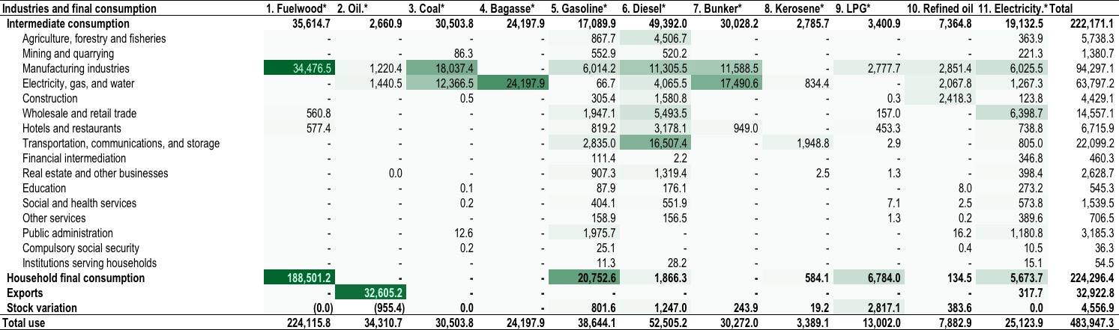](../../float/energy/energy-heatmap.jpg)  
*Figure 1. Energy use heatmap 2006 (terajoules) (click to enlarge)*

The largest user of energy of all types in the Guatemalan economy was by far the production and distribution of electricity with a total of 61,594 TJ, equivalent to 27% of the energy used by industries as inputs in 2006. This meant that the Guatemalan society used a large percentage of energy of different kinds (such as coal, bunker, diesel, bagasse, etc.), which in many cases was imported at high costs, to produce electricity.

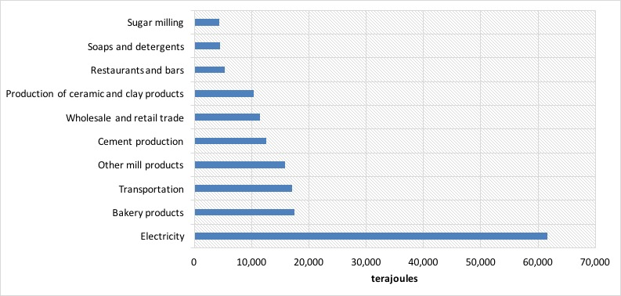 *Figure 2. Largest users of energy, 2006 (terajoules)*

## What happens with Greenhouse Gas Emissions?

The total human contribution to greenhouse gas emissions from the combustion of different energy sources in Guatemala amounted to 45.6 million carbon dioxide metric tons equivalent in 2006. In general terms, that was less than 1% of total world emissions. Nevertheless, since it is such an important topic in general terms, it could still carry financial consequences or opportunities regarding international treaties on the matter and we need to track its performance. Table 11 shows the distribution of emissions among groups of economic industries.

The figure below shows the greenhouse gas emissions of the top five emitting industries on the left of the vertical axis with bars and those of households on the right of the vertical axis with a line. Households emissions were considerably higher, due to the high carbon content of fuelwood and their large use of that product, coupled with their considerable use of gasoline. Among the top emitters, it is interesting to note that the emissions of the production and distribution of electricity more than doubled those of the industry that follows it. This was consistent with the high use of fossil fuels in the production of electricity.

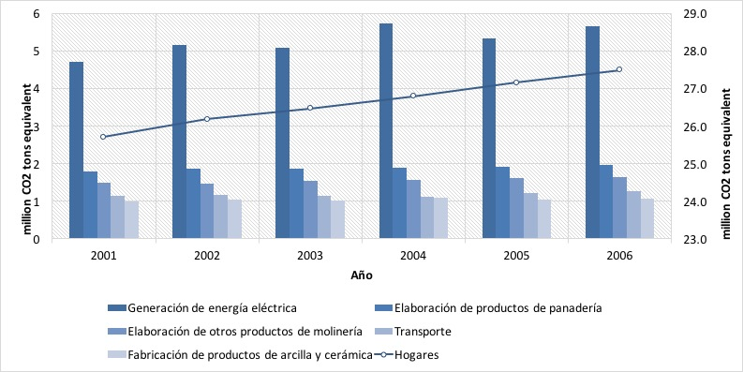 *Figure 3. Selected greenhouse gas emitters, 2006 (CO2 tons equivalent)*

The second industry on the graph is the production of bread which is there because of its high use of fuelwood. In a GHG inventory (those advocated by the Inter Governmental Panel on Climate Change) emissions from biomass do not count toward the total emissions and are left as “memorandum items”, this in order to avoid double counting. In the supply and use accounting structure of the SEEA, this is not a problem, and hence they were included. If fuelwood and bagasse were excluded, bakeries and mills would exit this list and cement production and retail trade would replace them. Finally, due to its high use of different fuels, the transportation industry was also important in this context.

## With what intensity is energy used by industries?

Figure 5 shows an indicator called energy intensity for six economic industries for 2001-2006. Due to the nature of each type of economic activity, we can find these at different general levels of intensity. Some industries needed less energy to produce one unit of wealth added to the economy in that year (value added), like retail trade for example, and others, like cement production needed considerably more. For that reason it is not altogether adequate to compare intensities between industries. However, it is possible to compare how a specific industry fares through time. In that way, we can see if use of energy per unit of newly added wealth has improved or become worse.

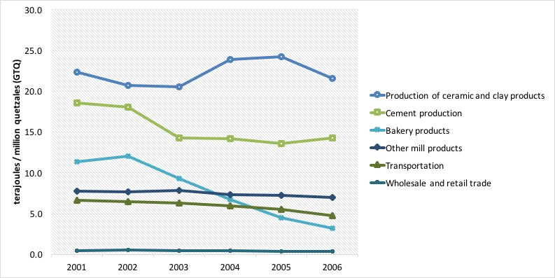 *Figure 4. Energy intensity for selected industries*

In the case of Guatemala, the production of bread showed a decrease in its intensity in the period. The production of ceramics showed a more erratic behavior, but mantained its high level of energy use, whereas transportation and general mills had a more stable energy intensity over time. This is probably due to the fact that technology is replaced less often in those activities.

## Summary

In this essay, we have introduced the Energy and Emissions Account of Guatemala. This account is a framework that allows us to understand the intricate relationship between the environment and the economy in terms of energy resources, and at the same time quantify the emissions that result from the combustion of the different types of energy.

In the last year of the analysis, there was an energy consumption of 483,947 terajoules.

Around 46% of all the energy consumed can be attributed to household final use, where fuelwood, gasoline, and electricity are predominant.

The production of electricity used about 13% of all energy consumption, equivalent to 61,594 TJ.

Among the relevant players in the consumption of energy we found the production of bakery products (3.6% of total use), transportation (3.5%), grain milling (3.3%), cement production (2.6%), wholesale and retail trade (2.2%), restaurants and bars (1.1%), sugar milling (1%), and the production of soaps and detergents (1%).

From the combustion of energy, a total of 45.6 million CO2 tons equivalent were emitted to the atmosphere, of which the 5 largest emitters (excluding households) were responsible for 11.6 million CO2 tons equivalent or 64%. Households emitted around 27.5 million CO2 tons equivalent.

In terms of intensity, a measure that compares energy use with value added generation, we have that the electricity generation industry requires 14.2 terajoules for every million quetzales (GTQ) that it contributes to GDP, which contrasts with the average for manufactures (2.9 TJ for every million GTQ), or trade activities that circle below 1 TJ for every million GTQ of value added.

* Some of this energy was produced locally and a portion was imported. [[return]](index.html#fnref:3cc96d9b80e0f953d1c554f50c09bdb0:8)

[Back to top](index.html#top)

## * * *

[Back to top](index.html#top)

[](http://creativecommons.org/licenses/by/4.0/)  
The System of Environmental And Economic Accounts of Guatemala by [BANGUAT/IARNA-URL](http://seeagt.github.io/credits)  
is licensed under a [Creative Commons Attribution 4.0 International License](http://creativecommons.org/licenses/by/4.0/).  
Based on a work at [www.infoiarna.org.gt](http://www.infoiarna.org.gt) with support from WAVES at The World Bank.