Horizon
-----------

Beyond San Andreas Fault lies a threat potentially ten times more destructive - just waiting to be triggered.

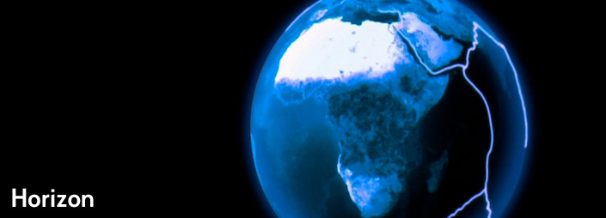

The West Coast of America has long been ready for 'The Big One': the moment when the San Andreas Fault springs to life. But what if defences have been pointing in the wrong direction?

What if a far bigger earthquake is on its way - one that could submerge Vancouver and destroy Seattle and Portland by unleashing a string of re-ignited volcanoes, landslides and tsunamis? Welcome to the world of the 'megathrust' quake - ten times bigger than anything San Andreas can deliver. Have the beginnings of a tremor already begun?

The sci-fi generation who felt let down by NASA are now in their 50s and 60s, and they are determined to realise their childhood dream of roaring rockets - even if it means putting their hands in their pockets and building their own.

They say anyone will be able to holiday in orbit within three years. But who will be the first to get tourists into space? Horizon looks at the contenders, from Richard Branson's Virgin Galactic to Jeff Bezos, founder of Internet retailer Amazon.com. The race is on.

Inspiring, authoritative and thrilling, Horizon is the definitive last word in science television for over 40 years. This award-winning series continues to find audiences right across the world with its informative reporting on the crucial issues from the frontiers of science and medicine.

