Sahara Manual
version 2.3
20-06-2007

Created by Seek You Too B.V. as commissioned by Surfnet B.V.
For further information please contact us at info@cq2.nl
Date | Version | Author(s) | Description
 | 2.0 | Thijs Janssen, CQ2  Sven Stringer, CQ2 | Compiled various pieces of Sahara documentation into one document.
2006-11-28 | 2.1 | J.B. Jonkers, CQ2 | Minor adjustments after document-review by Erik Saaman of Surfnet.
2007-04-19 | 2.2 | J.B. Jonkers, CQ2 | Additional installation information added
2007-06-20 | 2.3 | J.B. Jonkers, CQ2 | Deployment related information moved to seperate document.

Table of Contents
1.Intended audience 5
2.Introduction 6
3.Architecture 8
4.Web Control Panel 10
4.1.Main menu and navigation 11
4.2.User control panel 11
4.2.1.Domain administration 11
4.2.2.Repository group administration 14
4.2.3.Repository administration 15
4.3.Administrator control panel 17
4.3.1.Domain management 17
4.3.2.User account management 20
4.3.3.Mapping administration 21
4.3.4.Target administration 22
5.Harvesting 23
5.1.Overview 23
5.2.An Example 24
5.3.Harvesting Algorithm 25
5.3.1.Batches 25
5.3.2.Looping 25
5.3.3.Incremental harvesting 25
5.3.4.Clear 25
5.3.5.Refresh 26
5.3.6.Closing hours 26
5.4.Log File Details 26
5.4.1.Global logfile 26
5.4.2.Per-repository logfiles 27
5.5.Harvesting Details 27
5.5.1.Using screen 29
5.5.2.Using init.d 29
6.Get interface 30
6.1.Request 30
6.1.1.Authentication 30
6.2.Response 31
6.2.1.General 31
6.2.2.Error 32
6.2.3.GetRepositoryGroups 33
6.2.4.GetRepositories 35
6.2.5.GetRepository 38
6.2.6.GetMapping 40
6.2.7.GetTarget 42
6.2.8.GetIdentifiers 44
6.2.9.GetStatus 45
6.2.10.GetRecord 48
7.Sahara Software Components 51
7.1.Third-party packages 51
8.References 53

Intended audience
This manual is intended for application administrators who have to operate the Sahara harvester. This manual starts with an overview of Sahara.
The section on the web-control panel explains how repositories can be configured using the web-control panel provided by Sahara. This section also describes how to interpret the results of the harvester. All mechanisms Sahara offers to process the harvested data are covered in detail.
How to operate the harvester engine itself is described in a separate section. Last but not least, this manual describes all the operations provided by the SaharaGet interface.

Introduction
The system called Sahara consists of two subsystems, namely an OAI-harvester and a web-control panel. Throughout this document we will use the term Sahara by which we mean the system as a whole. Figure 1 shows how Sahara interacts with other systems.

Figure 1: Sahara System
repository
DSPace
repository
XYZ
repository
ABC
Sahara
Harvester
search
engine
SSE
search
engine
FAST
search
engine
Lucene
Client
Program
(e.g. website)
OAI-PMH
-SOAP
-HTTP
-SSH
-...
-SOAP
-HTTP
-...
Sahara Web
Control Panel
-SOAP
-HTTP
-...
Sahara
System

The harvester part of Sahara is the part that interacts with the repositories to retrieve the information stored in that repository. The format of contents that the harvester retrieves must comply to the OAI-PMH protocol in order for the harvester to harvest the contents successfully. Currently no other protocol to harvest repositories is supported by the Sahara. The harvester is also capable of converting the retrieved data from any given structure into another. After a possible conversion, the harvester can upload the data to a designated target. At the moment the Sahara system supports the SurfNet Search Engine (SSE) or Teddy/Lucene or a local file system as targets.
The web-control panel, as the name suggests, controls the behavior of the harvester by means of a website. This ranges from where on the internet the harvester should contact the repositories to what the harvester should do with the retrieved data. The web-control panel provides the means to add, modify and remove repositories, to group them under a single name and to specify the way the harvester should treat the harvested contents as mentioned above. The web-control panel also provides means to grant access to certain repositories to users by placing them in domains and allowing the application administrator to link users to these domains.
Besides providing an interface for humans, the web-control panel also provide an interface for other systems. This interface is the link between the web-control panel and the actual harvester. Using this interface, called SaharaGet, the harvester can retrieve the information it needs to harvest and process retrieved contents.
Sahara has been in production as of 2002 and since then, additional features have been added to make sure that repositories get harvested, no matter what happens. It can handle repositories being off-line often, variations in meta-data formats, expired resumption tokens, etc. Experience has shown that it takes more than OAI-PMH to get repositories harvested without constantly having to look after the process. This experience has been incorporated into Sahara.

Architecture
This section describes the architecture of Sahara in greater detail. Figure 2 shows the components that constitute Sahara: the web-control panel and the harvester engine. Both components and their relation are described below.

Figure 2: Sahara Architecture
The web-control panel is a web-based user interface to manage the harvester configuration data. The harvester accesses this configuration data through the SaharaGet interface. The SaharaGet interface provides a way to access the harvester configuration data in a controlled manner, avoiding data-level couplings.
The three main components that constitute the Harvester engine work together in a pipeline:
- The Collector collects XML meta data from repositories and feeds this to the Mapper. The repositories to be accessed are stored in the configuration data.
- A Mapper turns XML into a series of fields suitable for indexing. It uses mappings in the configuration data. Mappings typically describe were to find specific information such as URL's and in practice they add information too. The Mapper sends its output to the Uploader. This architecture is highly extendable, since mappings can be created to support any meta-data formats.
- The Uploader feeds the output of the Mapper to the target(s) specified in the configuration data. A target is a connection to a search engine. Currently three back-ends are supported, one for SurfNet SSE and one for Teddy/Lucene and one for a local filesystem. Sahara keeps targets in sync by issuing the necessary add or delete operations.
The harvester logs its activities. This logging data is used by the Web Control Panel to show status information about the harvesting activities.
For more information on the web-control panel, harvester and SaharaGet interface see the corresponding sections in this manual.

Web Control Panel
Sahara can be configured and controlled through a website. Users need to login to access the control panel. The home page (e.g. Sahara.mydomain.org) shows a link to the login page.
There are two types of users of Sahara: normal users and administrators. During installation an administrator account is created. With this administration account other user accounts can be created. Each user account is associated with a domain. These domains are also created by the administrator.
As explained, each user has its own domain (called mydomain in the menu). In this domain the user can:
- Create and delete repository groups. Repository groups form an additional unit of organization within the domain. These can be used for any logical collection of repositories, for example an institute or a collective of cooperating institutes or organizations.
- Populate repository groups by creating repositories. Repositories represent all configuration data of the OAI-PMH protocol needed to harvest data from some repository, such as its baseurl, its metadataPrefix and its set. These features will be explained in the corresponding section of this manual.
- Configure repositories for correct harvesting.
- Test mappings. Mappings define how the meta-data from the repository is transformed to a format that the search engine understands.
- View harvester status and throughput for a repository or domain.
An administrator has some extra privileges. He or she can also create, edit and delete:
- Domains. A Domain contains users, repository groups, mappings and targets that belong together.
- User accounts. Each user is associated with one domain.
- Mappings.
- Targets. A target defines how Sahara should connect to a search engine. Non-administrators must contact an administrator to request changes to the available mappings and targets.

Main menu and navigation
Users and administrators have access to a different web control panels. Both panels have a similar menu on the left though:
- HOME. Displays a welcome message.
- Release notes. Displays release notes of a particular Sahara release.
- Domains (in administrator panel) or My Domain (in user panel). Displays administrator panel and user panel respectively.
- Logout. Logs out and goes to Sahara home page (sahara.mydomain.org).
This manual describes the user panel and administrator panel in great detail. Both panels link to child panels. Each child panel has a link at the bottom to go back to its parent panel.
Both panels have much in common. The features of the user control panel are discussed first. All extra features in the administrator panel are described later.

User control panel
The user control panel provides three main administration panels on three different levels:
- The domain administration panel
- The repository group administration panel
- The repository administration panel
Each of them will be discussed in turn.

Domain administration
The domain administration panel allows the user to manage his domain. He can:
- Provide a description of his domain.
- Create and manage repository groups.
- View available targets.
- View and test available mappings.
- Check the status of the harvester for his domain.
Each action is described next.

Domain description
Figure 5.1 shows the domain description sub-panel. A description of the domain can be created or modified by filling in the text field. The save button will save any changes.
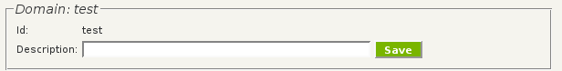Figure 1: Domain description sub-panel.

Repository groups
Figure 5.2 shows the repository groups sub-panel. A new repository group can be created by providing a name and clicking on the corresponding button. Only alphanumeric characters are accepted. New repository groups appear in the existing groups area.
To view or manage an existing group click on Edit/View. This links to the repository group administration panel discussed later.
Clicking on Delete will display a confirmation message. Be careful, deleting a repository group will delete the configuration of all repositories in it.
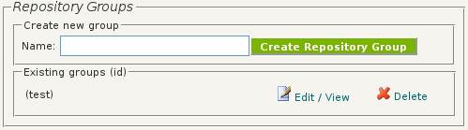Figure 2: Repository groups sub-panel.

Targets
Figure 5.3 shows the targets sub-panel with all available targets. A target contains the configuration information necessary to connect to a specific search engine. Only administrators can add or modify targets. Normal users can only view available targets. Clicking on the view link next to a target will show the target's configuration including:
- Name of the target
- Type of the target (e.g. SSE or any other supported search engine)
- User name to connect to the target
- Password to connect to the target
- Base url of the target
- Path to connect to the target
- Port to connect to the target
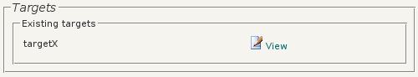Figure 3: Targets sub-panel.

Mappings
Figure 5.4 shows the mappings sub-panel with all available mappings. A mapping defines how repository data should be converted to a format understandable to the target. A normal user can view and test all available mappings.
Clicking on the view link next to mapping name will show the python code that implements the mapping. To modify a mapping it is necessary to contact an administrator.
Clicking on the test link will open the test mapping panel depicted. The panel is fairly self-explanatory and provides two options to test the mapping. The first option is to fill in an URL of a repository. The second option is to choose a repository name known by Sahara.
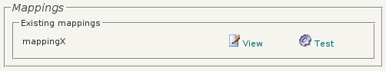Figure 4: Mappings sub-panel.

Status
Figure 5.5 shows the status sub-panel. It contains three links that give information about the harvester at domain level: harvester status and harvester throughput for the past week and month.
The harvester status of a domain displays for each repository in the domain the following information:
- Repository group name
- Repository name
- Last successful harvest
- Total records harvested for this repository
- Number of harvested/uploaded/deleted records in the last harvest
- Number of errors
Any harvester errors are displayed below the harvester status information. The error listing contains for each repository with errors:
- The last successful harvest date.
- The number of errors since that date.
- For the first 10 errors since the last successful harvest date: the date and time this error occurred and the error message.
The harvester throughput links show how many records are processed by the harvester in a certain timespan.
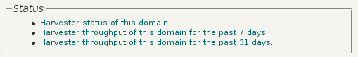Figure 5:Harvester status subpanel

Repository group administration
The repository group administration panel provides a way to manage repository groups: a repository group can be given a Dutch and/or English name, repositories can be created and modified and status information can be inspected. Each feature will be discussed next.

Repository group names
A repository group can be given a Dutch and/or English name. Figure 5.6 shows the sub-panel. To give or modify a name, fill it in the text field and click save.
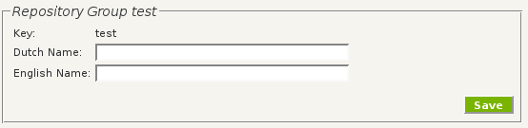Figure 6:Repository group sub-panel

Repositories
Figure 5.7shows the repositories sub-panel. To create a repository fill in a name and click on Create Repository. The characters of the repository name need to be alphanumeric. New repositories will appear in the existing repositories area.
Next to each repository are three links. The Edit/view link displays the repository administration panel, discussed in a later section. A repository can be deleted with the Delete link. This link show a confirmation window. Any deleted repository configuration will be irretrievable. The Test mapping link is similar to the one discussed in the domain administration panel. It allows the user to test the mapping associated with this repository.
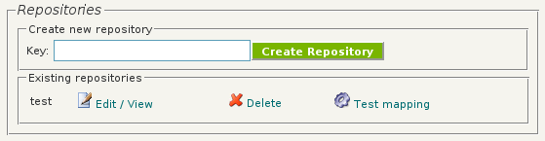Figure 7:Repositories sub-panel.

Status
The status sub-panel is similar to the one in the domain administration panel. The only difference is the level of information. This sub-panel only provides status information about one specific repository group.

Repository administration
The repository administration panel provides a way to configure a repository. A status sub-panel allows inspection of the harvester status for a specific repository. Furthermore a sub-panel with useful links is provided. Each feature will be discussed next.

Repository configuration
Figure 5.8 shows the repository configuration sub-panel. It contains all settings necessary for a harvester:
- Id uniquely identifies the repository
- Set can be filled in if you want to harvest a specific set in the repository. Not all OAI repositories implement this feature, and most of the time you want to harvest the entire repository.
- Baseurl is the base url of the OAI-PMH repository to be harvested.
- Metadataprefix is filled with the correct metadataprefix you want to harvest. It depends on what meta-data formats the repository supports.
- Mapping is the reference to how the meta-data is mapped to the search engine. All available mappings can be chosen from a drop down select box. (Mappings are configured separately, which is explained in the administrator section)
- Target specifies to which search engine records should be uploaded. All available targets can chosen from a drop down select box.
- Target collection tells the uploader to which collection the upload data must be stored. This can be necessary, since one search engine can have several different collections.
- The harvest check box is a switch to turn harvesting on or off. It can be used to temporarily stop harvesting a particular repository, without throwing all configuration information away.
- The next-action drop down select box can be used to choose a particular next action. There are three options: -, clear and refresh. The default option is -, which means the harvester will only harvest new records. Clear means the harvester will clear all records next time it passes this repository. Refresh means the harvester will reharvest this repository. For more information see the harvester section.
- The closing hours sub-panel allows to set time slots in which the harvester will not harvest this repository. Each time slot is defined by a begin and end time. By default a time slot is applied daily. However it is possible to set a week number and/or day to create even more specific time slots. After setting a time slot, it can be added with the Add button. Any number of time slots can be defined. The harvester checks if the current time is in any of the time slots. Only if this is not case, the harvester commences.
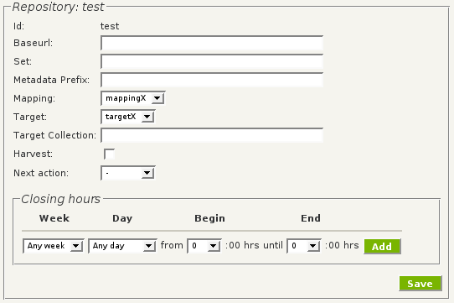Figure 8: Repository configuration sub-panel.
Any changes in the configuration need to be saved with the save button.

Status
The status sub-panel is similar to the one in the domain administration panel. The only difference is the level of information. This sub-panel only provides status information about one specific repository.

Useful links
Figure 5.9 shows the useful links subpanel. It contains two links. One lists all metadata formats. The other allows for testing the mapping associated with the repository. It is important to save any modifation before using these links.
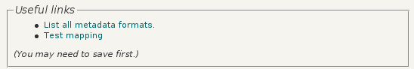Figure 9: Useful links sub-panel.
Next is a discussion about the administration panel.

Administrator control panel
This section discusses all extra features available in the administration control panel not available to normal users. The main panel for the administration is the domain administration panel. It allows for domain management and user account management. After discussing domain management and user management, the management of mappings and targets will be discussed. For management of repository groups and repositories see the discussion in the user control panel section.

Domain management
Figure 5.10 shows the domains sub-panel. It provides a text field to fill in a domain name. A domain needs to be unique and may only contain alphanumeric characters. After clicking the create button the domain is created and added to the existing domains area. Each existing domain can be edited and viewed by clicking the corresponding edit/view link. This link shows a domain edit panel, which is described next.

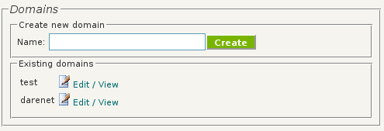Figure 10. Domains sub-panel.

Domain edit panel
The domain edit panel allows the administrator to:
- Add or modify a description of the domain.
- Create, edit and delete repository groups.
- Create, edit and delete targets.
- Create, edit and delete mappings.
- Inspect the harvester status of a domain.
Each feature is described next.

Domain description
Figure 5.11 shows the domain sub-panel. A description of the domain can be added or modified in the text field. It can be saved with the save button.
Figure 11: Domain sub-panel

Repository groups
Figure 5.12 shows the repository groups sub-panel. It is the same panel available to normal users. To create a repository group fill in a name and click on the button. The new group will appear in the existing groups area. To view, edit or delete a repository click on the corresponding links. The view/edit link displays the repository group management panel also available to normal users.

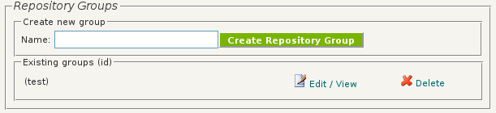Figure 12: Repository groups sub-panel.

Targets
Figure 5.13 shows the targets sub-panel. Each domain has a collection of targets that can be selected by users. To create a new mapping, fill in a target name and choose a type of target supported by Sahara. Click the button to create the target. The new target will appear in the existing targets area. A target can be configured by clicking on the Edit/view link next to it. The configuration of a target is discussed in the Target administration section. Of course a target can also be deleted with the corresponding link.
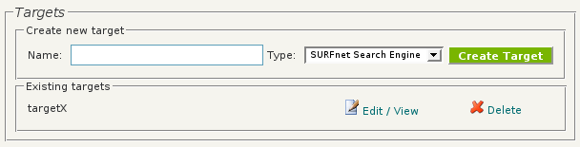Figure 13: Targets sub-panel.

Mappings
Figure 5.14 shows the mappings sub-panel. Mappings can be created by filling in a name and clicking on the Create Mapping button. New mappings appear in the existing mappings area. To create or edit a mapping script click on Edit/view. Like normal users the administrator can delete and test each mapping. More information on testing a mapping is available in the User control panel section.
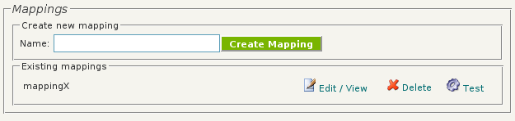Figure 14: Mappings sub-panel.

Status
Figure 5.15 shows the status sub-panel. It provides status information of the domain. It is similar to the status sub-panels for regular users.
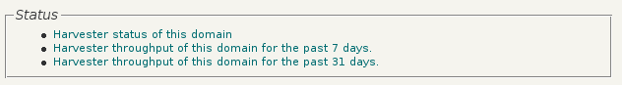Figure 15: Status sub-panel.

User account management
An administrator can also manage user accounts. Figure 5.16 shows the user account sub-panel. Each user is given a user name, an existing domain name and a password. After clicking the create button, the new user will show up in the existing users area. To edit and delete an existing user account click the corresponding links in the existing users area.

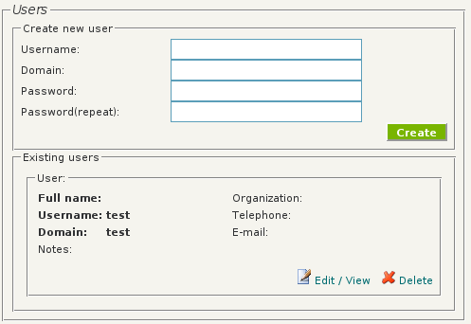Illustration 16. User account sub-panel

Editing an existing user
Figure 5.3 shows the user edit panel. All fields except user name can be modified. Domain is the only required field and it is important to fill in an existing domain name. The meaning of the other fields is self-explanatory.
A click on the save button will save all changes. To go back to the domain management panel follow the link on the bottom of the user edit panel.
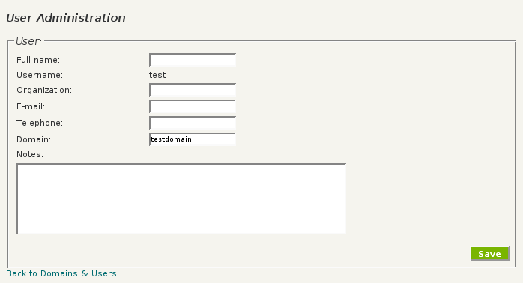Illustration 17. User edit panel

Mapping administration
Mappings can be set by administrators, and chosen by regular users. Mappings specify how to upload records from a specific meta-data set. They tell which meta-data set to use. Which part of the meta-data specifies fields, full text urls etc. The harvester uses a mapping for each record it harvests. So it maps one OAI Record at a time.
To create, edit or delete a mapping select Mappings in the administrator's menu. When creating a new mapping you get a screen where you can fill in it's name, a description and the script. The name and description are just to help you remember which mapping it is. The script describes how the mapping is done.

Mapping script
The mapping script is executed by the harvester. The script has two objects that can be used to create the mapping, and several methods to make it more convenient. The two objects are input and upload. The script language is python.
The input object gives access to the parts of the OAI record that has to be matched.
- input.header contains the presentation of the header part of the OAI Record.
- input.metadata contains the meta-data part of the OAI Record. Because of the parser we use, it is quite easy to get a certain part of the meta-data. For example, if you want to have the title of an oai_dc meta-data record, you simply use metadata.dc.title to get the title(s).
- input.repository contains some information about the repository being harvested, like url, key (e.g. 'eur' for the repository of Erasmus University).
The upload object is there to be filled with data you collect from the meta-data fields.
Other or new possibilities in the script are documented in the comments you get when you create a new script.

Target administration
Targets, like mappings, can be created and modified by administrators, and chosen by other users. Currently there is support for two different types of search engines:
- SOAP-XML to the SSE upload interface versions 3.5 and 4.1. It can upload or delete records.
- A direct connection over SSH to CQ2's Teddy Search Engine.
- A dump in a directory on the local file system.
Figure 5.18 shows the target administration panel. The following fields need to be filled in:
- Name of the target
- Type of the target (e.g. SURFnet Search Engine or any other supported search engine)
- User name to connect to the target
- Password to connect to the target
- Base url of the target
- Path to connect to the target
- Port to connect to the target
Save any changes and click on the link at the bottom to go back to the domain panel.
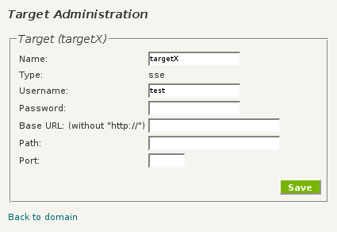Illustration 18.

Harvesting

Overview
The Sahara Web Control Panel configures domains, repositoryGroups, repositories, targets and mappings. The Sahara Harvester uses this information to perform the actual harvesting. Multiple harvesters, possibly running on different machines, may use the same configuration information, maintained in one instance of the Sahara Web Control Panel.
Harvesters access the configuration information by means of the SaharaGet interface, which is explained later in this manual.
The harvester consists of a set of command line tools to be run within a Linux command shell, such as Bash. Administrators may choose to run it interactively, from a screen session, or by an init.d script. Both ways are described in this chapter.
The Harvester engine automatically harvests all repositories that are configured in the web interface, and users need not worry about its implementation and exact workings. For now it suffices to say that the harvester uses the OAI ListRecords verb with correct parameters, maps the retrieved records using the Mapper and then uploads them using the correct Target to a search engine.
The harvester is run by a script that runs the main process, then waits 120 seconds and starts all over again. The main process does the following steps for each repository in the configuration.
First the harvester checks what next action is set for the repository. The default setting allows the harvester to continue harvesting. If clear is set, the repository is deleted, marked as empty and the harvester moves on to the next repository. If refresh is set, the repository reharvested before continuing to the next repository.
Before the harvester starts to harvest, it checks whether there are any closing hours time slots set for this repository. If the current time is inside one of the time slots, the harvester skips the repository and proceeds with the next one.
If the repository can be harvested, the following steps are performed:
  - When the repository is empty, not harvested yet or reset, harvesting is started.
  - When there is a resumptionToken, the repository is harvested with that token.
  - When the repository has not been harvested today, it is harvested from the last successful harvest date.
  - Else, nothing has to be done.
Everything the harvester does is being logged to monitor it's state and for error retrieval.

An Example
Before explaining the details of the harvester and it's command line options, an example is presented.
Suppose there is an installation of Sahara on a machine named sahara.mydomain.org. Suppose an administrator has used the Web Control Panel to configure the following information on this machine (for clarity, details about repositories are omitted):
Domain: musea
User: greg
Password: ****
RepositoryGroup: london
Repository: http://museum1.london.org.uk/base
Repository: http://museum2.london.org.uk/base
RepositoryGroup: wien
Repository: straus
http://straus.wien.at/request/
Repository: bach
http://bach.wien.at/request/

On the machine which hosts the Sahara Web Control Panel the harvester is installed by default. An administrator may need to take action to enable login as the user sahara, setting a password or installing an ssh key. Subsequently, the administrator logs in as sahara on this machine:
$ ssh sahara@sahara.mydomain.org
In the directory ~/harvester/examples, there is an example-script example-harvest.sh that runs the harvester continuously. The administrator starts this script:
$ examples/example-harvest.sh
This starts harvesting the domain musea (we'll see how to harvest other domains in a minute), and creates a log directory under ~/harvester/log/musea. Looking in this directory, the administrator sees log files for each repository of the domain:
$ cd ~/harvester/log/musea
$ ls
bach.events bach.ids bach.stats
straus.events straus.ids straus.stats
harvester.log
As these files are created when a repository is harvested for the first time, not all of them might be immediately available. When the administrator goes to the Sahara Web Control Panel the harvester status links display information based on these log files. This logging information is available via SaharaGet as well.
The following sections explain in detail the commands used to accomplish the harvesting of different domains.

Harvesting Algorithm

Batches
The harvester works in series of OAI records called batches. Batches are incomplete lists returned by the OAI ListRecords verb [OAI]. The open archive terminates an incomplete list with a resumption token. The harvester uses this resumption token as a starting mark of the next batch and as a save point. Any failure in processing a batch will cause the harvester to restart at the latest save point. Such failures include failing to download, failure caused by the mapping and failure to upload to the target. Doing so enables the harvester to create an exact image of the contents of a repository in a search engine.

Looping
The harvester starts harvesting at the first repository it encounters and works toward the end of the list. Then it starts over again. For each repository, it fetches one batch and processes this. Processing means applying a mapping to each individual record and then sending the results to the target configured for the repository. After each batch, the harvester proceeds with the next repository, returning to it only after all the others have been processed, thus limiting the load on the repositories. When no other repositories have batches left to process, the harvester waits a few minutes before getting back to the first one.

Incremental harvesting
When a repository has no more batches left to process (it does not yield resumption tokens anymore), the harvester automatically starts incremental harvesting. The harvester will visit the repository once a day to see if there are any new, updated or deleted records. It uses the OAI optional argument from with the date of the last successful harvest, using day granularity [OAI]. It sends new or updated records to the target and it deletes deleted records from the target. When incremental harvesting results in multiple batches, the harvester automatically continues to loop.

Clear
For repositories with the clear action set, the harvester removes all previously uploaded records, using the targets delete method. It identifies the records to be deleted by the same ID that was used to send them to the target. The clear happens during the loop, instead of the batch harvesting or incremental harvesting. After clearing all records and when the repository is not turned off, the harvester resets the repository in order to automatically restart harvesting.

Refresh
For repositories with the refresh action set, the harvester discards all resumption tokens and restarts the harvesting from the first record over again, resending all records to the target. Right after the initial loop has finished and just before the harvester starts incremental harvesting, it will remove from the target any record that has not be resend to the target, because that means it is no longer in the repository. The result is that the repository is completely refreshed and that records deleted from the repository are deleted from the target. Then, if the repository is not turned off, the harvester resumes incremental harvesting.

Closing hours
During closing hours of a repository, the harvester will not perform any of the actions described here. Note that closing hours do not influence the harvester's scheduling. The harvester checks the repositories closing hours just before each action. Also, it never interrupts a running action as a result of closing hours.

Log File Details
When harvesting, the harvester creates one global logfile and three logfiles for each repository.

Global logfile
The global log file harvester.log contains detailed information about the loop that the harvester is in. This file is useful for diagnosing problems. It contains entries for each action the harvester takes, in the following format:
timestamp event repository comment
Examples are:
[2006-09-14 20:55:17.818] START [uni-a] HarvestAction
[2006-09-18 17:22:12.927] ERROR [STOA] Traceback ....
[2006-09-18 00:08:33.813] END [vu] Harvested.
[2006-09-18 00:10:25.879] END [tue] Nothing to do!
[2006-09-15 20:44:22.521] START [uudare] SmoothAction
[2006-09-15 20:44:24.496] END [uudare] Smooth reharvest: Done.
[2006-09-11 11:23:36.460] START [vu] DeleteIdsAction
[2006-09-11 11:24:43.867] END [vu] Deleted
The START and END or ERROR events appear in pairs. The START's comment names the action the harvesters takes:
- HarvestAction – Start a batch or incremental harvest.
- SmoothAction – Refresh a repository
- DeleteIdsAction – Clear a repository
The END event's comment contains a status message explaining the results of the finished action:
- Harvested – The repository was successfully harvested
- Nothing to do – There were no remaining batches (resumption tokes) to process, nor is there any incremental work left.
- Smooth reharvest: <message> - A phase in refreshing the repository has completed. Phases are: initialized, harvested and done.
- Deleted – All records in the repository have been deleted.
The ERROR event's comment lists the traceback of the harvesters call-stack. This is useful for debugging repositories. Tracebacks may reveal errors during XML parsing, mapping errors, target errors and interrupts by the system administrator (Ctrl-C).

Per-repository logfiles
The harvesters log three files for each repository:
- *.events – This logfile contains the same type of information as the global logfile harvester.log, only on a per-repository basis. In addition, this file contains explicit logging done by mappings and targets. Also, repository status reports as created by SaharaGet GetStatus bases on this logfile.
- *.stats – This logfile describes the status of a repository. The harvesters uses this log file to determine the next action to take.
- *.ids – This logfile contains the identifiers of all harvested and processed records. The harvester uses this for it's internal administration, in particular for determining the records to delete when performing a clear or refresh action.

Harvesting Details
The harvesting command used to harvest is:
$ python startharvester.py [OPTIONS]
To run this, python must be in the PATH environment variable and the startharvester.py must be in the current directory. The harvester requires a few command line options. It accepts command line options GNU-style, which means it accepts both short format (one dash, a character, a space, and the optional value) and long format (two dashes, a word, and optionally an equality-sign and value).
The possible options are:
- -h, --help: Displays a help page and exit.
- -d <DOMAIN>, --domain=<DOMAIN>: The harvester harvests all repositories in the specified domain. Mandatory.
- -s <URL>, --saharaurl=<URL>: The url of the Sahara Web Control Panel, e.g. http://sahara.mydomain.org. It defaults to http://localhost. This url is used to retrieve all domain information, like repository baseurls, etc. from Sahara using the SaharaGet interface.
- -r <REPOSITORY>, --repository=<REPOSITORY>: An optional argument to let the harvester process one repository only. The value given is the repository key, e.g. strauss.
- -l <LOGPATH>, --logpath=<LOGPATH>: An optional argument to specify the path of the log files. It defaults to ./log. The harvester creates subdirectories with the names of the domains.
The next options are helpful for debugging or testing repositories. These options are best combined with the --logpath option to prevent unwanted state changes or incorrect statistics in the per-repository logfiles.
- --force-target=<TARGETID>: An optional argument that overrides the specified target in the configuration of the repository. The TARGETID is the identifier of a target that exists in Sahara for this domain. This identifier is a UUID which can be found using the SaharaGet interface.
- --force-mapping=<MAPPINGID>: An optional argument that overrides the specified mapping in the configuration of the repository. The MAPPINGID is the identifier of a mapping that exists in Sahara for this domain. This identifier is a UUID which can be found using the SaharaGet interface.
- --uploadLog=<FILEPATH>: An optional argument that disables the Target and sends the results to a file identified by FILEPATH.
- --no-action-done: The harvester will not send update messages to Sahara. For example, after a refresh action is finished the harvester notifies the Sahara Web Control Panel that the refresh has completed, allowing the Sahara Web Control Panel to reflect this in it's administration. This options prohibits these messages.

Using screen
One option to run the harvester is to start it using a screen. This program starts a virtual console which, pressing Ctrl-A D, will detach from the real console and run in the background. Later, after logging out and logging in again, the command screen -a attaches the virtual console again.
Running multiple harvesters, one for each domain, in separate detached screens is one option of running the harvester in the background.
See man screen for more details about the screen program.

Using init.d
Another way to start the harvester is creating a script that starts the harvester at system boot time. Consult the documentation of your Linux distribution on how to create init scripts. For Debian, init script are located in /etc/init.d/ and respond to start and stop. For example:
#!/bin/sh
case "$1" in
start)
/home/sahara/harvester/myharvest.sh &
;;
stop|reload|restart|force-reload)
killall myharvest.sh
;;
*)
echo "Usage: $N {start|stop|restart|force-reload}" >&2
exit 1
;;
esac

Get interface
Sahara's Get interface is a http interface that allows the harvester to access the repository configurations of Sahara. An example of a request is: /Saharaget?verb=GetRepositoryGroups&domainId=somedomain. Verbs tell the interface what information to export. In this case all repository groups are returned in a response that comply to a xsd. The response as well as the request are roughly based on the OAI-PMH protocol.
Every domain, repositoryGroup or repository is referred to using an id (or abbreviation). This id uniquely identifies the element within Sahara (e.g. we use ut for University of Twente)

Request
All Sahara's information is available using a HTTP-GET request on <saharaurl>/saharaget (currently http://<saharaurl>/saharaget) Which information is returned is determined by query arguments, e.g. ../saharaget?verb= getrepositorygroups&domain=some_coll returns all repository groups for a certain domain.
Argument | Info
verb | Mandatory argument, that determines what information to give. Allowed values are: getrepositorygroups, getidentifiers ....
domainId | Mandatory argument to determine the domain which should give info.

Authentication
By default the Sahara GET interface requires user authentication by means of HTTPS. For improved security, HTTP Connections are redirected to HTTPS. Authentication uses HTTP 'Basic Authentication Scheme', see http://www.w3.org/Protocols/HTTP/1.0/draft-ietf-http-spec.html#BasicAA. The realm is 'saharaget'.
The user name and password are the same as for the Sahara Web Control Panel. Access to domains is limited to users associated to that domain in Sahara.
The following table lists the availability of the verbs and protocols:
Verb | HTTP | HTTPS | Authentication
GetIdentifiers | No | Yes | Yes
GetMapping | No | Yes | Yes
GetRecord | No | Yes | Yes
GetRepositories | No | Yes | Yes
GetRepository | No | Yes | Yes
GetRepositoryGroups | Yes | Yes | No
GetStatus | No | Yes | Yes
GetTarget | No | Yes | Yes

Response
All responses comply to the XSD at http://<sahara-url>/xsd/Saharaget.xsd

General
All responses contain the root element saharaget containing the following elements:
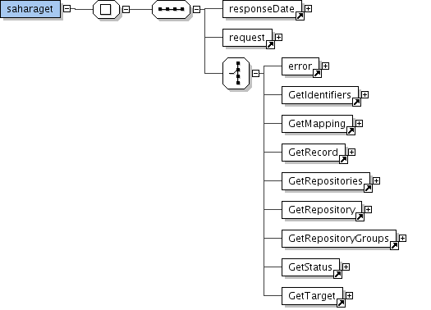
- responseDate, supplying the response date and time in ISO 8601 format. As suggested by that format the date and time are separated by a latin capital letter T and trailed by a capital letter Z, indicating UT/GMT, as in 1995-12-31T23:59:59Z
- Request, containing those attributes that are supplied in the original request and fall within the definition of this document as elements, e.g. the request contains the following “<verb>GetRepositoryGroups</verb><domainId>somedomain</domainId>” for a request that looks like “/saharaget?verb=GetRepositoryGroups&domainId=somedomain”
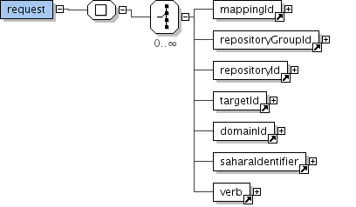
Verb and domain must always be supplied, and the others depend on the verb being called, e.g. target must be specified when GetTarget is being called.
- The last element in the request is response of the verb that is being called, e.g. A GetTarget element when calling the verb with the same name. The verb and the response always have the same name.
In the next paragraphs the different verbs are explained. For each verb a figure like the one above is provided.

Error
When using wrong information, like non-existing verbs, you will get an error response. It specifies the following things.
- request, the url to which the error occurred.
- code, the short code that state's the kind of error.
- message, a short explanation of what went wrong.
The XSD (as an image):
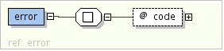
<?xml version="1.0" encoding="UTF-8"?>
<saharaget>
<responseDate>2006-03-16T10:41:08Z</responseDate>
<request>
/Saharaget?verb=GetRepositoryGroup&amp;domainId=noSuchDomain
</request>
<error code="badVerb">
Value of the verb argument is not a legal verb, the verb argument is missing, or the verb argument is repeated.
</error>
</saharaget>
These are the possible values for error codes:
- badVerb: Value of the verb argument is not a legal verb, the verb argument is missing, or the verb argument is repeated.
- badArgument: The request includes illegal arguments, is missing required arguments, includes a repeated argument, or values for arguments have an illegal syntax.
- idDoesNotExist: The value of an id is unknown or illegal.
- badDomain: The domain does not exist.
Note that other errors may occur on lower levels, i.e. an HTTP 403 (Forbidden) may be given if a client is not authorized to do a specific request.

GetRepositoryGroups
Using the verb GetRepositoryGroups returns all repositorygroups for a specific domain that is supplied as an argument.
Argument | Value | Info
verb | GetRepositoryGroups
domainId | <a domain> | Mandatory argument to determine the domain.

These are returned as elements with the name “repositorygroup”, with the following elements:
- id, indicating the id of the repositoryGroup
- name, indicating the display name of the repositoryGroup, in the language specified by the xml:name attribute
The XSD (as an image):
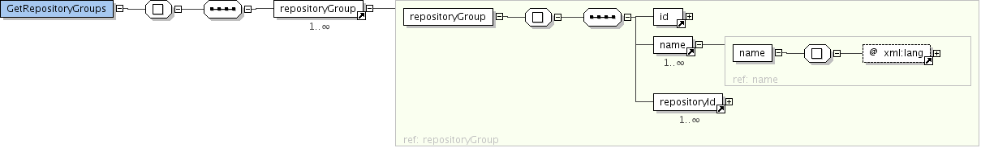
<?xml version="1.0" encoding="UTF-8"?>
<saharaget>
<responseDate>2006-03-16T10:41:15Z</responseDate>
<request>
<verb>GetRepositoryGroups</verb>
<domainId>darenet</domainId>
</request>
<GetRepositoryGroups>
<repositoryGroup>
<id>ut</id>
<name xml:lang="nl">Universiteit Twente</name>
<name xml:lang="en">University of Twente</name>
<repositoryId>ut</repositoryId>
<repositoryId>utkeur</repositoryId>
</repositoryGroup>

<repositoryGroup>
<id>aup</id>
<name xml:lang="nl">Amsterdam University Press</name>
<name xml:lang="en">Amsterdam University Press</name>
<repositoryId>aup</repositoryId>
</repositoryGroup>

<repositoryGroup>
<id>uva</id>
<name xml:lang="nl">Universiteit van Amsterdam</name>
<name xml:lang="en">University of Amsterdam</name>
<repositoryId>uvadis</repositoryId>
<repositoryId>uvapub</repositoryId>
<repositoryId>uvadiskeur</repositoryId>
<repositoryId>uvapubkeur</repositoryId>
</repositoryGroup>
</GetRepositoryGroups>
</saharaget>

GetRepositories
To query for the harvester's repostories' configuration one can use the verb GetRepositories. It returns all repositories for a certain repositoryGroup.

Argument | Value | Info
verb | GetRepositories
domainId | <a domain> | Mandatory argument to determine the domain.
repositoryGroup | <a group> | Optional argument to determine the group for which to return information. If omitted all repositories of this domain are returned.
Returned is a list of repositories:
- harvest: true or false. If true, this repository is actually harvested. If false, harvesting of the repository is (temporaraly) disabled.
- action: can be either empty, or one of clear / refresh. Actions are used to execute a specific action once and only once, the next time the repository is processed. The standard, or empty action (i.e. harvesting) is done continuously if no action is is specified.
- empty: the repository is harvested
- 'clear': all records from the repository are removed from the search engine. This allows for a clean, new start.
- 'refresh': the repository is reharvested completely. At the end of this process all records in the search engine that are no longer part of the repository are removed, but without any moment of downtime.
- id: uniquely identifies the repository in Sahara.
- baseurl: The baseurl where the repository can be found.
- set: A specific set that is harvested. (part of the OAI specification)
- collection: The search collection to harvest. (part of the Sahara model)
- metadataprefix: Part of the OAI specification.
- target: An id of the target machine to upload the harvested data to.
- mapping: An id of the mapping that maps the repostory's data to search engine data
The XSD (as an image):

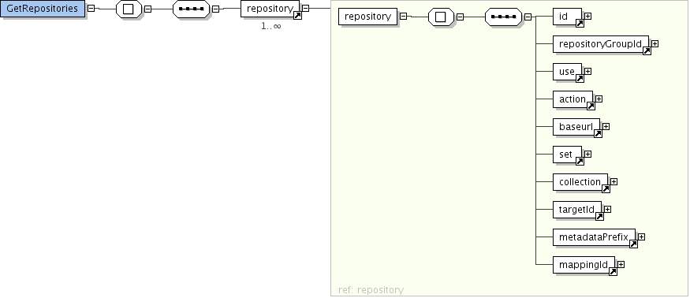
<?xml version="1.0" encoding="UTF-8"?>
<saharaget>
<responseDate>2006-03-16T10:41:14Z</responseDate>

<request>
<verb>GetRepositories</verb>
<domainId>darenet</domainId>
<repositoryGroupId>ut</repositoryGroupId>
</request>
<GetRepositories>

<repository>
<id>ut</id>
<repositoryGroupId>ut</repositoryGroupId>
<use>true</use>
<action/>
<baseurl>http://doc.utwente.nl/oai/so</baseurl>
<set>withfulltext</set>
<collection>darenetalgnewton</collection>
<targetId>07df52ac-6647-4fa6-abb2-7ce75f626b30</targetId>
<metadataPrefix>dare_didl</metadataPrefix>
<mappingId>59879212-f57e-47f6-bf95-2ce57f1f2e3c</mappingId>
</repository>

<repository>
<id>utkeur</id>
<repositoryGroupId>ut</repositoryGroupId>
<use>true</use>
<action/>
<baseurl>http://doc.utwente.nl/oai/so</baseurl>
<set>KEUR</set>
<collection>darenetknewton</collection>
<targetId>07df52ac-6647-4fa6-abb2-7ce75f626b30</targetId>
<metadataPrefix>dare_didl</metadataPrefix>
<mappingId>59879212-f57e-47f6-bf95-2ce57f1f2e3c</mappingId>
</repository>

</GetRepositories>
</saharaget>

GetRepository
To query for the harvester's repostories' configuration one can use the verb GetRepository. It returns just the information for one repository.

Argument | Value | Info
verb | GetRepository
domainId | <a domain> | Mandatory argument to determine the domain.
repositoryId | <a repository> | Mandatory argument to determine the repository for which to return information. Repository ids are unique within a domain.
Returned is:
- The Repository. This element contains the information like the repository in GetRepositoryGroups.
The XSD (as an image):
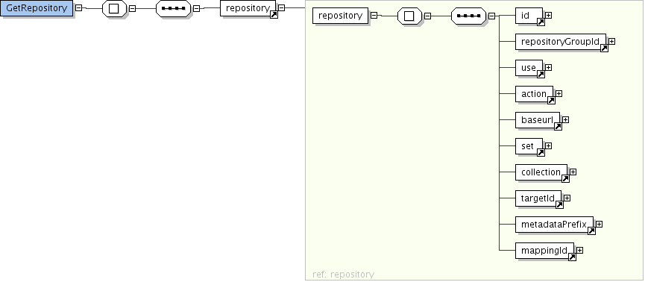
<?xml version="1.0" encoding="UTF-8"?>
<saharaget>
<responseDate>2006-03-16T10:40:59Z</responseDate>

<request>
<verb>GetRepository</verb>
<domainId>darenet</domainId>
<repositoryId>ut</repositoryId>
</request>
<GetRepository>

<repository>
<id>ut</id>
<repositoryGroupId>ut</repositoryGroupId>
<use>true</use>
<action/>
<baseurl>http://doc.utwente.nl/oai/so</baseurl>
<set>withfulltext</set>
<collection>darenetalgnewton</collection>
<targetId>07df52ac-6647-4fa6-abb2-7ce75f626b30</targetId>
<metadataPrefix>dare_didl</metadataPrefix>
<mappingId>59879212-f57e-47f6-bf95-2ce57f1f2e3c</mappingId>
</repository>
</GetRepository>
</saharaget>

GetMapping
The mapping of a repository is returned separate from the repository information itself. It is used by the harvester to convert xml input from an OAI-PMH repository to datadictionary for the searchengine (target). To retrieve the mapping use this verb and specify the reference given in the repository.
Argument | Value | Info
verb | GetRepository
domainId | <a domainId> | Mandatory argument to determine the domain.
mappingId | <a mappingId> | Mandatory argument to determine the mapping for which to return information.

Returned is a mapping, it contains the following elements:
- id, the id by which the mapping is referred to.
- name, a recognizable name.
- description, a short description of the mapping.
- code, the python code used by the harvester to map xml data.
The XSD (as an image):
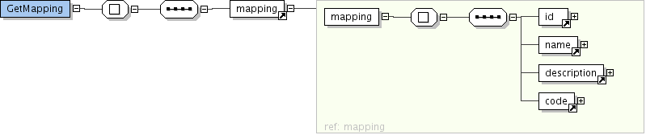
<?xml version="1.0" encoding="UTF-8"?>
<saharaget>
<responseDate>2006-03-16T10:40:56Z</responseDate>
<request>
<verb>GetMapping</verb>
<domainId>darenet</domainId>
<mappingId>59879212-f57e-47f6-bf95-2ce57f1f2e3c</mappingId>
</request>
<GetMapping>
<mapping>
<id>59879212-f57e-47f6-bf95-2ce57f1f2e3c</id>
<name>xmlcontainer2surf</name>
<description>Mapping from the new dare_didl format to the SURFnet search engine.</description>
<code>
upload.fields['repository'] = input.repository.id
upload.fields['identifier'] = input.header.identifier
upload.fields['group'] = input.repository.repositoryGroupId
upload.fields['modified'] = modifiedDate
upload.fields['dc.contributor'] = join(dc.contributor)
upload.fields['dc.coverage'] = join(dc.coverage)
...
</code>
</mapping>
</GetMapping>
</Saharaget>

GetTarget
The target specifies the configuration for the searchengine to be used by the harvester. Sahara is able to upload metadata to different types of searchengines.
Argument | Value | Info
verb | GetRepository
domainId | <a domain> | Mandatory argument to determine the domain.
targetId | <a mapping> | Mandatory argument to determine the target for which to return information.

Returned is a target, containing at least the following elements:
- id, the id by which the target is referred to.
- name, a recognizable name.
- targetType, identifying the type of the upload interface, currently there are two types:
  - “sse”, the SURFnet Search Engine
  - “teddy”, the Teddy Search Engine
  - “file system”
For the “sse” type, the following elements are returned:
- username
- baseurl of the search engine
- password
- path
- port, portnumber
For the “teddy” type, the following elements are returned:
- username
- hostname
- privateKey
- port
For the file system type, the following element are returned:
- the path of the local directory
The XSD (as an image):
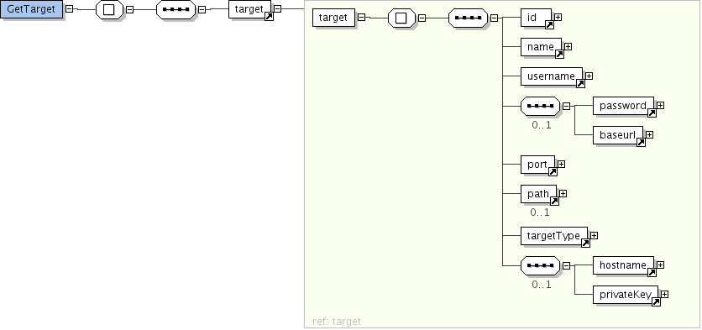
<?xml version="1.0" encoding="UTF-8"?>
<saharaget>
<responseDate>2006-03-16T10:40:57Z</responseDate>

<request>
<verb>GetTarget</verb>
<domainId>darenet</domainId>
<targetId>5cb4b172-c527-47ec-80e9-0ce26c70e29b</targetId>
</request>
<GetTarget>
<target>
<id>5cb4b172-c527-47ec-80e9-0ce26c70e29b</id>
<name>Argus_DARE</name>
<username>darenet</username>
<password>pwd4darenet</password>
<baseurl>argus.nic.surfnet.nl</baseurl>
<port>3128</port>
<path>/axis/services/upload</path>
<targetType>sse</targetType>
</target>
</GetTarget>
</saharaget>

GetIdentifiers
Using the verb GetIdentifiers returns all identifiers for a specific combination of a repositoryGroup and a domain.

Argument | Value | Info
verb | GetIdentifiers
domainId | <a domain> | Mandatory argument to determine the domain.
repositoryGroupId | <a group> | Mandatory argument to return all identifiers of a certain repository group.

These identifiers are returned as elements with the name “identifier”, containing the identifier as the element data.
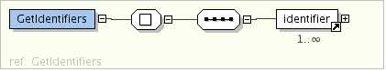
<?xml version="1.0" encoding="UTF-8"?>
<saharaget>
<responseDate>2006-03-16T10:40:56Z</responseDate>

<request>
<verb>GetIdentifiers</verb>
<domainId>darenet</domainId>
<repositoryGroupId>aup</repositoryGroupId>
</request>
<GetIdentifiers>
<identifier>aup:oai:aup:165260</identifier>
<identifier>aup:oai:aup:165247</identifier>
<identifier>aup:oai:aup:165245</identifier>
<identifier>aup:oai:aup:165244</identifier>
<identifier>aup:oai:aup:164723</identifier>
<identifier>aup:oai:aup:164722</identifier>

</GetIdentifiers>
</saharaget>

GetStatus
To retrieve information on the status of harvesting one can use the 'GetStatus' verb.
The target specifies the configuration for the searchengine to be used by the harvester.
Argument | Value | Info
verb | GetStatus
domainId | <a domain> | Mandatory argument to determine the domain.
repositoryGroupId | <a repositoryGroupId> | Optional argument to show only the status of this repositoryGroup
repositoryId | <a repositoryId> | Optional argument to show only the status of this repositoryId, if repositoryGroupId is also given, it will be ignored.

For each of the repositories an element is returned with the following information:
- lastHarvestDate, containing the date of the last succesful harvest or action in ISO 8601 format.
- harvested, containing the number of records harvested in that moment
- uploaded, containing the number of records uploaded to the searchengine in that moment
- deleted, containing the number of records deleted from the searchengine in that moment
- total, containing the total number of records uploaded to, and not deleted from, the searchengine.
- errors, contain the number of errors that occurred since the lastHarvestDate. Within the element the last errors are shown with a maximum of 10.
The XSD (as an image):
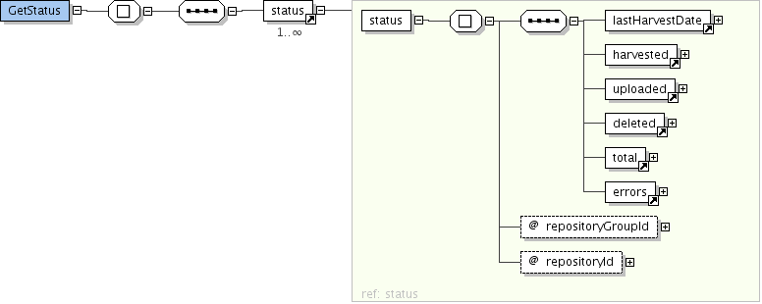
<?xml version="1.0" encoding="UTF-8"?>
<saharaget>
<responseDate>2006-03-16T10:41:17Z</responseDate>

<request>
<verb>GetStatus</verb>
<domainId>darenet</domainId>
<repositoryId>rug</repositoryId>
</request>
<GetStatus>
<status repositoryId="rug" repositoryGroupId="rug">
<lastHarvestDate>2006-03-06T10:47:46Z</lastHarvestDate>
<harvested>50</harvested>
<uploaded>50</uploaded>
<deleted>0</deleted>
<total>50</total>
<errors nr="3">
<error date="2006-03-09T08:53:29Z">Traceback (most recent call last):|File "/home/Sahara/harvester/harvester.py", line 93, in _harvest result, newtoken = self.fetchRecords(self._oairequest, self._logger.from_, self._logger.token, self._logger.total)|File "/home/Sahara/harvester/harvester.py", line 59, in fetchRecords records = self.listRecords(server, from_, token, self._repository.set)|File "/home/Sahara/harvester/harvester.py", line 45, in listRecords return server.listRecords(resumptionToken=token)|File "/home/Sahara/harvester/oairequest.py", line 30, in listRecords raise error|OAIError: The requested resumptionToken is invalid or has expired</error>
<error date="2006-03-09T08:44:48Z">Traceback (most recent call last):|File "/home/Sahara/harvester/harvester.py", line 93, in _harvest result, newtoken = self.fetchRecords(self._oairequest, self._logger.from_, self._logger.token, self._logger.total)|File "/home/Sahara/harvester/harvester.py", line 59, in fetchRecords records = self.listRecords(server, from_, token, self._repository.set)|File "/home/Sahara/harvester/harvester.py", line 45, in listRecords return server.listRecords(resumptionToken=token)|File "/home/Sahara/harvester/oairequest.py", line 30, in listRecords raise error|OAIError: The requested resumptionToken is invalid or has expired</error>
<error date="2006-03-09T08:36:02Z">Traceback (most recent call last):|File "/home/Sahara/harvester/harvester.py", line 93, in _harvest result, newtoken = self.fetchRecords(self._oairequest, self._logger.from_, self._logger.token, self._logger.total)|File "/home/Sahara/harvester/harvester.py", line 59, in fetchRecords records = self.listRecords(server, from_, token, self._repository.set)|File "/home/Sahara/harvester/harvester.py", line 45, in listRecords return server.listRecords(resumptionToken=token)|File "/home/Sahara/harvester/oairequest.py", line 30, in listRecords raise error|OAIError: The requested resumptionToken is invalid or has expired</error>
</errors>
</status>
</GetStatus>
</saharaget>

GetRecord
This is a special Sahara get operation, it uses configuration information from Sahara to retrieve the meta-data from an OAI-PMH repository. The repository and record is specified by the identifier from Sahara. It will call the OAI-verb GetRecord on a certain repository and streams back that result.
GetRecord is called using the url
/saharaget?verb=GetRecord&domainId=<domain>&saharaidentifier= <identifier>
The identifier is the same that is used by Sahara en is retrieved using the GetIdentifiers verb.
The identifier in Sahara is determined by combining the id from the repository to the OAI-identifier that is returned by a repository. E.g. 'sahara:oai:stuff:1234' means the record with identifier 'oai:stuff:1234' from the repository that is recognized by the id 'sahara'.
For the oai-verb 'GetRecord' there is also another argument required. the metadataPrefix. For this we will use the metadataPrefix configured for the repository.
Example:
Assume we have the repository 'wur' in the domain 'darenet', with url “http://library.wur.nl/oai” and metadataPrefix 'oai_dc'
A saharaidentifier could be 'wur:oai:library.wur.nl:wurpubs/1'
The GetRecord call would then look like:
/saharaget?verb=GetRecord&domainId=darenet&saharaidentifier=wur%3Aoai%3Alibrary.wur.nl%3Awurpubs%2F1
Sahara would call:
http://library.wur.nl/oai?verb=GetRecord&metadataPrefix=oai_dc&identifier=oai%3Alibrary.wur.nl%3Awurpubs%2F1

The XSD for the SaharaGet part as an image:

The result would look like:

Errors can occur, e.g. the repository or the identifier doesnot exist. This wil result in een OAI-PMH like error.
<?xml version="1.0" encoding="UTF-8"?>
<saharaget>
<responseDate>2006-03-16T10:41:16Z</responseDate>

<request>
<verb>GetRecord</verb>
<domainId>darenet</domainId>
<SaharaIdentifier>wur:oai:library.wur.nl:wurpubs/681</SaharaIdentifier>
</request>
<GetRecord>
<record xmlns="http://www.openarchives.org/OAI/2.0/">
<header>
<identifier>oai:library.wur.nl:wurpubs/681</identifier>
<datestamp>2005-05-17</datestamp>
<setSpec>public</setSpec>
<setSpec>keur</setSpec>
<setSpec>114:E</setSpec>
<setSpec>307:A</setSpec>
<setSpec>307:D</setSpec>
</header>
<metadata>
<oai_dc:dc xmlns:oai_dc="http://www.openarchives.org/OAI/2.0/oai_dc/" xmlns:xsi="http://www.w3.org/2001/XMLSchema-instance" xsi:schemaLocation="http://www.openarchives.org/OAI/2.0/oai_dc/ http://www.openarchives.org/OAI/2.0/oai_dc.xsd">
<dc:creator xmlns:dc="http://purl.org/dc/elements/1.1/">Katan, M.B.</dc:creator>
<dc:title xmlns:dc="http://purl.org/dc/elements/1.1/">Effect van voeding op plasmacholesterolgehalte en lipoproteinen.</dc:title>
<dc:source xmlns:dc="http://purl.org/dc/elements/1.1/">Voeding en ischemische hartziekten, J.W. van Ree, M. Stasse-Wolthuis, J. Fernandes and A.C.W.G. Geert-van der Weij (eds.). Samson (1986) 27-39.</dc:source>
<dc:subject xmlns:dc="http://purl.org/dc/elements/1.1/">Afdeling Humane voeding </dc:subject>
<dc:type xmlns:dc="http://purl.org/dc/elements/1.1/">Part of book or chapter of book</dc:type>
<dc:language xmlns:dc="http://purl.org/dc/elements/1.1/">nl</dc:language>
<dc:date xmlns:dc="http://purl.org/dc/elements/1.1/">1986</dc:date>
<dc:format xmlns:dc="http://purl.org/dc/elements/1.1/">application/pdf</dc:format>
<dc:identifier xmlns:dc="http://purl.org/dc/elements/1.1/">http://library.wur.nl/wasp/bestanden/LUWPUBRD_00000681_A502_001.pdf</dc:identifier>
<dc:relation xmlns:dc="http://purl.org/dc/elements/1.1/">http://library.wur.nl/WebQuery/wurpubs/681</dc:relation>
<dc:rights xmlns:dc="http://purl.org/dc/elements/1.1/">Wageningen UR</dc:rights>
</oai_dc:dc>
</metadata>
</record>
</GetRecord>
</saharaget>

Sahara Software Components
The following software components have been developed by Seek You Too and are packaged with Sahara:
Name: | Slowfoot
Version: | 6.4.2
Maintainer: | Seek You Too B.V.
License: | GPL
Description: | An integration system for web-based applications.
Name: | CQ2Utils
Version: | 2.4.2
Maintainer: | Seek You Too B.V.
License: | GPL
Description: | A package providing a wide-range of valuable tools.

Third-party packages
Sahara also requires third-party packages in order to operate. Following is detailed information on these packages.
Name: | Apache
Version: | 2.0 (or higher)
Maintainer: | The Apache Software Foundation
License: | Apache License, version 2.0
Location: | http://httpd.apache.org
Description: | An open-source HTTP server for modern platforms.

Name: | ModPython
Version: | 3.2.10
Maintainer: | The Apache Software Foundation
License: | Apache License, version 2.0
Location: | http://www.modpython.org
Description: | Mod_python is an Apache module that embeds the Python interpreter within the server allowing to write web-based applications in Python

Name: | Amara
Version: | 1.1.7
Maintainer: | Uche Ogbuji
License: | Custom license based on the Apache Software License, Version 1.1
Location: | http://uche.ogbuji.net/tech/4suite/amara/
Description: | Amara XML toolkit is an open-source collection of Python tools for XML processing. These tools have been built from the ground up to use Python idioms and take advantage of the many advantages of Python over other programming languages.

References
[OAI] http://www.openarchives.org/OAI/openarchivesprotocol.html
[AMARA] – http://uche.ogbuji.net/tech/4suite/amara/

