# Step 1

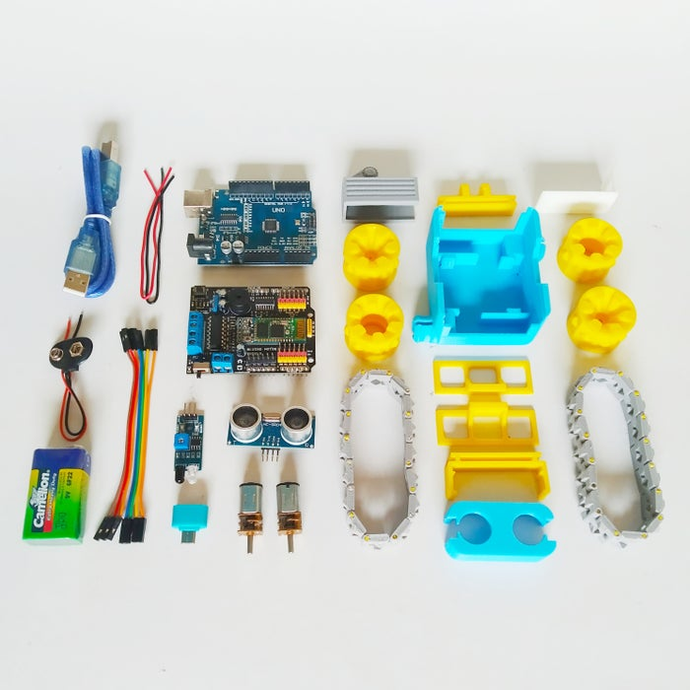Electronics parts:

* 1 x Arduino Uno R3 DIP
* 1 x Arduino Motor Shield
* 1 x Ultrasonic HC-SR04
* 1 x IR Sensor
* 2 x Geared Motor 200 RPM 6V
* 8 x Cable jumper female to female 10cm
* 4 x Cable AWG24
* 1 x Connector 9V Battery
* 1 x USB OTG
* 1 x 9V battery
* 1 x Battery Holder (2 x Li-ion 14500)
* 1 x USB Cabl

# Step 2 – Soldering

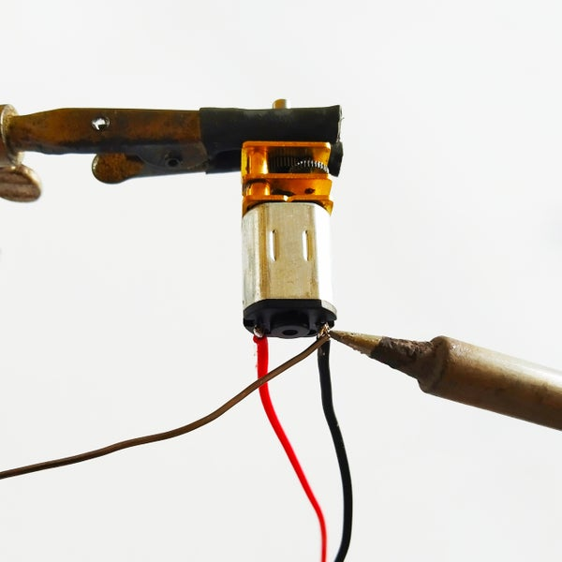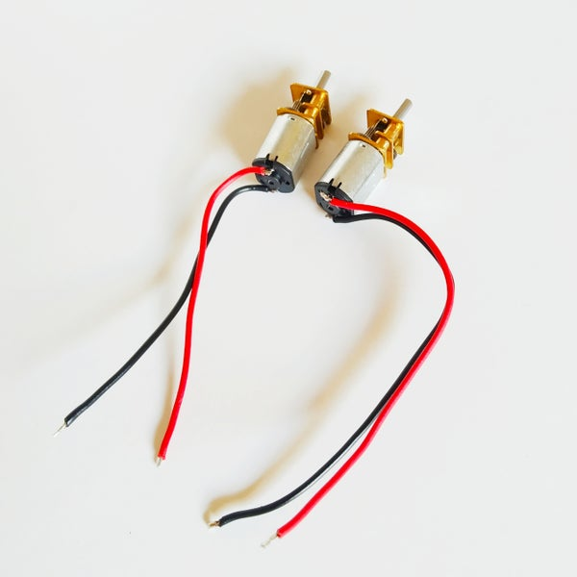

1. solder a 13cm red wire to the positive terminal for front wheel motor
2. solder a 13cm black wire to the negative terminal for front wheel motor
3. solder a 13cm red wire to the positive terminal for back wheel motor
4. solder a 13cm black wire to the negative terminal for back wheel motor

# Fit BatteryFit MotorsStep 3 – Attach Motors and Battery

# Fit Motors HoldersStep 4 – Attach Motor Holders

# Step 5 – Attach Wheels

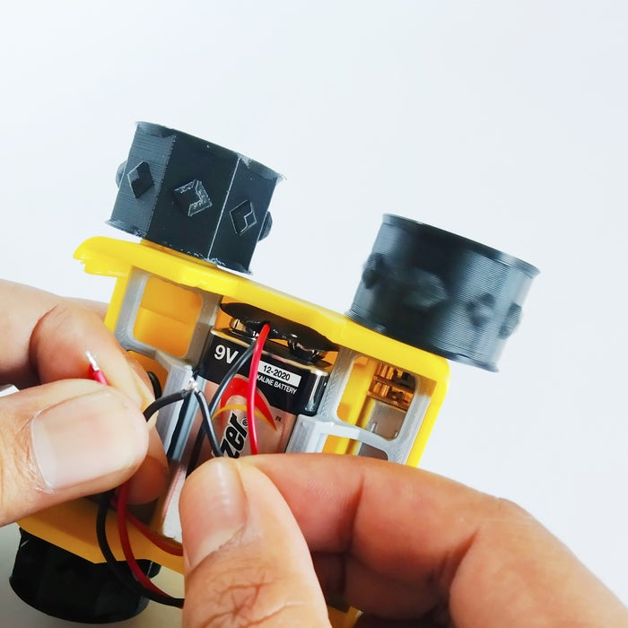There are two types of wheel - **Master and Slave**. The master wheels are driven by the motors, whereas the slave wheels are free spinning.

**Don’t forget to test the motors before closing the chassis!**

# Add ArduinoStep 6 – Slide the Arduino

To avoid splitting the top of the SMARS chassis, slowly insert the Arduino and stop and remove it if you encounter any resistance. Its best to sandpaper or file the channel if it is not large enough.