Report

Shifeng Li U24567277

It is a Prisoner's Dilemma model, so we should think about the prisoner mind. They hope to get both sentenced to a year in prison on a lesser charge. Each prisoner is given the opportunity either to: betray the other by testifying that the other committed the crime, or to cooperate with the other by remaining silent.

In my code, I set:

One prisoner is A and the other is B

if both of two prisoners keep silent, they will serve one year in the prison

if both of two prisoners betray each other, each of them serves five years in prison

If A betrays B but B remains silent, A will be set free and B will serve ten years in prison

I use a matrix to express

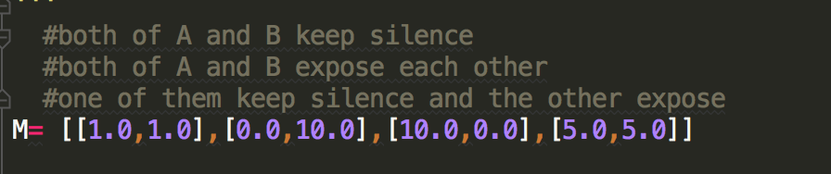

M[i][0] express the choice of prisoner A

M[i][1] express the choice of prisoner B

In my program, the initialization is random. Because they don’t know the situation of other prisoner. They can keep silence or betray other.

If one prisoner knows other prisoner betrays himself, then he will betray. Finally they will betray each other.

If they know they keep silence each other, they can keep silence next time or other. It is random

I use average number to express the result

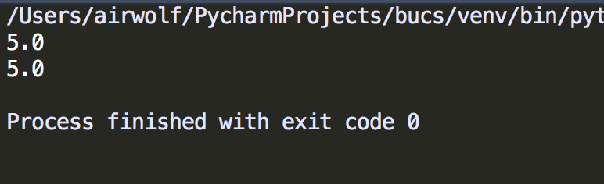

From the result, we can know they will betray each other.