Context-dependent expression of the egg size–number trade-off after experimental clutch loss in the European earwig species complex
Clint D. Kelly^{1,✉}
¹ Département des Sciences biologiques, Université du Québec à Montréal, Montréal, Canada
✉ Correspondence: Clint D. Kelly <kelly.clint@uqam.ca>

Abstract
Life-history theory predicts that females producing more offspring should invest less in each offspring, but differences in female condition can conceal this trade-off. I measured clutch size and mean egg perimeter in an initial clutch and an experimentally induced replacement clutch produced by 45 female European earwigs (the Forficula auricularia species complex). The initial clutch was removed at collection; females consequently did not provide the maternal egg care that normally follows oviposition. Females produced fewer eggs with smaller mean perimeters in replacement clutches. After accounting for this average shift and for structural size, a Bayesian bivariate model estimated negative within-female covariance between egg number and perimeter. Among females, egg number was unrelated to perimeter in initial clutches but negatively related to perimeter in replacement clutches. The negative replacement-clutch relationship persisted after removing a conspicuous observation, removing that female entirely, and using a robust Student-t likelihood. However, the 95% credible interval for the difference between initial- and replacement-clutch slopes included zero in the primary common-scale analysis. These results show that a pooled egg number–perimeter association can conceal context-specific patterns. Biologically, the pattern applies to reproduction following experimental clutch loss, altered temperature and photoperiod, feeding in a common laboratory environment, and access to new males; it should not be interpreted as an unconfounded effect of natural clutch order. The findings suggest that constraints on egg dimensions may become more visible during replacement reproduction, while leaving the responsible physiological or environmental mechanism unresolved.

Introduction
Life-history theory predicts that organisms must allocate finite resources among competing fitness components. A central example is the offspring size–number trade-off: for a fixed reproductive budget, producing more offspring should reduce the resources available to each offspring (Smith and Fretwell 1974; Roff 1992; Stearns 1992). Because larger eggs often improve offspring performance, selection is expected to favour an allocation of reproductive resources that balances offspring size against offspring number (Clutton-Brock 1991; Fox and Czesak 2000). Nevertheless, empirical studies frequently find weak, absent, or even positive phenotypic relationships between these traits (Bernardo 1996; Fox and Czesak 2000; Hargitai et al. 2005).
A weak phenotypic relationship does not necessarily imply that allocation is unconstrained. Females differ both in the total resources they acquire and in how they allocate those resources (Van Noordwijk and Jong 1986; Houle 1991; Careau and Wilson 2017). When variation in acquisition is large, well-resourced females may produce both more and larger offspring, masking a negative allocation relationship even after a proxy such as structural size is included: body size cannot capture every difference in current reserves, feeding history, or physiological state. Repeated measurements address a different part of this problem by separating two hierarchical levels. Among-female covariance asks whether females that generally produce more eggs also generally produce larger or smaller eggs. Within-female covariance asks whether a given female’s departure from her expected egg number is associated with a corresponding departure in egg dimensions, after accounting for systematic differences between reproductive events and persistent differences among females (Careau and Wilson 2017).
The size–number relationship may also vary among reproductive contexts. Females preparing an initial clutch after a long period of resource acquisition in the field may differ greatly in resource state, age, mating history, and environmental experience. Such heterogeneity can obscure allocation constraints. A replacement clutch produced after experimental loss of the initial clutch and exposure to a common laboratory environment may reduce variation in recent resource acquisition, potentially making a trade-off easier to detect. Alternatively, replacement reproduction may occur under stronger physiological or energetic limitation. Because these explanations predict a more detectable negative relationship in the replacement clutch but cannot be distinguished by this design, I expected the trade-off to be more evident after clutch loss without attributing any difference to a single mechanism.
European earwigs provide a useful system for examining these possibilities because females lay discrete clutches and normally provide prolonged, potentially costly maternal care to their eggs (Staerkle and Kölliker 2008; Meunier 2024). The name Forficula auricularia encompasses cryptic lineages that cannot be reliably separated by external morphology. The sampled insects were identified morphologically as European earwigs, but no molecular identification was performed; I therefore refer to them conservatively as the F. auricularia species complex. In the Montréal population, females generally produce one clutch in the field, although additional oviposition can occur under laboratory conditions (Tourneur and Gingras 1992; Tourneur 2018). Here, removing the initial clutch eliminated the normal period of maternal egg care and made the later event biologically closer to a replacement clutch than to an undisturbed natural second clutch. Previous work showed a negative egg number–egg mass association after accounting for female condition (Koch and Meunier 2014). The present study extends that work by separating among- from within-female covariance and testing whether the relationship changes following experimental clutch loss.
I used paired initial and replacement clutches to address two main questions. First, after accounting for the average difference between reproductive events, is egg number–perimeter covariance expressed as persistent differences among females or as deviations within females? Second, does the size-adjusted among-female relationship differ between the initial and replacement-clutch contexts? Change-score and within–between regressions were used as alternative descriptions of the within-female component, not as an independent biological question. The study tests whether the observed egg number–perimeter relationship depends on reproductive context; it does not directly measure resource acquisition or allocation.

Methods
I collected 351 adult female earwigs in September and October 2024 from Parc Outremont, an urban park in Montréal, Canada. Females were brought to the laboratory, assigned unique identification codes, and housed individually in 90-mm Petri dishes containing a thin layer of moist sand. Each female received a cotton-plugged water vial and TetraMin Tropical fish flakes ad libitum. Females were maintained at 10 °C in constant darkness. Of the 351 females, 238 laid an initial clutch. I haphazardly selected 55 females, without reference to clutch size or egg dimensions, for attempted replacement oviposition; this was a logistical subsample rather than a random sample of all initial-clutch layers. Nine were excluded because they laid eggs the day after transfer, indicating that they were still completing their initial clutch when treatment began. One female escaped after producing a replacement clutch and lacked a pronotum measurement. The final analysis therefore comprised 45 females with complete egg and structural-size data for both reproductive events.
Females were checked for oviposition twice daily, between 08:00–09:00 and 16:30–17:00. When eggs were found during the morning check, they were photographed that morning. For 12 females in the wider study, eggs were first found during the afternoon check but could not be photographed before I had to leave campus; these unphotographed clutches did not contribute egg measurements. Thus, inclusion reflected discovery and photography logistics rather than a biologically motivated 12-h threshold or evidence that egg dimensions change rapidly after oviposition. For photographed clutches, I recorded the date, removed all recovered eggs from the sand, and placed them on filter paper in a new Petri dish. Eggs were photographed at 0.68× magnification under a Leica S6D stereomicroscope using Enersight software, which added a scale bar, and were then discarded. Removal meant that females did not perform the maternal egg-care phase that would normally follow oviposition. Hatching success, developmental time, embryo viability, and the occurrence of trophic eggs were not measured.
To induce replacement oviposition after removal of the initial clutch, females were transferred to 23 °C under a 12 h light:12 h dark cycle. Each dish contained water, fish flakes, and a shelter constructed from four 4-cm straws. After two weeks, each female was paired with a haphazardly selected stock male for one week and then with a second stock male for another week. Stock males were drawn from a pool of 20 adults collected from the same Parc Outremont population and maintained communally with ad libitum food and water at 23 °C; individual males could therefore have been assigned to more than one female. The sequential exposure supplied females with access to sperm before replacement oviposition, but mating events were not recorded and the design did not test whether remating was necessary. Females were subsequently returned to 10 °C and constant darkness until they oviposited again, approximately one month after the initial clutch. The 10 °C setting reproduced the conditions used for initial oviposition in this Montréal sample, rather than representing the temperature generally used to induce additional clutches in European populations. Replacement-clutch eggs were collected and photographed using the same procedure. Females were euthanised by freezing after replacement oviposition, and their pronota were photographed to obtain an index of adult structural size.
I traced the outline of every photographed egg three times in separate measurement passes in Fiji (Schindelin et al. 2012), producing three perimeter estimates per egg. I estimated measurement repeatability separately for each reproductive event using egg identity as the grouping factor. Repeatability was high for both initial clutches (R = 0.977, 95% CI [0.976, 0.979]) and replacement clutches (R = 0.93, 95% CI [0.926, 0.937]). I therefore averaged the three perimeter estimates for each egg and then calculated mean egg perimeter for each female and event. Egg number was counted from the photographed eggs. Perimeter was selected because egg outlines and scale bars were available consistently across the image archive and repeated tracing quantified measurement reliability; egg mass was unavailable after eggs had been photographed and discarded. Perimeter captures two-dimensional egg dimensions but not mass, volume, composition, or energetic content. Throughout, “egg size” refers operationally to egg perimeter.
I also measured each female’s pronotum length three times to the nearest 0.001 mm, with measurements made in separate sessions, and estimated repeatability using female identity as the grouping factor. Pronotum measurements were highly repeatable (R = 0.98, 95% CI [0.97, 0.99]), so I used the mean value as an index of adult structural size. Pronotum length was preferred to body mass because adult earwigs do not molt and pronotum dimensions were therefore fixed before collection and could not be altered by the intervening reproductive or laboratory conditions (Meunier 2024).

Statistical analysis
All analyses were conducted in R using brms and the cmdstanr backend. Egg number and mean egg perimeter were log-transformed for the primary covariance analyses because proportional differences are biologically relevant and egg number was right-skewed. Both transformed traits were standardized to means of zero and standard deviations of one. Pronotum length was also log-transformed and standardized. Because structural body size could influence both egg number and egg dimensions, standardized log pronotum length was included as an additive covariate in the primary models. The reproductive-event term contrasts initial with replacement clutches. It simultaneously includes experimental clutch loss, absence of maternal care after the initial clutch, temperature and photoperiod changes, time in a common feeding environment, advancing age, access to new males, and the physiological consequences of prior oviposition. It is therefore a contextual contrast, not the causal effect of natural clutch order or any single treatment component.
For descriptive comparison, I calculated pooled and event-specific Pearson correlations, with confidence intervals obtained by resampling females to retain the paired structure. These unadjusted correlations are reported briefly because the hierarchical models provide the primary inference.
The primary hierarchical analysis was a Bayesian bivariate Gaussian mixed model. Standardized log egg number and standardized log mean egg perimeter were fitted jointly as response variables. Reproductive event and standardized log pronotum length were included as fixed effects in each submodel, and female identity was included as a correlated random intercept across responses. The correlation between female intercepts estimated persistent among-female covariance across events conditional on structural body size. The residual correlation estimated average within-female covariance after accounting for the event shift, structural body size, and persistent female differences. This residual correlation is a jointly estimated model parameter rather than a directly observed change score, and one correlation was estimated across both contexts.
I next tested whether the size-adjusted among-female relationship differed between reproductive events. Standardized log mean egg perimeter was predicted by event, standardized log egg number, their interaction, and standardized log pronotum length, with female identity included as a random intercept. Log egg number was standardized once using its pooled mean and standard deviation, so the predictor had the same scale in both events and the interaction directly compared event-specific slopes. Each slope therefore describes an among-female association within one reproductive context. As a scaling sensitivity analysis, I refitted the model after standardizing log egg number separately within each event.
Following a reviewer’s concern about the conspicuous replacement-clutch observation with 10 eggs and a mean perimeter greater than 4 mm, I calculated leverage and Cook’s distance from the corresponding ordinary regression as screening diagnostics. Because the female was the repeated-measures unit, I then refitted the Bayesian model after excluding only that observation and, separately, after excluding the entire female. Finally, posterior predictive checks indicated that a heavy-tailed response distribution could be useful, so I refitted the full-data model with a Student-t likelihood. A supplementary histogram with rug marks shows the egg-number distribution for each event (Figure 3).
To express the replacement-clutch relationship in original units, I used posterior predictions from the primary model for an average-sized female producing either 20 or 40 eggs. These round, representative values span a substantial portion of the observed replacement-clutch distribution and both lie within its observed range. Predictions were back-transformed from standardized log egg perimeter to millimetres.
I used two additional sets of sensitivity analyses to examine compensation within females. First, I fitted within–between regressions in which egg number was decomposed into each female’s mean and each event’s deviation from that mean (Pol and Wright 2009). Separate models used egg number and mean egg perimeter on their original scales or after log-transforming both traits, representing absolute and proportional differences, respectively. Standardized log pronotum length conditioned the between-female slope on structural size; the within-female slope is unaffected because pronotum does not vary within females. Second, because each female contributed exactly two observations, I calculated changes from the initial to the replacement clutch and regressed the change in egg perimeter on the change in egg number on both absolute and log scales. A negative slope indicates that females showing a relatively larger increase, or smaller decline, in egg number tended to show a relatively greater decline in egg perimeter. Pronotum length was omitted because differencing removes stable female characteristics by construction.
Regression coefficients in the bivariate model were assigned Normal(0, 1) priors and those in the univariate models were assigned Normal(0, 0.7) priors. Intercepts were assigned Normal(0, 1) priors, standard deviations Student-t(3, 0, 1) priors, and correlation matrices LKJ(2) priors. The bivariate model was run using four chains of 6,000 iterations, including 2,000 warm-up iterations. Each univariate model was run using four chains of 5,000 iterations, including 1,500 warm-up iterations. All models used adapt_delta = 0.99 and a maximum tree depth of 15. In Hamiltonian Monte Carlo, adapt_delta sets a conservative target acceptance probability that can reduce divergent transitions, while maximum tree depth limits the length of each sampling trajectory and flags inefficient exploration. Convergence and sampling quality were evaluated using trace plots, effective sample sizes, $\hat{R}$, divergent-transition counts, and maximum-tree-depth diagnostics. Model adequacy was evaluated using posterior predictive checks. Estimates are posterior medians and equal-tailed 95% credible intervals (CrI); for focal directional relationships, I also report the posterior probability that the parameter was negative.

Results
Focal posterior estimates from the covariance, event-specific, change-score, and within–between models are summarized in Table 1.

Changes between reproductive events
All estimates from the primary bivariate and event-specific models were adjusted for standardized log pronotum length. Initial clutches contained 51.64 ± 2.53 eggs (mean ± SE), whereas replacement clutches contained 34.60 ± 2.50 eggs. Mean egg perimeter declined from 3.55 ± 0.03 mm in initial clutches to 3.41 ± 0.03 mm in replacement clutches. In the bivariate model, standardized log egg number was lower in replacement clutches ($β$ = -0.76, 95% CrI [-1.10, -0.40]), as was standardized log egg perimeter ($β$ = -0.63, 95% CrI [-0.99, -0.28]). These coefficients describe the combined contextual contrast created by the protocol, not the causal effect of clutch order alone. Egg number declined in 38 of 45 females (84%), egg perimeter declined in 35 females (78%), and both traits declined in 28 females (62%).

Hierarchical covariance across reproductive events
When both reproductive events were pooled without accounting for hierarchy or context, the unadjusted egg number–perimeter correlation was close to zero (r = -0.05, 95% CI [-0.24, 0.15]). The corresponding descriptive correlations were 0.00 for initial clutches (95% CI [-0.25, 0.28]) and -0.48 for replacement clutches (95% CI [-0.65, -0.26]). In the hierarchical model, persistent among-female correlation across events was highly uncertain (r = -0.08, 95% CrI [-0.75, 0.73]). The residual correlation was negative (r = -0.28, 95% CrI [-0.50, -0.02]; P[r < 0] = 0.98), indicating that deviations toward higher egg number were associated with deviations toward smaller mean perimeter after accounting for event, structural size, and persistent female differences.

Event-specific among-female relationships
The pooled association concealed contrasting event-specific patterns (Figure 1). The standard deviation of log egg number was 0.35 in initial clutches and 0.95 in replacement clutches; the primary model nevertheless used a single pooled standard deviation so that both slopes were expressed on the same predictor scale. In initial clutches, the size-adjusted among-female slope was 0.13 (95% CrI [-0.38, 0.64]; P[$β$ < 0] = 0.30), providing no evidence that females producing more eggs produced smaller eggs. In replacement clutches, the slope was negative ($β$ = -0.31, 95% CrI [-0.52, -0.09]; P[$β$ < 0] = 1.00). Although the posterior distribution assigned 94.8% probability to the replacement-clutch slope being more negative, the primary 95% CrI for the difference included zero ($Δβ$ = -0.44, 95% CrI [-0.96, 0.10]). The primary analysis therefore did not establish a difference between slopes with 95% interval certainty. When log egg number was standardized separately within each event, the replacement-clutch slope was -0.38 (95% CrI [-0.64, -0.11]) and the contrast was more precisely negative ($Δβ$ = -0.44, 95% CrI [-0.79, -0.10]). Thus, the negative replacement-clutch relationship was robust, whereas the precision of the between-context contrast depended on standardization.
The conspicuous replacement-clutch observation identified by the reviewer had a Cook’s distance of 0.196 and leverage of 0.088. Excluding that observation yielded a replacement-clutch slope of -0.24 (95% CrI [-0.45, -0.03]); excluding the entire female gave -0.25 (95% CrI [-0.45, -0.04]). The Student-t model gave a similar full-data estimate of -0.29 (95% CrI [-0.50, -0.07]). The negative relationship was therefore not driven by the single observation or by the Gaussian likelihood.
On the original measurement scale, the model predicted that an average-sized female producing 20 eggs in her replacement clutch would produce eggs with a mean perimeter of 3.428 mm (95% CrI [3.368, 3.492]), compared with 3.370 mm (95% CrI [3.308, 3.433]) at 40 eggs. This corresponds to a predicted decrease of 0.059 mm (95% CrI [0.018, 0.099]), or approximately 1.7% of the predicted perimeter at 20 eggs.

Within-female compensation and sensitivity to scale
Most females moved toward both lower egg number and lower egg perimeter in their replacement clutch (Figure 2), but the magnitude of these changes was not clearly related on the absolute scale ($β$ = -0.05, 95% CrI [-0.35, 0.25]; P[$β$ < 0] = 0.63). On the proportional log scale, the change-score slope was more negative but remained uncertain ($β$ = -0.28, 95% CrI [-0.57, 0.01]; P[$β$ < 0] = 0.97).
The within–between regressions showed the same scale dependence. The within-female slope was centered near zero on the absolute scale ($β$ = -0.02, 95% CrI [-0.23, 0.21]) but was more negative on the proportional scale ($β$ = -0.18, 95% CrI [-0.38, 0.03]; P[$β$ < 0] = 0.95). The corresponding among-female slopes were negative but uncertain on both the absolute and proportional scales. Together, the sensitivity analyses were directionally consistent with negative within-female covariance when egg-number differences were expressed proportionally, but they did not provide scale-independent evidence of compensation.
All ten models sampled well. The maximum $\hat{R}$ was 1.00; the minimum bulk and tail effective sample sizes were 1626 and 1457, respectively, and there were no divergent transitions or iterations that reached the maximum tree depth.

Discussion
The egg number–perimeter relationship depended on reproductive context and on the hierarchical level examined. The pooled correlation was near zero, but the bivariate model estimated negative within-female residual covariance and the event-specific model identified a negative among-female relationship in replacement clutches. No corresponding relationship was evident in initial clutches, and persistent among-female covariance across both events was too imprecisely estimated for a firm conclusion. The replacement-clutch slope also remained negative when the conspicuous observation, its entire female, or sensitivity to a Gaussian likelihood was addressed. By contrast, the primary common-scale interval for the difference between event-specific slopes included zero. The evidence therefore supports a negative association within replacement clutches more strongly than it supports a precisely estimated difference between the two slopes.
The central biological qualification is that the later reproductive event was not an undisturbed natural second clutch. Removing the initial clutch created complete brood loss and prevented the maternal egg-care phase. European earwig females normally clean, guard, reposition, and protect eggs, and the costs and intensity of this care can vary among females (Staerkle and Kölliker 2008; Meunier 2024). A replacement clutch produced after loss may consequently be governed by different physiological and evolutionary decisions from a natural second clutch. The result is most appropriately interpreted as context-dependent reproduction after experimental clutch loss, not as a general rule about natural first-versus-second clutch allocation.
This reframing changes the biological meaning of the negative replacement-clutch relationship. It may indicate that a size–number constraint becomes visible when females reproduce again after already investing in an initial clutch but receiving no opportunity to complete egg care. Avoiding care could preserve resources and weaken a later constraint, whereas the energetic cost of initial egg production, the response to brood loss, or physiological limits on renewed oogenesis could strengthen it. Trophic eggs and maternal egg cannibalism would further complicate the relationship between counted eggs and maternal investment under natural care. Because eggs were removed and discarded, the experiment could measure none of these pathways. The study reveals the resulting phenotypic pattern but cannot identify its mechanism.
Several other components of the protocol changed between events: temperature, photoperiod, time under common feeding conditions, female age, access to new males, and prior oviposition. Exposure to 23 °C could itself affect female physiology, and access to males could impose costs even if stored sperm would have been sufficient. Mating was not recorded, fertilization was not verified, and the sequential-male design was not experimentally contrasted with no remating. The reproductive-event coefficient therefore bundles clutch loss with these environmental and physiological changes. This limitation precludes causal attribution to clutch order, resource depletion, laboratory standardization, heat exposure, or remating.
Two non-exclusive explanations remain plausible. Heterogeneity in acquisition and condition may have obscured a relationship among initial clutches: females collected from the field likely differed in recent feeding, reserves, age, and environmental history beyond what pronotum length could capture (Van Noordwijk and Jong 1986; De Jong and Van Noordwijk 1992; Reznick et al. 2000). Conversely, renewed egg production after clutch loss may have occurred under stronger physiological constraints. Replacement clutches contained both fewer and smaller eggs, and declining ovarian capacity has been proposed to limit later egg production in the Montréal population (Tourneur and Gingras 1992). The present data cannot discriminate between reduced heterogeneity, stronger constraints, or other protocol effects.
The decline in both traits also separates total reproductive output from allocation among eggs. Females did not compensate at the population mean for fewer replacement eggs by producing larger eggs; mean perimeter declined as well. Total reproductive effort can decrease while a negative size–number relationship remains detectable among females within one context (Smith and Fretwell 1974; Winkler and Wallin 1987). On the original scale, increasing the illustrative replacement clutch from 20 to 40 eggs corresponded to only about a 0.059-mm (1.7%) decrease in predicted mean perimeter. Its functional importance is unknown.
Evidence for compensation within females was more qualified. The bivariate model estimated negative residual covariance, but the change-score and within–between estimates depended on whether differences were expressed on absolute or proportional scales. With exactly two observations per female, the within-female deviation and change score are closely related mathematical descriptions and are not independent evidence. The most defensible interpretation is therefore that the data are consistent with negative within-female covariance, not that they demonstrate a universal allocation rule (Pol and Wright 2009; Careau and Wilson 2017; Westneat et al. 2020).
The study also did not measure hatching, developmental time, embryo viability, or fertilization. Differences in the fraction of viable or trophic eggs could therefore contribute to differences in both counted egg number and mean perimeter. Moreover, perimeter is a repeatable two-dimensional measurement but does not quantify egg mass, volume, composition, or energetic content. The results concern egg dimensions, not energetic allocation directly, and their fitness consequences cannot be evaluated without offspring performance. These limitations substantially constrain inference about adaptive maternal investment.
The findings refine earlier work rather than contradicting it. Koch and Meunier found that a negative egg number–egg mass relationship emerged after accounting for female condition (Koch and Meunier 2014). Here, structural size was controlled statistically, but repeated measurements additionally separated persistent among-female covariance from within-female deviations and showed that an association can be concentrated in a particular experimental context. The novelty is thus the hierarchical and context-specific decomposition following clutch loss, not a claim that condition is unimportant or that replacement clutches represent natural second broods.
More generally, the study shows why pooled phenotypic correlations can miss biologically structured associations. Combining an initial-clutch relationship centered near zero with a negative replacement-clutch relationship produced an overall correlation near zero. Future experiments should manipulate clutch loss and resources factorially while holding temperature, photoperiod, and access to males constant; allow some clutches to receive normal maternal care; identify the cryptic species molecularly; and measure egg mass, volume, viability, hatching, and offspring performance. For the present data, the strongest conclusion is deliberately narrow: a modest negative egg number–perimeter relationship was expressed among females during experimentally induced replacement reproduction and was robust to influence and likelihood checks, whereas its cause and relevance to natural clutch sequences remain unresolved.

Availability of data and material
The data supporting this study are available through the Open Science Framework repository at https://osf.io/jrs28/overview?view_only=7a78f30e724b497ab3bb62ffa1c97e10.

Code availability
The R code used to reproduce all analyses and figures will be available in the same Open Science Framework repository.

Author contributions
CDK collected and analysed the data and wrote the manuscript.

Funding
The study was funded by a Discovery Grant from the Natural Sciences and Engineering Research Council of Canada (NSERC).

Ethics approval
Formal institutional animal ethics approval was not required because the study involved an invertebrate species.

Competing interests
The author declares no competing interests.

Acknowledgements
I thank Andréanne Nault and Clara Smythe for assistance with animal care and data collection. I also thank Denis Réale and Pierre-Olivier Montiglio for discussion and feedback.

References
Bernardo J (1996) The particular maternal effect of propagule size, especially egg size: Patterns, models, quality of evidence and interpretations. Am Zool 36:216–236
Careau V, Wilson R (2017) Of uberfleas and krakens: Detecting trade-offs using mixed models. Integr Comp Biol 57:362–371
Clutton-Brock TH (1991) The Evolution of Parental Care. Princeton University Press
De Jong G, Van Noordwijk A (1992) Acquisition and allocation of resources: Genetic (co) variances, selection, and life histories. Am Nat 139:749–770
Fox CW, Czesak ME (2000) Evolutionary ecology of progeny size in arthropods. Annu Rev Entomol 45:341–369
Hargitai R, Török J, Tóth L, et al (2005) Effects of environmental conditions and parental quality on inter-and intraclutch egg-size variation in the collared flycatcher (Ficedula albicollis). Auk 122:509–522
Houle D (1991) Genetic covariance of fitness correlates: What genetic correlations are made of and why it matters. Evolution 45:630–648
Koch LK, Meunier J (2014) Mother and offspring fitness in an insect with maternal care: Phenotypic trade-offs between egg number, egg mass and egg care. BMC Evol Biol 14:125
Meunier J (2024) The biology and social life of earwigs (Dermaptera). Annu Rev Entomol 69:259–276
Pol M van de, Wright J (2009) A simple method for distinguishing within- versus between-subject effects using mixed models. Anim Behav 77:753–758
Reznick D, Nunney L, Tessier A (2000) Big houses, big cars, superfleas and the costs of reproduction. Trends Ecol Evol 15:421–425
Roff D (1992) Evolution of Life Histories: Theory and Analysis. Chapman & Hall, Inc., New York, NY
Schindelin J, Arganda-Carreras I, Frise E, et al (2012) Fiji: An open-source platform for biological-image analysis. Nat Method 9:676–682
Smith CC, Fretwell SD (1974) The optimal balance between size and number of offspring. Am Nat 108:499–506
Staerkle M, Kölliker M (2008) Maternal food regurgitation to nymphs in earwigs (Forficula auricularia). Ethology 114:844–850
Stearns SC (1992) The Evolution of Life Histories. Oxford University Press
Tourneur J-C (2018) Factors affecting the egg-laying pattern of Forficula auricularia (Dermaptera: Forficulidae) in three climatologically different zones of North America. Can Entomol 150:511–519
Tourneur J-C, Gingras J (1992) Egg laying in a northeastern North American (Montréal, Québec) population of Forficula auricularia L. (Dermaptera: Forficulidae). Can Entomol 124:1055–1061
Van Noordwijk AJ, Jong G de (1986) Acquisition and allocation of resources: Their influence on variation in life history tactics. Am Nat 128:137–142
Westneat DF, Araya-Ajoy YG, Allegue H, et al (2020) Collision between biological process and statistical analysis revealed by mean centring. J Anim Ecol 89:2813–2824
Winkler DW, Wallin K (1987) Offspring size and number: A life history model linking effort per offspring and total effort. Am Nat 129:708–720

Tables
Table 1: Posterior summaries of focal egg number–perimeter relationships. Estimates are correlations for the bivariate covariance model and standardized regression coefficients for the event-specific, change-score, and within–between models. Event-specific slopes are shown using both pooled and within-event standardization of log egg number. Proportional sensitivity models use log-transformed traits. CrI, credible interval; P(<0), posterior probability that the estimate is negative.
Analysis | Parameter | Scale | Estimate | 95% CrI | P(<0)
Bivariate covariance | Persistent among-female correlation | Proportional (log) | -0.08 | [-0.75, 0.73] | 0.58
 | Within-female residual correlation | Proportional (log) | -0.28 | [-0.50, -0.02] | 0.98
Event-specific slope | Initial clutch | Proportional (pooled SD) | 0.13 | [-0.38, 0.64] | 0.30
 | Replacement clutch | Proportional (pooled SD) | -0.31 | [-0.52, -0.09] | >0.99
 | Replacement minus initial | Proportional (pooled SD) | -0.44 | [-0.96, 0.10] | 0.95
 | Initial clutch | Proportional (within-brood SD) | 0.07 | [-0.20, 0.33] | 0.31
 | Replacement clutch | Proportional (within-brood SD) | -0.38 | [-0.64, -0.11] | >0.99
 | Replacement minus initial | Proportional (within-brood SD) | -0.44 | [-0.79, -0.10] | 0.99
Change score | Within-female change | Absolute | -0.05 | [-0.35, 0.25] | 0.63
 | Within-female change | Proportional (log) | -0.28 | [-0.57, 0.01] | 0.97
Within-between regression | Within-female slope | Absolute | -0.02 | [-0.23, 0.21] | 0.56
 | Within-female slope | Proportional (log) | -0.18 | [-0.38, 0.03] | 0.95
 | Among-female slope | Absolute | -0.24 | [-0.46, -0.03] | 0.99
 | Among-female slope | Proportional (log) | -0.18 | [-0.41, 0.04] | 0.95

Figures
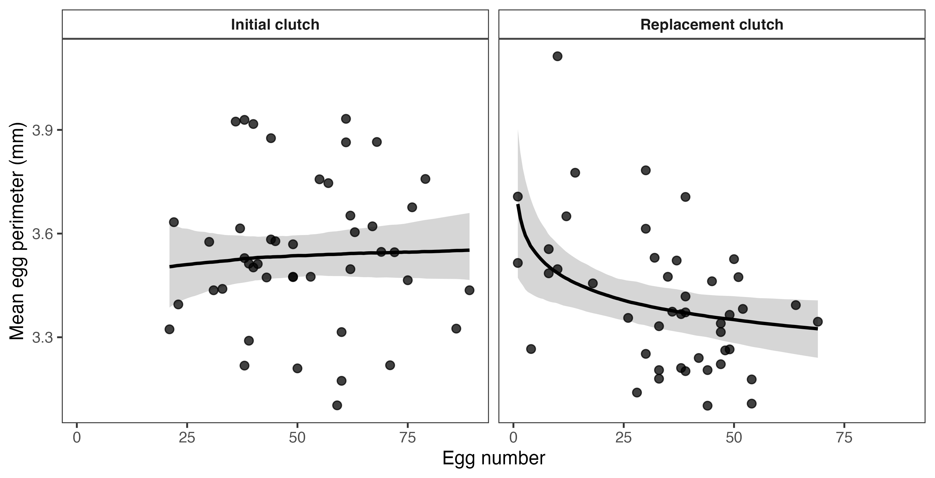
Figure 1: Among-female relationships between egg number and mean egg perimeter in initial and experimentally induced replacement clutches. Points represent clutch means for individual females. Lines show posterior median predictions from a Bayesian mixed model containing reproductive event, pooled-standardized log egg number, their interaction, and standardized log pronotum length; shaded regions denote 95% credible intervals. Predictions are for a female of average structural size and are displayed on the original scales, producing curvature after back-transformation. Egg number was not clearly associated with perimeter in initial clutches, whereas females producing more eggs produced smaller eggs in replacement clutches. The model contrasts the combined experimental contexts, not natural clutch order alone.

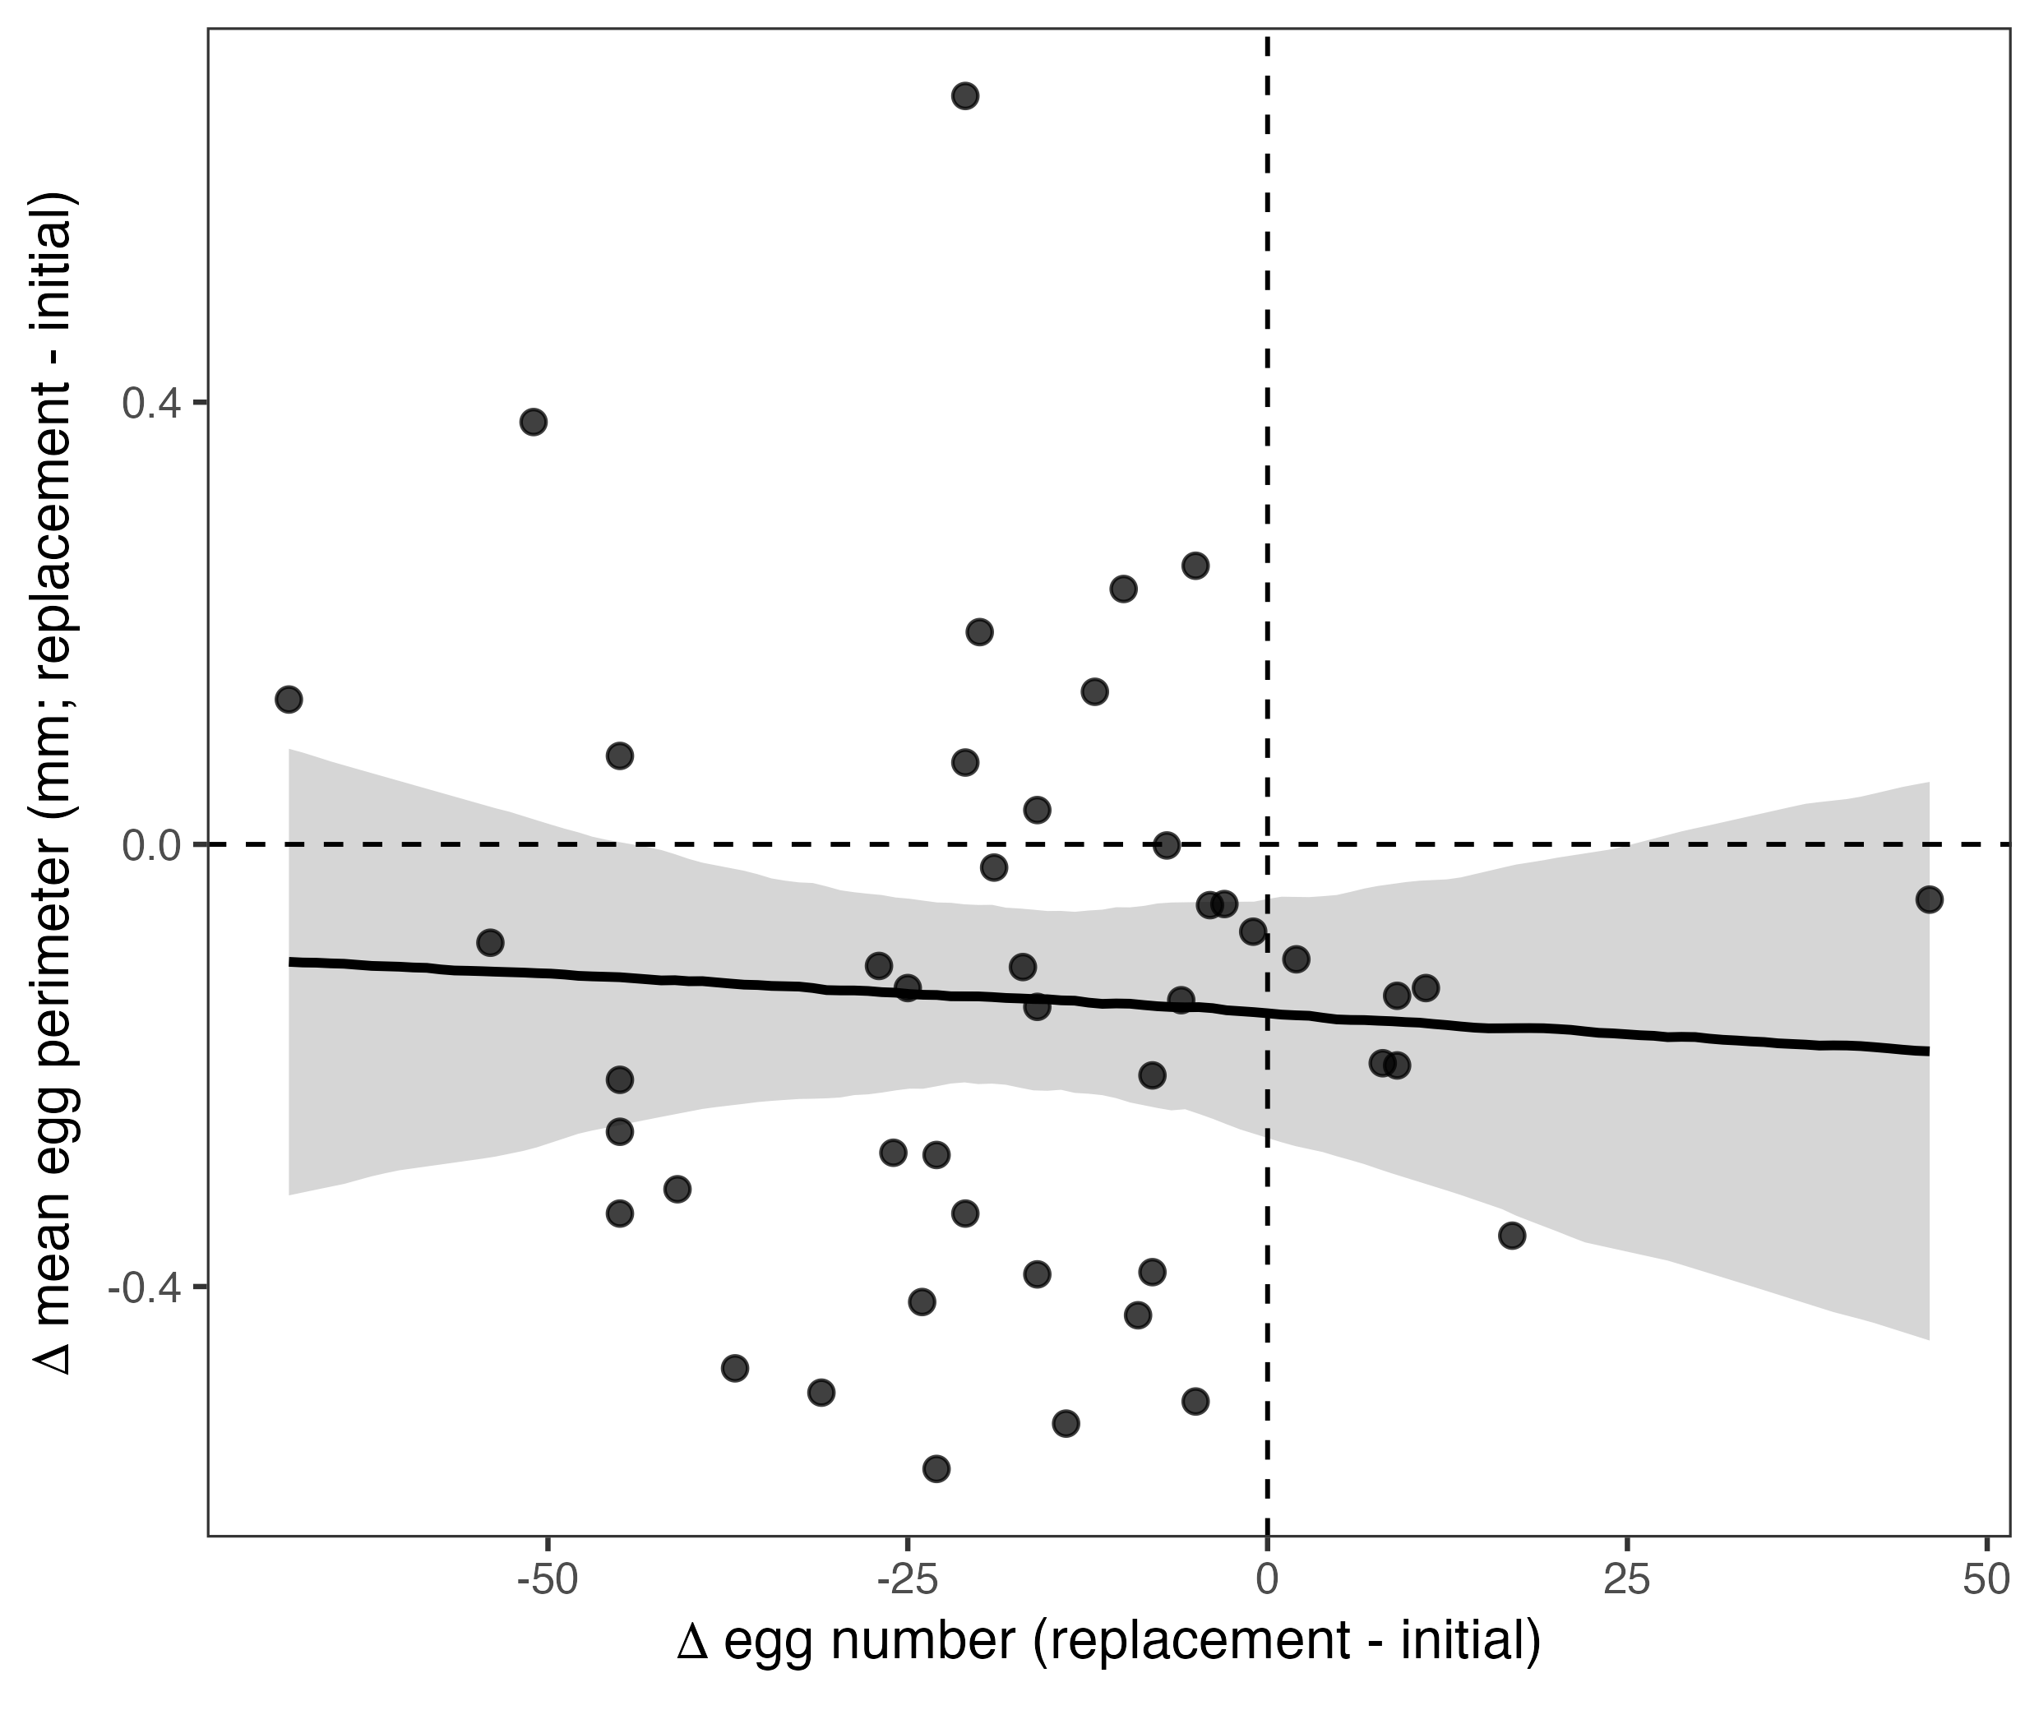
Figure 2: Within-female changes in egg number and mean egg perimeter from the initial to the replacement clutch. Each point represents one female; negative values indicate a decline. The line shows the posterior median relationship from the absolute-scale change-score model, and the shaded region denotes its 95% credible interval. Dashed lines indicate no change. Egg number declined in 38 of 45 females, egg perimeter declined in 35, and both traits declined in 28; the magnitudes of the absolute changes were not clearly associated.

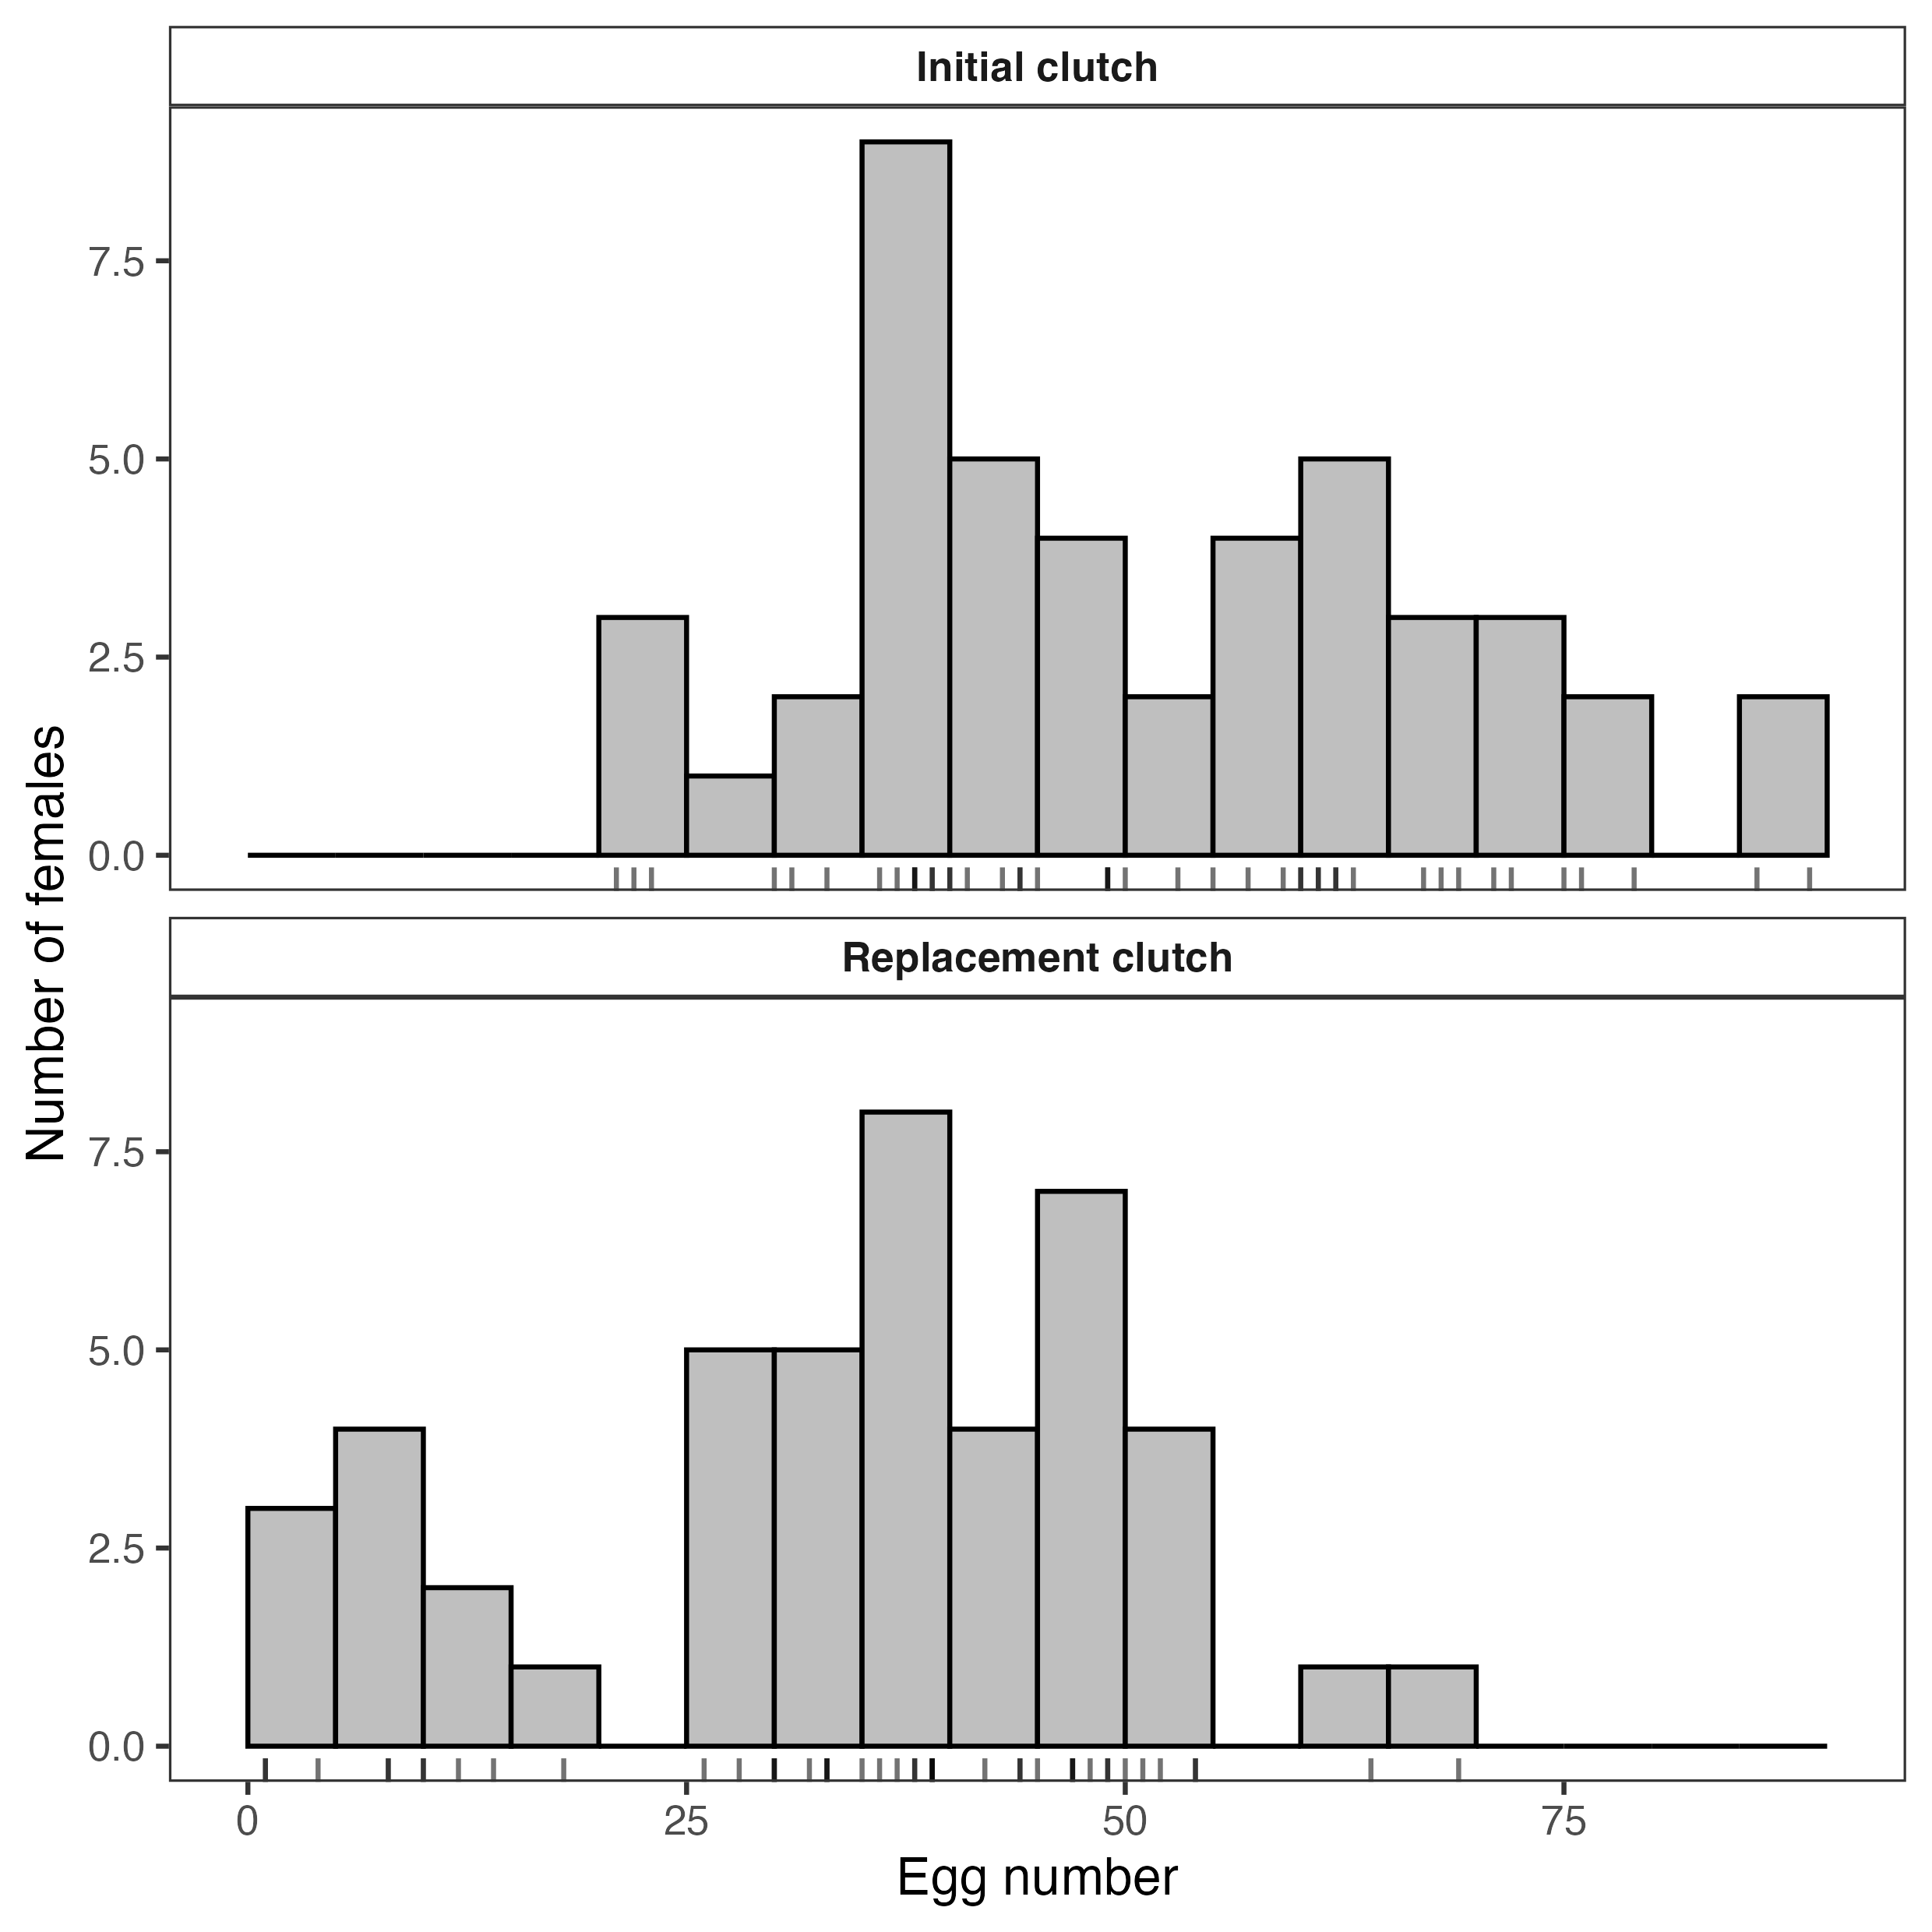
Figure 3: Distribution of egg number in initial and experimentally induced replacement clutches. Rug marks show individual females. The greater spread in replacement-clutch egg number motivates reporting the common-scale primary analysis together with the within-event standardization sensitivity analysis.

