Disentangling within- and between-female egg size–number trade-offs in the European earwig.
Clint D. Kelly^{1,✉}
¹ Département des Sciences biologiques, Université du Québec à Montréal, Montréal, Canada
✉ Correspondence: Clint D. Kelly <kelly.clint@uqam.ca>

Abstract
Life-history theory predicts a trade-off between offspring size and number, yet empirical studies often fail to detect the expected negative association. This discrepancy may occur because phenotypic correlations confuse variation in resource acquisition with variation in allocation strategy. Using repeated measures of female European earwigs (Forficula auricularia), I partitioned covariance between egg size and egg number into among- and within-female components using Bayesian mixed models. The raw phenotypic correlation was near zero. However, females that produced more eggs on average laid smaller eggs, revealing a modest negative association among females that aligns with an allocation trade-off. In contrast, there was no detectable within-female covariance once clutch order was accounted for. Egg number repeatability was effectively zero, suggesting that clutch size varies mainly within rather than among females, while egg size was highly repeatable. Both egg number and egg size decreased in second clutches, and within-clutch egg-size variance increased, indicating a reproductive constraint (i.e., fewer functional ovarioles) under a possibly diminished resource state. Together, these findings demonstrate that the size–number trade-off appears to be expressed among females through consistent differences in allocation strategy, whereas clutch size itself remains flexible. By separating hierarchical sources of variation, this study shows that allocation trade-offs can remain hidden at the phenotypic level and that evolutionary constraints act through stable allocation rules rather than through flexible clutch-size adjustments.

Introduction
Life-history theory predicts that organisms must allocate finite resources among competing fitness components. Because energy and time are limited, investment in one trait constrains investment in others (Roff, 1992; Stearns, 1992). A central expression of this principle is the offspring size–number trade-off: for a given reproductive budget, producing larger offspring reduces the number that can be produced (Parker, 1982; Smith and Fretwell, 1974). Since larger eggs often enhance offspring performance and survival (Clutton-Brock, 1991), selection is expected to favour an optimal balance between egg size and egg number that maximises maternal fitness (Fox and Czesak, 2000). Yet empirical tests of the size–number trade-off often fail to reveal the expected negative relationship. Across individuals within populations, egg size and egg number are often positively correlated (Bernardo, 1996; Fox and Czesak, 2000; Hargitai et al., 2005; Roff, 1992). This apparent contradiction arises because phenotypic correlations conflate two distinct biological processes: variation in resource acquisition and variation in allocation strategy. Van Noordwijk and De Jong (1986) showed that when variance in acquisition exceeds variance in allocation, individuals with greater resource pools can produce both more and larger eggs, generating positive among-individual correlations even if all individuals are constrained by the same underlying allocation trade-off. In such cases, the population-level pattern masks allocation constraints operating within individuals—an outcome conceptually analogous to Simpson’s paradox (Simpson, 1951).
From this perspective, the critical prediction of life-history theory is not simply a negative phenotypic correlation, but a negative within-individual covariance between egg size and egg number once among-individual differences in acquisition are accounted for (Careau and Wilson, 2017). Detecting such a masked trade-off, therefore, requires partitioning phenotypic variance and covariance into hierarchical components. Repeated measures of individuals allow estimation of (i) among-individual variance, reflecting consistent differences among females in total reproductive investment, and (ii) within-individual variance, reflecting how females adjust allocation across reproductive bouts. Careau and Wilson (2017) argue that only by decomposing covariance into these components using multivariate mixed models can we determine whether allocation trade-offs operate within individuals despite positive population-level associations.
Crucially, this framework also predicts that traits involved in allocation trade-offs should show substantial repeatability. If females differ consistently in resource acquisition, egg size and egg number should exhibit among-individual variance across clutches. High repeatability would, therefore, indicate persistent differences in total reproductive investment among females, consistent with variation in acquisition. The marked increase in within-clutch egg size variance in second broods further supports a resource constraint interpretation. Under reduced resource availability, females may be less able to maintain uniform provisioning across all eggs, leading to greater heterogeneity in egg size within a clutch. Such increased variance is consistent with diminished allocation precision when reproductive resources are limited, rather than an adaptive diversification of offspring size.
Despite the foundational importance of the size–number trade-off, empirical tests rarely partition covariance into within- and among-individual components to distinguish allocation from acquisition effects. Here, Here, I address this gap using the European earwig, Forficula auricularia, a species that allows repeated measures of reproductive investment within females but in which previous work has reported no clear or consistent pattern in the association between egg size and egg number (Koch and Meunier, 2014), highlighting the difficulty of interpreting phenotypic correlations without partitioning hierarchical sources of variation. Female earwigs lay a clutch within a short temporal window in a subterranean burrow (Meunier, 2024) and provide extended maternal care (Meunier, 2024; Staerkle and Kölliker, 2008). In Québec populations, environmental constraints typically render females effectively semelparous (Tourneur, 2018), but under favourable laboratory conditions, they can produce a second clutch. This system, therefore, enables direct estimation of within-female covariance across successive reproductive bouts. I test three predictions derived from acquisition–allocation theory (Van Noordwijk and Jong, 1986; see also Reznick, Nunney, and Tessier, 2000). First, if variance in resource acquisition among females exceeds variance in allocation strategy, then egg size and egg number should exhibit substantial repeatability and a positive among-individual correlation, whereas the within-individual correlation should be negative, revealing a masked allocation trade-off. Second, if maternal fitness is maximised at a particular offspring size or number (Smith and Fretwell, 1974), then one trait should remain relatively invariant across clutches while the other adjusts between reproductive bouts (Winkler and Wallin, 1987). Third, if reproductive investment is structured differently across bouts, then variance in egg size may differ between first and second clutches at both the among-female and within-clutch levels (e.g. Hargitai et al., 2005), providing further insight into how selection shapes the distribution of maternal investment across reproductive events.
By separating among-female differences in total reproductive investment from within-female allocation decisions, this study tests a fundamental question in life-history theory: do apparent positive associations between egg size and number reflect relaxed constraints, or do allocation trade-offs persist but remain hidden within individuals? Demonstrating a negative within-female covariance despite positive population-level patterns would show that acquisition can mask, but not erase, the constraints imposed by finite resources. In this way, my study evaluates not only the existence of a trade-off but also the hierarchical structure through which life-history constraints are expressed.

Methods
I collected adult female earwigs (n=42) in September and October 2024 in an urban park (Parc Outremont) in Montréal, Canada. All earwigs were brought into the laboratory, assigned a unique ID, and individually placed in a 90-mm-diameter Petri dish containing a thin layer of moist sand. Females were provided a cotton-plugged water vial and fed TetraMin Tropical fish flakes ad libitum. Females were maintained in an incubator (Percival Scientific, Iowa, USA) at 10°C in constant darkness.
Females were checked daily for oviposition. When a female laid eggs, I recorded the date, collected all eggs from the sand, and placed them on filter paper in a new Petri dish. The eggs were then photographed under a Leica S6D stereo microscope (Leica Microsystems Inc., Concord, ON, Canada) at 0.68x magnification using Enersight software (Leica Microsystems Inc., Concord, ON, Canada), which automatically adds a scale bar to the photo. Eggs were then discarded.
To stimulate females to lay a second clutch of eggs, I recreated a brief spring period during which they were allowed to accumulate resources for egg production and replenish their sperm stores. To achieve this, females that had recently oviposited were placed in a new Petri dish containing a cotton-plugged water vial, TetraMin Tropical fish flakes, and a shelter consisting of four 4 cm-long straws (Blowholes, Markham, Canada) glued together. These Petri dishes were placed in a 23 °C incubator with a 12L:12D light: dark cycle. Females were maintained under these conditions for two weeks, at which time a haphazardly chosen stock male from our colony was placed with her. The pair was kept together for a week, after which a new stock male replaced the original, and the new pair was kept together for another week. Females were then transferred to the 10 °C incubator and treated as previously until they laid their second clutch, at which point their eggs were photographed. Females were euthanised by freezing after laying their second clutch, and their pronotum was photographed as described above. Because female fecundity is often related to body size in insects (Honek, 1993) and could thus possibly explain a positive among-female covariance between egg number and size, I measured two proxies of size, pronotum length and body mass. Females were weighed to the nearest 0.01 mg using a Sartorius Secura 224-1S analytical balance. Females were weighed three times, with each weighing bout separated by four days. I used Fiji image analysis software (Schindelin et al., 2012) to measure the length of the female pronotum to the nearest 0.001 mm three times, with each measurement separated by 4 days. I used the same procedure to measure the perimeter of each egg.

Statistical analysis
I calculated the repeatability of the body mass, pronotum length and egg perimeter measurements using the R package rptR (Stoffel, Nakagawa, and Schielzeth, 2017). I entered the trait of interest as the response variable, female ID as a random effect, and assumed a Gaussian distribution. Each analysis was based on 1000 bootstrap samples. The measurements of my two morphological traits were highly repeatable (pronotum length: R [95% CI] = 0.98 [0.97, 0.99]; body mass: R [95% CI] = 0.99 [0.988, 0.996]); therefore, I used each female’s mean value for each trait where necessary. Because egg perimeter was highly repeatable in both clutches (first clutch: R [95% CI] = 0.977 [0.976, 0.979]; second clutch: R [95% CI] = 0.93 [0.926, 0.937] ), I calculated each egg’s average perimeter and then used these values to calculate the mean egg size for each clutch for each female.
To reduce the two correlated measures of body size (pronotum length and body mass) to a single structural size metric, I performed a principal components analysis (PCA) on the correlation matrix of standardized variables using the prcomp function in the R stats package (R Core Team, 2025). The first principal component (PC1) explained 60.8% of the total variance and was used as an index of structural body size. In addition, female body condition was estimated using the scaled mass index (SMI) following Peig and Green (2010, 2009; see also Kelly, Tawes, and Worthington, 2014), which standardizes body mass relative to structural size (pronotum length).
I first quantified associations among reproductive traits using raw phenotypic correlations. Pearson correlation coefficients were calculated using individual-level trait values, thereby capturing total phenotypic covariation across all sources of variation. These correlations reflect the combined contribution of consistent differences among females, variation among clutches within females, and residual effects. Consequently, raw phenotypic correlations provide a descriptive estimate of overall trait associations but do not distinguish between covariation arising from stable female differences and that arising from within-female (i.e., among-clutch) processes.
To distinguish covariance arising from within-female plasticity from covariance attributable to consistent among-female differences, I followed the within–between decomposition approach of van de Pol and Wright [(2009); see Supplementary Material for details]. This decomposition is necessary because residual covariance does not isolate within-individual effects and, in models with different response distributions, does not provide a directly interpretable estimate of within-female trade-offs. Although mean-centering has been shown to impose assumptions about underlying biological processes (Westneat et al., 2020), these assumptions are appropriate here because the biological question concerns how reproductive allocation varies within females across clutches versus how females differ consistently in allocation strategy. Egg number was decomposed into two components: a between-female component, defined as each female’s mean egg number across broods centered on the population mean, and a within-female component, defined as the deviation of each brood from that female’s own mean. Hereafter, we refer to “among-female” variation as differences between individuals and “within-female” variation as differences among clutches within individuals. These two predictors were included simultaneously in a Bayesian multivariate mixed-effects model in which egg number and mean egg size were modelled jointly. Egg number was modelled using a negative binomial distribution with a log link to account for overdispersion, whereas mean egg size was modelled assuming a Gaussian distribution with an identity link. Clutch (first vs. second clutch) was included as a fixed effect in both submodels. Female identity was included as a random intercept for both response variables. This structure allowed estimation of among-female variance in egg number, among-female variance in egg size, and the covariance (correlation) between female-level intercepts for the two traits.
This multivariate framework partitions total phenotypic covariance into components arising from consistent differences among females and from within-female deviations across clutches. Covariance attributable to consistent differences among females is captured by the female-level random effects, whereas covariance arising from within-female variation is captured by the fixed within-female component of egg number. The fixed between-female component estimates how mean egg size varies with mean egg number across females, thereby capturing systematic (i.e., explained) differences in allocation strategy among females. In contrast, the fixed within-female component tests whether egg size changes plastically when a female produces more or fewer eggs than her own mean. The correlation between female-level intercepts represents residual (latent) covariance among baseline trait values that is not explained by the fixed effects, including the between-female allocation relationship. Thus, the between-female slope tests whether females diverge in their mean allocation strategy (i.e., whether females that consistently produce more eggs also produce smaller eggs), whereas the intercept correlation quantifies any remaining covariance between egg number and egg size after accounting for these effects. Continuous predictors were standardized prior to analysis, such that standardized coefficients represent the expected change in egg size (in standard deviation units) associated with a one standard deviation change in egg number at the relevant hierarchical level.
To quantify the structure of egg-size variation specifically, I fitted a univariate mixed-effects model in which egg size (standardised mean egg perimeter) was modelled as a Gaussian response with female identity included as a random intercept (see Supplementary Material for details). This formulation partitions total phenotypic variance in egg size into variance attributable to differences among females and variance occurring within females among eggs within clutches. The among-female variance component reflects consistent maternal differences in egg size allocation, whereas the within-female component captures heterogeneity in provisioning within clutches and residual variation.
Repeatability was calculated on the observation scale for both traits. For egg size (Gaussian model):
$$R_{\text{egg size}}=\frac{V_{F}}{V_{F}+V_{R}}$$
where $V_{F}$ is the among-female variance (i.e., variance of the female random intercept) and $V_{R}$ is the residual variance. Because the Gaussian model is parameterized directly on the observation scale, this formulation corresponds to both latent- and observation-scale repeatability.
For egg number, which was modelled using a negative binomial distribution with a log link, the variance depends on both the expected mean and the dispersion (shape) parameter. Under the negative binomial parameterization used in brms, the observation-level (distribution-specific) variance is given by:
$$Var\left(Y\right)=μ+\frac{μ^{2}}{θ}$$
where $μ$ is the expected mean egg number and $θ$ is the dispersion (shape) parameter. Because the model includes a log link, the among-female variance estimated from the random intercept is expressed on the latent (log) scale and must be transformed to the observation scale before calculating repeatability. Following Nakagawa et al. (2017), the among-female variance on the observation scale was therefore calculated as:
$$V_{F}^{\text{obs}}=μ^{2}\left(exp\left(σ^{2}\right)-1\right)$$
where $σ^{2}$ is the variance of the random intercept on the latent scale.
Observation-scale repeatability for egg number was then calculated as:
$$R_{\text{egg number}}=\frac{V_{F}^{\text{obs}}}{V_{F}^{\text{obs}}+\left(μ+\frac{μ^{2}}{θ}\right)}$$
Both the transformed among-female variance and the distribution-specific variance were computed for each posterior draw using the corresponding posterior samples of $μ$, $σ^{2}$, and $θ$. To account for variation in expected values across observations, these quantities were first calculated at the observation level and then averaged within each posterior draw. This procedure yielded a posterior distribution of repeatability that fully propagates uncertainty from all variance components.
Repeatability for non-Gaussian traits was calculated following the framework of Nakagawa and Schielzeth (2010) and its extensions for generalized linear mixed models (Nakagawa, Johnson, and Schielzeth, 2017). Because distribution-specific variance can contribute substantially to total phenotypic variance in negative binomial models, repeatability estimates for count data are often lower than those obtained under Gaussian assumptions, even when among-individual variance is present (Nakagawa, Johnson, and Schielzeth, 2017; Nakagawa and Schielzeth, 2010). By calculating repeatability on the observation scale, these estimates represent the proportion of total phenotypic variance in observed egg number attributable to consistent differences among females.
I used weakly informative priors to constrain parameters to biologically realistic ranges while allowing the data to drive inference. Regression coefficients were assigned normal priors centered at zero (Normal(0, 0.5–1)), reflecting the expectation that clutch effects on egg traits would be moderate in magnitude. Intercepts were given normal priors scaled to each trait (egg number: Normal(0, 5); mean egg size: Normal(3.5, 1); standardized egg size: Normal(0, 0.5)). Among-female variation was assigned exponential priors (Exponential(1–2)), which favour small but non-zero individual differences. Residual variance (Gaussian models) and the negative binomial dispersion parameter were given Exponential(1) priors. Correlations among female-level random effects were regularized using an LKJ(2) prior to avoid overestimating trait associations. Posterior distributions were obtained using six Markov chains each with 4,000 iterations, including 1,000 warm-up iterations, and convergence was assessed using $\hat{R}$ statistics, effective sample sizes, and trace-plot inspection. Posterior distributions are summarised as posterior means with 95% credible intervals. Data were visualized using ggplot (Wickham, 2016) and tidybayes (Kay, 2020).

Results

Between- and within-female associations
Across all broods, the raw phenotypic correlation between egg number and egg size was weak and near zero ($r_{raw}$ = -0.04, 95% CI [-0.25, 0.19]), indicating no detectable population-level association when hierarchical structure was ignored.
Egg number (clutch one: $\overset{‾}{x}$ = 51.55 ± 2.49 eggs; clutch two: $\overset{‾}{x}$ = 34.14 ± 2.65 eggs) and egg size (first clutch: $\overset{‾}{x}$ = 3.54 ± 0.03 mm; second clutch: $\overset{‾}{x}$ ± SE = 3.41 ± 0.03 mm) both declined in second clutches. Egg number decreased on the log scale ($β$ = -0.41, 95% CrI (-0.64, -0.19; Figure 1; Supplementary Table 1), corresponding to an approximate 34% reduction on the natural scale ($e^{-0.413}≈0.66$). Mean egg size also declined in the second clutch ($β$ = -0.13, 95% CrI (-0.24, -0.02)).
The results did not support my prediction of a within-female plastic trade-off between egg number and egg size (Figure 1 a). The within-female deviation in egg number had a slope near zero ($β_{W}$ = -0.01, 95% CrI (-0.06, 0.05), indicating that females did not systematically adjust egg size when producing more or fewer eggs relative to their own mean. By comparison, the among-female association (captured by the fixed between-female slope) revealed a negative relationship between egg size and mean female egg number ($β_{B}$ = -0.05, 95% CrI (-0.10, 0.00; Figure 1 b). The posterior distribution of the among-female slope was centered on negative values, suggesting weak evidence for divergence in mean allocation strategy among females. The correlation between female-level intercepts for egg number and egg size was highly uncertain (median = -0.02, 95% CrI: -0.81, 0.82), indicating limited information for estimating latent covariance with only two broods per female. With only two repeated measures per female, intercept correlations are weakly identifiable and should be interpreted cautiously.
No measure of female size/condition was positively correlated with the number of eggs in the first brood (pronotum length: $r$ = 0.14, 95% CI [-0.19, 0.43]; body mass: $r$ = 0.12, 95% CI [-0.21, 0.43]; PC1: $r$ = -0.17, 95% CI [-0.44, 0.15]; scaled mass index: $r_{raw}$ = -0.02, 95% CI [-0.35, 0.33]) providing no evidence that larger females or those in better condition produce more eggs. I therefore did not include a measure of size/condition in this model. Together, these results show that the size–number trade-off is not apparent at the raw phenotypic level and is not expressed as within-female plasticity, but emerges as a modest negative association at the among-female level through differences in average allocation strategy.

Egg size variation between females and within clutches
Egg size exhibited substantial variation at both the between-female and within-clutch levels (Figure 2; Supplementary Table 2). Between-female variance was similar across reproductive events, with a median of 0.73 (95% CrI: 0.50, 1.12) in first clutches and 0.61 (95% CrI: 0.41, 0.96) in second clutches. The posterior median difference (second − first) was -0.11 (95% CrI: -0.56, 0.28), and the posterior probability that between-female variance was greater in second clutches was 0.28, indicating no clear evidence of a difference. In contrast, within-clutch (egg-to-egg) variance was substantially higher in second clutches (median = 0.35 (95% CrI: 0.33, 0.38) than in first clutches (median = 0.21 (95% CrI: 0.20, 0.22). The posterior median difference was 0.14 (95% CrI: 0.12, 0.17), with a posterior probability of 1.00, that within-clutch variance was greater in second clutches.

Egg number and egg size repeatability
Repeatability was calculated from posterior samples of the variance components on the observation scale. Egg number exhibited extremely low repeatability. Although there was some among-female variance in egg number (SD = 0.078, 95% CrI [0.003, 0.270]; Supplementary Table 1), the overwhelming majority of variance arose from distribution-specific (negative binomial) variance. Consequently, observation-scale repeatability was near zero (R=4.86×10-2,95% CrI 3.80×10-5,2.43×10-1), indicating that very little of the total phenotypic variation in clutch size was attributable to consistent differences among females.
Because variance components and repeatability were derived from different models, these quantities are reported separately. Among-female variance in egg size from the multivariate model was modest in absolute terms (SD = 0.082, 95% CrI [0.006, 0.155]; residual SD = 0.191, 95% CrI [0.155, 0.235]; Supplementary Table 1), providing a sense of the trait’s physical scale (mm). Repeatability, however, was estimated from the clutch-specific univariate model (Supplementary Table 2), in which among-female variance exceeded residual variance (SD = 0.855 vs 0.457 in first broods; 0.784 vs 0.594 in second broods), yielding R = 0.78 (95% CrI: 0.70, 0.84) in first broods and R = 0.63 (95% CrI: 0.53, 0.73) in second broods.

Discussion
Life-history theory predicts a trade-off between offspring size and number because both traits draw from a finite pool of reproductive resources (Lack, 1947; Roff, 1992; Smith and Fretwell, 1974; Stearns, 1992). Yet, as emphasised by van Noordwijk and de Jong (1992), phenotypic correlations need not directly reveal allocation trade-offs, because variation in resource acquisition can obscure underlying allocation rules (Careau and Wilson, 2017; Johnson and Nassrullah, 2024). This acquisition–allocation framework has become central to interpreting life-history covariance (Houle, 1991; Reznick, Nunney, and Tessier, 2000). By partitioning covariance into within- and among-female components, my results show that the size–number trade-off in this population of earwigs is modestly expressed among females but absent within them, illustrating how hierarchical structure shapes the detectability of life-history trade-offs (Careau and Wilson, 2017; Dingemanse and Dochtermann, 2013; Pol and Wright, 2009; Westneat et al., 2020).
At the phenotypic level, egg size and egg number were uncorrelated in my earwig population, consistent with Koch and Meunier (2014). Under the framework of van Noordwijk and de Jong (1986), such phenotypic independence is expected when variation in resource acquisition obscures underlying allocation trade-offs. After hierarchical decomposition, however, a weak negative association emerged at the among-female level: females that produced more eggs on average tended to lay slightly smaller eggs. This pattern is captured by the fixed between-female slope and reflects differences among females in their mean allocation strategy. In contrast, the correlation between female-level intercepts—representing residual (latent) covariance after accounting for this allocation relationship—was highly uncertain and overlapped zero, indicating little evidence for additional integration between traits beyond that explained by differences in mean allocation strategy (Roff and Fairbairn, 2007; Stearns, 1989).

In contrast, there was no evidence for a within-female plastic trade-off. Although each female contributed only two broods, the posterior distribution of the within-female slope was tightly centered on zero, suggesting that any within-female effect, if present, is small. Females did not reduce egg size when producing more eggs than their own average; instead, egg number and egg size shifted together across broods. This pattern is consistent with state-dependent life-history models in which allocation rules remain relatively stable while total resource state fluctuates across reproductive bouts (Houston and McNamara, 1999; McNamara and Houston, 1996). Rather than dynamically reallocating resources between offspring size and number, females appear to exhibit clutch-level shifts driven by overall energetic state.
Notably, egg number was not correlated with female structural size or body condition (i.e. scaled mass), indicating that persistent differences in morphology do not explain clutch-size variation. If stable acquisition differences were driving among-female variation, we would expect egg number to show repeatability and to covary with these morphological size/condition indicators. The absence of such patterns weakens the interpretation that persistent acquisition differences—at least as reflected by morphology—underlie among-female differences in reproductive output. Instead, clutch size appears predominantly state-sensitive and influenced by clutch-level constraints.
This interpretation also helps explain the pronounced decline in second clutches. That second clutches comprised both fewer and smaller eggs is consistent with previous work in North American and European populations (Koch and Meunier, 2014; Tourneur and Gingras, 1992). Tourneur and Gingras (1992) proposed that some ovarioles become non-functional after the first clutch, thereby reducing egg production capacity. Structural limitation could therefore contribute to smaller second clutches. However, structural reduction alone cannot explain the simultaneous decline in egg size. Under a strict allocation trade-off, a reduction in egg number would be expected to lead to compensatory increases in egg size if total resources remain constant. Instead, both traits declined, indicating that females likely entered the second reproductive bout with diminished resource reserves in addition to any physiological constraint. In the wild, females accumulate resources for months before producing their first clutch, whereas in the laboratory, they had only a brief interval (approx. one month) to replenish reserves before producing the second. Late reproduction, therefore, likely reflects both reduced energetic state and structural limitation.
The hierarchical variance structure supports a constraint-based interpretation of clutch-size variation. Egg size exhibited moderate repeatability across broods, indicating stable differences among females in mean per-offspring investment. In contrast, egg number showed extremely low repeatability, with most of the variance arising from brood effects and distribution-level variation rather than from persistent female differences. The absence of any association between egg number and female structural size or condition, together with the near-zero repeatability of clutch size, suggests that variation in egg number is not driven by stable differences in resource acquisition but instead reflects transient physiological state or clutch-level constraint. Thus, clutch size appears primarily state-sensitive, whereas egg size reflects a more stable allocation strategy (Houston and McNamara, 1999; McNamara and Houston, 1996). At the same time, within-clutch variance increased substantially in second broods, indicating reduced developmental precision under diminished resource availability. Structural and energetic constraints, therefore, appear to reduce total reproductive output while leaving mean allocation rules largely intact (Ricklefs and Wikelski, 2002; Zera and Harshman, 2001).
These patterns have broader implications for phenotypic integration and evolutionary potential. Repeatability places an upper bound on heritability (Falconer and MacKay, 1996; Lessells and Boag, 1987; Nakagawa and Schielzeth, 2013; Nakagawa and Schielzeth, 2010; but see Dohm, 2002). The moderate repeatability of egg size suggests that selection could act on persistent differences in mean provisioning, whereas the extremely low repeatability of egg number implies that clutch size may respond primarily to short-term environmental or physiological conditions (i.e. reduced ovariole function). The weak intercept correlation further indicates that egg size and egg number are only loosely integrated, consistent with models in which traits differ in their sensitivity to resource state versus allocation strategy (Houle, 1991). In this system, per-offspring investment appears more evolutionarily stable than the total number of offspring.
Viewed hierarchically, my results illustrate a broader conceptual point: life-history trade-offs may operate primarily through stable differences in allocation rules among individuals, while short-term variation reflects state-dependent constraint. Without decomposing within- and among-individual covariance, the modest among-female trade-off suggested here would have remained obscured. More generally, the evolutionary consequences of trade-offs depend not only on their sign but on their hierarchical expression and repeatability. A trade-off that reflects consistent among-individual differences in a repeatable trait is more likely to shape evolutionary responses than one arising primarily from transient, plastic variation within individuals. Future work measuring resource acquisition directly, experimentally manipulating body condition, or estimating genetic correlations between egg size and egg number will help determine whether the allocation divergence observed here reflects adaptive differentiation in allocation strategy or condition-dependent constraint (Lande, 1980; Roff, 1992).

Data availability
Data are available through the OSF repository at https://osf.io/jrs28/overview?view_only=7a78f30e724b497ab3bb62ffa1c97e10.

Author contributions
CDK collected and analyzed the data, and wrote the manuscript.

Funding
The study was funded by a Discovery Grant from the Natural Sciences and Engineering Research Council of Canada (NSERC).

Conflict of Interest
I declare no conflict of interest.

Acknowledgements
I thank Andréanne Nault and Clara Smythe for assistance in animal care and data collection. I also thank Denis Réale, Pierre-Olivier Montiglio, and two anonymous reviewers for their discussion and feedback.

References
Bernardo, J., 1996. The particular maternal effect of propagule size, especially egg size: Patterns, models, quality of evidence and interpretations. Am Zool 36, 216–236.
Careau, V., Wilson, R., 2017. Of uberfleas and krakens: Detecting trade-offs using mixed models. Integr Comp Biol 57, 362–371.
Clutton-Brock, T.H., 1991. The Evolution of Parental Care. Princeton University Press.
De Jong, G., Van Noordwijk, A., 1992. Acquisition and allocation of resources: Genetic (co) variances, selection, and life histories. Am Nat 139, 749–770.
Dingemanse, N.J., Dochtermann, N., 2013. Quantifying individual variation in behaviour: Mixed-effect modelling approaches. J Anim Ecol 82, 39–54.
Dohm, M.R., 2002. Repeatability estimates do not always set an upper limit to heritability. Funct Ecol 16, 273–280.
Falconer, D.S., MacKay, T.F.C., 1996. An Introduction Quantitative Genetics. Pearson Education Limited, Essex, England.
Fox, C.W., Czesak, M.E., 2000. Evolutionary ecology of progeny size in arthropods. Annu Rev Entomol 45, 341–369.
Hargitai, R., Török, J., Tóth, L., Hegyi, G., Rosivall, B., Szigeti, B., Szöllősi, E., 2005. Effects of environmental conditions and parental quality on inter-and intraclutch egg-size variation in the collared flycatcher (Ficedula albicollis). Auk 122, 509–522.
Honek, A., 1993. Intraspecific variation in body size and fecundity in insects: A general relationship. Oikos 483–492.
Houle, D., 1991. Genetic covariance of fitness correlates: What genetic correlations are made of and why it matters. Evolution 45, 630–648.
Houston, A.I., McNamara, J.M., 1999. Models of adaptive behaviour: An approach based on state. Cambridge University Press.
Johnson, M.T.J., Nassrullah, Z., 2024. The improbability of detecting trade-offs and some practical solutions. J Evol Biol 37, 1205–1214.
Kay, M., 2020. tidybayes: Tidy Data and Geoms for Bayesian Models [WWW Document]. R package version 3.0.5. URL http://mjskay.github.io/tidybayes/
Kelly, C.D., Tawes, B., Worthington, A., 2014. Evaluating indices of body condition in two cricket species. Ecol Evol 4, 4476–4487.
Koch, L.K., Meunier, J., 2014. Mother and offspring fitness in an insect with maternal care: Phenotypic trade-offs between egg number, egg mass and egg care. BMC Evol Biol 14, 125.
Lack, D., 1947. The significance of clutch-size in the partridge (Perdix perdix). J Anim Ecol 16, 19–25.
Lande, R., 1980. The genetic covariance between characters maintained by pleiotropic mutations. Genetics 94, 203–215.
Lessells, C., Boag, P.T., 1987. Unrepeatable repeatabilities: A common mistake. Auk 104, 116–121.
McNamara, J.M., Houston, A.I., 1996. State-dependent life histories. Nature 380, 215–221.
Meunier, J., 2024. The biology and social life of earwigs (Dermaptera). Annu Rev Entomol 69, 259–276.
Nakagawa, S., Johnson, P.C.D., Schielzeth, H., 2017. The coefficient of determination r² and intra-class correlation coefficient from generalized linear mixed-effects models revisited and expanded. J R Soc Interface 14, 20170213.
Nakagawa, S., Schielzeth, H., 2013. A general and simple method for obtaining R2 from generalized linear mixed‐effects models. Methods Ecol Evol 4, 133–142.
Nakagawa, S., Schielzeth, H., 2010. Repeatability for Gaussian and non-Gaussian data: A practical guide for biologists. Biol Rev Camb Philos Soc 85, 935–956.
Parker, G.A., 1982. Why are there so many tiny sperm? Sperm competition and the maintenance of two sexes. J Theor Biol 96, 281–294.
Peig, J., Green, A.J., 2010. The paradigm of body condition: A critical reappraisal of current methods based on mass and length. Funct Ecol 24, 1323–1332.
Peig, J., Green, A.J., 2009. New perspectives for estimating body condition from mass/length data: The scaled mass index as an alternative method. Oikos 118, 1883–1891.
Pol, M. van de, Wright, J., 2009. A simple method for distinguishing within- versus between-subject effects using mixed models. Anim Behav 77, 753–758.
R Core Team, 2025. R: A language and environment for statistical computing.
Reznick, D., Nunney, L., Tessier, A., 2000. Big houses, big cars, superfleas and the costs of reproduction. Trends Ecol Evol 15, 421–425.
Ricklefs, R.E., Wikelski, M., 2002. The physiology/life-history nexus. Trends Ecol Evol 17, 462–468.
Roff, D., 1992. Evolution of Life Histories: Theory and Analysis. Chapman & Hall, Inc., New York, NY.
Roff, D.A., Fairbairn, D.J., 2007. The evolution of trade-offs: Where are we? J Evol Biol 20, 433–447.
Schindelin, J., Arganda-Carreras, I., Frise, E., Kaynig, V., Longair, M., Pietzsch, T., Preibisch, S., Rueden, C., Saalfeld, S., Schmid, B., Tinevez, J.-Y., White, D.J., Hartenstein, V., Eliceiri, K., Tomancak, P., Cardona, A., 2012. Fiji: An open-source platform for biological-image analysis. Nat Method 9, 676–682.
Simpson, E.H., 1951. The interpretation of interaction in contingency tables. J. R. Stat. Soc. Ser. B Stat. Methodol. 13, 238–241.
Smith, C.C., Fretwell, S.D., 1974. The optimal balance between size and number of offspring. Am Nat 108, 499–506.
Staerkle, M., Kölliker, M., 2008. Maternal food regurgitation to nymphs in earwigs (Forficula auricularia). Ethology 114, 844–850.
Stearns, S.C., 1992. The Evolution of Life Histories. Oxford University Press.
Stearns, S.C., 1989. Trade-offs in life-history evolution. Funct Ecol 3, 259–268.
Stoffel, M.A., Nakagawa, S., Schielzeth, H., 2017. RptR: Repeatability estimation and variance decomposition by generalized linear mixed‐effects models. Methods Ecol Evol 8, 1639–1644.
Tourneur, J.-C., 2018. Factors affecting the egg-laying pattern of Forficula auricularia (Dermaptera: Forficulidae) in three climatologically different zones of North America. Can Entomol 150, 511–519.
Tourneur, J.-C., Gingras, J., 1992. Egg laying in a northeastern North American (Montréal, Québec) population of Forficula auricularia L. (Dermaptera: Forficulidae). Can Entomol 124, 1055–1061.
Van Noordwijk, A.J., Jong, G. de, 1986. Acquisition and allocation of resources: Their influence on variation in life history tactics. Am Nat 128, 137–142.
Westneat, D.F., Araya-Ajoy, Y.G., Allegue, H., Class, B., Dingemanse, N., Dochtermann, N.A., Garamszegi, L.Z., Martin, J.G.A., Nakagawa, S., Réale, D., Schielzeth, H., 2020. Collision between biological process and statistical analysis revealed by mean centring. J Anim Ecol 89, 2813–2824.
Wickham, H., 2016. ggplot2: Elegant graphics for data analysis. Springer, New York.
Winkler, D.W., Wallin, K., 1987. Offspring size and number: A life history model linking effort per offspring and total effort. Am Nat 129, 708–720.
Zera, A.J., Harshman, L.G., 2001. The physiology of life history trade-offs in animals. Annu Rev Ecol Syst 32, 95–126.

##Figures
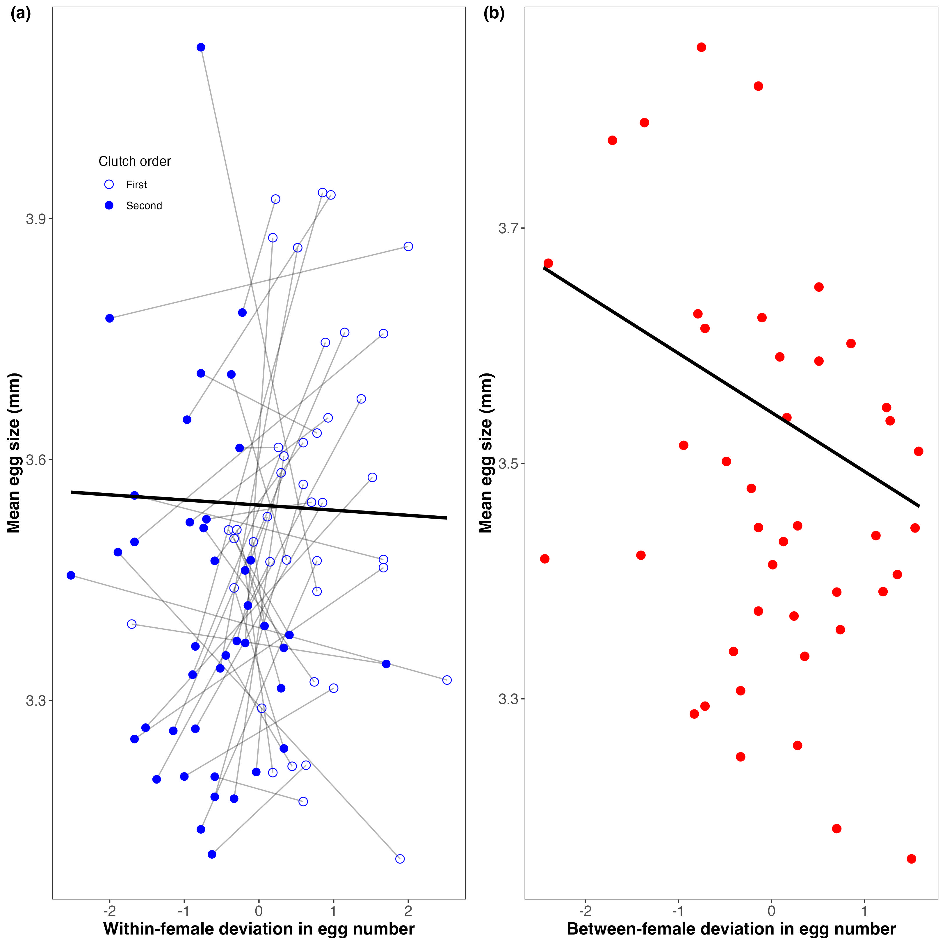
Figure 1: Partitioning the egg size–number trade-off into within- and between-female components. (a) Within-female (plastic) relationship between egg number and mean egg size. Points represent individual broods (first clutch: open circles; second clutch: closed circles), with grey lines connecting repeated measures from the same female. The x-axis shows standardized within-female deviation in egg number (0 = female mean). The solid black line represents the Bayesian population-level estimate of the within-female slope ($β_{W}$ = -0.01, 95% CrI (-0.06, 0.05). (b) Between-female relationship (i.e., differences in mean allocation strategy) based on female means across broods plotted against standardized between-female deviation in egg number. The black line represents the Bayesian population-level between-female slope ($β_{B}$ = -0.05, 95% CrI (-0.10, 0.00). Together, the panels distinguish plastic allocation within females from strategic differences among females, indicating weak support for a reproductive size–number trade-off.

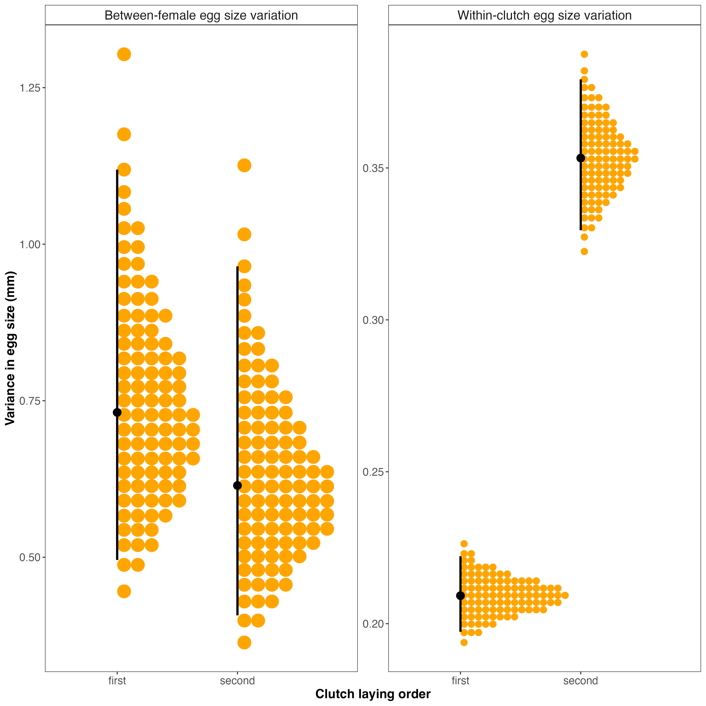
Figure 2: Clutch-specific variance components of egg size. (a) Between-female variance in egg size for first and second clutches, estimated from a hierarchical Bayesian model with clutch-specific female effects. (b) Within-clutch (egg-to-egg) variance for first and second clutches. Orange points represent posterior draws, black points indicate posterior medians, and vertical lines denote 95% credible intervals. Between-female variance did not differ clearly between clutches, whereas within-clutch variance was greater in second clutches.

