Hierarchical structuring of weapon allometry in the European earwig.
Céline Ozkan² and Clint D. Kelly^{1,✉}
¹ Département des Sciences biologiques, Université du Québec à Montréal, Montréal, Canada
² Université Claude Bernard Lyon 1, Lyon, France
✉ Correspondence: Clint D. Kelly <kelly.clint@uqam.ca>

Abstract
Static allometries are often treated as stable descriptors of morphological architecture, yet scaling relationships themselves may evolve and respond plastically to environmental conditions. We quantified sex- and morph-specific weapon allometries in the European earwig (Forficula auricularia) under experimental manipulation of developmental diet and density using hierarchical models that allow scaling exponents to vary across biological levels. Forceps length scaled positively with body size in all groups, but males exhibited substantially steeper allometric slopes than females. There was some evidence that nutritional stress was associated with reduced male scaling exponents, although support for these effects was variable and context-dependent, while density had little consistent influence on slopes. Female scaling relationships remained comparatively stable across environments. Among males, macrolabic individuals tended to show greater environmental sensitivity in scaling relationships than brachylabic males, although statistical support for these differences was limited. There was little evidence that environmental or morph-specific differences were driven by intercept shifts independent of body size. Among-family variation in slopes and intercepts was modest, and their covariance was weak and uncertain. Overall, these results suggest that weapon allometry is structured primarily through variation in scaling exponents and provide qualified support for the idea that slopes may represent condition-sensitive components of exaggerated trait architecture.

Introduction
Static allometry describes how trait size scales with body size among individuals at the same developmental stage and provides a central framework for understanding the evolution of exaggerated morphology. Sexually selected weapons often exhibit positive allometry, such that larger individuals invest disproportionately more in trait size (Kodric-Brown et al. 2006; Bonduriansky 2007a; Voje 2016). However, hyperallometry is not universal. When traits serve dual sexual and viability functions, or when functional and mechanical constraints limit disproportionate investment, isometry or hypoallometry may evolve instead (Bonduriansky and Day 2003; Eberhard et al. 2018; Kelly 2026). Consequently, the scaling relationship itself reflects how developmental allocation, functional performance, and selection interact to shape trait architecture.
Static allometry is typically described by a linear relationship between log-transformed trait size and body size. In this framework, the slope (scaling exponent) describes how strongly trait size changes with body size (i.e., size-dependent exaggeration), whereas the intercept (elevation) represents expected trait size at the mean body size (given that body size is centred). Static allometry can therefore diverge through changes in either parameter. Differences in scaling exponent reflect variation in how strongly a trait responds to body size, whereas intercept divergence reflects differences in baseline trait expression at a given body size. These components need not evolve together (Lande 1980; Cheverud 1982; Pélabon et al. 2014). Sexual dimorphism, for example, may arise because males and females differ in scaling sensitivity, in baseline allocation, or in both. Similarly, alternative male morphs may diverge through elevation shifts while retaining similar scaling exponents, or through fundamentally different scaling architectures (Tomkins et al. 2005). Distinguishing between slope-based and intercept-based divergence is therefore essential for understanding how exaggerated traits evolve (Bonduriansky 2007a; Shingleton and Frankino 2013; Pélabon et al. 2014; Voje 2016).
Species expressing alternative reproductive phenotypes provide particularly valuable models for examining the structure of allometry. In these species, males adopt discrete morphs that differ in weapon size, behaviour, and mating tactics (Gross 1996; Shuster and Wade 2003; Oliveira et al. 2008). Because morphs share much of their genome and developmental environment, differences in scaling architecture can reveal how developmental pathways partition exaggeration within a single species. However, empirical analyses of morph-specific static allometry remain scarce, and even fewer studies have investigated how environmental factors influence both slopes and intercepts in polymorphic systems (Kochensparger et al. 2024; Kelly 2026).
Environmental conditions can influence developmental allocation and consequently reshape static allometries (Emlen 1997; Frankino et al. 2005; Shingleton et al. 2007). Nutritional stress may decrease baseline investment in exaggerated traits, lowering intercepts, whereas social factors such as rearing density could alter competitive allocation patterns. Environmental effects on scaling exponents would indicate plasticity in the trait–body size relationship, whereas consistent slopes across environments would imply canalisation of scaling architecture (Frankino et al. 2005; Shingleton et al. 2007; Nijhout and German 2012). Determining whether environmental variation modifies intercepts, slopes, or both is therefore crucial for evaluating the developmental flexibility of trait exaggeration. Complementary structural modelling of the same study system demonstrates that environmental effects on forceps size are transmitted both indirectly via body size and directly through trait-specific allocation, particularly in males (Ozkan and Kelly submitted).
Beyond sex, morph, and environment, variation among maternal families of related individuals offers insights into the integration of scaling architecture. Intercept and slope may covary across lineages if developmental processes jointly regulate baseline allocation and scaling sensitivity (Lande 1980; Hansen and Houle 2008; Klingenberg 2008; Pélabon et al. 2014). A positive intercept–slope covariance indicates that families producing relatively larger weapons at average body size also have steeper scaling relationships, reflecting integrated exaggeration architecture (Bonduriansky and Day 2003; Hansen and Houle 2008; Pélabon et al. 2014). Conversely, independence between parameters suggests modularity or developmental decoupling of baseline exaggeration and scaling sensitivity.
The European earwig (Forficula auricularia) provides a powerful system for integrating these perspectives on static allometry. Males express discrete forceps morphs that vary considerably in size and curvature, commonly referred to as macrolabic and brachylabic forms , Figure 1. Forceps function both as sexual weapons during male–male interactions and as defensive structures, making them traits with dual roles (Kamimura 2014; Meunier 2024). Previous work has documented morph-specific differences in forceps exaggeration and scaling, suggesting that divergence occurs not only in absolute size but also potentially in scaling architecture. Nonetheless, most studies have primarily compared static slopes, with less attention to intercept divergence, environmental sensitivity of scaling parameters, and variation among families.
Here, we quantify sex-specific and morph-specific static allometries of forceps length in F. auricularia under experimentally manipulated diet and density. Rather than treating the scaling exponent as fixed, we test whether it functions as a condition-sensitive developmental parameter structured across biological levels. Specifically, we investigate whether sexual dimorphism in weapon exaggeration results from divergence in the scaling exponent, intercept, or both; whether macrolabic and brachylabic males differ mainly in baseline allocation or in the sensitivity of forceps growth to body size; and whether larval environmental conditions influence intercepts, slopes, or their covariance. Finally, by estimating variance among families in intercepts and scaling exponents, we determine whether baseline exaggeration and size sensitivity are developmentally integrated. Through integrating sex, morph, environment, and family components within a unified hierarchical framework, we assess whether static allometry is a stable architectural constant or an emergent property of layered growth regulation (see also Simmons and Tomkins 1996; Tomkins et al. 2005; Kelly 2026).

Methods

Study species and experimental design
Females (n = 115) were hand-collected at night from vegetation in Parc Outremont (Montréal, QC, Canada) during September and October 2024. Individuals were transported to the laboratory at the Université du Québec à Montréal and placed individually in 90-mm Petri dishes filled with moist sand. Each dish was provisioned with a cotton-plugged water tube, and TetraMin Tropical Flakes (United Pet Group, Inc., Germany), and each female was assigned a unique ID code. Earwigs were maintained in the dark at 10 °C in an incubator (Percival Scientific, Perry, IA, USA) to mimic overwintering conditions. Dishes were checked daily for egg laying, and food and water were replenished as needed. Food and water were removed at the time of egg laying (approximately early December), after which dishes were checked weekly. Starting January 2025, dishes were checked daily for egg hatching. The date of egg hatching was recorded; hatching occurred between 13 January and 29 January 2025, and all 115 females produced hatchlings.
For two weeks following hatching, families were provisioned with a water tube and food (TetraMin Tropical Flakes: crude protein: 46%, crude fat: 11%, crude fibre: 3%). This interval allowed nymphs to complete a moult and reach a size sufficient to withstand manual transfer to experimental dishes. To manipulate the developmental environment, we varied two ecological factors: nutritional condition (diet quality) and social density. Diet treatment consisted of two levels: a “good” diet (100% TetraMin Tropical Flakes), providing high nutritional quality, and a “poor” diet (75% TetraMin Tropical Flakes, 25% non-digestible $α$-cellulose), providing reduced nutritional content. Density treatment consisted of three levels: low density (one individual per Petri dish), medium density (4 individuals), and high density (8 individuals). These treatments allowed us to examine both nutritional and social environmental effects on growth and morphology. We used a split-brood experimental design in which offspring were randomly assigned to diet and density treatments within maternal families to minimise confounding between maternal background and environmental treatment. Experimental dishes were maintained at 20°C to mimic post-winter developmental conditions and contained a water tube, treatment-specific food, and a refuge (four small pieces of paper straw glued together). A total of 1,265 Petri dishes were prepared. Females (mothers) were euthanized by freezing at −20 °C after offspring had been assigned to treatments. Dishes were checked several times per week for mortality and sexual maturation, and food and water were replenished as needed.

Morphological measurements
Once offspring eclosed to adulthood, they were removed from their Petri dish, the date recorded, and assigned a unique ID code. Pronotum length (a proxy for overall body size) and forceps length were photographed under a Leica S6D stereo microscope (Leica Microsystems Inc., Concord, ON, Canada) at 0.68× magnification using Enersight software, which automatically adds a scale bar to each image. Measurements were taken to the nearest 0.001 mm (following Lieshout and Elgar 2009) using Fiji image analysis software (Schindelin et al., 2012). All measurements were taken blind to treatment where possible. To assess repeatability, a subset of 30 individuals was measured twice. Intraclass correlation coefficients indicated high repeatability (pronotum width ICC = 0.94; forceps length ICC = 0.97). Log-transformed pronotum width was mean-centred before analysis to facilitate interpretation of intercepts and reduce collinearity among predictors.

Data preparation
All analyses were conducted in R (v4.4.2; R Core Team (2025)). Data were processed using functions from the tidyverse (e.g., dplyr), including recoding, filtering, and grouping operations. We retained individuals from experimental dishes that met predefined density criteria to preserve the integrity of density treatments (low density: one survivor; medium density: ≥3 survivors; high density: ≥6 survivors). Individuals lacking sex information were excluded. Forceps length and pronotum width were log-transformed to linearize allometric relationships and reduce heteroscedasticity. Log-transformed pronotum length was not centred prior to analysis. As a result, model intercepts represent expected forceps length when log-transformed pronotum width equals zero and are therefore not directly interpretable as trait values at a biologically typical body size. Good diet and low density were treated as reference levels throughout. Female sex and brachylabic males served as reference categories where appropriate. Maternal identity was included as a random effect (grouping factor) in all models, with both random intercepts and random slopes for body size.

Male morph classification
Male morphs (brachylabic and macrolabic) were classified using finite mixture modelling implemented in the R package mixsmsn (Prates et al. 2013). We modelled the distribution of raw male forceps length as a two-component skew-normal mixture using the function smsn.mix(). Forceps length was analysed without prior size correction so that morph classification reflects emergent weapon phenotype rather than residual variation after accounting for body size. Models were estimated using the expectation–maximization algorithm with automatic initialization (maximum 1000 iterations). Support for bimodality was evaluated using AIC and BIC. Posterior probabilities of component membership were calculated for each male, and individuals were assigned to morphs based on maximum posterior probability. All individuals were retained for subsequent analyses, avoiding arbitrary thresholds and preserving variation near the morph boundary.

Sex-specific allometry
We analysed sex-specific and morph-specific allometries using two complementary models to address distinct biological questions. The sex-specific model evaluates overall differences between females and males in scaling relationships and their environmental sensitivity. Because males comprise two discrete morphs that differ in trait expression, this analysis effectively captures average differences between females and the male population as a whole, while allowing slopes to vary across predictors through interaction terms. The morph-specific model, restricted to males, explicitly tests for differences between brachylabic and macrolabic individuals in scaling parameters and their environmental sensitivity. This two-model approach therefore separates broad sex-level comparisons from within-male heterogeneity, avoiding the need to impose a single structure that simultaneously accommodates sex differences and morph variation within males. Results from the sex-specific model should thus be interpreted as averages across male morphs, whereas the morph-specific model resolves variation within males.
To quantify sex differences in allometric scaling and their environmental sensitivity, we fitted a hierarchical Gaussian model using the function brm() from the brms package (via the cmdstanr backend) (Bürkner 2017). Log-transformed forceps length was specified as the response variable. Fixed effects included log pronotum length (body size), sex, diet, density, and all corresponding interactions. Interactions between body size and other predictors allow the allometric slope (scaling exponent) to vary across sexes and environmental conditions. Main effects and lower-order interactions describe differences in intercepts; however, because body size was not centred, intercepts correspond to trait values at log body size equal to zero and are not directly biologically meaningful. Three-way and four-way interactions involving body size were included to capture potential sex-specific environmental modulation of scaling relationships. Maternal identity (n = 110 families) was included as a random intercept and random slope for body size, allowing families to vary in both intercepts and slopes.

Morph-specific allometry
To examine scaling architecture within males, we fitted a second hierarchical model restricted to males using brm(). Log-transformed forceps length was modelled as a function of body size, male morph (macrolabic versus brachylabic), diet, density, and all corresponding interactions. Body size × morph interactions quantify differences in scaling exponents between morphs, while lower-order terms describe differences in intercepts. Higher-order interactions with environmental variables allow both slopes and intercepts to vary across conditions in a morph-specific manner. As morph classification was based on absolute forceps expression, this analysis evaluates differences in scaling architecture among emergent weapon phenotypes without imposing size correction prior to morph assignment. Maternal identity (n = 104 families) was again included as a random intercept and slope for body size.

Priors and model fitting
Models were fitted in a Bayesian framework using brms. Weakly informative priors were specified for fixed effects and variance components to regularize estimates while remaining non-restrictive on the log scale. Models were fit using Hamiltonian Monte Carlo via cmdstanr. Convergence and sampling adequacy were assessed using standard diagnostics (R̂, effective sample sizes, and trace plots).

Estimation of scaling exponents and plasticity
Condition-specific allometric slopes were derived from posterior draws using the function emtrends() from the emmeans package (Lenth et al. 2019). Environmental plasticity in scaling was quantified as deviations in slope from the reference condition (good diet, low density). We report posterior medians and 95% credible intervals for all slopes, intercepts, and their contrasts. To aid interpretation, we also calculated posterior probabilities that slope differences exceeded zero and that their absolute magnitude exceeded 0.1 on the log–log scale. All inference is based on posterior distributions rather than null-hypothesis significance testing.

Results
Forceps length scaled positively with pronotum length across all individuals, confirming overall positive allometry (Table S1). Descriptively, females exhibited a continuous distribution of weapon sizes across body sizes ($\overset{‾}{x}$ ± SE pronotum length = 1.77 ± 0.005 mm; $\overset{‾}{x}$ ± SE forceps length = 3.59 ± 0.008 mm, n = 935), whereas males formed two discrete clusters corresponding to brachylabic ($\overset{‾}{x}$ ± SE pronotum length = 1.66 ± 0.006 mm; $\overset{‾}{x}$ ± SE forceps length = 4.064 ± 0.014 mm, n = 491) and macrolabic morphs ($\overset{‾}{x}$ ± SE pronotum length = 1.80 ± 0.006 mm; $\overset{‾}{x}$ ± SE forceps length = 5.93 ± 0.033; n = 488; Figure 2).

Sex differences in scaling relationships
Allometric slopes differed strongly between sexes. Because males comprise two morphs with differing scaling relationships, sex-specific results should be interpreted as averages across male phenotypes. Females showed a moderate positive relationship between body size and forceps length (logP: $β$ = 0.35, 95% CrI: 0.07–0.65; Figure 3 a), whereas males exhibited substantially steeper scaling (logP × sex: $β$ = 0.61, 95% CrI: 0.25–0.98; Table S1). This divergence is evident in Figure 3, where male scaling relationships are consistently steeper than those of females across conditions. There was little evidence for consistent differences in intercept terms associated with sex (sex: $β$ = -0.06, 95% CrI: -0.28–0.15 ). However, because body size was not centred, intercepts correspond to expected trait values at log body size equal to zero and are not directly biologically interpretable. Accordingly, differences between sexes are best understood in terms of divergence in scaling slopes rather than intercept shifts.
Including a quadratic term for body size provided no meaningful improvement in model fit. Although the quadratic model showed a slightly higher expected log predictive density, the difference was small relative to its standard error ($Δ$elpd = 3.7 ± 3.8). In addition, credible intervals for the quadratic term overlapped zero, indicating no clear evidence of curvature in the size–trait relationship. We therefore retained the linear model for all subsequent analyses.

Environmental effects on scaling
Environmental effects on allometry were generally weak. In females, scaling relationships were largely parallel across diet and density treatments (Figure 3 a), and interactions between body size and environmental variables had 95% credible intervals overlapping zero (Table S1), indicating little evidence for environmentally induced changes in scaling exponents. In males, there was some indication that nutritional environment may influence scaling relationships. The interaction between body size, sex, and diet was negative (logP × sex × diet: $β$ = -0.68, 95% CrI: -1.25 – -0.11), consistent with a reduction in the steep male allometric slope under poor dietary conditions. This pattern is visible in Figure 3 c, where slopes under poor diet appear shallower than under good diet, particularly at larger body sizes. However, credible intervals for several condition-specific slopes and derived contrasts overlapped zero (Table S1), indicating that support for diet-dependent changes in scaling is limited and should be interpreted with caution. By contrast, rearing density showed no consistent effect on scaling relationships. Although slopes varied slightly across density treatments (Figure 3), interactions involving density and body size had credible intervals overlapping zero (Table S1), providing little evidence for systematic density-dependent changes in scaling exponents. Environmental effects on intercept terms were also limited and uncertain. Main effects of diet and density overlapped zero, and although there was weak evidence for a sex-by-diet interaction (sex × diet: $β$ = 0.29, 95% CrI: -0.01 – 0.58), uncertainty in this estimate was high. As above, intercepts are not directly biologically interpretable due to the uncentred body size predictor.

Morph-specific patterns in males
Analyses separating male morphs (Table S2) showed clear differences in overall forceps size between morphs, with macrolabic males exhibiting larger forceps than brachylabic males (morph: $β$ = 0.26, 95% CrI: 0.07–0.44). Allometric slopes were positive across morphs (logP: $β$ = 0.36, 95% CrI: 0.14–0.59), but there was little evidence for consistent differences in scaling exponents between morphs (logP × morph: $β$ = 0.08, 95% CrI: -0.24–0.40). Visual patterns suggest that macrolabic males may exhibit greater sensitivity of scaling relationships to diet (Figure 3 c), whereas brachylabic males show more parallel scaling relationships across treatments (Figure 3 b). However, statistical support for morph-specific differences in slope plasticity was weak, with credible intervals for interactions between body size, morph, and environmental variables overlapping zero (Table S2; Figure 4). Our results indicate that while male morphs differ clearly in overall trait expression, there is limited evidence that they differ consistently in the environmental sensitivity of allometric scaling.

Among-family variation
Variation among families was modest but non-zero (Table S1). The standard deviation of family-level intercepts was low ($σ$_{Intercept} = 0.03, 95% CrI: 0.00–0.07), indicating limited variation among families in overall trait values. There was somewhat greater variation in allometric slopes among families ($σ$_{logP} = 0.05, 95% CrI: 0.00–0.13), consistent with the spread of slope estimates shown in Figure 4. The correlation between family-level intercepts and slopes was negative but highly uncertain (r = -0.21 95% CrI: -0.91-0.76), providing little evidence for a consistent association between intercepts and scaling among families.

Discussion
Static allometries are often regarded as stable descriptors of morphological architecture (Huxley 1932; Gould 1966; Voje 2016). However, the evolutionary flexibility of scaling relationships remains debated, with some studies suggesting that slopes can evolve while still being constrained by developmental integration (Harrison 2015). Our findings provide qualified support for the idea that the allometric slope can vary with environmental conditions, although evidence for such plasticity is uneven. In the European earwig, weapon exaggeration is not fully described by a single static slope, but instead shows patterns consistent with scaling relationships that differ between sexes and may vary across developmental environments. Males exhibited steep positive allometry, consistent with expectations for sexually selected weapons (Kelly 2005; Kodric-Brown et al. 2006; Bonduriansky 2007a), and slopes tended to be shallower under nutritional stress. However, uncertainty in several condition-specific estimates indicates that support for slope plasticity is limited and context-dependent. Females, by contrast, showed comparatively stable scaling relationships across environments. Together, these results suggest that the allometric slope is largely stable but may exhibit modest environmental sensitivity, rather than representing a strictly fixed constant (Frankino et al. 2005; Shingleton et al. 2007; Nijhout and German 2012). Accordingly, our study provides suggestive evidence that condition dependence may extend beyond variation in mean trait expression to aspects of size-dependent exaggeration itself (Rowe and Houle 1996; Cotton et al. 2004; Tomkins et al. 2004; Pélabon et al. 2014).
The evolution of exaggerated traits is often interpreted through condition dependence and genic capture theory (Rowe and Houle 1996; Cotton et al. 2004; Tomkins et al. 2004), which predict heightened environmental sensitivity of sexually selected characters. Although many studies have focused on mean trait expression, condition dependence has also been interpreted as variation in allometric slopes (e.g. Bonduriansky 2007b; Vea et al. 2023). However, empirical tests of how environmental conditions shape scaling exponents remain relatively rare. If growth processes are condition sensitive, the scaling exponent itself may vary across environmental contexts (Emlen 1997; Frankino et al. 2005; Shingleton et al. 2007; Nijhout and German 2012). Our findings provide suggestive but limited evidence for such slope variation in a weapon trait. In males, the relationship between trait size and body size tended to be less steep under poor diet, consistent with reduced exaggeration among larger individuals. However, uncertainty in several condition-specific slope estimates and contrasts indicates that support for diet-dependent changes in scaling is not uniformly strong. In contrast, we found little consistent evidence that rearing density alters scaling relationships. Because the scaling exponent captures how disproportionately trait size covaries with body size, even modest or context-dependent variation in slope could influence the strength of size-dependent exaggeration and therefore the opportunity for sexual selection to favour larger males. Accordingly, our results are most consistent with the idea that slope variation may be associated with environmentally mediated differences in growth processes, although the magnitude and generality of this effect remain uncertain.
Analyses separating male morphs refine the interpretation of morphological differentiation in earwig weapons. Macrolabic males exhibited the steepest allometric slopes under favourable conditions, but these slopes were reduced—and more variable—under poor diet, suggesting that any condition dependence may be more pronounced in this exaggerated morph, although statistical support for morph-specific differences in slope plasticity was limited. In contrast, brachylabic males showed more moderate slopes with comparatively little environmental sensitivity. Despite clear differences in trait size between morphs, we found little evidence that morphs differ consistently in intercepts independent of body size. Distinguishing between intercept and slope remains important because these parameters capture different statistical aspects of the relationship between trait size and body size: slope describes how trait size covaries with body size, whereas intercept reflects expected trait size at a given body size (Bonduriansky and Day 2003; Pélabon et al. 2014). Our results therefore suggest that morph differences in exaggeration arise primarily through differences in scaling relationships rather than fixed shifts in expected trait size. This pattern is broadly consistent with models in which exaggerated phenotypes are more sensitive to condition, even when overall scaling relationships are similar (Klingenberg 2008; Hansen and Houle 2008; Buzatto et al. 2015).
Body-size overlap between morphs also provides insight into the basis of morph determination. Although macrolabic males generally possess larger forceps, considerable overlap in body size occurs between morphs, with some small males expressing the exaggerated phenotype and many large males remaining brachylabic (see Figure 1). If morph expression depended solely on a strict body-size threshold, a sharper transition would be expected. Instead, these observations suggest that body size alone is insufficient to predict morph identity. Previous work has shown that both environmental and genetic factors influence morph expression in F. auricularia (Tomkins 1999). Our findings are consistent with this view: morphs differ strongly in trait expression yet show broadly similar scaling relationships, indicating that morph differentiation does not require fundamentally different scaling patterns (see also Kelly 2024; Kelly 2026). Although we cannot estimate the heritability of morph identity directly, the overlap in body size between morphs and the presence of modest among-family variation in scaling parameters suggest that morph determination is unlikely to be governed by a simple size-based switch.
This hierarchical structure—sex-specific differences in slopes combined with morph-specific differences in scaling sensitivity—indicates that exaggeration may evolve through modifications of scaling relationships across biological levels rather than uniform shifts in trait expression. Sex-limited expression may allow selection to modify male size–trait relationships without directly affecting females, whereas morph differentiation appears to influence how scaling relationships vary across conditions. Selection may therefore act on different components of scaling at different biological levels, particularly on slopes at the sex and morph level.
Among-family variation in scaling relationships was modest but non-zero, indicating that scaling parameters vary slightly across shared developmental or genetic backgrounds. However, we found little evidence for a consistent relationship between family-level intercepts and slopes, as estimates of their covariance were highly uncertain. While family effects combine genetic and shared environmental influences, these results suggest that most variation in scaling relationships in this system is structured by sex, morph, and environment rather than strong divergence among families. Nonetheless, the presence of among-family variation indicates that scaling relationships are not fixed and may still provide a substrate for evolutionary change (Lande 1980; Pélabon et al. 2014).
In summary, these results support a view of static allometry as an evolvable and potentially environmentally responsive trait complex (Pélabon et al. 2014), although the strength of this responsiveness appears limited. Scaling exponents may function as weakly condition-sensitive descriptors of trait–body size covariation, particularly in males, but the magnitude and consistency of this effect remain uncertain. In contrast, there is little evidence for consistent effects on intercepts, suggesting that variation in exaggeration is more closely associated with differences in scaling than with shifts in expected trait size, albeit with substantial uncertainty in some estimates. Importantly, many condition-specific slope estimates were associated with wide credible intervals that overlapped zero, indicating that support for slope plasticity is context-dependent and should be interpreted cautiously. Accordingly, our results are most consistent with the view that scaling relationships are largely stable but may exhibit modest, environmentally contingent variation. Together, these patterns suggest that the evolution of exaggerated weapons may involve modification of scaling relationships across biological levels, rather than relying solely on changes in average trait size. Our analyses quantify statistical patterns of covariation and do not directly identify the developmental mechanisms underlying these relationships. Future work integrating quantitative genetic estimates of slope variation with experimental manipulations of selection will be essential for determining how readily scaling relationships evolve.

Data availability
Data are available through the OSF repository at https://osf.io/m7c53/overview?view_only=ce50e42b29284cbe8164e768ecb9c2b1.

Funding
The study was funded by a Discovery Grant from the Natural Sciences and Engineering Research Council of Canada (NSERC) to CDK.

Conflict of Interest
We declare no conflicts of interest.

Acknowledgements
We thank Andreanne Nault for her help in the lab.

References
Bonduriansky, R. 2007a. Sexual selection and allometry: A critical reappraisal of the evidence and ideas. Evolution 61:838–849.
Bonduriansky, R. 2007b. The evolution of condition-dependent sexual dimorphism. Am Nat 169:9–9. Sydney, New South Wales 2052, Australia.
Bonduriansky, R., and T. Day. 2003. The evolution of static allometry in sexually selected traits. Evolution 57:2450–2458.
Bürkner, P.-C. 2017. brms: An R package for Bayesian multilevel models using Stan. Journal of Statistical Software 80:4308.
Buzatto, B., M. Buoro, W. Hazel, and J. Tomkins. 2015. Investigating the genetic architecture of conditional strategies using the environmental threshold model. Proc Biol Sci 282:20152075.
Cheverud, J. M. 1982. Phenotypic, genetic, and environmental morphological integration in the cranium. Evolution 36:499–516. Department of Anthropology, Northwestern University, Evanston, Illinois, 60201.
Cotton, S., K. Fowler, and A. Pomiankowski. 2004. Condition dependence of sexual ornament size and variation in the stalk-eyed fly Cyrtodiopsis dalmanni (Diptera: Diopsidae). Evolution 58:1038–1038. Oxford, United Kingdom.
Eberhard, W. G., R. L. Rodrı́guez, B. A. Huber, B. Speck, H. Miller, B. A. Buzatto, and G. Machado. 2018. Sexual selection and static allometry: The importance of function. The Quarterly Review of Biology 93:207–250.
Emlen, D. J. 1997. Alternative reproductive tactics and male-dimorphism in the horned beetle Onthophagus acuminatus (Coleoptera: Scarabaeidae). Behav Ecol Sociobiol 41:335–341.
Frankino, W. A., B. J. Zwaan, D. L. Stern, and P. M. Brakefield. 2005. Natural selection and developmental constraints in the evolution of allometries. Science 307:718–720. Section of Evolutionary Biology, Institute of Biology, Leiden University, P.O. Box 9516, 2300 RA Leiden, Netherlands. frankino@alumni.indiana.edu.
Gould, S. J. 1966. Allometry and size in ontogeny and phylogeny. Biol Rev Camb Philos Soc 41:587–640.
Gross, M. R. 1996. Alternative reproductive strategies and tactics: Diversity within sexes. Trends Ecol Evol 11:92–98.
Hansen, T. F., and D. Houle. 2008. Measuring and comparing evolvability and constraint in multivariate characters. J Evol Biol 21:1201–1219. Department of Biology, Center for Ecological; Evolutionary Synthesis, University of Oslo, Oslo, Norway.
Harrison, J. F. 2015. Evolvability and nonevolvability of allometric slopes. Proc Natl Acad Sci U S A 112:13426–13427. School of Life Sciences, Arizona State University, Tempe, AZ 85287-4501 j.harrison@asu.edu.
Huxley, J. 1932. Problems of relative growth.
Kamimura, Y. 2014. Pre‐ and postcopulatory sexual selection and the evolution of sexually dimorphic traits in earwigs (Dermaptera). Entomol Sci 17:139–166.
Kelly, C. D. 2005. Allometry and sexual selection of male weaponry in Wellington tree weta, Hemideina crassidens. Behav Ecol 16:145–152.
Kelly, C. D. 2024. Alternative mating strategies in the Wellington tree weta expressed via genetic polymorphism for precocial male maturation. Royal Society Open Science 11:240100.
Kelly, C. D. 2026. Can the form of sexual selection explain patterns of static weapon allometry expressed by alternative mating morphotypes? Evolution 80:191–201. Département des Sciences biologiques, Université du Québec à Montréal, Montréal, Canada.
Klingenberg, C. P. 2008. Morphological integration and developmental modularity. Annual Review of Ecology, Evolution, and Systematics 39:115–132.
Kochensparger, S. K., C. J. Painting, B. A. Buzatto, and E. L. McCullough. 2024. Are weapon allometries steeper in major or minor males? A meta-analysis. Behav Ecol 35:1–9.
Kodric-Brown, A., R. M. Sibly, and J. H. Brown. 2006. The allometry of ornaments and weapons. Proceedings of the National Academy of Sciences 103:8733–8738.
Lande, R. 1980. Sexual dimorphism, sexual selection, and adaptation in polygenic characters. Evolution 292–305.
Lenth, R., H. Singmann, J. Love, P. Buerkner, and M. Herve. 2019. Package “emmeans”: Estimated marginal means, aka least-squares means. Compr. R Arch. Netw 1–67.
Lieshout, E. van, and M. A. Elgar. 2009. Armament under direct sexual selection does not exhibit positive allometry in an earwig. Behav Ecol 20:258–264.
Meunier, J. 2024. The biology and social life of earwigs (Dermaptera). Annu Rev Entomol 69:259–276.
Nijhout, H. F., and R. Z. German. 2012. Developmental causes of allometry: New models and implications for phenotypic plasticity and evolution. Integr Comp Biol 52:43–52. Department of Biology, Duke University, Durham, NC 27708, USA. hfn@duke.edu.
Oliveira, R. F., M. Taborsky, and H. J. Brockmann. 2008. Alternative Reproductive Tactics. Cambridge University Press.
Ozkan, C., and C. D. Kelly. submitted. Sexual dimorphism in condition-dependent weapons arises through amplification of shared developmental pathways and enhanced trait-specific sensitivity.
Pélabon, C., C. Firmat, G. Bolstad, K. Voje, D. Houle, J. Cassara, A. Rouzic, and T. Hansen. 2014. Evolution of morphological allometry. Ann N Y Acad Sci 1320:58–75.
Prates, M. O., C. R. B. Cabral, and V. H. Lachos. 2013. Mixsmsn: Fitting finite mixture of scale mixture of skew-normal distributions. Journal of Statistical Software 54:96.
R Core Team. 2025. R: A language and environment for statistical computing. Vienna, Austria.
Rowe, L., and D. Houle. 1996. The lek paradox and the capture of genetic variance by condition dependent traits. Proc R Soc Lond, B 263:1415–1421.
Shingleton, A. W., and W. A. Frankino. 2013. New perspectives on the evolution of exaggerated traits. BioEssays 35:100–107.
Shingleton, A. W., W. A. Frankino, T. Flatt, H. F. Nijhout, and D. J. Emlen. 2007. Size and shape: The developmental regulation of static allometry in insects. BioEssays 29:536–548. Department of Zoology, Michigan State University, 203 Natural Science, East Lansing, MI 48910, USA. shingle9@msu.edu.
Shuster, S., and M. Wade. 2003. Mating Systems and Strategies. Princeton University Press.
Simmons, L., and J. Tomkins. 1996. Sexual selection and the allometry of earwig forceps. Evol Ecol 10:97–104.
Tomkins, J. 1999. Environmental and genetic determinants of the male forceps length dimorphism in the European earwig Forficula auricularia L. Behav Ecol Sociobiol 47:1–8.
Tomkins, J. L., J. S. Kotiaho, and N. R. LeBas. 2005. Matters of scale: Positive allometry and the evolution of male dimorphisms. Am Nat 165:389–402.
Tomkins, J., J. Radwan, J. Kotiaho, and T. Tregenza. 2004. Genic capture and resolving the lek paradox. Trends Ecol Evol 19:323–328. Environmental; Evolutionary Biology, Dyer’s Brae House, The Mitchell Building, University of St Andrews, Fife, UK, KY16 9TH.
Vea, I. M., A. S. Wilcox, W. A. Frankino, and A. W. Shingleton. 2023. Genetic variation in sexual size dimorphism is associated with variation in sex-specific plasticity in drosophila. Am Nat 202:368–381.
Voje, K. 2016. Scaling of morphological characters across trait type, sex, and environment: A meta-analysis of static allometries. Am Nat 187:89–98.

Figures
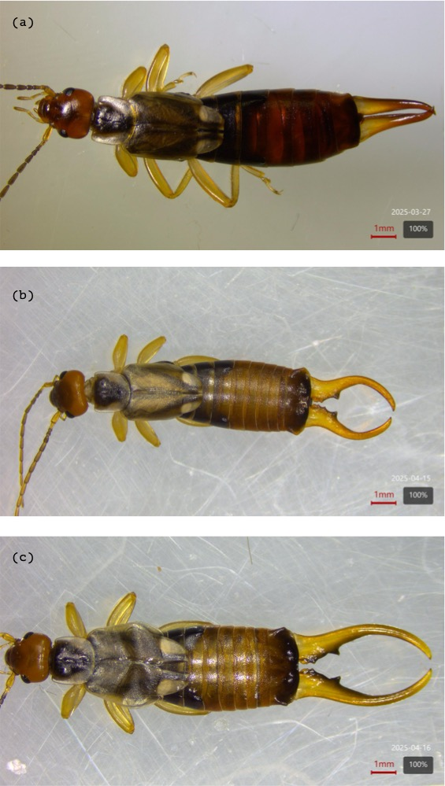
Figure 1: SVisual comparison of forceps size and shape across sexes and male morphs: (a) female, (b) brachylabic male, and (c) macrolabic male. Macrolabic males display exaggerated forceps consistent with positive allometry, while brachylabic males and females exhibit relatively reduced forceps. Scale bars = 1 mm.

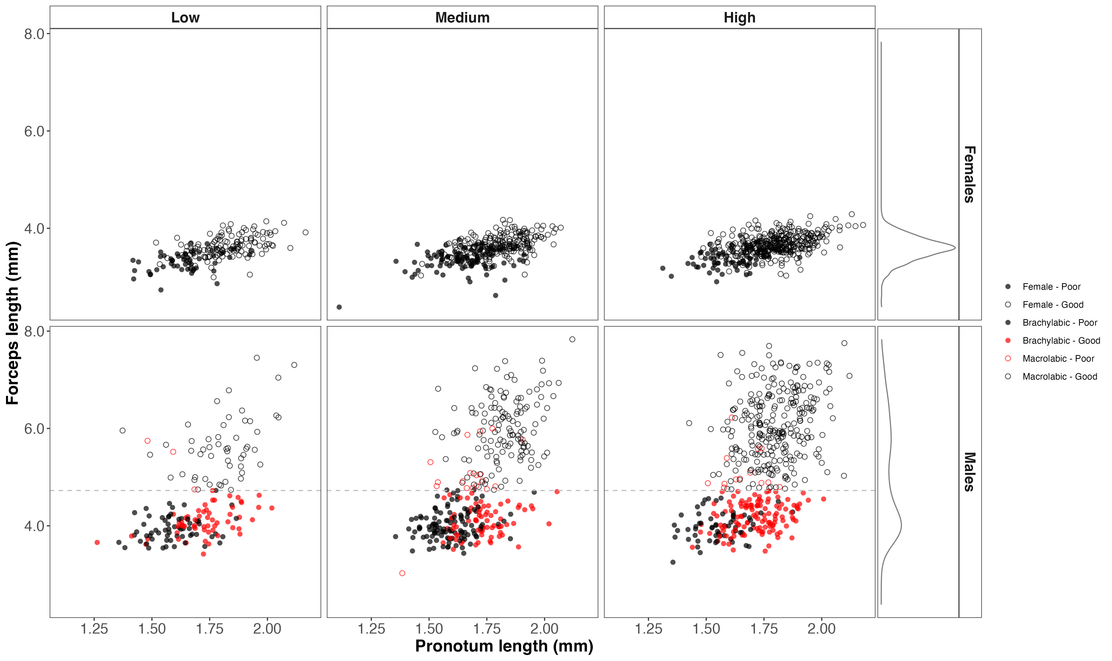
Figure 2: Static allometries of forceps length as a function of pronotum length across density treatments (low, medium, high). Females (top row) and males (bottom row) are shown separately. In males, brachylabic (solid points) and macrolabic (open points) morphs are distinguished, with diet treatments indicated by shading. Males form two discrete clusters corresponding to morphotype, with substantial overlap in body size between morphs. Environmental treatments shift forceps length within morphs but do not eliminate size overlap. The dashed horizontal line in the male panels indicates the approximate threshold commonly used to distinguish morphs based on forceps length.

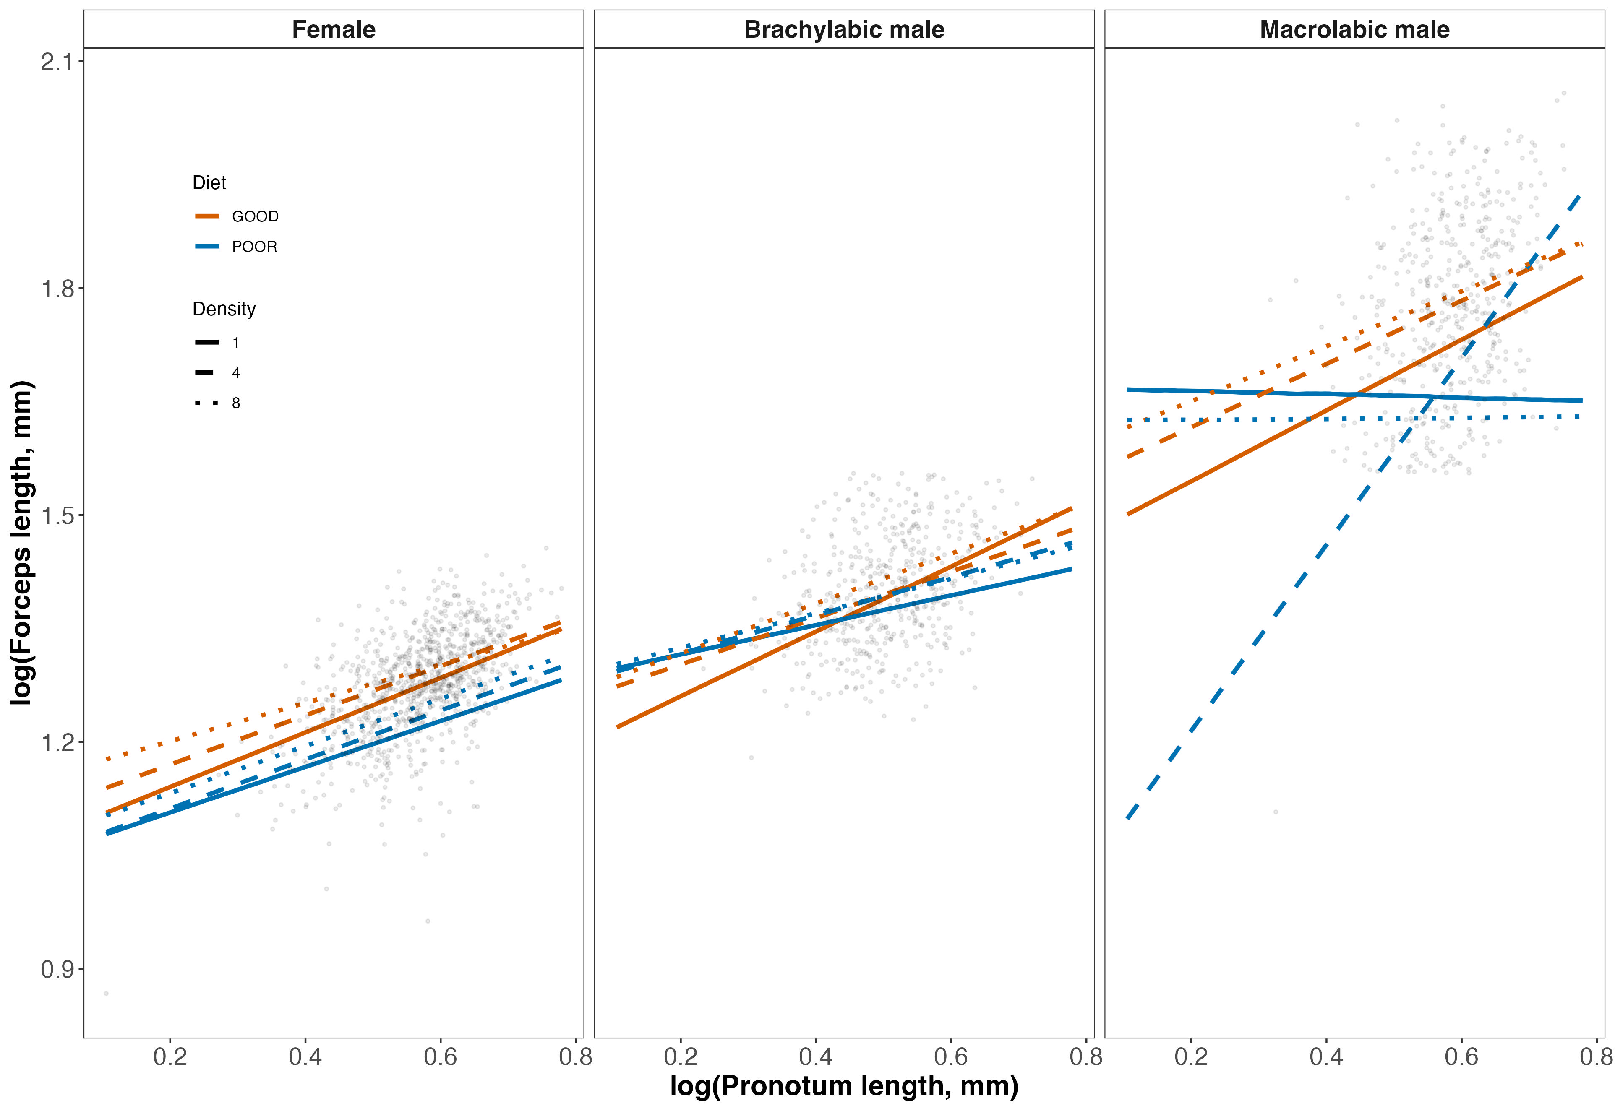
Figure 3: Predicted relationships between body size (log pronotum length, mm) and forceps length (mm) across sexes and male morphs. Lines show posterior median predictions from a unified Bayesian model. Points represent raw data.

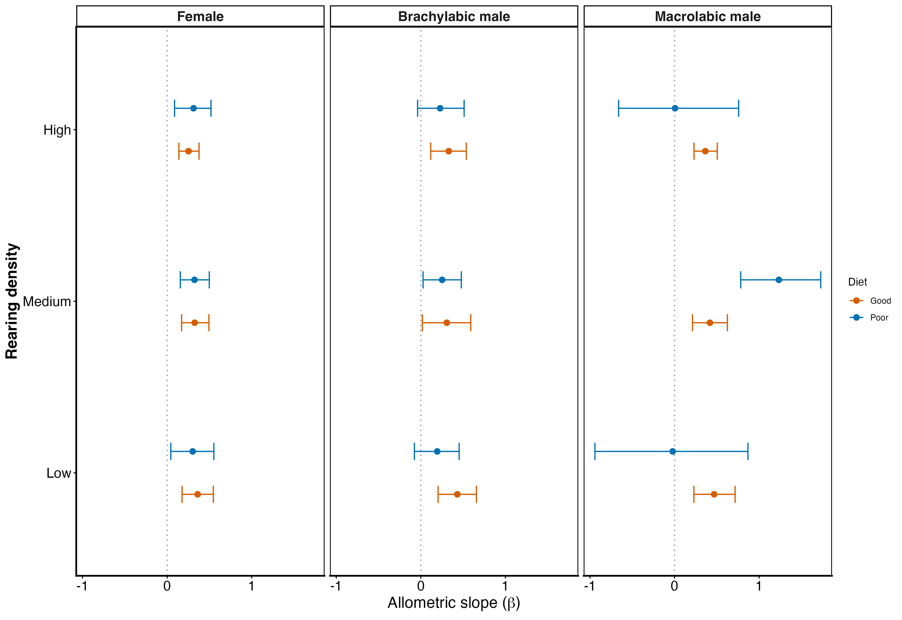
Figure 4: Posterior estimates of allometric slopes (β) across sexes and male morphs under different environmental conditions. Points show posterior medians and horizontal bars indicate 95% credible intervals from a unified Bayesian model.

