Abstract
Static allometries are often regarded as stable descriptors of morphological architecture, yet scaling relationships themselves can evolve and respond plastically to environmental variation. We quantified sex- and morph-specific weapon allometries in the European earwig (Forficula auricularia) under experimental manipulation of developmental diet and density, while estimating among-family variation in intercepts and scaling exponents. Forceps length scaled positively with body size in both sexes, but males exhibited steeper slopes under favourable conditions. Nutritional stress reduced male scaling exponents towards female-like values, whereas increased developmental density amplified male slopes, indicating environmentally sensitive reaction norms of scaling. Female scaling relationships remained comparatively stable across environments. In males, macrolabic and brachylabic morphs differed primarily in intercept rather than slope, suggesting divergence in baseline allocation within a shared scaling framework. Among families, intercepts and slopes covaried positively, indicating that evolutionary change in mean exaggeration would likely alter size-dependent exaggeration as a correlated response. Together, these results show that weapon allometry is structured across sex, morph, environment, and family levels, and that scaling exponents are evolvable components of exaggerated trait architecture.

Introduction
Static allometry describes how trait size scales with body size among individuals at the same developmental stage and provides a central framework for understanding the evolution of exaggerated morphology. Sexually selected weapons often exhibit positive allometry, such that larger individuals invest disproportionately more in trait size (Kodric-Brown et al. 2006; Bonduriansky 2007; Voje 2016). However, hyperallometry is not universal. When traits serve dual sexual and viability functions, or when functional and mechanical constraints limit disproportionate investment, isometry or hypoallometry may evolve instead (Bonduriansky and Day 2003; Eberhard et al. 2018; Kelly 2026). Consequently, the scaling relationship itself reflects how developmental allocation, functional performance, and selection interact to shape trait architecture.
Static allometry can diverge due to changes in the scaling exponent or the intercept. Differences in scaling exponent reflect variation in how strongly a trait responds to body size, whereas intercept divergence reflects differences in baseline trait expression at a given body size. These components need not evolve together (Lande 1980; Cheverud 1982; Pélabon et al. 2014). Sexual dimorphism, for example, may arise because males and females differ in scaling sensitivity, in baseline allocation, or in both. Similarly, alternative male morphs may diverge through elevation shifts while retaining similar scaling exponents, or through fundamentally different scaling architectures (Tomkins et al. 2005). Distinguishing between slope-based and intercept-based divergence is therefore essential for understanding how exaggerated traits evolve (Bonduriansky 2007; Shingleton and Frankino 2013; Pélabon et al. 2014; Voje 2016).
Species expressing alternative reproductive phenotypes provide particularly valuable models for examining the structure of allometry. In these species, males adopt discrete morphs that differ in weapon size, behaviour, and mating tactics (Gross 1996; Shuster and Wade 2003; Oliveira et al. 2008). Because morphs share much of their genome and developmental environment, differences in scaling architecture can reveal how developmental pathways partition exaggeration within a single species. However, empirical analyses of morph-specific static allometry remain scarce, and even fewer studies have investigated how environmental factors influence both slopes and intercepts in polymorphic systems (Kochensparger et al. 2024).
The European earwig (Forficula auricularia) serves as a classic example of male weapon polymorphism. Males express discrete forceps morphs that vary considerably in size and curvature, commonly referred to as macrolabic and brachylabic forms (Simmons and Tomkins 1996; Tomkins et al. 2005). Forceps function both as sexual weapons during male–male interactions and as defensive structures, making them traits with dual roles (Kamimura 2014; Meunier 2024). Previous work has documented morph-specific differences in forceps exaggeration and scaling, suggesting that divergence occurs not only in absolute size but potentially in scaling architecture. Nonetheless, most studies have primarily compared static slopes, with less focus on intercept divergence, environmental sensitivity of scaling parameters, and variation among families.
Environmental conditions can influence developmental allocation and consequently reshape static allometries (Emlen 1997; Frankino et al. 2005; Shingleton et al. 2007). Nutritional stress may decrease baseline investment in exaggerated traits, lowering intercepts, whereas social factors such as rearing density could alter competitive allocation patterns. Effects of the environment on scaling exponents would suggest plasticity in the trait-to-body size relationship, whereas consistent slopes across environments would imply canalisation of the scaling architecture (Frankino et al. 2005; Shingleton et al. 2007; Nijhout and German 2012). Determining whether environmental variation modifies intercepts, slopes, or both is therefore crucial to evaluating the developmental flexibility of trait exaggeration. Complementary structural modelling of the same study system demonstrates that environmental effects on forceps size are transmitted both indirectly via body size and directly through trait-specific allocation, particularly in males (Ozkan and Kelly submitted).
Besides sex, morph, and environment, variation among families offers insights into the integration of scaling architecture. Intercept and slope may covary across lineages if developmental processes jointly regulate baseline allocation and scaling sensitivity (Lande 1980; Hansen and Houle 2008; Klingenberg 2008; Pélabon et al. 2014). A positive intercept–slope covariance indicates that families producing relatively larger weapons at average body size also have steeper scaling relationships, reflecting integrated exaggeration architecture (Bonduriansky and Day 2003; Hansen and Houle 2008; Pélabon et al. 2014). Conversely, independence between parameters suggests modularity or developmental decoupling of baseline exaggeration and scaling sensitivity.
Here, we quantify sex-specific and morph-specific static allometries of forceps length in F. auricularia under experimentally manipulated diet and density. Rather than treating the scaling exponent as a fixed trait descriptor, we test whether it functions as a condition-sensitive developmental parameter structured across biological levels. Specifically, we investigate whether sexual dimorphism in weapon exaggeration results from divergence in the scaling exponent, intercept, or both; whether macrolabic and brachylabic males differ mainly in baseline allocation or in the sensitivity of forceps growth to body size; and whether larval environmental conditions influence intercepts, slopes, or their covariance. Finally, by estimating variance among families in intercepts and scaling exponents, we determine whether baseline exaggeration and size sensitivity are developmentally integrated. Through integrating sex, morph, environment, and family components within a unified hierarchical framework, we assess whether static allometry is a stable architectural constant or an emergent property of layered growth regulation (see also Simmons and Tomkins 1996; Tomkins et al. 2005; Kelly 2026).

Methods

Study species and experimental design
Females (n = 115) were hand-collected at night from vegetation in Parc Outremont (Montréal, QC, Canada) during September and October 2024. Individuals were transported to the laboratory at the Université du Québec à Montréal and placed individually in 90-mm Petri dishes filled with moist sand. Each dish was provisioned with a cotton-plugged water tube, and TetraMin Tropical Flakes (United Pet Group, Inc., Germany), and each female was assigned a unique ID code. Earwigs were maintained in the dark at 10 °C in an incubator (Percival Scientific, Perry, IA, USA) to mimic overwintering conditions. Dishes were checked daily for egg laying, and food and water were replenished as needed. Food and water were removed at the time of egg laying (approximately early December), after which dishes were checked weekly. Starting January 2025, dishes were checked daily for egg hatching. The date of egg hatching was recorded; hatching occurred between 13 January and 29 January 2025, and all 115 females produced hatchlings.
For two weeks following hatching, families were provisioned with a water tube and food (TetraMin Tropical Flakes). This interval allowed nymphs to complete a moult and reach a size sufficient to withstand manual transfer to experimental dishes. To manipulate the developmental environment, we varied two ecological factors: nutritional condition (diet quality) and social density. Diet treatment consisted of two levels: a “good” diet (100% TetraMin Tropical Flakes), providing high nutritional quality, and a “poor” diet (75% TetraMin Tropical Flakes, 25% alpha-cellulose), providing reduced nutritional content. Density treatment consisted of three levels: low density (one individual per Petri dish), medium density (4 individuals), and high density (8 individuals). These treatments allowed us to examine both nutritional and social environmental effects on growth and morphology. We used a split-brood experimental design in which offspring were randomly assigned to diet and density treatments within maternal families to minimise confounding between maternal background and environmental treatment. Experimental dishes were maintained at 20 °C to mimic post-winter developmental conditions and contained a water tube, treatment-specific food, and a refuge (four small pieces of paper straw glued together). A total of 1,265 Petri dishes were prepared. Females (mothers) were euthanized by freezing at −20 °C after offspring had been assigned to treatments. Dishes were checked several times per week for mortality and sexual maturation, and food and water were replenished as needed.

Morphological measurements
Once offspring eclosed to adulthood, they were removed from their Petri dish, the date recorded, and assigned a unique ID code. Pronotum width (a proxy for overall body size) and forceps length (following Lieshout and Elgar 2009) were photographed under a Leica S6D stereo microscope (Leica Microsystems Inc., Concord, ON, Canada) at 0.68× magnification using Enersight software, which automatically adds a scale bar to each image. Measurements were taken to the nearest 0.001 mm using Fiji image analysis software (Schindelin et al., 2012). All measurements were taken blind to treatment where possible. To assess repeatability, a subset of 30 individuals was measured twice. Intraclass correlation coefficients indicated high repeatability (pronotum width ICC = 0.94; forceps length ICC = 0.97). Log-transformed pronotum width was mean-centred before analysis to facilitate interpretation of intercepts and reduce collinearity among predictors.

Data preparation
All analyses were conducted in R (R Core Team 2025 version XXX). We retained individuals from experimental dishes that met predefined density criteria to maintain experimental integrity of the density treatments (density 1: one survivor; density 4: ≥3 survivors; density 8: ≥6 survivors). Individuals lacking sex information were excluded. Forceps length and pronotum width were log-transformed before analysis to linearize allometric relationships and reduce heteroscedasticity. Log pronotum width was mean-centred to facilitate interpretation of intercepts and reduce collinearity in interaction models. GOOD diet and density 1 were treated as reference levels throughout. Female sex and brachylabic males served as reference categories where appropriate. Maternal identity was included as a grouping factor in all models to account for shared developmental background among siblings.

Male morph classification
Male morphs (brachylabic and macrolabic) were classified using finite mixture modelling in the R package mixsmsn (Prates et al. 2013). Consistent with the documented weapon dimorphism in earwigs, we modelled the distribution of raw male forceps length as a two-component skew-normal mixture. Forceps length was analysed without prior size correction so that morph classification reflects emergent weapon phenotype rather than residual variation after size correction. Models were estimated using the expectation–maximization algorithm with automatic initialization (maximum 1000 iterations). Model support for bimodality was evaluated using AIC and BIC. Posterior probabilities of component membership were obtained for each male, and individuals were assigned to morphs based on maximum posterior probability. All males were retained for subsequent analyses, thereby avoiding arbitrary trait thresholds and preserving variation near the morph boundary.

Sex-specific allometry
To test whether males and females differed in forceps allometry and in the environmental sensitivity of scaling relationships, we fitted a hierarchical Gaussian model with log-transformed forceps length as the response. Fixed effects included mean-centred log pronotum width, sex, diet, density, and all lower-order interactions necessary to test sex differences in intercepts and scaling exponents across environmental treatments. Interactions between body size and environmental variables allowed scaling exponents to vary across conditions, and three-way interactions with sex tested whether environmental sensitivity of scaling differed between males and females. Maternal identity (n = 110 families) was included as a random intercept and random slope for body size, allowing families to vary in baseline forceps size and scaling exponent.

Morph-specific allometry
To examine scaling architecture within males, we fitted a second model restricted to males. Log-transformed forceps length was modeled as a function of body size, morph (macrolabic versus brachylabic), diet, density, and all corresponding interactions. Body size × morph interactions were tested to assess baseline slope divergence between morphs, and three-way interactions with environmental factors were evaluated to assess morph-specific slope plasticity. As morph classification was based on absolute forceps expression, this analysis tests whether emergent weapon phenotypes differ in scaling architecture without imposing size correction prior to morph assignment. Maternal identity (n = 104 families) was again included as a random intercept and slope for body size.

Priors and model fitting
Models were fitted in a Bayesian framework (brms, Bürkner 2017) using multilevel Gaussian regression. Weakly informative priors were specified for fixed effects and variance components to regularize estimates while remaining non-restrictive on the log scale. Convergence and sampling adequacy were verified using standard diagnostics.

Estimation of scaling exponents and plasticity
Condition-specific allometric slopes were derived from posterior draws as linear combinations of regression coefficients. Environmental plasticity in scaling was quantified as the deviation in slope from the reference condition (GOOD diet, density 1). We report posterior medians and 95% credible intervals for all slopes and slope differences. To evaluate biological relevance, we also calculated posterior probabilities that slope changes exceeded zero and that their absolute magnitude exceeded 0.1 on the log–log scale. All inference is based on posterior distributions rather than null-hypothesis significance testing.

Results

Sexual dimorphism in scaling relationships
Forceps length scaled positively with pronotum length in both sexes across all environmental treatments (Figure 1). Females exhibited a continuous distribution of weapon sizes across body sizes ($\overset{‾}{x}$ ± SE pronotum length = 1.77 ± 0.005 mm; $\overset{‾}{x}$ ± SE forceps length = 3.59 ± 0.008 mm, n = 935), whereas males formed two discrete clusters corresponding to brachylabic ($\overset{‾}{x}$ ± SE pronotum length = 1.66 ± 0.006 mm; $\overset{‾}{x}$ ± SE forceps length = 4.064 ± 0.014 mm, n = 491) and macrolabic morphs ($\overset{‾}{x}$ ± SE pronotum length = 1.80 ± 0.006 mm; $\overset{‾}{x}$ ± SE forceps length = 5.93 ± 0.033; n = 488), while maintaining the overall positive scaling relationship between body size and forceps length..
Forceps allometry differed markedly between the sexes (Table S1). Under good diet and low-density conditions (reference levels), females exhibited a positive but moderate scaling relationship between forceps length and body size (posterior mean slope = 0.33, 95% CrI: 0.08–0.55). Males showed substantially steeper scaling, as indicated by the positive interaction between body size and sex (log pronotum × sexmale = 0.53, 95% CrI: 0.22–0.84; Table S1). Under baseline conditions, the implied male slope was 0.86 (95% CrI: 0.64–1.08). This difference is evident in the separation of predicted scaling relationships between sexes (Figure 2) and in posterior slope estimates (Figure 3). The posterior probability that male slopes exceeded female slopes was > 0.9995, indicating pronounced sexual dimorphism in scaling exponent. Sexes also differed strongly in intercept. At mean body size, males had larger forceps than females (sexmale = 0.28, 95% CrI: 0.26–0.31; Table S1), demonstrating clear size dimorphism independent of slope differences. Thus, sexual dimorphism in weapon exaggeration reflects divergence in both scaling exponent and mean trait size.

Sex-specific environmental sensitivity

Intercept plasticity
Environmental effects on intercept were sex biased. Poor diet reduced forceps size at mean body size in females (dietPOOR = -0.06, 95% CrI: -0.08–-0.03; Table S1). This reduction was substantially stronger in males, as indicated by the negative sex × diet interaction (sexmale:dietPOOR = -0.10, 95% CrI: -0.13–-0.06; Table S1), yielding a total male intercept decline of approximately -0.15 under poor diet.
Density effects on female intercepts were weak. In contrast, males exhibited positive intercept shifts at higher densities (sexmale:density4 = 0.05; sexmale:density8 = 0.08, both credible intervals excluding zero; Table S1). Thus, males were more environmentally sensitive than females in mean weapon size, showing both nutritional suppression and density-associated increases in exaggeration.

Slope plasticity
Female slopes were relatively stable across environments. The interaction between body size and diet was centred near zero (log pronotum:dietPOOR = -0.01, 95% CrI: -0.24–0.23; Table S1), and density interactions similarly overlapped zero. Female slopes were relatively stable across environments (Figure 4).
In contrast, males exhibited pronounced environment-dependent changes in scaling exponent (Figure 4). Under a poor diet, the male slope declined substantially, as indicated by the negative three-way interaction (log pronotum × sexmale × dietPOOR = -0.53, 95% CrI: -0.88–-0.19; Table S1). This corresponds to a reduction from approximately 0.86 under a good diet to approximately 0.33 under a poor diet. Posterior probability that male slope decreased under a poor diet exceeded 0.999, and the probability that the magnitude of change exceeded 0.1 was > 0.993.
Density had the opposite effect, increasing male slopes at densities 4 and 8 (log pronotum × sexmale × density4 = 0.40; log pronotum × sexmale × density8 = 0.40; both credible intervals excluding zero). Posterior probabilities that male slope increases exceeded 0.1 were > 0.952625. Across treatments, male slope plasticity exceeded female slope plasticity with high probability (> 0.975).
Together, these results demonstrate pronounced male-specific plasticity in scaling exponent, whereas female scaling relationships appear comparatively canalized.

Morphotype differences among males
Given the strong male-specific plasticity, we next examined scaling architecture within males.

Baseline morph differences
Under good diet and low-density conditions, brachylabic males exhibited a slope of 0.35 (95% CrI: 0.13–0.57; Table S2). Macrolabic males showed a nearly identical baseline slope (log pronotum:morphmacrolabic = 0.36 (95% CrI: -0.31–0.33; Table S2), with posterior probability of a positive difference equal to 0.521. Thus, there was little evidence of baseline slope divergence between morphs. Baseline slope similarity between morphs is evident in predicted scaling relationships (Figure 2) and posterior slope estimates (Figure 3).
Morphs differed strongly in intercept. At mean body size, macrolabic males had substantially larger forceps than brachylabic males (macrolabic = 0.31, 95% CrI: 0.28–0.35; Table S2). Morph divergence in weapon size is therefore primarily elevation-based rather than slope-based.

Morph-specific environmental sensitivity
Diet had little effect on intercept in brachylabic males (dietPOOR = -0.01, 95% CrI: -0.04–0.01; Table S2), but reduced intercept in macrolabic males (morphmacrolabic:dietPOOR = -0.10, 95% CrI: -0.15–-0.06; Table S2). Nutritional stress, therefore, disproportionately reduced weapon size in the exaggerated morph.
Both morphs showed some tendency toward reduced scaling exponents under a poor diet. In brachylabic males, slope decline was modest (log pronotum:dietPOOR = -0.11, 95% CrI: -0.35–0.13; Table S2). In macrolabic males, the additional diet-dependent slope change in macrolabic males was positive but highly uncertain (log pronotum:morphmacrolabic:dietPOOR = 0.18, 95% CrI: -0.31–0.66; Table S2). Posterior contrasts indicated that diet-induced slope plasticity tended to be greater in macrolabic than brachylabic males (posterior probability ≈ 0.60), although credible intervals were broad.
Density-induced slope changes were comparatively weak and uncertain in both morphs, and there was little evidence that density altered scaling exponents differently between morphs. Morph-specific changes in allometric slope relative to baseline conditions are shown in Figure 5.
Overall, in males, morphological differentiation primarily reflects shifts in intercepts rather than fundamentally distinct scaling exponents.

Among-family variation
At the sex level, there was detectable among-maternal-family variance in scaling exponent (sd(log pronotum) = 0.13, 95% CrI: 0.01–0.25) and smaller variance in intercept (sd(Intercept) = 0.03). The intercept–slope correlation was weak and uncertain (r = 0.17, CrI overlapping zero), suggesting limited evidence for integrated family-level variation across sexes (Table S2).
Within males, family-level variation in slope was larger (sd(log pronotum) = 0.19, 95% CrI: 0.10–0.28). Intercepts and slopes were positively correlated among families (r = 0.59, 95% CrI: 0.05–0.93), indicating that broods producing sons with larger forceps at mean body size also tended to exhibit steeper scaling relationships.
Because females were field-collected and potentially multiply mated, these variance components reflect combined genetic and shared environmental effects. Nonetheless, the positive covariance demonstrates integrated brood-level variation in exaggeration architecture.

Summary
Weapon allometry exhibits a hierarchical structure. Sexual dimorphism is characterized by steeper and more environmentally sensitive scaling in males relative to females. In males, morphological divergence is primarily intercept-based, with macrolabic males consistently expressing larger weapons and greater sensitivity to nutritional stress at the intercept. Slope plasticity is pronounced at the sex level and detectable, though weaker and more uncertain, within males, while baseline slopes are similar across morphs. Finally, male scaling intercepts and exponents covary positively among maternal families, indicating integrated clutch-level variation in exaggeration architecture.

Discussion
Static allometries are often regarded as stable descriptors of morphological architecture (Huxley 1932; Gould 1966; Voje 2016). However, the evolutionary flexibility of scaling relationships remains debated, with some studies suggesting that slopes can evolve while still being constrained by developmental integration (Harrison 2015). Our findings challenge the view of a fixed scaling exponent by demonstrating that the allometric slope itself can act as a condition-dependent developmental parameter structured across biological levels. In the European earwig, weapon exaggeration is not defined by a single static slope but by reaction norms of scaling that differ between sexes, vary across developmental environments, and covary among families. Males exhibited steep positive allometry under favourable conditions, consistent with expectations for sexually selected weapons (Kelly 2005; Kodric-Brown et al. 2006; Bonduriansky 2007), yet their scaling exponents declined toward female-like values under nutritional stress and increased under higher developmental densities. Females, by contrast, showed comparatively stable scaling relationships across environments. These results indicate that the allometric slope is not a fixed architectural constant but an environmentally responsive parameter of growth regulation (Frankino et al. 2005; Shingleton et al. 2007; Nijhout and German 2012). By demonstrating environmentally sensitive scaling exponents, our study extends theories of condition dependence beyond variation in mean trait expression to the structure of size-dependent exaggeration itself (Rowe and Houle 1996; Cotton et al. 2004; Tomkins et al. 2004; Pélabon et al. 2014).
The evolution of exaggerated traits is often interpreted through condition dependence and genic capture theory (Rowe and Houle 1996; Cotton et al. 2004; Tomkins et al. 2004), which predicts heightened environmental sensitivity of sexually selected characters. Although most empirical work has focused on mean trait expression, theory does not restrict condition dependence to shifts in intercepts. If growth regulation is condition sensitive, the scaling exponent itself should respond to environmental inputs (Emlen 1997; Frankino et al. 2005; Shingleton et al. 2007; Nijhout and German 2012). Our findings provide direct evidence for such slope plasticity in a weapon trait. The size–trait relationship becomes less steep under a poor diet, indicating reduced exaggeration among larger males, whereas higher density steepens the relationship, amplifying exaggeration among large individuals. Because the scaling exponent determines how disproportionately trait size increases with body size, plasticity in slope directly alters the strength of size-dependent exaggeration and therefore the opportunity for sexual selection to favour larger males. Structural equation modelling of the same experimental population further indicates that nutritional effects on male weapon size are mediated primarily through body size, whereas density effects act more directly on trait allocation (Ozkan and Kelly submitted). Together, these results suggest that slope plasticity reflects amplification of shared developmental pathways combined with socially responsive allocation.
The absence of clear slope divergence between brachylabic and macrolabic males refines the interpretation of morphological differentiation in earwig weapons. Although macrolabic males express substantially larger forceps at a given body size, their scaling exponent is similar to that of brachylabic males, indicating that morph divergence arises primarily through elevation rather than slope differences. Tomkins (2005) however found that macrolabic males are positively allometric while brachylabics are isometric. Distinguishing between intercept and slope is important because these parameters reflect different aspects of growth regulation: slope describes how trait size responds to variation in body size, whereas intercept reflects baseline allocation at a given body size (Bonduriansky and Day 2003; Pélabon et al. 2014). Elevation shifts without major changes in the scaling exponent therefore suggest modification of allocation magnitude within a largely shared scaling framework (Klingenberg 2008; Hansen and Houle 2008). This pattern is consistent with environmental threshold models of conditional strategy evolution (Hazel et al. 1990; Tomkins and Hazel 2007; Buzatto et al. 2015), in which discrete phenotypes arise once condition exceeds a developmental threshold while underlying size-dependent growth relationships remain broadly conserved. Developmental models further show that such thresholds can emerge from nonlinear regulation of growth pathways (Douglas J. Emlen 2000). Our results, therefore, suggest that weapon dimorphism in the European earwig primarily reflects divergence in baseline allocation rather than the evolution of distinct allometric programmes. Similar patterns occur across taxa, where exaggerated sexually selected traits often retain comparable scaling relationships despite substantial differences in mean exaggeration (Painting et al. 2024).
Body-size overlap between morphs also provides insight into the developmental basis of morph determination. Although macrolabic males generally possess larger forceps, considerable overlap in body size occurs between morphs, with some small males expressing the exaggerated phenotype and many large males remaining brachylabic (see Figure 1). If morph expression depended solely on a strict body-size threshold, a sharper transition would be expected. Instead, these observations suggest that body size alone is insufficient to predict morph identity. Previous work has shown that both environmental and genetic factors influence morph expression in F. auricularia (Tomkins 1999). Our findings are consistent with this view: morphs share similar scaling exponents but differ substantially in intercept, implying partially distinct developmental pathways operating within a common scaling framework (see also Kelly 2024; Kelly 2026). Although we cannot estimate the heritability of morph identity directly, the overlap in body size between morphs and the presence of among-family variation in scaling parameters suggest that morph determination is unlikely to be governed by a simple size-based switch.
This hierarchical structure—sex-specific slope plasticity combined with morph-specific intercept divergence—indicates that exaggeration may evolve through layered modifications of scaling architecture rather than uniform shifts in trait expression. Sex-limited expression allows selection to modify the male size–trait reaction norm without constraining female growth pathways, whereas morph differentiation primarily alters allocation levels while maintaining a shared scaling framework. Selection may therefore act on different components of scaling architecture at different biological levels, modifying slopes at the sex level, intercepts at the morph level, and covariance patterns among families.
The positive covariance between intercept and slope among maternal families within males provides insight into the integration of scaling components and their potential evolvability. Families producing sons with relatively larger forceps at average body size also tend to exhibit steeper scaling exponents, indicating coordinated variation in baseline allocation and size sensitivity. Because intercept and slope covary positively, evolutionary change in mean exaggeration could simultaneously increase the degree of size-dependent exaggeration. Although family effects combine genetic and shared environmental influences, the presence of structured covariance demonstrates that scaling architecture itself varies among lineages rather than being developmentally fixed. Such integrated variation may provide the raw material for evolutionary change in the intensity of exaggeration (Lande 1980; Pélabon et al. 2014).
In summary, these results support a view of static allometry as an evolvable and environmentally responsive trait complex (Pélabon et al. 2014). Scaling exponents behave as condition-sensitive reaction norms that differ between sexes and vary among families. Morph differentiation in males mainly reflects shifts in baseline allocation, whereas the intercept–slope covariance reveals coordinated variation linking baseline exaggeration and size sensitivity. Together, these patterns indicate that the evolution of exaggerated weapons may proceed through hierarchical modification of growth regulation across sexes, morphs, and lineages, rather than through simple changes in average trait size. Future work integrating quantitative genetic estimates of slope variation with experimental manipulations of selection will be essential for determining how readily scaling architectures evolve.

Data availability
Data are available through the OSF repository at https://osf.io/m7c53/overview?view_only=ce50e42b29284cbe8164e768ecb9c2b1.

References
Bonduriansky, R. 2007. Sexual selection and allometry: A critical reappraisal of the evidence and ideas. Evolution 61:838–849.
Bonduriansky, R., and T. Day. 2003. The evolution of static allometry in sexually selected traits. Evolution 57:2450–2458.
Bürkner, P.-C. 2017. brms: An R package for Bayesian multilevel models using Stan. Journal of Statistical Software 80:4308.
Buzatto, B., M. Buoro, W. Hazel, and J. Tomkins. 2015. Investigating the genetic architecture of conditional strategies using the environmental threshold model. Proc Biol Sci 282:20152075.
Cheverud, J. M. 1982. Phenotypic, genetic, and environmental morphological integration in the cranium. Evolution 36:499–516. Department of Anthropology, Northwestern University, Evanston, Illinois, 60201.
Cotton, S., K. Fowler, and A. Pomiankowski. 2004. Condition dependence of sexual ornament size and variation in the stalk-eyed fly Cyrtodiopsis dalmanni (Diptera: Diopsidae). Evolution 58:1038–1038. Oxford, United Kingdom.
Douglas J. Emlen, H. F. N. 2000. The development and evolution of exaggerated morphologies in insects. Annu Rev Entomol 45:661–661.
Eberhard, W. G., R. L. Rodrı́guez, B. A. Huber, B. Speck, H. Miller, B. A. Buzatto, and G. Machado. 2018. Sexual selection and static allometry: The importance of function. The Quarterly Review of Biology 93:207–250.
Emlen, D. J. 1997. Alternative reproductive tactics and male-dimorphism in the horned beetle Onthophagus acuminatus (Coleoptera: Scarabaeidae). Behav Ecol Sociobiol 41:335–341.
Frankino, W. A., B. J. Zwaan, D. L. Stern, and P. M. Brakefield. 2005. Natural selection and developmental constraints in the evolution of allometries. Science 307:718–720. Section of Evolutionary Biology, Institute of Biology, Leiden University, P.O. Box 9516, 2300 RA Leiden, Netherlands. frankino@alumni.indiana.edu.
Gould, S. J. 1966. Allometry and size in ontogeny and phylogeny. Biol Rev Camb Philos Soc 41:587–640.
Gross, M. R. 1996. Alternative reproductive strategies and tactics: Diversity within sexes. Trends Ecol Evol 11:92–98.
Hansen, T. F., and D. Houle. 2008. Measuring and comparing evolvability and constraint in multivariate characters. J Evol Biol 21:1201–1219. Department of Biology, Center for Ecological; Evolutionary Synthesis, University of Oslo, Oslo, Norway.
Harrison, J. F. 2015. Evolvability and nonevolvability of allometric slopes. Proc Natl Acad Sci U S A 112:13426–13427. School of Life Sciences, Arizona State University, Tempe, AZ 85287-4501 j.harrison@asu.edu.
Hazel, W. N., R. S. Mock, and M. D. Johnson. 1990. A polygenic model for the evolution and maintenance of conditional strategies. Proc. R. Soc. Lond. B 242:181–187. Great Britain.
Huxley, J. 1932. Problems of relative growth.
Kamimura, Y. 2014. Pre‐ and postcopulatory sexual selection and the evolution of sexually dimorphic traits in earwigs (Dermaptera). Entomol Sci 17:139–166.
Kelly, C. D. 2005. Allometry and sexual selection of male weaponry in Wellington tree weta, Hemideina crassidens. Behav Ecol 16:145–152.
Kelly, C. D. 2024. Alternative mating strategies in the Wellington tree weta expressed via genetic polymorphism for precocial male maturation. Royal Society Open Science 11:240100.
Kelly, C. D. 2026. Can the form of sexual selection explain patterns of static weapon allometry expressed by alternative mating morphotypes? Evolution 80:191–201. Département des Sciences biologiques, Université du Québec à Montréal, Montréal, Canada.
Klingenberg, C. P. 2008. Morphological integration and developmental modularity. Annual Review of Ecology, Evolution, and Systematics 39:115–132.
Kochensparger, S. K., C. J. Painting, B. A. Buzatto, and E. L. McCullough. 2024. Are weapon allometries steeper in major or minor males? A meta-analysis. Behav Ecol 35:1–9.
Kodric-Brown, A., R. M. Sibly, and J. H. Brown. 2006. The allometry of ornaments and weapons. Proceedings of the National Academy of Sciences 103:8733–8738.
Lande, R. 1980. Sexual dimorphism, sexual selection, and adaptation in polygenic characters. Evolution 292–305.
Lieshout, E. van, and M. A. Elgar. 2009. Armament under direct sexual selection does not exhibit positive allometry in an earwig. Behav Ecol 20:258–264.
Meunier, J. 2024. The biology and social life of earwigs (dermaptera). Annu Rev Entomol 69:259–276.
Nijhout, H. F., and R. Z. German. 2012. Developmental causes of allometry: New models and implications for phenotypic plasticity and evolution. Integr Comp Biol 52:43–52. Department of Biology, Duke University, Durham, NC 27708, USA. hfn@duke.edu.
Oliveira, R. F., M. Taborsky, and H. J. Brockmann. 2008. Alternative Reproductive Tactics. Cambridge University Press.
Ozkan, C., and C. D. Kelly. submitted. Sexual dimorphism in condition-dependent weapons arises through amplification of shared developmental pathways and enhanced trait-specific sensitivity.
Painting, C. J., M. R. E. Symonds, and G. I. Holwell. 2024. The evolution of positive allometry and exaggerated traits in a diverse beetle clade. Funct Ecol 38:1265–1283.
Pélabon, C., C. Firmat, G. Bolstad, K. Voje, D. Houle, J. Cassara, A. Rouzic, and T. Hansen. 2014. Evolution of morphological allometry. Ann N Y Acad Sci 1320:58–75.
Prates, M. O., C. R. B. Cabral, and V. H. Lachos. 2013. Mixsmsn: Fitting finite mixture of scale mixture of skew-normal distributions. Journal of Statistical Software 54:96.
R Core Team. 2025. R: A language and environment for statistical computing. Vienna, Austria.
Rowe, L., and D. Houle. 1996. The lek paradox and the capture of genetic variance by condition dependent traits. Proc R Soc Lond, B 263:1415–1421.
Shingleton, A. W., and W. A. Frankino. 2013. New perspectives on the evolution of exaggerated traits. BioEssays 35:100–107.
Shingleton, A. W., W. A. Frankino, T. Flatt, H. F. Nijhout, and D. J. Emlen. 2007. Size and shape: The developmental regulation of static allometry in insects. BioEssays 29:536–548.
Shuster, S., and M. Wade. 2003. Mating Systems and Strategies. Princeton University Press.
Simmons, L., and J. Tomkins. 1996. Sexual selection and the allometry of earwig forceps. Evol Ecol 10:97–104.
Tomkins, J. 1999. Environmental and genetic determinants of the male forceps length dimorphism in the European earwig forficula auricularia L. Behav Ecol Sociobiol 47:1–8.
Tomkins, J. L., J. S. Kotiaho, and N. R. LeBas. 2005. Matters of scale: Positive allometry and the evolution of male dimorphisms. Am Nat 165:389–402.
Tomkins, J., and W. Hazel. 2007. The status of the conditional evolutionarily stable strategy. Trends Ecol Evol 22:522–528.
Tomkins, J., J. Radwan, J. Kotiaho, and T. Tregenza. 2004. Genic capture and resolving the lek paradox. Trends Ecol Evol 19:323–328. Environmental; Evolutionary Biology, Dyer’s Brae House, The Mitchell Building, University of St Andrews, Fife, UK, KY16 9TH.
Voje, K. 2016. Scaling of morphological characters across trait type, sex, and environment: A meta-analysis of static allometries. Am Nat 187:89–98.

Figures
Figure 1: Static allometries of forceps length as a function of pronotum length across density treatments (low, medium, high). Females (top row) and males (bottom row) are shown separately. In males, brachylabic (solid points) and macrolabic (open points) morphs are distinguished, with diet treatments indicated by shading. Males form two discrete clusters corresponding to morphotype, with substantial overlap in body size between morphs. Environmental treatments shift forceps length within morphs but do not eliminate size overlap. The dashed horizontal line in the male panels indicates the approximate threshold commonly used to distinguish morphs based on forceps length.

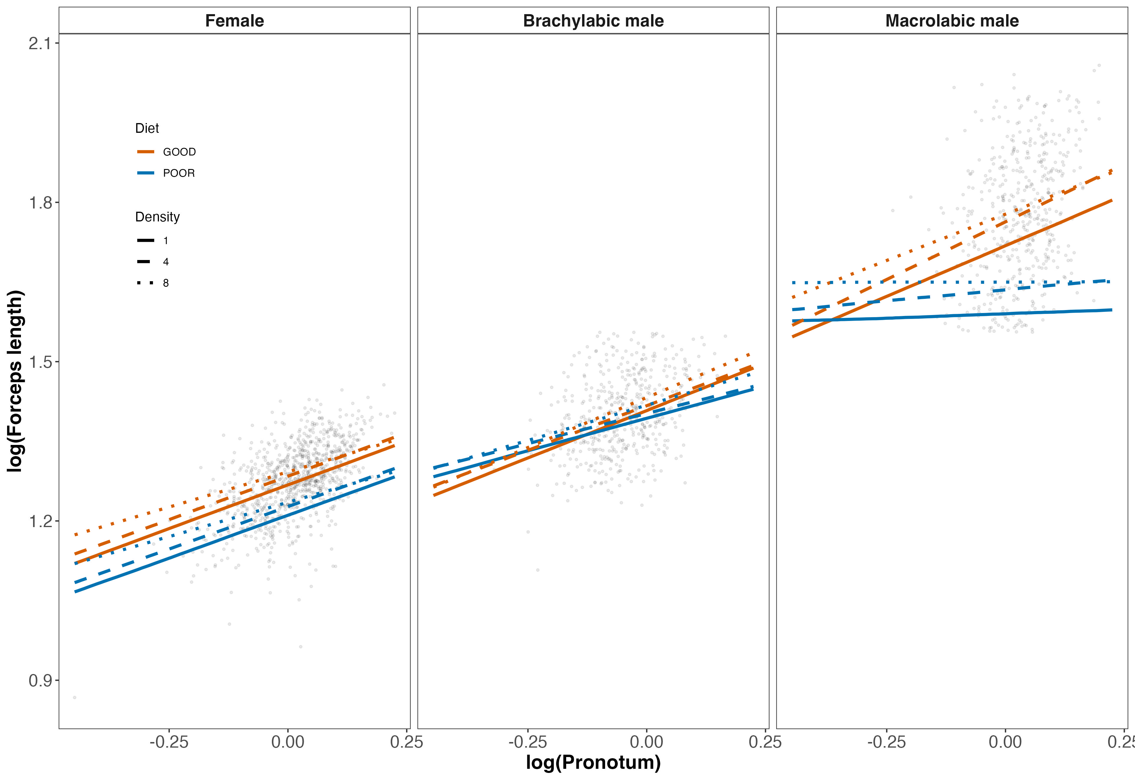
Figure 2: Predicted population-level relationships between log-transformed forceps length and log-transformed pronotum width across diet (GOOD vs POOR) and rearing density (1, 4, or 8 individuals per container). Panels show females (left), brachylabic males (center), and macrolabic males (right). Solid, dashed, and dotted lines correspond to density treatments; color indicates diet. Fitted lines represent posterior medians from Bayesian multilevel models excluding random family effects; grey points show raw data. Female slopes are relatively stable across environments, whereas male slopes exhibit pronounced environmental sensitivity. Morph divergence in males is primarily intercept-based, with macrolabic males exhibiting consistently larger forceps at a given body size and stronger slope reductions under poor diet.

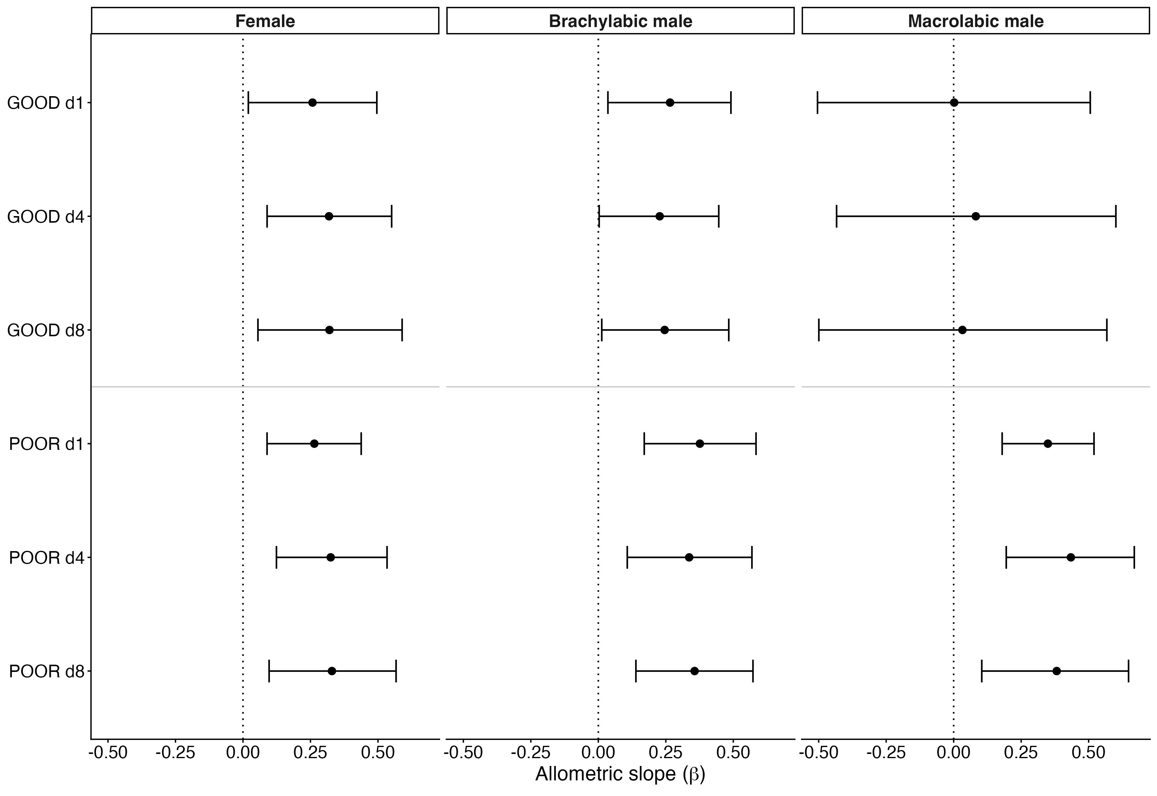
Figure 3: Points represent posterior medians and horizontal bars indicate 95% credible intervals for slopes relating log forceps length to log pronotum width. Treatments are grouped by diet (good vs. poor) and density (low, medium, or high). The vertical dotted line indicates a slope of zero. Female slopes cluster tightly and show little environmental sensitivity. In contrast, male slopes vary substantially across environments, with macrolabic males showing a higher posterior probability of substantial slope reduction under poor diet than brachylabic males. These estimates are derived from Bayesian multilevel models that incorporate among-family variance.

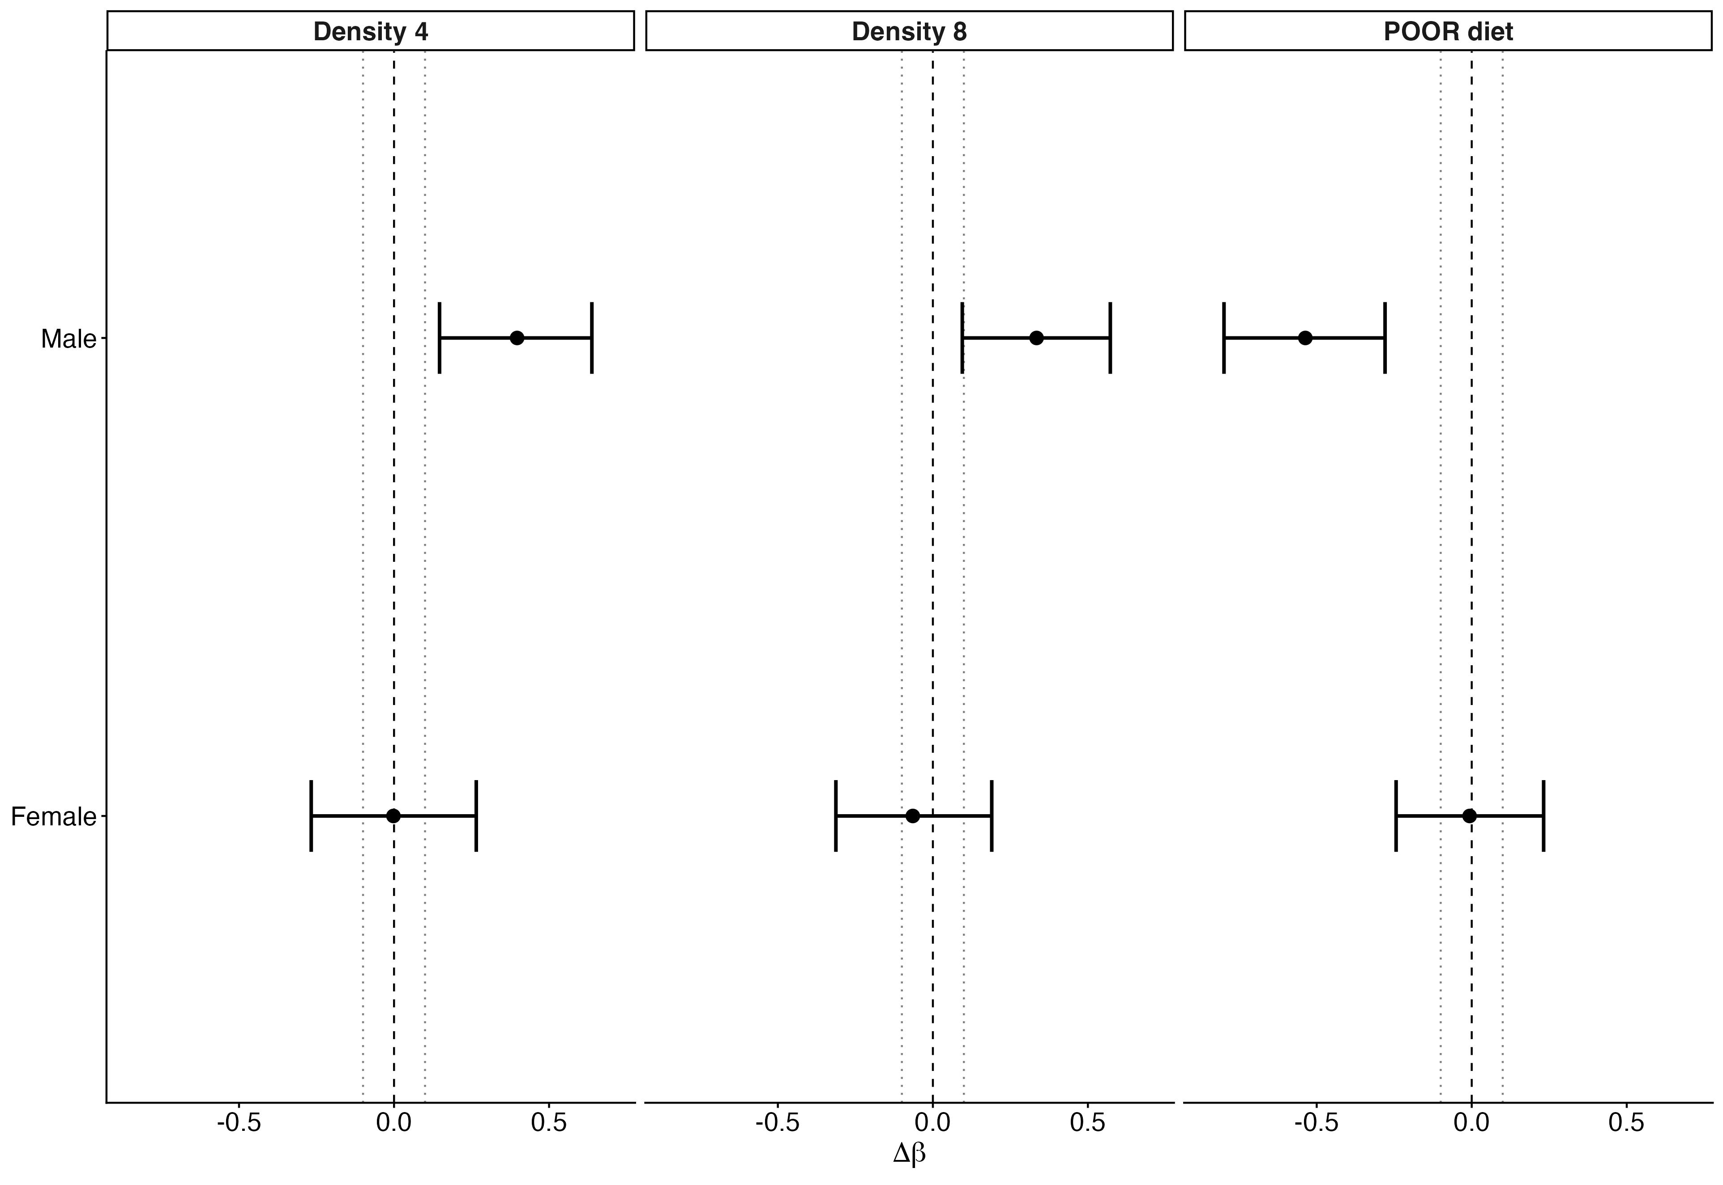
Figure 4: Posterior medians (points) and 95% credible intervals (horizontal bars) show changes in the allometric slope (Δβ) of log forceps length on log pronotum width relative to the baseline condition (good diet, low density). The vertical dashed line indicates no change in slope, and the dotted lines denote a biologically meaningful threshold of |Δβ| = 0.1. Females show little evidence of slope plasticity across environments. In contrast, males exhibit pronounced environmental sensitivity, with strong reductions in the scaling exponent under poor diet and substantial increases at elevated densities. Estimates are derived from the sex-specific multilevel model including sex × environment × body size interactions.

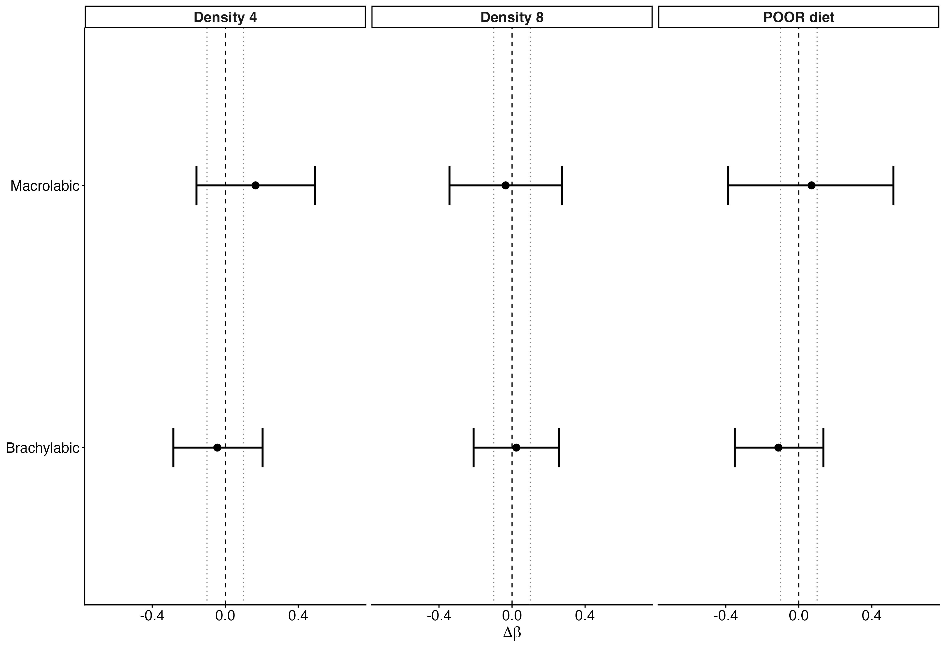
Figure 5: Posterior medians and 95% credible intervals show changes in the allometric slope (Δβ) relative to brachylabic males under good diet and low density. The vertical dashed line indicates no change in slope; dotted lines denote |Δβ| = 0.1. Both morphs show environmentally induced variation in slope, but the broad overlap of credible intervals provides limited evidence for strong morph-specific divergence in scaling plasticity. Morph differentiation in weapon exaggeration therefore reflects primarily intercept shifts rather than fundamentally distinct scaling exponents. Estimates are derived from the male-only multilevel model including morph × environment × body size interactions.

