Sexual size dimorphism and multivariate phenotypic selection in a flightless weevil
Clint D. Kelly^{1,✉}
¹ Département des Sciences biologiques, Université du Québec à Montréal, Montréal, Canada
✉ Correspondence: Clint D. Kelly <kelly.clint@uqam.ca>

Abstract
Body size can affect fecundity and access to mates in both sexes, yet field estimates of these components of selection are uncommon for females and males of the same population. I sampled paired and unpaired adults of an undescribed flightless New Zealand weevil (Lyperobates sp. A) and examined body length, hind leg length, pairing status, female egg load, sexual dimorphism, and size assortment. Females were larger than males in both morphological traits, and longer females carried more eggs, consistent with fecundity selection favouring greater female size. In both sexes, body length was positively associated and hind leg length negatively associated with observed pairing status. The male analysis also supported nonlinear and correlational selection, with the highest predicted pairing probability among relatively large-bodied, short-legged males. A pooled comparison, however, did not clearly demonstrate that this correlational association differed between the sexes. Body length was not assortative within the 25 observed pairs. These results reveal size-dependent nonrandom pairing in both sexes and a fecundity-related advantage of female body size. They show that contemporary components of selection may contribute to female-biased dimorphism without mapping simply onto the magnitude of the observed sex differences.

Introduction
Sexual size dimorphism (SSD) is a widespread and evolutionarily significant feature of animal morphology (Darwin, 1871; Fairbairn et al., 2007). Its direction and magnitude can reflect sex-specific fecundity and sexual selection, as well as viability selection, ecological divergence, developmental processes, and genetic constraints or correlations between the sexes (Blanckenhorn, 2000; Fairbairn, 1997; Fairbairn et al., 2007). Female-biased SSD is particularly common among insects and is often associated with fecundity selection because larger females can produce or carry more eggs (Blanckenhorn, 2005; Honek, 1993; Kingsolver & Pfennig, 2004; Pincheira-Donoso & Hunt, 2017; Zhu et al., 2025). A positive size–fecundity relationship, however, does not by itself demonstrate that fecundity selection produced SSD. Dimorphism is an evolved outcome of selection acting across generations, whereas estimates from one population and sampling period describe contemporary associations with particular components of fitness.
Sexual selection on body size can also operate in either sex. When female fecundity increases with size, males may benefit by preferentially courting, mounting, or investing in larger females (Bonduriansky, 2001). In the curculionid beetle Diaprepes abbreviatus, for example, males preferred larger, more fecund females, females accepted large males more readily, and competition contributed to size-assortative mating (Harari et al., 1999). Nonrandom pairing by size may therefore reflect female choice, male choice, mutual choice, competition, or some combination of these processes.
The sexes nevertheless share most of their genome, which can constrain independent responses to sex-specific selection. Experimental work on the seed beetle Callosobruchus maculatus revealed a strong intersexual autosomal genetic correlation for body size, while sex-linked variance enabled SSD to respond to selection (Kaufmann et al., 2021). Inbreeding can further alter phenotype–fitness relationships by exposing deleterious recessive variants; for example, six generations of full-sib mating in Tribolium castaneum reduced male body size, testis size, sperm length, lifespan, and reproductive output (Vasudeva et al., 2025). Population structure, relatedness, and genetic load could consequently influence sex-specific morphology and fitness, although evaluating those mechanisms requires pedigree or genomic information.
When sexual selection favours increased male body length, as often occurs under male–male contest competition, male-biased SSD may evolve, or female-biased SSD may be reduced (Andersson, 1994; Emlen & Oring, 1977). Conversely, female-biased SSD has sometimes been attributed to weak sexual selection on males or to selection favouring smaller, more mobile males (Fairbairn et al., 2007; Ghiselin, 1974). Scramble-competition polygyny is frequently invoked in this context because male reproductive success can depend on locating and securing females rather than defending resources (Andersson, 1994; Moya-Laraño et al., 2002). Smaller males, or males with locomotor morphology that facilitates mate searching, have higher mating success in some systems, including Japanese beetles (Popillia japonica) and Cook Strait giant weta (Deinacrida rugosa) (Kelly et al., 2008; Kelly, 2020; Kelly & Gwynne, 2023). Comparative evidence, however, shows that larger males are also favoured in many scramble-competitive arthropods (Herberstein et al., 2017). The direction of selection on male morphology therefore cannot be inferred from a broad mating-system label alone, especially when mate searching and pair formation have not been observed directly.
Multivariate analyses are important because the association between one trait and a fitness component can depend on other traits (Brodie et al., 1995; Lande & Arnold, 1983; Phillips & Arnold, 1989). For example, body length may influence competitive ability or persistence, whereas leg length may influence movement or the ability to remain attached to a female. Directional gradients describe average slopes of the phenotype–fitness relationship, while quadratic and correlational gradients describe curvature and dependence between traits. These latter components may reveal combinations of morphology associated with high fitness even when the directional gradients for individual traits appear similar between groups.
Assortative mating provides a related but distinct perspective on how morphology structures mating interactions. Positive assortment occurs when individuals with similar trait values pair more often than expected, whereas negative assortment occurs when dissimilar individuals pair preferentially (Crespi, 1989; Jiang et al., 2013). Assortment may arise through mutual mate choice, one-sex choice, competition, spatial or temporal covariation, and mechanical compatibility. It can influence the covariance between male and female phenotypes, alter the distribution of mating success, and thereby affect the opportunity for sexual selection and the evolutionary dynamics of sexually dimorphic traits (McDonald & Pizzari, 2016). The absence of assortment does not imply an absence of selection on morphology: a trait may affect whether an individual is paired without determining its partner’s phenotype.
Weevils (Curculionoidea) encompass substantial ecological and mating-system diversity across approximately 62,000 species (Haran et al., 2023), including around 1,500 species endemic to New Zealand (May, 1993; see also Brown, 2017). Lyperobates are flightless, ground-dwelling New Zealand weevils typically associated with alpine and subalpine habitats (Figure 1). This poorly known taxon offers an informative field system because paired and unpaired adults of both sexes can be sampled under the same conditions, while flightlessness makes body and leg morphology plausible contributors to mate searching and attachment. The study population was nocturnally active, individuals were commonly found on kawakawa (Piper excelsum), and males were sometimes observed mounted on females for extended periods. No systematic observations were collected on mating duration, remating frequency, pair formation, female rejection or detachment behaviour, or male–male contests. The apparent absence of resource defence is therefore consistent with, but does not demonstrate, a scramble-competitive mating system. Here, I examine SSD and contemporary phenotypic selection in an undescribed species of Lyperobates (Coleoptera: Curculionidae: Entiminae; hereafter Lyperobates sp. A).
I addressed four questions. First, is female body length positively associated with egg load, as expected under fecundity selection? Second, how are body length, hind leg length, and their combination associated with the probability that females and males were observed paired, and is there evidence that the correlational association differs between the sexes? Third, are females and males dimorphic in body and hind leg length, and do the contemporary selection gradients align with the direction and magnitude of that dimorphism? Finally, is body length assortative within observed mating pairs?

Methods

Study species and field sampling
I studied a population of an undescribed Lyperobates weevil (hereafter Lyperobates sp. A) along a 20-m sampling transect bordering forest habitat on Te Pākeka/Maud Island, New Zealand (41.023594°S, 173.896832°E). This taxon is under formal description but can be distinguished from described congeners by consistent differences in body length, colouration, and elytral morphology (C.D. Kelly, personal observation). All individuals used in this study conformed to the same diagnostic phenotype and are treated as a single operational taxonomic unit.
I collected adult weevils on 11 nights between 20 April and 5 May 2007, locating individuals opportunistically by searching the ground and low vegetation (≤2 m) along the transect. Sampling began approximately 1 h after sunset (about 18:30 h) and continued for 2 h. I found weevils almost exclusively on kawakawa leaves. I collected each observed male–female pair (N = 25), together with singleton males (N = 75) and females (N = 52), yielding 100 males and 77 females. Because collection was opportunistic and paired individuals may differ from singletons in detectability, this sample ratio should be interpreted cautiously and not as an estimate of the population or operational sex ratio. I placed each individual in a separate 50-mL Falcon tube, assigned it a unique identification code, transported it to the New Zealand Department of Conservation field laboratory on Maud Island, and subsequently euthanized it by freezing.
I photographed all individuals alongside a ruler for scale. I dissected females (N = 69) and quantified egg load as the number of eggs present in the reproductive tract at the time of collection. Egg load provides an index of current reproductive investment, but it may be influenced by female age, mating history, oviposition history, and the timing of egg maturation; it is therefore not equivalent to lifetime realized fecundity. I measured morphology digitally from the scaled photographs using the segmented-line tool in Fiji (version 2.16.0, Schindelin et al., 2012), rather than with callipers. I measured body length from the anterior edge of the thorax to the posterior edge of the abdomen, and hind leg length on the third leg pair from the proximal end of the femur to the distal end of the tibia, to the nearest 0.01 mm.

Ethical note
This study involved field collection and morphological measurement of adult Lyperobates sp. A weevils; individuals were not subjected to experimental behavioural manipulation. I minimized handling and housed weevils individually after collection to prevent unwanted interactions. I euthanized individuals by freezing before photography and dissection. Formal institutional animal ethics approval was not required because the study involved invertebrates. I conducted collection and handling under permit from the New Zealand Department of Conservation. All procedures complied with applicable New Zealand regulations and the Association for the Study of Animal Behaviour/Animal Behavior Society Guidelines for the Treatment of Animals in Behavioural Research and Teaching (“Guidelines for the Ethical Treatment of Nonhuman Animals in Behavioural Research and Teaching,” 2023).

Statistical analyses
All analyses were conducted in R (R Core Team, 2025). I use observed pairing status to describe whether an individual was collected as part of a male–female pair (paired = 1) or as a singleton (unpaired = 0). This cross-sectional measure is a component or proxy of mating success rather than a measure of lifetime mating or reproductive success. An association with pairing status could arise through differences in mate encounter, acceptance, mounting success, pair duration, or detectability. The selection analyses therefore assume that phenotypic differences between paired and unpaired individuals contain information about their relative propensity to be observed paired during the sampling period.
I assessed sex differences in total body length and total hind leg length using separate linear models of the form trait ~ sex. I also used a multivariate analysis of variance, with body and hind leg length as the joint response and sex as the predictor, to test for overall sexual dimorphism across the two traits. To describe static allometry between the traits, I fitted a log–log linear model of hind leg length as a function of body length, sex, and their interaction. The body length × sex interaction tested whether the allometric slope differed between females and males.
I analysed phenotypic selection through observed pairing status separately for males and females. The male analysis included 100 individuals, of which 25 were paired and 75 were unpaired; the female analysis included 77 individuals, of which 25 were paired and 52 were unpaired. For each sex, I fitted a generalized additive model using mgcv::gam() with the formula
mated ~ s(total_body, bs = "tp", k = 10) + s(total_leg, bs = "tp", k = 10).
I modelled pairing status using a binomial error distribution and logit link. Separate penalized thin-plate regression splines, each with a basis dimension of (k=10), represented body and hind leg length, and I selected smoothing parameters using the method = "GCV.Cp" option (Wood, 2017). The models were additive on the logit scale and did not include an explicit tensor-product interaction between the two traits.
I estimated standardized selection differentials and gradients following Lande and Arnold (1983) using the gsg package (Morrissey & Sakrejda, 2013). I fitted the GAMs to traits measured in millimetres, but gsg standardized the resulting differentials and gradients to units of one within-sex phenotypic standard deviation. I calculated standardized directional and quadratic selection differentials separately for each trait using moments.differentials() with 10,000 bootstrap replicates. Directional differentials (S) describe the total association between a trait and pairing status, whereas quadratic differentials (C) describe changes in trait variance associated with pairing status.
I calculated standardized linear, diagonal quadratic, and correlational selection gradients from each fitted GAM using gam.gradients(). Linear gradients (β) describe the average directional association between a trait and relative pairing status after accounting for the other trait. Diagonal quadratic gradients (γ_{ii}) describe average response-scale curvature, whereas the correlational gradient (γ_{ij}) is the response-scale cross-derivative describing how the association between one trait and pairing status varies with the other trait (Brodie et al., 1995; Phillips & Arnold, 1989). Because the models used a nonlinear logit link, the response-scale correlational gradient can be nonzero even though the GAM predictor contained separate additive smooths rather than an explicit interaction term.
The gam.gradients() function derives gradients from the fitted absolute-fitness function, divides them by mean fitness, and standardizes them by the observed phenotypic standard deviations. The returned estimates are therefore expressed on the standardized relative-fitness scale (Morrissey & Sakrejda, 2013). I report diagonal quadratic gradients and their standard errors exactly as returned by gam.gradients(), applying no additional doubling. I obtained standard errors and two-sided P-values from 10,000 parametric-bootstrap replicates (se.method = "boot.para"), fixing smoothing parameters during bootstrapping at the values estimated from the original data (refit.smooth = FALSE). I report values returned as zero as P < 0.001. I estimated the gradients separately by sex, so statistical support for a gradient in one sex but not the other does not by itself demonstrate that the corresponding gradients differed between the sexes.
To test the apparent sex contrast in correlational selection directly, I fitted an additional pooled quadratic logistic regression, standardizing body and hind leg length separately within each sex. The model included sex; the linear, squared, and cross-product terms for both traits; and interactions between sex and each morphological term. The sex × body length × hind leg length term tested whether the logit-scale cross-product association differed between females and males. Because the male and female in each observed pair shared the same pairing event, I calculated cluster-robust standard errors with pair identity as the clustering variable, assigning unpaired individuals to unique singleton clusters. This test is complementary to, but not numerically identical to, the response-scale gradients returned by gam.gradients(). I calculated the pooled model and its cluster-robust Wald test in R from the binomial score contributions of each pair or singleton cluster.
For the one-dimensional visualizations, I used fitness.landscape() to calculate predicted mean pairing probability across 25 values of the focal trait spanning one phenotypic standard deviation below to one standard deviation above its sex-specific mean. When body length was the focal trait, I retained hind leg length at its observed individual values, and vice versa, then averaged predictions across the observed distribution of the alternate trait. Thus, these curves are marginal fitness landscapes rather than predictions conditional on a single fixed value of the alternate trait. Shaded regions and dashed lines show central 95% parametric-bootstrap intervals based on 1,000 replicates, with smoothing parameters held fixed.
I generated the two-dimensional male response surface directly from the fitted male GAM, calculating predicted pairing probabilities on a 300 × 300 grid spanning the observed ranges of male body and hind leg length. To avoid displaying unsupported extrapolations, I excluded predictions for trait combinations outside the convex hull of the observed male phenotypes, and I superimposed the observed male phenotypes on the surface.
I analysed the relationship between female body length and egg load using a negative-binomial generalized linear model fitted with MASS::glm.nb() to accommodate overdispersion in egg counts (Venables & Ripley, 2002). The model formula was eggs ~ log(total_body), with the default logarithmic link. This analysis estimates the association between body length and egg load at collection; I interpret a positive association as consistent with, rather than definitive evidence of, fecundity selection.
I assessed body-length assortment among the 25 observed pairs by regressing standardized female body length on standardized male body length (Crespi, 1989; Jiang et al., 2013). I also conducted a two-sided randomization test with 10,000 iterations. In each iteration, I randomly reassigned females among the sampled males, recalculated the regression slope, and compared the absolute randomized slope with the absolute observed slope. The randomization P-value was the proportion of iterations producing a slope at least as extreme as the observed value.

Results

Sexual dimorphism
The sampled adults comprised 100 males and 77 females (56.5% male), but this opportunistic sample cannot be used to infer the population sex ratio. Females were larger than males in both total body length and total hind leg length (Figure 2). Mean body length was 9.95 ± 0.07 mm (n = 77) in females and 8.95 ± 0.04 mm (n = 100) in males, so females were approximately 11.2% longer (female:male ratio = 1.11). Males were, on average, 1.00 mm shorter than females ($β$ = -1.00 ± 0.08, t = -13.34, p<0.001; R² = 0.50).
Females also had longer hind legs than males (7.05 ± 0.04 mm versus 6.68 ± 0.03 mm), a difference of 5.5% (female:male ratio = 1.06). This difference was statistically supported ($β$ = -0.37 ± 0.05, t = -6.95, p<0.001; R² = 0.22). The multivariate sex effect was also supported (MANOVA: Pillai’s trace = 0.57, F_{2,174} = 117.46, p<0.001). Hind leg length increased with body length in the static allometric model, but the log–log slope did not differ clearly between females and males (body length × sex: $β$ = 0.10 ± 0.08, t = 1.22, p=0.223).

Female body length and egg load
Female egg load increased with body length (Figure 3). Egg number was positively associated with log-transformed body length ($β$ = 4.50 ± 1.33, z = 3.39, p<0.001). This association is consistent with fecundity selection favouring greater female body length, although egg load is a snapshot of current reproductive state rather than lifetime fecundity.

Phenotypic selection through observed pairing status
The directional selection gradients on body and hind leg length through observed pairing status were qualitatively similar in females and males (Table 1; Figure 4). In both sexes, body length was positively associated with pairing status (males: β_{body} = 0.97 ± 0.25, p<0.001; females: β_{body} = 0.93 ± 0.39, p=0.032), whereas hind leg length was negatively associated with pairing status (males: β_{leg} = -0.95 ± 0.25, p<0.001; females: β_{leg} = -1.22 ± 0.33, p<0.001). The two sexes therefore did not experience opposing directional selection regimes on these traits. These associations may reflect differences in encounter, mounting, attachment duration, or another unmeasured process and should not be interpreted automatically as differences in lifetime reproductive success.
Despite the qualitative similarity of the directional gradients, the male analysis also supported nonlinear and correlational selection (Table 1; Figure 5). Both male traits had significant positive diagonal quadratic gradients (males: $γ$_{ii_body} = 0.60 ± 0.35, p<0.001; $γ$_{ii_leg} = 0.58 ± 0.36, p<0.001) and there was significant negative correlational selection between male body and hind leg length ($γ$_{ij} = -0.59 ± 0.34, p<0.001). The fitted surface therefore indicated that, on the probability scale, the association between either male trait and observed pairing status varied with the value of the other trait. Within the observed phenotypic range, predicted pairing probability was highest among males combining relatively large body length with short hind legs.
The female analysis provided no statistical support for nonlinear selection on body length ($γ$_{ii_body} = -0.59 ± 2.16, p=0.391), nonlinear selection on hind leg length ($γ$_{ii_leg} = 0.45 ± 0.41, p=0.105), or correlational selection between the traits ($γ$_{ij} = -0.23 ± 0.48, p=0.414). The difference in statistical support between the separate sex-specific analyses did not establish a sex difference. In the pooled quadratic model, the sex × body length × hind leg length term provided little evidence that the logit-scale cross-product association differed between females and males (z = -1.31, P = 0.190). Thus, the correlational pattern was supported within males, but the data did not clearly demonstrate that it was stronger in males than in females.

Assortative mating
There was no evidence of assortative mating for body length within the 25 observed pairs. The relationship between male and female body length was weak and non-significant ($β$ = -0.23 ± 0.20, t = -1.14, p=0.265), and the observed slope did not differ from the randomized distribution (P = 0.271). Thus, body length did not measurably structure which sampled male was paired with which sampled female.

Discussion
Females were larger than males in both body and hind leg length, and longer females carried more eggs. Observed pairing was also nonrandom with respect to morphology in both sexes: pairing status increased with body length and decreased with hind leg length. The male analysis additionally supported nonlinear and correlational selection, with the highest predicted pairing probability among relatively large-bodied, short-legged males, although the pooled comparison did not clearly demonstrate that this association differed between the sexes. Body length was not assortative within observed pairs. Together, the results identify concordant directional pairing-status selection in females and males, a fecundity-related advantage of female size, and a complex multivariate pairing surface.
The positive association between female body length and egg load is consistent with a common mechanism proposed for female-biased SSD: larger females can allocate more space or resources to egg production (Blanckenhorn, 2005; Honek, 1993; Kingsolver & Pfennig, 2004; Pincheira-Donoso & Hunt, 2017). The inference is nevertheless narrower than a direct estimate of lifetime fecundity selection. The number of eggs present at dissection represents current egg load and may vary with age, reproductive stage, previous oviposition, and the rate at which eggs mature (e.g. Kelly et al., 2024). Consequently, the results show that longer females carried more eggs at collection; they do not establish how body length affects lifetime egg production, offspring recruitment, or population growth. Repeated measures of oviposition or lifetime reproductive output would provide a stronger test.
Several behavioural mechanisms could generate these pairing patterns. Larger paired males could reflect female preference or greater male success in competition, mounting, or remaining attached. Larger paired females could reflect male choice because female body length predicted egg load, although size-dependent encounter rates or pair duration could generate the same association. Selection through observed pairing status is therefore consistent with female choice for larger males, male choice for larger females, or mutual choice, but does not distinguish among them. The negative hind-leg gradients and male response surface additionally suggest testable hypotheses involving movement, leverage, stability while mounted, or attachment endurance.
Pair duration and sexual conflict are especially relevant alternatives. In the seed beetle Callosobruchus maculatus, spined male genitalia damage the female reproductive tract and female kicking shortens copulation and reduces damage (Crudgington & Siva-Jothy, 2000). I did not quantify attachment duration in Lyperobates sp. A or collect systematic observations of kicking, induced detachment, genital morphology, or reproductive-tract scarring. A phenotype associated with prolonged attachment could therefore be overrepresented among observed pairs even without increasing the number of matings or fertilizations. Direct observations of pair formation, detachment, remating, and copulation duration would distinguish mate acquisition from persistence and sexual conflict.
The qualitative similarity of the directional gradients between the sexes is a central feature of the results. Both females and males showed positive body-length gradients and negative hind-leg gradients, with similar estimated magnitudes. Although the male analysis supported a correlational gradient and the corresponding female gradient was not supported, the pooled sex comparison provided little evidence that the cross-product association differed between females and males. The apparent male-only result may therefore reflect lower precision in the female analysis rather than a genuinely sex-specific surface. Existing dimorphism could instead reflect past selection, sex-specific viability, development, ecology, genetic architecture, or fitness components not measured here (Blanckenhorn, 2000; Fairbairn, 1997; Fairbairn et al., 2007). Inbreeding is another potential modifier: it can depress male morphology and reproduction (Vasudeva et al., 2025), but relatedness and genetic load were not measured in this population and cannot be inferred from the restricted spatial sample. The greater proportional dimorphism in body length than in hind leg length likewise does not map straightforwardly onto the contemporary gradients, and there was no clear sex difference in the static allometric slope relating the two traits. This mismatch illustrates why a single fitness component cannot by itself identify the historical cause of SSD.
The absence of body-length assortment indicates that, among the 25 pairs sampled, large males were no more likely to be paired with large females than expected by chance. This result does not contradict selection through pairing status. Morphology may affect the probability of being paired while having little effect on the phenotype of the eventual partner (McDonald & Pizzari, 2016). The modest number of pairs nevertheless limits power to detect weak assortment, and a single nocturnal snapshot cannot reveal whether assortment varies through the season or across sites.
The main inferential limit is the cross-sectional design: 25 pairs were sampled at one site during 11 nights, egg load was measured once, and pairing behaviour was not recorded directly. Pairing status is consequently a measure of observed precopulatory success, not lifetime mating or reproductive success, and the sampled sex ratio may reflect activity or detectability rather than abundance. The study nevertheless provides comparative field estimates for both sexes of a poorly known species. Replication across dates, populations, and related weevils, combined with observations or experiments on mate searching, choice, attachment, and reproductive output, would test the mechanisms suggested by the present patterns.
In conclusion, female and male Lyperobates sp. A paired nonrandomly with respect to size: longer-bodied, shorter-legged individuals of both sexes were more likely to be observed paired. Larger females also carried more eggs, and females were larger than males in both traits. The male analysis further identified a high-pairing region combining large bodies with short legs, although the pooled comparison did not establish that the correlational association differed between the sexes. Size therefore matters for both female reproductive investment and pairing in this wild population, while the correspondence between contemporary selection and existing female-biased dimorphism remains incomplete.

Data availability
Data are available through the OSF repository at https://osf.io/khqgs/overview?view_only=728733529d06410ab17086f648a49a38.

Funding
This research was supported by a Natural Sciences and Engineering Research Council of Canada (NSERC) Discovery Grant.

Conflict of Interest
I declare no conflict of interest.

Acknowledgements
I thank Steve Ward and the New Zealand Department of Conservation for access to the Maud Island field laboratory and for logistical support during the study. I also thank Samuel Brown (The New Zealand Institute for Plant & Food Research Limited), Neil Birrell (University of Auckland), and Rich Leschen (New Zealand Arthropod Collection, Landcare Research Group) for help with taxonomic identification of my study species.

References
Andersson, M. B. (1994). Sexual Selection. Princeton University Press.
Blanckenhorn, W. U. (2000). The evolution of body size: What keeps organisms small? Q. Rev. Biol., 75(4), 385–407.
Blanckenhorn, W. U. (2005). Behavioral causes and consequences of sexual size dimorphism. Ethology, 111(11), 977–1016. https://doi.org/10.1111/j.1439-0310.2005.01147.x
Bonduriansky, R. (2001). The evolution of Male mate choice in insects: A synthesis of ideas and evidence. Biol Rev Camb Philos Soc, 76(3), 305–339. https://doi.org/10.1017/s1464793101005693
Brodie, E. D., Moore, A. J., & Janzen, F. J. (1995). Visualizing and quantifying natural selection. Trends Ecol Evol, 10(8), 313–318. https://doi.org/10.1016/S0169-5347(00)89117-X
Brown, S. D. J. (2017). Austromonticola, a new genus of broad-nosed weevil (Coleoptera, Curculionidae, Entiminae) from montane areas of New Zealand. Zookeys, (707), 73–130. https://doi.org/10.3897/zookeys.707.12649
Crespi, B. J. (1989). Causes of assortative mating in arthropods. Anim. Behav., 38(6), 980–1000. https://doi.org/10.1016/S0003-3472(89)80138-1
Crudgington, H. S., & Siva-Jothy, M. T. (2000). Genital damage, kicking and early death. Nature, 407(6806), 855–856. https://doi.org/10.1038/35038154
Darwin, C. (1871). The Descent of Man, and Selection in Relation to Sex (pp. viii, 423). John Murray. https://doi.org/10.1037/12293-000
Emlen, S. T., & Oring, L. W. (1977). Ecology, sexual selection, and the evolution of mating systems. Science, 197(4300), 215–223. https://doi.org/10.1126/science.327542
Fairbairn, D. J. (1997). Allometry for sexual size dimorphism: Pattern and process in the coevolution of body size in males and females. Annu. Rev. Ecol. Evol. Syst., 28(Volume 28, 1997), 659–687. https://doi.org/10.1146/annurev.ecolsys.28.1.659
Fairbairn, D. J., Blanckenhorn, W. U., & Székely, T. (2007). Sex, Size and Gender Roles. Oxford University Press.
Ghiselin, M. T. (1974). The Economy of Nature and the Evolution of Sex. Univ of California Press.
Guidelines for the ethical treatment of nonhuman animals in behavioural research and teaching. (2023). In ASAB. https://www.asab.org/ethics; Association for the Study of Animal Behaviour/Animal Behavior Society.
Haran, J., Li, X., Allio, R., Shin, S., Benoit, L., Oberprieler, R. G., Farrell, B. D., Brown, S. D. J., Leschen, R. A. B., Kergoat, G. J., & McKenna, D. D. (2023). Phylogenomics illuminates the phylogeny of flower weevils (Curculioninae) and reveals ten independent origins of brood-site pollination mutualism in true weevils. Proc Biol Sci, 290(2008), 20230889. https://doi.org/10.1098/rspb.2023.0889
Harari, A. R., Handler, A. M., & Landolt, P. J. (1999). Size-assortative mating, male choice and female choice in the curculionid beetle Diaprepes Abbreviatus. Anim. Behav., 58(6), 1191–1200.
Herberstein, M. E., Painting, C. J., & Holwell, G. I. (2017). Scramble competition polygyny in terrestrial arthropods. In Advances in the Study of Behavior (pp. 237–295). Elsevier. https://doi.org/10.1016/bs.asb.2017.01.001
Honek, A. (1993). Intraspecific variation in body size and fecundity in insects: A general relationship. Oikos, 483–492. https://doi.org/10.2307/3544943
Jiang, Y., Bolnick, D. I., & Kirkpatrick, M. (2013). Assortative mating in animals. Am. Nat., 181(6), E125–38. https://doi.org/10.1086/670160
Kaufmann, P., Wolak, M. E., Husby, A., & Immonen, E. (2021). Rapid evolution of sexual size dimorphism facilitated by Y-linked genetic variance. Nat. Ecol. Evol., 5(10), 1394–1402. https://doi.org/10.1038/s41559-021-01530-z
Kelly, C. D. (2020). Sexual selection on the size and shape of morphological traits in the Japanese beetle (Popillia Japonica). Behav. Ecol., 31, 1073–1083. https://doi.org/10.1093/beheco/araa054
Kelly, C. D., Bussière, L. F., & Gwynne, D. T. (2008). Sexual selection for male mobility in a giant insect with female-biased size dimorphism. Am. Nat., 172(3), 417–423. https://doi.org/10.1086/589894
Kelly, C. D., & Gwynne, D. T. (2023). Mating assortment and the strength of sexual selection in a polyandrous population of Cook Strait giant weta. Behav. Ecol., 34, 506–513. https://doi.org/10.1093/beheco/arad017/49802299/arad017.pdf
Kelly, C. D., Peruzzini, W., Chasse-Bilodeau, R., Roche, D. G., & Olivier-Montiglio, P. (2024). Effect of age and mating on body condition, fecundity and metabolic rate in female sand crickets,. Anim. Behav., 213, 23–32. https://doi.org/10.1016/j.anbehav.2024.04.005
Kingsolver, J. G., & Pfennig, D. W. (2004). Individual-level selection as a cause of Cope’s rule of phyletic size increase. Evolution, 58(7), 1608–1612. https://doi.org/10.1111/j.0014-3820.2004.tb01740.x
Lande, R., & Arnold, S. J. (1983). The measurement of selection on correlated characters. Evolution, 37(6), 1210–1226. https://doi.org/10.2307/2408842
May, B. M. (1993). Larvae of Curculionoidea (Insecta: Coleoptera): A systematic overview. Fauna N. Z., 28.
McDonald, G. C., & Pizzari, T. (2016). Why patterns of assortative mating are key to study sexual selection and how to measure them. Behav Ecol Sociobiol, 70, 209–220. https://doi.org/10.1007/s00265-015-2041-7
Morrissey, M. B., & Sakrejda, K. (2013). Unification of regression-based methods for the analysis of natural selection. Evolution, 67(7), 2094–2100. https://doi.org/10.1111/evo.12077
Moya-Laraño, J., Halaj, J., & Wise, D. H. (2002). Climbing to reach females: Romeo should be small. Evolution, 56(2), 420–425.
Phillips, P. C., & Arnold, S. J. (1989). Visualizing multivariate selection. Evolution, 43(6), 1209–1222. https://doi.org/10.2307/2409357
Pincheira-Donoso, D., & Hunt, J. (2017). Fecundity selection theory: Concepts and evidence. Biol Rev Camb Philos Soc, 92(1), 341–356.
R Core Team. (2025). R: A language and environment for statistical computing. R Foundation for Statistical Computing.
Schindelin, J., Arganda-Carreras, I., Frise, E., Kaynig, V., Longair, M., Pietzsch, T., Preibisch, S., Rueden, C., Saalfeld, S., Schmid, B., Tinevez, J.-Y., White, D. J., Hartenstein, V., Eliceiri, K., Tomancak, P., & Cardona, A. (2012). Fiji: An open-source platform for biological-image analysis. Nat. Methods, 9(7), 676–682. https://doi.org/10.1038/nmeth.2019
Vasudeva, R., Sales, K., Gage, M. J. G., & Hosken, D. J. (2025). Inbreeding depression in Male reproductive traits. J. Evol. Biol., 38(4), 504–515. https://doi.org/10.1093/jeb/voaf017
Venables, W. N., & Ripley, B. D. (2002). Modern Applied Statistics with S. Springer.
Wood, S. N. (2017). Generalized Additive Models: An Introduction with R, Second Edition (2nd ed.). Chapman and Hall/CRC. https://doi.org/10.1201/9781315370279
Zhu, M., Niklas, K. J., Chen, L., Wang, L., Jiao, Y., & Shi, P. (2025). Scaling relationships and sexual size dimorphism among the body parts of Holotrichia Oblita (Coleoptera: Scarabaeidae). Ecol Evol, 15(7), e71760. https://doi.org/10.1002/ece3.71760

Table 1: Selection differentials (S, C) and standardized linear (β) and diagonal quadratic (γ) selection gradients through observed pairing status for female and male Lyperobates sp. A weevils. Estimates are means ± SE. Differentials quantify total phenotypic selection, whereas gradients describe associations with each trait after accounting for the other trait. Estimates were returned directly by gsg::gam.gradients() on the relative-fitness scale; diagonal quadratic gradients and SEs were not doubled. Standard errors and two-sided P-values were obtained from 10,000 parametric-bootstrap replicates.
 |  | Differentials |  |  |  |  | Gradients
 | Trait | S_{i} ± SE | P | C_{ii} ± SE | P |  | β_{i} ± SE | P | γ ± SE | P
(a) Females
 | body length | -0.040 ± 0.146 | 0.788 | -0.388 ± 0.220 | 0.090 |  | 0.930 ± 0.391 | 0.032 | -0.593 ± 2.163 | 0.391
 | hind leg length | -0.148 ± 0.153 | 0.335 | -0.246 ± 0.217 | 0.283 |  | -1.224 ± 0.332 | <0.001 | 0.454 ± 0.406 | 0.105
 | body length × hind leg length |  |  |  |  |  |  |  | -0.228 ± 0.483 | 0.414
(b) Males
 | body length | 0.210 ± 0.165 | 0.205 | -0.092 ± 0.199 | 0.620 |  | 0.968 ± 0.247 | <0.001 | 0.601 ± 0.354 | <0.001
 | hind leg length | -0.175 ± 0.165 | 0.289 | -0.121 ± 0.213 | 0.553 |  | -0.954 ± 0.251 | <0.001 | 0.584 ± 0.360 | <0.001
 | body length × hind leg length |  |  |  |  |  |  |  | -0.593 ± 0.335 | <0.001

Figure 1: Mating pair of Lyperobates sp. A weevils. The male is mounted dorsally on the female in a typical copulatory position. (a) Lateral (side) view showing the male positioned atop the female’s abdomen, with legs grasping the female’s body. (b) Frontal view illustrating the alignment of the pair and relative positioning of the male on the female’s dorsum.

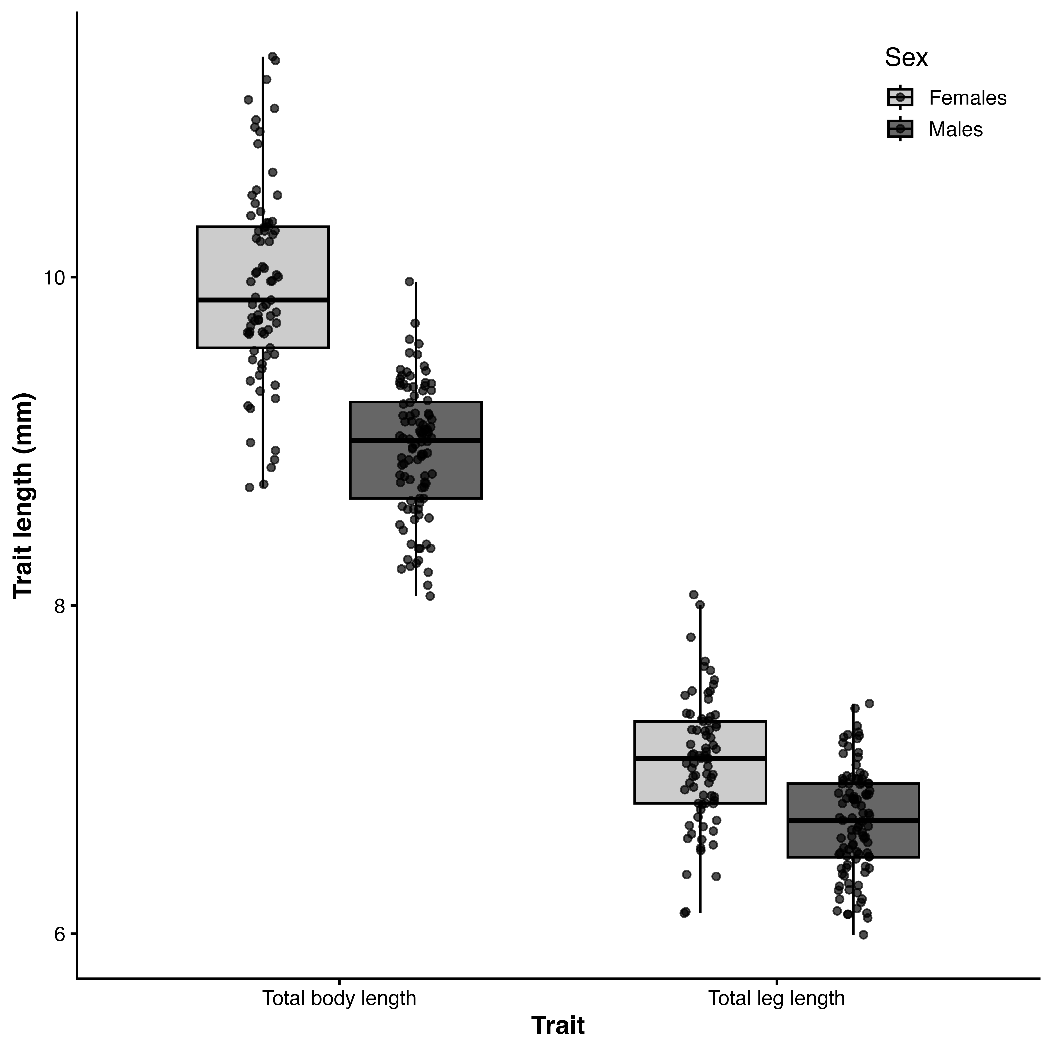
Figure 2: Sexual dimorphism in body and hind leg length. Boxplots show total body length and total hind leg length (mm) for females (light grey) and males (dark grey), with points representing individuals. Horizontal lines are medians, boxes are interquartile ranges, and whiskers extend to 1.5× the interquartile range. Females were significantly larger than males for both traits, as assessed by the linear models reported in the Results.

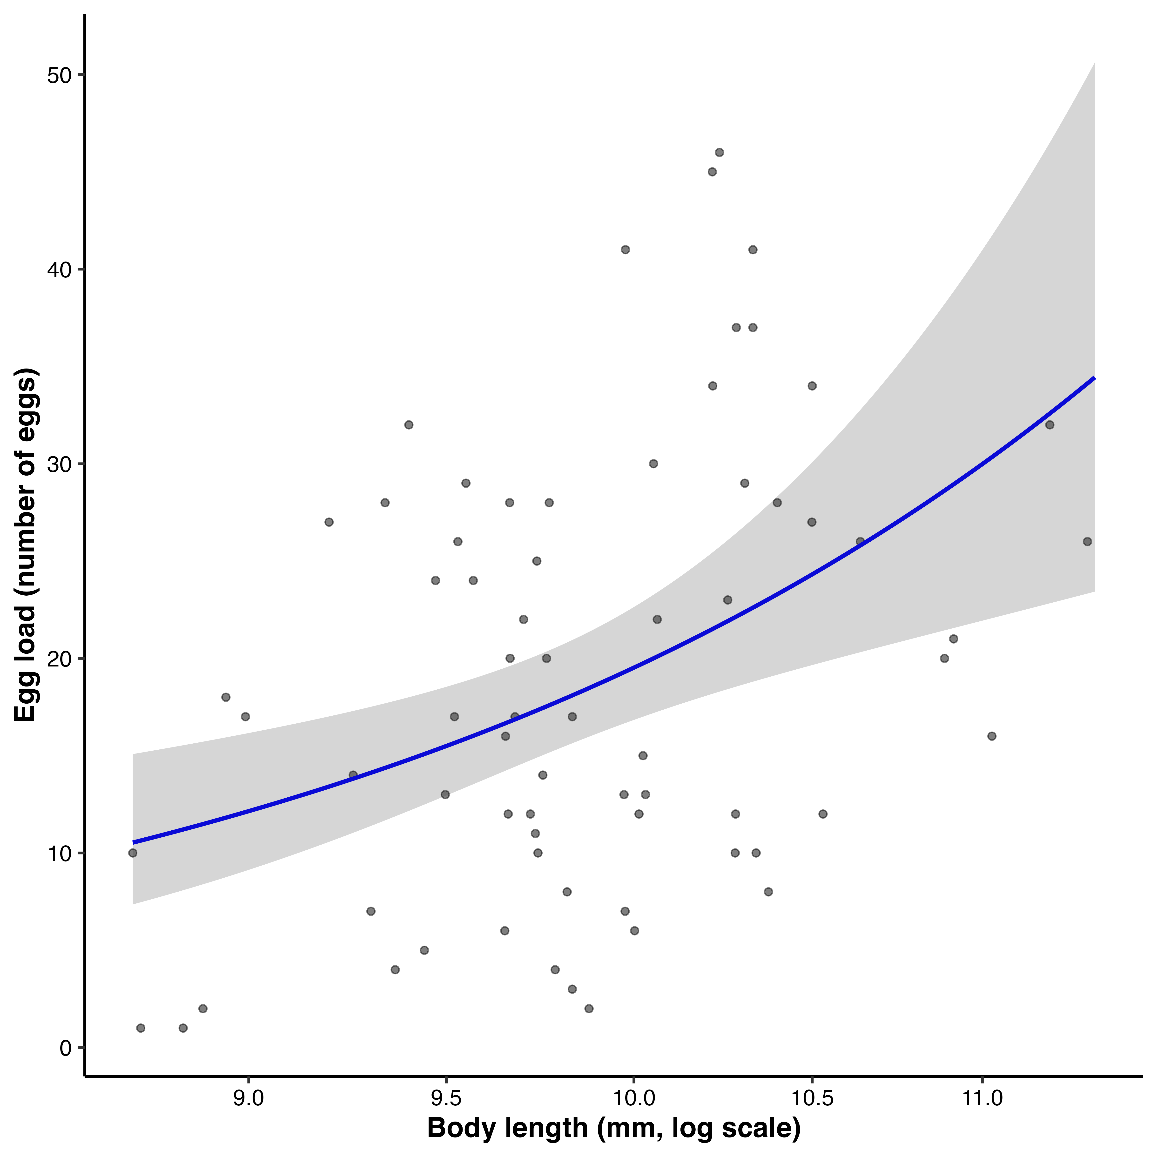
Figure 3: Relationship between female body length and egg load. Points represent individual females, and egg load is the number of eggs present in the reproductive tract at dissection. Body length is plotted on a log scale. The line shows the fitted mean from the negative-binomial generalized linear model, and the shaded region is the 95% confidence interval. Egg load increased with body length; this cross-sectional measure is not equivalent to lifetime realized fecundity.

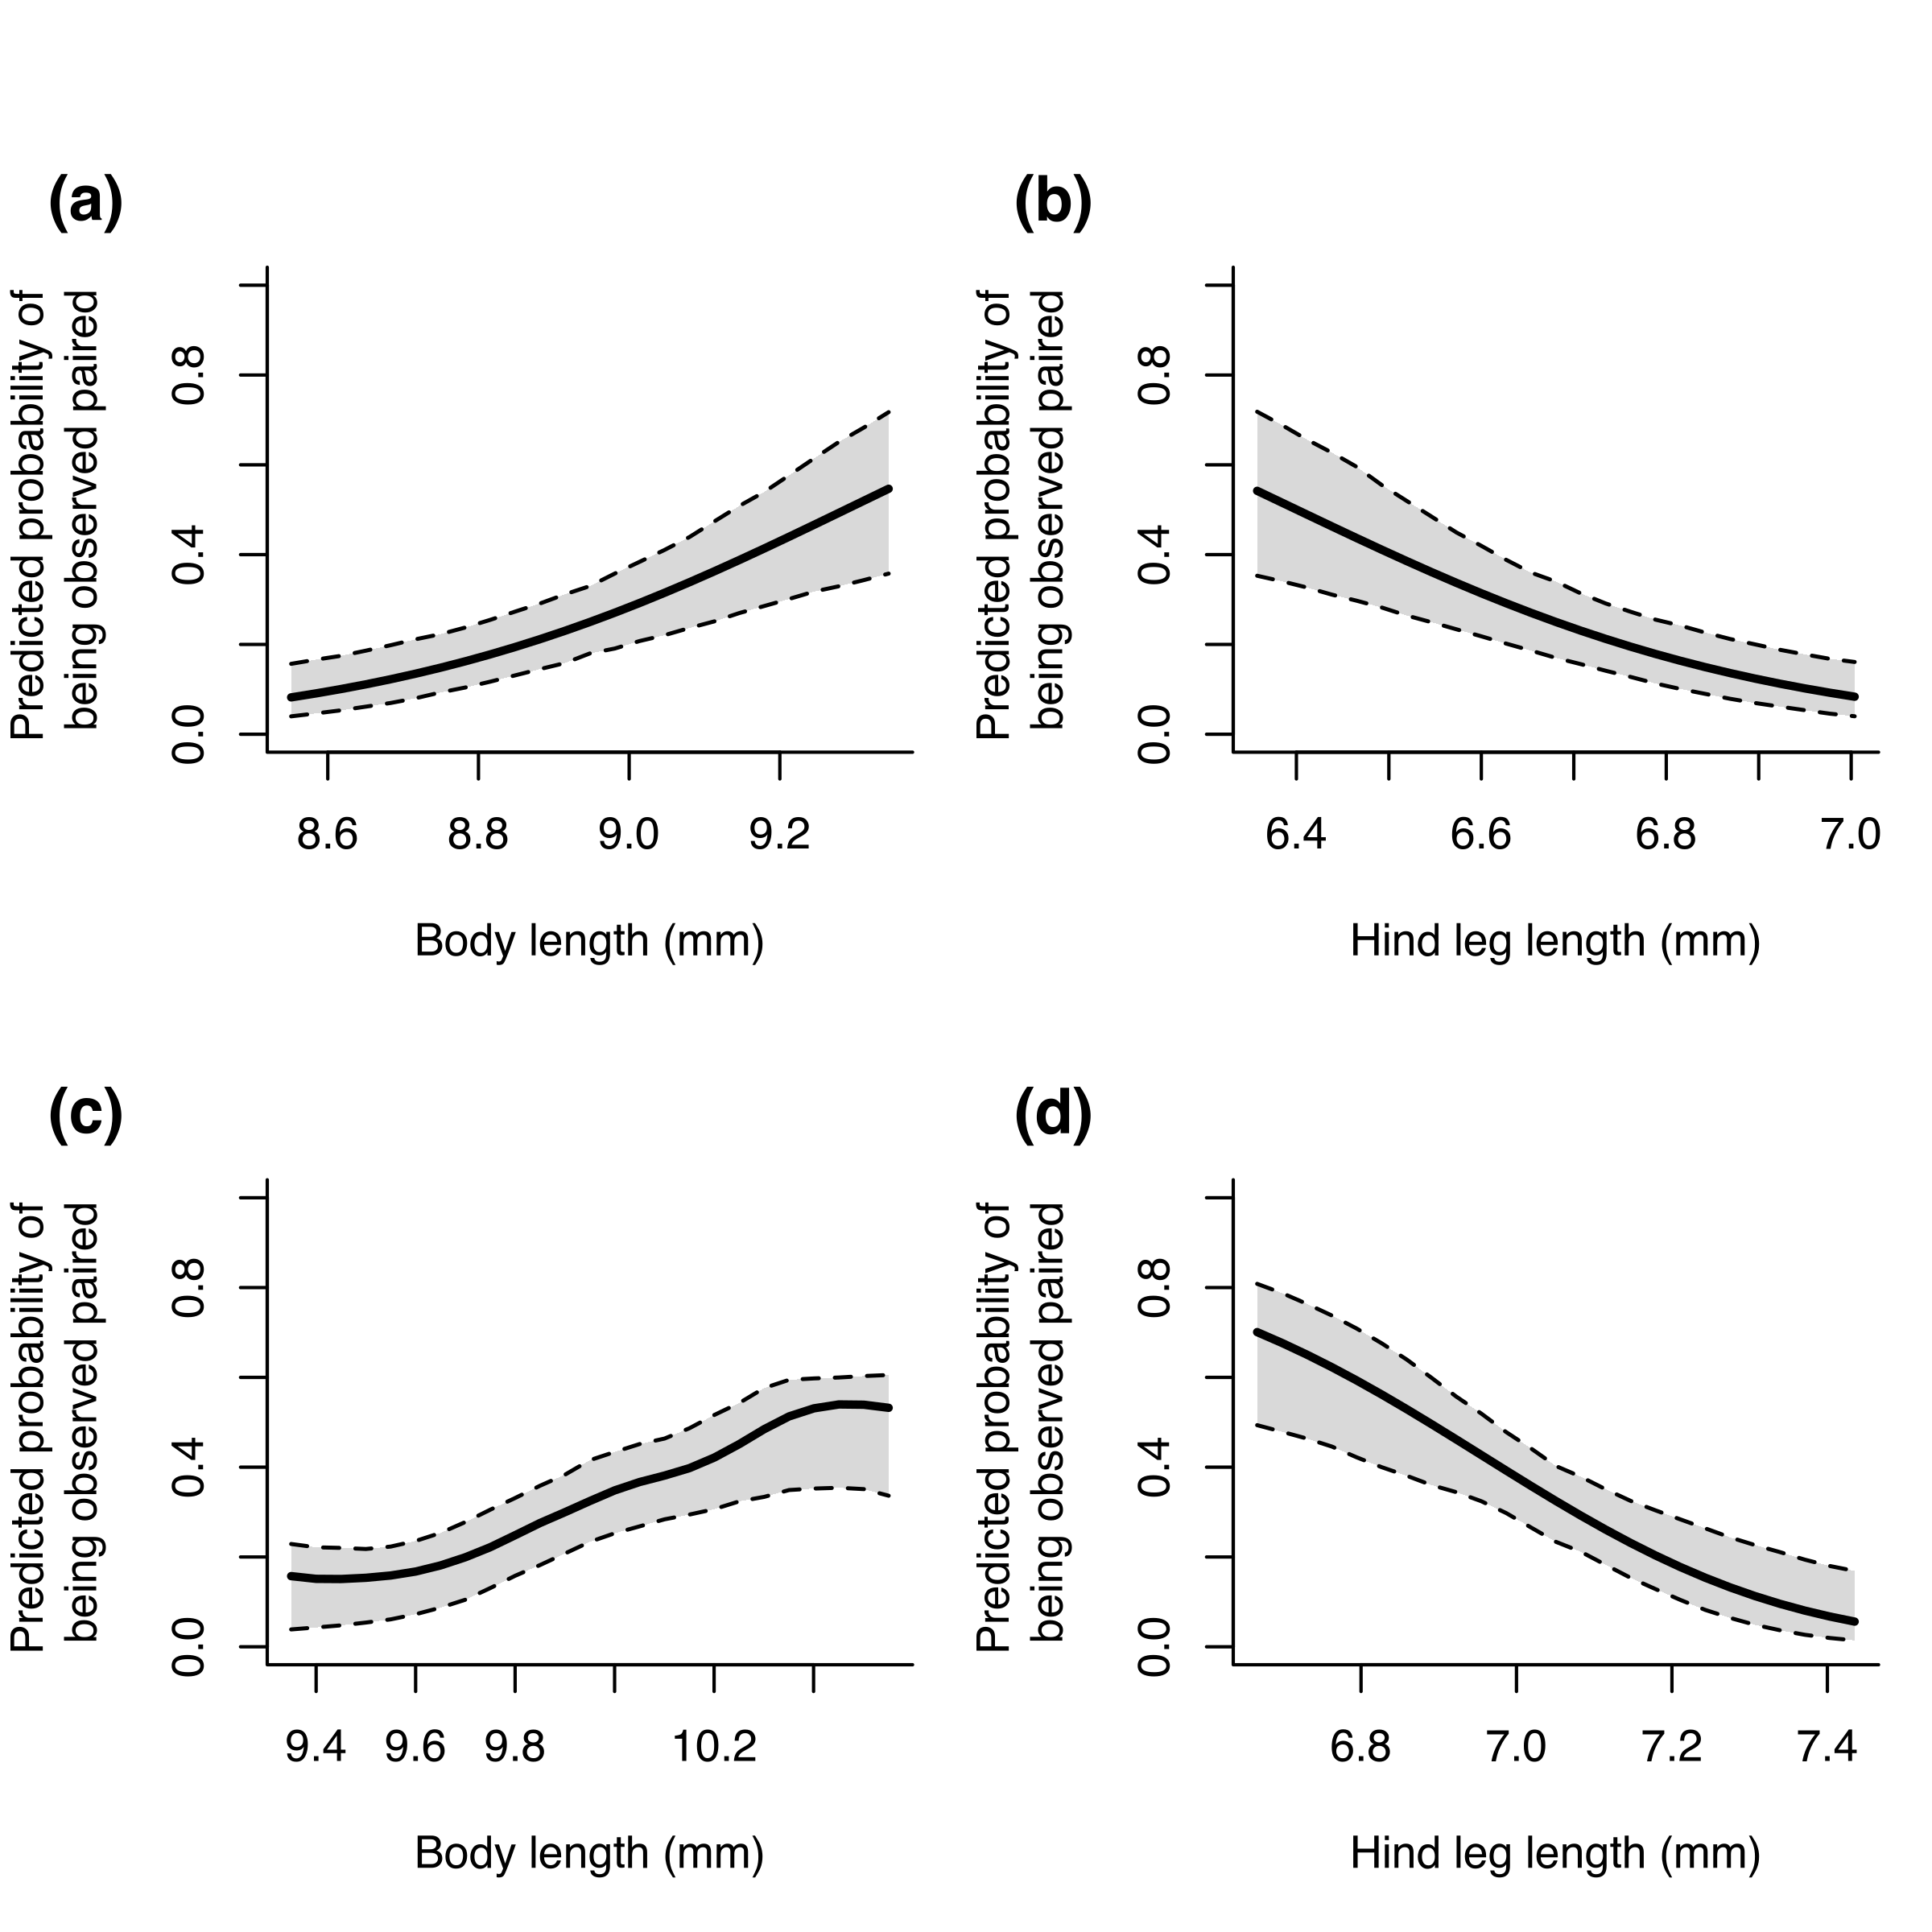
Figure 4: Associations between morphology and observed pairing status in males (a–b) and females (c–d). Panels show the predicted probability of being observed paired from binomial generalized additive models as a function of body length (a, c) and hind leg length (b, d), averaged over the observed distribution of the alternate trait. Solid lines are model predictions and dashed lines are 95% intervals estimated by parametric bootstrapping. In both sexes, body length had a positive directional gradient and hind leg length had a negative directional gradient. Pairing status is a cross-sectional proxy and may reflect encounter, mounting, or pair duration rather than lifetime reproductive success.

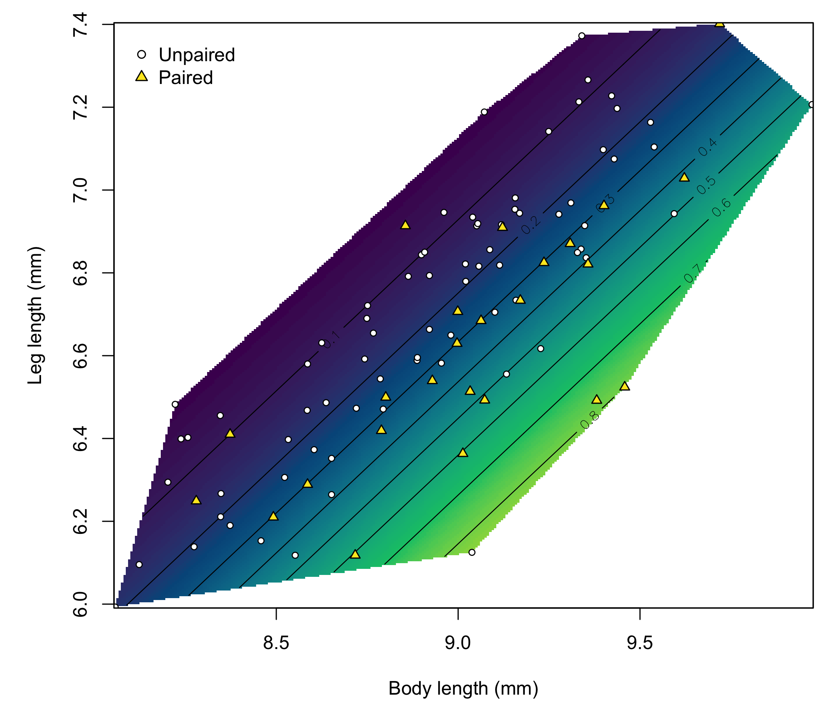
Figure 5: Predicted probability that a male was observed paired as a function of body length and leg length. Colours and labelled contours represent fitted probabilities from the generalized additive model. White circles show unpaired males and yellow triangles show paired males; predictions are restricted to the convex hull of the observed combinations of body and leg length. Higher pairing probabilities were associated with greater body length relative to leg length.

