Quarto demonstration.
Clint D. Kelly^{1,✉}
¹ Département des Sciences biologiques, Université du Québec à Montréal, Montréal, Canada
✉ Correspondence: Clint D. Kelly <kelly.clint@uqam.ca>

Abstract

Introduction

Methods

Study animals

Statistical analysis
Post-hoc contrasts are claculated wuing the R package emmeans (Lenth et al. 2019).

Results

Sex difference in development time
We found a two-way interaction between diet and density (Estimate = -1.12 [-2.63, 0.39]) that was driven by high density earwigs on a poor diet requiring more time than expected to reach adulthood (interaction contrast: low density vs medium density: $Δ$$\overline{x}$ = 0.34 [-0.70, 1.47]; low density vs. high density: $Δ$$\overline{x}$ = 1.22 [0.17, 2.23; medium density vs high density: $Δ$$\overline{x}$ = 0.88 [0.13, 1.62; Figure 1). We also found that individuals raised on a poor diet required more time to develop than those raised on a good diet (Estimate = -15.73, [-17.10, -14.37]).

Discussion

References
Lenth, R., H. Singmann, J. Love, P. Buerkner, and M. Herve. 2019. Package “emmeans”: Estimated marginal means, aka least-squares means. Compr. R Arch. Netw 1–67.

Table 1: Phenotypic variance partitioning of four traits for female and male European earwig (Forficula auricularia) families raised on either a poor or good diet at low, medium, or high density. P²_{RN} is the proportion of the phenotypic variance arising from average plastic responses to to the nutritional environment, H²_{RN} is the broad-sense heritability of the trait when fully accounting for its reaction norm, and T²_{RN} is the proportion of the phenotypic variance explained by the plastic and genetically variable reaction norm. Numbers in brackets are 95% credible intervals (CrIs).
 | Females |  |  |  |  | Males
 | Development time | Pronotum length | Forceps length | Relative forceps length |  | Development time | Pronotum length | Forceps length | Relative forceps length
(a) Low density
P²_{RN} | 0.772 [0.690, 0.836] | 0.497 [0.339, 0.625] | 0.531 [0.362, 0.661] | 0.005 [-0.034, 0.108] |  | 0.777 [0.708, 0.830] | 0.485 [0.339, 0.604] | 0.426 [0.267, 0.562] | 0.140 [0.009, 0.291]
H²_{RN} | 0.073 [0.010, 0.160] | 0.108 [0.010, 0.263] | 0.201 [0.044, 0.382] | 0.337 [0.059, 0.625] |  | 0.169 [0.112, 0.237] | 0.070 [0.005, 0.195] | 0.136 [0.013, 0.285] | 0.098 [0.005, 0.250]
T²_{RN} | 0.845 [0.776, 0.906] | 0.605 [0.454, 0.747] | 0.732 [0.565, 0.857] | 0.342 [0.054, 0.632] |  | 0.946 [0.914, 0.968] | 0.554 [0.419, 0.682] | 0.562 [0.402, 0.708] | 0.238 [0.065, 0.435]
(b) Medium density
P²_{RN} | 0.795 [0.754, 0.829] | 0.446 [0.361, 0.520] | 0.467 [0.385, 0.542] | 0.004 [-0.007, 0.031] |  | 0.836 [0.794, 0.871] | 0.601 [0.517, 0.677] | 0.540 [0.436, 0.631] | 0.344 [0.212, 0.461]
H²_{RN} | 0.118 [0.086, 0.158] | 0.116 [0.055, 0.185] | 0.142 [0.081, 0.218] | 0.133 [0.061, 0.222] |  | 0.081 [0.049, 0.125] | 0.110 [0.055, 0.182] | 0.138 [0.072, 0.230] | 0.128 [0.047, 0.233]
T²_{RN} | 0.913 [0.896, 0.929] | 0.562 [0.472, 0.640] | 0.609 [0.527, 0.683] | 0.137 [0.061, 0.232] |  | 0.918 [0.896, 0.936] | 0.710 [0.638, 0.774] | 0.678 [0.591, 0.757] | 0.472 [0.335, 0.592]
(c) High density
P²_{RN} | 0.847 [0.821, 0.872] | 0.482 [0.417, 0.540] | 0.492 [0.432, 0.552] | 0.011 [-0.005, 0.040] |  | 0.829 [0.795, 0.854] | 0.565 [0.514, 0.613] | 0.479 [0.412, 0.542] | 0.277 [0.208, 0.349]
H²_{RN} | 0.080 [0.059, 0.106] | 0.110 [0.069, 0.155] | 0.133 [0.091, 0.183] | 0.129 [0.069, 0.200] |  | 0.091 [0.067, 0.120] | 0.065 [0.036, 0.102] | 0.084 [0.053, 0.123] | 0.100 [0.060, 0.148]
T²_{RN} | 0.928 [0.917, 0.937] | 0.592 [0.536, 0.642] | 0.625 [0.573, 0.675] | 0.140 [0.077, 0.216] |  | 0.920 [0.908, 0.931] | 0.630 [0.582, 0.677] | 0.563 [0.502, 0.618] | 0.377 [0.306, 0.446]

##Figures
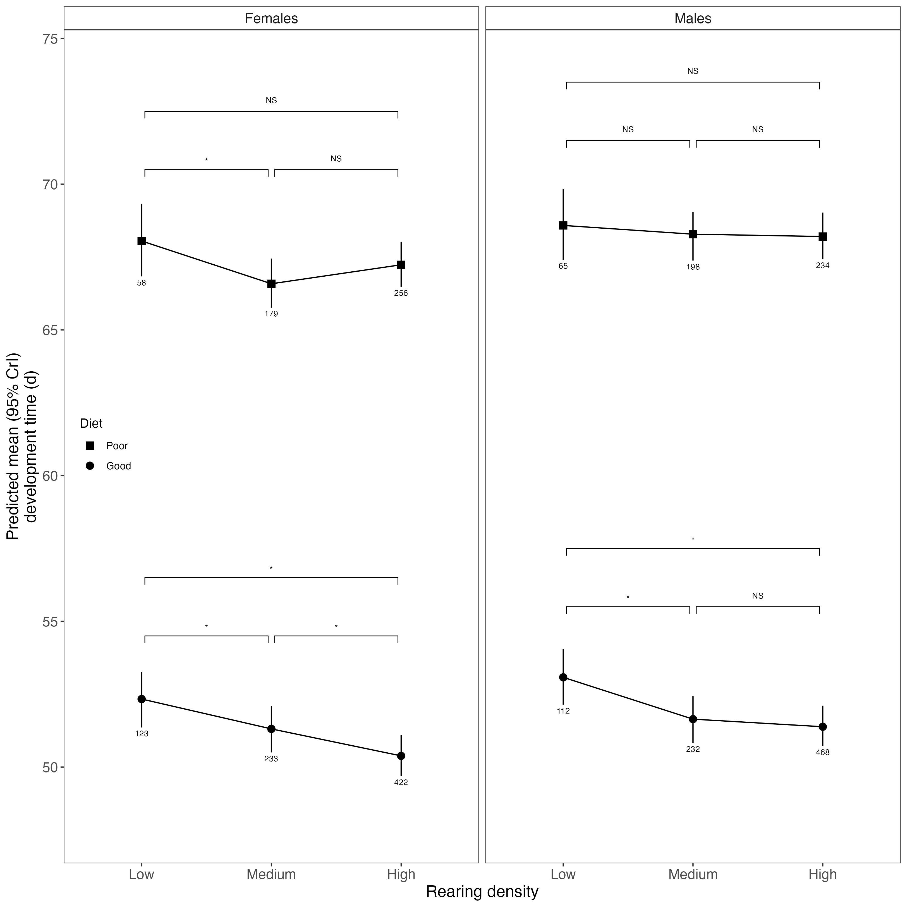
Figure 1: Mean (±95% CrI) trait sizes of female and male earwigs raised on either a poor or good diet at low, medium, or high density. * above bracket denotes that the 95% CrI of the mean difference between two density levels did not include zero whereas NS denotes that the 95% CrI of the mean difference did include zero. Sample sizes are given below data points.

