Supplementary material
A single dominant axis of locomotor and sensory divergence across alternative mating strategies in Wellington tree wētā

Overview
This supplement provides measurement-reliability results and detailed weapon–trait and sensory estimates (Tables S1–S6), multivariate and robustness analyses (Tables S7–S13), and additional estimates from the leg and sensory models (Tables S14–S17). Tables S18–S19 summarize within-group correlations and the precision of planned leg contrasts. Figures S1–S4 show within-group correlations, individual-level ordination, body-size distributions and leg allometries.
The distinction between the five-trait reference analysis and head-inclusive sensitivities identifies the trait sets, not their confirmatory status. Dimensionality, matrix comparisons, equivalence-region checks and the cross-analysis multiplicity audit are exploratory. Both documents use the same analysis outputs and retain the original morph assignments. Reproduction instructions and additional model outputs are supplied with the analysis code.

Supplementary methods

Measurement reliability
Forty-eight specimens from the 2016 collection were measured on three occasions. The measurement-order file records 12 individuals per sex or morph group and one from each of 12 size strata within each group. Repeatability was estimated for pooled, morph-adjusted and morph-plus-round models. Relative technical error of measurement, absolute-agreement ICC(A,1), round-pair bias and measurement-order trends were also calculated. The order analyses were treated as diagnostics; their minimum Benjamini–Hochberg-adjusted p-values were 0.524 for signed drift and 0.867 for absolute-error drift.

Multivariate sensitivity analyses
The reference female-referenced contrast-vector and PCA analyses excluded composite head size because head length contributed to male morph assignment. Each log trait was standardized by its residual standard deviation from a pooled regression on log pronotum length. Sensitivities restored head size and fitted a rank-one (single-axis) approximation to the six unstandardized log traits. Single-axis tests used 9999 residual randomizations; the matrix tests used 9999 randomizations.
Pairwise directional comparisons constrained two male–female contrast vectors to share a direction while leaving the third unconstrained. The angle between each pair was compared with its pair-specific single-axis randomization distribution, with Holm adjustment across the three pairs. Group-stratified bootstrap samples provided percentile 95% intervals for vector angles and differences in magnitude (Table S2).
Morph assignments were based on head-length categories derived from mixture models in Kelly & Adams (2010) and Kelly (2026), rather than models fitted to this sample. Archived assignments correspond to boundaries of approximately 18.51 and 24.15 mm; the exact cut-offs used to reconstruct them are 18.50579 and 24.15225 mm. The 2010 boundaries of 19.04 and 24.20 mm provide an alternative category definition. I excluded males whose labels differed between these definitions and repeated the five-trait single-axis analysis, recalculating standardization and group-specific size adjustments. The same exclusion was assessed for the individual-level PCA and head-adjusted eye model. These checks assess dependence on category boundaries, not the accuracy of individual developmental histories.

Matrix comparisons and unequal sample sizes
Within-group covariance and correlation matrices for the five non-head traits were compared using omnibus and pairwise Frobenius-distance randomization tests. Pairwise p-values were adjusted by both Benjamini–Hochberg and Holm procedures. Matrix-element correlations and random-skewers similarities were used as descriptive orientation measures. To evaluate unequal group sizes, each group was repeatedly rarefied to 38 specimens, the size of the tenth-instar male group.

Repeated-leg covariance structure
The main repeated-leg model estimated separate residual variances for fore-, mid- and hindlegs and freely estimated the three within-individual residual correlations. It was compared with compound-symmetry and heterogeneous compound-symmetry structures using fits with identical fixed effects. The selected unstructured model is used for main-text inference and the associated precision calculations.

Secondary integration, equivalence and sampling checks
Main-text weapon–leg relationships were estimated in one stage from raw log composite head size while controlling for pronotum length, group and leg identity. Weapon–ear slopes were likewise estimated in one stage; an exploratory equivalence sensitivity assessed them against an illustrative standardized near-zero region of −0.20 to 0.20. All-pairs sensory tests were Holm-adjusted within each six-comparison trait family and are separate from the main text’s planned contrast families. For Holm-tested contrasts, simultaneous 95% confidence intervals use Bonferroni adjustment over the stated family; slope and predicted-mean intervals are pointwise. The separate precision estimates use pointwise intervals and approximate minimum detectable effects for a single two-sided test at 80% power and $α=0.05$. They do not include a correction for testing several contrasts. Morph-composition χ² tests compared the analysed males with two published empirical compositions; they diagnose compositional mismatch but cannot identify its cause because collection microhabitat and gallery-search effort were not retained.

Secondary instar comparisons
The final secondary analysis allowed an independent intercept, body-size slope and residual variance for each group in each trait. Four separate log-trait regressions on centred log pronotum length provide the same estimates and covariance as a fully interacted generalized least-squares model with group-specific residual variances. At 7.2 mm pronotum length, the average male change per instar was $\left(μ_{10}−μ_{8}\right)/2$ and the matched-sex contrast was $μ_{10}−μ_{F}$. Their direct difference is $μ_{F}−\left(μ_{8}+μ_{10}\right)/2$; forming this contrast retains the covariance introduced by the shared tenth-instar estimate. The ninth-instar mean was unconstrained. Contrast variances were sums of squared contrast weights times the group prediction variances, with analytic Welch–Satterthwaite degrees of freedom. Pointwise 95% intervals and three separate five-trait Holm families were used.
The earlier model assumed a common body-size slope, common residual variance and equal male instar increments. Diagnostic checks identified discrepancies in leg means and spreads under that specification. The final flexible model was applied to every trait because the observations represent discrete adult morphs and do not require equal developmental increments. It was not chosen by the significance of the contrasts. Table S20 reports both specifications. These comparisons describe associations among adult groups, not causal effects of additional moults or weaponry. Main-text repeated-leg allocation tests retain their joint covariance model; the secondary instar analysis makes no joint comparison across leg pairs.

Cross-analysis multiplicity audit
The within-family Holm adjustments reported for planned contrasts remain the manuscript’s inferential corrections. As a separate sensitivity analysis, ten selected omnibus p-values were adjusted together using Benjamini–Hochberg and Holm procedures. This broader audit is descriptive and does not replace the main-text tests.

Supplementary results

Reliability and measurement-session effects
All traits were highly repeatable, including after adjustment for morph and measurement round (Table S1). Round effects were detectable for several traits, but their magnitude was small relative to among-individual variation. No evidence of progressive signed or absolute-error drift was detected within remeasurement sessions.

Directional dimensionality
The base five-trait single-axis model captured 88.8% of design-weighted group-effect variation, while the standardized six-trait and raw-log six-trait sensitivities captured 90.3% and 98.3%, respectively. In every case the residual component beyond a single axis exceeded the randomization distribution (p < 0.001; Table S7). Excluding 10 category-disagreement males retained 301 complete cases and a single-axis share of 88.6%, with a detectable residual beyond a single axis (p < 0.001). Parallel analysis retained one component in the reference five-trait analysis, the six-trait sensitivity and the classification-exclusion sensitivity (Supplementary Figure S2). These exploratory results show one dominant dimension together with a smaller detected secondary direction in adjusted group means.

Matrix structure
The base five-trait omnibus tests detected neither a covariance-matrix difference (p = 0.398) nor a correlation-matrix difference (p = 0.848; Supplementary Figure S1). The six-trait sensitivity, which restores head size, detected a covariance-matrix difference (p = 0.042), but not a correlation-matrix difference (p = 0.581). Thus the five-trait null result cannot be generalized to all measured traits; neither nonsignificant test establishes matrix equivalence. No five-trait pairwise matrix comparison survived Holm adjustment (Table S8). Matrix-element correlations, random-skewers similarities and rarefaction summaries are reported in Table S9 rather than interpreted as independent hypothesis tests.

Repeated-leg covariance and secondary analyses
In the alternative covariance-structure fits, unstructured repeated-leg covariance was preferred to heterogeneous compound symmetry (likelihood-ratio statistic = 74.50, p < 0.001; Table S10a). Pairwise residual correlations ranged from 0.690 to 0.871 (Table S10b). All 12 one-stage raw-head weapon–leg slope estimates were positive, with 95% confidence intervals excluding zero for 11; planned differences among slopes were imprecise (Tables S3–S4). Weapon–ear slopes did not meet the illustrative equivalence criterion in any group (Table S5).

Classification and sample composition
The archived file contained 195 males. The published 2010 thresholds disagreed with 10 archived labels (5.1%). Excluding those specimens did not alter the head-adjusted eye-length omnibus conclusion (Table S11). Male composition differed from both published empirical references (Table S11), but the source of the difference cannot be resolved from the archive. The 7.2-mm reference pronotum used for adjusted comparisons fell within the observed range of every group (Supplementary Figure S3).

Sensitivity of the instar comparison
The matched-sex contrast exceeded the average male change per instar for forelegs, midlegs, tympanic size and eyes under both the original and flexible specifications (Table S20). For hindlegs, the original model supported a larger instar change, whereas the flexible model did not distinguish the two contrasts (Holm-adjusted p = 0.158). The main text therefore treats the hindleg ordering as uncertain. This result does not demonstrate equality of the contrasts.

Cross-analysis multiplicity
In the selected unstructured model, the group-by-leg allocation effect and the raw-head weapon–leg interaction remained supported in the ten-test audit. The body-size-by-group-by-leg interaction was unsupported before cross-analysis adjustment. The body-size-by-group term was supported within its model but did not survive the broader ten-test audit (Table S12), reinforcing the exploratory status of detailed allometric comparisons.

Supplementary tables
Table S1. Repeatability, agreement and measurement-round diagnostics for 11 morphological traits measured three times.
Trait | Pooled | Morph-adjusted | Morph + round | rTEM (%) | ICC(A,1) | Max. bias (%) | Holm p
Pronotum length | 0.9950  (0.9916–0.9968) | 0.9819  (0.9690–0.9887) | 0.9942  (0.9900–0.9965) | 0.65 | 0.9951 | 1.08 | <0.001
Head length | 0.9997  (0.9995–0.9998) | 0.9960  (0.9931–0.9976) | 0.9982  (0.9968–0.9989) | 0.48 | 0.9997 | 0.70 | <0.001
Head width | 0.9991  (0.9984–0.9994) | 0.9886  (0.9810–0.9932) | 0.9937  (0.9894–0.9962) | 0.60 | 0.9991 | 0.81 | <0.001
Forefemur length | 0.9938  (0.9893–0.9962) | 0.9794  (0.9642–0.9869) | 0.9803  (0.9657–0.9876) | 0.72 | 0.9939 | 0.36 | 0.136
Foretibia length | 0.9934  (0.9887–0.9960) | 0.9817  (0.9687–0.9889) | 0.9864  (0.9765–0.9917) | 0.69 | 0.9935 | 0.66 | <0.001
Midfemur length | 0.9946  (0.9911–0.9967) | 0.9824  (0.9707–0.9893) | 0.9851  (0.9750–0.9909) | 0.61 | 0.9947 | 0.44 | 0.001
Midtibia length | 0.9959  (0.9930–0.9975) | 0.9880  (0.9790–0.9925) | 0.9880  (0.9788–0.9926) | 0.54 | 0.9959 | 0.16 | 0.705
Hindfemur length | 0.9955  (0.9924–0.9972) | 0.9835  (0.9724–0.9898) | 0.9847  (0.9742–0.9905) | 0.64 | 0.9955 | 0.39 | 0.039
Hindtibia length | 0.9868  (0.9773–0.9919) | 0.9562  (0.9249–0.9733) | 0.9596  (0.9302–0.9754) | 1.21 | 0.9868 | 0.73 | 0.039
Ear area | 0.9763  (0.9610–0.9855) | 0.9488  (0.9158–0.9691) | 0.9565  (0.9276–0.9736) | 2.57 | 0.9765 | 2.15 | 0.001
Eye length | 0.9906  (0.9841–0.9942) | 0.9717  (0.9527–0.9826) | 0.9714  (0.9519–0.9824) | 1.13 | 0.9906 | 0.23 | 0.705
Note. Repeatability values are individual-level ICCs with 95% bootstrap confidence intervals. rTEM is the within-individual standard deviation divided by the trait mean × 100. ICC(A,1) is the single-measure absolute-agreement coefficient. Maximum bias is the largest absolute round-pair mean difference as a percentage of the trait mean. Round-effect p-values are Holm-adjusted across traits.

Table S2. Exploratory pairwise descriptions of standardized female-referenced contrast vectors for the five nonclassification traits. D8, D9 and D10 denote the female-referenced eighth-, ninth- and tenth-instar male vectors. The global single-axis test is reported separately in Table S7.
Pair | Angle (°) | Lower 95% | Upper 95% | Angle Holm p | Δ magnitude | Δ lower 95% | Δ upper 95%
D8–D9 | 46.3 | 25.0 | 65.5 | 0.006 | 0.84 | 0.15 | 1.35
D8–D10 | 59.5 | 36.9 | 79.7 | 0.018 | 2.52 | 1.65 | 3.17
D9–D10 | 13.6 | 7.9 | 22.0 | 0.003 | 1.68 | 1.11 | 2.22

Table S3. Group- and leg-specific partial slopes of log leg length on log composite head size (the geometric mean of head length and width), controlling for log pronotum length in the repeated-trait model. Confidence intervals and individual slope p-values are unadjusted. Minimum detectable slopes are approximate values for a single two-sided test at 80% power and $α=0.05$, using the same approximate Satterthwaite degrees of freedom as the slope intervals.
Group | Leg | Slope | Lower 95% CI | Upper 95% CI | p-value | Minimum detectable slope
Female | Foreleg | 0.419 | 0.281 | 0.557 | <0.001 | 0.20
Eighth instar | Foreleg | 0.459 | 0.347 | 0.570 | <0.001 | 0.16
Ninth instar | Foreleg | 0.323 | 0.216 | 0.430 | <0.001 | 0.15
Tenth instar | Foreleg | 0.234 | -0.050 | 0.518 | 0.106 | 0.41
Female | Midleg | 0.422 | 0.288 | 0.555 | <0.001 | 0.19
Eighth instar | Midleg | 0.472 | 0.364 | 0.580 | <0.001 | 0.15
Ninth instar | Midleg | 0.361 | 0.257 | 0.464 | <0.001 | 0.15
Tenth instar | Midleg | 0.367 | 0.093 | 0.641 | 0.009 | 0.39
Female | Hindleg | 0.633 | 0.489 | 0.777 | <0.001 | 0.21
Eighth instar | Hindleg | 0.348 | 0.231 | 0.466 | <0.001 | 0.17
Ninth instar | Hindleg | 0.365 | 0.253 | 0.477 | <0.001 | 0.16
Tenth instar | Hindleg | 0.533 | 0.237 | 0.830 | <0.001 | 0.42

Table S4. Planned contrasts among weapon–leg slopes. P-values are Holm-adjusted and simultaneous 95% confidence intervals are Bonferroni-adjusted within the three-contrast family for each leg pair.
Leg | Contrast | Difference | Lower 95% CI | Upper 95% CI | Adjusted p
Foreleg | Eighth instar - Tenth instar | 0.224 | -0.149 | 0.598 | 0.448
Foreleg | Ninth instar - midpoint(Eighth instar,Tenth instar) | -0.024 | -0.252 | 0.204 | 0.804
Foreleg | Tenth instar - Female | -0.185 | -0.571 | 0.201 | 0.499
Midleg | Eighth instar - Tenth instar | 0.105 | -0.256 | 0.466 | 1.000
Midleg | Ninth instar - midpoint(Eighth instar,Tenth instar) | -0.059 | -0.279 | 0.161 | 1.000
Midleg | Tenth instar - Female | -0.055 | -0.428 | 0.319 | 1.000
Hindleg | Eighth instar - Tenth instar | -0.185 | -0.576 | 0.205 | 0.762
Hindleg | Ninth instar - midpoint(Eighth instar,Tenth instar) | -0.076 | -0.314 | 0.163 | 0.891
Hindleg | Tenth instar - Female | -0.099 | -0.503 | 0.304 | 0.891

Table S5a. Within-group partial slopes of log linearised tympanic size on log composite head size, controlling for log pronotum length. Confidence intervals are pointwise. Minimum detectable slopes are approximate values for a single two-sided test at 80% power and $α=0.05$.
Group | Slope | SE | Lower 95% CI | Upper 95% CI | Minimum detectable slope
Female | 0.397 | 0.111 | 0.178 | 0.615 | 0.31
Eighth instar | 0.167 | 0.090 | -0.010 | 0.344 | 0.25
Ninth instar | 0.130 | 0.086 | -0.039 | 0.300 | 0.24
Tenth instar | 0.291 | 0.228 | -0.159 | 0.740 | 0.64
Table S5b. Within-group standardized partial slopes of log linearized tympanal size on raw log composite head size, controlling for log pronotum length. Linearized tympanal size is the square root of tympanal area. Equivalence required the complete 90% confidence interval to fall within −0.20 to 0.20; robust slopes are Huber M-estimates.
Group | n | Standardized slope | Lower 90% CI | Upper 90% CI | Robust slope | TOST p | Equivalent within ±0.20
Female | 118 | 0.466 | 0.255 | 0.676 | 0.437 | 0.981 | No
Eighth instar | 78 | 0.275 | 0.043 | 0.507 | 0.263 | 0.705 | No
Ninth instar | 79 | 0.167 | -0.033 | 0.367 | 0.172 | 0.392 | No
Tenth instar | 38 | 0.218 | -0.077 | 0.513 | 0.221 | 0.541 | No

Table S6. Exploratory all-pairs group contrasts in size-adjusted tympanal area and eye length at a pronotum length of 7.2 mm. These six-pair families differ from the planned contrast families in the main manuscript. Ratios greater than one indicate that the first named group had the larger predicted trait. P-values are Holm-adjusted and simultaneous 95% confidence intervals are Bonferroni-adjusted across the six group pairs within each trait. Because the adjustments differ, a Holm-adjusted p-value below 0.05 can accompany an interval containing one.
Trait | Contrast | Ratio | Lower 95% CI | Upper 95% CI | Adjusted p
Tympanal area | Female - Eighth instar | 0.992 | 0.930 | 1.059 | 0.757
Tympanal area | Female - Ninth instar | 0.913 | 0.870 | 0.957 | <0.001
Tympanal area | Female - Tenth instar | 0.867 | 0.828 | 0.908 | <0.001
Tympanal area | Eighth instar - Ninth instar | 0.920 | 0.879 | 0.962 | <0.001
Tympanal area | Eighth instar - Tenth instar | 0.874 | 0.818 | 0.933 | <0.001
Tympanal area | Ninth instar - Tenth instar | 0.950 | 0.901 | 1.001 | 0.020
Eye length | Female - Eighth instar | 0.914 | 0.879 | 0.951 | <0.001
Eye length | Female - Ninth instar | 0.860 | 0.836 | 0.885 | <0.001
Eye length | Female - Tenth instar | 0.799 | 0.778 | 0.822 | <0.001
Eye length | Eighth instar - Ninth instar | 0.941 | 0.916 | 0.966 | <0.001
Eye length | Eighth instar - Tenth instar | 0.874 | 0.841 | 0.909 | <0.001
Eye length | Ninth instar - Tenth instar | 0.929 | 0.901 | 0.959 | <0.001

Table S7. Sensitivity of dimensionality to trait definition, scaling and category boundaries. For single-axis analyses, the null reference is the 95th percentile of the residual share beyond a single axis; it is compared with 100% minus the reported single-axis share. PCA rows instead compare an individual-level eigenvalue with its parallel-analysis threshold.
Approach | Scenario | Estimate | Null reference | p-value | Conclusion
Female-referenced single-axis test | Five traits, standardized; head excluded (base scenario) | 88.8% captured by a single axis | Residual share: 95th percentile = 2.1% | <0.001 | Departure from a single axis detected
Female-referenced single-axis test | Six traits, standardized; head included | 90.3% captured by a single axis | Residual share: 95th percentile = 1.8% | <0.001 | Departure from a single axis detected
Female-referenced single-axis test | Six traits on raw log scale | 98.3% captured by a single axis | Residual share: 95th percentile = 0.4% | <0.001 | Departure from a single axis detected
Female-referenced single-axis test | Five traits after excluding category disagreements | 88.6% captured by a single axis | Residual share: 95th percentile = 2.1% | <0.001 | Departure from a single axis detected
PCA with parallel analysis | Five traits, standardized; head excluded (base scenario) | PC1 = 68.7%; eigenvalue 3.433 | 95th-percentile eigenvalue = 1.238 | — | One component retained
PCA with parallel analysis | Six traits, standardized; head included | PC1 = 68.6%; eigenvalue 4.116 | 95th-percentile eigenvalue = 1.268 | — | One component retained
PCA with parallel analysis | Five traits after excluding classification-sensitive males | PC1 = 68.4%; eigenvalue 3.418 | 95th-percentile eigenvalue = 1.242 | — | One component retained

Table S8a. Omnibus permutation comparisons of within-group covariance and correlation matrices.
Trait set | Matrix | Statistic | Permutations | p-value
Five non-head traits (base scenario) | Covariance | 116.446 | 9,999 | 0.398
Five non-head traits (base scenario) | Correlation | 0.360 | 9,999 | 0.848
Six traits including head (sensitivity) | Covariance | 325.208 | 9,999 | 0.042
Six traits including head (sensitivity) | Correlation | 0.825 | 9,999 | 0.581
Table S8b. Pairwise permutation comparisons of within-group covariance and correlation matrices. P-values are reported with both Benjamini–Hochberg and Holm adjustment across the six group pairs within each matrix type.
Matrix | Pair | Frobenius distance | Raw p | BH p | Holm p
Covariance | Female – Eighth instar | 0.989 | 0.314 | 0.471 | 1.000
Covariance | Female – Ninth instar | 0.994 | 0.298 | 0.471 | 1.000
Covariance | Female – Tenth instar | 0.924 | 0.505 | 0.606 | 1.000
Covariance | Eighth instar – Ninth instar | 0.585 | 0.929 | 0.929 | 1.000
Covariance | Eighth instar – Tenth instar | 1.546 | 0.115 | 0.471 | 0.692
Covariance | Ninth instar – Tenth instar | 1.420 | 0.199 | 0.471 | 0.997
Correlation | Female – Eighth instar | 0.278 | 0.935 | 0.935 | 1.000
Correlation | Female – Ninth instar | 0.325 | 0.804 | 0.935 | 1.000
Correlation | Female – Tenth instar | 0.620 | 0.434 | 0.935 | 1.000
Correlation | Eighth instar – Ninth instar | 0.421 | 0.738 | 0.935 | 1.000
Correlation | Eighth instar – Tenth instar | 0.598 | 0.662 | 0.935 | 1.000
Correlation | Ninth instar – Tenth instar | 0.483 | 0.694 | 0.935 | 1.000

Table S9. Descriptive matrix similarities and unequal-sample-size rarefaction. Rarefaction used 2,000 subsamples that reduced each group to 38 specimens; intervals are the 2.5th and 97.5th percentiles of the resulting distance distribution.
Matrix | Pair | Element correlation | Random-skewers similarity | Rarefied distance, median (95% interval) | Target n
Covariance | Female – Eighth instar | 0.884 | 0.969 | 1.399 (0.765–2.471) | 38
Covariance | Female – Ninth instar | 0.902 | 0.975 | 1.363 (0.720–2.728) | 38
Covariance | Female – Tenth instar | 0.817 | 0.955 | 1.096 (0.657–2.163) | 38
Covariance | Eighth instar – Ninth instar | 0.956 | 0.981 | 1.145 (0.631–2.093) | 38
Covariance | Eighth instar – Tenth instar | 0.717 | 0.935 | 1.669 (0.973–2.502) | 38
Covariance | Ninth instar – Tenth instar | 0.835 | 0.965 | 1.515 (0.787–2.585) | 38
Correlation | Female – Eighth instar | 0.987 | 0.993 | 0.664 (0.327–1.148) | 38
Correlation | Female – Ninth instar | 0.993 | 0.994 | 0.624 (0.289–1.314) | 38
Correlation | Female – Tenth instar | 0.947 | 0.972 | 0.733 (0.454–1.264) | 38
Correlation | Eighth instar – Ninth instar | 0.984 | 0.987 | 0.671 (0.337–1.221) | 38
Correlation | Eighth instar – Tenth instar | 0.958 | 0.974 | 0.703 (0.390–1.139) | 38
Correlation | Ninth instar – Tenth instar | 0.952 | 0.981 | 0.594 (0.354–0.954) | 38

Table S10a. Comparison of covariance structures for the repeated-leg model. All models contain the same fixed-effects specification and were fitted by REML. The selected unstructured fit is used for main-text inference.
Model | Parameters | AIC | BIC | Log likelihood | Comparison | Likelihood-ratio statistic | p-value
Compound symmetry | 26 | -4,009.84 | -3,884.64 | 2,030.92 | — |  | —
Heterogeneous compound symmetry | 28 | -4,019.19 | -3,884.36 | 2,037.60 | 1 vs 2 | 13.35 | 0.001
Unstructured covariance | 30 | -4,089.70 | -3,945.23 | 2,074.85 | 2 vs 3 | 74.50 | <0.001
Table S10b. Estimated parameters from the selected unstructured covariance model.
Parameter | Estimate
Foreleg-midleg residual correlation | 0.871
Foreleg-hindleg residual correlation | 0.690
Midleg-hindleg residual correlation | 0.725
Midleg/foreleg residual SD ratio | 0.997
Hindleg/foreleg residual SD ratio | 1.074

Table S11a. Morph-classification and sample-composition sensitivity checks. Observed counts are ordered as eighth / ninth / tenth instar.
Reference | Observed | Expected eighth | Expected ninth | Expected tenth | χ² | df | p-value
Kelly 2026 retained assignments | 78 / 79 / 38 | 44.1% | 29.1% | 26.8% | 13.36 | 2 | 0.001
Kelly and Adams 2010 field sample | 78 / 79 / 38 | 43.3% | 30.9% | 25.8% | 9.29 | 2 | 0.010
Table S11b. Head-adjusted eye-length group test under the archived labels and after excluding males whose labels disagree with the published 2010 thresholds.
Dataset | Numerator df | Residual df | F | p-value
Current archived labels | 3 | 307 | 10.65 | <0.001
Excluded labels disagreeing with 2010 cutoffs | 3 | 297 | 10.79 | <0.001
Table S11c. Head-size and group contributions to eye length when pronotum, composite head size and group are fitted jointly.
Analysis | Numerator df | Residual df | F | p-value
Head-size contribution to eye length after pronotum and group | 1 | 307 | 112.99 | <0.001
Group effect on eye length after pronotum and head size | 3 | 307 | 10.65 | <0.001

Table S11d. Observed composite head-size ranges. The reversed common bounds show that the four groups have no shared head-size support.
Group | n | Minimum head size | Maximum head size | Common lower bound | Common upper bound | Common support
Female | 118 | 8.491 | 11.246 | 16.818 | 11.246 | No
Eighth instar | 78 | 9.794 | 14.034 | 16.818 | 11.246 | No
Ninth instar | 79 | 13.321 | 17.299 | 16.818 | 11.246 | No
Tenth instar | 38 | 16.818 | 19.673 | 16.818 | 11.246 | No

Table S12. Cross-analysis multiplicity sensitivity for ten selected omnibus tests. The repeated-leg entries use the selected unstructured covariance model and the weapon–leg entry uses raw composite head size, as in the main manuscript. This descriptive audit does not replace the within-family Holm adjustments used for planned contrasts.
Analysis | Tier | Raw p | BH p | Holm p
Leg allocation group x leg | Primary | <0.001 | <0.001 | <0.001
Leg allometry body size x group | Secondary | 0.015 | 0.051 | 0.122
Leg allometry body size x group x leg | Secondary | 0.096 | 0.236 | 0.671
Raw head size x group x leg | Primary | 0.002 | 0.009 | 0.016
Ear body-size slope x group | Secondary | 0.862 | 0.862 | 1.000
Eye body-size slope x group | Secondary | 0.596 | 0.745 | 1.000
Raw ear-foretibia slope x group | Secondary | 0.264 | 0.377 | 1.000
Raw eye-head slope x group | Secondary | 0.118 | 0.236 | 0.707
Raw weapon-ear slope x group | Secondary | 0.261 | 0.377 | 1.000
Five-trait correlation-matrix equality | Exploratory | 0.848 | 0.862 | 1.000

Table S13. Exploratory sensitivity of ninth-instar midpoint equivalence to illustrative ±2.5% and ±5% regions. Equivalence under each stated region requires the complete 90% confidence interval to fall within it; lack of equivalence is not evidence of a difference.
Trait | Scale | Equivalence region | Ratio | Lower 90% CI | Upper 90% CI | TOST p | Equivalent
Foreleg | Length ratio | ±2.5% | 1.001 | 0.988 | 1.014 | 0.001 | Yes
Midleg | Length ratio | ±2.5% | 1.005 | 0.992 | 1.018 | 0.006 | Yes
Hindleg | Length ratio | ±2.5% | 1.009 | 0.995 | 1.023 | 0.032 | Yes
Foreleg | Length ratio | ±5% | 1.001 | 0.988 | 1.014 | <0.001 | Yes
Midleg | Length ratio | ±5% | 1.005 | 0.992 | 1.018 | <0.001 | Yes
Hindleg | Length ratio | ±5% | 1.009 | 0.995 | 1.023 | <0.001 | Yes
Tympanal area | area ratio | ±2.5% | 1.016 | 0.994 | 1.039 | 0.263 | No
Tympanal area | area ratio | ±5% | 1.016 | 0.994 | 1.039 | 0.009 | Yes
Eye length | length ratio | ±2.5% | 0.994 | 0.981 | 1.007 | 0.009 | Yes
Eye length | length ratio | ±5% | 0.994 | 0.981 | 1.007 | <0.001 | Yes

Detailed estimates from the main-text models
The following tables use the same analysis_outputs/weta_trait_analysis results as the accompanying main manuscript. They report exact estimates underlying its figures and selected contrasts. They are separate from the exploratory and sensitivity analyses in Tables S1–S13.
Table S14. Male–female contrasts in predicted leg length at a pronotum length of 7.2 mm from the main-text repeated-trait model. Percent differences are relative to females; positive values indicate longer legs in males. Confidence limits are for the male-to-female ratio. P-values are Holm-adjusted and simultaneous 95% confidence limits are Bonferroni-adjusted across the three male–female contrasts within each leg pair.
Leg | Contrast | Difference (%) | Ratio lower 95% CI | Ratio upper 95% CI | Adjusted p
Foreleg | Eighth instar - Female | 5.8 | 1.031 | 1.086 | <0.001
Foreleg | Ninth instar - Female | 11.4 | 1.094 | 1.134 | <0.001
Foreleg | Tenth instar - Female | 16.9 | 1.142 | 1.198 | <0.001
Midleg | Eighth instar - Female | 2.1 | 0.995 | 1.048 | 0.053
Midleg | Ninth instar - Female | 7.5 | 1.056 | 1.095 | <0.001
Midleg | Tenth instar - Female | 12.2 | 1.095 | 1.148 | <0.001
Hindleg | Eighth instar - Female | -6.3 | 0.911 | 0.963 | <0.001
Hindleg | Ninth instar - Female | -0.5 | 0.976 | 1.015 | 0.573
Hindleg | Tenth instar - Female | 3.9 | 1.013 | 1.066 | <0.001

Table S15. Group- and leg-specific allometric slopes of log leg length on log pronotum length from the main-text repeated-trait model. Confidence intervals describe individual slopes. Because the omnibus group-by-leg slope interaction was not supported, these estimates are descriptive rather than evidence of morph-specific slope differences.
Group | Leg | Slope | Lower 95% CI | Upper 95% CI
Female | Foreleg | 0.711 | 0.595 | 0.827
Eighth instar | Foreleg | 0.741 | 0.609 | 0.873
Ninth instar | Foreleg | 0.604 | 0.441 | 0.766
Tenth instar | Foreleg | 0.332 | 0.062 | 0.601
Female | Midleg | 0.727 | 0.612 | 0.843
Eighth instar | Midleg | 0.690 | 0.558 | 0.822
Ninth instar | Midleg | 0.655 | 0.492 | 0.817
Tenth instar | Midleg | 0.329 | 0.060 | 0.597
Female | Hindleg | 0.809 | 0.685 | 0.934
Eighth instar | Hindleg | 0.646 | 0.504 | 0.789
Ninth instar | Hindleg | 0.569 | 0.395 | 0.744
Tenth instar | Hindleg | 0.273 | -0.017 | 0.562

Table S16. Exploratory nested-model tests for group-specific allometric slopes of femur and tibia segments. These are six separate ordinary least-squares comparisons, not contrasts from the joint repeated-trait model; p-values are unadjusted.
Segment | Numerator df | Residual df | F | p-value
Forefemur: logP_c x group | 3 | 305 | 4.06 | 0.007
Foretibia: logP_c x group | 3 | 305 | 1.45 | 0.228
Midfemur: logP_c x group | 3 | 304 | 2.82 | 0.039
Midtibia: logP_c x group | 3 | 304 | 1.95 | 0.121
Hindfemur: logP_c x group | 3 | 304 | 3.79 | 0.011
Hindtibia: logP_c x group | 3 | 303 | 4.20 | 0.006

Table S17. Body-size-adjusted predicted tympanic organ area and eye length at a pronotum length of 7.2 mm from the main-text sensory models. Estimates and 95% confidence intervals are back-transformed to the stated units; these are group predictions, not pairwise contrasts.
Trait | Group | Estimate | Lower 95% CI | Upper 95% CI
Tympanic organ area (mm²) | Female | 2.822 | 2.758 | 2.888
Tympanic organ area (mm²) | Eighth instar | 2.844 | 2.754 | 2.936
Tympanic organ area (mm²) | Ninth instar | 3.092 | 3.025 | 3.159
Tympanic organ area (mm²) | Tenth instar | 3.255 | 3.158 | 3.355
Eye length (mm) | Female | 2.475 | 2.441 | 2.509
Eye length (mm) | Eighth instar | 2.707 | 2.655 | 2.759
Eye length (mm) | Ninth instar | 2.877 | 2.840 | 2.914
Eye length (mm) | Tenth instar | 3.096 | 3.040 | 3.152

Table S18. Within-group correlations among the five size-adjusted traits, consolidated from the upstream correlation table. This descriptive sign audit identifies observed negative phenotypic associations; it cannot establish the presence or absence of an underlying resource-allocation cost.
Group | Pairwise correlations | Positive | Negative | Mean r | Minimum r | Maximum r
Eighth instar | 10 | 10 | 0 | 0.45 | 0.10 | 0.90
Female | 10 | 10 | 0 | 0.47 | 0.05 | 0.84
Ninth instar | 10 | 10 | 0 | 0.52 | 0.16 | 0.88
Tenth instar | 10 | 10 | 0 | 0.52 | 0.35 | 0.86
Note. All observed size-adjusted within-group correlations in the primary five-trait set were positive. No negative phenotypic association was detected, but this does not demonstrate the absence of an allocation cost, because variation among individuals in resource acquisition generates positive covariance among costly traits even when those traits compete for allocation (Van Noordwijk & de Jong, 1986).

Table S19. Precision of planned body-size-adjusted leg contrasts. Pointwise 95% intervals and approximate minimum detectable effects use the main model’s standard errors and Satterthwaite degrees of freedom. Detectable effects assume 80% power for a single two-sided test at $α=0.05$, without multiplicity adjustment. Allocation contrasts compare leg pairs and are expressed as ratios of ratios. These precision estimates do not themselves establish equivalence (Table S13).
Leg | Contrast | Difference (%) | Ratio lower 95% | Ratio upper 95% | Minimum detectable (%)
Foreleg | Tenth instar - Eighth instar | 10.5 | 1.079 | 1.132 | 3.5
Foreleg | Ninth instar - midpoint(Eighth instar, Tenth instar) | 0.1 | 0.986 | 1.017 | 2.2
Foreleg | Tenth instar - Female | 16.9 | 1.147 | 1.192 | 2.8
Midleg | Tenth instar - Eighth instar | 9.8 | 1.072 | 1.125 | 3.5
Midleg | Ninth instar - midpoint(Eighth instar, Tenth instar) | 0.5 | 0.989 | 1.020 | 2.2
Midleg | Tenth instar - Female | 12.2 | 1.100 | 1.143 | 2.8
Hindleg | Tenth instar - Eighth instar | 11.0 | 1.081 | 1.139 | 3.8
Hindleg | Ninth instar - midpoint(Eighth instar, Tenth instar) | 0.9 | 0.992 | 1.026 | 2.4
Hindleg | Tenth instar - Female | 3.9 | 1.018 | 1.061 | 3.0
All legs (allocation) | Tenth instar - Eighth instar: foreleg relative to hindleg | -0.4 | 0.976 | 1.016 | 2.9
All legs (allocation) | Tenth instar - Female: foreleg relative to hindleg | 12.5 | 1.108 | 1.143 | 2.3
All legs (allocation) | Tenth instar - Female: midleg relative to hindleg | 7.9 | 1.063 | 1.095 | 2.2

Table S20. Sensitivity of the secondary instar comparison to model specification. The original model imposed a common body-size slope, common residual variance and equal male instar increments. The final model allows separate group means, body-size slopes and residual variances. Average male change per instar and the matched-sex contrast are evaluated at 7.2 mm pronotum length and expressed as percentages of length or linearised tympanic size. The difference interval is pointwise and on the log scale; its p-value is Holm-adjusted across five traits within each specification. Positive differences favour the average male change; negative differences favour the matched-sex contrast.
Trait | Model | Mean per instar (%) | Sex contrast (%) | Difference 95% CI (log) | Difference Holm p
Foreleg length | Original | 5.05 | 15.92 | -0.1106 to -0.0864 | <0.001
Foreleg length | Final | 5.12 | 16.95 | -0.1224 to -0.0908 | <0.001
Midleg length | Original | 4.30 | 10.91 | -0.0734 to -0.0494 | <0.001
Midleg length | Final | 4.73 | 12.15 | -0.0842 to -0.0527 | <0.001
Hindleg length | Original | 4.55 | 2.22 | 0.0093 to 0.0357 | <0.001
Hindleg length | Final | 5.25 | 3.93 | -0.0050 to 0.0303 | 0.158
Tympanic organ size | Original | 3.55 | 7.91 | -0.0572 to -0.0252 | <0.001
Tympanic organ size | Final | 3.61 | 7.77 | -0.0611 to -0.0177 | <0.001
Eye length | Original | 6.86 | 24.64 | -0.1730 to -0.1349 | <0.001
Eye length | Final | 7.44 | 27.01 | -0.1929 to -0.1419 | <0.001

Supplementary figures
Supplementary Figure S1. Within-group correlation matrices of size-adjusted residuals for foreleg, midleg, hindleg, linearized tympanal size and eye length. Head size was excluded because head length contributed to male morph assignment. The omnibus permutation test detected no difference among correlation matrices (p = 0.848).
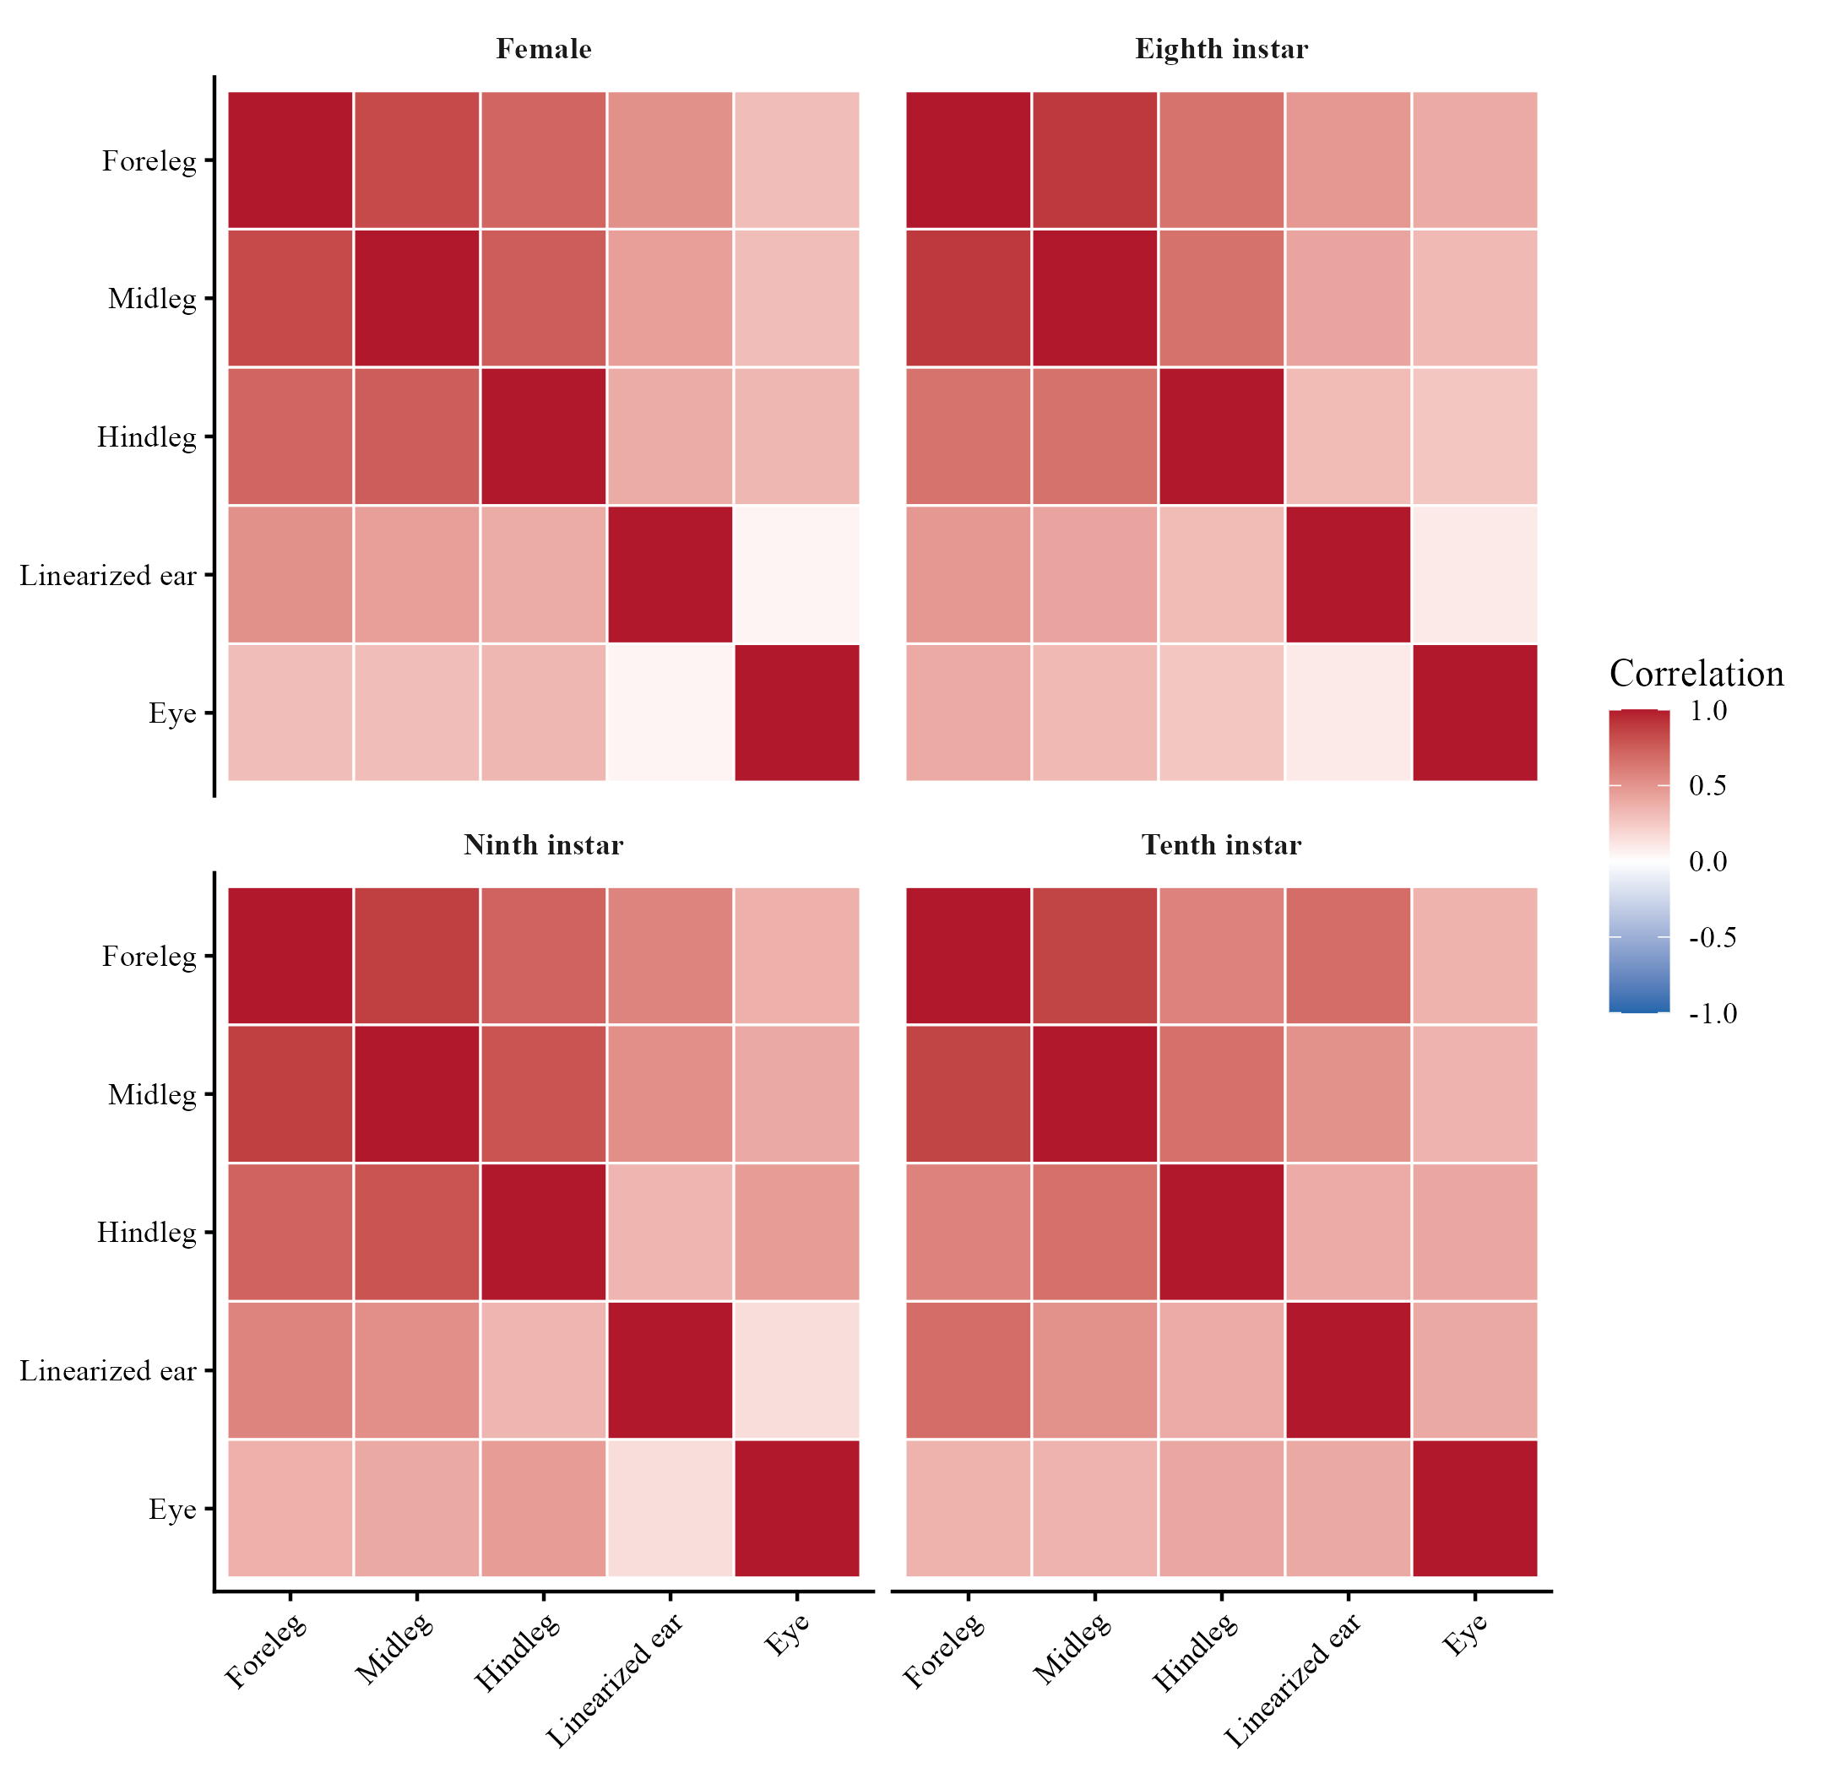
Supplementary Figure S2. Individual scores on the first two principal components of the five nonclassification traits after group-specific adjustment to a pronotum length of 7.2 mm. Diamonds show group centroids and ellipses show descriptive 68% normal regions. Parallel analysis retained PC1 but not PC2.
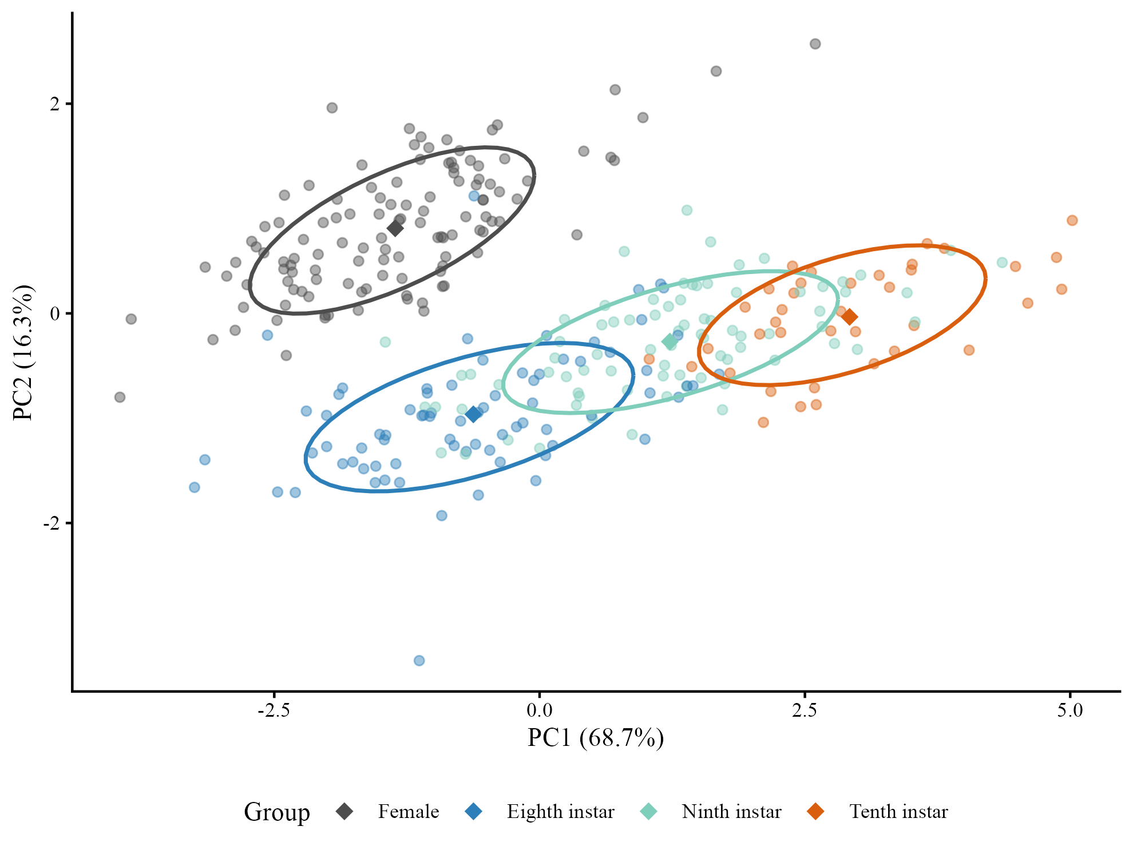

Supplementary Figure S3. Observed pronotum-length distributions by group. The dashed line marks the 7.2-mm reference used for adjusted means and contrasts; it falls within the common observed support of all four groups.
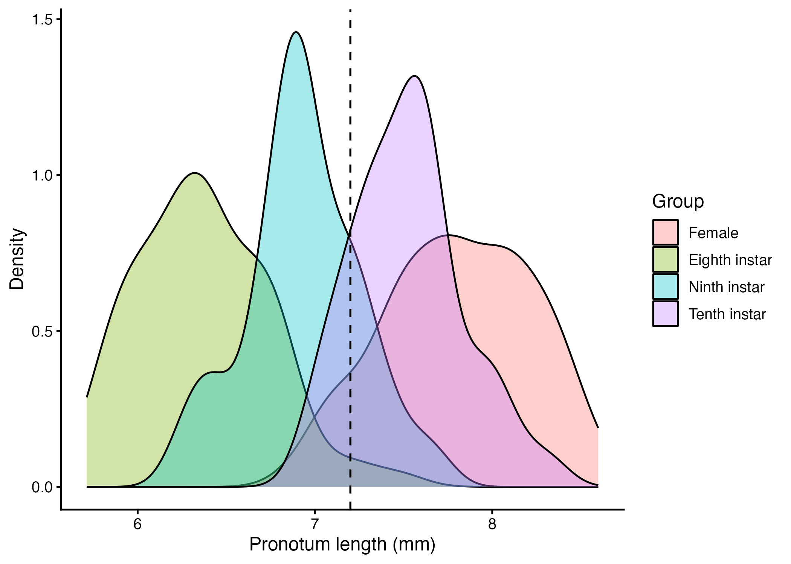

Supplementary Figure S4. Log–log relationships between pronotum length and total foreleg, midleg and hindleg length in females and the three male morphs. Points show individual measurements; fitted lines describe group-specific body-size relationships.
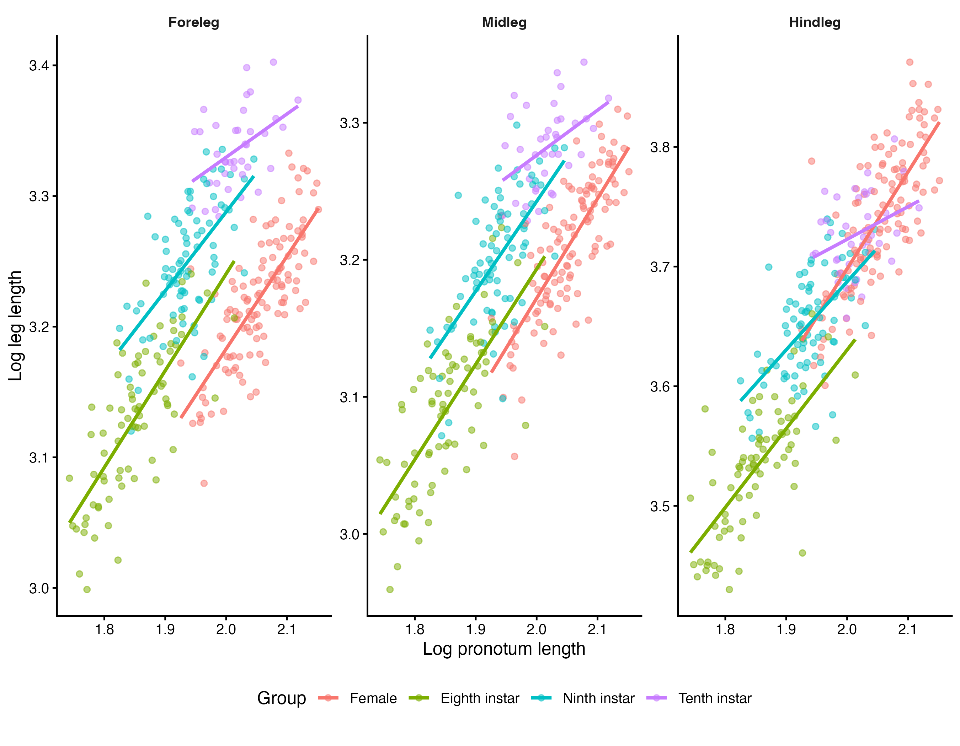

Supplementary references
Kelly, C.D. 2026. Can the form of sexual selection explain patterns of static weapon allometry expressed by alternative mating morphotypes? Evolution 80: 191–201.
Kelly, C.D. & Adams, D.C. 2010. Sexual selection, ontogenetic acceleration, and hypermorphosis generates male trimorphism in wellington tree weta. Evol. Biol. 37: 200–209.
Van Noordwijk, A.J. & de Jong, G. 1986. Acquisition and allocation of resources: Their influence on variation in life history tactics. Am. Nat. 128: 137–142. University of Chicago Press.

