A single dominant axis of locomotor and sensory divergence across alternative mating strategies in Wellington tree wētā

Abstract
Alternative mating strategies may involve coordinated divergence in locomotor and sensory morphology as well as weaponry. I examined these relationships in Wellington tree wētā (Hemideina crassidens), whose male morphs mature at the eighth, ninth or tenth instar and differ in weapon size and mating behaviour. Using field-collected adults, I compared body-size-adjusted leg lengths, eye length and tympanic organ area among females and the three male morphs. Leg and sensory dimensions generally increased from eighth- to tenth-instar males; searching males did not show the predicted enlargement of legs or eyes. Tenth-instar males also showed greater anterior leg allocation than females. A dominant axis captured 88.8% of adjusted group-effect variation, although smaller departures from that axis were detectable. All 40 within-group correlations among the five non-head traits were positive. No covariance- or correlation-matrix difference was detected in this primary trait set, but adding head size revealed a covariance-magnitude difference. Head size was positively associated with leg length, whereas male weapon–ear associations remained imprecise. Comparisons with females at the same terminal instar distinguished a within-male instar gradient from a sex-associated difference, without isolating a causal weapon effect. These results describe predominantly coordinated phenotypic divergence. They do not establish uniform covariance structure across all traits or exclude allocation costs masked by variation in resource acquisition.
Keywords: alternative mating strategies; allometry; morphological integration; phenotypic covariance; sexual selection; trait compensation; wētā

Introduction
Alternative mating strategies allow males to achieve reproductive success through different routes to mate competition. Large or well-armed males may defend females or reproductive resources, whereas smaller males obtain matings through sneaking, satellite behaviour or active searching (Gross, 1996; Shuster & Wade, 2003; Oliveira et al., 2008). These strategies can involve coordinated differences in morphology, physiology, behaviour and life history, rather than variation in weaponry alone (West-Eberhard, 2003). Understanding this coordination requires distinguishing differences among morph means from covariance among individuals within each morph.
Exaggerated sexual structures can impose developmental or performance costs. Secondary sexual trait compensation occurs when enlargement of supporting structures mitigates those costs (Tomkins et al., 2005; Husak & Swallow, 2011). If larger weapons increase the demands on structures used to support or manoeuvre the body during contests, weapon enlargement should be accompanied by enlargement of those structures. A further prediction of stronger weapon–supporting-trait associations in heavily armed morphs requires the additional assumption that these demands couple their expression more tightly. Alternatively, structures competing for limited developmental resources may trade off (Nijhout & Emlen, 1998; Emlen, 2001; Moczek & Nijhout, 2004), while variation in resource acquisition can elevate several costly traits together (van Noordwijk & de Jong, 1986; Bonduriansky & Day, 2003). Positive phenotypic covariance therefore need not demonstrate adaptive compensation, and its presence does not exclude an allocation trade-off. Developmental switches may also alter trait covariance among morphs, creating different patterns of integration within the same body plan (Snell-Rood et al., 2010; Rohner et al., 2020).
Studies of weapon-bearing insects illustrate this variation. Horn length covaries positively with leg morphology in dung beetles, sometimes more strongly in major than minor males (Tomkins et al., 2005; Rohner et al., 2020). Relatively long-horned rhinoceros beetles also have relatively long wings and foretibiae, but horn size is unrelated to eye size after body-size adjustment (McCullough & Emlen, 2013). In the stag beetle Prosopocoilus inclinatus, weapon size is integrated with eye size in major males and with foreleg length in minor males (Ito et al., 2017). Thus, weapon enlargement need not be accompanied by the same supporting traits in every morph.
Locomotor and sensory demands may differ between males that search for mates and those that defend them. Searching males could benefit from structures that facilitate movement and detection, whereas defenders could benefit from appendages that provide support during combat. In the desert bee Centris pallida, small males rely primarily on vision for mate detection and have relatively larger eyes than large males, which rely more on chemosensory cues (Barrett et al., 2021; Barrett & O’Donnell, 2026). Defending males might nevertheless require substantial sensory investment for assessing rivals or mating sites. Examining locomotor and sensory traits together can reveal whether strategy-associated divergence is broadly coordinated or differs among functional systems.
Coordinated trait expression can also arise through shared developmental influences, without each association representing a separate compensatory adaptation (Rohner et al., 2020). Variation in resource acquisition provides one route to positive covariance among traits (van Noordwijk & de Jong, 1986). Under a simple shared-growth model, several traits respond positively to a common developmental influence, and morphs differ mainly in the extent of that response. Their adjusted mean differences should then be concentrated along one dominant multivariate axis. If the same developmental relationships operate within morphs, positive within-morph associations would also be expected. Retention of those relationships across morphs predicts similar patterns of correlation, although variances and covariance magnitudes could differ. Here, shared growth refers to coordinated trait expression remaining after adjustment for structural body size, rather than simply larger animals having larger parts.
The Wellington tree wētā, Hemideina crassidens, is a flightless, nocturnal orthopteran in which females shelter communally in tree cavities, hereafter galleries. Males use enlarged heads and mandibles in contests for female-occupied galleries; larger weapons generally confer an advantage in escalated fights (Kelly, 2005, 2006; Kelly & Adams, 2010). Males express three genetically polymorphic, irreversible morphotypes through maturation at the eighth, ninth or tenth juvenile instar (Nason & Kelly, 2020; Kelly, 2024). Tenth-instar males have the most exaggerated weapons and commonly defend galleries. Eighth-instar males may circumvent defenders or search vegetation for undefended females; ninth-instar males combine fighting and sneaking according to social context (Wilson & Kelly, 2019; Kelly, 2025). Similar average reproductive fitness among strategies is consistent with maintenance of the polymorphism (Nason & Kelly, 2020).
Tympanal membranes receive airborne sound in H. crassidens, and the frequency of greatest auditory sensitivity overlaps the spectral peak of conspecific stridulation (Field et al., 1980). This establishes the relevance of tympanic organs to sensory comparisons, but does not establish greater reliance on hearing by searching males or a simple relationship between membrane area and detection performance.
I compared the relative expression and allometry of fore-, mid- and hindleg lengths, eye length and tympanic organ area among these male morphs and females. Females provide a reference sharing the general body plan without the exaggerated male weapons. I tested whether groups differed in anterior–posterior leg allocation and whether composite head size, used as a proxy for weapon investment, covaried with leg or sensory size after body-size adjustment. These are phenotypic comparisons, not direct measurements of resource allocation or performance.
I used three complementary hypotheses to organize comparisons of adjusted group means, within-group associations and multivariate structure. The searching-and-detection hypothesis predicts relatively longer legs and larger eyes in eighth-instar males than in tenth-instar males, assuming these dimensions improve movement and visual detection during searching. Extending this prediction to larger tympanic organs additionally assumes that searching increases reliance on acoustic cues and that membrane area reflects the relevant performance. These among-morph predictions do not specify the sign of within-morph weapon–trait covariance.
The positive-integration hypothesis predicts relatively larger supporting structures in the heavily armed tenth-instar morph and positive within-morph weapon–trait associations. Stronger associations in tenth-instar males are a further, conditional prediction if greater weapon-support demands tighten the relationship between trait dimensions. This rationale is most direct for legs; extending it to eyes or tympanic organs requires a sensory contribution to weapon-associated behaviour. Positive integration describes the predicted pattern, whereas compensation is one possible functional explanation.
The shared-growth-axis hypothesis predicts that most adjusted divergence among groups lies along one multivariate axis, with positive within-group covariance if shared developmental influences also operate among individuals. Similar correlation patterns across morphs would be consistent with retained developmental relationships; identical covariance magnitudes are not required. I assessed these structural predictions through exploratory multivariate analyses. The three hypotheses are not mutually exclusive: compensation can depend on shared development, and positive covariance alone cannot distinguish their underlying mechanisms.
Male morphs differ in both weapon size and terminal instar number, so comparisons among males cannot separate those attributes. Females mature at the tenth instar, allowing a comparison with tenth-instar males at matched instar number. I therefore estimated a within-male per-instar gradient and a tenth-instar male–female contrast in the same model. This distinguishes two descriptive components of divergence, but the matched contrast differs in sex as well as weapon expression and cannot isolate a causal weapon effect. I also examined the dimensionality of adjusted group differences and within-group covariance, and assessed whether ninth-instar males were intermediate between the other male morphs.

Materials and methods

Study site and specimen collection
The sample comprised 313 adult H. crassidens collected haphazardly at night from vegetation on Te Pākeka/Maud Island, New Zealand (41°02′ S, 173°54′ E), during March and April 2016. The island is a 309-ha scientific reserve in the Marlborough Sounds, free of introduced mammalian predators. Vegetation sampling may under-represent gallery occupants, and the analysed male morph composition differed from published reference samples. Collection microhabitat and search effort were not retained in sufficient detail to correct this potential selection bias. The results therefore describe the sampled adults; fixed adult morphology does not guarantee that either group means or within-group covariance is representative of the population.
Adult males were assigned to eighth-, ninth- or tenth-instar morphotypes using mixture models of head length fitted with mixsmsn (Prates et al., 2013), following Kelly & Adams (2010) and Kelly (2026). Individuals were euthanized by freezing at −20 °C. The head, pronotum and both legs of each pair were dissected and stored together in a labelled tube preserving the individual’s identifier.
Institutional animal-ethics approval was not required for this invertebrate study. The Department of Conservation provided permits for specimen collection and access to Te Pākeka/Maud Island.

Imaging and morphological measurements
Each dissected structure was photographed with a Canon EOS 5D Mark IV camera, Canon EF 100 mm f/2.8L IS USM Macro lens and Canon MT-26EX-RT flashes. The camera was mounted approximately 40 cm above the specimen with its sensor parallel to the imaging surface. A ruler and specimen identifier were photographed in the same plane; images were calibrated from the ruler and given a 5-mm scale bar using ImageJ.
Measurements were made in Fiji (Schindelin et al., 2012). Linear measurements used consistent anatomical landmarks and the straight-line tool; tympanic organ area was obtained by tracing the membrane perimeter (Figure 1). Traits were pronotum length, head length and width, eye length, and femur and tibia lengths for all three leg pairs. Bilateral structures were measured separately and averaged; the available side was used when only one side was measured. Total leg length was the sum of the corresponding femur and tibia lengths.

Measurement repeatability
Forty-eight individuals were remeasured twice from the original images, giving three measurements per trait. The sample contained 12 individuals from each sex or morph group, one from each of 12 recorded size strata. Image order was randomized independently for each round, and previous measurements were not consulted.
For each trait, a random-intercept model estimated repeatability as $R=V_{individual}/\left(V_{individual}+V_{residual}\right)$. Morph-adjusted and measurement-round-adjusted models, absolute-agreement coefficients, measurement error, round-pair bias and order diagnostics are reported in the supplement (Table S1).

Statistical analysis
Analyses used R (R Core Team, 2025), with tidyverse for preparation and visualization (Wickham et al., 2019), base R for ordinary least-squares models, nlme for generalized least squares (Pinheiro et al., 2024), and emmeans for adjusted means, trends and contrasts (Lenth et al., 2019). Diagnostics used performance, see and broom (Robinson, 2014; Lüdecke et al., 2021a; b). Females and the three male morphs formed the four levels of group.
Pronotum length represented structural body size. Composite head size was the geometric mean of head length and width. Tympanic organ area was square-root transformed to a linear dimension, and all continuous morphological variables were then natural-log transformed. Log–log slopes are consequently allometric exponents. Log pronotum length was centred at 7.2 mm, $logP_{c}=log\left(pronotum\right)−log\left(7.2\right)$, within the body-size range shared by all groups. Adjusted means at $logP_{c}=0$ thus represent interpolation. Data were checked for duplicate identifiers, unexpected labels, missing or nonpositive measurements and implausible ranges; missing observations were excluded per model.

Dimensionality and covariance
The primary multivariate trait set comprised foreleg, midleg and hindleg length, linearised tympanic organ size and eye length. Head size was excluded because head length contributes to morph assignment. These analyses used the 311 individuals complete for all five traits. The dimensionality and matrix tests are exploratory descriptions of integration, distinct from the planned marginal contrasts below.
A multivariate model with group-specific body-size slopes estimated adjusted group differences at 7.2 mm. Traits were standardized by pooled residual standard deviations, and the three male groups were expressed as contrasts with a shared female reference. A design-weighted singular value decomposition quantified the fraction of group-effect variation captured by a rank-one approximation. A test based on 9999 randomizations permuted multivariate residual vectors around the fitted rank-one model and assessed departures from rank one. This procedure preserves the shared female reference and does not treat repeated copies of females as independent groups. Sensitivity analyses added head size and repeated the six-trait analysis on unstandardized log measurements (Table S7).
Principal component analysis described individual-level size-adjusted variation. For each trait, the adjusted value was its group-specific fitted value at 7.2 mm plus its residual, retaining adjusted group differences while removing the estimated within-group body-size slope. Parallel analysis compared observed correlation-matrix eigenvalues with the 95th percentiles obtained by independently permuting trait columns in 9999 randomizations. This individual-level ordination and the rank-one analysis of group effects address different sources of variation.
Within-group covariance and correlation matrices were calculated from residuals of group-specific trait–body-size regressions. Omnibus and pairwise Frobenius-distance tests used 9999 randomizations of residual-vector group membership, retaining observed group sizes. Pairwise p-values were adjusted by Holm and Benjamini–Hochberg procedures. Adding head size tested sensitivity to trait selection; matrix similarities and rarefaction assessed descriptive structure and unequal sample sizes (Tables S8–S9). I also counted positive and negative within-group pairwise correlations and summarized their range and mean. This sign audit is descriptive: positive phenotypic covariance can mask allocation costs when resource acquisition varies among individuals (van Noordwijk & de Jong, 1986).

Leg allometry and allocation
Separate leg models compared common and group-specific slopes using nested-model $F$-tests. The principal analysis of relative leg allocation was a repeated-trait generalized least-squares model,
$$log\left(leg length\right)∼logP_{c}×group×leg.$$
Each individual contributed up to three leg measurements. An unstructured residual covariance matrix allowed separate residual variances for the three leg pairs and freely estimated within-individual correlations. It fitted better than heterogeneous compound symmetry (Table S10). Models used restricted maximum likelihood, with type III joint tests and approximate Satterthwaite denominator degrees of freedom. The three-way interaction tested whether group differences in body-size slope depended on leg identity.
Adjusted means were estimated by leg pair at 7.2 mm and exponentiated to geometric means. Exponentiated contrasts are ratios, with values above one indicating a larger estimate for the first-named group. Planned comparisons contrasted eighth- with tenth-instar males, ninth-instar males with the eighth/tenth midpoint, and tenth-instar males with females. Difference-in-differences contrasts compared foreleg with hindleg, midleg with hindleg, and the mean of the anterior leg pairs with hindleg. These quantify relative anterior–posterior allocation rather than absolute leg size. Separate femur and tibia models and detailed slope comparisons were exploratory (Tables S14–S16).

Weapon and sensory associations
Weapon–leg integration was tested by adding raw log composite head size to the repeated-trait model,
$$logL∼\left(logP_{c}+logH\right)×G×J,$$
where $L$ is leg length, $H$ is composite head size, $G$ is group and $J$ is leg identity.
The same unstructured residual covariance was retained. Group- and leg-specific partial head-size slopes controlled for pronotum length and were compared within the relevant contrast families. Positive slopes describe positive phenotypic integration; negative slopes would be consistent with a morphological trade-off. Neither sign alone identifies a developmental mechanism. Earlier residual-predictor models are retained as exploratory checks, not as the basis of the principal weapon–leg inference.
Body-size-adjusted sensory models related log-linearised ear size and log eye length to $logP_{c}$, group and their interaction. Common- and group-specific-slope models were compared by nested $F$-tests, and means were estimated at 7.2 mm. Eye estimates were exponentiated to lengths. Ear estimates were returned to area as $exp\left(2\hat{μ}\right)$, and ear contrast ratios were squared after exponentiation.
Local associations were tested in one-stage models containing group-specific body-size effects plus raw log foretibia length for the ear or raw log head size for the eye. Each anatomical predictor was allowed to interact with group, and a nested-model test compared this with a common partial slope. The corresponding ear model with head size tested weapon–ear covariance. These models distinguish size-adjusted associations from shared body size but cannot identify adaptive integration, resource allocation or developmental independence. Head size also reflects feeding structures and the substrate bearing the eyes, not weaponry alone.

Instar-matched comparisons and precision
Each log trait was modelled as
$$log\left(trait\right)∼logP_{c}+{instar}_{c}+sex,$$
where ${instar}_{c}$ is terminal instar number minus ten. The instar coefficient describes the within-male change per additional instar; the sex coefficient describes tenth-instar males relative to females at matched instar number. Their difference was tested directly. These are contrasts on a common log scale, not estimates of independently manipulated developmental and weapon effects. The latter is termed the instar-matched weapon component for continuity, but it includes any other sex-associated differences. One additional instar and the male–female comparison are also different biological contrasts, so their relative coefficients are not proportions of a causal variance partition.
The same decomposition was fitted jointly across leg pairs with the previously described residual covariance and fixed effects $\left(logP_{c}+{instar}_{c}+sex\right)×leg$. Estimated marginal means and trends are reported with 95% confidence intervals. Planned leg and allocation contrasts, weapon–leg slopes and male weapon–ear slopes are accompanied by approximate minimum detectable effects at 80% power and $α=0.05$, calculated from observed standard errors and reference $t$ quantiles. These describe precision conditional on the fitted model; they do not turn a nonsignificant result into evidence of equivalence. Exploratory equivalence tests used specified illustrative regions (Tables S5 and S13).

Inference and diagnostics
Holm adjustments were applied within the reported contrast families, including male–female, male-strategy and allocation contrasts, and across the five traits within each component of the instar-matched decomposition. The cross-analysis multiplicity audit is a separate sensitivity analysis (Table S12). Interpretation considered effect direction, confidence intervals and precision as well as $α=0.05$; exploratory tests were not treated as additional confirmatory evidence.
Graphical diagnostics assessed residual normality, variance and residual–fitted relationships; variance-inflation diagnostics assessed collinearity. Cook’s distance above $4/n$, leverage above $2p/n$, or an absolute standardized residual above 3 flagged observations for inspection, where $n$ is sample size and $p$ the number of coefficients. These criteria did not trigger automatic deletion.

Results

Sample composition and body-size overlap
The analysis included 313 individuals across four groups (Table 1). Pronotum lengths overlapped from 6.99 to 7.49 mm, encompassing the 7.2-mm reference used for adjusted comparisons.

Dimensionality and covariance
For the five non-head traits, the dominant axis captured 88.8% of design-weighted group-effect variation (Table 2). The remaining variation exceeded the rank-one randomization distribution (p < 0.001; 9999 randomizations), indicating smaller but detectable departures from a single axis. Across the 3 trait-set and scaling scenarios, the rank-one share ranged from 88.8% to 98.3% (Table S7).
Parallel analysis of individual-level adjusted measurements retained 1 component, explaining 68.7% of variance. The second eigenvalue (0.82) was below its randomization threshold (1.12). All five first-component loadings had the same sign, describing coordinated variation in leg and sensory dimensions. This result concerns individual-level variation and does not negate the smaller departure from rank one detected among adjusted group means.
In the primary five-trait analysis, no difference was detected among groups in covariance matrices (p = 0.398) or correlation matrices (p = 0.848; 9999 randomizations), and no pairwise comparison survived Holm adjustment (Table S8). When head size was restored in the six-trait sensitivity analysis, a covariance-matrix difference was detected (p = 0.042), but a correlation-matrix difference was not (p = 0.581). The absence of a detected difference therefore applies to the primary non-head trait set, not to all measured morphology.
All 40 of the 40 within-group pairwise correlations among the five adjusted traits were positive (Table 3). Mean correlations ranged from 0.45 to 0.52 among groups, with a minimum individual correlation of 0.05. This audit found no negative phenotypic covariance in the primary trait set. It neither establishes the absence of allocation costs nor demonstrates that covariance matrices are equivalent among groups.

Locomotor morphology

Relative allocation among leg pairs
Group differences depended strongly on leg identity in the repeated-trait model ($F_{6,301.27}=71.97,p<0.001$). Male–female differences therefore varied among forelegs, midlegs and hindlegs (Figure 2; Table S14). At the common body size, forelegs of eighth-, ninth- and tenth-instar males were respectively 5.8% longer (Holm-adjusted p < 0.001), 11.4% longer (Holm-adjusted p < 0.001) and 16.9% longer (Holm-adjusted p < 0.001) than those of females. Corresponding midleg differences were 2.1% longer (Holm-adjusted p = 0.053), 7.5% longer (Holm-adjusted p < 0.001) and 12.2% longer (Holm-adjusted p < 0.001). Hindleg differences were 6.3% shorter (Holm-adjusted p < 0.001), 0.5% shorter (Holm-adjusted p = 0.573) and 3.9% longer (Holm-adjusted p < 0.001).
Tenth-instar males had longer legs than eighth-instar males across all three pairs. Eighth-instar forelegs were 9.5% shorter (Holm-adjusted p < 0.001) and hindlegs 9.9% shorter (p < 0.001). Ninth-instar estimates were near the eighth/tenth midpoint. Exploratory two-one-sided tests supported equivalence within a ±2.5% region for all three pairs (largest p = 0.032; Table S13). The largest absolute midpoint contrast was 0.9%, compared with a maximum minimum-detectable difference of 2.4% (Table 5). Equivalence here is specific to the chosen region, not evidence of identical means.
The planned anterior–posterior allocation contrasts among male morphs were not supported (all Holm-adjusted p-values at least 1.000). Tenth-instar males nevertheless showed an anterior shift relative to females: their foreleg-to-hindleg ratio was 12.5% greater (ratio of ratios 1.13; Holm-adjusted p < 0.001). All three planned tenth-instar male–female allocation contrasts were supported (largest Holm-adjusted p < 0.001).

Allometric variation
All estimated group-by-leg slopes were below one (Figure 3; Table S15). The body-size-by-group interaction was supported ($F_{3,306.04}=3.53,p=0.015$), but the body-size-by-group-by-leg interaction was not ($F_{6,301.23}=1.81,p=0.096$). Thus, some group variation in scaling was detected without clear evidence that it differed by leg pair. Tenth-instar males had the shallowest point estimates, but corrected comparisons did not establish a consistent morph ordering. The adjusted means provide the clearest description of group differences; detailed slopes and femur–tibia analyses remain exploratory (Tables S15–S16).

Instar-matched comparisons
Both the within-male per-instar component and the tenth-instar male–female component were supported for all five traits (Table 4). The largest Holm-adjusted p-values were 2.69e-08 and 0.000633, respectively. Their coefficients also differed for every trait (largest Holm-adjusted p < 0.001).
For forelegs, midlegs, eyes and linearised tympanic organ size, the matched male–female component exceeded the per-instar component. Matched male–female differences were 15.9%, 10.9%, 24.6% and 7.9%, compared with per-instar changes of 5.0%, 4.3%, 6.9% and 3.6%. Hindlegs showed the reverse: a 4.5% per-instar change exceeded the 2.2% matched male–female difference.
The joint leg decomposition gave similar estimates (per-instar changes 4.4–5.0%; matched male–female differences 2.2–15.9%). The hindleg gradient thus tracked terminal instar number more closely than the same-instar sex contrast. These associations do not establish that extra moults caused the differences, or that the sex contrast measures weapon effects alone.

Weapon–leg integration
After adjustment for pronotum length, 11 of 12 head–leg slopes had 95% confidence intervals entirely above zero; no estimated slope was negative (Table S3). The group-by-leg-by-head interaction was supported ($F_{6,301.6}=3.62,p=0.002$), indicating heterogeneity among partial slopes. Planned morph contrasts were nevertheless uniformly nonsignificant after Holm adjustment (Table S4), so they did not establish a simple morph ranking in integration strength. Positive weapon–leg association was widespread, but neither identical slopes nor a causal compensation mechanism was demonstrated.

Sensory morphology

Adjusted group differences
Group-specific body-size slopes were not supported for ear size ($F_{3,305}=0.25,p=0.862$) or eye length ($F_{3,305}=0.63,p=0.596$), and adjusted comparisons used common-slope models. At 7.2 mm pronotum length, tenth-instar males had tympanic organ areas 15.3% larger than females (Holm-adjusted p < 0.001). Eighth-instar males had areas 12.6% smaller than tenth-instar males (p < 0.001).
Tenth-instar males had eyes 25.1% longer than females (Holm-adjusted p < 0.001); eighth-instar eyes were 12.6% shorter than tenth-instar eyes (p < 0.001). Ninth-instar midpoint contrasts were nonsignificant for both ear (p = 0.241) and eye (p = 0.459), with exploratory equivalence tests in Table S13. Sensory dimensions followed the same broad eighth-to-tenth-instar gradient as leg length (Figure 2; Table S17).

Local associations and weapon–ear covariance
No group difference in partial slope was detected for ear–foretibia ($F_{3,301}=1.33,p=0.264$) or eye–head ($F_{3,301}=1.97,p=0.118$) associations. Confidence intervals were entirely positive for 4 of 4 ear–foretibia slopes and 4 of 4 eye–head slopes. These findings describe positive local associations without demonstrating equivalence among groups. Eye–head slopes ranged from 0.40 to 0.94 and may partly reflect the shared geometry of the head capsule.
The weapon–ear group-by-head interaction was not supported ($F_{3,301}=1.34,p=0.261$). The female slope was positive (0.397, 95% confidence interval 0.178–0.615; p < 0.001), whereas none of the three male intervals excluded zero. Male estimates ranged from 0.130 to 0.291, and approximate minimum detectable slopes averaged 0.38 and reached 0.64 (Table 6). No standardized slope met the illustrative ±0.20 near-zero equivalence criterion (Table S5). Male associations therefore remain imprecise: these results neither demonstrate a negative weapon–ear relationship nor establish negligible association. A significant female slope and nonsignificant male slopes do not themselves establish a sex difference.

Model diagnostics
Observed and predicted trait distributions corresponded closely. Residuals were approximately normal with broadly homogeneous variance and minor curvature at fitted-range extremes. Diagnostic checks did not identify an observation requiring exclusion after measurement inspection. The log–log models and repeated-trait generalized least-squares specification were retained.

Discussion
The sampled male morphs showed coordinated divergence in body-size-adjusted locomotor and sensory dimensions. Eighth-instar searching males did not have the longest legs or largest sensory structures; these traits generally increased towards tenth-instar males. This pattern opposed the searching-and-detection predictions for legs and eyes. A dominant axis summarized most adjusted group-effect variation, but a smaller departure from rank one was detectable. The findings therefore describe predominantly, rather than exclusively, one-dimensional divergence.
All within-group correlations among the five non-head traits were positive, and no covariance- or correlation-matrix difference was detected for that primary trait set. This is compatible with a shared pattern of integration, not proof of invariant covariance. The six-trait sensitivity detected a covariance-magnitude difference when head size was restored. Because head length contributes to male classification, excluding it addresses an important source of dependence, but the sensitivity result prevents extending the five-trait null result to the entire phenotype.

Locomotor divergence among strategies
Tenth-instar males had the longest adjusted legs and eighth-instar males the shortest, with ninth-instar estimates close to the midpoint. This intermediate position is consistent with flexible fighting and sneaking (Wilson & Kelly, 2019; Kelly, 2025), but it may also follow from maturation at an intermediate instar. Morphological intermediacy alone does not demonstrate adaptation for behavioural flexibility.
The strongest anterior–posterior allocation contrast involved tenth-instar males and females, rather than two male morphs. Foreleg enlargement could help heavily armed males stabilize the body, maintain purchase or manoeuvre during contests. Comparable support functions have been proposed for weapon-associated leg enlargement in beetles (Tomkins et al., 2005; McCullough & Emlen, 2013). However, these data contain no measurements of leverage, locomotor performance or fighting success, so the proposed function remains untested.
Among male morphs, differences were principally a general leg-length gradient rather than a supported redistribution between anterior and posterior legs. The simple expectation of long-legged searching males contrasted with anteriorly specialized defenders was therefore not supported. Some group variation in body-size scaling was detected, but the three-way interaction and corrected slope comparisons did not resolve a consistent leg-specific morph pattern. Adjusted means provide firmer evidence of morphological divergence than the exploratory slope rankings. Previously reported weapon allometry (Kelly, 2026) cannot be assumed to apply to supporting structures.

Positive integration and masked allocation costs
Individuals with relatively larger heads generally had relatively longer legs. This is consistent with secondary sexual trait compensation, in which supporting structures enlarge alongside costly weaponry (Tomkins et al., 2005; Husak & Swallow, 2011). It also resembles positive weapon–hindleg integration in exaggerated male European earwigs, Forficula auricularia (Tomkins et al., 2005). Both earwigs and tree wētā grow through successive nymphal instars rather than within a closed pupal system, making their developmental comparison relevant. Nevertheless, positive phenotypic associations alone cannot identify compensation or explain differences between hemimetabolous and holometabolous insects.
The acquisition–allocation distinction is central. Variation in acquired resources can generate positive covariance among costly traits even when those traits compete for a limited allocation pool (van Noordwijk & de Jong, 1986). Resource acquisition was not measured in these field-collected adults. Consequently, the absence of negative covariance means that no negative phenotypic association was detected in the measured primary trait set; it does not rule out underlying developmental costs.
Positive weapon–leg relationships were widespread rather than restricted to the most heavily armed morph. Although the omnibus interaction detected slope heterogeneity, planned contrasts did not establish consistently stronger integration in tenth-instar males. A shared growth process, compensatory development and correlated selection remain possible explanations. The dimensionality and sign results are compatible with shared growth but do not discriminate decisively among those mechanisms. Manipulating acquisition while tracking several traits would provide a more direct test of allocation costs than further cross-sectional correlations alone.

Sensory divergence and local anatomy
The eye-length gradient ran opposite to the expectation that actively searching eighth-instar males would invest most in visual detection. This contrasts with relatively larger eyes in small searching Centris pallida males (Barrett et al., 2021; Barrett & O’Donnell, 2026). Strategy-associated sensory investment therefore cannot be inferred simply from whether males search or defend. Gallery defence may itself require rival assessment or navigation, or sensory enlargement may accompany a broader developmental programme without being a tactic-specific adaptation. The parallel tympanic-organ gradient is informative descriptively, but the corresponding search-related prediction remains conditional on an untested link between hearing and mate searching.
Male–female differences suggest a separate possibility. All male morphs had relatively longer eyes than females, and ninth- and tenth-instar males had larger tympanic organs. If males are more mobile, a sensory correlate of mate searching might be expressed between sexes rather than among male morphs. Mobility was not measured here, so that interpretation remains a hypothesis. Common-slope sensory models describe shifts in adjusted trait elevation, but common estimated slopes do not establish a shared developmental mechanism. Elevation differences can generate substantial sensory exaggeration without steeper scaling, as reported for crane-fly antennae (Hirani & Bonduriansky, 2026).
Neither eye length nor tympanic membrane area measures sensory performance directly. Larger eyes could differ in ommatidial number or sensitivity, or simply reflect head-capsule geometry. Membrane area alone does not specify hearing thresholds or frequency response. These traits are therefore indices of morphological investment whose functional significance requires physiological or behavioural measurements.
Positive ear–foretibia and eye–head associations were expected given their anatomical relationships. Eyes and mandibles occupy the same head capsule, so shared geometry can contribute to eye–head covariance independently of adaptive coordination between vision and weaponry. No local slope differences were detected, but those tests did not establish equivalent associations across groups.
Weapon–ear covariance illustrates why among-group divergence and within-group integration must be separated. Ear area followed the male morph gradient, yet within-male head–ear slopes were imprecise and did not meet the near-zero equivalence criterion. The results support neither developmental independence nor strong male integration. They also do not establish a female–male slope difference. Parallel morph means can coexist with uncertain within-morph associations, and the uncertainty should not be converted into evidence of biological decoupling.

What the female reference resolves
Females revealed an anterior allocation shift and sensory differences that a male-only comparison would miss. They also supplied the only terminal-instar-matched reference. The per-instar coefficient was larger than the matched sex coefficient for hindlegs, whereas the matched sex coefficient was larger for anterior legs and sensory dimensions. This describes where divergence tracks the male instar gradient and where a larger same-instar sex difference remains.
Females are not an unselected control: their morphology is subject to reproductive, locomotor and sensory demands of its own. Nor does matching terminal instar isolate weapon expression. The comparison still differs in sex, and terminal instar number is not a direct measurement of chronological development time. The two components are useful descriptive contrasts, but cannot assign causal shares of divergence to extra moults and weapons. Longitudinal developmental measurements or manipulations are required for that inference.

Limitations and future tests
Genetic polymorphism in morph expression makes these comparisons less dependent on nutritionally induced morph determination than many insect polyphenisms (Kelly, 2024). It does not remove environmental variation within morphs. Food, temperature, health and developmental history may affect several adult traits together, even at the same final pronotum length. Body-size adjustment cannot eliminate all consequences of different maturation pathways.
Vegetation sampling and unequal group sizes further constrain inference. Gallery occupants may be under-represented, and the sampled morph composition differed from published population references. Unrecorded sampling differences could affect both estimated means and covariance. Tenth-instar males were less numerous than other groups, limiting precision for some slopes and interactions. The reported confidence intervals, equivalence sensitivities and minimum detectable effects make these limitations explicit but do not correct the sampling frame.
Functional experiments could test whether anterior leg dimensions improve stability or contest performance independently of weapon size, and whether eye or tympanic dimensions predict detection under natural conditions. Common-garden studies following genetically assigned morphs through successive instars could separate developmental history from strategy-associated allocation. Combining resource manipulations with estimates of genetic covariance and selection would help distinguish shared growth from adaptive compensation.

Conclusions
Locomotor and sensory dimensions generally increased from eighth- to tenth-instar males, with most adjusted group divergence concentrated along one dominant axis and smaller detectable departures from it. No negative within-group phenotypic covariance or matrix restructuring was detected in the primary five-trait analysis, but head-inclusive sensitivity results qualify any broader claim of homogeneous covariance. Positive head–leg and local sensory associations do not exclude masked allocation costs, and male weapon–ear integration remains uncertain. Instar-matched female comparisons reveal an additional sex-associated contrast without isolating a causal weapon effect. Alternative mating strategies in this sample are therefore characterized by predominantly coordinated morphological divergence whose developmental and functional causes remain to be tested.

References
Barrett, M. & O’Donnell, S. 2026. Sex, head size, and Male mate location behavior affect allometric scaling of the eyes in Centris Pallida (hymenoptera: Apidae) bees. Integr. Org. Biol. 8: obag016.
Barrett, M., Schneider, S., Sachdeva, P., Gomez, A., Buchmann, S. & O’Donnell, S. 2021. Neuroanatomical differentiation associated with alternative reproductive tactics in Male arid land bees, Centris Pallida and Amegilla Dawsoni. J. Comp. Physiol. A 207: 497–504.
Bonduriansky, R. & Day, T. 2003. The evolution of static allometry in sexually selected traits. Evolution 57: 2450–2458.
Emlen, D.J. 2001. Costs and the diversification of exaggerated animal structures. Science 291: 1534–6.
Field, L.H., Hill, K.G. & Ball, E.E. 1980. Physiological and biophysical properties of the auditory system of the New Zealand weta Hemideina crassidens (blanchard, 1851) (ensifera: stenopelmatidae). J. Comp. Physiol. 141: 31–37.
Gross, M.R. 1996. Alternative reproductive strategies and tactics: Diversity within sexes. Trends Ecol Evol 11: 92–8.
Hirani, S. & Bonduriansky, R. 2026. Scaling and developmental integration of a secondary sexual sensory trait. Evol. Ecol. 40: 8–25.
Husak, J.F. & Swallow, J.G. 2011. Compensatory traits and the evolution of male ornaments. Behaviour 148: 1–29. BRILL.
Ito, J., Ohkubo, Y. & Hasegawa, E. 2017. Morph-Specific Weapon-Correlated Traits in a Male Dimorphic Stag Beetle Prosopocoilus inclinatus, (Coleoptera: Lucanidae). Ann. Entomol. Soc. Am. 110: 281–285. Entomological Society of America.
Kelly, C.D. 2025. A behaviourally plastic jack-of-all-trades mating strategy in the Wellington tree wētā. Anim. Behav. 229: 123332. Elsevier.
Kelly, C.D. 2005. Allometry and sexual selection of male weaponry in Wellington tree weta, Hemideina crassidens. Behav. Ecol. 16: 145–152.
Kelly, C.D. 2024. Alternative mating strategies in the Wellington tree weta expressed via genetic polymorphism for precocial male maturation. R. Soc. Open Sci. 11: 240100.
Kelly, C.D. 2026. Can the form of sexual selection explain patterns of static weapon allometry expressed by alternative mating morphotypes? Evolution 80: 191–201.
Kelly, C.D. 2006. Fighting for harems: Assessment strategies during male–male contests in the sexually dimorphic wellington tree weta. Anim. Behav. 72: 727–736. Elsevier BV.
Kelly, C.D. & Adams, D.C. 2010. Sexual selection, ontogenetic acceleration, and hypermorphosis generates male trimorphism in wellington tree weta. Evol. Biol. 37: 200–209.
Lenth, R., Singmann, H., Love, J., Buerkner, P. & Herve, M. 2019. Package “emmeans”: Estimated marginal means, aka least-squares means.
Lüdecke, D., Ben-Shachar, M., Patil, I., Waggoner, P. & Makowski, D. 2021a. Performance: An package for assessment, comparison and testing of statistical models. J. Open Source Softw. 6: 3139. The Open Journal.
Lüdecke, D., Patil, I., Ben-Shachar, M.S., Wiernik, B.M., Waggoner, P. & Makowski, D. 2021b. See: An R Package for Visualizing Statistical Models. J. Open Source Softw. 6: 3393.
McCullough, E. & Emlen, D. 2013. Evaluating the costs of a sexually selected weapon: Big horns at a small price. Anim. Behav. 86: 977–985.
Moczek, A.P. & Nijhout, H.F. 2004. Trade-offs during the development of primary and secondary sexual traits in a horned beetle. Am. Nat. 163: 184–191.
Nason, S.E. & Kelly, C.D. 2020. Equal fitness among alternative mating strategies in a harem polygynous insect. Proc. R. Soc. B Biol. Sci. 287: 20200975. The Royal Society.
Nijhout, H.F. & Emlen, D.J. 1998. Competition among body parts in the development and evolution of insect morphology. Proc. Natl. Acad. Sci. 95: 3685–3689. Proceedings of the National Academy of Sciences.
Oliveira, R.F., Taborsky, M. & Brockmann, H.J. 2008. Alternative Reproductive Tactics. Cambridge University Press.
Pinheiro, J., Bates, D. & R Core Team. 2024. Nlme: Linear and nonlinear mixed effects models.
Prates, M.O., Cabral, C.R.B. & Lachos, V.H. 2013. Mixsmsn: Fitting finite mixture of scale mixture of skew-normal distributions. J. Stat. Softw. 54: 96–114.
R Core Team. 2025. R: A language and environment for statistical computing. R Foundation for Statistical Computing.
Robinson, D. 2014. Broom: An R Package for Converting Statistical Analysis Objects Into Tidy Data Frames. arXiv.
Rohner, P.T., Macagno, A.L.M. & Moczek, A.P. 2020. Evolution and plasticity of morph-specific integration in the bull-headed dung beetle Onthophagus Taurus. Ecol. Evol. 10: 10558–10570.
Schindelin, J., Arganda-Carreras, I., Frise, E., Kaynig, V., Longair, M., Pietzsch, T., et al. 2012. Fiji: An open-source platform for biological-image analysis. Nat. Methods 9: 676–82.
Shuster, S.M. & Wade, M.J. 2003. Mating Systems and Strategies. Princeton University Press.
Snell-Rood, E.C., Van Dyken, J.D., Cruickshank, T., Wade, M.J. & Moczek, A.P. 2010. Toward a population genetic framework of developmental evolution: The costs, limits, and consequences of phenotypic plasticity. Bioessays 32: 71–81.
Tomkins, J.L., Kotiaho, J.S. & Lebas, N.R. 2005. Phenotypic plasticity in the developmental integration of morphological trade-offs and secondary sexual trait compensation. Proc Biol Sci 272: 543–51.
van Noordwijk, A.J. & de Jong, G. 1986. Acquisition and allocation of resources: Their influence on variation in life history tactics. The American Naturalist 128: 137–142.
West-Eberhard, M.J. 2003. Developmental Plasticity and Evolution. Oxford University Press, Oxford, UK.
Wickham, H., Averick, M., Bryan, J., Chang, W., McGowan, L.D., François, R., et al. 2019. Welcome to the Tidyverse. J. Open Source Softw. 4: 1686.
Wilson, A.D.M. & Kelly, C.D. 2019. Do alternative reproductive strategies in the ellington tree weta represent different behavioural types? Ethology 125: 380–391. Wiley.

Tables
Table 1: Sample sizes and descriptive body-size statistics for females and the three male developmental groups.
Group | Sample size | Pronotum mean | Pronotum SD | Pronotum minimum | Pronotum maximum
Female | 118 | 7.81 | 0.41 | 6.86 | 8.60
Eighth instar | 78 | 6.37 | 0.37 | 5.71 | 7.49
Ninth instar | 79 | 6.93 | 0.32 | 6.20 | 7.73
Tenth instar | 38 | 7.52 | 0.31 | 6.99 | 8.31

Table 2: Structure of morphological integration among the five non-head traits.
Quantity | Value
Rank-one share of group-effect variation | 88.8%
Range across analysis scenarios | 88.8–98.3%
Residual beyond rank one (permutation p) | p < 0.001
Components retained (parallel analysis) | 1
Variance explained by the first component | 68.7%
Group difference in covariance matrices (p) | p = 0.398
Group difference in correlation matrices (p) | p = 0.848
Negative size-adjusted within-group covariances | 0 of 40
Traits and groups in the sign audit | 5 traits x 4 groups

Table 3: Within-group correlations among the five size-adjusted traits, by group.
Group | Pairs | Positive | Negative | Mean r | Median r | Min r | Max r
Eighth instar | 10 | 10 | 0 | 0.45 | 0.41 | 0.10 | 0.90
Female | 10 | 10 | 0 | 0.47 | 0.42 | 0.05 | 0.84
Ninth instar | 10 | 10 | 0 | 0.52 | 0.49 | 0.16 | 0.88
Tenth instar | 10 | 10 | 0 | 0.52 | 0.46 | 0.35 | 0.86

Table 4: Descriptive decomposition into a within-male per-instar change and an instar-matched male–female contrast. The latter is labelled the weapon component but includes other sex-associated differences; it is not a causal weapon effect. Ear percentages refer to linearised tympanic organ size.
Trait | n | Per instar (%) | Per instar P | Weapon (%) | Weapon P | Difference P | Larger component
Foreleg length | 313 | 5.0 | <0.001 | 15.9 | <0.001 | <0.001 | Weapon
Midleg length | 312 | 4.3 | <0.001 | 10.9 | <0.001 | <0.001 | Weapon
Hindleg length | 311 | 4.5 | <0.001 | 2.2 | <0.001 | <0.001 | Per instar
Tympanic organ size | 313 | 3.6 | <0.001 | 7.9 | <0.001 | <0.001 | Weapon
Eye length | 313 | 6.9 | <0.001 | 24.6 | <0.001 | <0.001 | Weapon

Table 5: Planned contrasts in body-size-adjusted leg length with approximate minimum detectable effects. Ratios compare the first-named group with the second; percentage differences use the second as the reference. Allocation contrasts are ratio-of-ratios comparisons. The 95% intervals are on the ratio scale.
Leg | Contrast | Difference (%) | 95% CI | Minimum detectable (%)
Foreleg | Tenth instar - Eighth instar | 10.5 | 1.08–1.13 | 3.5
Midleg | Tenth instar - Eighth instar | 9.8 | 1.07–1.12 | 3.5
Hindleg | Tenth instar - Eighth instar | 11.0 | 1.08–1.14 | 3.8
Foreleg | Tenth instar - Female | 16.9 | 1.15–1.19 | 2.8
Midleg | Tenth instar - Female | 12.2 | 1.10–1.14 | 2.8
Hindleg | Tenth instar - Female | 3.9 | 1.02–1.06 | 3.0
Foreleg | Ninth instar - midpoint(Eighth instar, Tenth instar) | 0.1 | 0.99–1.02 | 2.2
Midleg | Ninth instar - midpoint(Eighth instar, Tenth instar) | 0.5 | 0.99–1.02 | 2.2
Hindleg | Ninth instar - midpoint(Eighth instar, Tenth instar) | 0.9 | 0.99–1.03 | 2.4
All (allocation) | Tenth instar - Female: foreleg relative to hindleg | 12.5 | 1.11–1.14 | 2.3
All (allocation) | Tenth instar - Female: midleg relative to hindleg | 7.9 | 1.06–1.10 | 2.2
All (allocation) | Tenth instar - Eighth instar: foreleg relative to hindleg | -0.4 | 0.98–1.02 | 2.9

Table 6: Within-group weapon–ear slopes and the smallest slope distinguishable from zero with 80% power.
Group | Weapon–ear slope | SE | 95% CI | Excludes zero | Minimum detectable slope
Female | 0.397 | 0.111 | 0.18–0.62 | yes | 0.31
Eighth instar | 0.167 | 0.090 | -0.01–0.34 | no | 0.25
Ninth instar | 0.130 | 0.086 | -0.04–0.30 | no | 0.24
Tenth instar | 0.291 | 0.228 | -0.16–0.74 | no | 0.64

Figures
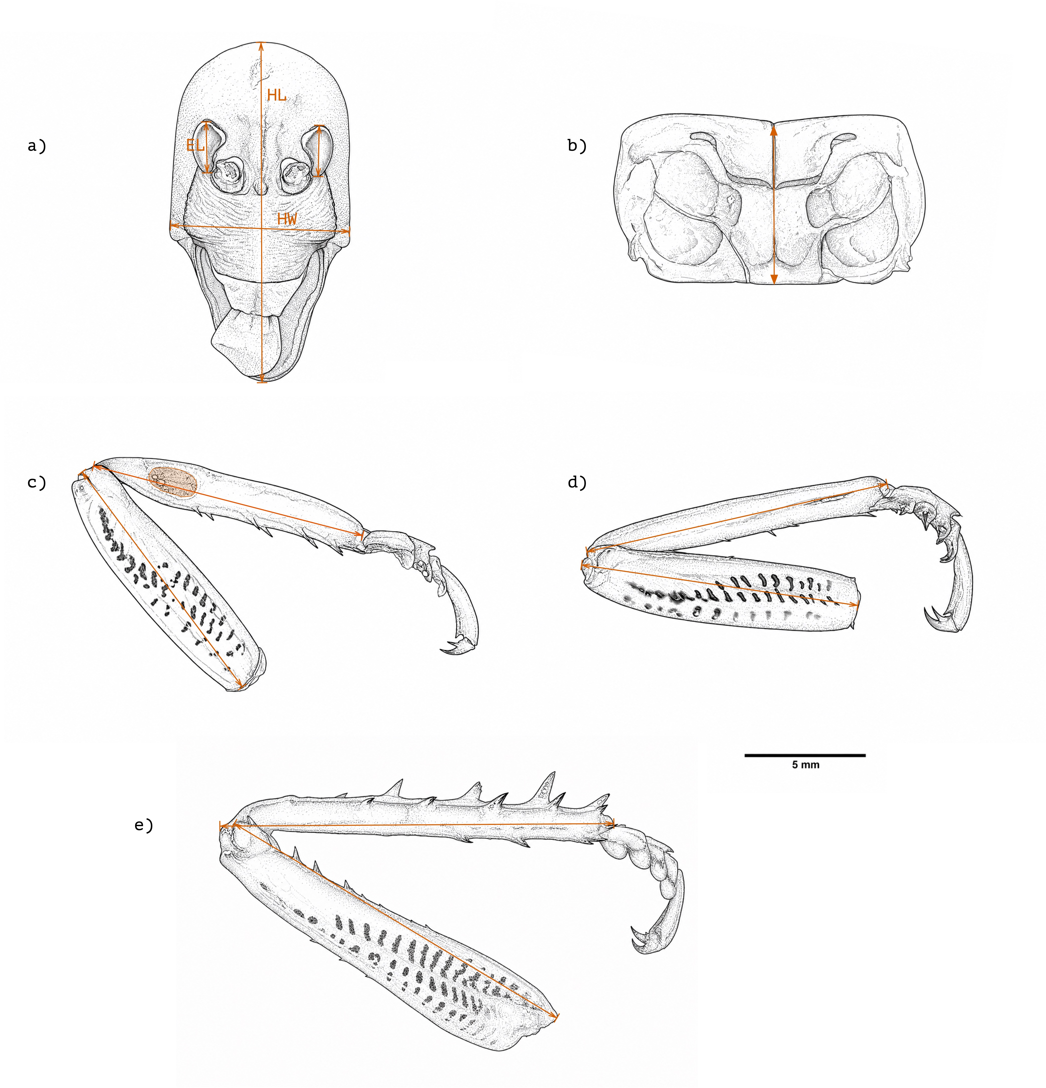
Figure 1: Morphological landmarks used to measure Wellington tree wētā. (a) Dorsal head view showing head length (HL), head width (HW), and eye length (EL). (b) Dorsal pronotum view showing pronotum length. (c–e) Foreleg, midleg, and hindleg, respectively, showing femur and tibia lengths; panel c also indicates the tympanal membrane, whose area was measured by tracing its perimeter. Orange arrows indicate measurement endpoints. Scale bar = 5 mm.

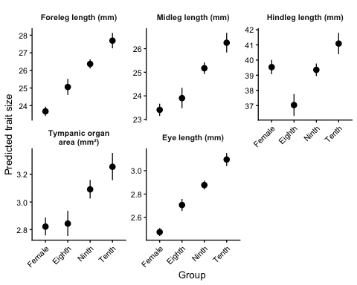
Figure 2: Body-size-adjusted predicted lengths of the three leg pairs and eye, and predicted tympanic organ area, for females and the three male morphotypes at a pronotum length of 7.2 mm. Points are model estimates; bars are 95% confidence intervals. Scales differ among panels, and tympanic organ area is in square millimetres.

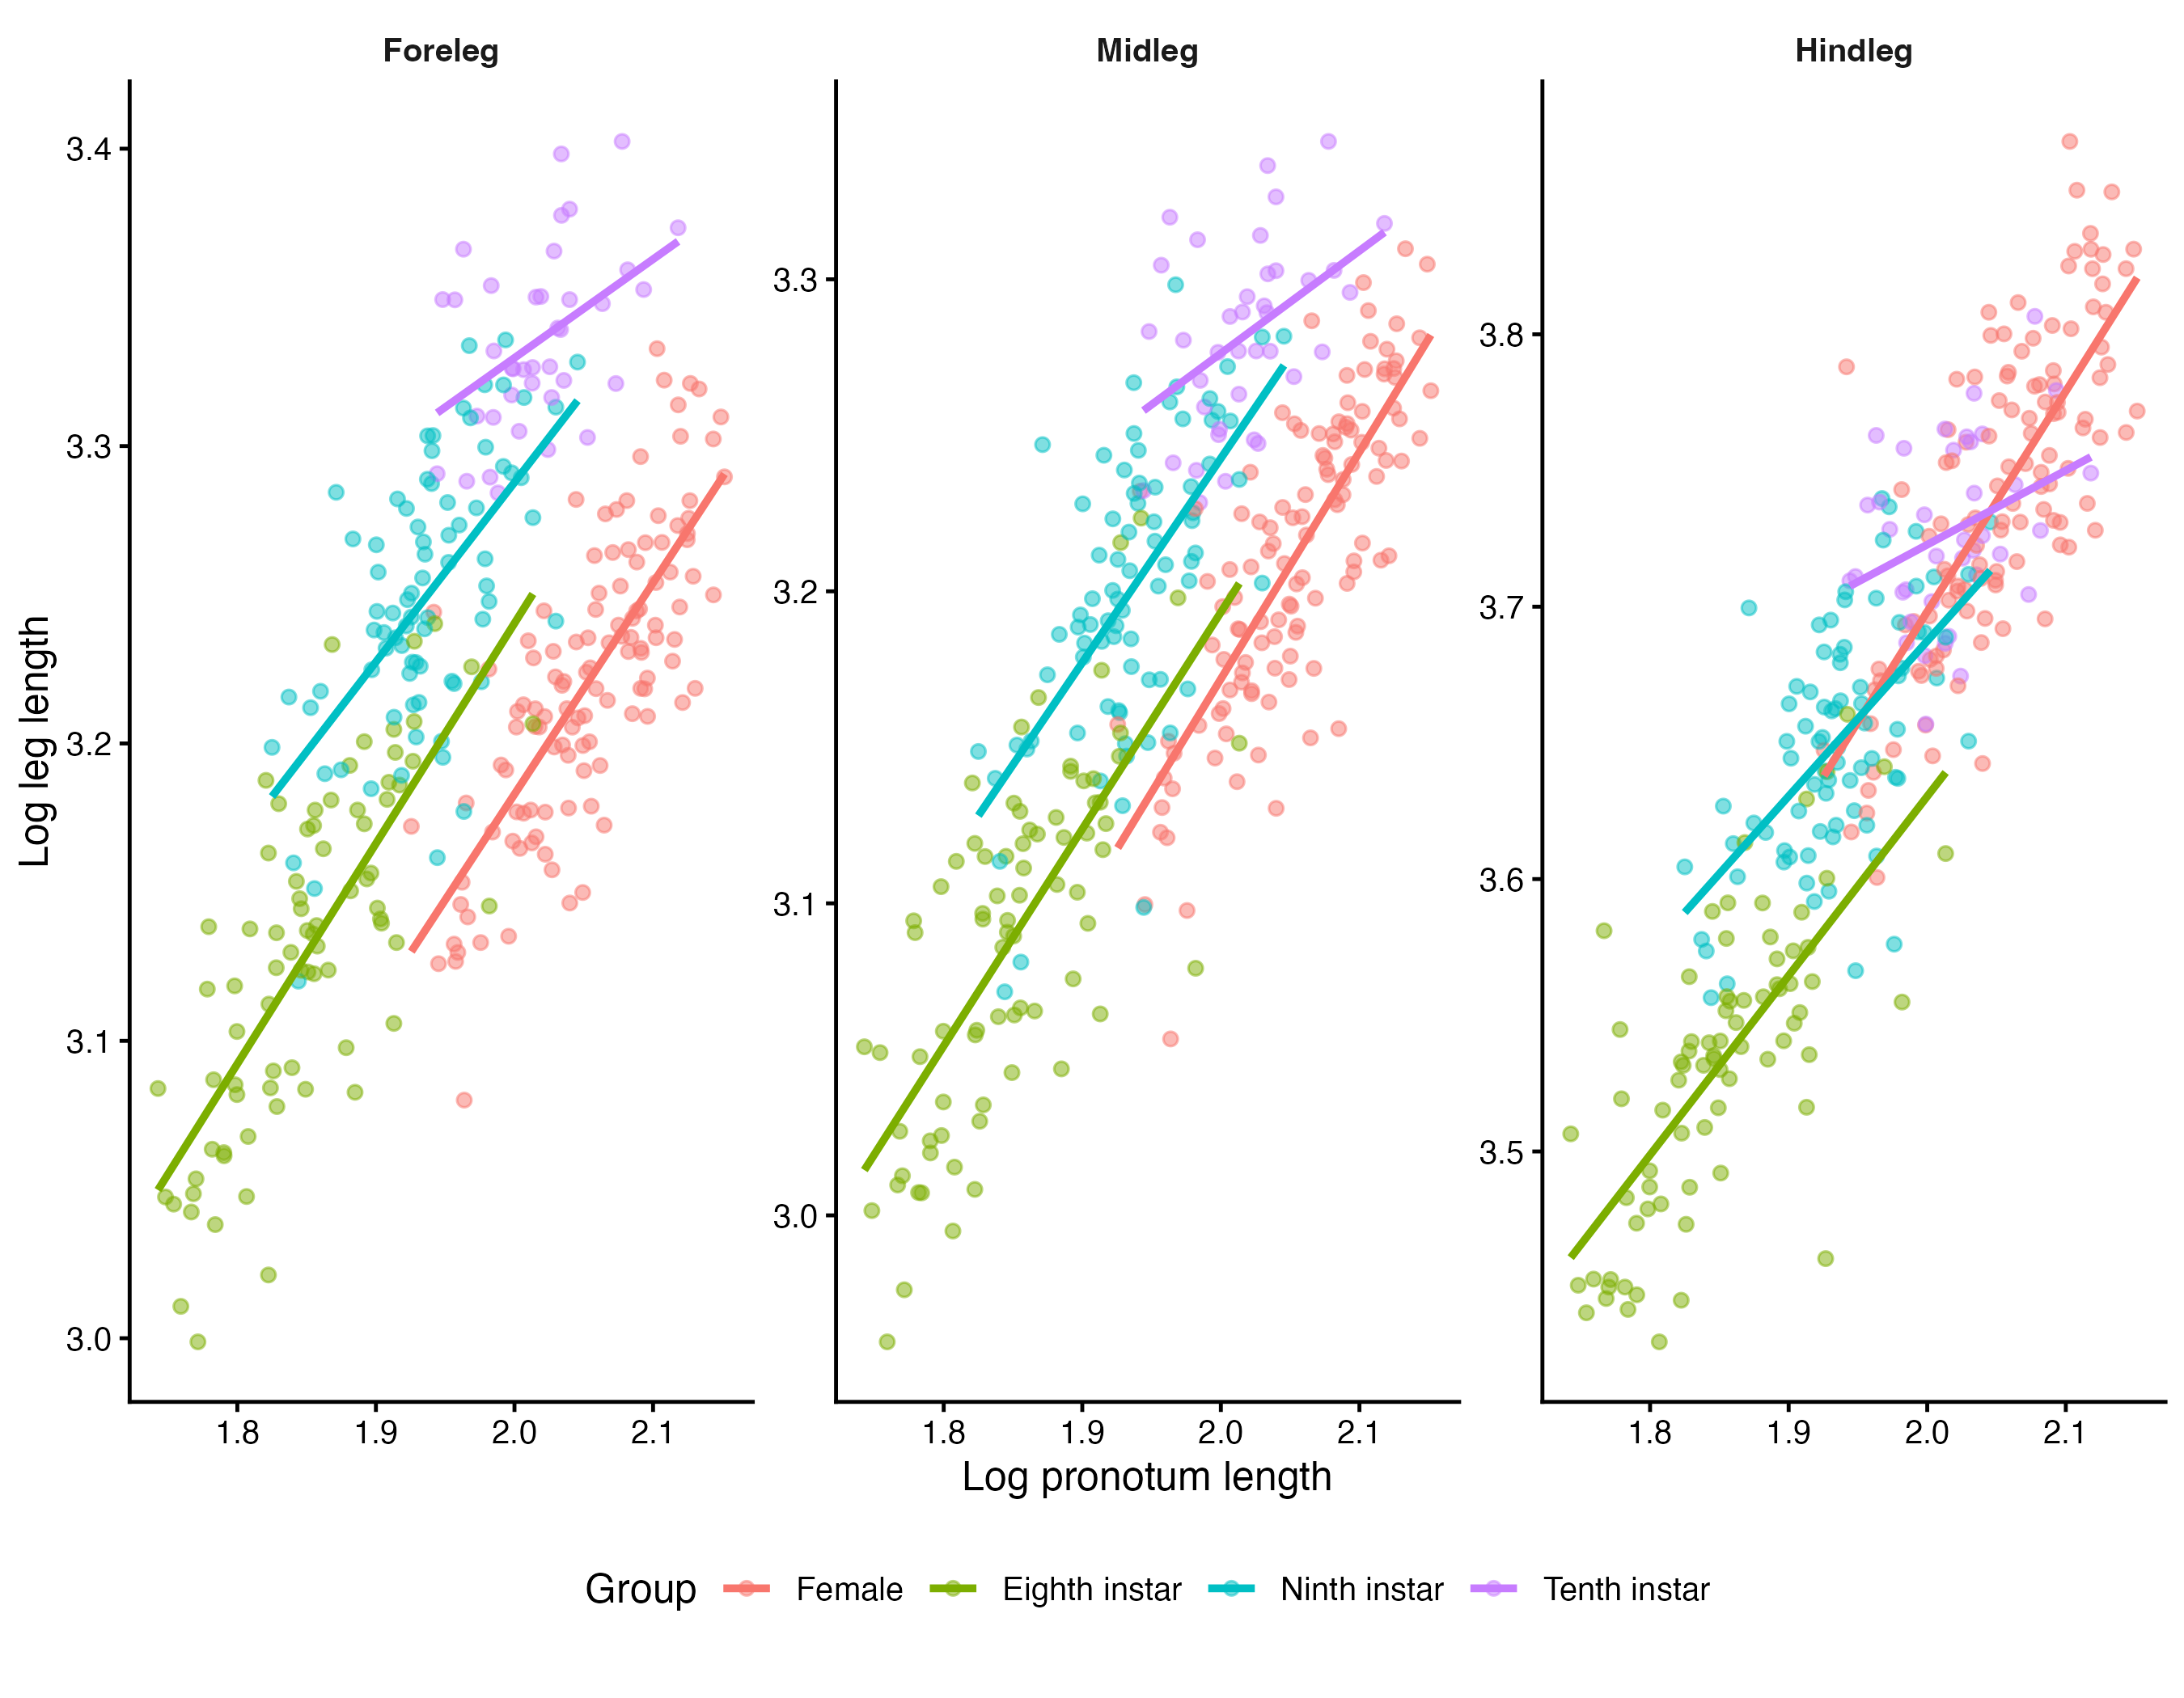
Figure 3: Log–log relationships between pronotum length and total foreleg, midleg, and hindleg length in females and the three male morphotypes.

