Wellington tree wētā morphological allocation
Draft Results section

1. Results

1.1 Sample composition and body-size overlap
The analysis included 313 individuals: 118 females, 78 eighth-instar males, 79 ninth-instar males, and 38 tenth-instar males. Mean pronotum length was 7.81 ± 0.41 mm in females, 6.37 ± 0.37 mm in eighth-instar males, 6.93 ± 0.32 mm in ninth-instar males, and 7.52 ± 0.31 mm in tenth-instar males. All four groups overlapped in pronotum length from 6.99 to 7.49 mm. The reference size of 7.2 mm used for adjusted comparisons therefore lay within the region of common support.
Table 1: Sample sizes and descriptive body-size statistics for females and the three male developmental groups.
Group | Sample size | Pronotum mean | Pronotum SD | Pronotum minimum | Pronotum maximum
Female | 118 | 7.81 | 0.41 | 6.86 | 8.60
Eighth | 78 | 6.37 | 0.37 | 5.71 | 7.49
Ninth | 79 | 6.93 | 0.32 | 6.20 | 7.73
Tenth | 38 | 7.52 | 0.31 | 6.99 | 8.31

1.2 Locomotory morphology

1.2.1 Relative allocation among leg pairs
The joint repeated-trait model showed that group differences depended strongly on leg identity (F(6, 622.86) = 100.35, p < 0.001). Thus, the male developmental groups were not uniformly longer- or shorter-legged than females; instead, the magnitude and direction of group differences varied among forelegs, midlegs, and hindlegs. There was also evidence that group-specific allometric slopes depended on leg identity (F(6, 622.72) = 2.18, p = 0.044), although this three-way effect was much weaker than the group-by-leg interaction. The body-size-by-group interaction was also supported within the joint model (F(3, 312.31) = 3.62, p = 0.013).
At a pronotum length of 7.2 mm, eighth-, ninth-, and tenth-instar males had forelegs that were 5.8% longer (Holm-adjusted p < 0.001), 11.4% longer (Holm-adjusted p < 0.001), and 16.9% longer (Holm-adjusted p < 0.001), respectively, than those of females. Midlegs were 2.1% longer (Holm-adjusted p = 0.057), 7.5% longer (Holm-adjusted p < 0.001), and 12.2% longer (Holm-adjusted p < 0.001), respectively. Hindlegs showed a contrasting pattern: eighth-instar males had hindlegs that were 6.3% shorter (Holm-adjusted p < 0.001), ninth-instar males had hindlegs that were 0.5% shorter (Holm-adjusted p = 0.555), and tenth-instar males had hindlegs that were 3.9% longer (Holm-adjusted p < 0.001) relative to females. Overall, foreleg enlargement increased progressively across the male developmental groups, midleg enlargement was concentrated in the ninth- and tenth-instar groups, and hindleg morphology followed a different trajectory.
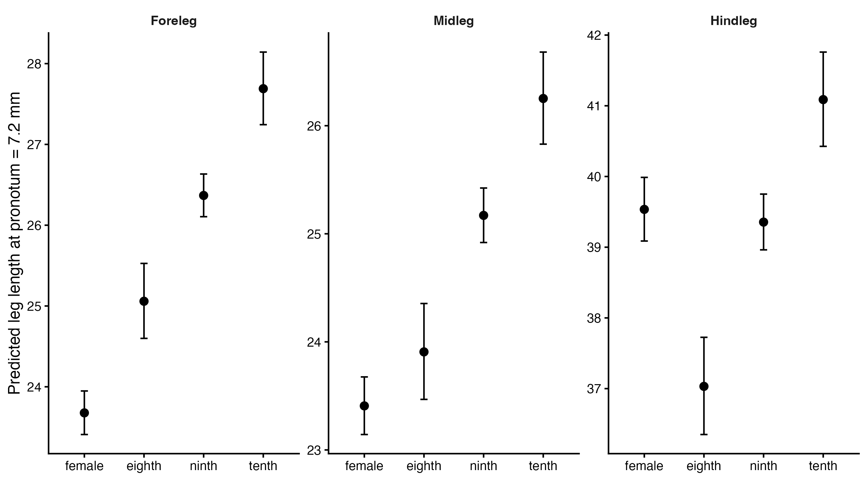
Figure 1: Size-adjusted predicted foreleg, midleg, and hindleg lengths for females and the three male developmental groups at a pronotum length of 7.2 mm. Error bars are 95% confidence intervals.
Table 2: Male–female contrasts in predicted leg length at a pronotum length of 7.2 mm. Percent differences are expressed relative to females; positive values indicate longer legs in males. P-values are Holm-adjusted within leg pair.
Leg | Contrast | Percent difference | Ratio lower 95% CI | Ratio upper 95% CI | Adjusted p
Foreleg | eighth - female | 5.8 | 1.031 | 1.087 | <0.001
Foreleg | ninth - female | 11.4 | 1.093 | 1.134 | <0.001
Foreleg | tenth - female | 16.9 | 1.141 | 1.198 | <0.001
Midleg | eighth - female | 2.1 | 0.995 | 1.049 | 0.057
Midleg | ninth - female | 7.5 | 1.056 | 1.095 | <0.001
Midleg | tenth - female | 12.2 | 1.095 | 1.149 | <0.001
Hindleg | eighth - female | -6.3 | 0.912 | 0.962 | <0.001
Hindleg | ninth - female | -0.5 | 0.977 | 1.014 | 0.555
Hindleg | tenth - female | 3.9 | 1.014 | 1.065 | <0.001

1.2.2 Allometric variation
Estimated allometric slopes were below one for all group-by-leg combinations, indicating negative allometry of leg length relative to pronotum length. Tenth-instar males had the shallowest estimated slope for all three leg pairs. After Holm correction within each leg, the clearest specific contrast was the hindleg slope difference between females and tenth-instar males (difference = 0.537, p = 0.003). The exhaustive decomposition of the three-way interaction further showed that the female–eighth-instar slope contrast differed between forelegs and hindlegs (difference-in-differences = -0.193, p = 0.048). Females and eighth-instar males therefore had nearly parallel foreleg allometries, whereas their hindleg allometries were more divergent. Other corrected slope contrasts were not clearly supported.
Table 3: Group- and leg-specific allometric slopes from the joint repeated-trait model.
Group | Leg | Slope | Lower 95% CI | Upper 95% CI
Female | Foreleg | 0.711 | 0.592 | 0.829
Eighth | Foreleg | 0.741 | 0.606 | 0.876
Ninth | Foreleg | 0.604 | 0.437 | 0.770
Tenth | Foreleg | 0.332 | 0.056 | 0.607
Female | Midleg | 0.727 | 0.609 | 0.846
Eighth | Midleg | 0.690 | 0.555 | 0.826
Ninth | Midleg | 0.655 | 0.488 | 0.821
Tenth | Midleg | 0.329 | 0.053 | 0.604
Female | Hindleg | 0.809 | 0.691 | 0.928
Eighth | Hindleg | 0.647 | 0.511 | 0.782
Ninth | Hindleg | 0.569 | 0.403 | 0.736
Tenth | Hindleg | 0.273 | -0.003 | 0.548

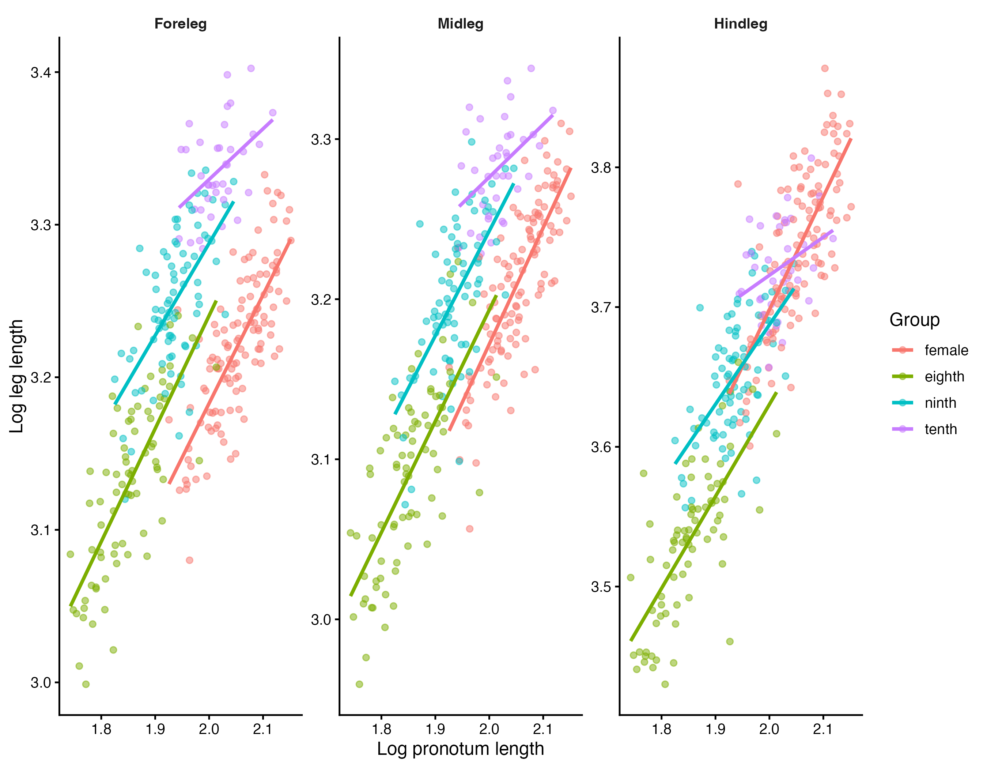
Figure 2: Log–log relationships between pronotum length and total foreleg, midleg, and hindleg length in females and the three male developmental groups.

1.2.3 Femur and tibia components
Group-specific allometric slopes were supported for Forefemur, Midfemur, Hindfemur, Hindtibia; the remaining segment models were adequately described by common slopes. These secondary analyses indicate which femur or tibia components contributed to the group-level differences in total leg allometry.
Table 4: Nested-model tests of group-specific allometric slopes for each femur and tibia component.
Segment | Numerator df | Residual df | F | P-value | Result
Forefemur | 3 | 305 | 4.06 | 0.007 | Different slopes
Foretibia | 3 | 305 | 1.45 | 0.228 | Common slope adequate
Midfemur | 3 | 304 | 2.82 | 0.039 | Different slopes
Midtibia | 3 | 304 | 1.95 | 0.121 | Common slope adequate
Hindfemur | 3 | 304 | 3.79 | 0.011 | Different slopes
Hindtibia | 3 | 303 | 4.20 | 0.006 | Different slopes

1.3 Sensory morphology

1.3.1 Ear size and foretibia length
The ear–foretibia slope did not differ among groups (F(3, 301) = 1.33, p = 0.264). Across groups, linearized ear size increased with foretibia length with an allometric slope of 0.795 (95% CI 0.673–0.917). The ear–pronotum interaction was also not supported (F(3, 304) = 0.86, p = 0.464). After accounting for pronotum size and foretibia length, Eighth-instar males were 5.0% smaller in area than females (Holm-adjusted p = 0.013); Ninth-instar males were 5.7% smaller in area than females (Holm-adjusted p = 0.005); Tenth-instar males were 5.7% smaller in area than females (Holm-adjusted p = 0.012).
Table 5: Adjusted predicted ear area at a pronotum length of 7.2 mm and mean foretibia length.
Group | Predicted ear area | Lower 95% CI | Upper 95% CI
Female | 3.032 | 2.967 | 3.098
Eighth | 2.881 | 2.807 | 2.956
Ninth | 2.858 | 2.798 | 2.919
Tenth | 2.860 | 2.771 | 2.952

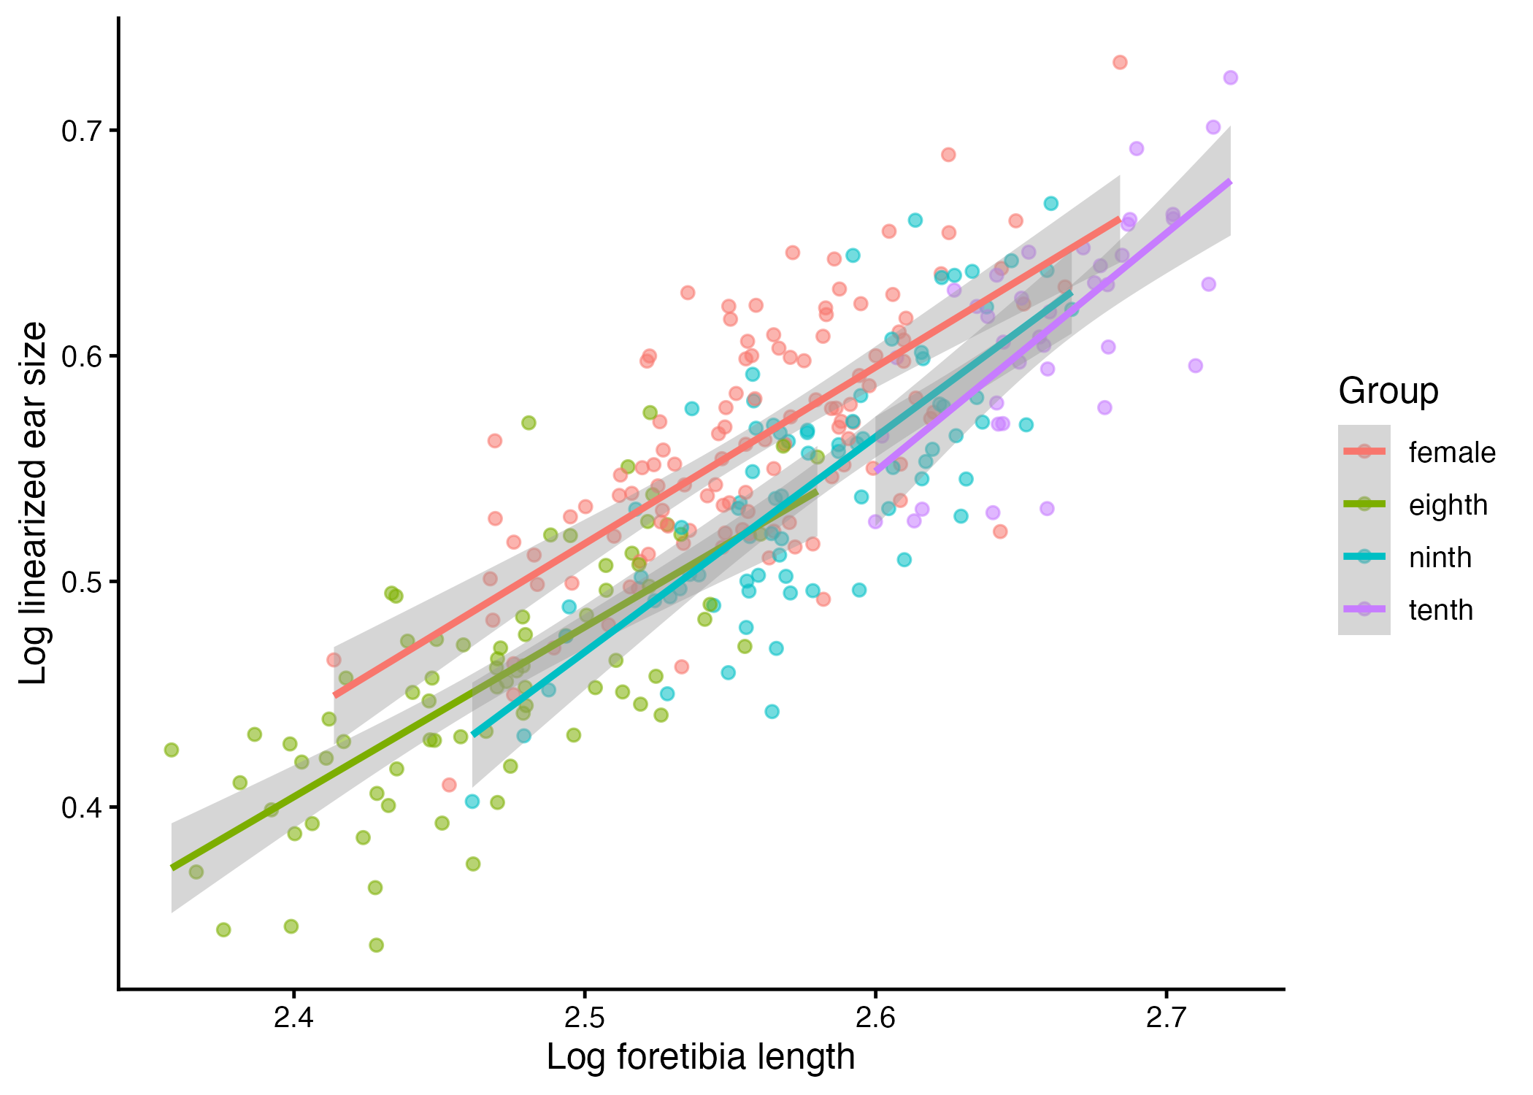
Figure 3: Relationship between linearized ear size and foretibia length in females and the three male developmental groups.

1.3.2 Eye length and head size
The eye–head-size slope did not differ among groups (F(3, 301) = 1.97, p = 0.118). Across groups, eye length scaled with head size with an allometric slope of 0.575 (95% CI 0.469–0.682). The eye–pronotum interaction was not supported (F(3, 304) = 1.03, p = 0.380). At a pronotum length of 7.2 mm and mean head size, Eighth-instar males were 10.8% shorter than females (Holm-adjusted p < 0.001); Ninth-instar males were 13.4% shorter than females (Holm-adjusted p < 0.001); Tenth-instar males were 12.5% shorter than females (Holm-adjusted p < 0.001).
Table 6: Adjusted predicted eye length at a pronotum length of 7.2 mm and mean head size.
Group | Predicted eye length | Lower 95% CI | Upper 95% CI
Female | 2.920 | 2.826 | 3.018
Eighth | 2.606 | 2.560 | 2.653
Ninth | 2.528 | 2.463 | 2.596
Tenth | 2.555 | 2.458 | 2.656

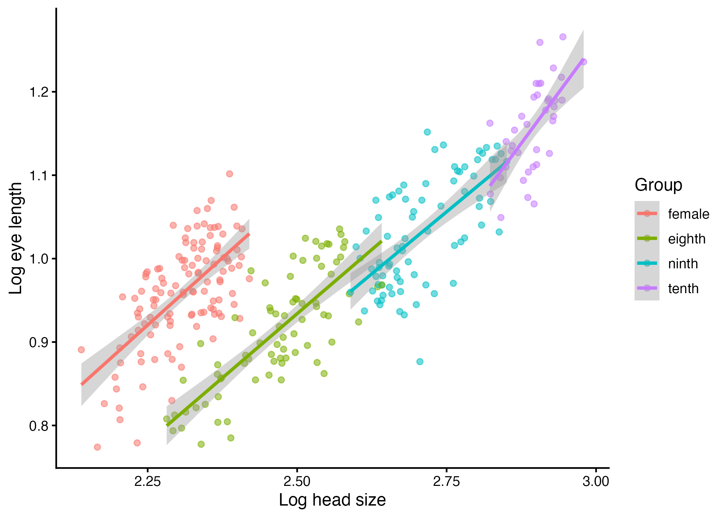
Figure 4: Relationship between eye length and composite head size in females and the three male developmental groups.

1.4 Model diagnostics
Observed and model-predicted trait distributions corresponded closely. Residuals were approximately normally distributed and showed broadly homogeneous variance, with only minor curvature near the extremes of the fitted ranges. Collinearity remained below conventional concern thresholds, and no observation showed sufficient influence to justify exclusion after the underlying measurements had been checked. The log–log linear models and the repeated-trait mixed model were therefore retained for inference.

