Supplementary material
Coordinated locomotory and sensory divergence across alternative mating strategies in Wellington tree wētā
Clint D. Kelly
Département des Sciences biologiques, Université du Québec à Montréal, Montréal, Canada
Correspondence: kelly.clint@uqam.ca; ORCID: 0000-0002-0693-7211

Overview
This supplement contains supporting, sensitivity and diagnostic analyses for the accompanying manuscript. The main text is restricted to analyses that directly test the dimensionality of group-mean divergence, locomotory allocation, sensory divergence, within-group matrix structure, and prespecified equivalence contrasts. Analyses below evaluate measurement reliability, the robustness of multivariate conclusions to trait definition and morph classification, pairwise matrix comparisons, unequal group sizes, the repeated-leg covariance specification, secondary weapon–trait relationships, sample composition and cross-analysis multiplicity.
Residual-index models, separate segment-level decompositions and extensive group-specific slope searches are retained in the reproducibility archive but are not promoted as inferential evidence. They either duplicate a one-stage model reported here or do not materially change the biological conclusions.

Supplementary methods

Measurement reliability
Forty-eight specimens were measured on three occasions. Repeatability was estimated for pooled, morph-adjusted and morph-plus-round models. Relative technical error of measurement, absolute-agreement ICC(A,1), round-pair bias and measurement-order trends were also calculated. The order analyses were treated as diagnostics; their minimum Benjamini–Hochberg-adjusted p-values were 0.524 for signed drift and 0.867 for absolute-error drift.

Multivariate sensitivity analyses
The primary female-referenced contrast-vector and PCA analyses excluded composite head size because head length contributed to male morph assignment. Sensitivity analyses restored head size, repeated the rank-one decomposition on unstandardized log traits, and repeated the five-trait PCA after excluding males whose archived labels disagreed with the published 2010 head-length thresholds. All randomization analyses used 9,999 permutations.

Matrix comparisons and unequal sample sizes
Within-group covariance and correlation matrices for the five non-head traits were compared using omnibus and pairwise Frobenius-distance randomization tests. Pairwise p-values were adjusted by both Benjamini–Hochberg and Holm procedures. Matrix-element correlations and random-skewers similarities were used as descriptive orientation measures. To evaluate unequal group sizes, each group was repeatedly rarefied to 38 specimens, the size of the tenth-instar male group.

Repeated-leg covariance structure
The focal repeated-leg model estimated separate residual variances for fore-, mid- and hindlegs and freely estimated the three within-individual residual correlations. It was compared with compound-symmetry and heterogeneous compound-symmetry structures using fits with identical fixed effects. A separate individual-by-leg random intercept is not identifiable because each individual-by-leg cell contains one observation.

Secondary integration, equivalence and sampling checks
Weapon–leg relationships were estimated in one stage from raw log composite head size while controlling for pronotum length, group and leg identity. Weapon–ear slopes were likewise estimated in one stage and evaluated against a prespecified standardized near-zero region of −0.20 to 0.20. Sensory pairwise comparisons were Holm-adjusted within each six-comparison trait family. Morph-composition χ² tests compared the analysed males with two published empirical compositions; they diagnose compositional mismatch but cannot identify its cause because collection microhabitat and gallery-search effort were not retained.

Cross-analysis multiplicity audit
The manuscript’s prespecified Holm families remain the inferential corrections for planned contrasts. As a separate sensitivity analysis, ten focal omnibus p-values were adjusted together using Benjamini–Hochberg and Holm procedures. This deliberately conservative audit assesses whether conclusions depend on treating related model families separately.

Supplementary results

Reliability and measurement-session effects
All traits were highly repeatable, and the conclusions were unchanged after adjustment for morph and measurement round (Table S1). Round effects were detectable for several traits, but their magnitude was small relative to among-individual variation. No evidence of progressive signed or absolute-error drift was detected within remeasurement sessions.

Directional dimensionality
The primary rank-one model captured 88.8% of design-weighted group-effect variation, while the standardized six-trait and raw-log six-trait sensitivities captured 90.3% and 98.3%, respectively. In every case the residual component beyond rank one exceeded the randomization distribution (<0.001; Table S7). Parallel analysis retained one component in the primary five-trait analysis, the six-trait sensitivity and the classification-exclusion sensitivity (Supplementary Figure S2). Thus the data consistently show one dominant dimension together with a smaller, statistically supported secondary direction in the adjusted group means.

Matrix structure
The primary five-trait omnibus tests detected neither a covariance-matrix difference (0.398) nor a correlation-matrix difference (0.848; Supplementary Figure S1). The six-trait sensitivity detected a covariance-magnitude difference (0.042), but not a correlation-matrix difference (0.581). No five-trait pairwise matrix comparison survived Holm adjustment (Table S8). Matrix-element correlations, random-skewers similarities and rarefaction summaries are reported in Table S9 rather than interpreted as independent hypothesis tests.

Repeated-leg covariance and secondary analyses
The unstructured repeated-leg covariance was strongly preferred to heterogeneous compound symmetry (likelihood-ratio statistic = 74.50, <0.001; Table S10). Pairwise residual correlations ranged from 0.690 to 0.871. The one-stage weapon–leg slopes were positive in 11 of 12 group-by-leg combinations, but planned differences among slopes were imprecise (Tables S3–S4). Weapon–ear slopes were not equivalent to the prespecified near-zero region in any group (Table S5).

Classification and sample composition
The archived file contained 195 males. Applying the published 2010 thresholds changed 10 labels (5.1%). Excluding those specimens did not alter the head-adjusted eye-length omnibus conclusion (Table S11). Male composition differed from both published empirical references (Table S11), but the source of the difference cannot be resolved from the archive. The 7.2-mm reference pronotum used for adjusted comparisons fell within the observed range of every group (Supplementary Figure S3).

Cross-analysis multiplicity
The group-by-leg allocation effect and the raw-head weapon–leg interaction remained supported in the conservative ten-test audit. The body-size-by-group-by-leg interaction was unsupported before and after adjustment (Table S12). These results reinforce the decision to treat detailed allometric-slope comparisons as exploratory.

Supplementary tables
Supplementary Table S1. Repeatability, agreement and measurement-round diagnostics for 11 morphological traits measured three times.
Trait | Pooled | Morph-adjusted | Morph + round | rTEM (%) | ICC(A,1) | Max. bias (%) | Holm p
Pronotum length | 0.9950  (0.9916–0.9968) | 0.9819  (0.9690–0.9887) | 0.9942  (0.9900–0.9965) | 0.65 | 0.9951 | 1.08 | <0.001
Head length | 0.9997  (0.9995–0.9998) | 0.9960  (0.9931–0.9976) | 0.9982  (0.9968–0.9989) | 0.48 | 0.9997 | 0.70 | <0.001
Head width | 0.9991  (0.9984–0.9994) | 0.9886  (0.9810–0.9932) | 0.9937  (0.9894–0.9962) | 0.60 | 0.9991 | 0.81 | <0.001
Forefemur length | 0.9938  (0.9893–0.9962) | 0.9794  (0.9642–0.9869) | 0.9803  (0.9657–0.9876) | 0.72 | 0.9939 | 0.36 | 0.136
Foretibia length | 0.9934  (0.9887–0.9960) | 0.9817  (0.9687–0.9889) | 0.9864  (0.9765–0.9917) | 0.69 | 0.9935 | 0.66 | <0.001
Midfemur length | 0.9946  (0.9911–0.9967) | 0.9824  (0.9707–0.9893) | 0.9851  (0.9750–0.9909) | 0.61 | 0.9947 | 0.44 | 0.001
Midtibia length | 0.9959  (0.9930–0.9975) | 0.9880  (0.9790–0.9925) | 0.9880  (0.9788–0.9926) | 0.54 | 0.9959 | 0.16 | 0.705
Hindfemur length | 0.9955  (0.9924–0.9972) | 0.9835  (0.9724–0.9898) | 0.9847  (0.9742–0.9905) | 0.64 | 0.9955 | 0.39 | 0.039
Hindtibia length | 0.9868  (0.9773–0.9919) | 0.9562  (0.9249–0.9733) | 0.9596  (0.9302–0.9754) | 1.21 | 0.9868 | 0.73 | 0.039
Ear area | 0.9763  (0.9610–0.9855) | 0.9488  (0.9158–0.9691) | 0.9565  (0.9276–0.9736) | 2.57 | 0.9765 | 2.15 | 0.001
Eye length | 0.9906  (0.9841–0.9942) | 0.9717  (0.9527–0.9826) | 0.9714  (0.9519–0.9824) | 1.13 | 0.9906 | 0.23 | 0.705
Note. Repeatability values are individual-level ICCs with 95% bootstrap confidence intervals. rTEM is the within-individual standard deviation divided by the trait mean × 100. ICC(A,1) is the single-measure absolute-agreement coefficient. Maximum bias is the largest absolute round-pair mean difference as a percentage of the trait mean. Round-effect p-values are Holm-adjusted across traits.

Supplementary Table S2. Pairwise descriptions of standardized female-referenced contrast vectors for the five nonclassification traits. D8, D9 and D10 denote the female-referenced eighth-, ninth- and tenth-instar male vectors. Angular tests and confidence intervals are supporting descriptions; the global rank-one test is the primary directional test.
Pair | Angle (°) | Lower 95% | Upper 95% | Angle Holm p | Δ magnitude | Δ lower 95% | Δ upper 95%
D8–D9 | 46.3 | 25.0 | 65.5 | 0.006 | 0.84 | 0.15 | 1.35
D8–D10 | 59.5 | 36.9 | 79.7 | 0.018 | 2.52 | 1.65 | 3.17
D9–D10 | 13.6 | 7.9 | 22.0 | 0.003 | 1.68 | 1.11 | 2.22

Supplementary Table S3. Group- and leg-specific partial slopes of log leg length on raw log composite head size, where composite head size is the geometric mean of head length and head width. The one-stage repeated-trait model also contains log pronotum length, group, leg identity and their specified interactions. Individual slope p-values are unadjusted.
Group | Leg | Slope | Lower 95% CI | Upper 95% CI | p-value
Female | Foreleg | 0.419 | 0.281 | 0.557 | <0.001
Eighth instar | Foreleg | 0.459 | 0.347 | 0.570 | <0.001
Ninth instar | Foreleg | 0.323 | 0.216 | 0.430 | <0.001
Tenth instar | Foreleg | 0.234 | -0.050 | 0.518 | 0.106
Female | Midleg | 0.422 | 0.288 | 0.555 | <0.001
Eighth instar | Midleg | 0.472 | 0.364 | 0.580 | <0.001
Ninth instar | Midleg | 0.361 | 0.257 | 0.464 | <0.001
Tenth instar | Midleg | 0.367 | 0.093 | 0.641 | 0.009
Female | Hindleg | 0.633 | 0.489 | 0.777 | <0.001
Eighth instar | Hindleg | 0.348 | 0.231 | 0.466 | <0.001
Ninth instar | Hindleg | 0.365 | 0.253 | 0.477 | <0.001
Tenth instar | Hindleg | 0.533 | 0.237 | 0.830 | <0.001

Supplementary Table S4. Planned contrasts among weapon–leg slopes. P-values are Holm-adjusted within the three-contrast family for each leg pair.
Leg | Contrast | Difference | Lower 95% CI | Upper 95% CI | Adjusted p | Holm family
Foreleg | Eighth instar - Tenth instar | 0.224 | -0.149 | 0.598 | 0.448 | Three planned strategy slope contrasts within Foreleg
Foreleg | Ninth instar - midpoint(Eighth instar,Tenth instar) | -0.024 | -0.252 | 0.204 | 0.804 | Three planned strategy slope contrasts within Foreleg
Foreleg | Tenth instar - Female | -0.185 | -0.571 | 0.201 | 0.499 | Three planned strategy slope contrasts within Foreleg
Midleg | Eighth instar - Tenth instar | 0.105 | -0.256 | 0.466 | 1.000 | Three planned strategy slope contrasts within Midleg
Midleg | Ninth instar - midpoint(Eighth instar,Tenth instar) | -0.059 | -0.279 | 0.161 | 1.000 | Three planned strategy slope contrasts within Midleg
Midleg | Tenth instar - Female | -0.055 | -0.428 | 0.319 | 1.000 | Three planned strategy slope contrasts within Midleg
Hindleg | Eighth instar - Tenth instar | -0.185 | -0.576 | 0.205 | 0.762 | Three planned strategy slope contrasts within Hindleg
Hindleg | Ninth instar - midpoint(Eighth instar,Tenth instar) | -0.076 | -0.314 | 0.163 | 0.891 | Three planned strategy slope contrasts within Hindleg
Hindleg | Tenth instar - Female | -0.099 | -0.503 | 0.304 | 0.891 | Three planned strategy slope contrasts within Hindleg

Supplementary Table S5. Within-group standardized partial slopes of log linearized tympanal size on raw log composite head size, controlling for log pronotum length. Linearized tympanal size is the square root of tympanal area. Equivalence required the complete 90% confidence interval to fall within −0.20 to 0.20; robust slopes are Huber M-estimates.
Group | n | Standardized slope | Lower 90% CI | Upper 90% CI | Robust slope | TOST p | Equivalent within ±0.20
Female | 118 | 0.466 | 0.255 | 0.676 | 0.437 | 0.981 | No
Eighth instar | 78 | 0.275 | 0.043 | 0.507 | 0.263 | 0.705 | No
Ninth instar | 79 | 0.167 | -0.033 | 0.367 | 0.172 | 0.392 | No
Tenth instar | 38 | 0.218 | -0.077 | 0.513 | 0.221 | 0.541 | No

Supplementary Table S6. All pairwise group contrasts in size-adjusted tympanal area and eye length at a pronotum length of 7.2 mm. Ratios greater than one indicate that the first named group had the larger predicted trait. P-values are Holm-adjusted within the six group pairs for each trait.
Trait | Contrast | Ratio | Lower 95% CI | Upper 95% CI | Adjusted p | Holm family
Tympanal area | Female - Eighth instar | 0.992 | 0.930 | 1.059 | 0.757 | Six all-pairwise group contrasts for tympanal area
Tympanal area | Female - Ninth instar | 0.913 | 0.870 | 0.957 | <0.001 | Six all-pairwise group contrasts for tympanal area
Tympanal area | Female - Tenth instar | 0.867 | 0.828 | 0.908 | <0.001 | Six all-pairwise group contrasts for tympanal area
Tympanal area | Eighth instar - Ninth instar | 0.920 | 0.879 | 0.962 | <0.001 | Six all-pairwise group contrasts for tympanal area
Tympanal area | Eighth instar - Tenth instar | 0.874 | 0.818 | 0.933 | <0.001 | Six all-pairwise group contrasts for tympanal area
Tympanal area | Ninth instar - Tenth instar | 0.950 | 0.901 | 1.001 | 0.020 | Six all-pairwise group contrasts for tympanal area
Eye length | Female - Eighth instar | 0.914 | 0.879 | 0.951 | <0.001 | Six all-pairwise group contrasts for eye length
Eye length | Female - Ninth instar | 0.860 | 0.836 | 0.885 | <0.001 | Six all-pairwise group contrasts for eye length
Eye length | Female - Tenth instar | 0.799 | 0.778 | 0.822 | <0.001 | Six all-pairwise group contrasts for eye length
Eye length | Eighth instar - Ninth instar | 0.941 | 0.916 | 0.966 | <0.001 | Six all-pairwise group contrasts for eye length
Eye length | Eighth instar - Tenth instar | 0.874 | 0.841 | 0.909 | <0.001 | Six all-pairwise group contrasts for eye length
Eye length | Ninth instar - Tenth instar | 0.929 | 0.901 | 0.959 | <0.001 | Six all-pairwise group contrasts for eye length

Supplementary Table S7. Sensitivity of dimensionality conclusions to trait definition, scaling and morph-classification uncertainty.
Approach | Scenario | Estimate | Null reference | p-value | Conclusion
Female-referenced rank-one test | Five traits, standardized; head excluded (primary) | 88.8% captured by rank one | 95th percentile = 2.1% | <0.001 | Secondary direction detected
Female-referenced rank-one test | Six traits, standardized; head included | 90.3% captured by rank one | 95th percentile = 1.8% | <0.001 | Secondary direction detected
Female-referenced rank-one test | Six traits on raw log scale | 98.3% captured by rank one | 95th percentile = 0.4% | <0.001 | Secondary direction detected
PCA with parallel analysis | Five traits, standardized; head excluded (primary) | PC1 = 68.7%; eigenvalue 3.433 | 95th-percentile eigenvalue = 1.238 | — | One component retained
PCA with parallel analysis | Six traits, standardized; head included | PC1 = 68.6%; eigenvalue 4.116 | 95th-percentile eigenvalue = 1.268 | — | One component retained
PCA with parallel analysis | Five traits after excluding classification-sensitive males | PC1 = 68.4%; eigenvalue 3.418 | 95th-percentile eigenvalue = 1.242 | — | One component retained

Supplementary Table S8. Omnibus and pairwise permutation comparisons of within-group covariance and correlation matrices. Pairwise p-values are reported with both Benjamini–Hochberg and Holm adjustment across the six group pairs within each matrix type.
Trait set | Matrix | Statistic | Permutations | p-value
Five non-head traits (primary) | Covariance | 116.446 | 9,999 | 0.398
Five non-head traits (primary) | Correlation | 0.360 | 9,999 | 0.848
Six traits including head (sensitivity) | Covariance | 325.208 | 9,999 | 0.042
Six traits including head (sensitivity) | Correlation | 0.825 | 9,999 | 0.581
Matrix | Pair | Frobenius distance | Raw p | BH p | Holm p
Covariance | Female – Eighth instar | 0.989 | 0.314 | 0.471 | 1.000
Covariance | Female – Ninth instar | 0.994 | 0.298 | 0.471 | 1.000
Covariance | Female – Tenth instar | 0.924 | 0.505 | 0.606 | 1.000
Covariance | Eighth instar – Ninth instar | 0.585 | 0.929 | 0.929 | 1.000
Covariance | Eighth instar – Tenth instar | 1.546 | 0.115 | 0.471 | 0.692
Covariance | Ninth instar – Tenth instar | 1.420 | 0.199 | 0.471 | 0.997
Correlation | Female – Eighth instar | 0.278 | 0.935 | 0.935 | 1.000
Correlation | Female – Ninth instar | 0.325 | 0.804 | 0.935 | 1.000
Correlation | Female – Tenth instar | 0.620 | 0.434 | 0.935 | 1.000
Correlation | Eighth instar – Ninth instar | 0.421 | 0.738 | 0.935 | 1.000
Correlation | Eighth instar – Tenth instar | 0.598 | 0.662 | 0.935 | 1.000
Correlation | Ninth instar – Tenth instar | 0.483 | 0.694 | 0.935 | 1.000

Supplementary Table S9. Descriptive matrix similarities and unequal-sample-size rarefaction. Rarefaction used 2,000 subsamples that reduced each group to 38 specimens; intervals are the 2.5th and 97.5th percentiles of the resulting distance distribution.
Matrix | Pair | Element correlation | Random-skewers similarity | Rarefied distance, median (95% interval) | Target n
Covariance | Female – Eighth instar | 0.884 | 0.969 | 1.399 (0.765–2.471) | 38
Covariance | Female – Ninth instar | 0.902 | 0.975 | 1.363 (0.720–2.728) | 38
Covariance | Female – Tenth instar | 0.817 | 0.955 | 1.096 (0.657–2.163) | 38
Covariance | Eighth instar – Ninth instar | 0.956 | 0.981 | 1.145 (0.631–2.093) | 38
Covariance | Eighth instar – Tenth instar | 0.717 | 0.935 | 1.669 (0.973–2.502) | 38
Covariance | Ninth instar – Tenth instar | 0.835 | 0.965 | 1.515 (0.787–2.585) | 38
Correlation | Female – Eighth instar | 0.987 | 0.993 | 0.664 (0.327–1.148) | 38
Correlation | Female – Ninth instar | 0.993 | 0.994 | 0.624 (0.289–1.314) | 38
Correlation | Female – Tenth instar | 0.947 | 0.972 | 0.733 (0.454–1.264) | 38
Correlation | Eighth instar – Ninth instar | 0.984 | 0.987 | 0.671 (0.337–1.221) | 38
Correlation | Eighth instar – Tenth instar | 0.958 | 0.974 | 0.703 (0.390–1.139) | 38
Correlation | Ninth instar – Tenth instar | 0.952 | 0.981 | 0.594 (0.354–0.954) | 38

Supplementary Table S10. Comparison of covariance structures for the repeated-leg model. All models contain the same fixed-effects specification and were fitted by REML.
Model | Parameters | AIC | BIC | Log likelihood | Comparison | Likelihood-ratio statistic | p-value
Compound symmetry | 26 | -4,009.84 | -3,884.64 | 2,030.92 | — |  | —
Heterogeneous compound symmetry | 28 | -4,019.19 | -3,884.36 | 2,037.60 | 1 vs 2 | 13.35 | 0.001
Unstructured covariance | 30 | -4,089.70 | -3,945.23 | 2,074.85 | 2 vs 3 | 74.50 | <0.001
Estimated parameters from the selected unstructured covariance model.
Parameter | Estimate
Foreleg-midleg residual correlation | 0.871
Foreleg-hindleg residual correlation | 0.690
Midleg-hindleg residual correlation | 0.725
Midleg/foreleg residual SD ratio | 0.997
Hindleg/foreleg residual SD ratio | 1.074

Supplementary Table S11. Morph-classification, head-adjusted eye and sample-composition sensitivity checks. Observed counts are ordered as eighth / ninth / tenth instar.
Reference | Observed | Expected eighth | Expected ninth | Expected tenth | χ² | df | p-value
Kelly 2026 retained assignments | 78 / 79 / 38 | 44.1% | 29.1% | 26.8% | 13.36 | 2 | 0.001
Kelly and Adams 2010 field sample | 78 / 79 / 38 | 43.3% | 30.9% | 25.8% | 9.29 | 2 | 0.010
Head-adjusted eye-length group test under the archived labels and after excluding males whose labels disagree with the published 2010 thresholds.
Dataset | Numerator df | Residual df | F | p-value
Current archived labels | 3 | 307 | 10.65 | <0.001
Excluded labels disagreeing with 2010 cutoffs | 3 | 297 | 10.79 | <0.001
Head-size and group contributions to eye length when pronotum, composite head size and group are fitted jointly.
Analysis | Numerator df | Residual df | F | p-value
Head-size contribution to eye length after pronotum and group | 1 | 307 | 112.99 | <0.001
Group effect on eye length after pronotum and head size | 3 | 307 | 10.65 | <0.001

Observed composite head-size ranges. The reversed common bounds show that the four groups have no shared head-size support.
Group | n | Minimum head size | Maximum head size | Common lower bound | Common upper bound | Common support
Female | 118 | 8.491 | 11.246 | 16.818 | 11.246 | No
Eighth instar | 78 | 9.794 | 14.034 | 16.818 | 11.246 | No
Ninth instar | 79 | 13.321 | 17.299 | 16.818 | 11.246 | No
Tenth instar | 38 | 16.818 | 19.673 | 16.818 | 11.246 | No

Supplementary Table S12. Conservative cross-analysis multiplicity sensitivity for ten focal omnibus tests. This audit does not replace the prespecified families used for planned contrasts.
Analysis | Tier | Raw p | BH p | Holm p
Leg allocation group x leg | Primary | <0.001 | <0.001 | <0.001
Leg allometry body size x group | Secondary | 0.015 | 0.051 | 0.122
Leg allometry body size x group x leg | Secondary | 0.096 | 0.236 | 0.671
Raw head size x group x leg | Primary | 0.002 | 0.009 | 0.016
Ear body-size slope x group | Secondary | 0.862 | 0.862 | 1.000
Eye body-size slope x group | Secondary | 0.596 | 0.745 | 1.000
Raw ear-foretibia slope x group | Secondary | 0.264 | 0.377 | 1.000
Raw eye-head slope x group | Secondary | 0.118 | 0.236 | 0.707
Raw weapon-ear slope x group | Secondary | 0.261 | 0.377 | 1.000
Five-trait correlation-matrix equality | Primary | 0.848 | 0.862 | 1.000

Supplementary Table S13. Sensitivity of ninth-instar midpoint equivalence to ±2.5% and ±5% regions. Equivalence requires the complete 90% confidence interval to fall within the stated region.
Trait | Scale | Equivalence region | Ratio | Lower 90% CI | Upper 90% CI | TOST p | Equivalent
Foreleg | Length ratio | ±2.5% | 1.001 | 0.988 | 1.014 | 0.001 | Yes
Midleg | Length ratio | ±2.5% | 1.005 | 0.992 | 1.018 | 0.006 | Yes
Hindleg | Length ratio | ±2.5% | 1.009 | 0.995 | 1.023 | 0.032 | Yes
Foreleg | Length ratio | ±5% | 1.001 | 0.988 | 1.014 | <0.001 | Yes
Midleg | Length ratio | ±5% | 1.005 | 0.992 | 1.018 | <0.001 | Yes
Hindleg | Length ratio | ±5% | 1.009 | 0.995 | 1.023 | <0.001 | Yes
Tympanal area | area ratio | ±2.5% | 1.016 | 0.994 | 1.039 | 0.263 | No
Tympanal area | area ratio | ±5% | 1.016 | 0.994 | 1.039 | 0.009 | Yes
Eye length | length ratio | ±2.5% | 0.994 | 0.981 | 1.007 | 0.009 | Yes
Eye length | length ratio | ±5% | 0.994 | 0.981 | 1.007 | <0.001 | Yes

Supplementary figures
Supplementary Figure S1. Within-group correlation matrices of size-adjusted residuals for foreleg, midleg, hindleg, linearized tympanal size and eye length. Head size was excluded because head length contributed to male morph assignment. The omnibus permutation test detected no difference among correlation matrices (p = 0.8475).
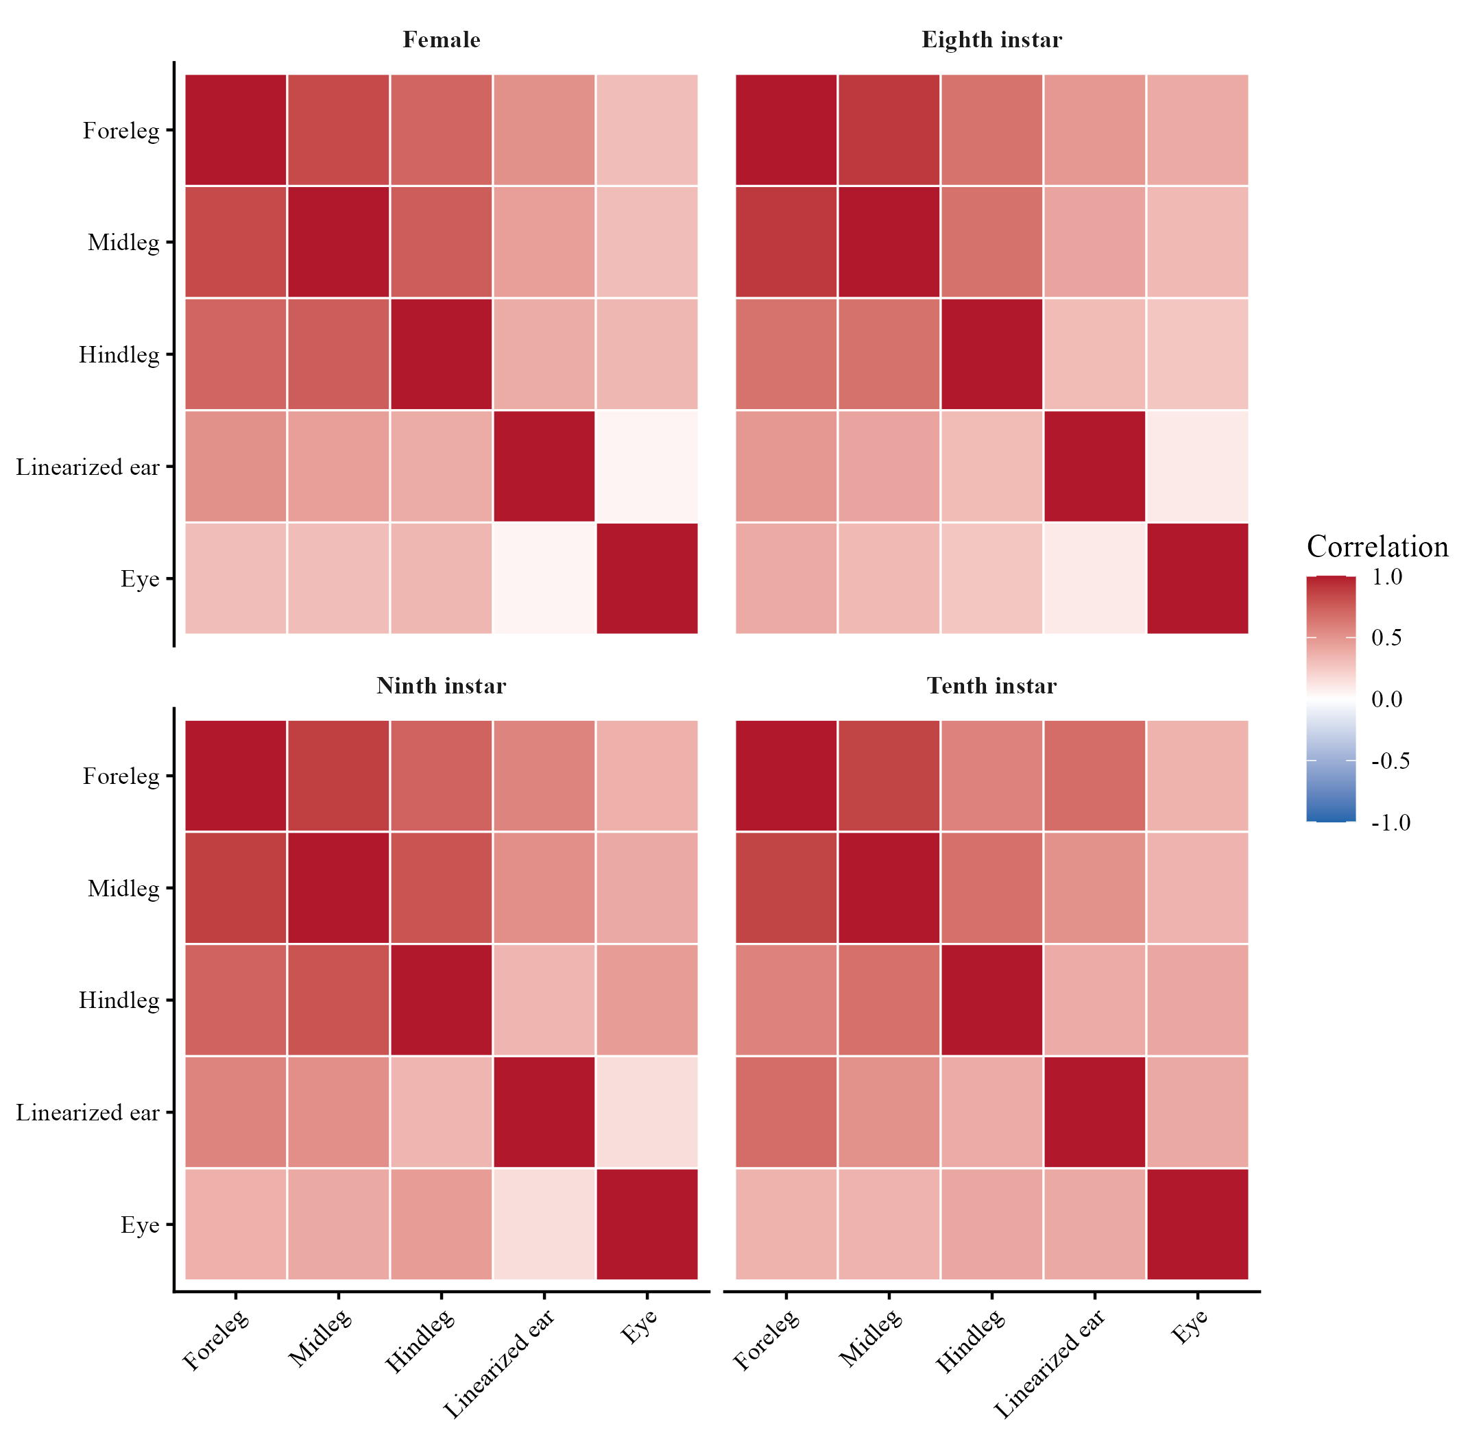
Supplementary Figure S2. Individual scores on the first two principal components of the five nonclassification traits after group-specific adjustment to a pronotum length of 7.2 mm. Diamonds show group centroids and ellipses show descriptive 68% normal regions. Parallel analysis retained PC1 but not PC2.
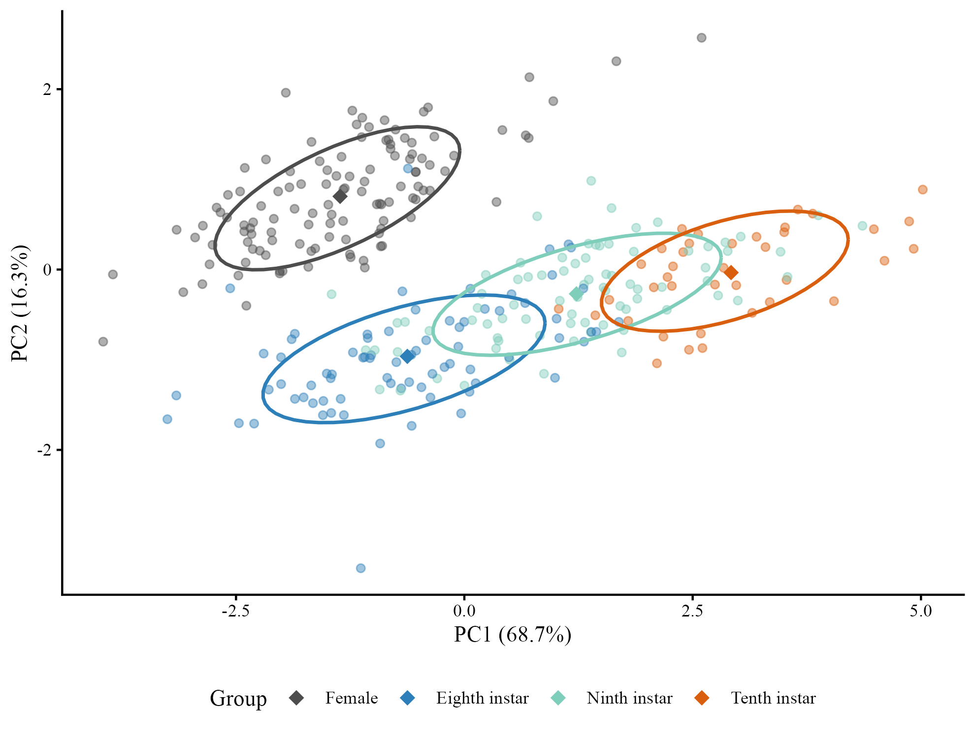

Supplementary Figure S3. Observed pronotum-length distributions by group. The dashed line marks the 7.2-mm reference used for adjusted means and contrasts; it falls within the common observed support of all four groups.
