respeakerV2 + Twilio 发短信信息(需要VPN)

Twilio:

<https://www.twilio.com/>

点击Get a free API key >



添加注册信息：然后点击Get Startd

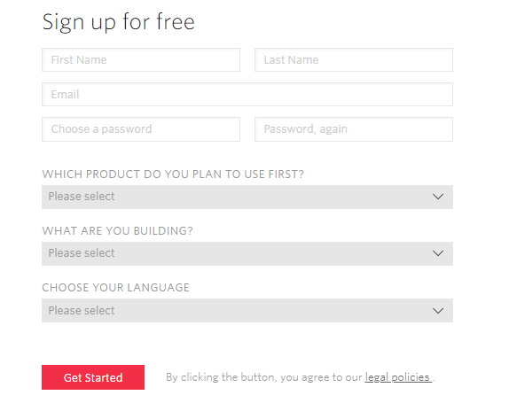

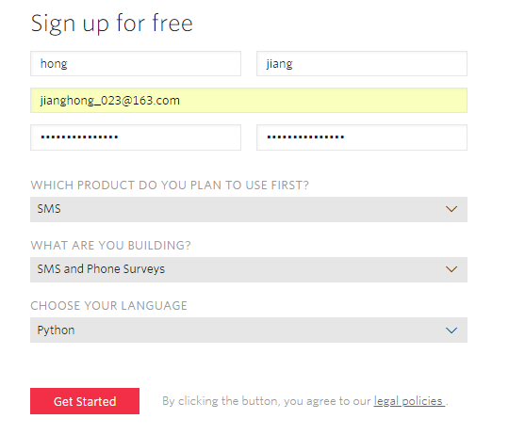

检验注册号码：

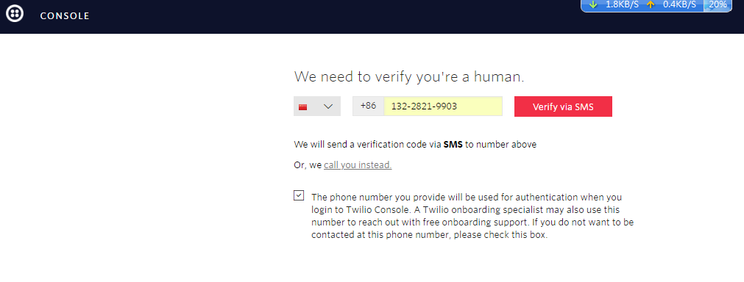

点击：Verify via SMS

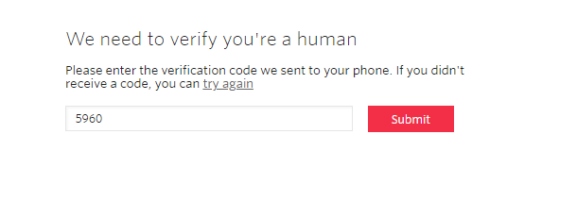

点击：Submit ,这个可以先不管它。

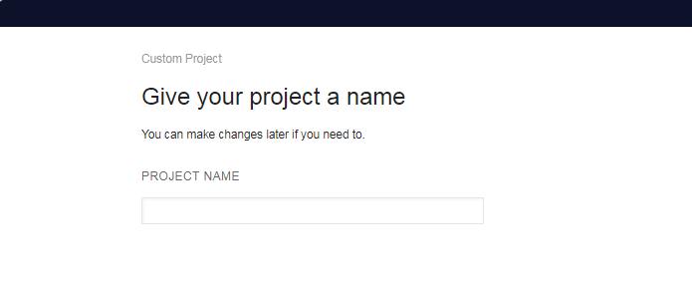

点击：

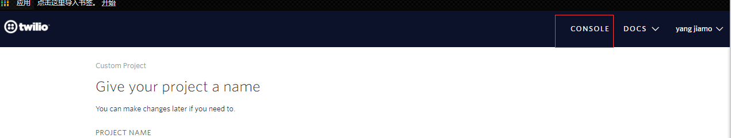

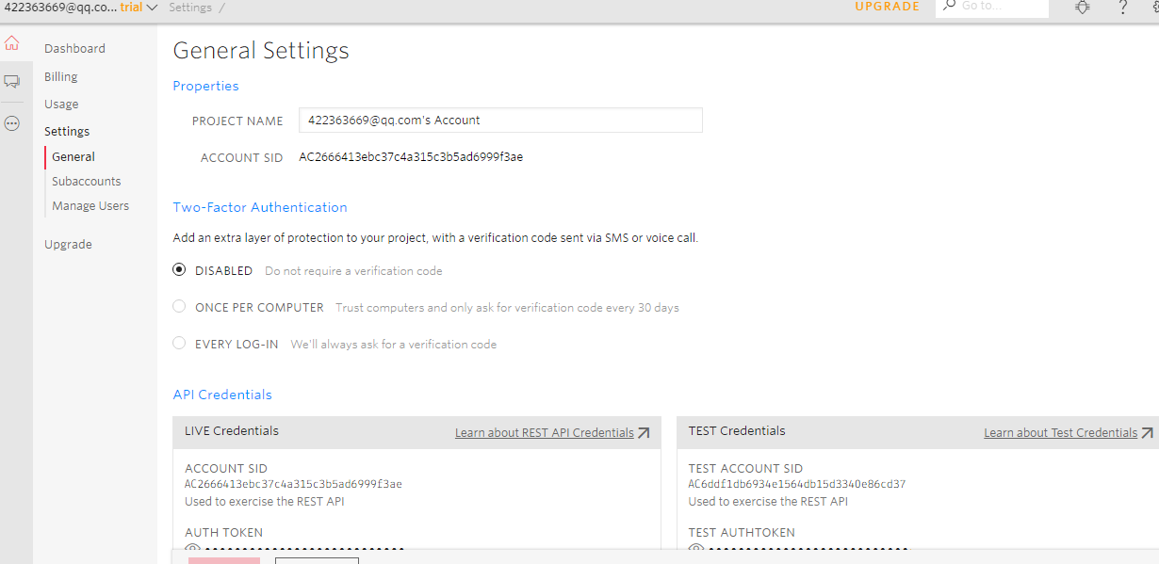

点击：Get Startd

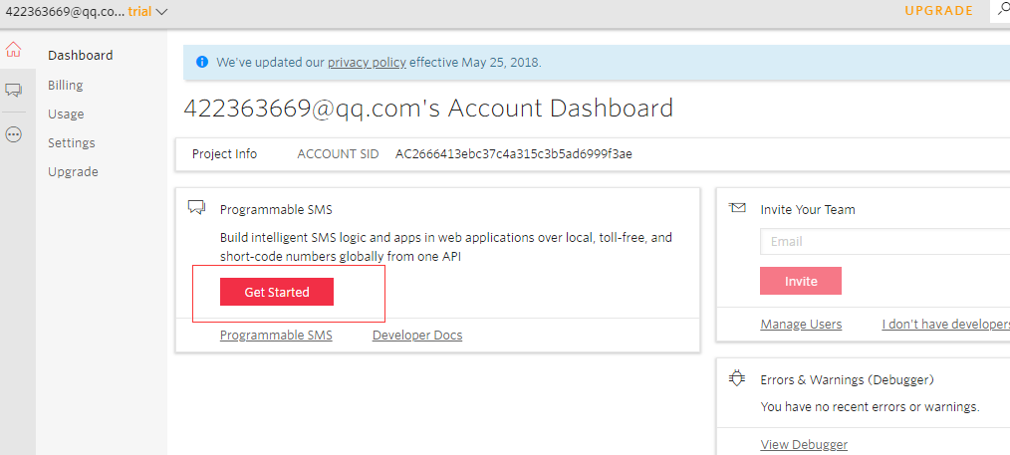

点击：线色圈住地方，然后Get Started

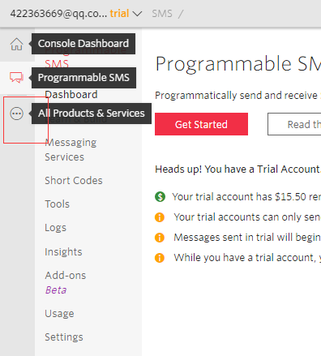

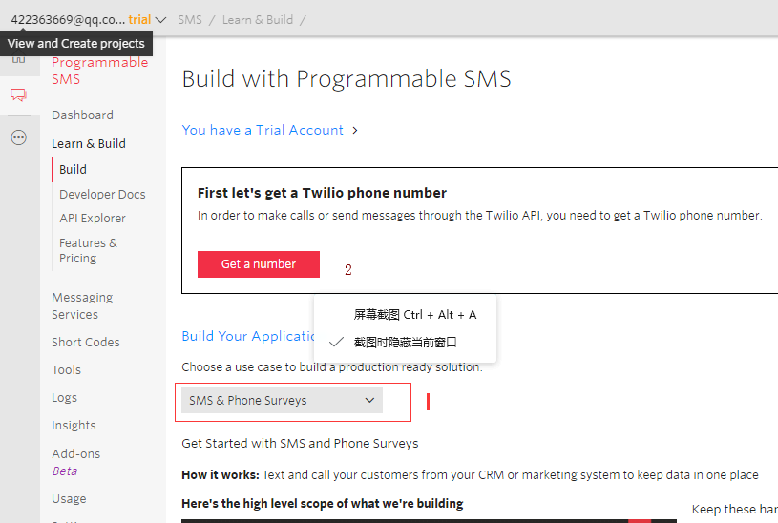

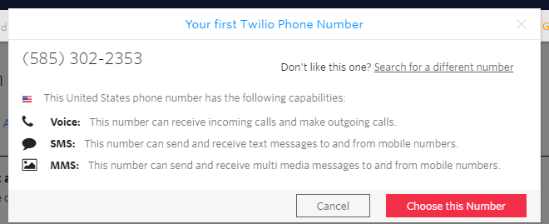

点击choose this Number:会生成一个号码，这个号码在pyhton编程中作为主机发送号：

接着点击done，会看到如下：

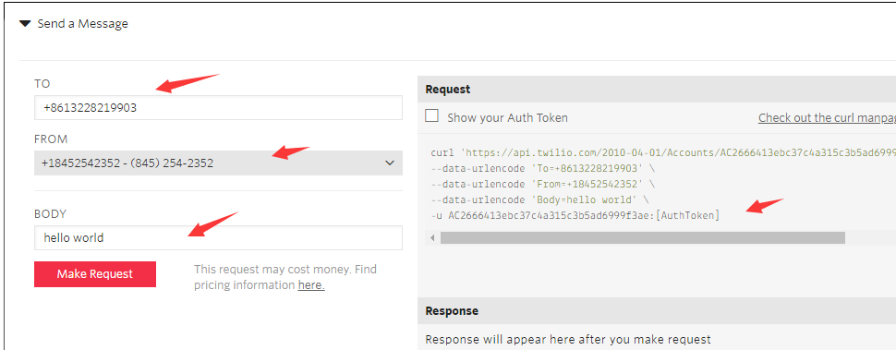

添加相应信息测试是否能收到消息：Make request

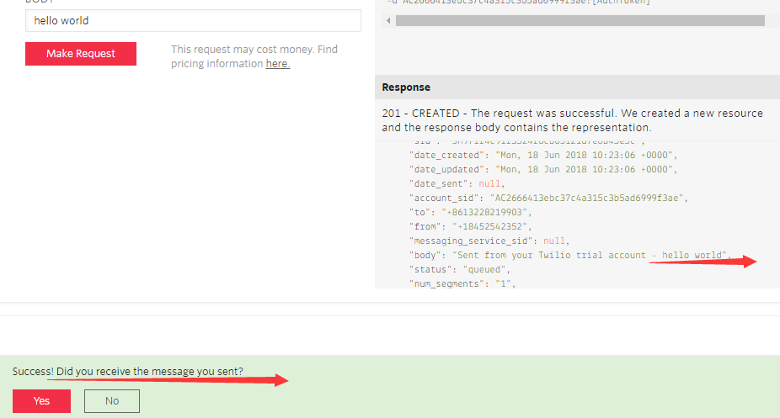

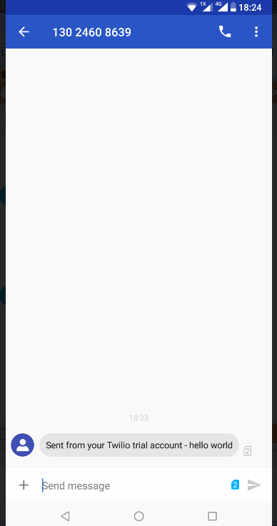

测试通过后，安装：

AVS 参考：respeaker_v2_bing

.docx

安装:

Twilio:

sudo apt-get install libffi-dev

pip install cffi

sudo apt-get install libssl-dev libxml2-dev

pip install twilio

这几个网址在测试你会用到：

<https://www.twilio.com/console/sms/settings/geo-permissions>

<https://www.twilio.com/docs/api/errors>

<https://twilio.com/user/account/phone-numbers/verified>

<https://www.twilio.com/console/voice/calls/geo-permissions/low-risk>

代码如下：python

#!/usr/bin/python

# coding:utf-8

# import Speech SDK

'''

文件名 : speach.py

支持百度中英语音，中文识别率较高，但英语识别率不理想，

若想用中文请打开宏开关 ，中英文切换，true = zh , false = en

同时改变百度为云端解析

bing /baidu 宏开关 False=baidu ,True=bing

'''

from evdev import InputDevice,categorize,ecodes

from pypinyin import pinyin, lazy_pinyin

from aip import AipSpeech

from ctypes import *

from pixel_ring import pixel_ring

from respeaker.bing_speech_api import BingSpeechAPI,RequestError

from twilio.rest import Client

from twilio.twiml.voice_response import VoiceResponse

from voice_engine.kws import KWS

from voice_engine.ns import NS

from voice_engine.source import Source

from voice_engine.channel_picker import ChannelPicker

from qcloudsms_py import SmsSingleSender

from qcloudsms_py.httpclient import HTTPError

from voice_engine.element import Element

import mraa

import logging

import ConfigParser

import threading,signal

import time

import sys,stat

import os

import re

import json

import copy

if sys.version_info[0] < 3:

import Queue as queue

else:

import queue

is_pressed = False

is_record = False

is_music = False

is_noteinfo = False

is_callflags = False

flags = 0

gfd = -1

led_ring = False

parse_flags = False

key_time_zh = 2

key_time_en = 4

starttime = 0

lasttime = 0

recvok = False

stringcopy = ''

'''

Twilio Message

'''

'''

baidu key

'''

BING_KEY = 'e8816ea657c643ecab1f0a66ddf121ae'

'''

中英文切换，true = zh , false = en

'''

#zh_en_on = False

zh_en_on = True

'''

宏开关

'''

TREAD_ON = 1

ON = 0

'''

bing /baidu 宏开关 False=baidu ,True=bing

'''

BING_BAIDU_ON = True

#BING_BAIDU_ON = False

'''

led

'''

en = mraa.Gpio(12)

'''

bing api

'''

def bing_api_call():

logging.basicConfig(level=logging.DEBUG)

'''

defined

http:

'''

APP_ID = '11203359'

API_KEY = 'wG9Iqfg2OplwQmXQaM5fxzRY'

SECRET_KEY = '2VuEDoSSi7rgFUggYSfzrTeQ4YGLhSlW'

'''

tencent api

'''

appid = 1400102718

appkey = "214b971761479e894e5fd27227d4e936"

'''

init AipSpeech object

'''

aipSpeech = AipSpeech(APP_ID, API_KEY, SECRET_KEY)

'''

led ring

'''

en.dir(mraa.DIR_OUT)

class Bing(Element):

def __init__(self, key):

super(Bing, self).__init__()

self.key = key

self.queue = queue.Queue()

self.listening = False

self.done = False

self.event = threading.Event()

self.bing = BingSpeechAPI(BING_KEY)

def put(self, data):

if self.listening:

self.queue.put(data)

def start(self):

self.done = False

thread = threading.Thread(target=self.run)

thread.daemon = True

thread.start()

def stop(self):

self.done = True

def listen(self):

self.listening = True

self.event.set()

def run(self):

while not self.done:

self.event.wait()

def gen():

count = 0

while count < 16000 * 6:

data = self.queue.get()

if not data:

break

yield data

count += len(data) / 2

#recognize speech using Microsoft Bing Voice Recognition

try:

# text = bing.recognize(gen(), language='zh-CN')

text = self.bing.recognize(gen())

global stringcopy

print('Bing:{}'.format(text).encode('utf-8'))

stringcopy = format(text).encode('utf-8')

except ValueError:

print('Not recognized')

global is_music

is_music = False

time.sleep(1)

#play_other('mpg123 /home/respeaker/twilio/notfind.mp3')

play_other('mpg123 /home/respeaker/twilio/not_clear.mp3')

except RequestError as e:

print('Network error {}'.format(e))

time.sleep(1)

play_other('mpg123 /home/respeaker/twilio/net_error.mp3')

self.listening = False

self.event.clear()

self.queue.queue.clear()

global recvok,is_record

recvok = True

is_record = True

def recv_string():

global recvok

while recvok != True:

time.sleep(0.1)

recvok = False

print(stringcopy)

return stringcopy

'''

Twilio,no used

'''

def sendmessage(employee,gestName,employeeNumber):

"""

Some example usage of different twilio resources.

"""

client = Client('AC126c5beb95795762e545c22121d61d24', '4d036c85d72c9de3005fd757d1d8663a')

# Get all messages

all_messages = client.messages.list()

print('There are {} messages in your account.'.format(len(all_messages)))

# Get only last 10 messages...

some_messages = client.messages.list(limit=10)

print('Here are the last 10 messages in your account:')

for m in some_messages:

print(m)

# Get messages in smaller pages...

all_messages = client.messages.list(page_size=10)

print('There are {} messages in your account.'.format(len(all_messages)))

print('Sending a message...')

print('+86'+employeeNumber)

print('Hello,'+employee+'.'+gestName+' is here to see you. Please meet them at the door.')

#Hello, <employee>. <guest> is here to see you. Please meet them at the door.

new_message = client.messages.create(to='+86'+employeeNumber, from_='+15109014046', body='Hello,'+employee+'.'+gestName+' is here to see you. Please meet them at the door.')

def tencentSendMesaage(employee,gestName,employeeNumber):

## Enum{0: 普通短信, 1: 营销短信}

sms_type = 0

template_id = 151036

params = []

params.append(employee)

params.append(employeeNumber)

ssender = SmsSingleSender(appid, appkey)

try:

sendStr = "Hello,"+employee+"."+gestName+" is here to see you. Please meet them at the door."

print(sendStr)

result = ssender.send(sms_type, 86, employeeNumber,sendStr)

#result = ssender.send(sms_type, 86, employeeNumber,"Hello,search.jcr is here to see you. Please meet them at the door.")

# 签名参数未提供或者为空时，会使用默认签名发送短信

#result = ssender.send_with_param(86, employeeNumber,template_id, params)

except HTTPError as e:

print(e)

except Exception as e:

print(e)

print('tencnet:{}'.format(result).decode('unicode_escape'))

def led_pixel_ring():

en.write(0)

pixel_ring.set_brightness(20)

while led_ring :

try:

pixel_ring.wakeup()

time.sleep(0.1)

pixel_ring.off()

time.sleep(0.1)

pixel_ring.off()

except KeyboardInterrupt:

break

pixel_ring.off()

en.write(1)

'''

list

'''

def convert_to_list():

result=[]

fd = file("/home/respeaker/twilio/allname.txt", "r")

for line in fd.readlines():

result.append(''.join(list(line.lower().rstrip().split(','))))

'''

for item in result:

for it in item :

print(it)

'''

fd.close()

return result

def fuzzyfinder(parse_name,result):

suggestions = []

pattern = '.*'.join(parse_name) # Converts 'tes' to 't.*e.*s'

regex = re.compile(pattern) # Compiles a regex.

for item in result:

for it in item:

match = regex.search(it) # Checks if the current item matches the regex.

if match:

suggestions.append(it)

print(suggestions)

return suggestions

'''

parse local file

'''

def search_user(user):

print(user[0:len(user)-3])

cf = ConfigParser.ConfigParser()

cf.read("/home/respeaker/twilio/username.txt")

is_ = cf.has_option("db", user[0:len(user)-3])

if is_ :

db_phone = cf.get("db", user[0:len(user)-3])

if db_phone.isdigit() :

return db_phone

else:

return 0;

else:

return 0;

'''

parse local file

'''

def search_user_en(user):

print(len(user))

print(user)

cf = ConfigParser.ConfigParser()

cf.read("/home/respeaker/twilio/username_en.txt")

is_ = cf.has_option("db", user)

if is_ :

db_phone = cf.get("db", user)

if db_phone.isdigit() :

return db_phone

else:

return 0;

else:

return 0;

def bing_hande(self):

text = ""

bing = BingSpeechAPI(key=BING_KEY)

try:

fd = open(self.path)

conect = fd.read(-1)

text = bing.recognize(conect)

fd.close()

return text

except Exception as e:

print(e.message)

return text

def parse_array(text):

array =[]

array = text.lower().split(' ')

return array

def parse_array_noneuplow(text):

array =[]

array = text.split(' ')

return array

def filter_re(string):

names = re.search(r'.*?[^A-Z]\.', string).group(0)

return map(lambda x: x.replace('and', '').replace('et al','').strip(), names.rstrip('.').split(','))

'''

百度API云端处理

'''

class baidu_bing_aip_speech(object):

def __init__(self,_path,_format):

self.path = _path

self.format = _format

'''

read file

'''

def get_file_content(self):

with open(self.path, 'rb') as fp:

return fp.read()

def bing__parse_speech(self):

global is_music,is_find,count,stringcopy

try:

bing.listen()

text = recv_string()

stringcopy = ''

print('Recognized text %s' % text)

if text:

print('Recognized %s' % text)

is_find = False

array = parse_array(text)

print("---------------------------\n")

convert_lis = convert_to_list()

'''

for strd in convert_lis:

print(strd)

print("\n")

'''

# start parse voice

for i in array:

for employee in convert_lis:

if i == employee :

#do what you want to do

print(employee)

print("\n")

is_find = True

is_music = False

play_request_thanks()

count=2

while(count):

bing.listen()

time.sleep(0.1)

gestName = recv_string()

stringcopy = ''

is_music = True

is_music = False

getGestName = ''

if gestName:

result = []

str_list = parse_array_noneuplow(gestName)

print(len(str_list))

list_len = len(str_list)

if list_len == 1:

getGestName = str_list[list_len-1]

elif list_len == 2:

getGestName = str_list[0]+'.'+str_list[1]

elif list_len >= 3:

getGestName = str_list[list_len-2]+'.'+str_list[list_len-1]

print(getGestName)

time.sleep(0.1)

play_request_sendMessage()

time.sleep(0.1)

employeeNumber = search_user_en(''.join(employee).lower())

print(employeeNumber)

#sendmessage(employee,getGestName,employeeNumber)

tencentSendMesaage(employee,getGestName,employeeNumber)

print("********Bing_English****************")

count = 0

return 0

else:

count = count -1

if count == 0 :

return 0

if is_find == False:

#Oh, sorry, I didn't find it.

is_music = False

play_other('mpg123 /home/respeaker/twilio/notfind.mp3')

else:

return -1

except Exception as e:

print(e.message)

'''

call 调用

'''

def pre_play(v):

global is_pressed,is_music,is_record,is_noteinfo,led_ring,parse_flags

while True:

if is_pressed == True:

'''

Welcome to x.factory. Who are you here to see?

'''

os.system("mpg123 /home/respeaker/twilio/welcome.mp3")

is_pressed = False

try:

'''

数据解析及电话连线使能

'''

#global is_music

is_music = True

par = baidu_bing_aip_speech('/home/respeaker/twilio/test.wav', 'wav')

'''

baidu api call

'''

if par.bing__parse_speech() == 0 :

is_music = False

parse_flags = False

else:

parse_flags = True

is_music = False

except Exception,e:

is_music = False

is_noteinfo = False

print e.message

led_ring = False

time.sleep(0.1)

'''

访客按键处理

'''

def key_hander(v):

global is_pressed,is_noteinfo,led_ring,starttime,lasttime

key = InputDevice("/dev/input/event0")

for event in key.read_loop():

if event.type == ecodes.EV_KEY:

print(categorize(event))

'''

hold time

'''

if event.value == 2 :

lasttime = event.sec

sp_time = lasttime - starttime

'''

down

'''

elif event.value == 1 :

starttime = event.sec

'''

up

'''

else:

led_ring = True

is_pressed = True

is_noteinfo = True

starttime = 0

lasttime = 0

'''

数据解析及电话连线时提示音

'''

def play_music(v):

global is_music

while True:

time.sleep(1)

def play_request_thanks():

'''

Thank you. What is your name?

'''

os.system("mpg123 /home/respeaker/twilio/Thanks.mp3")

def play_other(strInfo):

'''

Thank you. What is your name?

'''

os.system(strInfo)

def play_request_sendMessage():

'''

Thank you. I will send them a message

'''

os.system("mpg123 /home/respeaker/twilio/message.mp3")

'''

CTRL + C

'''

def CtrlC(signum, frame):

os.kill(os.getpid(),signal.SIGKILL)

'''

main start ...

'''

if __name__ == "__main__":

try:

src = Source(channels=8)

ch0 = ChannelPicker(channels=src.channels, pick=0)

ns = NS()

bing = Bing(BING_KEY)

src.pipeline(ch0, ns, bing)

bing_api_call()

'''

调试时CTRL + C 处理

'''

signal.signal(signal.SIGINT, CtrlC)

signal.signal(signal.SIGTERM, CtrlC)

thread_key = threading.Thread(target=key_hander,args=(1,))

thread_play = threading.Thread(target=pre_play, args=(1,))

thread_music = threading.Thread(target=play_music, args=(1,))

thread_key.setDaemon(True)

thread_play.setDaemon(True)

thread_music.setDaemon(True)

thread_key.start()

thread_play.start()

thread_music.start()

src.recursive_start()

if TREAD_ON == ON :

thread_key.join()

thread_play.join()

thread_music.join()

else :

while True:

led_pixel_ring()

time.sleep(1)

pass

'''

异常处理

'''

except Exception,exc:

print exc