A leakage-aware computational benchmark of hosted single-cell representations for blood T-cell aging prediction
Article type: Original Research Article

Abstract
Background: Public single-cell atlases and hosted representations are increasingly used for downstream prediction, but random-cell evaluation can be optimistic when cells from the same donor, study-specific metadata, assay structure, or metadata-derived labels are shared across training and test data.
Methods: We developed a leakage-aware benchmark for CELLxGENE-hosted single-cell representations using blood T-cell young-versus-old age classification as an empirical case study. The benchmark compared hosted scVI and TranscriptFormer embeddings with a metadata-only baseline across 30 repeated splits, including random-cell, donor-holdout, grouped dataset-holdout, disease-free, label-shuffling, leave-one-dataset-out, and sampling-depth diagnostics.
Results: Random-cell evaluation gave relatively high apparent performance, and the metadata-only baseline exceeded or matched embedding models (AUROC 0.769 for metadata-only, 0.749 for TranscriptFormer, and 0.707 for scVI). Donor-aware evaluation changed both ranking and interpretation: donor-mean TranscriptFormer reached AUROC 0.855 under donor-holdout, whereas grouped dataset-holdout performance was lower and unstable (AUROC 0.659 for donor-mean TranscriptFormer and 0.566 for donor-mean scVI). Leave-one-dataset-out analysis identified only one eligible held-out dataset, making feasibility itself an important diagnostic of public metadata constraints.
Conclusions: Validation design strongly alters conclusions about hosted single-cell representations. These results support a reusable audit framework for leakage, confounding, and dataset shift, but do not constitute validation of a clinical aging clock.
Keywords: single-cell RNA sequencing; representation learning; data leakage; dataset shift; donor-aware validation; CELLxGENE

Introduction
Large public single-cell resources have made it possible to reuse harmonized cell annotations, metadata, and hosted representations across studies. The Human Cell Atlas, Human Cell Landscape, Tabula Sapiens, and CZ CELLxGENE Discover illustrate this shift from isolated single-cell studies toward reusable atlas-scale infrastructure [1-4]. In parallel, aging research has used molecular clocks and single-cell atlases to describe age-associated changes at tissue and cell-type resolution [5-11]. These resources create opportunities for benchmark studies, but they also make the unit of prediction more complicated: a cell may be the measured observation, whereas age, disease status, sex, cohort, and study origin are usually donor- or dataset-level properties.
Representation learning methods further increase the need for careful evaluation. Variational models such as scVI and broader transcriptomic representation models can provide useful low-dimensional summaries of single-cell state [13-18]. Hosted embeddings lower the barrier to downstream analysis because users can evaluate standardized representations without retraining models from raw counts. However, convenience does not remove validation risk. If random cells are split across training and test data, models can benefit from donor identity, dataset-specific processing, assay signatures, or metadata structure rather than age-associated biology.
Aging prediction is a useful stress test for such resources because it combines a biologically meaningful donor-level label with strong opportunities for confounding. Donor age is often correlated with study design, disease recruitment, tissue acquisition, and assay chemistry. In single-cell data, those correlations are amplified because each donor contributes many cells, but the label usually belongs to the donor rather than to the cell. Evaluation therefore requires a validation scheme that respects both the biological unit of the label and the technical unit of data generation.
These risks are familiar in biomedical machine learning and single-cell integration, where batch effects, dataset shift, small effective sample size, and leakage can inflate apparent performance [19-25]. In public single-cell data, the issue is sharpened by repeated cells per donor, uneven cells per donor, age imbalance across studies, disease labels that covary with age, and age labels inferred from public metadata fields rather than harmonized clinical age. A high cell-level AUROC may therefore describe recovery of dataset or metadata structure rather than a transferable biological signal.
What is still missing is a compact risk-control framework that maps common public single-cell prediction risks to explicit diagnostics. This study addresses that gap by building a donor-, disease-, and dataset-aware benchmark of CELLxGENE-hosted scVI and TranscriptFormer representations for blood T-cell age classification. We treat the task as benchmark evidence, not as development of a clinical aging clock. The contribution is the leakage-aware audit design: random-cell, donor-holdout, grouped dataset-holdout, metadata-only, disease-free, label-shuffling, leave-one-dataset-out, and sampling-depth analyses are used together to determine how much the evaluation conclusion depends on validation design.
The present work is deliberately narrower than a general benchmark of all transcriptomic foundation models. It evaluates two CELLxGENE-hosted representations available for the sampled blood T-cell stratum and uses a metadata-only model as a diagnostic comparator. This design makes it possible to ask whether an embedding adds value beyond metadata and whether that value survives increasingly strict validation designs. The answer is expected to be conditional on the public metadata, the eligible donors, and the fixed hosted embeddings rather than universal across tissues or models.

Materials and methods

Study design and data source
We designed an Original Research Article benchmark around a single empirical stratum: human blood T cells represented in CELLxGENE-hosted embeddings. The target task was young-versus-old age classification. The study was framed as a computational audit of validation design, leakage risk, and metadata confounding rather than as development of a clinical aging-clock model.

Benchmark cohort and age-label construction
The benchmark used the existing project cohort constructed from CELLxGENE public metadata and hosted embeddings. Eligible cells were blood T cells with donor identifiers, dataset identifiers, age-class labels derived from public development_stage metadata, and available scVI and TranscriptFormer hosted embeddings. The completed benchmark sample contains 1,075 cells from 140 donors. Age labels were treated as donor-level categorical labels; cell counts were not interpreted as independent donor counts.

Hosted single-cell representations
Two hosted representations were evaluated: scVI embeddings and TranscriptFormer (TF-Sapiens) embeddings. Both were treated as fixed pretrained or hosted representations. No new foundation model training was performed, and Geneformer, scGPT, scFoundation, GeneCompass, and other models were not directly benchmarked.

Leakage and confounding risk-control framework
We mapped anticipated public single-cell prediction risks to explicit diagnostics or controls before interpreting performance. The goal was not to eliminate every source of bias, which is not possible with public metadata alone, but to make the remaining risks visible and to avoid interpreting inflated random-cell performance as transferable age prediction.
Table 1. Major leakage and confounding risks and their corresponding diagnostic controls.
Risk | Definition | Apparent artifact | Diagnostic/control | Residual limitation
Donor identity leakage | Repeated cells from one donor appear in both train and test sets. | A model recognizes donor-specific structure instead of age. | Donor-holdout splitting groups all cells from a donor. | Cannot remove unmeasured cohort effects shared among donors.
Dataset/study-origin confounding | Age classes are unevenly distributed across source datasets. | Dataset signatures mimic age prediction. | Grouped dataset-holdout and LODO diagnostics. | Few datasets contain both age classes, limiting transfer tests.
Disease-age confounding | Disease labels covary with age or dataset. | Performance reflects disease composition rather than aging. | Disease-free sensitivity analysis and metadata summaries. | Public disease labels may be incomplete or heterogeneously curated.
Assay confounding | Assay chemistry differs by dataset or age group. | Assay-specific embedding structure predicts age labels. | Assay composition audit and metadata-only baseline. | Assay effects cannot be fully harmonized without raw-data reprocessing.
Sex imbalance | Sex distribution differs by age class or dataset. | Sex-associated expression or metadata drives apparent age signal. | Sex metadata audit and metadata-only model. | Sex labels may be missing or uneven across studies.
Metadata-derived label leakage | Age class is inferred from development_stage metadata. | Metadata variables may encode label construction. | Metadata-only baseline and cautious label interpretation. | No harmonized donor-age field was available.
Unequal cells per donor | Donors contribute different cell counts. | Donors with more cells dominate cell-level metrics. | Donor-mean aggregation and sampling-depth sensitivity. | Eight-cell cap limits deeper donor summaries.
Train-test preprocessing leakage | Standardization or transformations are fit using test data. | Test-set information improves apparent model performance. | Code audit confirmed pipeline fitting within training folds. | Prediction-level calibration outputs were not stored for extra checks.
Age-class imbalance | Young and old donors are uneven across datasets. | AUROC may be unstable and transfer tests infeasible. | Class checks, balanced accuracy, AUPRC, and LODO exclusions. | Some datasets cannot be evaluated without changing the task.
Split-seed instability | Single random split gives a fragile estimate. | A favorable seed can be mistaken for robust performance. | Thirty repeated split seeds and paired seed comparisons. | Seed variability is not independent cohort uncertainty.

Validation schemes
The benchmark compared random-cell splits, donor-holdout splits, grouped dataset-holdout splits, disease-free variants, label-shuffling negative controls, leave-one-dataset-out diagnostics, and sampling-depth sensitivity. Logistic regression classifiers were evaluated across 30 repeated split seeds where applicable. Donor-holdout splitting grouped all cells from the same donor into the same partition, whereas grouped dataset-holdout splitting used dataset identifiers as the grouping unit.

Statistical analysis
Performance was summarized using AUROC, AUPRC, and balanced accuracy. Intervals reported for 30-seed analyses describe split-seed variability and should not be read as independent cohort confidence intervals. Paired comparisons used seed-matched AUROC differences. LODO results were reported separately as a dataset-transfer diagnostic because only one held-out dataset satisfied the class-balance requirements.

Reproducibility and software environment
The analysis used fixed scripts, saved metadata tables, hosted embedding caches, and generated result tables in the project repository. For double-blind peer review, repository identity and archival details are anonymized in the main manuscript and provided only in non-blinded submission materials if permitted by journal policy.

Results
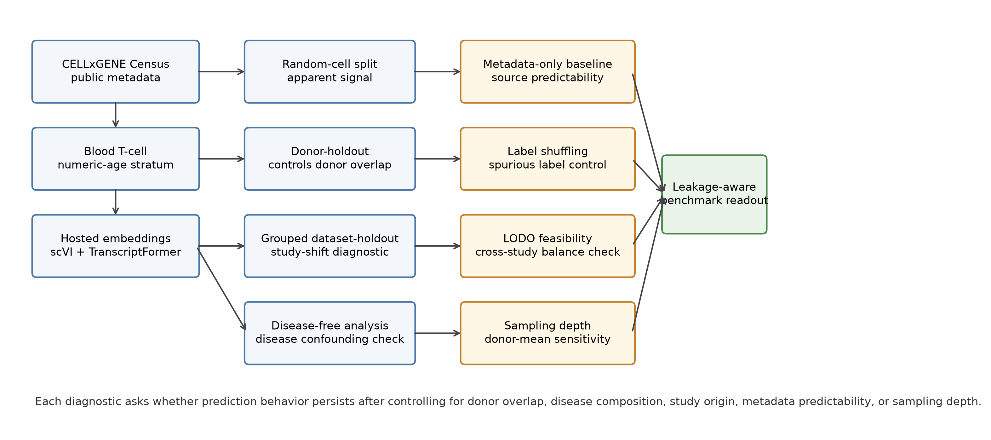
Figure 1. Leakage-aware benchmark workflow. The workflow starts from public CELLxGENE metadata and hosted embeddings, restricts analysis to an eligible blood T-cell benchmark stratum, then evaluates fixed scVI and TranscriptFormer representations with metadata-only, donor-aware, disease-aware, dataset-aware, label-shuffling, LODO, and sampling-depth diagnostics. The figure emphasizes the validation designs used to detect identity leakage, metadata confounding, study-origin shift, and label-unit mismatch.

Feasibility of constructing public-data benchmark strata
The metadata feasibility audit supported blood T cells as the completed empirical stratum. The benchmark contained 1,075 cells from 140 donors after requiring donor identifiers, age-class labels, dataset identifiers, and hosted scVI and TranscriptFormer embeddings. This scope is intentionally narrower than a pan-tissue aging benchmark, because several additional tissue or cell-type strata did not satisfy the same metadata and representation requirements.
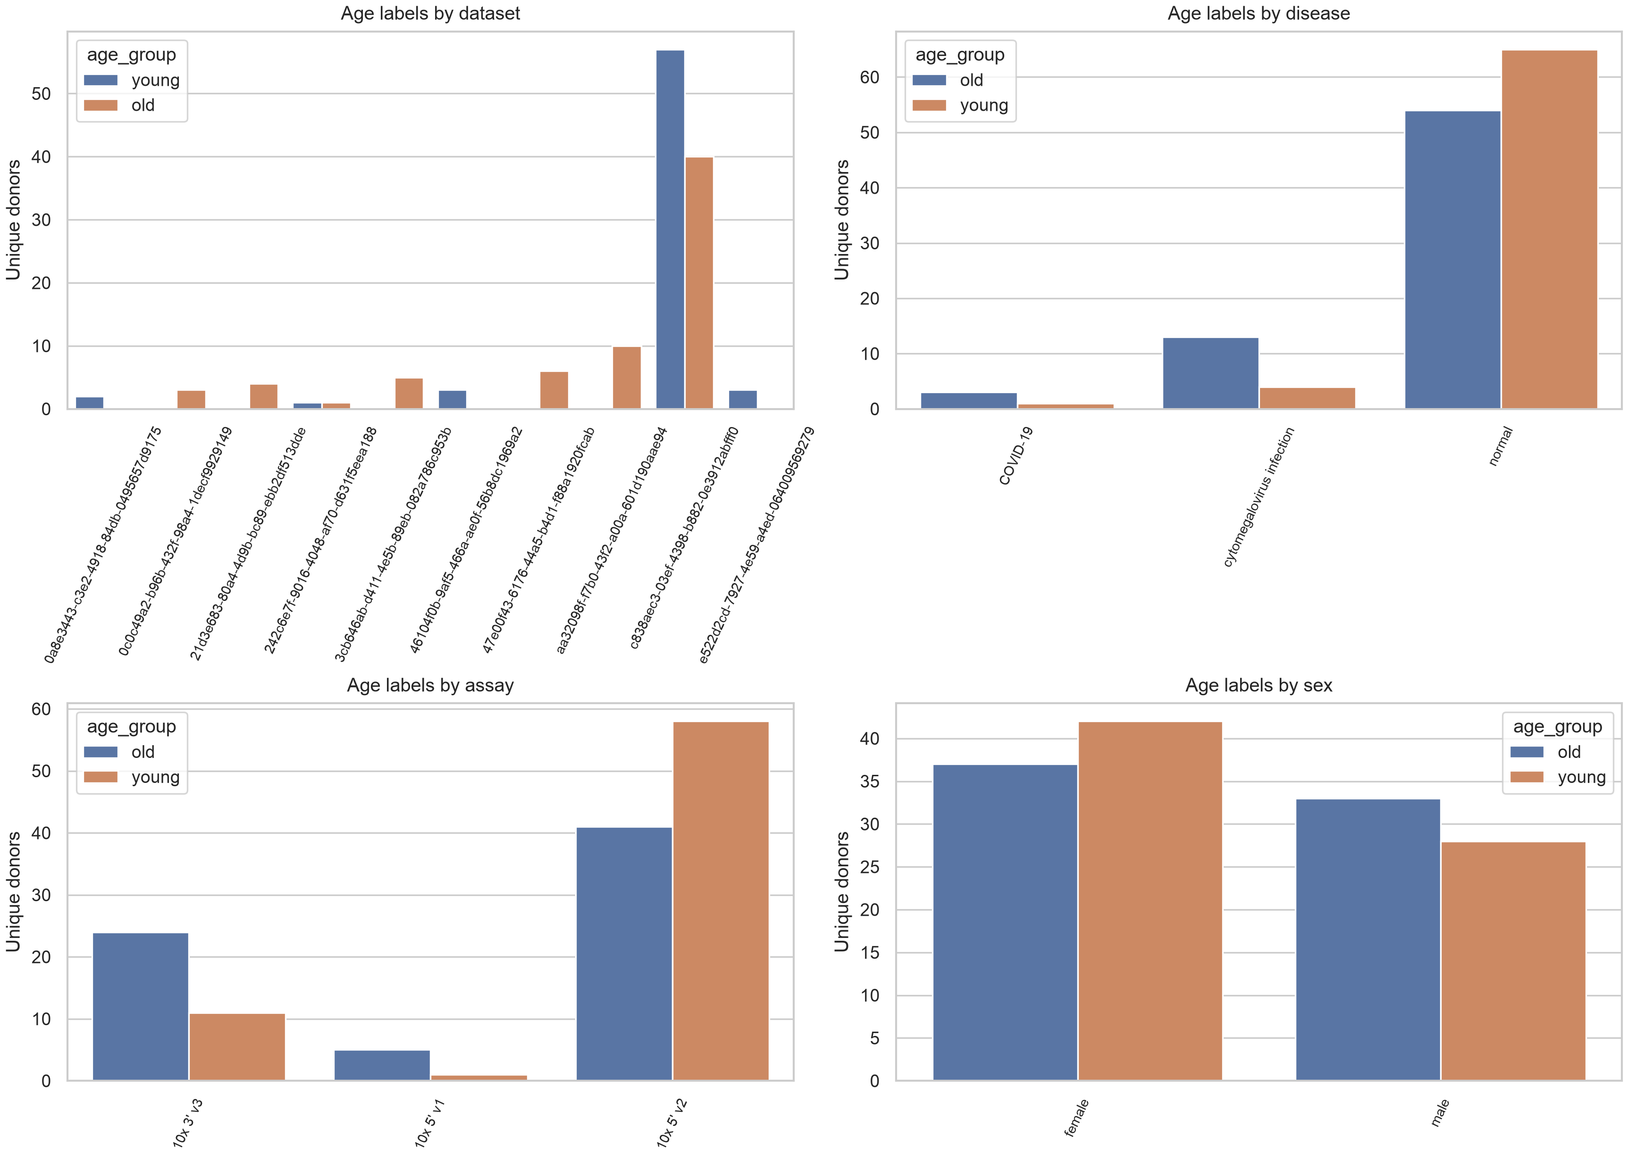
Figure 2. Benchmark cohort and metadata-confounding structure. The panels summarize how young and old labels were distributed across public metadata variables in the completed blood T-cell stratum, including dataset, assay, sex, and disease-related fields. These summaries motivate the metadata-only baseline and grouped validation designs used later in the benchmark.

Random-cell evaluation produces optimistic apparent performance
Random-cell evaluation gave relatively high apparent performance for both embeddings and the metadata-only baseline. The metadata-only model reached AUROC 0.769 (0.762-0.776), compared with 0.749 (0.744-0.754) for TranscriptFormer and 0.707 (0.699-0.716) for scVI. Because the metadata-only model exceeded or matched embedding models in this setting, random-cell performance was interpreted as potentially inflated by donor-, study-, assay-, or metadata-derived structure.
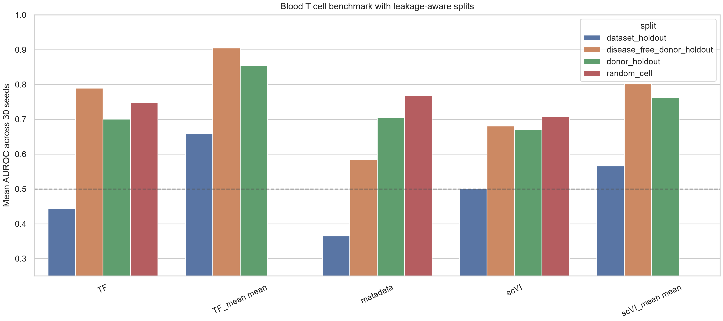
Figure 3. Thirty-seed performance across validation designs. AUROC, AUPRC, and balanced accuracy are summarized across random-cell, donor-holdout, grouped dataset-holdout, disease-free, and donor-mean analyses. Random-cell results should be interpreted as apparent performance because cells from the same donor or study structure can create optimistic estimates.

Donor-aware evaluation changes model ranking and uncertainty
Under donor-holdout evaluation, cell-level TranscriptFormer reached AUROC 0.701 (0.689-0.713) and scVI reached 0.671 (0.654-0.688), while the metadata-only baseline reached 0.705 (0.678-0.731). Donor-mean aggregation changed the performance pattern: donor-mean TranscriptFormer reached 0.855 (0.837-0.874) and donor-mean scVI reached 0.763 (0.737-0.789). These results support donor-level aggregation as a useful sensitivity analysis when the label is donor-level.
Table 2. Core AUROC summary by validation design. Values are mean AUROC with 95% intervals across 30 split seeds; intervals describe split-seed variability, not independent-cohort uncertainty.
Model or baseline | Status | Random-cell | Donor-holdout | Dataset-holdout | Disease-free donor-holdout
Metadata-only logistic | Available | 0.769 (0.762-0.776) | 0.705 (0.678-0.731) | 0.366 (0.265-0.466) | 0.585 (0.561-0.610)
Raw-expression baseline | Not available in current release | Not estimated | Not estimated | Not estimated | Not estimated
scVI cell-level logistic | Available | 0.707 (0.699-0.716) | 0.671 (0.654-0.688) | 0.501 (0.435-0.567) | 0.681 (0.666-0.695)
TranscriptFormer cell-level logistic | Available | 0.749 (0.744-0.754) | 0.701 (0.689-0.713) | 0.445 (0.385-0.504) | 0.790 (0.778-0.802)
scVI donor-mean logistic | Available | Not applicable | 0.763 (0.737-0.789) | 0.566 (0.479-0.653) | 0.802 (0.781-0.823)
TranscriptFormer donor-mean logistic | Available | Not applicable | 0.855 (0.837-0.874) | 0.659 (0.569-0.748) | 0.905 (0.896-0.915)

Metadata and study origin explain substantial predictive structure
The high metadata-only random-cell result, together with age imbalance across dataset, assay, sex, and disease metadata summaries, indicated that non-expression variables carried substantial age-associated structure in the public metadata. These variables are useful diagnostics, but they also create risk if performance is interpreted as a purely transcriptomic age signal.
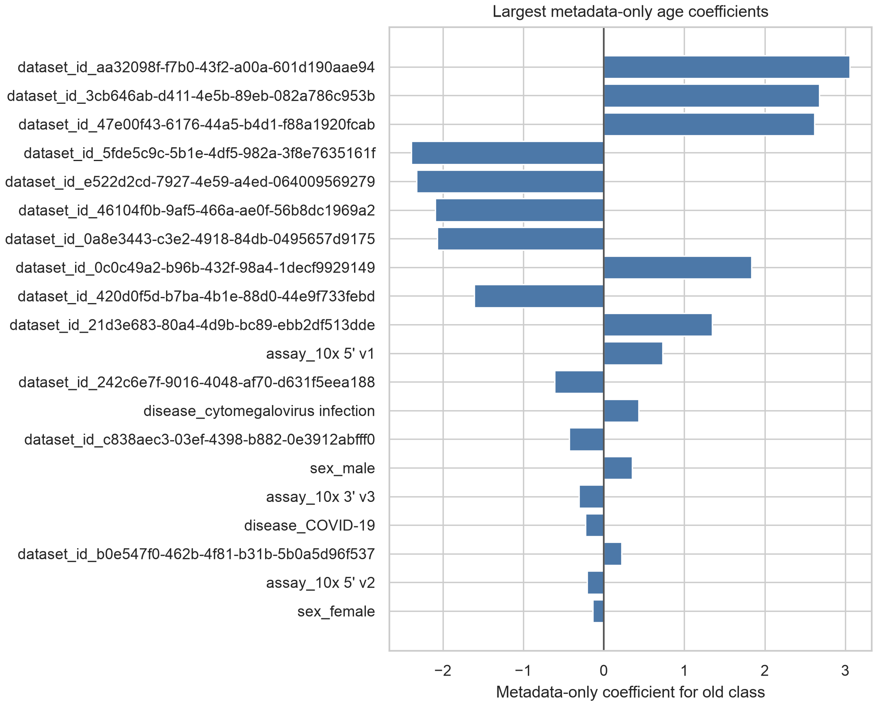
Figure 4. Metadata-only model coefficients. Coefficients summarize the non-expression metadata variables that contributed to metadata-only age classification. The model was included as a confounding diagnostic rather than as a biological predictor, because strong metadata-only performance indicates that age labels can be partly recoverable from public metadata and study structure.

Disease-free and negative-control analyses
Disease-free donor-holdout analyses retained high performance for donor-mean embeddings, with AUROC 0.905 (0.896-0.915) for TranscriptFormer and 0.802 (0.781-0.823) for scVI. Cell-level disease-free donor-holdout AUROC was 0.790 (0.778-0.802) for TranscriptFormer and 0.681 (0.666-0.695) for scVI. Label-shuffling diagnostics remained part of the audit framework and were used to identify performance patterns compatible with split or metadata artifacts.
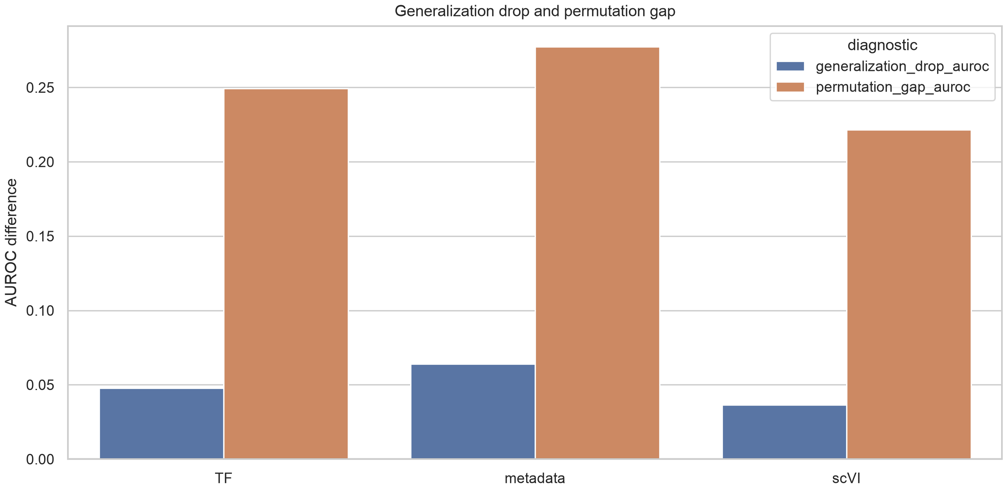
Figure 5. Disease-free and label-shuffling diagnostics. Disease-free analyses evaluate whether results persist after excluding donors with recorded disease labels, whereas label-shuffling controls estimate performance compatible with split-specific or metadata artifacts. These diagnostics constrain, but do not eliminate, residual cohort and assay effects.

Dataset transfer and LODO feasibility
Grouped dataset-holdout performance was lower and more variable than donor-holdout performance. Donor-mean dataset-holdout AUROC was 0.659 (0.569-0.748) for TranscriptFormer and 0.566 (0.479-0.653) for scVI, whereas the metadata-only baseline reached 0.366 (0.265-0.466). LODO diagnostics found only one eligible held-out dataset after class-balance filtering; in that dataset, AUROC was 0.630 for TranscriptFormer, 0.519 for scVI, and 0.552 for metadata-only.
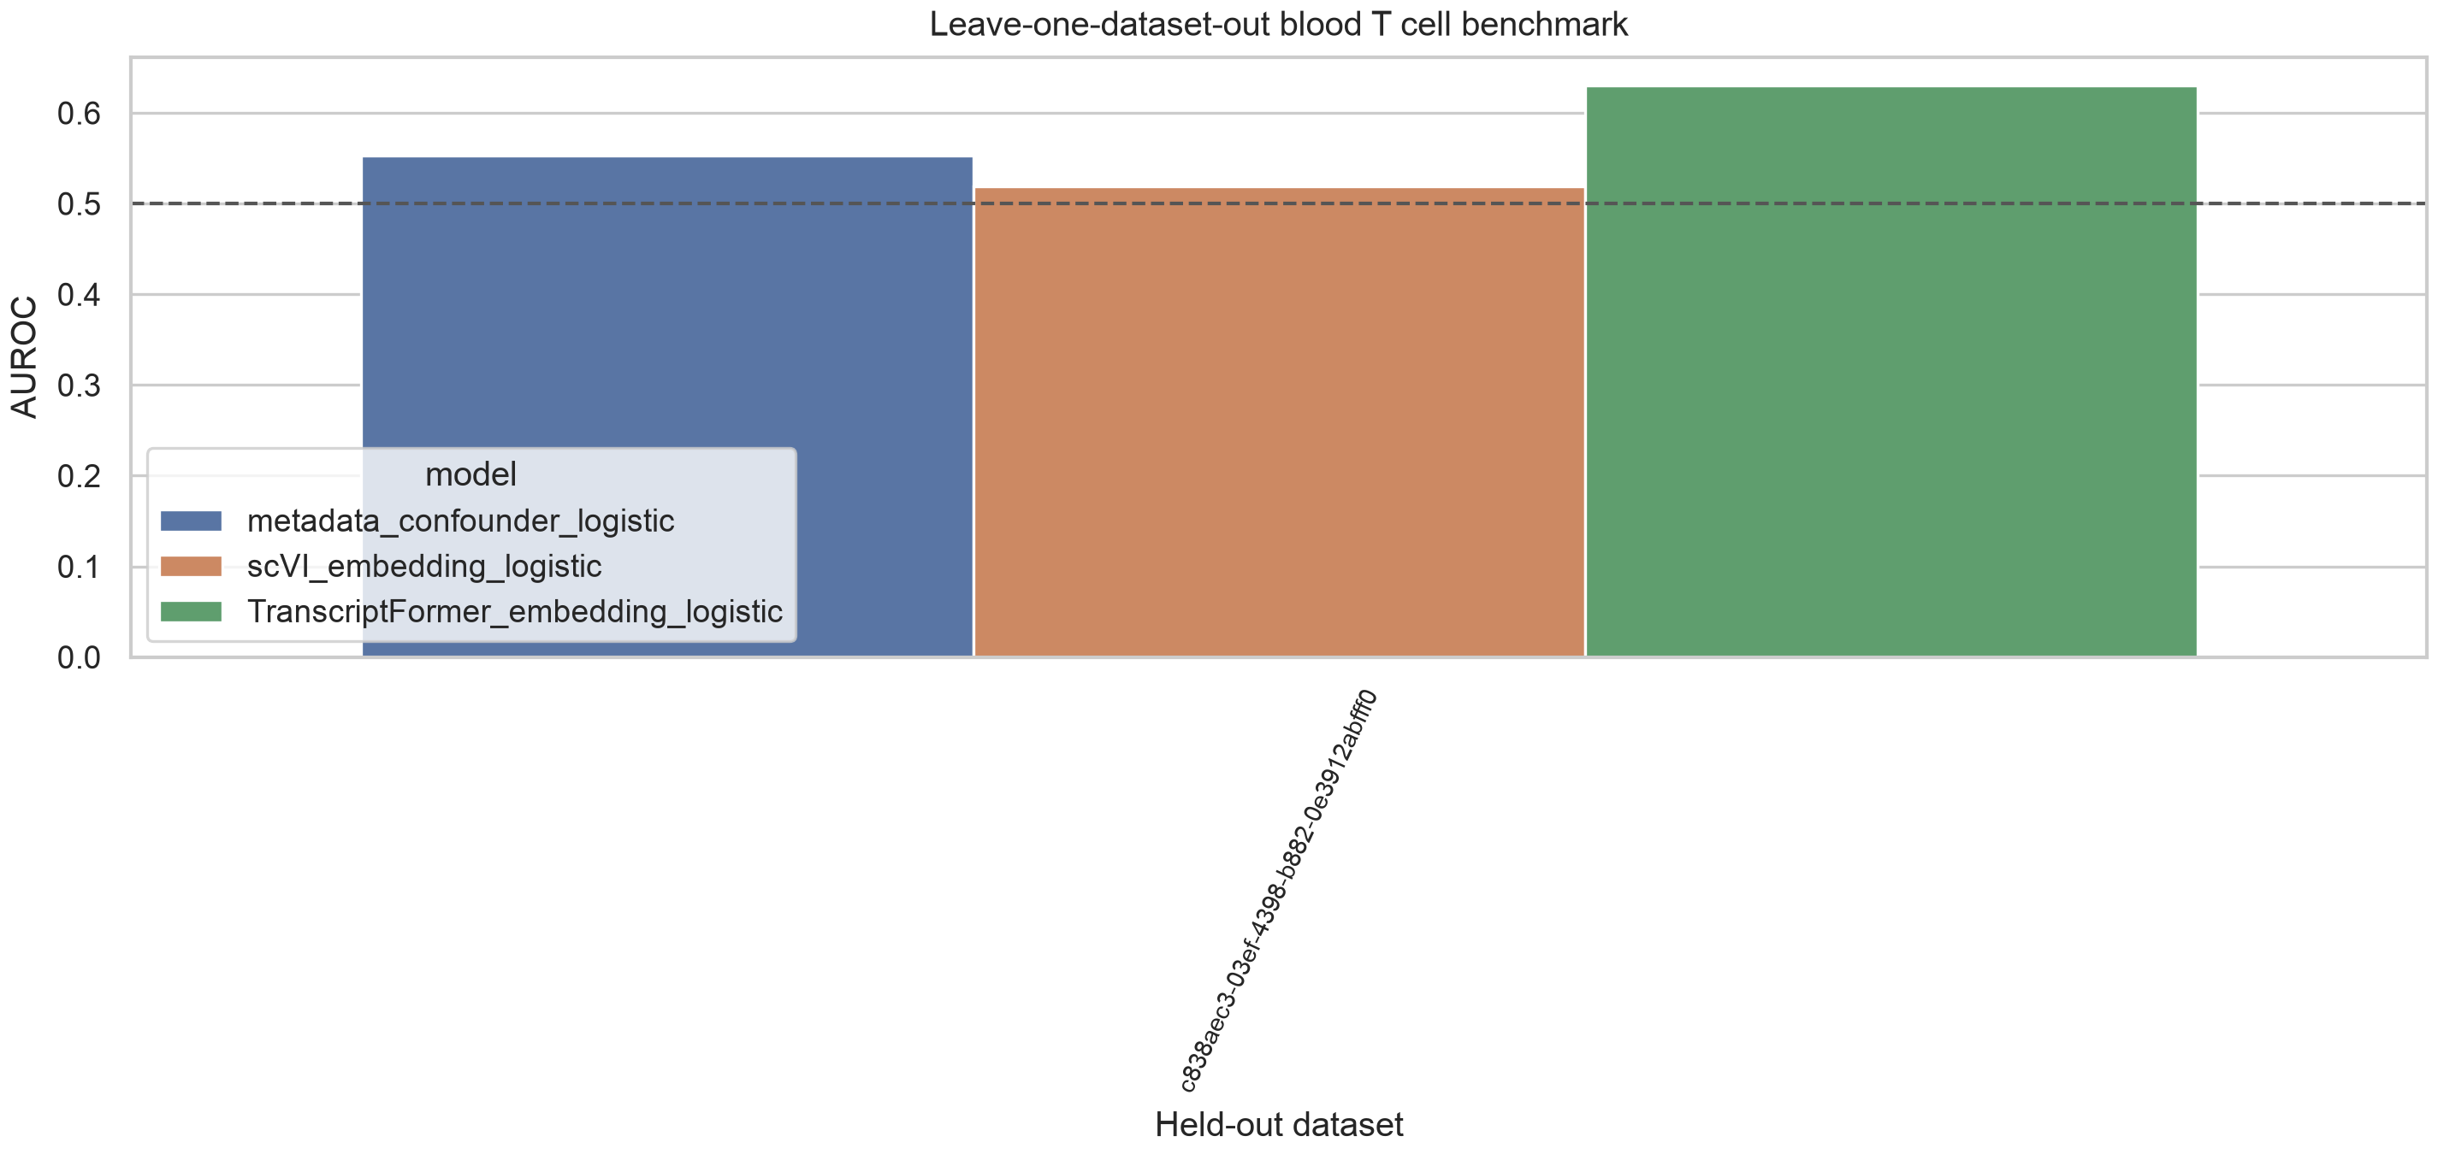
Figure 6. Leave-one-dataset-out diagnostic. Only one dataset satisfied the requirement that both the held-out dataset and the remaining training data contain young and old donors. Performance on this eligible held-out dataset is therefore reported as a limited dataset-transfer diagnostic, not as multicohort external validation.

Sampling-depth sensitivity
Sampling-depth sensitivity showed that donor-mean performance depended on the number of cells contributing to a donor summary. TranscriptFormer donor-holdout AUROC increased from 0.671 at one requested cell per donor to 0.855 at eight cells per donor. The requested 16-cell condition was capped by the existing eight-cell-per-donor sample and therefore reproduced the eight-cell result rather than adding new cellular depth.
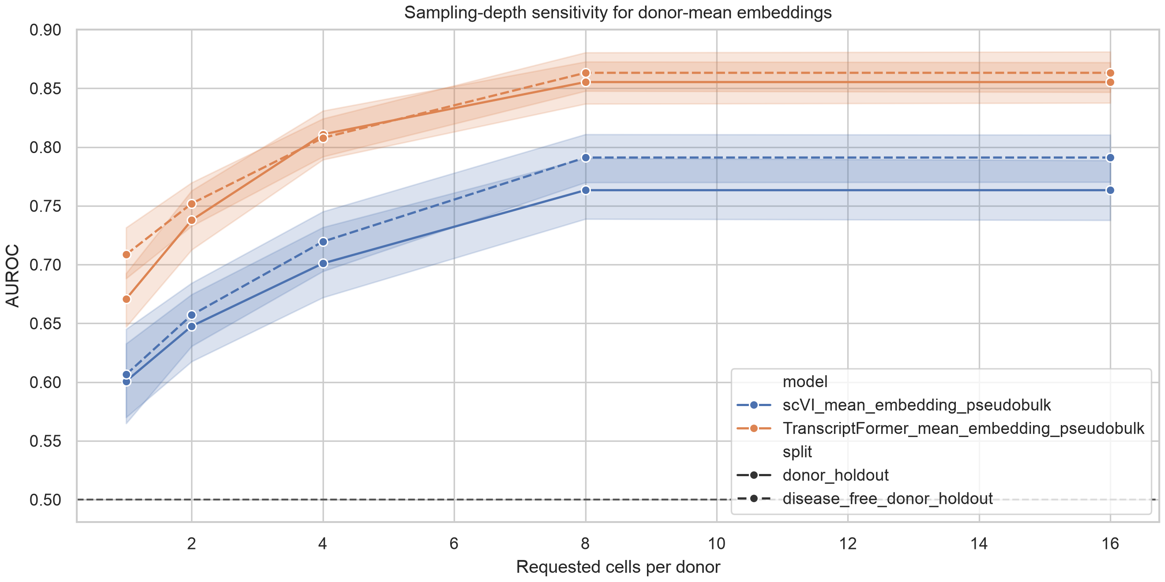
Figure 7. Sampling-depth sensitivity. Donor-mean embedding performance is shown as the requested number of cells per donor increases. The 16-cell condition is capped by the available eight-cell-per-donor sample, so it repeats the eight-cell result and should not be interpreted as additional sampling depth.

Discussion
This study used blood T-cell age classification as an empirical case study to evaluate a broader methodological question: how should public single-cell representations be audited when labels are donor-level and metadata are uneven across studies? The main finding is that validation design changes the interpretation of hosted embeddings. Random-cell evaluation produced favorable apparent performance, but donor-aware and dataset-aware analyses exposed substantial dependence on donor grouping, study origin, and age-class imbalance. This pattern is consistent with wider concerns in biomedical machine learning, where leakage and distribution shift can dominate nominal model performance when the validation unit is not aligned with the biological label [30-34].
Random-cell performance was especially informative as a warning signal. In this benchmark, the metadata-only random-cell AUROC (0.769) exceeded TranscriptFormer (0.749) and scVI (0.707). Because the metadata-only model used donor-, assay-, and dataset-associated variables rather than transcriptomic embeddings, this result indicates that apparent age prediction can be recovered from public metadata structure alone. The result does not imply that embeddings lack biological information. It means that random-cell evaluation cannot separate biological age signal from donor identity, dataset origin, assay composition, and metadata-derived label structure. Similar caveats underlie single-cell batch-correction and atlas-integration benchmarks, where performance depends strongly on the chosen unit of comparison and the treatment of batch variables [19-24].
The metadata-only result is also important for how public benchmark leaderboards should be read. A metadata baseline is sometimes treated as a weak comparator, but in aggregated public resources it can be a strong proxy for study design. Dataset identifiers, assay terms, disease labels, and related public metadata may encode decisions about recruitment and preprocessing that are correlated with age. When this baseline performs well, embedding performance needs to be interpreted against a stricter null: the model is not merely asked to classify age, but to do so beyond information already present in public metadata.
Donor-level aggregation gave a more coherent label unit for age classification. Age is a donor-level property, whereas individual cells are repeated observations nested within donors. Aggregating hosted embeddings to donor means reduced the mismatch between cell-level observations and donor-level labels, and donor-mean TranscriptFormer showed higher donor-holdout AUROC than cell-level TranscriptFormer. This should be interpreted as improved benchmark stability under the available labels, not as evidence of a clinically validated aging model. The donor-level result also depends on how many cells per donor are available, as the sampling-depth analysis showed that one-cell donor summaries were less stable than summaries based on larger donor samples.
The donor-holdout and donor-mean analyses also clarify why the effective sample size is the number of donors rather than the number of cells. A cell-level split can create thousands of observations, but those observations are not independent with respect to age. Donor-mean aggregation is not a replacement for external validation, and it may hide within-donor heterogeneity that is biologically relevant. Its value here is diagnostic: it tests whether predictions are more stable when the representation is summarized at the same unit as the age label.
Dataset-aware analyses gave a more restrictive view of generalization. Grouped dataset-holdout performance was lower and had wider split-to-split variability than donor-holdout performance, and leave-one-dataset-out analysis identified only one eligible held-out dataset after requiring both young and old donors in the held-out and training partitions. That limited LODO feasibility is itself a diagnostic result. It shows that public metadata can support selected benchmark strata, but it does not yet provide broad multicohort external validation for this task. The single eligible held-out dataset analysis should therefore be read as a dataset-transfer diagnostic, not as proof of external clinical generalization.
The disease-free analyses help narrow one source of confounding but do not remove all cohort structure. High disease-free donor-holdout AUROC can coexist with residual dataset, assay, recruitment, processing, and cohort effects because excluding donors with recorded disease labels does not harmonize all study-level variables. Public disease labels may also differ in detail and curation across contributing studies. For this reason, disease-free performance should be interpreted as a sensitivity analysis within public metadata constraints, not as evidence that disease, recruitment, and study effects have been eliminated.
The comparison between scVI and TranscriptFormer is therefore secondary to the audit framework. scVI and TranscriptFormer represent different hosted representation strategies, and their relative ranking changed across validation designs. TranscriptFormer performed well in donor-mean donor-holdout and disease-free donor-holdout settings, whereas dataset-holdout results were more limited and uncertain. This pattern argues against using one split type to declare a representation broadly superior. It also cautions against extending the present findings to Geneformer, scGPT, scFoundation, GeneCompass, or other models that were cited for context but not directly benchmarked here [14-18].
This boundary matters for interpreting hosted representations. Hosted embeddings are valuable because they make large atlas resources accessible without requiring every user to retrain a model on raw counts. The present analysis supports their use in reproducible benchmarking, but only when evaluation explicitly accounts for leakage and study structure. A hosted embedding can be technically convenient and biologically useful while still producing misleading performance estimates under an evaluation design that leaks donor or dataset information.
Several limitations define the boundary of the study. The completed empirical benchmark is restricted to blood T cells. Age labels were derived from public development_stage metadata rather than from a harmonized donor-age field. Dataset-holdout and LODO diagnostics were constrained by strong age-class imbalance. The 30 repeated seeds quantify split variability, not uncertainty across independent external cohorts. Calibration metrics and a traditional raw-expression baseline were not added because prediction-level outputs and raw expression matrices for the exact sampled cells were not packaged in the current release. The 16-cell sampling-depth condition is capped by the existing eight-cell-per-donor sampled data and therefore duplicates the eight-cell condition.
The raw-expression baseline is the clearest missing comparator in the current release. A normalized-expression or pseudobulk baseline would help determine whether hosted embeddings improve over a simpler expression workflow under identical donors and splits. Adding such a baseline is feasible in principle, but it must be implemented with fold-specific normalization, HVG selection, dimensionality reduction, and model fitting. Running those steps on a different cell set or fitting preprocessing on the full data matrix would create exactly the kind of leakage this manuscript is designed to avoid.
Future benchmarks should pair hosted embeddings with train-fold-safe raw-expression baselines, donor-level bootstrap or permutation procedures based on stored prediction scores, and broader benchmark strata where metadata support balanced dataset transfer. Public repositories should also preserve the exact cells, donors, splits, embeddings, metadata transformations, and code used for each analysis. With those extensions, leakage-aware audits can become a routine part of public single-cell representation evaluation rather than an optional post hoc check.

Conclusions
A leakage-aware evaluation of CELLxGENE-hosted blood T-cell embeddings showed that validation design strongly changes apparent age-prediction performance. Metadata-only random-cell performance was high, donor-aware aggregation improved stability for donor-level labels, and dataset-transfer diagnostics were constrained by age-class imbalance. The main contribution is a reusable audit framework for public single-cell prediction tasks, not a clinical aging-clock model or a pan-tissue validation study.

Statements and Declarations
For double-blind peer review, author identities, affiliations, acknowledgements, funding details, repository owner identity, and archival DOI information are provided only in the separate title page. The blinded manuscript refers to an anonymized analysis package supplied with the submission.

References
1. Regev A, Teichmann SA, Lander ES, Amit I, Benoist C, Birney E, et al. The Human Cell Atlas. eLife. 2017;6:e27041. doi:10.7554/eLife.27041.
2. Han X, Zhou Z, Fei L, Sun H, Wang R, Chen Y, et al. Construction of a human cell landscape at single-cell level. Nature. 2020;581:303-309. doi:10.1038/s41586-020-2157-4.
3. Tabula Sapiens Consortium. The Tabula Sapiens: a multiple-organ, single-cell transcriptomic atlas of humans. Science. 2022;376:eabl4896. doi:10.1126/science.abl4896.
4. Abdulla S, Aevermann BD, Assis P, Badajoz S, Bell SM, Bezzi E, et al. CZ CELLxGENE Discover: a single-cell data platform for scalable exploration, analysis and modeling of aggregated data. Nucleic Acids Research. 2025;53:D886-D900. doi:10.1093/nar/gkae1142.
5. Horvath S. DNA methylation age of human tissues and cell types. Genome Biology. 2013;14:R115. doi:10.1186/gb-2013-14-10-r115.
6. Hannum G, Guinney J, Zhao L, Zhang L, Hughes G, Sadda S, et al. Genome-wide methylation profiles reveal quantitative views of human aging rates. Molecular Cell. 2013;49:359-367. doi:10.1016/j.molcel.2012.10.016.
7. Tabula Muris Consortium. A single-cell transcriptomic atlas characterizes ageing tissues in the mouse. Nature. 2020;583:590-595. doi:10.1038/s41586-020-2496-1.
8. Zou Z, Long X, Zhao Q, Zheng Y, Song M, Ma S, et al. A single-cell transcriptomic atlas of human skin aging. Developmental Cell. 2021;56:383-397.e8. doi:10.1016/j.devcel.2020.11.002.
9. Zakar-Polyak E, Csordas A, Palovics R, Kerepesi C. Profiling the transcriptomic age of single-cells in humans. Communications Biology. 2024;7:1397. doi:10.1038/s42003-024-07094-5.
10. Kedlian VR, Wang Y, Herder C, et al. Human skeletal muscle aging atlas. Nature Aging. 2024;4:727-744. doi:10.1038/s43587-024-00613-3.
11. Bartz J, Ma X, Zhang L, Dong X. Human Cell Aging Transcriptome Atlas (HCATA): a single-cell atlas of age-associated transcriptomic alterations across human tissues. Communications Biology. 2025. doi:10.1038/s42003-025-08845-8.
12. Aging Fly Cell Atlas Consortium. Aging Fly Cell Atlas identifies exhaustive aging features at cellular resolution. Science. 2023;380:eadg0934. doi:10.1126/science.adg0934.
13. Lopez R, Regier J, Cole MB, Jordan MI, Yosef N. Deep generative modeling for single-cell transcriptomics. Nature Methods. 2018;15:1053-1058. doi:10.1038/s41592-018-0229-2.
14. Gayoso A, Lopez R, Xing G, Boyeau P, Valiollah Pour Amiri V, Hong J, et al. A Python library for probabilistic analysis of single-cell omics data. Nature Biotechnology. 2022;40:163-166. doi:10.1038/s41587-021-01206-w.
15. Theodoris CV, Xiao L, Chopra A, Chaffin MD, Al Sayed ZR, Hill MC, et al. Transfer learning enables predictions in network biology. Nature. 2023;618:616-624. doi:10.1038/s41586-023-06139-9.
16. Cui H, Wang C, Maan H, Pang K, Luo F, Duan N, et al. scGPT: toward building a foundation model for single-cell multi-omics using generative AI. Nature Methods. 2024;21:1470-1480. doi:10.1038/s41592-024-02201-0.
17. Hao M, Gong J, Zeng X, Liu C, Guo Y, Cheng X, et al. Large-scale foundation model on single-cell transcriptomics. Nature Methods. 2024;21:1481-1491. doi:10.1038/s41592-024-02305-7.
18. Yang X, Liu G, Feng G, et al. GeneCompass: deciphering universal gene regulatory mechanisms with a knowledge-informed cross-species foundation model. Cell Research. 2024;34:830-845. doi:10.1038/s41422-024-01034-y.
19. Pearce JD, Simmonds SE, Mahmoudabadi G, Krishnan L, Palla G, Istrate AM, et al. TranscriptFormer: a generative cell atlas across 1.5 billion years of evolution. Science. 2026;eaec8514. doi:10.1126/science.aec8514.
20. Luecken MD, Theis FJ. Current best practices in single-cell RNA-seq analysis: a tutorial. Molecular Systems Biology. 2019;15:e8746. doi:10.15252/msb.20188746.
21. Stuart T, Butler A, Hoffman P, Hafemeister C, Papalexi E, Mauck WM 3rd, et al. Comprehensive integration of single-cell data. Cell. 2019;177:1888-1902.e21. doi:10.1016/j.cell.2019.05.031.
22. Haghverdi L, Lun ATL, Morgan MD, Marioni JC. Batch effects in single-cell RNA-sequencing data are corrected by matching mutual nearest neighbors. Nature Biotechnology. 2018;36:421-427. doi:10.1038/nbt.4091.
23. Korsunsky I, Millard N, Fan J, Slowikowski K, Zhang F, Wei K, et al. Fast, sensitive and accurate integration of single-cell data with Harmony. Nature Methods. 2019;16:1289-1296. doi:10.1038/s41592-019-0619-0.
24. Johnson WE, Li C, Rabinovic A. Adjusting batch effects in microarray expression data using empirical Bayes methods. Biostatistics. 2007;8:118-127. doi:10.1093/biostatistics/kxj037.
25. Tran HTN, Ang KS, Chevrier M, Zhang X, Lee NYS, Goh M, et al. A benchmark of batch-effect correction methods for single-cell RNA sequencing data. Genome Biology. 2020;21:12. doi:10.1186/s13059-019-1850-9.
26. Luecken MD, Buttner M, Chaichoompu K, Danese A, Interlandi M, Mueller MF, et al. Benchmarking atlas-level data integration in single-cell genomics. Nature Methods. 2022;19:41-50. doi:10.1038/s41592-021-01336-8.
27. Polanski K, Young MD, Miao Z, Meyer KB, Teichmann SA, Park JE. BBKNN: fast batch alignment of single cell transcriptomes. Bioinformatics. 2020;36:964-965. doi:10.1093/bioinformatics/btz625.
28. Hie B, Bryson B, Berger B. Efficient integration of heterogeneous single-cell transcriptomes using Scanorama. Nature Biotechnology. 2019;37:685-691. doi:10.1038/s41587-019-0113-3.
29. Buttner M, Miao Z, Wolf FA, Teichmann SA, Theis FJ. A test metric for assessing single-cell RNA-seq batch correction. Nature Methods. 2019;16:43-49. doi:10.1038/s41592-018-0254-1.
30. Varoquaux G. Cross-validation failure: small sample sizes lead to large error bars. NeuroImage. 2018;180:68-77. doi:10.1016/j.neuroimage.2017.06.061.
31. Vabalas A, Gowen E, Poliakoff E, Casson AJ. Machine learning algorithm validation with a limited sample size. PLoS ONE. 2019;14:e0224365. doi:10.1371/journal.pone.0224365.
32. Collins GS, Reitsma JB, Altman DG, Moons KGM. Transparent reporting of a multivariable prediction model for individual prognosis or diagnosis (TRIPOD): the TRIPOD statement. Annals of Internal Medicine. 2015;162:55-63. doi:10.7326/M14-0697.
33. Luo W, Phung D, Tran T, Gupta S, Rana S, Karmakar C, et al. Guidelines for developing and reporting machine learning predictive models in biomedical research: a multidisciplinary view. Journal of Medical Internet Research. 2016;18:e323. doi:10.2196/jmir.5870.
34. Kelly CJ, Karthikesalingam A, Suleyman M, Corrado G, King D. Key challenges for delivering clinical impact with artificial intelligence. BMC Medicine. 2019;17:195. doi:10.1186/s12916-019-1426-2.
35. Roberts M, Driggs D, Thorpe M, Gilbey J, Yeung M, Ursprung S, et al. Common pitfalls and recommendations for using machine learning to detect and prognosticate for COVID-19 using chest radiographs and CT scans. Nature Machine Intelligence. 2021;3:199-217. doi:10.1038/s42256-021-00307-0.
36. Wynants L, Van Calster B, Collins GS, Riley RD, Heinze G, Schuit E, et al. Prediction models for diagnosis and prognosis of covid-19 infection: systematic review and critical appraisal. BMJ. 2020;369:m1328. doi:10.1136/bmj.m1328.
37. Koh PW, Sagawa S, Marklund H, Xie SM, Zhang M, Balsubramani A, et al. WILDS: a benchmark of in-the-wild distribution shifts. Proceedings of Machine Learning Research. 2021;139:5637-5664.
38. Bzdok D, Engemann DA, Thirion B. Inference and prediction diverge in biomedicine. Patterns. 2020;1:100119. doi:10.1016/j.patter.2020.100119.
39. Riley RD, Ensor J, Snell KIE, Harrell FE Jr, Martin GP, Reitsma JB, et al. Calculating the sample size required for developing a clinical prediction model. BMJ. 2020;368:m441. doi:10.1136/bmj.m441.
40. Open Science Collaboration. Estimating the reproducibility of psychological science. Science. 2015;349:aac4716. doi:10.1126/science.aac4716.
41. Levine ME, Lu AT, Quach A, Chen BH, Assimes TL, Bandinelli S, et al. An epigenetic biomarker of aging for lifespan and healthspan. Aging. 2018;10:573-591. doi:10.18632/aging.101414.
42. Lu AT, Quach A, Wilson JG, Reiner AP, Aviv A, Raj K, et al. DNA methylation GrimAge strongly predicts lifespan and healthspan. Aging. 2019;11:303-327. doi:10.18632/aging.101684.
43. Craig T, Smelick C, Tacutu R, Wuttke D, Wood SH, Stanley H, et al. The Digital Ageing Atlas: integrating the diversity of age-related changes into a unified resource. Nucleic Acids Research. 2015;43:D873-D878. doi:10.1093/nar/gku843.
44. Aging Atlas Consortium. Aging Atlas: a multi-omics database for aging biology. Nucleic Acids Research. 2021;49:D825-D830. doi:10.1093/nar/gkaa894.
45. Lu Y, Brommer B, Tian X, Krishnan A, Meer M, Wang C, et al. Reprogramming to recover youthful epigenetic information and restore vision. Nature. 2020;588:124-129. doi:10.1038/s41586-020-2975-4.
46. Amezquita RA, Lun ATL, Becht E, Carey VJ, Carpp LN, Geistlinger L, et al. Orchestrating single-cell analysis with Bioconductor. Nature Methods. 2020;17:137-145. doi:10.1038/s41592-019-0654-x.
47. Wolf FA, Angerer P, Theis FJ. SCANPY: large-scale single-cell gene expression data analysis. Genome Biology. 2018;19:15. doi:10.1186/s13059-017-1382-0.
48. Virshup I, Rybakov S, Theis FJ, Angerer P, Wolf FA. anndata: annotated data. bioRxiv. 2021. doi:10.1101/2021.12.16.473007.
49. Pedregosa F, Varoquaux G, Gramfort A, Michel V, Thirion B, Grisel O, et al. Scikit-learn: Machine Learning in Python. Journal of Machine Learning Research. 2011;12:2825-2830.

