A Reproducibility-Aware Decision-Support Evaluation Framework for Multimodal ECG Diagnostic Classification
Yi Zha^1^, Da Lin^1^, Ying Chen^2^, Yue Liu^2^, Yu Zhang^1,*
^1^ The Second Affiliated Hospital of Wenzhou Medical University, Wenzhou, Zhejiang, China.
^2^ Wenzhou Medical University, Wenzhou, Zhejiang, China.
*Correspondence: Yu Zhang, zhangyu1@wzhealth.com; ORCID: 0000-0001-8579-3692.

Abstract
Background: Multimodal electrocardiogram (ECG) models can combine waveform representations with structured ECG-derived measurements, but public-data studies need to distinguish internal multimodal performance from external transportability and feature-reproducibility constraints. We evaluated whether released PTB-XL+ structured features support internal multimodal complementarity and whether comparable structured features can be reconstructed with enough fidelity and coverage for external multimodal validation.
Methods: We used PTB-XL waveforms and released PTB-XL+ structured features for internal development and evaluation across five diagnostic superclasses: NORM, MI, STTC, CD, and HYP. Model groups included signal-only, signal-embedding, structured-feature, matched multimodal concatenation, and gated-fusion models. Model selection, threshold tuning, and temperature scaling used internal validation data only. External evaluation was restricted to signal-only validation on CPSC2018 and the Chapman-Shaoxing-Ningbo ECG database using restricted high-confidence label subsets. A structured-feature reproducibility audit tested whether a numerically concordant reduced feature subset could preserve internal multimodal gain and provide adequate external joinability.
Results: With the released full PTB-XL+ schema, matched multimodal concatenation achieved AUROC 0.919, average precision 0.795, and F1 0.721, exceeding the signal-embedding comparator by +0.010 AUROC, +0.023 average precision, and +0.021 F1. Gated fusion had slightly higher point estimates but no statistically clear advantage over concatenation. The structured-feature reproducibility audit found 138 numerically concordant features, but this concordance-selected subset did not preserve internal multimodal gain. Robustness controls showed that random and internally importance-ranked 138-feature subsets recovered internal gains, indicating loss of informative structured features rather than a feature-count limit alone. External multimodal validation was not attempted because the current external structured-feature extraction-and-joining workflow produced candidate structured rows for only two records per external dataset. Signal-only external validation achieved macro AUROC 0.907 on CPSC2018 and 0.874 on the Chapman-Shaoxing-Ningbo high-confidence label subset, with low AP/F1 in low-prevalence labels.
Conclusions: Released PTB-XL+ features supported modest internal multimodal complementarity, but current external structured-feature extraction was not sufficiently complete to support external multimodal validation. The most informative robustness finding was that numerically reproducible features were not necessarily the features carrying multimodal signal. Externally reproducible, sufficiently informative, and complete structured-feature extraction is needed before external multimodal or clinical-use claims can be considered.

Keywords
Electrocardiography; Clinical decision support; Multimodal fusion; Signal-level external validation; Model calibration; Uncertainty estimation; Explainable artificial intelligence; Reproducibility; Public datasets; Evidence boundary.

Background
Automated ECG interpretation has become an important test case for public-data medical artificial intelligence because 12-lead ECGs combine rich waveform structure, clinically meaningful measurements, and heterogeneous diagnostic labels. Public resources such as PTB-XL have enabled reproducible benchmarking for multi-label ECG classification, while PTB-XL+ extends this setting with structured ECG-derived features aligned to PTB-XL records [1–3]. These resources make it possible to ask whether waveform representations and structured ECG measurements provide complementary information for cardiac diagnostic assessment.
For health decision-support research, however, performance-only reporting is insufficient. A model with strong internal discrimination may still be poorly calibrated, unstable under distribution shift, difficult to audit, or dependent on features that cannot be reproduced outside the development dataset. Calibration matters because risk estimates may be interpreted as probabilities; uncertainty analysis can identify cases where prediction confidence is lower; explainability can support model auditing; and decision-curve analysis can explore threshold-dependent consequences [4–11]. None of these components establishes clinical readiness by itself, but together they provide a more cautious evaluation of whether a model behaves like a decision-support candidate rather than only a benchmark classifier.
Multimodal ECG studies face an additional reproducibility problem. Structured ECG features depend on delineation software, preprocessing choices, lead handling, and feature definitions. ECGdeli provides an open-source ECG delineation context, but a local delineation output is not automatically equivalent to a released PTB-XL+ structured-feature schema [3,12]. If an internal multimodal model uses released structured values from one dataset, external multimodal validation is only justified when comparable structured features can be generated externally with adequate fidelity and coverage. External ECG datasets such as CPSC2018 and Chapman-Shaoxing-Ningbo also differ from PTB-XL in label scope, prevalence, and annotation structure [13–15]. These differences make it important to separate internal multimodal gains from signal-level external transportability and from structured-feature reconstruction feasibility.
The gap addressed here is therefore not only model performance. A central methodological question is whether the features that are easiest to reproduce numerically are also the features that carry clinically and statistically useful multimodal signal. Our robustness analysis showed that this need not be true: concordance-selected features were reproducible but weak, whereas random and internally importance-ranked 138-feature controls recovered internal gains. This distinction gives the study a positive methodological focus: responsible multimodal ECG evaluation must test not only internal performance, but also whether externally reconstructed structured features are both reproducible and informative.
In this study, we evaluated a reproducibility-aware multimodal ECG decision-support framework using PTB-XL/PTB-XL+ internally and CPSC2018 plus the Chapman-Shaoxing-Ningbo ECG database externally. The primary objective was to define whether an internal PTB-XL/PTB-XL+ multimodal result can be responsibly extended to external multimodal validation when structured features must be reconstructed de novo. Secondary objectives were to quantify the internal value of released PTB-XL+ structured features beyond ECG signal embeddings, compare matched concatenation with gated fusion, and report signal-only external behavior under restricted high-confidence label subsets. This was a conservative public-data evaluation, not a clinical deployment study.

Methods

Study design
This was a public-data model development and evaluation study. The primary internal analysis used PTB-XL waveforms and released PTB-XL+ structured features [1,3]. External validation used CPSC2018 and Chapman-Shaoxing-Ningbo waveforms for signal-only evaluation [13–15]. External structured-feature generation was audited for reproducibility and coverage feasibility, but external structured features were not used for validated multimodal external testing.
The evaluation followed a prespecified staged workflow. Initial data-ingestion checks verified the PTB-XL local data layout, parsed diagnostic labels, and generated frozen train, validation, and test files. Internal modeling then compared signal-only, signal-embedding, structured-only, matched concat, and gated fusion models. Subsequent analyses evaluated calibration, uncertainty triage, post-hoc explainability, exploratory decision-curve analysis, signal-only external validation, and structured-feature reproducibility.

AI-assisted tools and author responsibility
AI-assisted programming and language-polishing tools were used to support code generation, debugging, manuscript editing, and figure-package preparation. All analytic decisions, generated outputs, evidence boundaries, and final manuscript wording were reviewed by the authors, who take responsibility for the integrity and accuracy of the work.
A TRIPOD+AI-oriented reporting checklist is provided as Supplementary Table S7 [20].

Data sources and roles
PTB-XL served as the internal waveform dataset. PTB-XL+ served as the internal released structured-feature resource. The internal label scope used five diagnostic superclasses: NORM, MI, STTC, CD, and HYP. Official PTB-XL split logic was preserved, with training, validation, and test partitions kept frozen throughout model development and evaluation.
CPSC2018 and the PhysioNet Chapman-Shaoxing-Ningbo ECG database served as external waveform datasets for signal-only validation. CPSC2018 was evaluated for the restricted high-confidence NORM/CD label subset. The Chapman-Shaoxing-Ningbo combined WFDB release was evaluated for the restricted MI/CD/HYP label subset; sinus rhythm labels were not treated as main-analysis NORM. The evaluated 45,150 records refer to this combined PhysioNet release after waveform-readability filtering, not to the earlier 10,646-record Chapman-Shaoxing publication alone. Records that could not be read as WFDB waveforms were excluded. No external threshold tuning, external model selection, or external retraining was performed.
The external label mappings are provided as a supplementary audit table. Main external evaluation retained only high-confidence mappings: CPSC2018 contributed NORM and CD, while the Chapman-Shaoxing-Ningbo database contributed MI, CD, and HYP. Medium-confidence labels such as ST-T abnormalities were not used in the main external analysis. This design makes external results label-scope-specific and prevents direct comparison with the five-label internal macro metrics.
External structured features were treated as an audit target rather than a validation input. Candidate ECGdeli-derived features and concordant reduced-schema features were assessed for feasibility, but they were not considered official PTB-XL+ external structured features.

Model groups
Five internal model groups were evaluated:
- Strong signal-only model using 100 Hz 12-lead PTB-XL waveforms.
- Signal-embedding MLP using a 256-dimensional signal representation.
- Structured-feature MLP using 531 released PTB-XL+ structured features.
- Matched MLP-concat model combining the 256-dimensional signal embedding with 531 structured features.
- Gated fusion MLP using the same signal and structured input interface.
The strong signal-only model used a one-dimensional residual network with 12 input channels, 100 Hz waveforms, base channel width 64, three residual stages with two blocks per stage, dropout 0.2, and five output labels. Residual learning was used as the general architectural background [16]. The model provided both a direct waveform comparator and the 256-dimensional signal embedding for controlled multimodal comparison; embeddings were extracted from the penultimate representation of the trained signal model and then treated as frozen inputs for downstream MLP and matched-fusion experiments. Signal-embedding and structured MLP comparators used hidden dimensions 256/128 and 512/256, respectively, with dropout 0.3. The matched concat MLP used hidden dimensions 512/256, and the gated-fusion MLP used a 256-unit gating layer and a 256-unit classifier layer. Models used sigmoid multi-label outputs trained with binary cross-entropy with logits. Neural models used AdamW optimization in PyTorch with learning rate 0.001, weight decay 0.0001, batch size 64 for the signal model and 128 for MLP models, validation AUROC-based model selection, and early stopping patience of 8 epochs for the signal model and 10 epochs for MLP models. Maximum epochs were 50 for the signal model and 100 for MLP or gated models. The primary random seed was 2026; repeated-seed checks used seeds 2026, 2027, and 2028. The matched fusion dataset combined signal embeddings and released structured features after median imputation and standardization defined on the training set.
Waveform records were read from the 100 Hz PTB-XL records100 WFDB files using wfdb.rdsamp. For signal-model inputs, each ECG record was represented as a 12-channel waveform and each lead was standardized within record to zero mean and unit variance with a small numerical floor on the standard deviation. The same signal-loader convention was used for signal-level external evaluation after dataset-specific WFDB compatibility checks. For the structured-feature reconstruction audit, candidate ECGdeli processing used the ECGdeli filtering and delineation workflow, including 1-40 Hz band-pass filtering, 50 Hz notch filtering, isoline correction, multichannel fiducial-point annotation, and subsequent amplitude or interval feature extraction where available.
The signal-embedding MLP and the strong signal-only model therefore answer related but distinct questions. The signal-embedding MLP controls for the frozen representation used by multimodal fusion, whereas the strong signal-only model evaluates the end-to-end waveform classifier. Both comparators are reported to avoid attributing a multimodal gain to classifier-head differences alone.

Matched-comparison principle
The gated fusion model was compared against matched concat because multimodal gains should not be attributed to architectural complexity when a simple fusion strategy can capture similar information. Signal-embedding, structured-only, matched concat, and gated fusion models used the same frozen splits, label scope, validation-only early stopping, and validation-derived thresholds. This design was intended to isolate the contribution of modality complementarity from the contribution of extra model complexity.

Calibration
Calibration was assessed using stored validation and test predictions. Temperature scaling was fit on internal validation logits and evaluated on frozen internal test predictions [4]. For external signal-only calibration, the internally fitted temperature source was carried forward without external refitting. Reliability data, Brier score, expected calibration error, and maximum calibration error were reported [5–6]. External calibration was interpreted as behavior under distribution shift, not as clinical calibration readiness.

Uncertainty triage
Uncertainty triage was evaluated as a conservative decision-support layer. Prediction uncertainty was used to compare retained subsets across coverage levels. These analyses were informed by uncertainty estimation and selective prediction concepts [7–8]. They were intended to describe whether lower-uncertainty predictions had more favorable internal performance, not to define a deployment-ready triage workflow.

Explainability and XAI
Post-hoc explainability analyses included structured feature attribution, signal attribution case reports, and gate summaries where available. XAI outputs were used for model auditing and interpretation. Feature attribution and saliency-style outputs were interpreted cautiously, consistent with prior explainability methods and medical AI cautions [9–10,17–18]. They were not treated as evidence of causal clinical reasoning or mechanistic explanation.

Decision-curve analysis
Decision-curve analysis was evaluated as an exploratory, threshold-dependent analysis [11]. Label-specific net-benefit curves were used as supplementary decision-support diagnostics. Aggregated net-benefit summaries were not treated as standard clinical-utility endpoints and were not used to claim readiness for practice.

Structured-feature reproducibility audit
The structured-feature reproducibility analysis was treated as a core feasibility audit. Instead of continuing attempts to reconstruct the full PTB-XL+ 531-column schema externally, the audit used a reduced structured-feature subset that had passed internal numerical concordance checks against released PTB-XL+ values. Candidate ECGdeli features were recomputed for a PTB-XL audit sample and compared with released PTB-XL+ values by feature name and ecg_id. A feature entered the reduced subset only when all non-missing paired values satisfied numpy-style allclose criteria with absolute tolerance 1e-6 and relative tolerance 1e-6; the manifest reports missingness, mean absolute error, median absolute error, and maximum absolute error for each selected feature. This subset contained 138 features. The reduced schema was tested internally with signal-embedding, structured-only, and matched concat models, and external coverage was checked for CPSC2018 and the Chapman-Shaoxing-Ningbo database.
External joinability was defined operationally as the presence of both a signal-model prediction record and a candidate structured-feature row keyed by the standardized external record identifier after dataset-specific filename normalization. The two-record coverage result therefore supports a narrower conclusion: the current external extraction-and-joining pipeline did not provide enough matched structured rows for external multimodal evaluation. It should not be read as proof that compatible external structured-feature reconstruction is impossible in principle.
The decision rule was conservative. External multimodal validation would only be considered if the reduced schema preserved internal multimodal gain and if external structured-feature coverage was adequate. If internal gain disappeared or external coverage was insufficient, external multimodal validation would not be supported.
The concordant-subset audit used a strict numerical agreement rule (absolute and relative tolerance 1e-6) to avoid treating implementation-dependent floating-point drift as interchangeable structured information. A robustness audit evaluated tolerance sensitivity and 138-feature count controls. The feature count remained 138 at 1e-4 and 1e-3 and increased only to 141 at 1e-2; substantially looser tolerances admitted more features but were not treated as exact reproduction. The same audit compared the concordance-selected 138 features with random and internally attribution-ranked 138-feature subsets under the same frozen internal split and validation-only model-selection rules. These controls were used to interpret the failure mechanism of the concordance-selected subset, not to establish external multimodal validation.

Statistical analysis
Discrimination was summarized using macro AUROC, macro average precision, and macro F1. Macro metrics were computed as the unweighted mean across labels in the evaluated label scope. Thresholded metrics used thresholds selected on internal validation data. The frozen PTB-XL split included 17,418 training records, 2,183 validation records, and 2,198 test records after records without the required five-superclass label representation or readable waveform/feature alignment were excluded from the analysis set. Matched concat was compared with the strongest unimodal comparators using paired record-level bootstrap resampling on the frozen internal test set. Gated fusion and matched concat were also compared using paired bootstrap resampling on the frozen internal test set [19]. For each bootstrap replicate, ECG records were resampled with replacement, all class-specific metrics were recomputed in the resampled set, macro metrics were then recomputed within that replicate, and model deltas were calculated on the paired resample. The primary internal multimodal-gain bootstrap used 2,000 record-level resamples; other diagnostic bootstrap summaries used 1,000 resamples and percentile 95% confidence intervals. Bootstrap confidence intervals were reported without multiplicity adjustment and interpreted descriptively. External diagnostics were reported per dataset and per class. No external threshold optimization was performed.
Exploratory decision-curve analysis was calculated per label and reported as supplementary source data. Because net benefit is conventionally defined for a specific decision threshold and outcome, cross-label aggregate summaries were treated only as descriptive audit outputs and were not emphasized as main clinical-utility endpoints.

Results

Internal full-schema multimodal evaluation
Internal full-schema PTB-XL/PTB-XL+ results supported multimodal complementarity. The strong signal-only model achieved test AUROC 0.910, AP 0.772, and F1 0.700. The signal-embedding MLP achieved AUROC 0.909, AP 0.772, and F1 0.700. The structured MLP achieved AUROC 0.905, AP 0.765, and F1 0.690.
Matched MLP-concat achieved AUROC 0.919, AP 0.795, and F1 0.721. Gated fusion MLP achieved AUROC 0.920, AP 0.798, and F1 0.726. Although the gated model had slightly higher raw point estimates, paired bootstrap intervals for gated minus matched concat contained zero; the simpler matched concat model was therefore used as the primary multimodal comparator.

Statistical support for the internal multimodal gain
Paired record-level bootstrap analysis supported the internal matched concat gain over the signal-embedding comparator and the strong signal-only comparator. For matched concat minus signal-embedding MLP, the AUROC delta was +0.010 with a 95% CI from +0.0067 to +0.0131, the AP delta was +0.023 with a 95% CI from +0.0157 to +0.0302, and the F1 delta was +0.021 with a 95% CI from +0.0088 to +0.0324. For matched concat minus strong signal-only, the AUROC delta was +0.009 with a 95% CI from +0.0062 to +0.0127, the AP delta was +0.023 with a 95% CI from +0.0151 to +0.0308, and the F1 delta was +0.021 with a 95% CI from +0.010 to +0.0319. None of these confidence intervals contained zero.
These results provide statistical support for an internal multimodal gain, while remaining limited to the PTB-XL/PTB-XL+ internal evaluation setting. The absolute gain was modest, particularly for AUROC, so the result should be interpreted as evidence of modality complementarity rather than as a large performance improvement.
Per-superclass internal diagnostics showed that the largest matched-concat improvement over the signal-embedding comparator occurred for HYP, where AUROC increased from 0.8359 to 0.8791, AP from 0.4839 to 0.5918, and F1 from 0.4444 to 0.5393. Differences for NORM, MI, STTC, and CD were smaller and should be interpreted as descriptive per-class context rather than separate confirmatory tests.

Gated fusion versus matched concat
Gated fusion did not show a statistically clear advantage over matched concat. The paired bootstrap delta for AUROC was +0.000 with a 95% CI from -0.0015 to 0.0021. The AP delta was +0.003 with a 95% CI from -0.0014 to 0.0070. The F1 delta was +0.005 with a 95% CI from -0.0044 to 0.0142. All confidence intervals contained zero.
These findings support a conservative interpretation: the internal multimodal gain is better attributed to modality complementarity than to an additional benefit from gating.

Calibration and decision-support diagnostics
Internal temperature-scaled calibration was evaluated for the main model groups. Temperature scaling was fitted on internal validation data and evaluated on frozen test predictions. The strong signal-only model had macro Brier score 0.0903 and macro ECE 0.0320. The structured MLP had macro Brier score 0.0942 and macro ECE 0.0212. Matched concat had macro Brier score 0.0864 and macro ECE 0.0283. Gated fusion had macro Brier score 0.0844 and macro ECE 0.0193.
Uncertainty triage, post-hoc explainability, and exploratory decision-curve analysis were retained as decision-support diagnostics and are reported primarily in supplementary materials. In the gated-fusion uncertainty analysis, retaining the lowest-uncertainty 80% of the test set retained 1,757 of 2,198 records and referred 441 records, with more favorable discrimination and calibration among retained cases. These analyses were used to audit model behavior, not to replace the main uncalibrated Table 1 default-threshold performance endpoints.

Signal-only external validation
CPSC2018 signal-only external validation included 9,944 evaluated records for the NORM/CD high-confidence label scope. Macro AUROC was 0.907, macro AP was 0.651, and macro F1 was 0.590. This supports limited signal-level external transportability in the evaluated label subset.
Chapman-Shaoxing-Ningbo signal-only external validation included 45,150 evaluated records for the MI/CD/HYP high-confidence label scope. Macro AUROC was 0.874, macro AP was 0.173, and macro F1 was 0.165. These results should be interpreted mainly as ranking behavior under label shift rather than as strong thresholded-performance evidence. The MI mapping was especially weak for clinical interpretation: only 123 records were mapped as MI-positive (prevalence 0.003), with AP 0.080 and F1 0.028. This very low prevalence suggests that the Chapman-Shaoxing-Ningbo MI label scope is not directly comparable with the PTB-XL MI superclass; it is retained as a label-mapping stress test rather than as a robust external MI performance result.
External validation was signal-only. No external multimodal validation was performed.

External signal-only calibration
External calibration was evaluated without external refitting. CPSC2018 had macro Brier 0.1268, micro Brier 0.1268, macro ECE 0.1262, and macro MCE 0.4099. Chapman-Shaoxing-Ningbo had macro Brier 0.0855, micro Brier 0.0855, macro ECE 0.1412, and macro MCE 0.7277. This no-refit design was intentional: refitting temperature on external test labels would have violated the no-external-tuning evaluation principle.
These results should be reported as transparent calibration behavior under distribution shift, not as evidence of clinical calibration readiness. The high external MCE values indicate that temperature scaling fitted on internal validation data did not transfer reliably to external label/data settings; therefore, external probabilities should not be interpreted as calibrated risks.

Structured-Feature Reproducibility Audit
The structured-feature reproducibility audit found that only 138 structured features were available in the numerically concordant subset. In the reduced-schema internal test, the signal-embedding MLP achieved AUROC 0.909, AP 0.7722, and F1 0.6981. The reduced structured-only MLP showed marked degradation, with AUROC 0.570, AP 0.304, and F1 0.000. The zero F1 reflected default-threshold predictions after loss of most structured-feature information; with validation-tuned thresholds, the same reduced structured-only model reached test F1 0.4002, confirming that the zero default-threshold F1 was a thresholding/probability-scale artifact rather than an empty evaluation pipeline. Reduced matched concat achieved AUROC 0.910, AP 0.773, and F1 0.694, which did not show stable gain over the signal-embedding MLP.
A robustness audit clarified the mechanism of this reduced-schema failure. The strict concordance count was stable across tolerances up to 1e-3 and rose minimally to 141 features at 1e-2. However, feature-count controls showed that 138 features were not inherently insufficient: a random 138-feature subset achieved matched-concat test AUROC 0.920, AP 0.796, and F1 0.711, while an internally importance-ranked 138-feature subset achieved AUROC 0.922, AP 0.803, and F1 0.731. Both controls exceeded the signal-embedding comparator in screening paired bootstrap analyses using 300 record-level resamples. These findings indicate that the concordance-selected subset lost informative structured features; they do not support external multimodal validation because external candidate feature records remained limited to two per dataset.
External structured-feature reconstruction did not reach a scale suitable for evaluation. In the current external audit, candidate ECGdeli-derived structured rows were available for only 2 CPSC2018 records among 9,944 signal prediction records and only 2 Chapman-Shaoxing-Ningbo records among 45,150 signal prediction records. Because the candidate feature records were themselves sparse, this result is best interpreted as an engineering feasibility limitation of the present extraction-and-joining workflow, not as a scientific estimate that PTB-XL+-compatible external reconstruction is impossible in principle.

Tables
Table 1 Internal full-schema model performance on the frozen PTB-XL/PTB-XL+ test set
Model | Test AUROC | Test AP | Test F1
strong signal-only | 0.910 | 0.772 | 0.700
signal-embedding MLP | 0.909 | 0.772 | 0.700
structured MLP | 0.905 | 0.765 | 0.690
matched MLP-concat | 0.919 | 0.795 | 0.721
gated fusion MLP | 0.920 | 0.798 | 0.726
Note. AP = average precision; AUROC = area under the receiver operating characteristic curve.
Table 2 Statistical support for the internal multimodal gain
Note. Deltas are calculated from unrounded prediction-level estimates and paired bootstrap resamples, so displayed deltas may differ slightly from subtraction of rounded table values.
Comparison | Metric | Matched concat | Comparator | Delta | 95% CI | CI contains zero
matched concat minus signal-embedding MLP | AUROC | 0.919 | 0.909 | +0.010 | +0.007 to +0.013 | no
matched concat minus signal-embedding MLP | AP | 0.795 | 0.772 | +0.023 | +0.016 to +0.030 | no
matched concat minus signal-embedding MLP | F1 | 0.721 | 0.700 | +0.021 | +0.009 to +0.032 | no
matched concat minus strong signal-only | AUROC | 0.919 | 0.910 | +0.009 | +0.006 to +0.013 | no
matched concat minus strong signal-only | AP | 0.795 | 0.772 | +0.023 | +0.015 to +0.031 | no
matched concat minus strong signal-only | F1 | 0.721 | 0.700 | +0.021 | +0.010 to +0.032 | no
Note. AP = average precision; AUROC = area under the receiver operating characteristic curve; CI = confidence interval. Thresholds were selected on internal validation data only.
Table 3 Gated fusion versus matched concat on the frozen internal test set
Metric | Delta gated minus matched concat | 95% CI | Interpretation
AUROC | +0.000 | -0.002 to 0.002 | CI contains zero
AP | +0.003 | -0.001 to 0.007 | CI contains zero
F1 | +0.005 | -0.004 to 0.014 | CI contains zero
Note. AP = average precision; AUROC = area under the receiver operating characteristic curve; CI = confidence interval.
Table 4 Signal-only external validation
Dataset | Label scope | N | Macro AUROC | Macro AP | Macro F1
CPSC2018 | NORM/CD | 9,944 | 0.907 | 0.651 | 0.590
Chapman-Shaoxing-Ningbo | MI/CD/HYP | 45,150 | 0.874 | 0.173 | 0.165
Note. AP = average precision; AUROC = area under the receiver operating characteristic curve. External validation was signal-only, and thresholds were selected on internal validation data only.
Table 5 External signal-only calibration
Dataset | Macro Brier | Micro Brier | Macro ECE | Macro MCE
CPSC2018 | 0.127 | 0.127 | 0.126 | 0.410
Chapman-Shaoxing-Ningbo | 0.086 | 0.086 | 0.141 | 0.728
Note. ECE = expected calibration error; MCE = maximum calibration error. External calibration was evaluated without external refitting.
Table 6a Structured-feature reproducibility audit reduced-schema internal results
Model | AUROC | AP | F1
Signal-embedding MLP (reduced-schema audit) | 0.909 | 0.772 | 0.698
Reduced structured-only MLP | 0.570 | 0.304 | 0.000
Reduced matched-concat MLP | 0.910 | 0.773 | 0.694
Note. AP = average precision; AUROC = area under the receiver operating characteristic curve. structured-feature reproducibility audit was a reproducibility/feasibility audit, not an external multimodal validation result.
Table 6b Structured-feature reproducibility audit external structured-feature coverage
Dataset | Signal records | Joinable structured records | Coverage
CPSC2018 | 9,944 | 2 | 0.00020
Chapman-Shaoxing-Ningbo | 45,150 | 2 | 0.00004
Note. The external structured-feature coverage was insufficient to support external multimodal validation.

Discussion

Principal findings
This study evaluated a reproducibility-aware decision-support framework for multimodal ECG diagnostic classification. The principal finding is not that external multimodal validation failed as a model comparison, because such validation was not performed. Rather, the study shows a reproducibility-informativeness gap: released PTB-XL+ features supported modest internal multimodal complementarity, but the numerically concordant features that could be reproduced most strictly were not the features that preserved internal multimodal gain, and current external feature extraction produced too few candidate rows for multimodal testing.
The internal full-schema results showed that released PTB-XL+ structured features added value beyond ECG signal embeddings under frozen PTB-XL splits. The signal model used here should be viewed as a controlled comparator rather than a leaderboard-optimized PTB-XL classifier; stronger published PTB-XL benchmarks may report higher signal-only AUROC with larger architectures or training recipes. This design choice was deliberate because the study's target was matched multimodal evidence attribution, calibration, and reproducibility boundaries rather than state-of-the-art waveform classification.
Per-superclass diagnostics suggested that much of the internal multimodal gain was concentrated in HYP: AUROC increased from 0.8359 to 0.8791, AP from 0.4839 to 0.5918, and F1 from 0.4444 to 0.5393 when matched concat was compared with the signal-embedding MLP. This pattern narrows the interpretation of modality complementarity: the released structured measurements appear most helpful for the hypertrophy superclass in this benchmark, while gains for NORM, MI, STTC, and CD were smaller and should be read descriptively.

External validation and transportability
The external evidence is intentionally limited to signal-only validation. CPSC2018 supported limited signal-level external transportability for the NORM/CD high-confidence label subset. Chapman-Shaoxing-Ningbo showed preserved ranking performance but weak AP and F1, especially in low-prevalence labels. The MI result should be interpreted as a label-shift stress test rather than robust diagnostic evidence because only 123 of 45,150 evaluated records were MI-positive under the mapping used here.
These results should not be used to claim external multimodal validation. They show how the signal model behaves across external ECG waveform datasets under constrained label mappings. They do not test whether PTB-XL+ structured features generalize externally, because externally compatible structured features were not validated.

Decision-support evaluation layers
Calibration, uncertainty triage, XAI, and decision-curve analysis provided complementary evaluation layers. Calibration results described probability behavior under internal testing and external distribution shift. Uncertainty triage examined whether lower-uncertainty retained subsets had more favorable internal behavior. XAI outputs supported model auditing and interpretability. Decision-curve analysis summarized threshold-dependent internal net-benefit patterns. These components are useful for decision-support evaluation, but none establishes clinical readiness. They should be described as safety- and audit-oriented diagnostics rather than deployment evidence.

Structured-feature reproducibility as a feasibility boundary
The structured-feature reproducibility audit is an important BMC MIDM-compatible contribution because it separates internal reuse of released PTB-XL+ features from de novo reconstruction of comparable external structured features. The robustness controls sharpened this interpretation. Random and internally importance-ranked 138-feature subsets recovered internal multimodal gains, whereas the concordance-selected 138-feature subset did not. The audit should therefore be read as evidence of a reproducibility-informativeness gap: the easiest features to reproduce numerically were not the features carrying most of the internal multimodal signal. The practical implication remains conservative: released internal PTB-XL+ values can support internal multimodal experiments, but the present external WFDB reconstruction workflow is not complete enough for external multimodal validation.
This distinction protects the internal findings while clarifying the external limitation. Internal multimodal experiments remain reproducible because they use released PTB-XL+ feature values under frozen splits. The reproducibility limitation concerns de novo external reconstruction of the same structured-feature schema, not reuse of the released PTB-XL+ resource.

Strengths
The study's main strength is transparent boundary-setting. It avoids claiming more than the data support and directly reports negative or near-null findings, including the gated-versus-concat null result and the unsupported external multimodal validation decision. This approach is well suited to medical informatics, where model-performance claims need to be connected to reproducibility, calibration, external transportability, and auditability.

Limitations
Several limitations should be emphasized. First, all analyses used public retrospective datasets. Second, no prospective validation was performed. Third, external validation was signal-only; there was no validated external multimodal evaluation. Fourth, thresholds were not tuned on external test labels, which avoids overfitting but can reduce F1 under prevalence shift. Fifth, label mappings across PTB-XL, CPSC2018, and Chapman-Shaoxing-Ningbo were necessarily incomplete, and very low-prevalence Chapman-Shaoxing-Ningbo labels should be treated as weak thresholded-performance evidence. Sixth, exact external reconstruction of PTB-XL+ structured features was not achieved. Seventh, bootstrap intervals and multiple diagnostic comparisons were reported descriptively without multiplicity correction. Eighth, decision-curve analysis was exploratory, internal, and threshold-dependent. Ninth, no clinical workflow, clinician interaction, or patient-outcome study was performed.

Conclusions
This framework supports reproducibility-aware evaluation of multimodal ECG diagnostic classification. It showed modest internal multimodal complementarity, while external validation was limited to signal-only evaluation and did not test multimodal complementarity. Simple matched concat captured the main internal multimodal gain, while gated fusion did not provide statistically clear additional benefit. External multimodal validation remains unavailable because PTB-XL+ compatible structured-feature reconstruction was not validated externally with adequate coverage and fidelity. Further work with externally reproducible structured features and prospective clinical data is needed before clinical-use claims can be considered.

List of Abbreviations
AP: average precision; AUROC: area under the receiver operating characteristic curve; CD: conduction disturbance; DCA: decision-curve analysis; ECG: electrocardiogram; ECE: expected calibration error; F1: F1 score; HYP: hypertrophy; MI: myocardial infarction; MLP: multilayer perceptron; MCE: maximum calibration error; NORM: normal ECG; PTB-XL: Physikalisch-Technische Bundesanstalt large ECG dataset; STTC: ST/T change; XAI: explainable artificial intelligence.

Declarations

Ethics approval and consent to participate
This study used only publicly available, de-identified datasets. Ethical approval and consent procedures were handled by the original dataset creators as described in the corresponding dataset publications and repositories. No new human participants were recruited and no identifiable private health information was accessed. Under the authors' institutional policies for secondary analysis of public de-identified data, no additional institutional review board approval was required.

Consent for publication
Not applicable.

Availability of data and materials
PTB-XL is available from PhysioNet at https://physionet.org/content/ptb-xl/. PTB-XL+ is available from PhysioNet at https://physionet.org/content/ptb-xl-plus/. CPSC2018 is available from the China Physiological Signal Challenge 2018 website at http://2018.icbeb.org/Challenge.html. The external Chapman-Shaoxing-Ningbo ECG database used here is the PhysioNet large-scale 12-lead ECG database for arrhythmia study at https://physionet.org/content/ecg-arrhythmia/ with DOI https://doi.org/10.13026/wgex-er52. The analysis code and manuscript artifacts are available at https://github.com/seefreewind/ecg-ptbxl-multimodal-decision-support and archived on Zenodo at https://doi.org/10.5281/zenodo.21091784.

Competing interests
The authors declare that they have no competing interests.

Funding
The authors received no specific funding for this work.

Authors' contributions
YZha and YZhang conceived and designed the study. YZha and DL curated the datasets, implemented the analysis workflow, and performed model training and evaluation. YC and YL contributed to data checking, external validation diagnostics, calibration review, and result interpretation. YZha prepared the first manuscript draft. DL, YC, YL, and YZhang critically reviewed and revised the manuscript for methodological and clinical content. YZhang supervised the study. All authors read and approved the final manuscript.

Acknowledgements
Not applicable.

References
1. Wagner P, Strodthoff N, Bousseljot RD, Kreiseler D, Lunze FI, Samek W, Schaeffter T. PTB-XL, a large publicly available electrocardiography dataset. Scientific Data. 2020;7:154. doi:10.1038/s41597-020-0495-6.
2. Goldberger AL, Amaral LA, Glass L, Hausdorff JM, Ivanov PC, Mark RG, Mietus JE, Moody GB, Peng CK, Stanley HE. PhysioBank, PhysioToolkit, and PhysioNet: components of a new research resource for complex physiologic signals. Circulation. 2000;101(23):e215–e220.
3. Strodthoff N, Mehari T, Nagel C, Aston PJ, Sundar A, Graff C, Kanters JK, Haverkamp W, Doessel O, Loewe A, Bar M, Schaeffter T. PTB-XL+, a comprehensive electrocardiographic feature dataset. Scientific Data. 2023;10:279. doi:10.1038/s41597-023-02153-8.
4. Guo C, Pleiss G, Sun Y, Weinberger KQ. On calibration of modern neural networks. Proceedings of the 34th International Conference on Machine Learning. 2017;70:1321–1330.
5. Brier GW. Verification of forecasts expressed in terms of probability. Monthly Weather Review. 1950;78:1–3.
6. Naeini MP, Cooper GF, Hauskrecht M. Obtaining well calibrated probabilities using Bayesian binning. Proceedings of the AAAI Conference on Artificial Intelligence. 2015;29.
7. Gal Y, Ghahramani Z. Dropout as a Bayesian approximation: representing model uncertainty in deep learning. Proceedings of the 33rd International Conference on Machine Learning. 2016;48:1050–1059.
8. Geifman Y, El-Yaniv R. Selective classification for deep neural networks. Advances in Neural Information Processing Systems. 2017;30.
9. Lundberg SM, Lee SI. A unified approach to interpreting model predictions. Advances in Neural Information Processing Systems. 2017;30.
10. Sundararajan M, Taly A, Yan Q. Axiomatic attribution for deep networks. Proceedings of the 34th International Conference on Machine Learning. 2017;70:3319–3328.
11. Vickers AJ, Elkin EB. Decision curve analysis: a novel method for evaluating prediction models. Medical Decision Making. 2006;26:565–574. doi:10.1177/0272989X06295361.
12. Pilia N, Nagel C, Lenis G, Becker S, Doessel O, Loewe A. ECGdeli: An open source ECG delineation toolbox for MATLAB. SoftwareX. 2021;13:100639. doi:10.1016/j.softx.2020.100639.
13. Liu F, Liu C, Zhao L, Zhang X, Wu X, Xu X, Liu Y, Ma C, Wei S, He Z, Li J, Ng E. An open access database for evaluating the algorithms of electrocardiogram rhythm and morphology abnormality detection. Journal of Medical Imaging and Health Informatics. 2018;8:1368–1373. doi:10.1166/jmihi.2018.2442.
14. Zheng J, Zhang J, Danioko S, Yao H, Guo H, Rakovski C. A 12-lead electrocardiogram database for arrhythmia research covering more than 10,000 patients. Scientific Data. 2020;7:48. doi:10.1038/s41597-020-0386-x.
15. Zheng J, Guo H, Chu H. A large scale 12-lead electrocardiogram database for arrhythmia study. PhysioNet. 2022. doi:10.13026/wgex-er52.
16. He K, Zhang X, Ren S, Sun J. Deep residual learning for image recognition. Proceedings of the IEEE Conference on Computer Vision and Pattern Recognition. 2016:770–778.
17. Selvaraju RR, Cogswell M, Das A, Vedantam R, Parikh D, Batra D. Grad-CAM: Visual explanations from deep networks via gradient-based localization. IEEE International Conference on Computer Vision. 2017:618–626.
18. Ghassemi M, Oakden-Rayner L, Beam AL. The false hope of current approaches to explainable artificial intelligence in health care. The Lancet Digital Health. 2021;3:e745–e750. doi:10.1016/S2589-7500(21)00208-9.
19. Efron B, Tibshirani RJ. An Introduction to the Bootstrap. Chapman and Hall/CRC. 1993.
20. Collins GS, Moons KGM, Dhiman P, Riley RD, Beam AL, Van Calster B, et al. TRIPOD+AI statement: updated guidance for reporting clinical prediction models that use regression or machine learning methods. BMJ. 2024;385:e078378. doi:10.1136/bmj-2023-078378.

Figure Legends
Figure 1. Reproducibility-aware ECG decision-support evaluation framework and evidence boundaries. Panels summarize internal PTB-XL/PTB-XL+ multimodal inputs, matched model comparison, conservative decision-support diagnostics, and the external evidence boundary. External multimodal validation was not performed, and no clinical deployment claim is made.
Figure 2. Internal model performance, paired bootstrap support for matched concat, and gated-fusion comparison. Panel A shows frozen-test AUROC, AP, and F1 across model groups. Panel B shows paired bootstrap deltas supporting matched concat gain over unimodal comparators. Panel C shows that gated fusion did not provide a statistically clear additional benefit over matched concat.
Figure 3. External signal-only validation and Chapman-Shaoxing-Ningbo per-class diagnostic context. Panel A shows macro AUROC, AP, and F1 for CPSC2018 and Chapman-Shaoxing-Ningbo. Panel B shows Chapman-Shaoxing-Ningbo MI/CD/HYP prevalence, AP, and F1. Panel C states the evidence boundary: signal-level external transportability only, no external multimodal validation, and no external threshold tuning.
Figure 4. Calibration and reliability under internal testing and external distribution shift. Panel A summarizes internal macro Brier and macro ECE. Panel B shows internal reliability curves with an ideal calibration reference. Panel C reports external no-refit calibration behavior using temperature scaling fitted on internal validation data.
Supplementary Figure S1. Structured-feature reproducibility audit funnel. Panels show reduction from the released 531-column PTB-XL+ schema to the 138-feature numerically concordant subset, reduced-schema internal results, external structured-feature coverage, and the unsupported decision for external multimodal validation under current coverage/fidelity checks.

Supplementary Material List
- Supplementary Table S1: External signal-only per-class diagnostics.
- Supplementary Table S2: External signal-only calibration.
- Supplementary Table S3: Structured-feature reproducibility audit.
- Supplementary Figure S1: Structured-feature reproducibility audit.
- Supplementary Table S4: Uncertainty triage diagnostics.
- Supplementary Table S5: Exploratory decision-curve analysis.
- Supplementary Table S6: XAI case-selection and attribution audit.
- Supplementary Table S7: TRIPOD+AI reporting checklist.
- Supplementary Table S8: Internal per-superclass performance diagnostics.
- Supplementary Table S9: External label-mapping audit.
Supplementary Table S10: Reduced-schema internal threshold diagnostics.
Supplementary Table S11: Tolerance-sensitivity audit.
Supplementary Table S12: Feature-count control results.
Supplementary Table S13: External join-failure audit.

Figures
Separate high-resolution PNG/PDF/SVG figure files are available for upload where applicable.

Figure 1. Reproducibility-aware ECG decision-support evaluation framework and evidence boundaries.
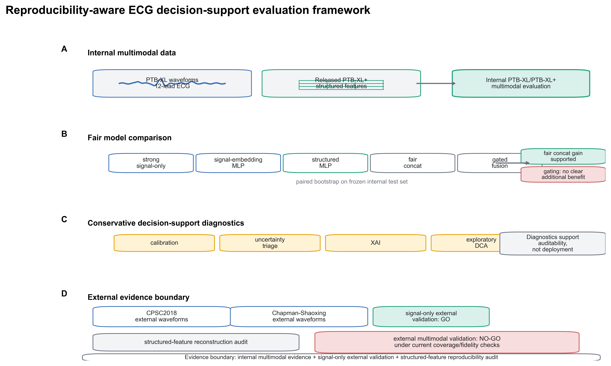

Figure 2. Internal model performance, paired bootstrap support for matched concat, and gated-fusion comparison.
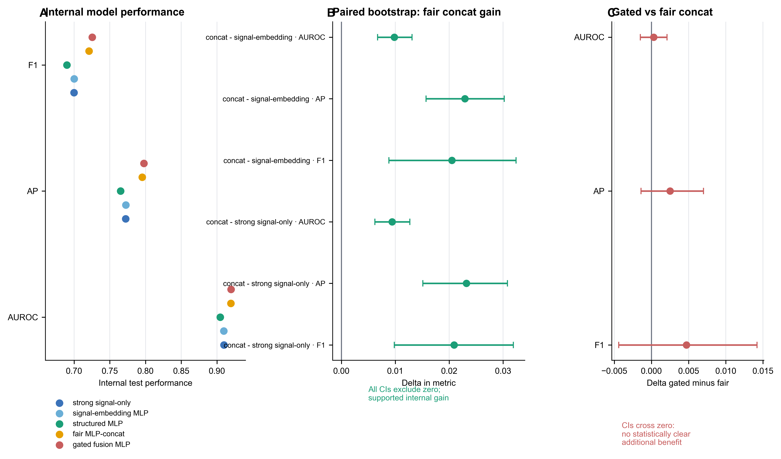

Figure 3. External signal-only validation and Chapman-Shaoxing-Ningbo per-class diagnostic context.
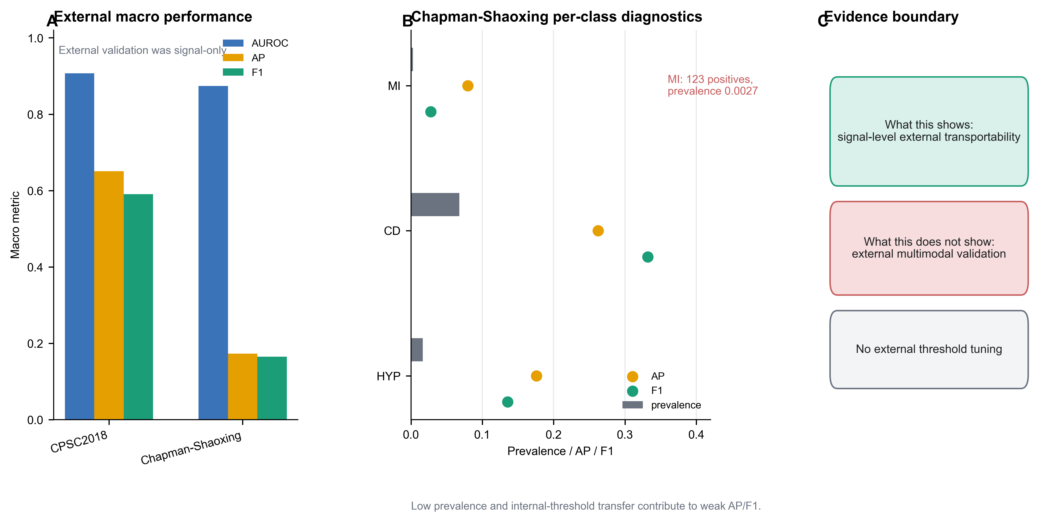

Figure 4. Calibration and reliability under internal testing and external distribution shift.
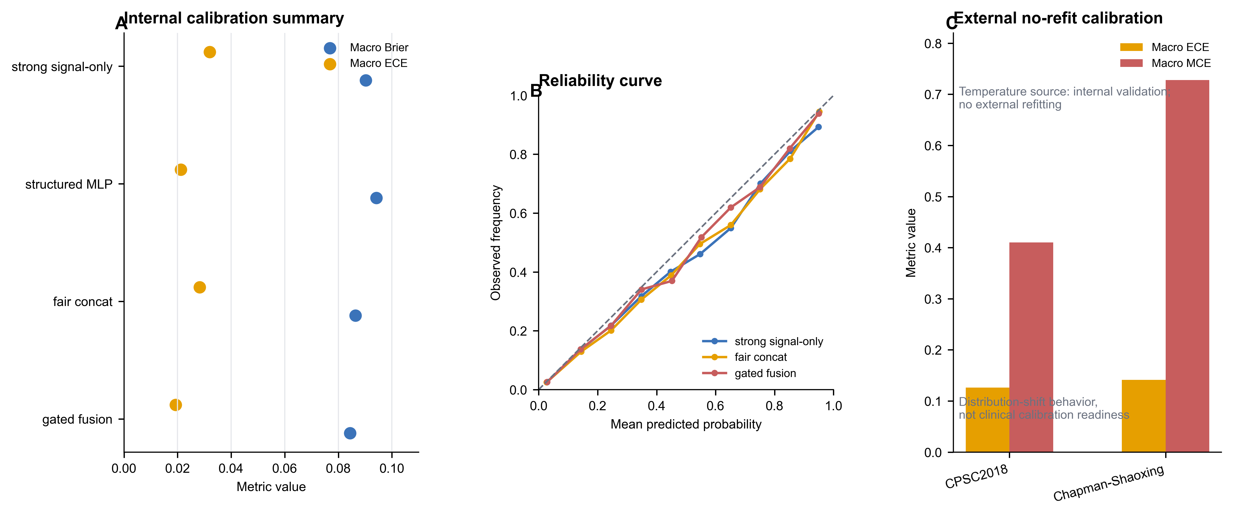

Supplementary Figure S1. Structured-feature reproducibility audit funnel.

