A Reproducibility-Aware Decision-Support Evaluation Framework for Multimodal ECG Diagnostic Classification
Yi Zha^1^, Da Lin^1^, Ying Chen^2^, Yue Liu^2^, Yu Zhang^1,*
^1^ The Second Affiliated Hospital of Wenzhou Medical University, Wenzhou, Zhejiang, China.
^2^ Wenzhou Medical University, Wenzhou, Zhejiang, China.
*Correspondence: Yu Zhang, zhangyu1@wzhealth.com; ORCID: 0000-0001-8579-3692.

Abstract
Background: Multimodal electrocardiogram (ECG) models can combine waveform representations with structured ECG-derived measurements, but public-data studies need to distinguish internal multimodal performance from external transportability and feature-reproducibility constraints. We evaluated whether released PTB-XL+ structured features support internal multimodal complementarity and whether comparable structured features can be reconstructed with enough fidelity and coverage for external multimodal validation.
Methods: We used PTB-XL waveforms and released PTB-XL+ structured features for internal development and evaluation across five diagnostic superclasses: NORM, MI, STTC, CD, and HYP. Model groups included signal-only, signal-embedding, structured-feature, matched multimodal concatenation, and gated-fusion models. Model selection, threshold tuning, and temperature scaling used internal validation data only. External evaluation was restricted to signal-only validation on CPSC2018 and the Chapman-Shaoxing-Ningbo ECG database using restricted high-confidence label subsets. A structured-feature reproducibility audit tested whether a numerically concordant reduced feature subset could preserve internal multimodal gain and provide adequate external joinability.
Results: The structured-feature reproducibility audit found 138 numerically concordant features, reduced-schema structured-only degradation, no stable reduced-schema multimodal gain, and only two joinable external structured records per dataset; external multimodal validation was therefore not supported. In internal PTB-XL/PTB-XL+ testing with the released full structured schema, matched multimodal concatenation achieved AUROC 0.9193, average precision 0.7953, and F1 0.7208, exceeding the signal-embedding comparator by +0.0098 AUROC, +0.0229 average precision, and +0.0205 F1. Gated fusion showed no statistically clear advantage over concatenation. Signal-only external validation achieved macro AUROC 0.9071 on CPSC2018 and 0.8742 on the Chapman-Shaoxing-Ningbo high-confidence label subset, but AP and F1 were low in labels with low prevalence and transferred thresholds.
Conclusions: The main contribution is a reproducibility-aware evidence boundary: released PTB-XL+ features supported modest internal multimodal complementarity, but current external structured-feature extraction and joining did not support external multimodal validation. Further work requires externally reproducible structured features and prospective clinical data before clinical-use claims can be considered.

Keywords
Electrocardiography; Clinical decision support; Multimodal fusion; Signal-level external validation; Model calibration; Uncertainty estimation; Explainable artificial intelligence; Reproducibility; Public datasets; Risk stratification.

Background
Automated ECG interpretation has become an important test case for public-data medical artificial intelligence because 12-lead ECGs combine rich waveform structure, clinically meaningful measurements, and heterogeneous diagnostic labels. Public resources such as PTB-XL have enabled reproducible benchmarking for multi-label ECG classification, while PTB-XL+ extends this setting with structured ECG-derived features aligned to PTB-XL records [1–3]. These resources make it possible to ask whether waveform representations and structured ECG measurements provide complementary information for cardiac diagnostic assessment.
For health decision-support research, however, performance-only reporting is insufficient. A model with strong internal discrimination may still be poorly calibrated, unstable under distribution shift, difficult to audit, or dependent on features that cannot be reproduced outside the development dataset. Calibration matters because risk estimates may be interpreted as probabilities; uncertainty analysis can identify cases where prediction confidence is lower; explainability can support model auditing; and decision-curve analysis can explore threshold-dependent consequences [4–11]. None of these components establishes clinical readiness by itself, but together they provide a more cautious evaluation of whether a model behaves like a decision-support candidate rather than only a benchmark classifier.
Multimodal ECG studies face an additional reproducibility problem. Structured ECG features depend on delineation software, preprocessing choices, lead handling, and feature definitions. ECGdeli provides an open-source ECG delineation context, but a local delineation output is not automatically equivalent to a released PTB-XL+ structured-feature schema [3,12]. If an internal multimodal model uses released structured values from one dataset, external multimodal validation is only justified when comparable structured features can be generated externally with adequate fidelity and coverage. External ECG datasets such as CPSC2018 and Chapman-Shaoxing-Ningbo also differ from PTB-XL in label scope, prevalence, and annotation structure [13–15]. These differences make it important to separate internal multimodal gains from signal-level external transportability and from structured-feature reconstruction feasibility.
The gap addressed here is therefore not only model performance. Many public ECG artificial intelligence studies report internal metrics, but fewer explicitly separate internal multimodal evidence, external signal-only evaluation, calibration, uncertainty, explainability, decision-curve analysis, and structured-feature reproducibility. This distinction is especially relevant for medical informatics and decision-support research, where transparent evidence boundaries may be as important as incremental performance gains.
In this study, we evaluated a reproducibility-aware multimodal ECG decision-support framework using PTB-XL/PTB-XL+ internally and CPSC2018 plus the Chapman-Shaoxing-Ningbo ECG database externally. The primary objective was to define whether an internal PTB-XL/PTB-XL+ multimodal result can be responsibly extended to external multimodal validation when structured features must be reconstructed de novo. Secondary objectives were to quantify the internal value of released PTB-XL+ structured features beyond ECG signal embeddings, compare matched concatenation with gated fusion, and report signal-only external behavior under restricted high-confidence label subsets. This was a conservative public-data evaluation, not a clinical deployment study.

Methods

Study design
This was a public-data model development and evaluation study. The primary internal analysis used PTB-XL waveforms and released PTB-XL+ structured features [1,3]. External validation used CPSC2018 and Chapman-Shaoxing-Ningbo waveforms for signal-only evaluation [13–15]. External structured-feature generation was audited for reproducibility and coverage feasibility, but external structured features were not used for validated multimodal external testing.
The evaluation followed a prespecified staged workflow. Initial data-ingestion checks verified the PTB-XL local data layout, parsed diagnostic labels, and generated frozen train, validation, and test files. Internal modeling then compared signal-only, signal-embedding, structured-only, matched concat, and gated fusion models. Subsequent analyses evaluated calibration, uncertainty triage, post-hoc explainability, exploratory decision-curve analysis, signal-only external validation, and structured-feature reproducibility.

AI-assisted tools and author responsibility
AI-assisted programming and language-polishing tools were used to support code generation, debugging, manuscript editing, and figure-package preparation. All analytic decisions, generated outputs, evidence boundaries, and final manuscript wording were reviewed by the authors, who take responsibility for the integrity and accuracy of the work.
A TRIPOD+AI-oriented reporting checklist is provided as Supplementary Table S7 [20].

Data sources and roles
PTB-XL served as the internal waveform dataset. PTB-XL+ served as the internal released structured-feature resource. The internal label scope used five diagnostic superclasses: NORM, MI, STTC, CD, and HYP. Official PTB-XL split logic was preserved, with training, validation, and test partitions kept frozen throughout model development and evaluation.
CPSC2018 and the PhysioNet Chapman-Shaoxing-Ningbo ECG database served as external waveform datasets for signal-only validation. CPSC2018 was evaluated for the restricted high-confidence NORM/CD label subset. The Chapman-Shaoxing-Ningbo combined WFDB release was evaluated for the restricted MI/CD/HYP label subset; sinus rhythm labels were not treated as main-analysis NORM. The evaluated 45,150 records refer to this combined PhysioNet release after waveform-readability filtering, not to the earlier 10,646-record Chapman-Shaoxing publication alone. Records that could not be read as WFDB waveforms were excluded. No external threshold tuning, external model selection, or external retraining was performed.
The external label mappings are provided as a supplementary audit table. Main external evaluation retained only high-confidence mappings: CPSC2018 contributed NORM and CD, while the Chapman-Shaoxing-Ningbo database contributed MI, CD, and HYP. Medium-confidence labels such as ST-T abnormalities were not used in the main external analysis. This design makes external results label-scope-specific and prevents direct comparison with the five-label internal macro metrics.
External structured features were treated as an audit target rather than a validation input. Candidate ECGdeli-derived features and concordant reduced-schema features were assessed for feasibility, but they were not considered official PTB-XL+ external structured features.

Model groups
Five internal model groups were evaluated:
- Strong signal-only model using 100 Hz 12-lead PTB-XL waveforms.
- Signal-embedding MLP using a 256-dimensional signal representation.
- Structured-feature MLP using 531 released PTB-XL+ structured features.
- Matched MLP-concat model combining the 256-dimensional signal embedding with 531 structured features.
- Gated fusion MLP using the same signal and structured input interface.
The strong signal-only model used a one-dimensional residual network with 12 input channels, 100 Hz waveforms, base channel width 64, three residual stages with two blocks per stage, dropout 0.2, and five output labels. Residual learning was used as the general architectural background [16]. The model provided both a direct waveform comparator and the 256-dimensional signal embedding for controlled multimodal comparison; embeddings were extracted from the penultimate representation of the trained signal model and then treated as frozen inputs for downstream MLP and matched-fusion experiments. Signal-embedding and structured MLP comparators used hidden dimensions 256/128 and 512/256, respectively, with dropout 0.3. The matched concat MLP used hidden dimensions 512/256, and the gated-fusion MLP used a 256-unit gating layer and a 256-unit classifier layer. Neural models were trained with Adam-compatible optimization settings as implemented in PyTorch using learning rate 0.001, weight decay 0.0001, batch size 64 for the signal model and 128 for MLP models, validation AUROC-based model selection, and early stopping patience of 8 epochs for the signal model and 10 epochs for MLP models. The fair fusion dataset combined signal embeddings and released structured features after median imputation and standardization defined on the training set.
The signal-embedding MLP and the strong signal-only model therefore answer related but distinct questions. The signal-embedding MLP controls for the frozen representation used by multimodal fusion, whereas the strong signal-only model evaluates the end-to-end waveform classifier. Both comparators are reported to avoid attributing a multimodal gain to classifier-head differences alone.

Fair comparison principle
The gated fusion model was compared against matched concat because multimodal gains should not be attributed to architectural complexity when a simple fusion strategy can capture similar information. Signal-embedding, structured-only, matched concat, and gated fusion models used the same frozen splits, label scope, validation-only early stopping, and validation-derived thresholds. This design was intended to isolate the contribution of modality complementarity from the contribution of extra model complexity.

Calibration
Calibration was assessed using stored validation and test predictions. Temperature scaling was fit on internal validation logits and evaluated on frozen internal test predictions [4]. For external signal-only calibration, the internally fitted temperature source was carried forward without external refitting. Reliability data, Brier score, expected calibration error, and maximum calibration error were reported [5–6]. External calibration was interpreted as behavior under distribution shift, not as clinical calibration readiness.

Uncertainty triage
Uncertainty triage was evaluated as a conservative decision-support layer. Prediction uncertainty was used to compare retained subsets across coverage levels. These analyses were informed by uncertainty estimation and selective prediction concepts [7–8]. They were intended to describe whether lower-uncertainty predictions had more favorable internal performance, not to define a deployment-ready triage workflow.

Explainability and XAI
Post-hoc explainability analyses included structured feature attribution, signal attribution case reports, and gate summaries where available. XAI outputs were used for model auditing and interpretation. Feature attribution and saliency-style outputs were interpreted cautiously, consistent with prior explainability methods and medical AI cautions [9–10,17–18]. They were not treated as evidence of causal clinical reasoning or mechanistic explanation.

Decision-curve analysis
Decision-curve analysis was evaluated as an exploratory, threshold-dependent analysis [11]. It was used to summarize internal net-benefit patterns across models and thresholds. It was not used to claim clinical utility or readiness for practice.

Structured-feature reproducibility audit
The structured-feature reproducibility analysis was treated as a core feasibility audit. Instead of continuing attempts to reconstruct the full PTB-XL+ 531-column schema externally, the audit used a reduced structured-feature subset that had passed internal numerical concordance checks against released PTB-XL+ values. Candidate ECGdeli features were recomputed for a PTB-XL audit sample and compared with released PTB-XL+ values by feature name and ecg_id. A feature entered the reduced subset only when all non-missing paired values satisfied numpy-style allclose criteria with absolute tolerance 1e-6 and relative tolerance 1e-6; the manifest reports missingness, mean absolute error, median absolute error, and maximum absolute error for each selected feature. This subset contained 138 features. The reduced schema was tested internally with signal-embedding, structured-only, and matched concat models, and external coverage was checked for CPSC2018 and the Chapman-Shaoxing-Ningbo database.
External joinability was defined operationally as the presence of both a signal-model prediction record and a candidate structured-feature row keyed by the standardized external record identifier after dataset-specific filename normalization. The two-record coverage result therefore supports a narrower conclusion: the current external extraction-and-joining pipeline did not provide enough matched structured rows for external multimodal evaluation. It should not be read as proof that compatible external structured-feature reconstruction is impossible in principle.
The decision rule was conservative. External multimodal validation would only be considered if the reduced schema preserved internal multimodal gain and if external structured-feature coverage was adequate. If internal gain disappeared or external coverage was insufficient, external multimodal validation would not be supported.

Statistical analysis
Discrimination was summarized using macro AUROC, macro average precision, and macro F1. Macro metrics were computed as the unweighted mean across labels in the evaluated label scope. Thresholded metrics used thresholds selected on internal validation data. The frozen PTB-XL split included 17,418 training records, 2,183 validation records, and 2,198 test records after records without the required five-superclass label representation or readable waveform/feature alignment were excluded from the analysis set. Matched concat was compared with the strongest unimodal comparators using paired record-level bootstrap resampling on the frozen internal test set. Gated fusion and matched concat were also compared using paired bootstrap resampling on the frozen internal test set [19]. For each bootstrap replicate, ECG records were resampled with replacement, all class-specific metrics were recomputed in the resampled set, macro metrics were then recomputed within that replicate, and model deltas were calculated on the paired resample. The primary internal multimodal-gain bootstrap used 2,000 record-level resamples; other diagnostic bootstrap summaries used 1,000 resamples and percentile 95% confidence intervals. Bootstrap confidence intervals were reported without multiplicity adjustment and interpreted descriptively. External diagnostics were reported per dataset and per class. No external threshold optimization was performed.
Exploratory decision-curve analysis was calculated per label and then summarized descriptively. The reported macro net benefit is the unweighted mean of label-specific net benefits at a given threshold; this aggregation is not a standard clinical utility endpoint and was used only to summarize internal threshold-dependent behavior. Label-specific DCA results are provided in supplementary source data.

Results

Internal full-schema multimodal evaluation
Internal full-schema PTB-XL/PTB-XL+ results supported multimodal complementarity. The strong signal-only model achieved test AUROC 0.9098, AP 0.7721, and F1 0.6998. The signal-embedding MLP achieved AUROC 0.9094, AP 0.7724, and F1 0.7002. The structured MLP achieved AUROC 0.9046, AP 0.7652, and F1 0.6899.
Matched MLP-concat achieved AUROC 0.9193, AP 0.7953, and F1 0.7208. Gated fusion MLP achieved AUROC 0.9196, AP 0.7978, and F1 0.7255. These results indicate that combining signal embeddings with released PTB-XL+ structured features improved internal performance over either unimodal comparator. The improvement should be interpreted as internal PTB-XL/PTB-XL+ evidence under frozen splits.

Statistical support for the internal multimodal gain
Paired record-level bootstrap analysis supported the internal matched concat gain over the signal-embedding comparator and the strong signal-only comparator. For matched concat minus signal-embedding MLP, the AUROC delta was +0.0098 with a 95% CI from +0.0067 to +0.0131, the AP delta was +0.0229 with a 95% CI from +0.0157 to +0.0302, and the F1 delta was +0.0205 with a 95% CI from +0.0088 to +0.0324. For matched concat minus strong signal-only, the AUROC delta was +0.0094 with a 95% CI from +0.0062 to +0.0127, the AP delta was +0.0232 with a 95% CI from +0.0151 to +0.0308, and the F1 delta was +0.0209 with a 95% CI from +0.0098 to +0.0319. None of these confidence intervals contained zero.
These results provide statistical support for an internal multimodal gain, while remaining limited to the PTB-XL/PTB-XL+ internal evaluation setting. The absolute gain was modest, particularly for AUROC, so the result should be interpreted as evidence of modality complementarity rather than as a large performance improvement.
Per-superclass internal diagnostics showed that the largest matched-concat improvement over the signal-embedding comparator occurred for HYP, where AUROC increased from 0.8359 to 0.8791, AP from 0.4839 to 0.5918, and F1 from 0.4444 to 0.5393. Differences for NORM, MI, STTC, and CD were smaller and should be interpreted as descriptive per-class context rather than separate confirmatory tests.

Gated fusion versus matched concat
Gated fusion did not show a statistically clear advantage over matched concat. The paired bootstrap delta for AUROC was +0.0003 with a 95% CI from -0.0015 to 0.0021. The AP delta was +0.0025 with a 95% CI from -0.0014 to 0.0070. The F1 delta was +0.0047 with a 95% CI from -0.0044 to 0.0142. All confidence intervals contained zero.
These findings support a conservative interpretation: the internal multimodal gain is better attributed to modality complementarity than to an additional benefit from gating.

Calibration and decision-support diagnostics
Internal temperature-scaled calibration was evaluated for the main model groups. Temperature scaling was fitted on internal validation data and evaluated on frozen test predictions. The strong signal-only model had macro Brier score 0.0903 and macro ECE 0.0320. The structured MLP had macro Brier score 0.0942 and macro ECE 0.0212. Matched concat had macro Brier score 0.0864 and macro ECE 0.0283. Gated fusion had macro Brier score 0.0844 and macro ECE 0.0193.
Uncertainty triage, post-hoc explainability, and exploratory decision-curve analysis were retained as decision-support diagnostics. In the gated-fusion uncertainty analysis, retaining the lowest-uncertainty 80% of the test set retained 1,757 of 2,198 records and referred 441 records. In this retained subset, macro AUROC was 0.9303, AP was 0.8189, F1 was 0.7597, Brier score was 0.0687, and ECE was 0.0161. The corresponding full-coverage uncertainty-analysis values were macro AUROC 0.9196, AP 0.7978, temperature-scaled F1 0.7314, Brier score 0.0844, and ECE 0.0193; the primary Table 1 default-threshold gated-fusion F1 remains 0.7255 under the main performance-evaluation pipeline. Case-level explainability summaries identified retained correct examples, retained errors, and high-uncertainty referred errors; top structured features and signal leads were reported as audit outputs rather than causal explanations. Exploratory internal decision-curve analysis is best interpreted from the threshold curves and representative thresholds rather than as a clinical decision rule. For matched concat, macro net benefit was 0.2146 at threshold 0.10, 0.1908 at threshold 0.20, and 0.1724 at threshold 0.30; the corresponding net benefit versus treat-all was 0.0434, 0.1232, and 0.2380.

Signal-only external validation
CPSC2018 signal-only external validation included 9,944 evaluated records for the NORM/CD high-confidence label scope. Macro AUROC was 0.9071, macro AP was 0.6509, and macro F1 was 0.5904. This supports limited signal-level external transportability in the evaluated label subset.
Chapman-Shaoxing-Ningbo signal-only external validation included 45,150 evaluated records for the MI/CD/HYP high-confidence label scope. Macro AUROC was 0.8742, macro AP was 0.1727, and macro F1 was 0.1650. The Chapman-Shaoxing-Ningbo results suggest preserved ranking performance but weak AP and F1. Per-class diagnostics support this interpretation: MI had 123 positive cases with prevalence 0.0027, AP 0.0796, and F1 0.0277; CD had prevalence 0.0677, AP 0.2624, and F1 0.3319; and HYP had prevalence 0.0166, AP 0.1760, and F1 0.1353. These values should be interpreted in relation to low prevalence, imperfect cross-dataset label comparability, and transfer of thresholds selected on PTB-XL validation data. The MI result in particular should be viewed as diagnostic context rather than strong evidence of comparable thresholded performance.
External validation was signal-only. No external multimodal validation was performed.

External signal-only calibration
External calibration was evaluated without external refitting. CPSC2018 had macro Brier 0.1268, micro Brier 0.1268, macro ECE 0.1262, and macro MCE 0.4099. Chapman-Shaoxing-Ningbo had macro Brier 0.0855, micro Brier 0.0855, macro ECE 0.1412, and macro MCE 0.7277. This no-refit design was intentional: refitting temperature on external test labels would have violated the no-external-tuning evaluation principle.
These results should be reported as transparent calibration behavior under distribution shift, not as evidence of clinical calibration readiness. The high external MCE values indicate that temperature scaling fitted on internal validation data did not transfer reliably to external label/data settings; therefore, external probabilities should not be interpreted as calibrated risks.

structured-feature reproducibility audit
The structured-feature reproducibility audit found that only 138 structured features were available in the numerically concordant subset. In the reduced-schema internal test, the signal-embedding MLP achieved AUROC 0.9094, AP 0.7722, and F1 0.6981. The reduced structured-only MLP showed marked degradation, with AUROC 0.5704, AP 0.3045, and F1 0.0000. The zero F1 reflected default-threshold predictions after loss of most structured-feature information; with validation-tuned thresholds, the same reduced structured-only model reached test F1 0.4002, confirming that the zero default-threshold F1 was a thresholding/probability-scale artifact rather than an empty evaluation pipeline. Reduced matched concat achieved AUROC 0.9097, AP 0.7731, and F1 0.6938, which did not show stable gain over the signal-embedding MLP.
External structured-feature coverage also failed the quality gate. CPSC2018 had 2 joinable candidate structured records among 9,944 signal prediction records, for coverage 0.000201. Chapman-Shaoxing-Ningbo had 2 joinable candidate structured records among 45,150 signal prediction records, for coverage 0.000044.
The audit did not support external multimodal validation. This should be presented as a structured-feature reproducibility and feasibility result, not as a failed external multimodal model.

Tables
Table 1 Internal full-schema model performance on the frozen PTB-XL/PTB-XL+ test set
Model | Test AUROC | Test AP | Test F1
strong signal-only | 0.9098 | 0.7721 | 0.6998
signal-embedding MLP | 0.9094 | 0.7724 | 0.7002
structured MLP | 0.9046 | 0.7652 | 0.6899
matched MLP-concat | 0.9193 | 0.7953 | 0.7208
gated fusion MLP | 0.9196 | 0.7978 | 0.7255
Note. AP = average precision; AUROC = area under the receiver operating characteristic curve.
Table 2 Statistical support for the internal multimodal gain
Note. Deltas are calculated from unrounded prediction-level estimates and paired bootstrap resamples, so displayed deltas may differ slightly from subtraction of rounded table values.
Comparison | Metric | Matched concat | Comparator | Delta | 95% CI | CI contains zero
matched concat minus signal-embedding MLP | AUROC | 0.9193 | 0.9094 | +0.0098 | +0.0067 to +0.0131 | no
matched concat minus signal-embedding MLP | AP | 0.7953 | 0.7724 | +0.0229 | +0.0157 to +0.0302 | no
matched concat minus signal-embedding MLP | F1 | 0.7208 | 0.7002 | +0.0205 | +0.0088 to +0.0324 | no
matched concat minus strong signal-only | AUROC | 0.9193 | 0.9098 | +0.0094 | +0.0062 to +0.0127 | no
matched concat minus strong signal-only | AP | 0.7953 | 0.7721 | +0.0232 | +0.0151 to +0.0308 | no
matched concat minus strong signal-only | F1 | 0.7208 | 0.6998 | +0.0209 | +0.0098 to +0.0319 | no
Note. AP = average precision; AUROC = area under the receiver operating characteristic curve; CI = confidence interval. Thresholds were selected on internal validation data only.
Table 3 Gated fusion versus matched concat on the frozen internal test set
Metric | Delta gated minus fair | 95% CI | Interpretation
AUROC | +0.0003 | -0.0015 to 0.0021 | CI contains zero
AP | +0.0025 | -0.0014 to 0.0070 | CI contains zero
F1 | +0.0047 | -0.0044 to 0.0142 | CI contains zero
Note. AP = average precision; AUROC = area under the receiver operating characteristic curve; CI = confidence interval.
Table 4 Signal-only external validation
Dataset | Label scope | N | Macro AUROC | Macro AP | Macro F1
CPSC2018 | NORM/CD | 9,944 | 0.9071 | 0.6509 | 0.5904
Chapman-Shaoxing-Ningbo | MI/CD/HYP | 45,150 | 0.8742 | 0.1727 | 0.1650
Note. AP = average precision; AUROC = area under the receiver operating characteristic curve. External validation was signal-only, and thresholds were selected on internal validation data only.
Table 5 External signal-only calibration
Dataset | Macro Brier | Micro Brier | Macro ECE | Macro MCE
CPSC2018 | 0.1268 | 0.1268 | 0.1262 | 0.4099
Chapman-Shaoxing-Ningbo | 0.0855 | 0.0855 | 0.1412 | 0.7277
Note. ECE = expected calibration error; MCE = maximum calibration error. External calibration was evaluated without external refitting.
Table 6a Structured-feature reproducibility audit reduced-schema internal results
Model | AUROC | AP | F1
stage14l_signal_embedding_mlp | 0.9094 | 0.7722 | 0.6981
stage14l_structured_mlp | 0.5704 | 0.3045 | 0.0000
stage14l_fair_concat_mlp | 0.9097 | 0.7731 | 0.6938
Note. AP = average precision; AUROC = area under the receiver operating characteristic curve. structured-feature reproducibility audit was a reproducibility/feasibility audit, not an external multimodal validation result.
Table 6b Structured-feature reproducibility audit external structured-feature coverage
Dataset | Signal records | Joinable structured records | Coverage
CPSC2018 | 9,944 | 2 | 0.000201
Chapman-Shaoxing-Ningbo | 45,150 | 2 | 0.000044
Note. The external structured-feature coverage was insufficient to support external multimodal validation.

Discussion

Principal findings
This study evaluated a reproducibility-aware decision-support framework for multimodal ECG diagnostic classification. The principal finding is that internal multimodal evidence and external multimodal validation can diverge when structured features are released for the internal dataset but cannot be reconstructed and joined externally with adequate fidelity and coverage. The full-schema PTB-XL/PTB-XL+ experiments supported modest internal multimodal complementarity, but the structured-feature reproducibility audit did not support external multimodal validation. This evidence-boundary result is the central contribution of the study.
The internal full-schema results showed that released PTB-XL+ structured features added value beyond ECG signal embeddings under frozen PTB-XL splits. Paired bootstrap analysis supported the matched concat gain over both the signal-embedding MLP and the strong signal-only comparator for AUROC, AP, and F1. The effect size was modest, however: the AUROC gain over the signal-embedding comparator was less than one percentage point, while AP and F1 gains were larger but still incremental. This distinction between statistical support and practical magnitude is important for decision-support interpretation. Gated fusion was numerically close to matched concat, but paired bootstrap intervals contained zero for AUROC, AP, and F1. This finding argues against making architectural complexity the central claim. For a decision-support evaluation paper, the more defensible contribution is the fair comparison framework and the statistically supported but modest internal modality complementarity.

External validation and transportability
The external evidence is intentionally limited to signal-only validation. CPSC2018 supported limited signal-level external transportability for the NORM/CD high-confidence label subset. Chapman-Shaoxing-Ningbo showed preserved ranking performance but weak AP and F1, especially in low-prevalence labels. The per-class diagnostic table supports this explanation: Chapman-Shaoxing-Ningbo MI had only 123 positive cases among 45,150 evaluated records, with prevalence 0.0027, AP 0.0796, and F1 0.0277. This pattern is consistent with label mapping constraints, prevalence differences, and transfer of thresholds selected on internal validation data. It also means that the Chapman-Shaoxing-Ningbo MI result should be interpreted primarily as a stress test of signal ranking under label shift, not as robust thresholded-performance evidence. The absence of external threshold tuning strengthens the evaluation protocol but also limits thresholded performance.
These results should not be used to claim external multimodal validation. They show how the signal model behaves across external ECG waveform datasets under constrained label mappings. They do not test whether PTB-XL+ structured features generalize externally, because externally compatible structured features were not validated.

Decision-support evaluation layers
Calibration, uncertainty triage, XAI, and decision-curve analysis provided complementary evaluation layers. Calibration results described probability behavior under internal testing and external distribution shift. Uncertainty triage examined whether lower-uncertainty retained subsets had more favorable internal behavior. XAI outputs supported model auditing and interpretability. Decision-curve analysis summarized threshold-dependent internal net-benefit patterns. These components are useful for decision-support evaluation, but none establishes clinical readiness. They should be described as safety- and audit-oriented diagnostics rather than deployment evidence.

Structured-feature reproducibility as a central finding
The structured-feature reproducibility audit is a key BMC MIDM-compatible contribution because it shows why external multimodal claims are difficult in public multimodal ECG research. The audit found that a reproducibility-validated numerically concordant subset contained only 138 features. This subset did not preserve internal multimodal gain, and external joinable structured coverage was only two records per external dataset. The practical implication is that released internal PTB-XL+ features can support internal multimodal experiments, but de novo reconstruction of the same structured schema on external WFDB datasets was not validated.
This distinction protects the internal findings while clarifying the external limitation. Internal multimodal experiments remain reproducible because they use released PTB-XL+ feature values under frozen splits. The reproducibility limitation concerns de novo external reconstruction of the same structured-feature schema, not reuse of the released PTB-XL+ resource.

Strengths
The study's main strength is transparent boundary-setting. It avoids claiming more than the data support and directly reports negative or near-null findings, including the gated-versus-concat null result and the unsupported external multimodal validation decision. This approach is well suited to medical informatics, where model-performance claims need to be connected to reproducibility, calibration, external transportability, and auditability.

Limitations
Several limitations should be emphasized. First, all analyses used public retrospective datasets. Second, no prospective validation was performed. Third, external validation was signal-only; there was no validated external multimodal evaluation. Fourth, thresholds were not tuned on external test labels, which avoids overfitting but can reduce F1 under prevalence shift. Fifth, label mappings across PTB-XL, CPSC2018, and Chapman-Shaoxing-Ningbo were necessarily incomplete, and very low-prevalence Chapman-Shaoxing-Ningbo labels should be treated as weak thresholded-performance evidence. Sixth, exact external reconstruction of PTB-XL+ structured features was not achieved. Seventh, bootstrap intervals and multiple diagnostic comparisons were reported descriptively without multiplicity correction. Eighth, decision-curve analysis was exploratory, internal, and threshold-dependent. Ninth, no clinical workflow, clinician interaction, or patient-outcome study was performed.

Conclusions
This framework supports reproducibility-aware evaluation of multimodal ECG diagnostic classification and demonstrates internal multimodal complementarity with signal-level external validation. Simple matched concat captured the main internal multimodal gain, while gated fusion did not provide statistically clear additional benefit. External multimodal validation remains unavailable because PTB-XL+ compatible structured-feature reconstruction was not validated externally with adequate coverage and fidelity. Further work with externally reproducible structured features and prospective clinical data is needed before clinical-use claims can be considered.

List of Abbreviations
AP: average precision; AUROC: area under the receiver operating characteristic curve; CD: conduction disturbance; DCA: decision-curve analysis; ECG: electrocardiogram; ECE: expected calibration error; F1: F1 score; HYP: hypertrophy; MI: myocardial infarction; MLP: multilayer perceptron; MCE: maximum calibration error; NORM: normal ECG; PTB-XL: Physikalisch-Technische Bundesanstalt large ECG dataset; STTC: ST/T change; XAI: explainable artificial intelligence.

Declarations

Ethics approval and consent to participate
This study used publicly available, de-identified datasets. Ethical approval and consent procedures were handled by the original dataset creators as described in the corresponding dataset publications and repositories. No new human participants were recruited for this secondary analysis. No new institutional review board approval number is reported here.

Consent for publication
Not applicable.

Availability of data and materials
PTB-XL is available from PhysioNet at https://physionet.org/content/ptb-xl/. PTB-XL+ is available from PhysioNet at https://physionet.org/content/ptb-xl-plus/. CPSC2018 is available from the China Physiological Signal Challenge 2018 website at http://2018.icbeb.org/Challenge.html. The external Chapman-Shaoxing-Ningbo ECG database used here is the PhysioNet large-scale 12-lead ECG database for arrhythmia study at https://physionet.org/content/ecg-arrhythmia/ with DOI https://doi.org/10.13026/wgex-er52. The analysis code and manuscript artifacts are available at https://github.com/seefreewind/ecg-ptbxl-multimodal-decision-support and archived on Zenodo at https://doi.org/10.5281/zenodo.21091784.

Competing interests
The authors declare that they have no competing interests.

Funding
The authors received no specific funding for this work.

Authors' contributions
YZha and YZhang conceived and designed the study. YZha and DL curated the datasets, implemented the analysis workflow, and performed model training and evaluation. YC and YL contributed to data checking, external validation diagnostics, calibration review, and result interpretation. YZha prepared the first manuscript draft. DL, YC, YL, and YZhang critically reviewed and revised the manuscript for methodological and clinical content. YZhang supervised the study. All authors read and approved the final manuscript.

Acknowledgements
Not applicable.

References
1. Wagner P, Strodthoff N, Bousseljot RD, Kreiseler D, Lunze FI, Samek W, Schaeffter T. PTB-XL, a large publicly available electrocardiography dataset. Scientific Data. 2020;7:154. doi:10.1038/s41597-020-0495-6.
2. Goldberger AL, Amaral LA, Glass L, Hausdorff JM, Ivanov PC, Mark RG, Mietus JE, Moody GB, Peng CK, Stanley HE. PhysioBank, PhysioToolkit, and PhysioNet: components of a new research resource for complex physiologic signals. Circulation. 2000;101(23):e215–e220.
3. Strodthoff N, Mehari T, Nagel C, Aston PJ, Sundar A, Graff C, Kanters JK, Haverkamp W, Doessel O, Loewe A, Bar M, Schaeffter T. PTB-XL+, a comprehensive electrocardiographic feature dataset. Scientific Data. 2023;10:279. doi:10.1038/s41597-023-02153-8.
4. Guo C, Pleiss G, Sun Y, Weinberger KQ. On calibration of modern neural networks. Proceedings of the 34th International Conference on Machine Learning. 2017;70:1321–1330.
5. Brier GW. Verification of forecasts expressed in terms of probability. Monthly Weather Review. 1950;78:1–3.
6. Naeini MP, Cooper GF, Hauskrecht M. Obtaining well calibrated probabilities using Bayesian binning. Proceedings of the AAAI Conference on Artificial Intelligence. 2015;29.
7. Gal Y, Ghahramani Z. Dropout as a Bayesian approximation: representing model uncertainty in deep learning. Proceedings of the 33rd International Conference on Machine Learning. 2016;48:1050–1059.
8. Geifman Y, El-Yaniv R. Selective classification for deep neural networks. Advances in Neural Information Processing Systems. 2017;30.
9. Lundberg SM, Lee SI. A unified approach to interpreting model predictions. Advances in Neural Information Processing Systems. 2017;30.
10. Sundararajan M, Taly A, Yan Q. Axiomatic attribution for deep networks. Proceedings of the 34th International Conference on Machine Learning. 2017;70:3319–3328.
11. Vickers AJ, Elkin EB. Decision curve analysis: a novel method for evaluating prediction models. Medical Decision Making. 2006;26:565–574. doi:10.1177/0272989X06295361.
12. Pilia N, Nagel C, Lenis G, Becker S, Doessel O, Loewe A. ECGdeli: An open source ECG delineation toolbox for MATLAB. SoftwareX. 2021;13:100639. doi:10.1016/j.softx.2020.100639.
13. Liu F, Liu C, Zhao L, Zhang X, Wu X, Xu X, Liu Y, Ma C, Wei S, He Z, Li J, Ng E. An open access database for evaluating the algorithms of electrocardiogram rhythm and morphology abnormality detection. Journal of Medical Imaging and Health Informatics. 2018;8:1368–1373. doi:10.1166/jmihi.2018.2442.
14. Zheng J, Zhang J, Danioko S, Yao H, Guo H, Rakovski C. A 12-lead electrocardiogram database for arrhythmia research covering more than 10,000 patients. Scientific Data. 2020;7:48. doi:10.1038/s41597-020-0386-x.
15. Zheng J, Guo H, Chu H. A large scale 12-lead electrocardiogram database for arrhythmia study. PhysioNet. 2022. doi:10.13026/wgex-er52.
16. He K, Zhang X, Ren S, Sun J. Deep residual learning for image recognition. Proceedings of the IEEE Conference on Computer Vision and Pattern Recognition. 2016:770–778.
17. Selvaraju RR, Cogswell M, Das A, Vedantam R, Parikh D, Batra D. Grad-CAM: Visual explanations from deep networks via gradient-based localization. IEEE International Conference on Computer Vision. 2017:618–626.
18. Ghassemi M, Oakden-Rayner L, Beam AL. The false hope of current approaches to explainable artificial intelligence in health care. The Lancet Digital Health. 2021;3:e745–e750. doi:10.1016/S2589-7500(21)00208-9.
19. Efron B, Tibshirani RJ. An Introduction to the Bootstrap. Chapman and Hall/CRC. 1993.
20. Collins GS, Moons KGM, Dhiman P, Riley RD, Beam AL, Van Calster B, et al. TRIPOD+AI statement: updated guidance for reporting clinical prediction models that use regression or machine learning methods. BMJ. 2024;385:e078378. doi:10.1136/bmj-2023-078378.

Figure Legends
Figure 1. Reproducibility-aware ECG decision-support evaluation framework and evidence boundaries. Panels summarize internal PTB-XL/PTB-XL+ multimodal inputs, fair model comparison, conservative decision-support diagnostics, and the external evidence boundary. External multimodal validation was not performed, and no clinical deployment claim is made.
Figure 2. Internal model performance, paired bootstrap support for matched concat, and gated-fusion comparison. Panel A shows frozen-test AUROC, AP, and F1 across model groups. Panel B shows paired bootstrap deltas supporting matched concat gain over unimodal comparators. Panel C shows that gated fusion did not provide a statistically clear additional benefit over matched concat.
Figure 3. External signal-only validation and Chapman-Shaoxing-Ningbo per-class diagnostic context. Panel A shows macro AUROC, AP, and F1 for CPSC2018 and Chapman-Shaoxing-Ningbo. Panel B shows Chapman-Shaoxing-Ningbo MI/CD/HYP prevalence, AP, and F1. Panel C states the evidence boundary: signal-level external transportability only, no external multimodal validation, and no external threshold tuning.
Figure 4. Calibration and reliability under internal testing and external distribution shift. Panel A summarizes internal macro Brier and macro ECE. Panel B shows internal reliability curves with an ideal calibration reference. Panel C reports external no-refit calibration behavior using temperature scaling fitted on internal validation data.
Supplementary Figure S1. Structured-feature reproducibility audit funnel. Panels show reduction from the released 531-column PTB-XL+ schema to the 138-feature numerically concordant subset, reduced-schema internal results, external structured-feature coverage, and the unsupported decision for external multimodal validation under current coverage/fidelity checks.

Supplementary Material List
- Supplementary Table S1: External signal-only per-class diagnostics.
- Supplementary Table S2: External signal-only calibration.
- Supplementary Table S3: Structured-feature reproducibility audit.
- Supplementary Figure S1: Structured-feature reproducibility audit.
- Supplementary Table S4: Uncertainty triage diagnostics.
- Supplementary Table S5: Exploratory decision-curve analysis.
- Supplementary Table S6: XAI case-selection and attribution audit.
- Supplementary Table S7: TRIPOD+AI reporting checklist.
- Supplementary Table S8: Internal per-superclass performance diagnostics.
- Supplementary Table S9: External label-mapping audit.

Figures
Separate high-resolution PNG/PDF/SVG figure files are available for upload where applicable.

Figure 1. Reproducibility-aware ECG decision-support evaluation framework and evidence boundaries.
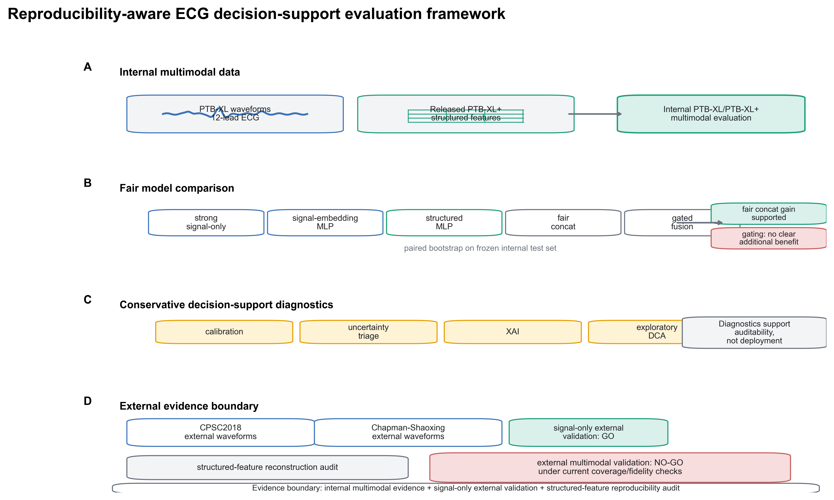

Figure 2. Internal model performance, paired bootstrap support for matched concat, and gated-fusion comparison.
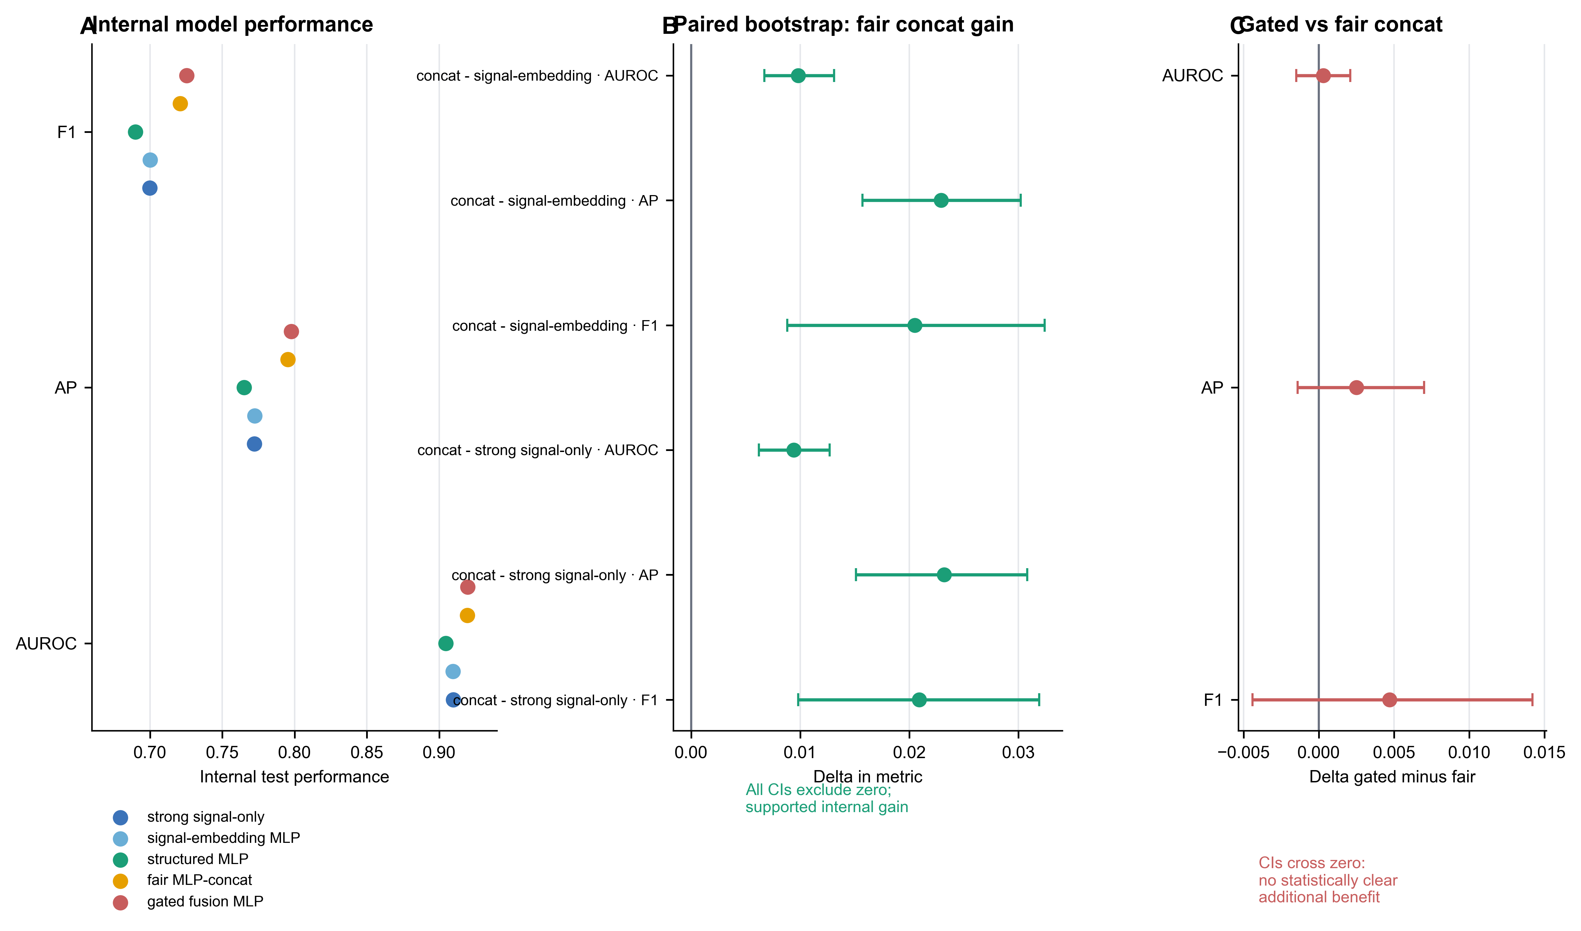

Figure 3. External signal-only validation and Chapman-Shaoxing-Ningbo per-class diagnostic context.
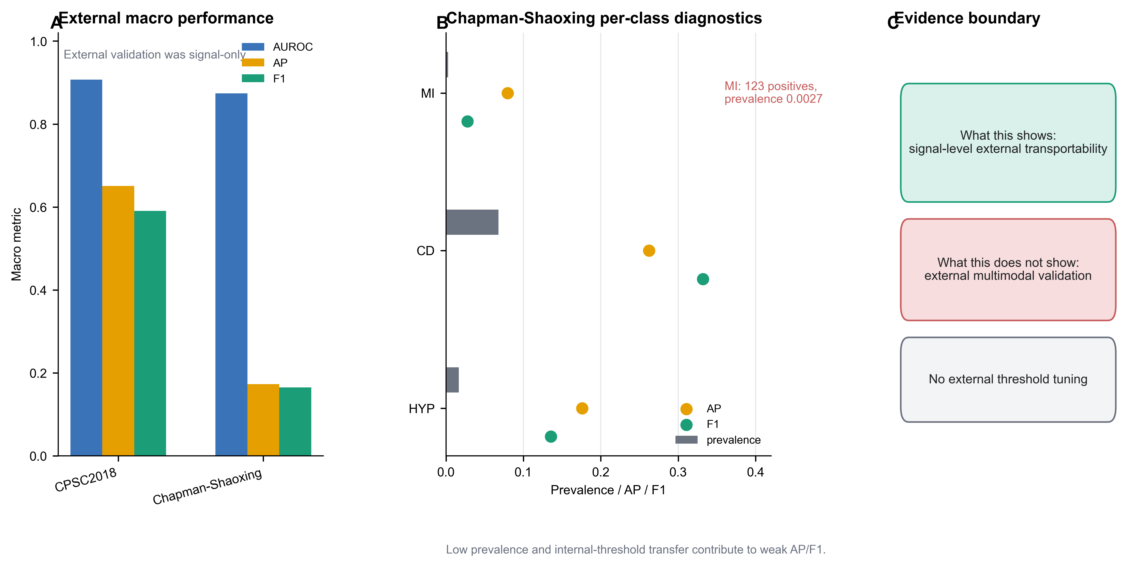

Figure 4. Calibration and reliability under internal testing and external distribution shift.
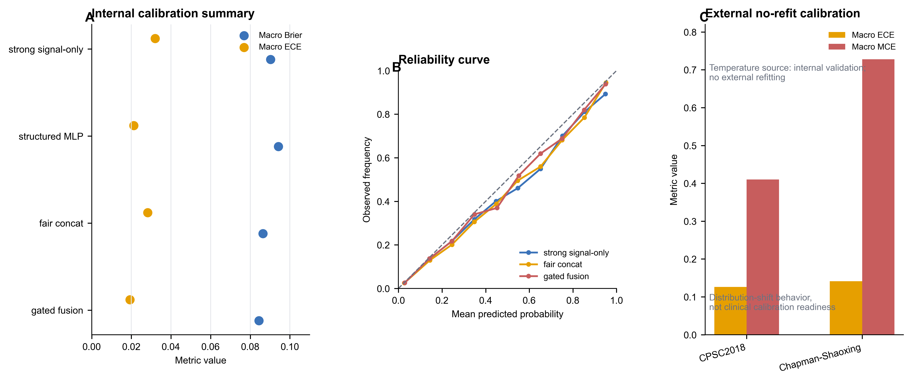

Supplementary Figure S1. Structured-feature reproducibility audit funnel.

