Communications Biology Figure Atlas
Psoriasis molecular programs and multisystem shared genetic architecture

Figure Storyline
Figure narrative type: multi-omics integration, disease-mechanism boundary setting, and shared genetic architecture. The main figures should move from the study contract and data scope to the instability of discrete endotypes, the reproducibility of continuous molecular programs, donor-level cellular and spatial contextualization, the negative boundary for axis-specific genetics, and then the genome-wide, local and regulatory architecture of overall psoriasis susceptibility. The key visual argument is not that each molecular program is a genetic endotype. It is that the tissue-state layer and the inherited-liability layer are connected but non-equivalent.

Main Figure Plan
Figure | Purpose | Expected message | Current status | Main risk
Figure 1 | Study design and transition from unstable discrete endotypes to continuous molecular programs | The study begins with a stability boundary: discrete k = 2 classes were not robust, so the paper moves to frozen continuous programs. | Existing panels available; needs final numbering cleanup before submission. | Figure 1 currently mixes Phase 1 and earlier Figure 2B file names; narrative is correct, but source filenames are not manuscript-final.
Figure 2 | Molecular-program prioritization and independent bulk replication | F1, F2, F6 and F7 are retained as frozen programs with skin-primary or systemic-supportive roles. | Existing panels available; strongest current molecular-program figure. | Panel density is high; final layout may need panel cropping or a two-row asymmetric design.
Figure 3 | Directional single-cell and spatial contextualization | Frozen programs receive donor-level cellular and spatial support, but remain contextual tissue-state programs. | Existing panels available; claim strength should remain directional/contextual. | Spatial support is not a definitive patient-level mechanism; legend must state contextual interpretation.
Figure 4 | Axis-specific genetics fails while overall psoriasis susceptibility remains the genetic layer | F1/F2/F6/F7 do not become genetically anchored endotypes; this motivates the pivot to overall psoriasis susceptibility. | Existing Phase 3A panels available, but manuscript numbering should change from old Figure 6 to final Figure 4. | This is a failure-boundary figure. It must not look like an afterthought or supplemental-only negative result.
Figure 5 | Genome-wide and local shared genetic architecture | Overall psoriasis susceptibility, not molecular axes, shows disease-specific shared architecture with CAD, PsA and IBD patterns. | Composite already available in PNG/PDF/SVG/TIFF. | CAD is the cleanest non-neighbour signal; IBD direction must be framed as heterogeneous and QC-sensitive.
Figure 6 | Restricted regulatory prioritization and layered biological model | SMR/HEIDI and coloc prioritize restricted regulatory candidates, but these do not directly overlap frozen molecular programs. | Existing Phase 4C/4D composites available; should be merged or split into final Figure 6 plus Extended Data. | This figure is visually large. A final submission version may need a hero panel plus source-data table rather than two dense composites.

Figure 1. Study design and transition from unstable discrete endotypes to continuous molecular programs
Core message: The study begins with a stability boundary: discrete k = 2 classes were not robust, so the paper moves to frozen continuous programs.
Status: Existing panels available; needs final numbering cleanup before submission.
Reviewer risk: Figure 1 currently mixes Phase 1 and earlier Figure 2B file names; narrative is correct, but source filenames are not manuscript-final.
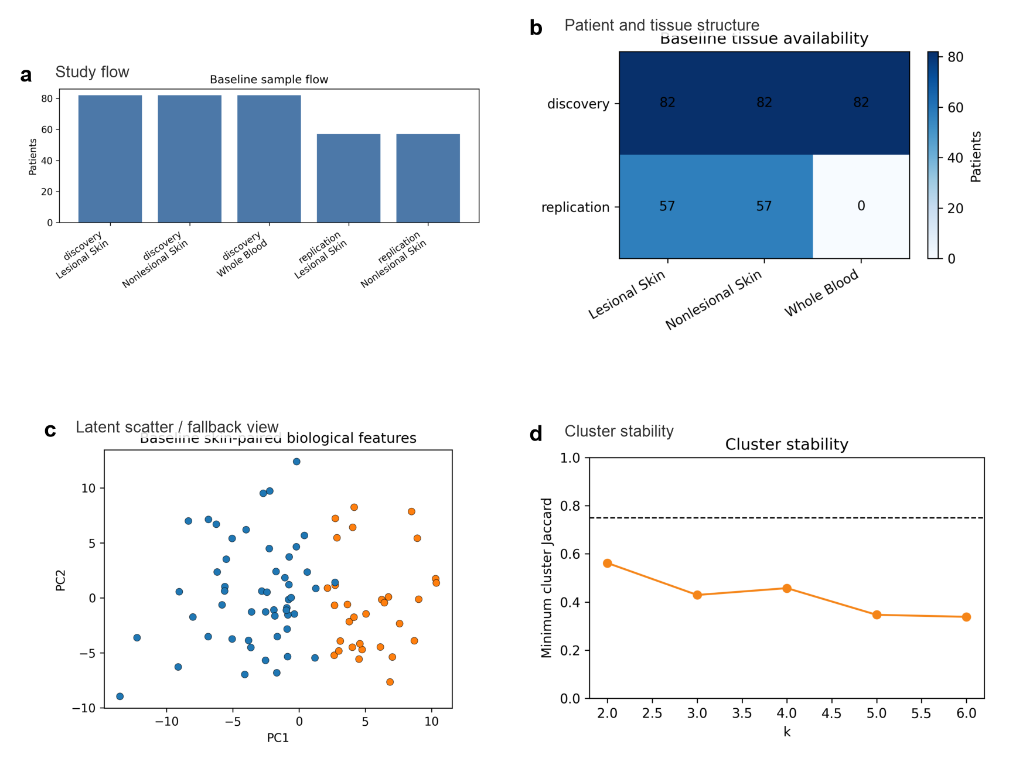
Review composite for Figure 1. Use original SVG/PDF/TIFF sources for final submission.

Figure 2. Molecular-program prioritization and independent bulk replication
Core message: F1, F2, F6 and F7 are retained as frozen programs with skin-primary or systemic-supportive roles.
Status: Existing panels available; strongest current molecular-program figure.
Reviewer risk: Panel density is high; final layout may need panel cropping or a two-row asymmetric design.
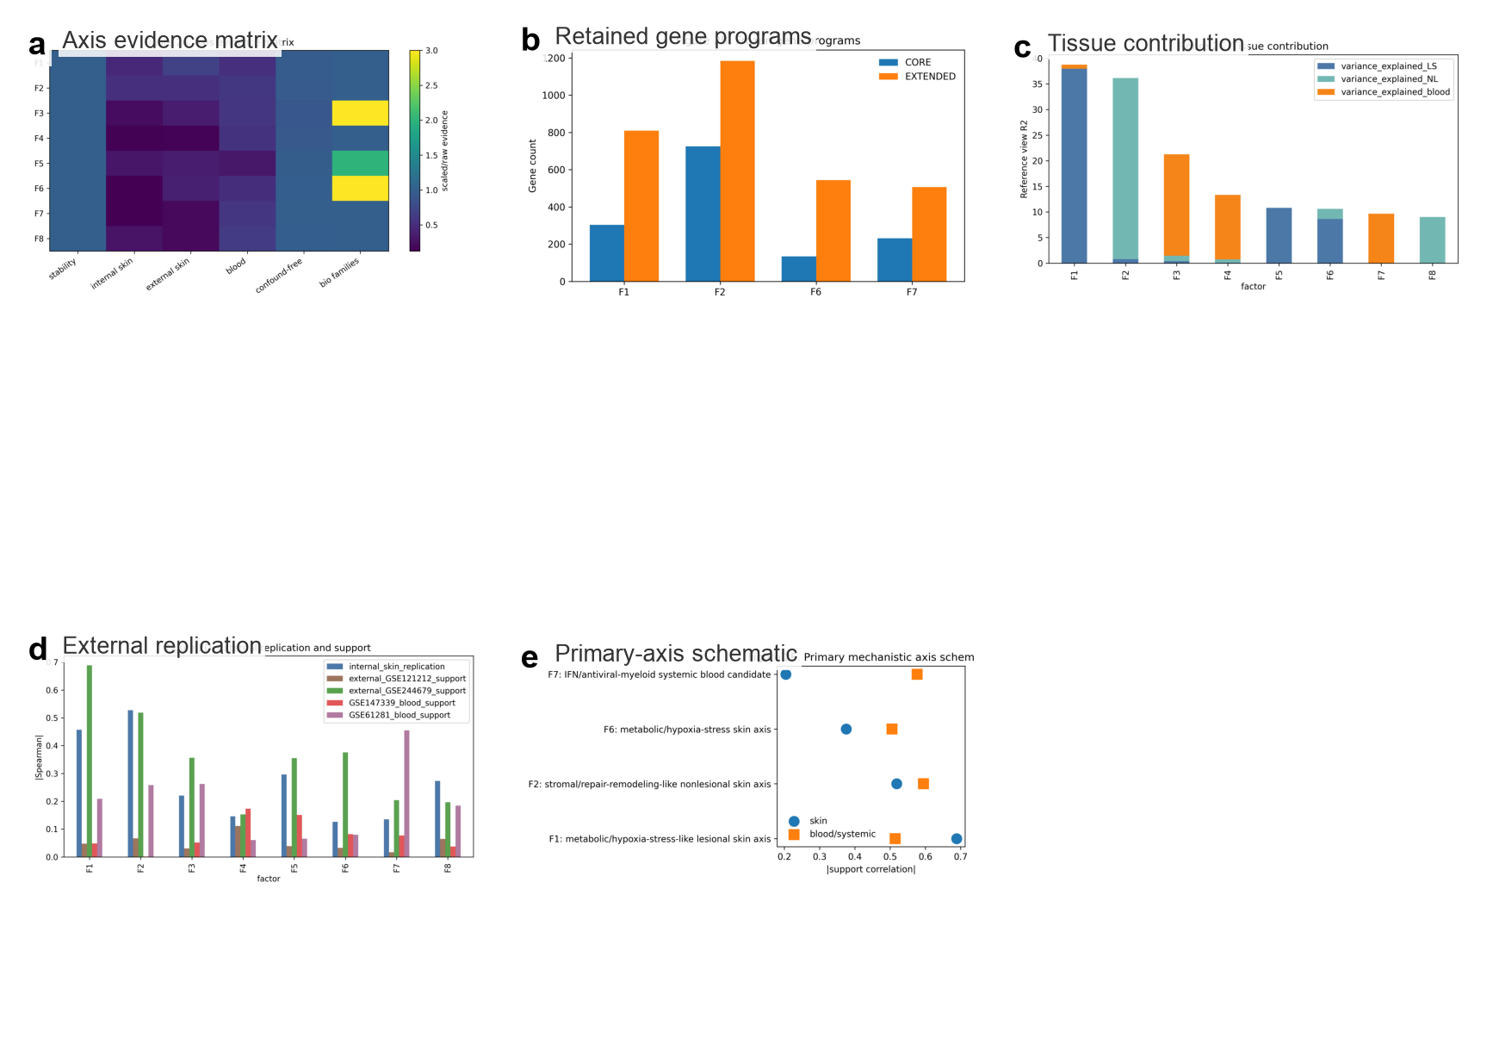
Review composite for Figure 2. Use original SVG/PDF/TIFF sources for final submission.

Figure 3. Directional single-cell and spatial contextualization
Core message: Frozen programs receive donor-level cellular and spatial support, but remain contextual tissue-state programs.
Status: Existing panels available; claim strength should remain directional/contextual.
Reviewer risk: Spatial support is not a definitive patient-level mechanism; legend must state contextual interpretation.
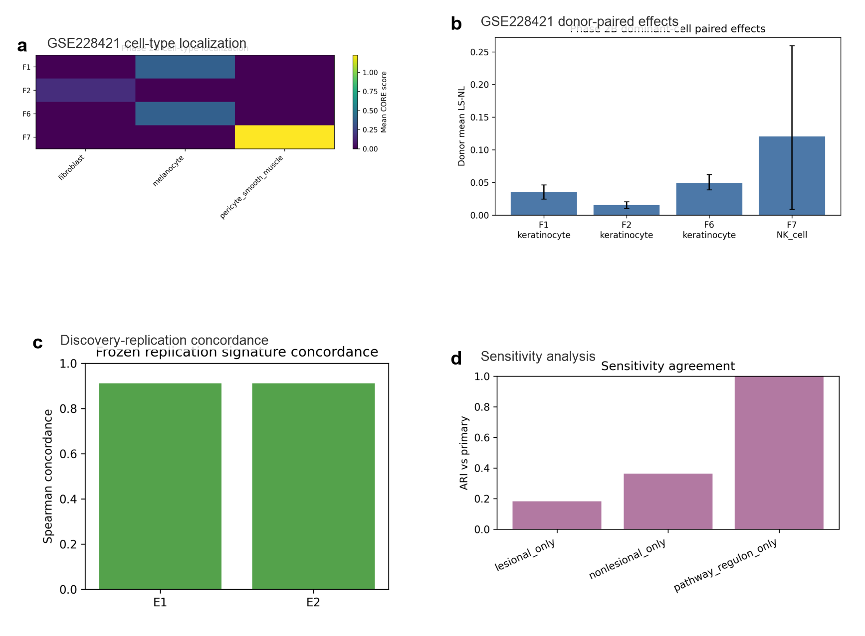
Review composite for Figure 3. Use original SVG/PDF/TIFF sources for final submission.

Figure 4. Axis-specific genetics fails while overall psoriasis susceptibility remains the genetic layer
Core message: F1/F2/F6/F7 do not become genetically anchored endotypes; this motivates the pivot to overall psoriasis susceptibility.
Status: Existing Phase 3A panels available, but manuscript numbering should change from old Figure 6 to final Figure 4.
Reviewer risk: This is a failure-boundary figure. It must not look like an afterthought or supplemental-only negative result.
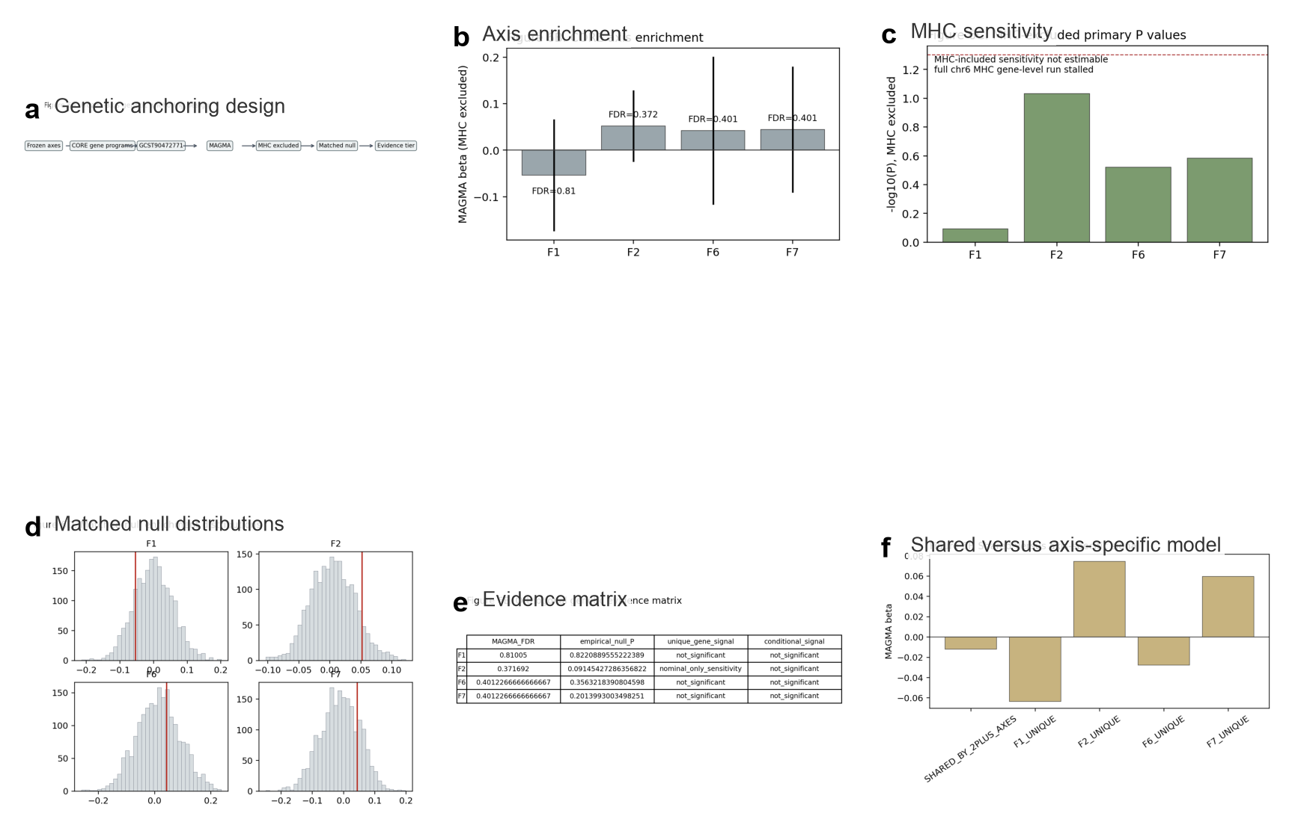
Review composite for Figure 4. Use original SVG/PDF/TIFF sources for final submission.

Figure 5. Genome-wide and local shared genetic architecture
Core message: Overall psoriasis susceptibility, not molecular axes, shows disease-specific shared architecture with CAD, PsA and IBD patterns.
Status: Composite already available in PNG/PDF/SVG/TIFF.
Reviewer risk: CAD is the cleanest non-neighbour signal; IBD direction must be framed as heterogeneous and QC-sensitive.
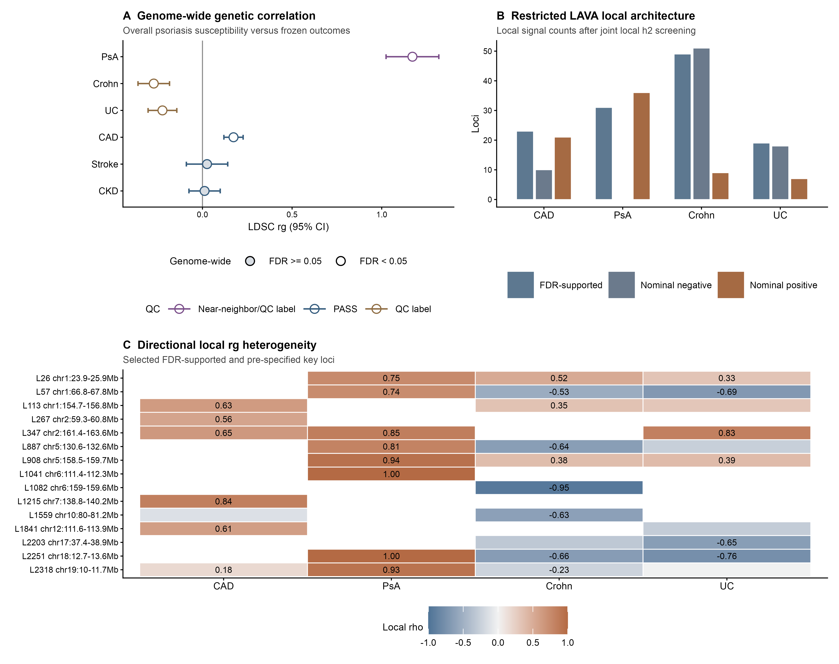
Review composite for Figure 5. Use original SVG/PDF/TIFF sources for final submission.

Figure 6. Restricted regulatory prioritization and layered biological model
Core message: SMR/HEIDI and coloc prioritize restricted regulatory candidates, but these do not directly overlap frozen molecular programs.
Status: Existing Phase 4C/4D composites available; should be merged or split into final Figure 6 plus Extended Data.
Reviewer risk: This figure is visually large. A final submission version may need a hero panel plus source-data table rather than two dense composites.
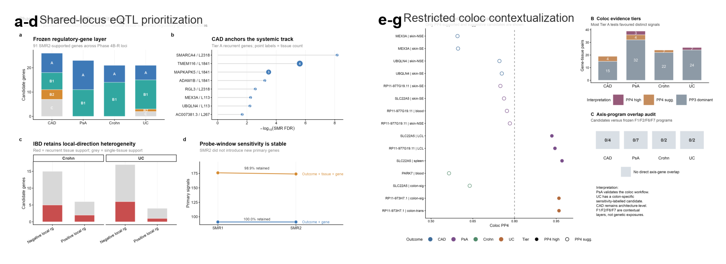
Review composite for Figure 6. Use original SVG/PDF/TIFF sources for final submission.

Supplementary Figure Plan
Supplementary figure | Purpose | Content
Supplementary Fig. 1 | Molecular discovery QC | Complete clustering stability, factor stability, missingness and preprocessing summaries.
Supplementary Fig. 2 | External replication details | Full GSE244679/GSE121212/GSE61281/GSE147339 projection and sensitivity outputs.
Supplementary Fig. 3 | Single-cell/spatial sensitivity | Donor-level bootstrap, dropout robustness, treatment/timepoint sensitivity and full cell-type panels.
Supplementary Fig. 4 | Phase 3A genetic no-go details | Full matched-null, MHC sensitivity and gene-set negative-control diagnostics.
Supplementary Fig. 5 | LDSC/LAVA QC | Munge QC, h²/intercepts, local h² screening and LD-reference sensitivity.
Supplementary Fig. 6 | SMR/coloc sensitivity | Full Tier A/B/C tables, HEIDI filters, coloc PP3/PP4 details and MAF-proxy flags.

Figure-to-Method Mapping
Figure | Required analysis | Input | Output
Figure 1 | Cluster stability and continuous-factor discovery | E-MTAB-14509 matched skin/blood data | Study design, k = 2 instability, continuous axis decision
Figure 2 | Axis prioritization and bulk replication | Frozen F1/F2/F6/F7 programs and paired skin replication | Program evidence matrix and tissue contribution
Figure 3 | Donor-level single-cell and spatial contextualization | GSE228421, GSE173706, GSE225475, GSE202011 | Cellular/spatial directional support
Figure 4 | Axis-specific genetic anchoring test | Frozen molecular programs and psoriasis GWAS | NO-GO for genetically anchored axes
Figure 5 | Overall psoriasis × comorbidity LDSC/LAVA | GCST90472771 plus frozen comorbidity GWAS | Genome-wide and local shared architecture
Figure 6 | SMR/HEIDI, coloc and transcriptomic contextualization | GTEx v8, Tier 1/2 loci and frozen molecular programs | Restricted regulatory candidates and no direct axis overlap

Weakness Check
- Figure 1 establishes the study contract, but old source filenames and final manuscript numbering still need cleanup.
- Figure 4 is the key failure-boundary figure and should not be demoted to supplementary material.
- Figure 6 currently combines two large Phase 4C/4D composites; the final version may need one hero panel plus two evidence panels.
- IBD legends should keep the directional-heterogeneity and QC-sensitive wording, not a global negative-liability conclusion.
- Images in this Word file are review previews; final submission should use the original PDF/SVG/TIFF files and source data.

