Auditing chemical and cellular train–test overlap in perturbation-response prediction
Da Lin¹, Ying Chen², Yue Liu², Yu Zhang¹*
¹The Second Affiliated Hospital of Wenzhou Medical University, Wenzhou, Zhejiang, China
²Wenzhou Medical University, Wenzhou, Zhejiang, China
*Correspondence: zhangyu1@wzhealth.com

Abstract
Background:
Chemical perturbation-response datasets contain repeated compounds, cellular contexts, doses, and related mechanisms. These relations can cross a random train–test split, so performance depends on which entities and neighbors remain familiar. We developed an evaluation protocol that records these relations and compares random, scaffold-held-out, and joint cellular-plus-scaffold-held-out tasks in two public datasets.
Results:
The protocol uses fixed train/test/excluded manifests, neighborhood audits, transparent prediction probes, and matched-random controls. Under joint held-out evaluation, the global training mean matched or exceeded every main-text probe in both datasets. The OpenProblems cell-context + drug-fingerprint ridge had Pearson 0.362 under random validation and 0.118 under joint validation, with a joint gain over the global mean of -0.054. The Sci-Plex 3 dose-aware ridge had corresponding scores of 0.292 and 0.060, with a joint gain of -0.016. On records held out by both random and joint fits, their paired differences remained 0.250 and 0.229. Random OpenProblems splits retained same-drug and same-scaffold neighbors for 98.9% and 97.4% of test records; 42.7% of annotated scaffold-strict test records retained same-mechanism neighbors. Seed resampling quantified sensitivity to split construction on these fixed cohorts. The training-only gene-selection sensitivity retained this pattern across all 30 Sci-Plex seeds.
Conclusions:
For the evaluated probes, chemical features improved random-split prediction but did not improve joint extrapolation over the global mean. Fixed manifests, neighborhood audits, baseline-adjusted scores, and control analyses help distinguish these evaluation settings. The results characterize these cohorts and probes and do not establish the performance of untested model families.
Keywords: benchmark validation; data leakage; single-cell perturbation; drug response prediction; chemical scaffold; reproducibility

Background
Single-cell chemical perturbation screens measure how compounds alter transcription across cellular contexts. They support response prediction and the prioritization of follow-up experiments. Predicting a familiar compound in a familiar context, a new chemical scaffold, or a compound in an unseen cellular context are different tasks. A validation design should identify which of these tasks a reported score represents [1].
This study uses OpenProblems perturbation-response records and Sci-Plex 3 pseudobulk responses [2, 3]. Each record links a compound to a cellular context and a response vector; dose and time provide additional links where available. Splitting records at random can leave identical drugs, related scaffolds, or the same cellular context in both training and test sets. We use “single-cell-derived” to describe the origin of these data. The prediction unit here is a response record, not an individual-cell distribution.
Random validation is appropriate for predicting missing combinations among familiar entities. It does not estimate performance on unseen entities merely because record identifiers differ. Validation that conflicts with an intended application can produce optimistic estimates [4]. DataSAIL already formalizes one- and two-dimensional entity- and similarity-aware splitting, including records lost when paired entities belong to different folds [5]. Our joint cell-plus-scaffold task applies this established two-dimensional principle using discrete cell labels and Bemis–Murcko scaffold groups. We do not propose a new general splitting algorithm.
Recent perturbation evaluations show that simple linear predictors can compete with deep models and that performance depends on the task and metric [6, 7]. For chemical perturbation prediction, a further question is whether a chemistry-aware predictor improves on a mean response once both cellular and chemical groups are unfamiliar. Comparing absolute scores across different test sets cannot answer this alone: the test composition and the training mean can also change. Comparisons should therefore include means scored on the same records, controls for selected split properties, and common-test-record sensitivity analyses.
We compare random, cellular-held-out, scaffold-held-out, and joint tasks, and audit drug identity, scaffold, cellular context, dose, annotated mechanism, and nearest-training-drug similarity. These fields describe what information remains across each boundary. They also distinguish structural exclusion from mechanism exclusion: compounds with different scaffolds can retain an annotated mechanism. Fixed record assignments and explicit exclusion counts make the resulting comparisons inspectable without implying that one split is appropriate for every application.
We present an evaluation protocol and accompanying analysis code. Transparent predictors are used to examine the protocol rather than to rank contemporary model families. We ask whether chemical descriptors improve on training-mean baselines under random, scaffold-held-out, and joint evaluation. We compare paired gains over the global mean, matched-random controls, and test records shared by random and joint fits. Reproducing an original published perturbation model remains outside the completed model panel.

Methods

Datasets and response targets
OpenProblems served as the primary benchmark. The local metadata included 553 records, 140 stored drug labels, four immune-cell contexts, and a single dose placeholder. The treated-record evaluator subset contained 545 records, 138 stored drug labels, and 136 drugs with nonmissing scaffold labels, representing 134 distinct scaffolds. These counts reflect the records retained after joining stored metadata, fixed candidate manifests, and the response evaluator; absent labels were not imputed or remapped. The response target was the supplied clipped_sign_log10_pval vector. Differentially expressed (DE)-gene Pearson used the provided is_de mask and required at least 10 DE genes per record.
Sci-Plex 3 was used as an external 24-hour pseudobulk cohort. Qualifying cells were grouped by perturbation, cell line, numeric dose, and time. The response vector was treated mean log1p counts per 10,000 (CP10K) expression minus the matched cell-line control mean. We selected the 2,000 genes with the largest total raw count across qualifying cells; this fixed feature set was defined before split-specific model fitting. The final cohort contained 2,200 records, 188 drugs, 164 nonmissing scaffolds, three cell lines, and four dose levels. Sci-Plex 3 did not provide a per-record DE mask, so its results use all-gene metrics. This cohort-wide ranking is transductive: test-cohort count frequencies helped define the target coordinates. We additionally reconstructed the full-gene pseudobulk targets from the original cells and repeated the global-mean and dose-aware ridge analyses with training-only gene selection for all 30 seeds and three main splits. Within each split, the 2,000 genes were ranked by summed raw counts from its treated training records only. The same public cell-line control references defined the response target. This sensitivity check addresses gene selection, while retaining the control-reference convention.
Table 1. Dataset characteristics in the fixed local evaluation cohorts. NA indicates not applicable for the reported cohort.
Dataset | Stage | Records | Drugs | Cells | Unique scaffolds | Doses
OpenProblems | raw local metadata | 553 | 140 | 4 | NA | 1
OpenProblems | treated evaluator subset | 545 | 138 | 4 | 134 | 1
Sci-Plex 3 | final pseudobulk cohort | 2,200 | 188 | 3 | 164 | 4

Evaluation tasks and deterministic manifests
Each record rᵢ = (cᵢ, dᵢ, sᵢ, zᵢ, mᵢ, yᵢ) contains a cellular context or cell line cᵢ, drug label dᵢ, scaffold sᵢ, dose zᵢ where available, possibly missing MoA annotation mᵢ, and response vector yᵢ. We use local interpolation for random validation, chemical structural extrapolation for scaffold-held-out validation, and joint cellular plus chemical extrapolation for the joint cell-plus-scaffold held-out task.
For each seed, a fixed manifest assigned records to train, test, or excluded. Random splits used a target test fraction of 0.20. Cell-held-out and scaffold-held-out splits sampled groups without replacement. The joint task held out the intersection of selected cell and scaffold groups as test; records satisfying exactly one held-out condition were excluded, and records satisfying neither condition formed training data. Missing scaffold groups were excluded from scaffold-group sampling and retained as missing metadata. All reported results use seeds 1–100 for OpenProblems and seeds 1–30 for Sci-Plex 3; seed 0 was not used.
Table 2. Fixed-manifest and evaluator record accounting (mean ± standard deviation (SD) across seeds). Manifest counts define split membership; evaluable-test counts define the denominator of a response metric.
Dataset | Split | Seeds | Manifest train | Manifest test | Excluded | Evaluable test
OpenProblems | cell held-out | 100 | 414.7 ± 1.9 | 138.3 ± 1.9 | 0.0 ± 0.0 | 136.3 ± 1.9
OpenProblems | joint held-out | 100 | 333.5 ± 2.1 | 27.2 ± 1.0 | 192.3 ± 1.5 | 26.8 ± 1.2
OpenProblems | random | 100 | 443.0 ± 8.7 | 110.0 ± 8.7 | 0.0 ± 0.0 | 108.4 ± 8.5
OpenProblems | scaffold held-out | 100 | 444.7 ± 2.6 | 108.3 ± 2.6 | 0.0 ± 0.0 | 106.7 ± 3.7
Sci-Plex 3 | cell held-out | 30 | 1,468.8 ± 10.5 | 731.2 ± 10.5 | 0.0 ± 0.0 | 731.2 ± 10.5
Sci-Plex 3 | joint held-out | 30 | 1,183.7 ± 25.8 | 141.9 ± 11.8 | 874.4 ± 14.9 | 141.9 ± 11.8
Sci-Plex 3 | random | 30 | 1,762.5 ± 16.4 | 437.5 ± 16.4 | 0.0 ± 0.0 | 437.5 ± 16.4
Sci-Plex 3 | scaffold held-out | 30 | 1,772.9 ± 35.0 | 427.1 ± 35.0 | 0.0 ± 0.0 | 427.1 ± 35.0

Neighborhood audit
For each test record, the audit reports same-drug, same-scaffold, same-cell, dose-neighbor, and same-MoA indicators, plus maximum Tanimoto similarity to a unique training drug. Drug labels were retained exactly as stored for split construction and prediction. For MoA joins only, stripped lower-case drug labels were compared; a multi-label annotation matched when its label set intersected the union of training labels. Missing MoA annotations and annotated records with no matching training MoA were recorded as different states.
Stored simplified molecular-input line-entry system (SMILES) strings were parsed with RDKit. Invalid or missing structures received all-zero 1,024-bit model fingerprints and missing similarity values. The scaffold field used the precomputed canonical output of MurckoScaffold.GetScaffoldForMol. Model fingerprints used radius-2 Morgan vectors of length 1,024 with useChirality=False; audit similarity used radius-2, 2,048-bit Morgan vectors with the same chirality setting. Exact numeric dose overlap was recorded for Sci-Plex 3. Integrity checks verified train/test separation, exclusion of joint-excluded records from train and test, and zero same-drug and same-scaffold overlap for strict scaffold and joint test sets. We separately counted missing or invalid SMILES, zero fingerprints, absent scaffold labels, and annotated MoA coverage over each complete final cohort; these counts are not seed-averaged test denominators.

Matched-random controls
Matched-random controls were drawn only from the fixed random split for the same seed. The joint manifest supplied target counts but never contributed record identities to a random-control training, validation, or test set. The test-size-matched control matched the joint test count while retaining the random training set. The train-and-test-size-matched control matched both joint train and test counts. For OpenProblems, a third control also matched each joint test record by cell context and DE-gene-count quartile, using cell-only and then random-pool fallbacks. This composition-matched control did not match scaffold composition. The controls therefore address test-set size and the listed composition variables; they do not identify a causal neighborhood effect or match every property of the joint split.

Probe models and training restrictions
We evaluated transparent probes: global training mean, cell-context or cell-line mean, drug mean, drug-fingerprint ridge, cell-context ridge, and cell-context plus drug-fingerprint ridge. Sci-Plex additionally used cell-line plus dose plus drug-fingerprint ridge. For the ridge probes, cell features were one-hot encoded from training records. Sci-Plex ridge dose was log10 transformed and standardized from training data only. Ridge used a pre-specified α = 10 and an intercept, without test-set hyperparameter selection.
The nonlinear probe was named the control-conditioned nonlinear benchmark. It is a benchmark-compatible pseudobulk adaptation, not a reproduction of TranSiGen. It used basal/control expression, a 1,024-bit drug fingerprint, log10(dose + 1), and indicators from the fixed three-cell-line input vocabulary. The network had two 128-unit ReLU layers, dropout 0.1, AdamW with learning rate 1 × 10⁻³, up to 12 epochs, and early stopping based on a deterministic 10% validation partition drawn only from manifest training records. The model initialization seed matched the split seed. Basal expression was the supplied cell-line control reference, including the held-out line when that input was required by the contract. For this probe, cellular holdout therefore means that treated-response records from the held-out cell line are absent from training, while its measured basal/control profile remains available as an input. This setting is not a zero-shot task for a completely unobserved cellular context. The dose transform and declared input vocabulary were fixed; feature and target standardization were fitted on training-fit records only. Training and validation loss traces were saved for the newly added matched controls. PRnet-interface outputs are reported only in the Supplementary Information as an adaptation-status result and are not used to characterize the original PRnet workflow.

Metrics, uncertainty, and result reporting
The primary metric was mean row-wise Pearson correlation. We also recorded root mean squared error (RMSE) and, for OpenProblems, Pearson restricted by the supplied DE mask. We calculated the paired Pearson gain over the global training mean within each dataset, seed, split, and metric. This gain measures improvement over that baseline on the same test records; it does not remove all context structure or constitute a residual-response metric. Random-to-strict and matched-control comparisons were paired by manifest seed. We also compared saved predictions only on record identifiers present in both random and joint test sets, without refitting. No common-test record was a training record in either compared fit. We used 10,000 bootstrap resamples of seeds to summarize split-construction sensitivity conditional on the fixed observed cohorts. Repeated seeds reuse biological records; these intervals do not represent independent biological replication or population-level uncertainty. The comparisons are descriptive, and no multiplicity-adjusted significance claims are made. Prediction archives and result tables preserve record alignment, vector length, seed, split, and completion status.

Use of artificial intelligence-assisted tools
OpenAI Codex was used to assist with code drafting and debugging, code readability, formatting, and English-language editing. The authors are responsible for reviewing the code, verifying results and references, and approving all interpretations and manuscript content. No raw data were generated and no results were fabricated with these tools.

Results

Evaluation tasks and record accounting
Figure 1 outlines the analysis workflow. Table 1 describes the two local cohorts, and Table 2 distinguishes manifest membership from evaluable response records. Joint splits exclude records that meet only one held-out condition. Their scores therefore describe the unseen-cell–unseen-scaffold intersection, with a different training and test composition from random validation.
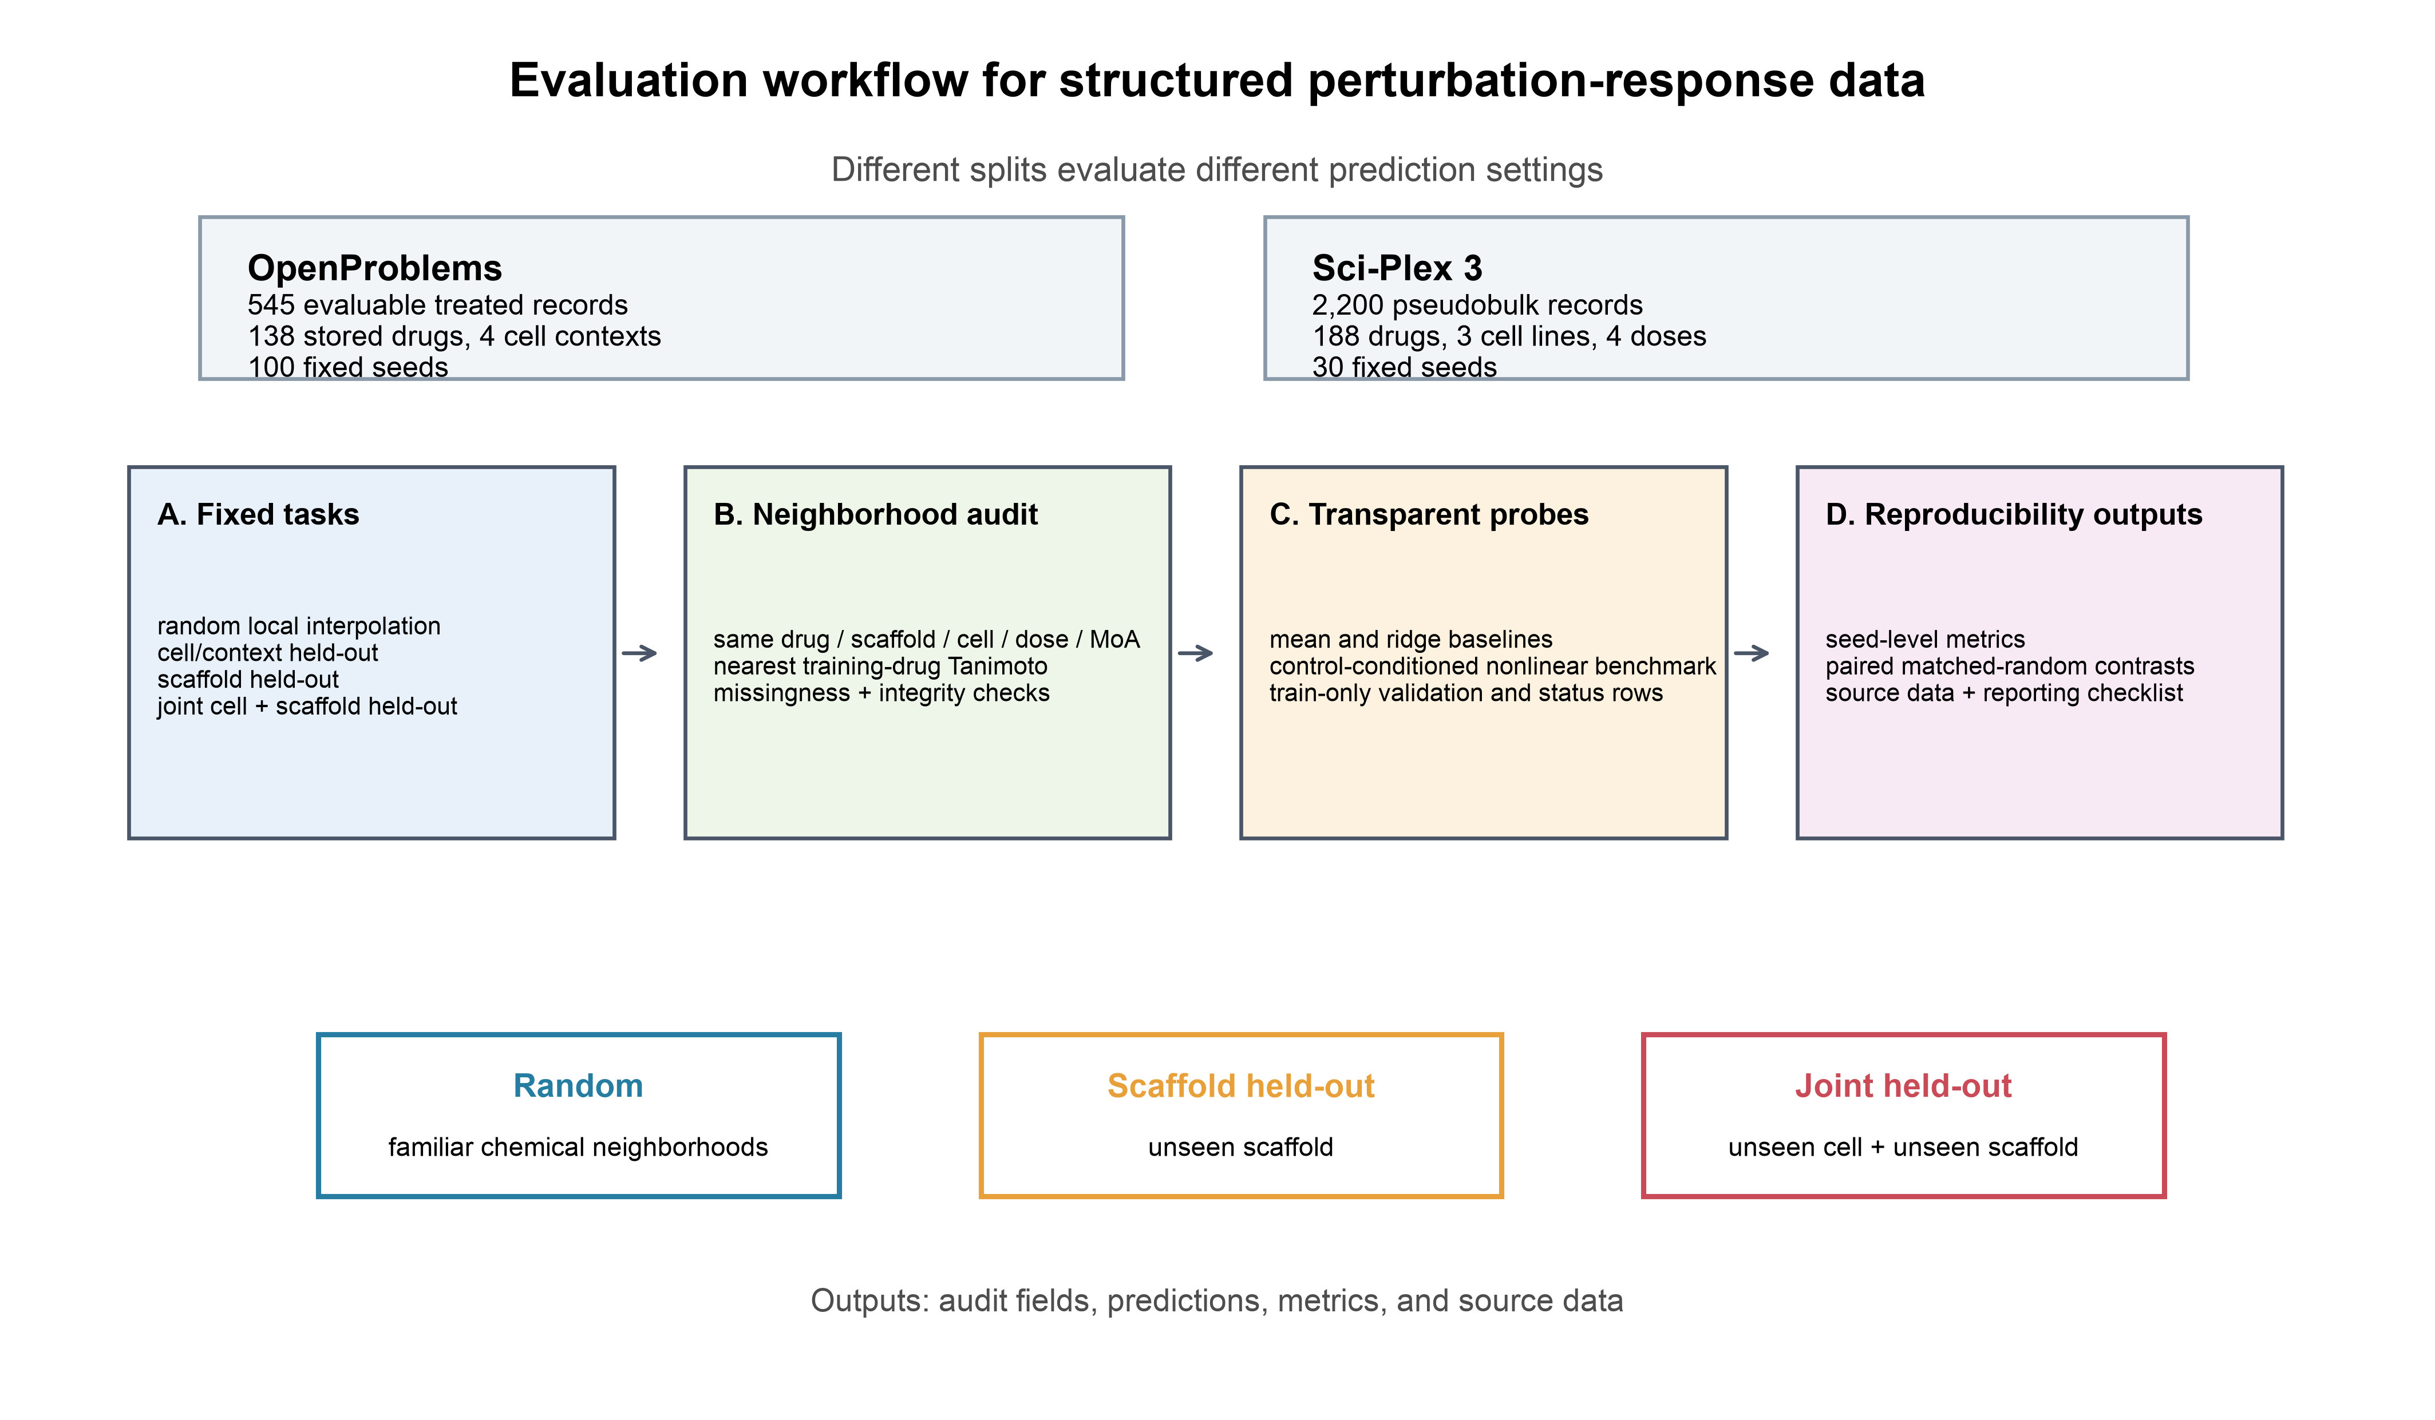
Figure 1. Evaluation workflow for single-cell-derived perturbation-response records. Inputs are cohort metadata, molecular structures, response vectors, and fixed seed-specific assignments. Outputs are neighborhood audit fields, probe predictions, seed-level metrics, and paired controls. Random, scaffold-held-out, and joint-held-out tasks differ in the entities available in training. The diagram describes this analysis protocol and does not imply automatic support for every perturbation model. Figure-specific source data are available in the public revision archive.

Random validation retains extensive chemical and cellular neighborhoods
Figure 2 shows the neighborhood audit. In OpenProblems, 98.9% and 97.4% of random-split evaluable test records retained same-drug and same-scaffold training neighbors. Both overlaps were zero under scaffold and joint exclusion. Mean nearest-training-drug Tanimoto changed from 0.997 to 0.278. Same-MoA overlap remained 42.7% among annotated strict-split test records. All 138 treated drug labels and 545 treated records mapped to at least one annotation in the supplied OpenProblems MoA file. This is label coverage, not evidence that each mechanism annotation is complete. Missingness and no shared MoA remain separate audit states. Neither final cohort had a missing or invalid SMILES or an all-zero fingerprint in the revision check. Scaffold labels were absent for 2 OpenProblems drugs (8 records) and 6 Sci-Plex drugs (72 records).
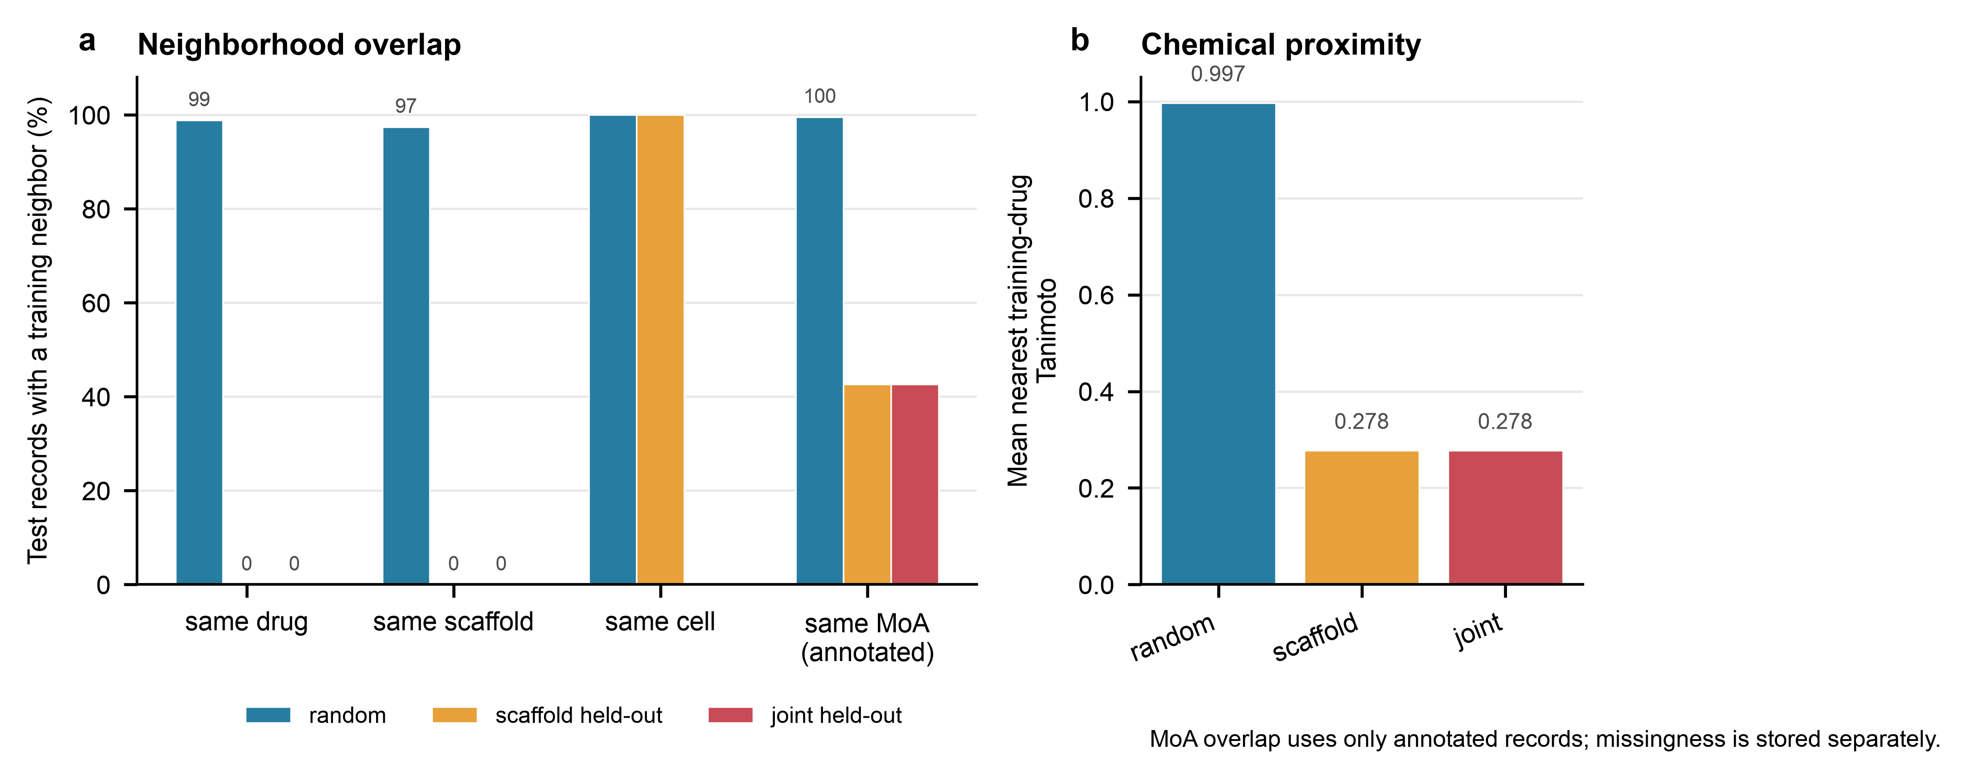
Figure 2. OpenProblems neighborhood audit over 100 fixed seeds. a, Mean test-record overlap with training drug, scaffold, cell context, and annotated MoA. b, Mean nearest-training-drug Tanimoto (radius 2; 2,048 bits). Missing MoA is distinct from no shared label. Source tables report denominators and missingness.

Matched-random controls address selected size and composition differences
Figure 3 presents the seed-paired matched-random controls. The cell-context plus drug-fingerprint ridge had mean Pearson 0.118 under the OpenProblems joint split. Test-size-matched, train-and-test-size-matched, and composition plus train-and-test-size-matched random controls had means of 0.365, 0.336, and 0.342, respectively. The paired train-and-test-size-matched random-minus-joint difference was 0.218 (95% split-seed bootstrap interval, 0.208–0.228; Table 3). In Sci-Plex 3, the control-conditioned nonlinear benchmark had mean Pearson 0.017 under joint evaluation and 0.245 under the train-and-test-size-matched random control. The paired difference was 0.228 (95% split-seed bootstrap interval, 0.219–0.238; Table 3). Random controls retained the familiar chemical and cellular neighbors expected from random partitions. For these controls, the separation was not explained by training-set size, test-set size, or the specified OpenProblems composition variables alone. The random and joint conditions still use different test records and training neighborhoods; the controls do not estimate a causal effect of chemical overlap.
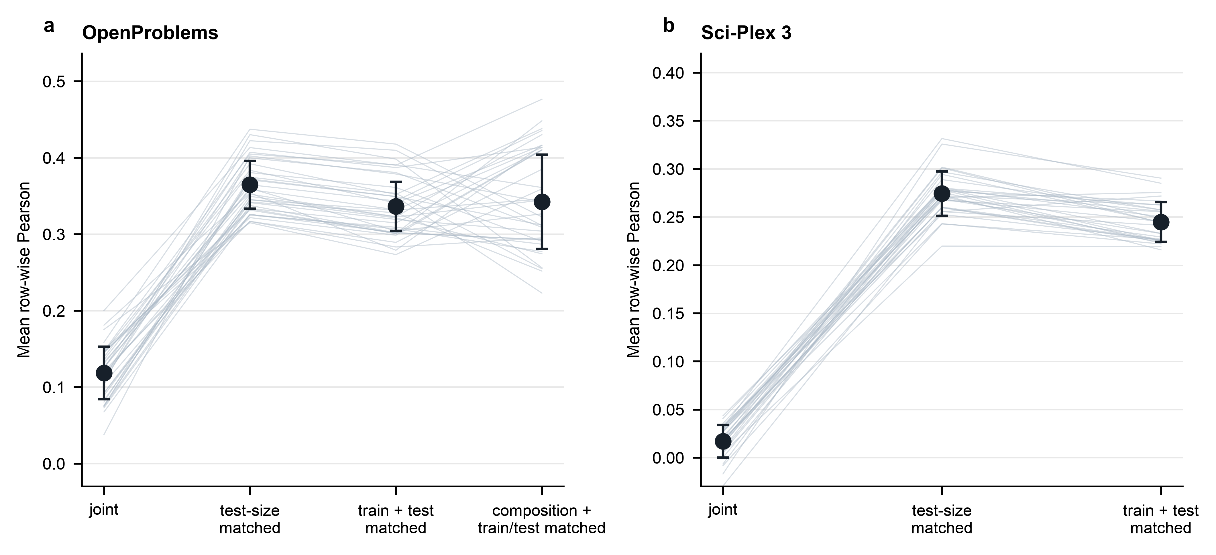
Figure 3. Seed-paired matched-random controls. a, OpenProblems cell-context plus drug-fingerprint ridge under joint evaluation and three same-seed random controls: test-size matched, train-and-test-size matched, and composition plus train-and-test-size matched. b, Sci-Plex 3 control-conditioned nonlinear benchmark under joint evaluation and same-seed test-size-matched or train-and-test-size-matched random controls. Gray lines show deterministic subsets of paired seeds; black points and error bars show the mean ± SD. The OpenProblems composition control matches cell context and DE-gene-count quartile but not scaffold composition. Source data are available in the public revision archive.
Table 3. Paired train-and-test-size-matched random minus joint contrasts. The 95% split-seed bootstrap intervals summarize sensitivity to partition construction on the fixed cohorts, not uncertainty across independently sampled biological cohorts.
Dataset | Probe | Seeds | Difference | 95% split-seed bootstrap interval
OpenProblems | Cell-context + fingerprint ridge | 100 | 0.218 | 0.208 to 0.228
Sci-Plex 3 | Control-conditioned nonlinear benchmark | 30 | 0.228 | 0.219 to 0.238

Training means outperform chemical-feature probes under joint evaluation
Figure 4 and Table 4 show that the global training mean matched or exceeded all completed main-text probes under joint evaluation. OpenProblems global-mean Pearson was 0.172, compared with 0.118 for both fingerprint ridge probes; the cell-only and drug-mean predictors tied the global mean because their unavailable groups fell back to it. Sci-Plex global-mean Pearson was 0.076, compared with 0.058 for fingerprint ridge, 0.060 for dose-aware fingerprint ridge, and 0.017 for the nonlinear probe. Within each dataset, the context mean had the highest mean Pearson among the main-text scaffold-held-out probes (0.307 and 0.230), despite using no chemical representation. The OpenProblems cell-context + drug-fingerprint ridge gain over the global mean was -0.054 under joint evaluation (95% split-seed bootstrap interval, -0.059 to -0.049). The Sci-Plex dose-aware ridge gain was -0.016 (-0.020 to -0.012), and the nonlinear gain was -0.059 (-0.070 to -0.048). These comparisons use identical test records for a probe and its baseline. The same pattern was observed for OpenProblems DE-gene Pearson. Under joint evaluation, the context-plus-fingerprint ridge and fingerprint ridge had gains over the global mean of -0.079 and -0.080, respectively (Table S1). The nonlinear predictor is the adaptation defined in Methods; these scores do not evaluate the original TranSiGen model.
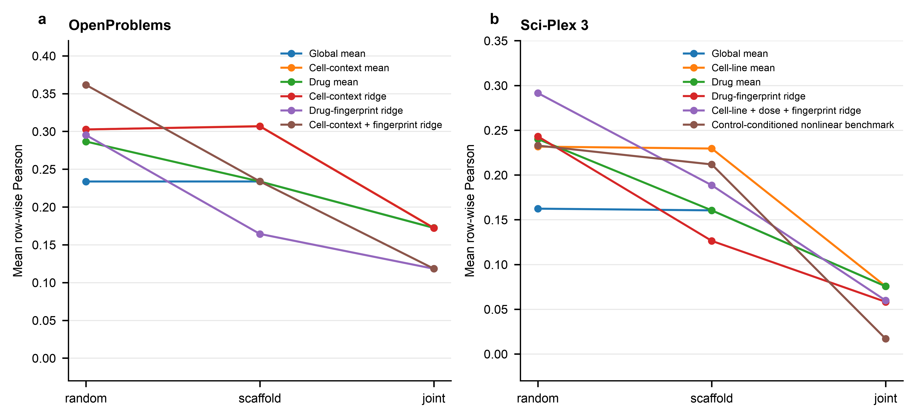
Figure 4. Completed probes across evaluation tasks. a, OpenProblems mean and ridge predictors across random, scaffold-held-out, and joint-held-out manifests. b, Sci-Plex mean, ridge, and control-conditioned nonlinear predictors. Points represent mean row-wise Pearson across 100 OpenProblems or 30 Sci-Plex seeds; Table 4 and source data report seed-level variation. The global-mean benchmark must be considered alongside every chemistry-aware predictor. The nonlinear probe implements the pseudobulk contract specified in Methods.
Table 4. Mean row-wise Pearson correlation ± SD across fixed seeds for completed main-text probes.
Dataset | Probe | Random | Scaffold held-out | Joint held-out
OpenProblems | Global mean | 0.234 ± 0.016 | 0.234 ± 0.032 | 0.172 ± 0.048
OpenProblems | Cell-context mean | 0.303 ± 0.016 | 0.307 ± 0.031 | 0.172 ± 0.048
OpenProblems | Drug mean | 0.287 ± 0.016 | 0.234 ± 0.032 | 0.172 ± 0.048
OpenProblems | Cell-context ridge | 0.303 ± 0.016 | 0.307 ± 0.032 | 0.172 ± 0.048
OpenProblems | Drug-fingerprint ridge | 0.295 ± 0.016 | 0.164 ± 0.027 | 0.118 ± 0.034
OpenProblems | Cell-context + drug-fingerprint ridge | 0.362 ± 0.016 | 0.234 ± 0.027 | 0.118 ± 0.034
Sci-Plex 3 | Global mean | 0.162 ± 0.007 | 0.160 ± 0.018 | 0.076 ± 0.026
Sci-Plex 3 | Cell-line mean | 0.232 ± 0.007 | 0.230 ± 0.020 | 0.076 ± 0.026
Sci-Plex 3 | Drug mean | 0.240 ± 0.008 | 0.160 ± 0.018 | 0.076 ± 0.026
Sci-Plex 3 | Drug-fingerprint ridge | 0.243 ± 0.008 | 0.126 ± 0.018 | 0.058 ± 0.023
Sci-Plex 3 | Cell-line + dose + drug-fingerprint ridge | 0.292 ± 0.008 | 0.189 ± 0.019 | 0.060 ± 0.025
Sci-Plex 3 | Control-conditioned nonlinear benchmark | 0.233 ± 0.013 | 0.212 ± 0.020 | 0.017 ± 0.017

Common test records and baseline-adjusted performance
On the intersection of random and joint test identifiers, OpenProblems had 99 nonempty paired seeds, with a mean of 5.3 common records (range 1–10). The fingerprint ridge random-minus-joint difference was 0.250 (95% split-seed bootstrap interval, 0.235 to 0.265); the global-mean difference was 0.068 (0.064 to 0.073). In Sci-Plex, all 30 seeds had common records, averaging 29.4 (range 20–42). The dose-aware ridge difference was 0.229 (0.216 to 0.241), compared with 0.083 (0.079 to 0.087) for the global mean. The persistent mean-baseline difference shows that the training response distribution also changes. Restricting test identities therefore resolves one source of variation but does not isolate a neighborhood effect. Complete common-record and baseline-adjusted results are in the Supplementary Information. Training-only gene selection yielded dose-aware ridge Pearson means of 0.292, 0.189, and 0.064 under random, scaffold-held-out, and joint evaluation, respectively, across 30 fixed seeds. This sensitivity analysis selected a separate gene panel in each training split; its absolute scores therefore use different target coordinates from the fixed-panel analysis. Table 5 lists the fields needed to interpret and reproduce these comparisons.
Table 5. Minimum reporting checklist for structured perturbation-response benchmarks.
Item | Minimum report
Evaluation target | State whether the task is local interpolation, chemical structural extrapolation, cellular extrapolation, or a joint task.
Manifest accounting | Release fixed seed-specific train, test, and excluded identifiers and report their counts.
Neighborhood audit | Report overlapping drug, scaffold, cell, dose, MoA, missingness, and nearest training-drug similarity fields where applicable.
Matched controls | State exactly which training, test, and composition variables are matched.
Model contract | Report inputs, preprocessing, train-only validation, initialization, and hyperparameter-selection restrictions.
Metric context | Pair absolute response-vector fit with baseline-adjusted, residualized, DE-gene, pathway, or retrieval metrics when perturbation-specific signal is the target.
Result reporting | Release seed-level metrics, paired contrasts, alignment information, source data, and integrity checks.

Discussion
The clearest result is that the tested chemical representations did not improve on the global mean under joint evaluation. This occurred in both cohorts, although they use different response targets. In OpenProblems, the context + fingerprint ridge performed well under random validation but had a negative gain over the global mean when both cell context and scaffold were held out. The Sci-Plex dose-aware ridge and nonlinear adaptation also had negative joint gains. A constant response vector is consequently an essential comparator in this panel. These findings concern the fitted probes and the observed cohorts; they do not establish the behavior of every perturbation-prediction model.
The context mean also outperformed the main-text chemistry-aware probes under scaffold exclusion. Here, familiar cellular contexts remained available, even though scaffolds were absent from training. Together with the joint result, this pattern suggests that the evaluated descriptors added little transferable response information beyond context averages in the stricter tasks. Competitive simple baselines are reported in recent genetic perturbation studies [6, 8]. Systema addresses a related metric concern by separating perturbation prediction from systematic variation [9]. These studies motivate explicit comparison with means rather than interpreting a positive absolute Pearson score as sufficient evidence of perturbation-specific prediction.
The neighborhood audit describes the information available to these probes. Random OpenProblems validation retained same-drug and same-scaffold neighbors for nearly every test record. Scaffold and joint exclusion removed those discrete overlaps, while nearest-training-drug similarity quantified the remaining structural proximity. Bemis–Murcko scaffolds, Morgan fingerprints, and Tanimoto similarity are established tools [10, 11, 12]. Our contribution is their combined reporting with cellular, dose, and mechanism relations in two single-cell-derived response datasets. This application extends earlier leakage-sensitive validation work and molecular benchmarks [4, 13]; the observed decrease alone is not a new splitting principle.
Mechanism annotations identify another boundary. The 42.7% same-MoA overlap means that scaffold exclusion did not guarantee mechanism exclusion. Scaffold hopping can preserve pharmacological activity [14], and transcriptomic signature resources link compounds through downstream response programs [15, 16]. Full mapping of this local OpenProblems cohort to a supplied annotation file makes the reported denominator explicit, but it does not remove annotation ambiguity: labels can be broad, multi-valued, or incomplete. The audit describes shared available labels. It does not establish that compounds without a shared label act through independent biological mechanisms.
DataSAIL provides the relevant prior art for the joint design [5]. Its two-dimensional entity/similarity-aware tasks separate both interacting entity types and can leave cross-fold interactions unassigned. Our cell-plus-scaffold split uses that same general exclusion logic, with cells as one dimension and discrete scaffold groups as the other. It differs in implementation: groups are sampled directly rather than optimized over pairwise similarities and class-balance constraints. We retained the existing fixed group manifests to examine these predefined tasks, so DataSAIL was not used as a generator or evaluated head-to-head. The present analysis does not show that these manifests minimize similarity leakage or are preferable to DataSAIL.
DrEval offers a broader example of reusable drug-response evaluation, including baseline and literature models, tuning, ablations, and standardized reports [17]. PerturBench and scArchon similarly support modular perturbation comparisons [7, 18]. Our completed implementation is narrower: it supplies an audit utility and cohort-specific scripts, manifests, and result tables. It does not yet provide a validated plug-in implementation for every model or a comprehensive contemporary leaderboard. Published approaches such as scGen, CPA, and chemCPA [19, 20, 21], GEARS, TranSiGen, and PRnet [22, 23, 24], and PerturbNet or larger perturbation models [1, 25] require model-specific reproduction and tuning before they can be compared fairly under these contracts.
Baseline adjustment makes one part of metric interpretation empirical. Subtracting the global-mean Pearson on the same records measures whether a predictor improves on a constant response. The negative joint gains show that the positive absolute scores did not imply improvement on this benchmark. This adjustment remains a score difference, not a reconstruction of perturbation-specific residuals: broad response structure may still influence both terms. DE-gene evaluation restricts the target in OpenProblems, while the Sci-Plex cohort lacks a supplied record-specific DE mask. Additional residualized or retrieval endpoints would address different questions about biological specificity.
The matched controls and common-record analysis address different sources of variation. Sampling random pools to match train and test counts left substantial differences from joint evaluation; selected cell-context and DE-count matching also did not remove the OpenProblems gap. These comparisons do not match chemical diversity, scaffold composition, response magnitude, or every training-data property. The common-record comparison fixes test identities but retains different fitted training distributions. Its global-mean difference confirms that these distributions matter. The supported conclusion is that the observed separation was not explained by the matched variables or test identities alone, rather than that chemical proximity caused the entire difference.
Two limitations directly affect statistical interpretation. First, the OpenProblems joint task averages only 26.8 evaluable test records and spans four cell contexts. Its common-test intersection is smaller still. Bootstrap resampling of repeated split seeds summarizes variation across partitions of these same records; it does not create new biological observations. Small-sample validation uncertainty and distribution shift remain relevant [26, 27, 28]. Second, the fixed Sci-Plex top-2,000 panel was selected from the complete qualifying cohort. The new training-only analysis tests sensitivity to this selection rule, while retaining the public control-reference definition. Different training panels evaluate different gene coordinates, so their absolute scores should not be treated as a like-for-like replacement for the fixed-panel endpoint. The nonlinear adaptation was not rerun with split-specific gene panels. For this probe, cellular holdout excludes treated responses but retains the held-out line’s measured basal/control profile; it does not evaluate a completely unobserved cellular context. Pseudobulk responses also do not measure cell-level distributions or within-condition heterogeneity.
The analysis provides directly inspectable cohorts, assignments, overlap fields, and paired results. Its limitations include two datasets, a restricted predictor panel, operational scaffold definitions, and unmeasured donor, site, or patient transfer. The current revision resources are publicly archived as Zenodo version 1 (https://doi.org/10.5281/zenodo.23116924), corresponding to GitHub release 1 at commit c644e76c6139b27313542434bf44ed22c8f53919. Dataset and model documentation principles support this version-specific reporting [29, 30]. Further evaluation should reproduce established models under their original workflows and use independent datasets to assess biological rather than only partition-level uncertainty.

Conclusions
Across the two evaluated cohorts, the global training mean matched or exceeded all main-text probes under joint cellular-plus-scaffold exclusion. Chemical features improved random validation but did not establish transferable gains in that task. Neighborhood audits, paired baseline gains, fixed manifests, and controls make the limits of these scores explicit. The protocol supports evaluation of these defined prediction settings and requires further model-specific and dataset-level validation before broader conclusions can be drawn.

Abbreviations
CI: confidence interval; CP10K: counts per 10,000; DE: differentially expressed; MoA: mechanism of action; RMSE: root mean squared error; SD: standard deviation; SMILES: simplified molecular-input line-entry system.

Supplementary information
Supplementary Information includes paired gains over the global mean, common-test-record contrasts, chemical and MoA coverage, complete seed-level values, and the training-only feature-selection sensitivity where completed. A public revision archive contains the matched-control scripts, Figure 3 source tables, fixed manifests, model input-contract schema, and MoA retrieval instructions. The current revision resources are archived at https://doi.org/10.5281/zenodo.23116924; the earlier release remains a separate historical archive.

Acknowledgements
We thank the maintainers of the OpenProblems and Sci-Plex resources.

Authors' contributions
Da Lin: Conceptualization, Methodology, Software, Formal analysis, Visualization, Writing—original draft. Ying Chen: Data curation, Validation, Investigation, Writing—review and editing. Yue Liu: Validation, Visualization, Writing—review and editing. Yu Zhang: Conceptualization, Supervision, Project administration, Writing—review and editing. All authors read and approved the final manuscript.

Funding
No external funding was received for this study.

Availability of data and materials
This study analysed two publicly available secondary datasets. The OpenProblems perturbation-response data were obtained from the OpenProblems Perturbation Prediction benchmark (https://openproblems.bio/benchmarks/perturbation_prediction/), the task repository (https://github.com/openproblems-bio/task_perturbation_prediction), and the Open Problems Single-Cell Perturbations Kaggle competition (https://www.kaggle.com/competitions/open-problems-single-cell-perturbations); the associated benchmark publication is Szalata et al., Advances in Neural Information Processing Systems, 2024, doi:10.52202/079017-0650. The Sci-Plex 3 data were obtained from the Gene Expression Omnibus series GSE139944 (https://www.ncbi.nlm.nih.gov/geo/query/acc.cgi?acc=GSE139944), specifically the sciPlex3 A549/MCF7/K562 screen sample GSM4150378, with BioProject PRJNA587707 and SRA accession SRP228591; the associated publication is Srivatsan et al., Science, 2020, doi:10.1126/science.aax6234. Code, fixed manifests, master result tables, figure source data, and supplementary materials generated in this study are available at https://github.com/seefreewind/single-cell-perturbation-leakage-benchmark and archived at https://doi.org/10.5281/zenodo.23116924. Upstream datasets remain subject to their original access terms. The MoA annotations were obtained from the OpenProblems public file https://openproblems-bio.s3.amazonaws.com/public/neurips-2023-competition/moa_annotations.csv (SHA256: 2ab652b6ec33239b5e4172176fb8a68980e7066b0fae9fd54a12efc8f920d30e). The public revision archive contains the matched-control scripts, current figure source tables, fixed manifests, and annotation retrieval instructions. Zenodo version 1 archives GitHub release 1 at commit c644e76c6139b27313542434bf44ed22c8f53919, including the revision analysis scripts, fixed manifests, frozen result tables, figure source data, logs, and consolidated Supplementary Information.

Ethics approval and consent to participate
This secondary analysis used public, de-identified datasets and involved no new human-participant recruitment, intervention, or collection of identifiable information. Ethical approval and consent procedures for the original studies are described in their source publications.

Consent for publication
Not applicable.

Competing interests
The authors declare that they have no competing interests.

References
[1] Miladinovic D., Höppe T., Chevalley M., et al. In silico biological discovery with large perturbation models. Nature Computational Science, 2025, vol. 5(11), pp. 1029–1040. doi: 10.1038/s43588-025-00870-1.
[2] Szalata A., Benz A., Cannoodt R., et al. A benchmark for prediction of transcriptomic responses to chemical perturbations across cell types. Advances in Neural Information Processing Systems, 2024, vol. 37, pp. 20566–20616. doi: 10.52202/079017-0650.
[3] Srivatsan S. R., McFaline-Figueroa J. L., Ramani V., et al. Massively multiplex chemical transcriptomics at single-cell resolution. Science, 2020, vol. 367(6473), pp. 45–51. doi: 10.1126/science.aax6234.
[4] Kapoor S., Narayanan A. Leakage and the reproducibility crisis in machine-learning-based science. Patterns, 2023, vol. 4(9), pp. 100804. doi: 10.1016/j.patter.2023.100804.
[5] Joeres R., Blumenthal D. B., Kalinina O. V. Data splitting to avoid information leakage with DataSAIL. Nature Communications, 2025, vol. 16, pp. 3337. doi: 10.1038/s41467-025-58606-8.
[6] Ahlmann-Eltze C., Huber W., Anders S. Deep-learning-based gene perturbation effect prediction does not yet outperform simple linear baselines. Nature Methods, 2025, vol. 22, pp. 1657–1661. doi: 10.1038/s41592-025-02772-6.
[7] Wu Y., Wershof E., Schmon S. M., et al. PerturBench: Benchmarking Machine Learning Models for Cellular Perturbation Analysis. 2024. doi: 10.48550/arXiv.2408.10609.
[8] Wei Z., Wang Y., Gao Y., et al. Benchmarking algorithms for generalizable single-cell perturbation response prediction. Nature Methods, 2026, vol. 23, pp. 451–464. doi: 10.1038/s41592-025-02980-0.
[9] Viñas Torné R., Wiatrak M., Piran Z., et al. Systema: a framework for evaluating genetic perturbation response prediction beyond systematic variation. Nature Biotechnology, 2026, vol. 44, pp. 1050–1059. doi: 10.1038/s41587-025-02777-8.
[10] Bemis G. W., Murcko M. A. The properties of known drugs. 1. Molecular frameworks. Journal of Medicinal Chemistry, 1996, vol. 39(15), pp. 2887–2893. doi: 10.1021/jm9602928.
[11] Rogers D., Hahn M. Extended-connectivity fingerprints. Journal of Chemical Information and Modeling, 2010, vol. 50(5), pp. 742–754. doi: 10.1021/ci100050t.
[12] Bajusz D., Rácz A., Héberger K. Why is Tanimoto index an appropriate choice for fingerprint-based similarity calculations? Journal of Cheminformatics, 2015, vol. 7, pp. 20. doi: 10.1186/s13321-015-0069-3.
[13] Wu Z., Ramsundar B., Feinberg E. N., et al. MoleculeNet: a benchmark for molecular machine learning. Chemical Science, 2018, vol. 9, pp. 513–530. doi: 10.1039/C7SC02664A.
[14] Sun H., Tawa G., Wallqvist A. Classification of scaffold-hopping approaches. Drug Discovery Today, 2012, vol. 17(7–8), pp. 310–324. doi: 10.1016/j.drudis.2011.10.024.
[15] Lamb J., Crawford E. D., Peck D., et al. The Connectivity Map: Using gene-expression signatures to connect small molecules, genes, and disease. Science, 2006, vol. 313(5795), pp. 1929–1935. doi: 10.1126/science.1132939.
[16] Zheng M., Okawa S., Bravo M., et al. ChemPert: mapping between chemical perturbation and transcriptional response for non-cancer cells. Nucleic Acids Research, 2023, vol. 51(D1), pp. D877–D889. doi: 10.1093/nar/gkac862.
[17] Bernett J., Iversen P., Picciani M., et al. Critical evaluation of drug response prediction models with DrEval. Nature Communications, 2026, vol. 17, article 4238. doi: 10.1038/s41467-026-72903-w.
[18] Radig J., Droit R., Doncevic D., et al. scArchon: a scalable benchmarking framework for assessing single-cell perturbation models. Genome Biology, 2026, vol. 27(1), pp. 162. doi: 10.1186/s13059-026-04104-z.
[19] Lotfollahi M., Wolf F. A., Theis F. J. scGen predicts single-cell perturbation responses. Nature Methods, 2019, vol. 16, pp. 715–721. doi: 10.1038/s41592-019-0494-8.
[20] Lotfollahi M., Klimovskaia Susmelj A., De Donno C., et al. Predicting cellular responses to complex perturbations in high-throughput screens. Molecular Systems Biology, 2023, vol. 19(6), pp. e11517. doi: 10.15252/msb.202211517.
[21] Hetzel L., et al. Predicting Cellular Responses to Novel Drug Perturbations at a Single-Cell Resolution. Advances in Neural Information Processing Systems, 2022, vol. 35, pp. 26711–26722.
[22] Roohani Y., Huang K., Leskovec J. Predicting transcriptional outcomes of novel multigene perturbations with GEARS. Nature Biotechnology, 2024, vol. 42, pp. 927–935. doi: 10.1038/s41587-023-01905-6.
[23] Tong X., Qu N., Kong X., et al. Deep representation learning of chemical-induced transcriptional profile for phenotype-based drug discovery. Nature Communications, 2024, vol. 15, pp. 5378. doi: 10.1038/s41467-024-49620-3.
[24] Qi X., Zhao L., Tian C., et al. Predicting transcriptional responses to novel chemical perturbations using deep generative model for drug discovery. Nature Communications, 2024, vol. 15, pp. 9256. doi: 10.1038/s41467-024-53457-1.
[25] Yu H., Qian W., Song Y., et al. PerturbNet predicts single-cell responses to unseen chemical and genetic perturbations. Molecular Systems Biology, 2025, vol. 21(8), pp. 960–982. doi: 10.1038/s44320-025-00131-3.
[26] Varoquaux G. Cross-validation failure: Small sample sizes lead to large error bars. NeuroImage, 2018, vol. 180, pp. 68–77. doi: 10.1016/j.neuroimage.2017.06.061.
[27] Quiñonero-Candela J., Sugiyama M., Schwaighofer A., et al. Dataset Shift in Machine Learning. MIT Press, 2009.
[28] Koh P. W., Sagawa S., Marklund H., et al. WILDS: A benchmark of in-the-wild distribution shifts. Proceedings of the 38th International Conference on Machine Learning, 2021, vol. 139, pp. 5637–5664.
[29] Gebru T., Morgenstern J., Vecchione B., et al. Datasheets for datasets. Communications of the ACM, 2021, vol. 64(12), pp. 86–92. doi: 10.1145/3458723.
[30] Mitchell M., Wu S., Zaldivar A., et al. Model cards for model reporting. Proceedings of the Conference on Fairness, Accountability, and Transparency, 2019, pp. 220–229. doi: 10.1145/3287560.3287596.

