Evaluation design reshapes apparent generalization in spatial omics prediction
Yu Zhang1, Ying Chen2, Yue Liu2, Da Lin1
1 Department of Ophthalmology, The Second Affiliated Hospital of Wenzhou Medical University, No. 109 Xueyuan West Road, Lucheng District, Wenzhou, Zhejiang Province, China
2 Wenzhou Medical University, Wenzhou, Zhejiang Province, China
Correspondence: Da Lin, 212574@wzhealth.com; ORCID 0009-0009-4410-0218

Abstract
Random spot-level splits are common in spatial omics model evaluation, but section context and subject-associated structure can make their test performance hard to interpret. We developed SpatialLeak, a leakage-resistant evaluation framework that compares random spot splits with buffered spatial, section-held-out, subject-held-out and dataset-held-out regimes. In dense Visium breast data, Spatial kNN showed strong spatial-neighborhood inflation, with hop5 relative leakage inflation (RLI) of 0.796. GraphSAGE showed large subject-associated losses in Andersson and Thrane, with RLI values of 0.695 and 0.711. In GSE278936 prostate Visium, PCA+Ridge changed little at hop0 but decreased under non-zero spatial buffers, reaching hop5 RLI 0.222. Random-size-matched controls indicated that reduced sample count alone did not explain the main spatial-buffer losses. SpatialLeak provides a hierarchy for matching benchmark design to the level of generalization being claimed.

Introduction
Spatial transcriptomics and related spatial omics assays connect molecular measurements to tissue architecture, enabling prediction tasks that dissociated profiling cannot address [1]. Early spatial prediction and enhancement methods focused on unmeasured genes and registration between molecular and spatial modalities [2,3,4]. Graph-based and spatial-domain methods then made tissue neighborhoods an explicit part of the model. These approaches use location, morphology and local context to recover biologically meaningful spatial structure [5,6,7]. Recent histology-transcriptomics and deep representation models have extended this trajectory toward large-scale multimodal learning [8,9,10]. As these models are compared across tissues and cohorts, the evaluation design must match the level of generalization being claimed.
Spatial observations do not follow the conventional independent and identically distributed (IID) setting. Random spot-level splits can place neighboring tissue locations, similar local cell compositions, shared section background or shared subject-associated structure on both sides of the train-test boundary. In this setting, apparent test performance can mix local interpolation with broader transfer. Leakage has long been recognized as a source of optimistic machine-learning estimates when information crosses the boundary between model development and evaluation [11,12]. Recent work has moved this concern from general warnings to leakage-reduced biological data splitting and empirical demonstrations that subject reuse or pipeline leakage can inflate biomedical prediction performance [13,14]. Spatial omics adds a further challenge because biological proximity itself may carry genuine predictive information.
Spatial dependence can be part of the signal. Spatial autocorrelation is a defining property of many tissue measurements and has a formal statistical history [15]. A spatially aware model may legitimately exploit tissue architecture when the intended task is local interpolation, or when the learned signal remains predictive across the separation required by the scientific claim. Modern spatial omics benchmarks increasingly evaluate robustness, generalizability and scenario-specific performance [16,17,18]. Systematic technology comparisons also show substantial platform-dependent variation [19]. The relevant question is whether the information used by a model remains predictive under the separation implied by the claim. Local interpolation, spatial transfer, section transfer, patient or donor transfer, dataset transfer and cross-platform transfer are distinct evaluation targets.
Existing benchmarks have broadened spatial omics evaluation, yet the field still lacks a unified hierarchy linking the train-test boundary to the generalization claim. Spatial prediction studies show that within-study accuracy, cross-study generalizability and translational utility can rank methods differently [17]. Benchmarks of alignment and related spatial tasks similarly show that cross-platform and multi-slice scenarios expose limitations missed by easier evaluations [18]. These studies leave two practical questions unresolved. Which dependence channel drives apparent performance inflation: local spatial neighborhoods, subject-associated structure or broader distributional differences? And are non-overlapping spatial partitions sufficient to remove local dependence? Here we introduce SpatialLeak, a multi-tier evaluation framework that compares random spot splits with buffered spatial, section-held-out, subject-held-out and dataset-held-out regimes across public spatial transcriptomics datasets and diagnostic model classes. We show that apparent generalization can be attenuated through distinct spatial-neighborhood and subject-associated channels. We also show that non-zero spatial buffers can be necessary to expose local dependence, and that model comparisons change with the evaluation tier. SpatialLeak organizes spatial omics benchmarking into a generalization evidence hierarchy that links evaluation design to the claim it can support.

Results

Random spot-level evaluation inflates apparent predictive generalization
SpatialLeak first tested whether random spot-level performance was retained when the train-test boundary matched a stricter generalization claim (Figs. 1 and 2). Across dorsolateral prefrontal cortex (DLPFC), Andersson, Thrane and Visium breast, random splits produced higher apparent performance than the relevant stricter split for the main interpretable dataset-model combinations. These results place random spot evaluation in a permissive interpolation setting. On its own, it does not establish section-, subject- or dataset-level generalization.
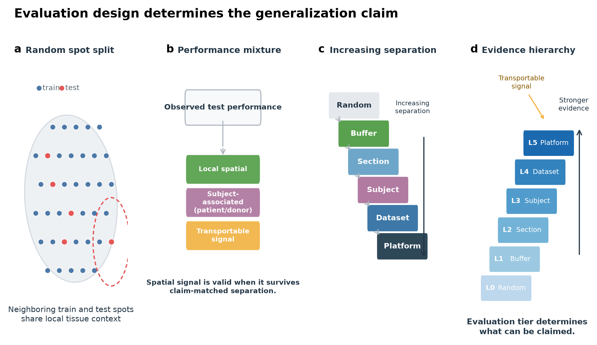
Figure 1. Evaluation design determines the generalization claim. (a) Random spot splitting can place neighboring training and test spots within the same local tissue context. (b) Observed test performance under permissive evaluation may combine local spatial dependence, subject-associated structure and transportable signal. (c) Increasing separation adds spatial buffers, section separation, subject separation (patient or donor), dataset separation and platform separation. (d) The evidence hierarchy links each evaluation tier to the level of generalization it can support; signal retained under stricter tiers provides stronger evidence for transportable signal.
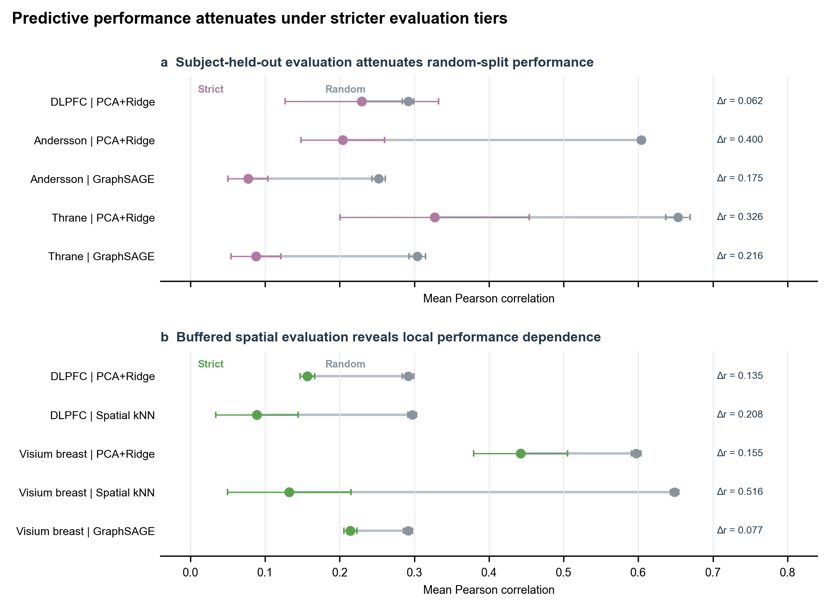
Figure 2. Predictive performance attenuates under stricter evaluation tiers. (a) Subject-associated evaluation compares random spot-level performance with patient- or donor-held-out performance in datasets supporting subject-level separation. (b) Spatial evaluation compares random performance with minimum graph distance ≥5 buffered spatial evaluation in datasets supporting within-section separation. Points indicate mean Pearson correlation across target genes, and connecting lines show the change between random and the corresponding stricter evaluation regime; Δr denotes random minus strict-tier Pearson correlation. Error bars indicate ±1 standard deviation (s.d.); random and spatial-buffer estimates summarize predefined seeds, whereas subject-held-out estimates summarize held-out subject groups as detailed in Source Data. Because dispersion units differ between random seed summaries and subject-held-out group summaries, error-bar widths should not be interpreted as directly comparable measures of sampling uncertainty. Dataset-model combinations with near-zero random performance, for which relative inflation is not interpretable, are excluded from the main display and reported in the Supplementary Information.
The subject-associated datasets showed the clearest random-to-subject losses (Fig. 3). We use subject-associated as the framework-level term for patient- or donor-level grouping, including donor-held-out evaluation in DLPFC and patient-held-out evaluation in tumor datasets. In Andersson, patient RLI was 0.662 for PCA+Ridge and 0.695 for GraphSAGE. In Thrane, patient RLI was 0.499 for PCA+Ridge and 0.711 for GraphSAGE. These results show that graph-based modeling still required grouped evaluation.
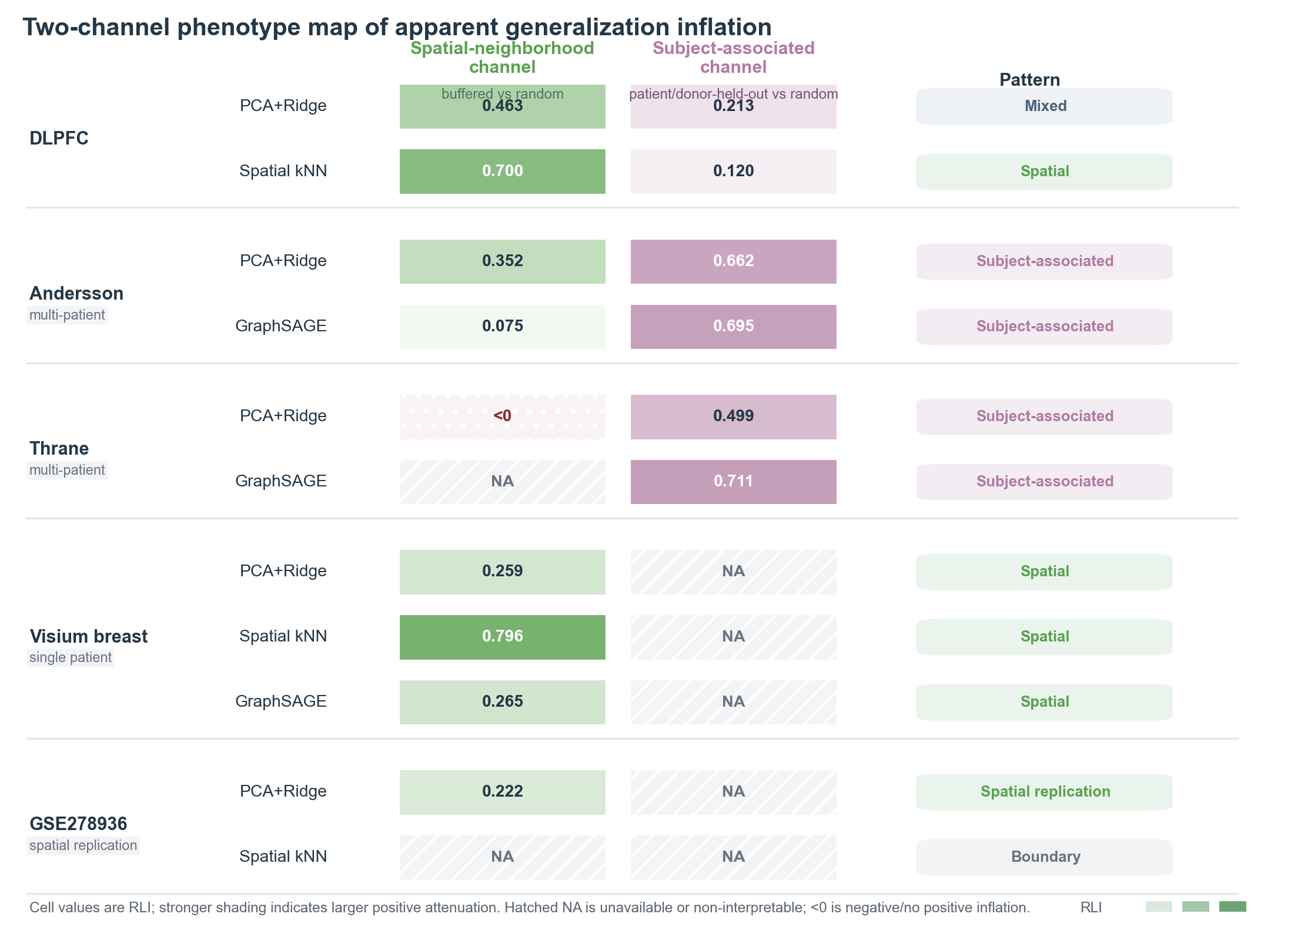
Figure 3. SpatialLeak reveals heterogeneous channels of apparent generalization inflation across datasets and model classes. Rows represent interpretable dataset-model combinations, grouped by dataset. The spatial-neighborhood channel reports relative leakage inflation (RLI) between random and the prespecified hop-buffered spatial evaluation, prioritizing +5-hop where resolvable; exact strict splits are listed in Source Data. The subject-associated channel reports RLI between random and patient- or donor-held-out evaluation. Cell values show RLI, with stronger shading indicating larger positive evaluation-dependent attenuation. <0 denotes a negative RLI and therefore no positive inflation under the corresponding contrast. Hatched NA cells indicate evaluation tiers that were unavailable from the dataset structure or non-interpretable under the prespecified near-zero random-performance rule; NA values are not treated as zero. Descriptive pattern labels summarize the observed profile and do not represent threshold-based classifications.

Non-zero spatial buffers reveal local neighborhood dependence
SpatialLeak next tested whether non-overlapping spatial partitions were sufficient to remove local neighborhood dependence (Fig. 4). In DLPFC and Visium breast, increasing hop distance reduced performance, especially for Spatial kNN. Visium breast showed the strongest spatial-channel example, with Spatial kNN hop5 RLI 0.796.
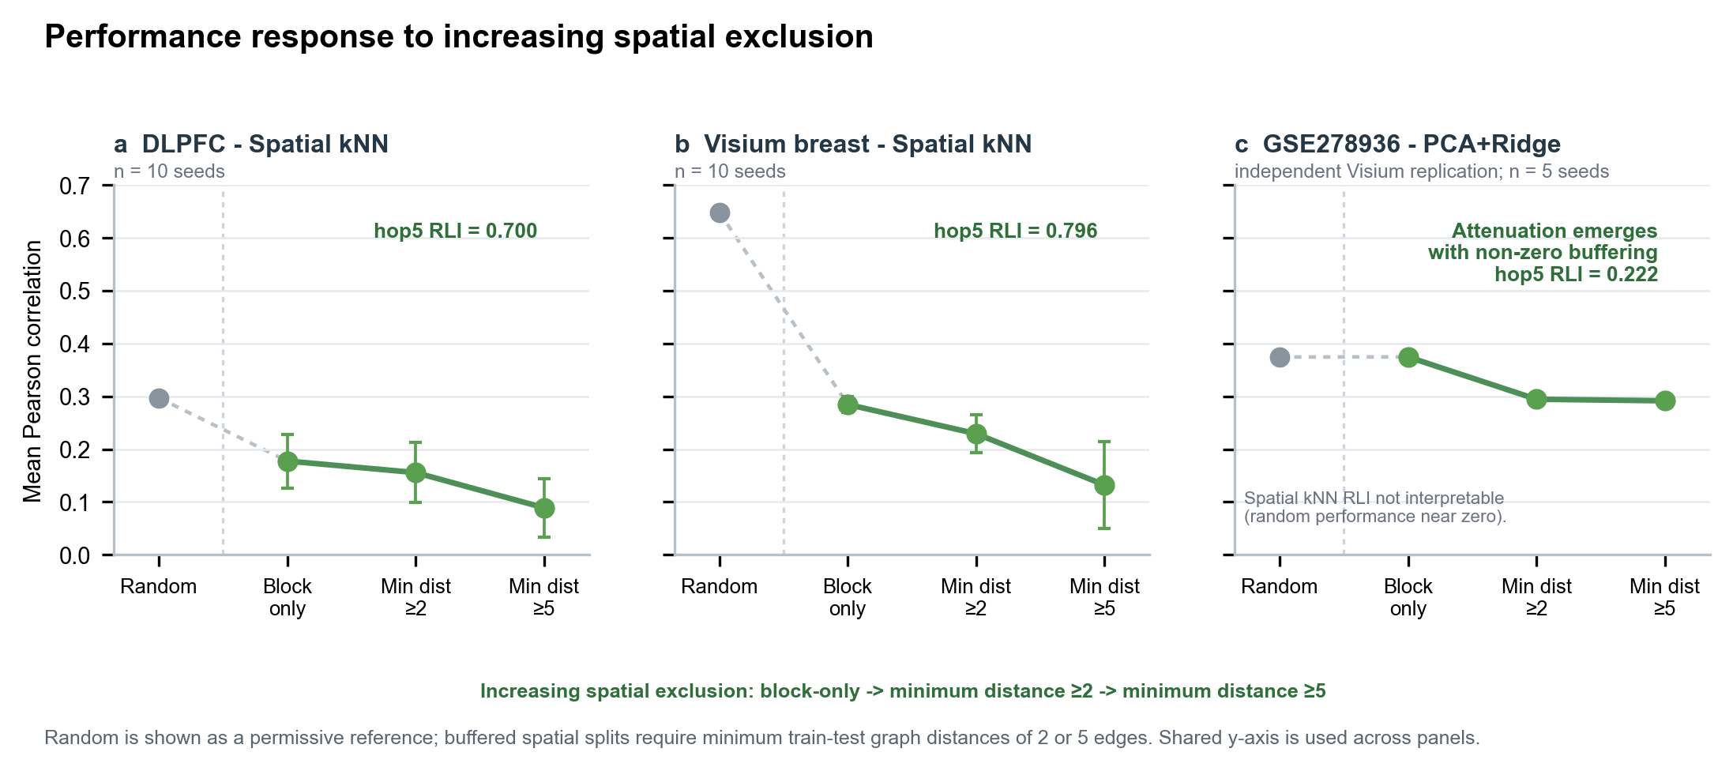
Figure 4. Increasing spatial exclusion reveals dataset-dependent local neighborhood dependence. (a) Spatial kNN performance in DLPFC under random evaluation and increasingly buffered spatial splits. (b) Spatial kNN in dense Visium breast data, showing pronounced attenuation with increasing exclusion distance. (c) PCA+Ridge in the independent GSE278936 Visium cohort, where block-only separation produced little change relative to random evaluation, whereas non-zero graph-distance buffers reduced performance. Points show mean Pearson correlation across target genes; error bars indicate ±1 s.d. across frozen seeds (n = 10 for DLPFC and Visium breast; n = 5 for GSE278936). Random evaluation is shown as a permissive reference. Minimum graph distance ≥2 and ≥5 denote retained test spots whose nearest training spot is at least two or five graph edges away, respectively. Random-size-matched controls are reported in the Supplementary Information.
GSE278936 provided an independent high-density Visium spatial-channel replication. PCA+Ridge changed little under block-only separation (hop0; RLI ≈ 0) but decreased under hop2 and hop5 buffers, reaching hop5 RLI 0.222. This pattern shows that a non-zero exclusion buffer can be required to expose local neighborhood dependence. The random-size-matched control showed that the main spatial-buffer losses were larger than losses caused by downsampling random splits to similar sample sizes.

Subject-held-out evaluation identifies a distinct subject-associated channel
Subject-held-out evaluation measured a different axis of dependence from within-section spatial buffering (Fig. 3). Andersson and Thrane had large patient-held-out losses even when Spatial kNN was near zero or when high-hop spatial curves were not resolvable in lower-density spatial transcriptomics geometry. DLPFC showed a mixed pattern, with both spatial and donor-associated effects.
The subject-associated channel captures dependence linked to patient or donor grouping. It can include subject identity, section background, tissue processing, sample handling, cohort structure and biological heterogeneity. Random spot splits can use this structure even when it is not retained after subject-associated groups are separated.

Dominant generalization-inflation channels vary across datasets and model classes
The two-channel phenotype map shows structured variation in evaluation sensitivity (Fig. 3). DLPFC exhibited mixed spatial and donor-associated attenuation. Andersson and Thrane were subject-associated dominant, while dense Visium breast exposed a strong local spatial channel in a single-patient setting. GSE278936 provided an external spatial-channel replication and a kNN boundary condition, because random kNN performance was below zero.
This two-channel landscape explains why one split or one model cannot diagnose all settings. Spatial kNN is useful as a local-neighborhood probe when it has signal. PCA+Ridge provides a strong non-graph baseline. GraphSAGE tests whether graph learning follows the same split-dependent behavior as simpler baselines.

Apparent model advantage depends on evaluation regime
Model comparisons changed when the evaluation claim changed (Supplementary Fig. 1). Spatial kNN was strong in dense random or local settings but weak when spatial signal was absent or isolated. GraphSAGE retained random-split performance in some settings but showed strong subject-held-out losses in tumor datasets. PCA+Ridge often retained broader transfer signal better than a purely local spatial-neighbor baseline.
These observations argue against using a single random-split leaderboard as evidence of model superiority. A method can be useful for local interpolation but less informative for subject transfer. A model that appears robust under a spatial split may also lose performance under subject-held-out evaluation.

SpatialLeak defines a hierarchy for spatial omics generalization claims
SpatialLeak formalizes six evaluation tiers (Fig. 1). Level 0, random spot interpolation, supports local interpolation. Level 1, buffered spatial transfer, tests local neighborhood separation. Level 2, section-held-out transfer, tests transfer across sections. Level 3, subject-held-out transfer, including patient- or donor-held-out evaluation, tests retention across subject-associated groups. Level 4, dataset-held-out transfer, tests broader dataset transportability. Level 5, cross-platform transfer, tests robustness when measurement platforms also change.
This hierarchy also defines the scope of each dataset-specific claim. Visium breast supports dense Visium spatial and section-level evidence. GSE278936 supports spatial-channel replication. Andersson-to-Visium transfer remains a supplementary cross-platform stress test rather than a central validation result.

Discussion
SpatialLeak shows that apparent performance in spatial omics prediction depends materially on the evaluation design used to define generalization. Across tissues and datasets, replacing random spot-level evaluation with stricter designs attenuated performance through two distinct channels: local spatial-neighborhood dependence and subject-associated structure. This extends recent benchmarking work showing that spatial omics methods rarely have a single evaluation-independent ranking. Large comparative studies of spatial clustering and histology-based spatial gene-expression prediction have found that apparent method superiority varies across accuracy, robustness, generalizability and downstream utility [16,17]. Benchmarks of spatial alignment further show that challenging cross-platform and multi-slice scenarios can change apparent method behavior [18]. SpatialLeak adds a complementary point: the split itself is part of the estimand, because different train-test boundaries test different forms of generalization.
The requirement for a non-zero spatial exclusion buffer highlights the difference between nominal partitioning and effective independence. Assigning neighboring spots to different spatial blocks prevents literal overlap, but it does not remove correlation generated by continuous tissue architecture, spatially structured cell composition or molecular gradients. Spatial autocorrelation can determine the effective information distance between nominally separate training and test observations, beyond its role as a property of the response variable [15]. Contemporary benchmarks increasingly treat spatial continuity and technology-dependent variation as distinct dimensions of performance, instead of assuming that observations are exchangeable [16,19]. This agrees with broader data-splitting work in biology, where similarity-aware partitions reduce leakage that remains under naive random splitting [13]. GSE278936 illustrates this point clearly: hop0 was nearly indistinguishable from random evaluation, whereas positive exclusion distances exposed a stable loss despite random-size-matched controls. A spatial split should be defined by the dependence it removes, not only by whether train and test labels occupy different geometric partitions.
Subject-held-out evaluation exposed a second dependence structure beyond local spatial-neighborhood effects. In Andersson and Thrane, substantial subject-associated losses persisted for both PCA+Ridge and GraphSAGE even when local spatial-neighbor baselines were weak. Within-section proximity was insufficient to explain the observed attenuation. This channel reflects subject-associated context, not a single batch effect. Patient or donor identity can be entangled with tissue composition, disease heterogeneity, section preparation, sequencing characteristics and other technical factors. Multi-site spatial transcriptomics studies have independently shown that platform and processing context can account for major variation, motivating standardized reproducibility metrics across sites and technologies [20]. This interpretation is consistent with broader machine-learning work showing that non-independent grouping between development and evaluation data can produce optimistic estimates when the intended deployment unit is a new biological subject [11,13,14]. Subject-held-out evaluation measures the portability of a predictive relationship across subject-associated contexts; it does not identify which individual source of heterogeneity caused the loss.
Performance that persists after stricter separation is not automatically residual leakage. Spatial organization is an intrinsic component of tissue biology, and conserved anatomical or pathological structures may legitimately support prediction across sections or subjects. The important distinction is between local interpolation and transportable structure, not between models that use spatial information and models that do not. Recent work on spatial prediction similarly indicates that prediction accuracy and generalizability are separate properties: methods that perform strongly within a study may show weaker cross-study or cross-platform transfer [17]. Robust and uncertainty-aware spatial prediction frameworks further show that nominally accurate predictions can differ in reliability for downstream inference [21,22]. We view the SpatialLeak hierarchy as an extrapolation ladder. Retention under progressively broader separation tiers provides progressively stronger evidence that a learned relationship reflects transportable structure. Strict-split loss can also include legitimate distribution shift, so RLI should be interpreted as evaluation-dependent inflation rather than as the causal fraction of performance attributable to leakage [13,17].
The dependence of apparent model advantage on evaluation regime has implications for how spatial omics leaderboards are interpreted. In our analyses, models that benefited strongly from local neighborhoods under random evaluation often lost that advantage under subject- or spatially isolated testing. This is consistent with independent spatial omics benchmarks in which no method dominates all evaluation criteria. Spatial clustering algorithms show complementary performance across accuracy, continuity and robustness [16], and histology-to-expression prediction methods can rank differently for within-study accuracy, cross-study generalizability and translational utility [17]. A recent benchmark of spatial alignment methods likewise found that performance is scenario-dependent, with challenging cross-platform or multi-slice settings exposing limitations missed by conventional evaluations [18]. A leaderboard without an explicit generalization regime is underspecified. Spatial omics studies should specify whether model superiority refers to local interpolation, subject transfer, dataset transfer or platform transportability.
These findings support a shift from single-split benchmarking toward tiered reporting standards for spatial omics. Recent spatial transcriptomics benchmark initiatives have called for standardized performance metrics, reference tissues and reproducible workflows because platform resolution, molecular capture, sequencing depth and other technical characteristics can materially alter analytical conclusions [19]. Multi-site imaging-based spatial studies further demonstrate the importance of harmonized procedures and standardized reproducibility metrics when results are compared across laboratories or platforms [20]. Contemporary method benchmarks increasingly include robustness, usability and challenging cross-platform scenarios instead of relying on a single internal accuracy measure [18]. For predictive modeling, authors should report at minimum the biological grouping unit, exact spatial exclusion rule, patient or donor separation where relevant, uncertainty at the biological-unit level, strong non-spatial and spatial diagnostic baselines, and machine-readable split manifests. Similarity-aware split descriptions are especially important when nominally separate observations remain biologically or technically related [13]. This would make explicit which claim each reported performance estimate can support, without requiring a universal split for all studies.
Several limitations define the scope of this framework and motivate the next generation of spatial omics benchmarks. First, our model set was deliberately diagnostic rather than exhaustive; the study was designed to identify evaluation-sensitive behavior rather than establish a new state-of-the-art leaderboard. Second, public datasets differ in tissue composition, platform density and sample structure. Visium breast contains a single patient, whereas the public GSE278936 cohort contains one section per patient, preventing clean decomposition of patient and section effects. Future evaluations would benefit from multi-patient, multi-section and multi-site reference resources of the kind now emerging for spatial omics reproducibility studies [20]. Third, our main task focused on gene-expression prediction. Evaluation dependence should also be tested in multimodal translation, spatial domain inference, alignment and representation learning, where recent methods and benchmarks already show strong scenario-specific behavior [10,18,22]. Finally, point performance alone does not capture the reliability of predicted spatial quantities. Future leakage-resistant benchmarks should integrate uncertainty calibration and downstream inference alongside predictive accuracy metrics [21]. These limitations constrain the breadth of our conclusions, but they also define a path toward benchmark designs that distinguish interpolation, biological transportability and out-of-domain transfer.

Methods

Datasets
SpatialLeak used public spatial transcriptomics datasets covering human dorsolateral prefrontal cortex (DLPFC), HER2-positive breast cancer, cutaneous malignant melanoma, two public 10x Visium breast cancer sections and GSE278936 prostate Visium data [23,24,25,26,27,28,29]. Restricted EGA validation data from the prostate study were not used. Dataset roles were defined by public sample structure: Visium breast contained one patient and two sections, and GSE278936 was used only as a spatial-channel replication dataset because the public release contains one section per patient.

Preprocessing
Each section or sample was library-size normalized with normalize_total(target_sum = 10,000) and transformed with log1p using Scanpy [30]. The target panel was then defined as described below. Up to 2,000 highly variable genes (HVGs) were selected once during dataset preprocessing with the Scanpy Seurat-flavor HVG procedure after excluding target genes; 2,000 predictors were used whenever available. This predictor set was frozen before split-specific model fitting rather than reselected within each split. HVG selection was treated as a fixed, unsupervised dataset-level feature-definition step and did not use downstream model performance, labels or evaluation-tier outcomes. Slide or section identifiers and patient or donor metadata were retained where available. Spatial coordinates were standardized within slide for model input while preserving within-slide geometry for split construction.

Target panels
Dataset-specific panels used the top 50 Moran-ranked genes after normalization and log transformation. Moran ranking was computed on the normalized and log-transformed expression matrix before predictor-gene selection to define the prediction task, not to tune models or select results. Shared-panel analyses used the frozen shared_panel_50 target set. Target selection was independent of downstream model performance and fixed across evaluation regimes.

Split construction
Random spot splits used an 80/10/10 train/validation/test partition. Matched spatial block splits assigned 3 × 3 grid blocks within each section to train, validation or test folds. Balanced assignments were selected from 300 random candidates per seed using spot count, library size, Moran signal and layer composition where available. matched_hop0 denotes block-only separation: non-overlapping block assignment without a positive exclusion buffer. Hop2 and hop5 splits required each retained test spot to have a nearest-training shortest-path distance of at least two or five edges, respectively, on a within-slide spatial kNN graph with k = 15. Equivalently, test spots with nearest-training graph distance below two or five edges were removed. These splits are denoted matched_hop2 and matched_hop5, or +2-hop and +5-hop buffers. Subject-held-out splits held out all sections from a patient or donor where available. Validation sections were selected from the remaining training patients or donors, rather than from the held-out test subject. Section-held-out (slide-held-out) splits held out sections but were not treated as subject-held-out unless patient or donor identity was also separated.
Dataset- and platform-level evaluation was used only as a supplementary stress test. In the Andersson-to-Visium comparison, PCA+Ridge was trained on Andersson HER2-positive breast cancer spatial transcriptomics data and evaluated on 10x Visium breast data using the shared target-gene intersection. The model used 49 of the 50 shared-panel targets because SEPT4 was absent from the cross-dataset target-gene intersection; it also used 2,000 common predictor features. Preprocessing and target-panel definitions were frozen before model fitting. PCA and Ridge parameters were fitted on the training dataset only and then applied to the held-out Visium dataset without refitting on test observations. Spatial kNN was excluded because spatial coordinates are not comparable across platforms. This analysis was reported as a dataset-held-out/cross-platform stress test rather than as central validation.

Spatial graph construction
Spatial graphs were built within slides only. kNN edges were calculated from spatial coordinates, preventing cross-slide graph connections. GraphSAGE performed message passing over within-slide graph neighborhoods but never aggregated test labels [31].

Models
Principal component analysis plus Ridge regression (PCA+Ridge) used up to 2,000 predictor genes, with 2,000 used whenever available, excluding the 50 target genes. Principal component analysis (PCA) used 64 components and was fit only on training observations. Ridge regression used alpha = 1.0 and was fit separately for each target gene. Spatial k-nearest-neighbour (Spatial kNN) used k = 15 nearest training spots in normalized per-slide coordinates. Predictions used inverse-distance weights 1/(d + 10⁻⁶), normalized to sum to one for each test spot. Neighbors were drawn only from the training split; when fewer than 15 training spots were available, all available training spots were used. GraphSAGE used train-only PCA and train-only feature scaling. It used two GraphSAGE layers with a hidden dimension of 128 in all reported analyses, within-slide graph k = 10 with self-loops, ReLU activation, no dropout and mean-squared-error loss on training nodes. Optimization used Adam with learning rate 10⁻³ and weight decay 10⁻⁴ for up to 500 epochs, with validation-loss early stopping after patience 60 and validation-loss checkpoint selection. The kNN graph used for split construction (k = 15) was distinct from the GraphSAGE message-passing graph (k = 10). Test performance was not used for checkpoint selection.

Metrics and inference
The primary metric was mean Pearson correlation across target genes. Leakage inflation was defined as random performance minus strict-tier performance. Relative leakage inflation (RLI) was defined as the random-minus-strict performance difference divided by random performance, and retention was defined as strict-tier performance divided by random performance. RLI is an operational measure of evaluation-dependent performance inflation and is not interpreted as the fraction of performance causally attributable to leakage. RLI was not interpreted when absolute random mean Pearson was below 0.05. Main DLPFC, Andersson, Thrane and Visium breast baseline analyses used seeds 0–9; GSE278936 spatial-channel replication used seeds 0–4. Random-size-matched controls downsampled the random split to comparable sample sizes without using strict-split performance. Bootstrap summaries used slide-level resampling with 1000 bootstrap replicates where available. Wilcoxon signed-rank tests used paired seed summaries with Benjamini-Hochberg false-discovery-rate correction within comparison families. Mixed-effects models included Moran's I and model class as fixed effects and dataset as a random intercept.

Reproducibility
Seeds were frozen before final analyses. Test performance was not used for hyperparameter selection, checkpoint selection, target-panel selection or seed selection. Scripts for regenerating frozen paper assets and unit tests for core split and evaluation functions are provided with the accompanying code repository.

Data Availability
DLPFC, Andersson, Thrane, the two public 10x Visium breast sections and GSE278936 public data were used from the public resources cited above. Restricted EGA validation data from the prostate study were not used. Project-derived split manifests, source-data files, analysis scripts and paper assets are available at https://github.com/seefreewind/spatialleak and archived at https://doi.org/10.5281/zenodo.21881438.

Code Availability
Code for preprocessing, target-panel definition, split generation, benchmarking, statistical analysis, figure generation and source-data generation is available at https://github.com/seefreewind/spatialleak (v1.0.0) and archived at https://doi.org/10.5281/zenodo.21881438.

Author Contributions
Yu Zhang: Conceptualization, methodology, software, formal analysis, visualization, data curation and writing of the original draft. Ying Chen: Data curation, preprocessing review, result checking and manuscript review. Yue Liu: Source-data preparation, reproducibility checks and manuscript review. Da Lin: Supervision, conceptualization, interpretation, correspondence and manuscript review.

Funding
No specific funding was received for this work.

Competing Interests
The authors declare no competing interests.

References
1. Ståhl, P.L. et al. Visualization and analysis of gene expression in tissue sections by spatial transcriptomics. Science 353, 78-82 (2016). https://doi.org/10.1126/science.aaf2403
2. Abdelaal, T., Mourragui, S., Mahfouz, A. & Reinders, M.J.T. SpaGE: Spatial Gene Enhancement using scRNA-seq. Nucleic Acids Res. 48, e107 (2020). https://doi.org/10.1093/nar/gkaa740
3. Biancalani, T. et al. Deep learning and alignment of spatially resolved single-cell transcriptomes with Tangram. Nat. Methods 18, 1352-1362 (2021). https://doi.org/10.1038/s41592-021-01264-7
4. Chen, S., Zhang, B., Chen, X., Zhang, X. & Jiang, R. stPlus: a reference-based method for the accurate enhancement of spatial transcriptomics. Bioinformatics 37, i299–i307 (2021). https://doi.org/10.1093/bioinformatics/btab298
5. Long, Y. et al. Spatially informed clustering, integration, and deconvolution of spatial transcriptomics with GraphST. Nat. Commun. 14, 1155 (2023). https://doi.org/10.1038/s41467-023-36796-3
6. Dong, K. & Zhang, S. Deciphering spatial domains from spatially resolved transcriptomics with an adaptive graph attention auto-encoder. Nat. Commun. 13, 1739 (2022). https://doi.org/10.1038/s41467-022-29439-6
7. Hu, J. et al. SpaGCN: Integrating gene expression, spatial location and histology to identify spatial domains and spatially variable genes by graph convolutional network. Nat. Methods 18, 1342-1351 (2021). https://doi.org/10.1038/s41592-021-01255-8
8. He, B. et al. Integrating spatial gene expression and breast tumour morphology via deep learning. Nat. Biomed. Eng. 4, 827-834 (2020). https://doi.org/10.1038/s41551-020-0578-x
9. Xu, H. et al. Unsupervised spatially embedded deep representation of spatial transcriptomics. Genome Med. 16, 12 (2024). https://doi.org/10.1186/s13073-024-01283-x
10. Chen, W. et al. A visual–omics foundation model to bridge histopathology with spatial transcriptomics. Nat. Methods 22, 1568-1582 (2025). https://doi.org/10.1038/s41592-025-02707-1
11. Kapoor, S. & Narayanan, A. Leakage and the reproducibility crisis in machine-learning-based science. Patterns 4, 100804 (2023). https://doi.org/10.1016/j.patter.2023.100804
12. Kaufman, S., Rosset, S., Perlich, C. & Stitelman, O. Leakage in data mining. ACM Trans. Knowl. Discov. Data 6, 1-21 (2012). https://doi.org/10.1145/2382577.2382579
13. Joeres, R., Blumenthal, D.B. & Kalinina, O.V. Data splitting to avoid information leakage with DataSAIL. Nat. Commun. 16, 3337 (2025). https://doi.org/10.1038/s41467-025-58606-8
14. Rosenblatt, M., Tejavibulya, L., Jiang, R., Noble, S. & Scheinost, D. Data leakage inflates prediction performance in connectome-based machine learning models. Nat. Commun. 15, 1829 (2024). https://doi.org/10.1038/s41467-024-46150-w
15. Moran, P.A.P. Notes on continuous stochastic phenomena. Biometrika 37, 17–23 (1950). https://doi.org/10.1093/biomet/37.1-2.17
16. Yuan, Z. et al. Benchmarking spatial clustering methods with spatially resolved transcriptomics data. Nat. Methods 21, 712-722 (2024). https://doi.org/10.1038/s41592-024-02215-8
17. Wang, C. et al. Benchmarking the translational potential of spatial gene expression prediction from histology. Nat. Commun. 16, 1544 (2025). https://doi.org/10.1038/s41467-025-56618-y
18. Yan, Y. et al. Benchmarking alignment methods for spatial transcriptomics data. Nat. Comput. Sci. 6, 524-541 (2026). https://doi.org/10.1038/s43588-026-00977-z
19. You, Y. et al. Systematic comparison of sequencing-based spatial transcriptomic methods. Nat. Methods 21, 1743-1754 (2024). https://doi.org/10.1038/s41592-024-02325-3
20. Plummer, J.T. et al. Standardized metrics for assessment and reproducibility of imaging-based spatial transcriptomics datasets. Nat. Biotechnol. 44, 1213-1225 (2026). https://doi.org/10.1038/s41587-025-02811-9
21. Sun, E.D., Ma, R., Navarro Negredo, P., Brunet, A. & Zou, J. TISSUE: uncertainty-calibrated prediction of single-cell spatial transcriptomics improves downstream analyses. Nat. Methods 21, 444-454 (2024). https://doi.org/10.1038/s41592-024-02184-y
22. Tan, X. et al. Robust and interpretable prediction of gene markers and cell types from spatial transcriptomics data. Nat. Commun. 17, 1781 (2026). https://doi.org/10.1038/s41467-026-68487-0
23. Maynard, K.R. et al. Transcriptome-scale spatial gene expression in the human dorsolateral prefrontal cortex. Nat. Neurosci. 24, 425-436 (2021). https://doi.org/10.1038/s41593-020-00787-0
24. Andersson, A. et al. Spatial deconvolution of HER2-positive breast cancer delineates tumor-associated cell type interactions. Nat. Commun. 12, 6012 (2021). https://doi.org/10.1038/s41467-021-26271-2
25. Andersson, A. et al. Spatial deconvolution of HER2-positive breast cancer delineates tumor-associated cell type interactions: dataset record. Zenodo (2021). https://doi.org/10.5281/zenodo.4751624
26. Thrane, K., Eriksson, H., Maaskola, J., Hansson, J. & Lundeberg, J. Spatially Resolved Transcriptomics Enables Dissection of Genetic Heterogeneity in Stage III Cutaneous Malignant Melanoma. Cancer Res. 78, 5970-5979 (2018). https://doi.org/10.1158/0008-5472.CAN-18-0747
27. 10x Genomics. Human Breast Cancer (Block A Section 1): Spatial Gene Expression dataset. 10x Genomics dataset, version 1.0.0, Block A Section 1; Accessed 2026-08-10. https://www.10xgenomics.com/datasets/human-breast-cancer-block-a-section-1-1-standard-1-0-0 (2020).
28. 10x Genomics. Human Breast Cancer (Block A Section 2): Spatial Gene Expression dataset. 10x Genomics dataset, version 1.1.0, Block A Section 2; Accessed 2026-08-11. https://www.10xgenomics.com/datasets/human-breast-cancer-block-a-section-2-1-standard-1-1-0 (2020).
29. Kiviaho, A. et al. Single cell and spatial transcriptomics highlight the interaction of club-like cells with immunosuppressive myeloid cells in prostate cancer. Nat. Commun. 15, 9949 (2024). https://doi.org/10.1038/s41467-024-54364-1
30. Wolf, F.A., Angerer, P. & Theis, F.J. SCANPY: large-scale single-cell gene expression data analysis. Genome Biol. 19, 15 (2018). https://doi.org/10.1186/s13059-017-1382-0
31. Hamilton, W.L., Ying, R. & Leskovec, J. Inductive representation learning on large graphs. In Advances in Neural Information Processing Systems 30, 1024-1034 (2017).

