Snowsql error

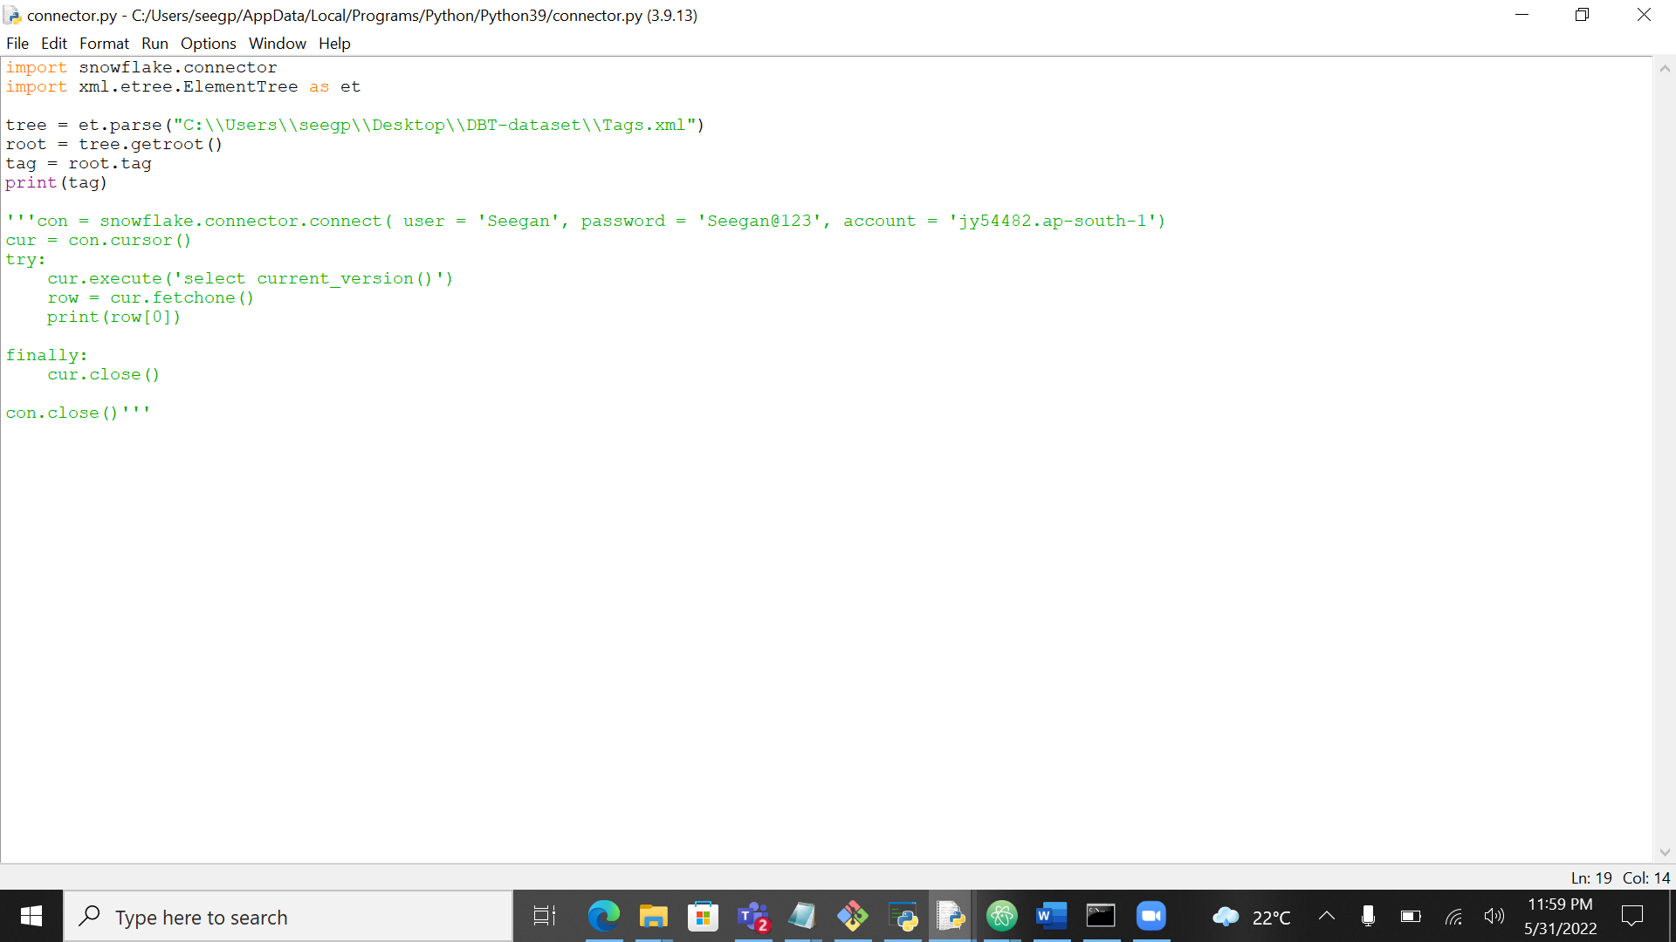

In python I was not able to read the attributes of xml

Manual method

Output:

Top 10 Badges

Print the text of questions asked by user whose display name contains the string nau

