PLEASE READ TOP INSTRUCTIONS BEFORE OPENING ANYTHING

Notes:
- The items in the bag are arranged for easy identification and assembly.
- Only open one pocket at a time, starting from the end where the arrow is pointing.
- Solder the components onto the bottom of the PCB first. They are arranged so the board will stay flat and steady with everything soldered.
- Flux is your friend. If there are still flux pins around, please use them.
- I will be hanging out in the HHV a lot of the time, so if you have questions feel free to ask, and I will have some extra components if something gets lost or damaged. Please note, however, that I will not solder your board for you. If something gets messed up I will show you how to fix it on a different board, but you are here to learn how to solder, so you will have to fix your own mistakes. I would also encourage you to practice soldering components onto the practice boards that should be floating around.

How to solder SMT components for noobs:
- Hit every golden pad with a flux pin. You are not painting the Mona Lisa, so just hit each pad real quick and move onto the next one. The whole board should only take about a minute to flux up. Seriously, this is not an art project.
- Put a small amount of solder onto the pad by putting a small amount onto your iron and touching the pad. You do not need complete coverage of the pad.
- Place component in desired location. Make sure it is somewhat well aligned, and hold it in plate by putting some pressure on the top with tweezers or a fingernail.
- Touch the pad you already soldered with your iron so the component partially solders.
  - This will not be a good solder as it only needs to keep the component from falling off. This is fine, don’t try to fix it unless the component is not actually soldered.
- Make a proper solder joint on the undersold pad.
- Fix the solder joint on the previous pad. Note: this might need more flux.
  - For components with multiple legs, do a single pad as in steps 2-4 making sure component is in perfect alignment.
  - Properly solder pad in opposite corner.
  - Solder rest of pads.

- To fix a solder bridge:
  - Flux up affected area.
  - Clean off iron
  - Touch iron to affected area and drag outward to suck up excess solder. May need to be done multiple times.
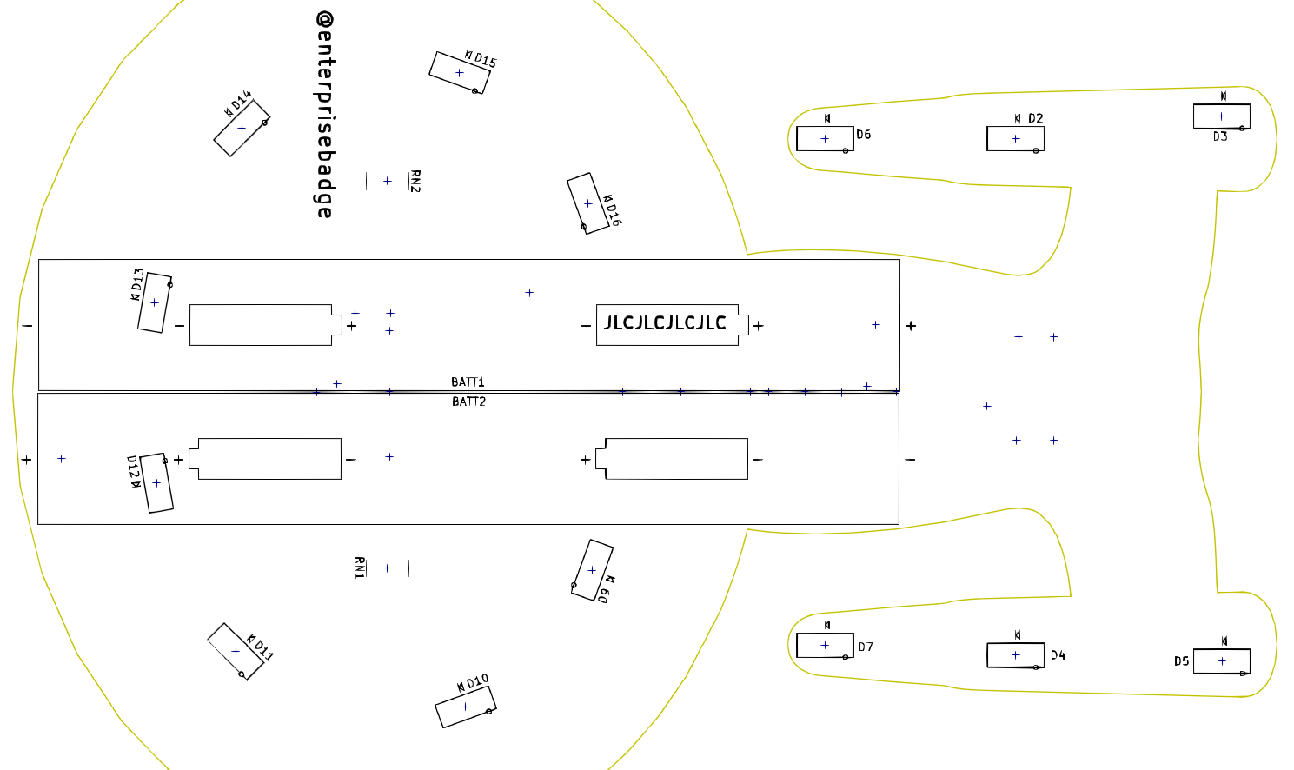
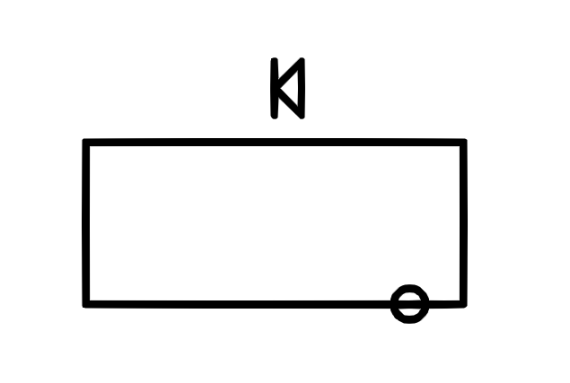
Note: These two LEDs are facing backwards.
Blue
Orange
Orange
Orange
Orange
Orange
Orange
Orange
Orange
Red
Red
Blue
LED polarity:

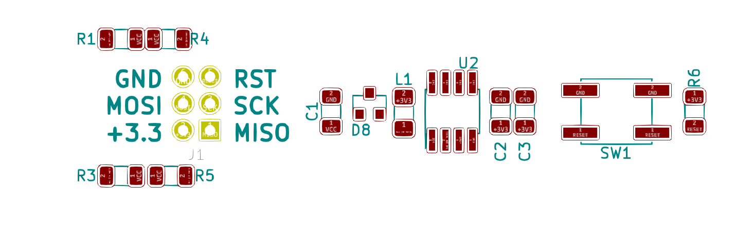
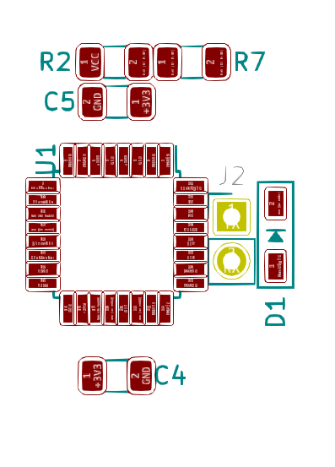
Pin 1
Note circle
0

Pin 1
ATMEL

