DC 404 Solder Training Badge
All source files can be found at https://github.com/seeigecannon/DC404TrainingBadge
Safety Notes:

Soldering irons are hot. Try not to touch them. It is best to never hand an iron directly to somebody else, but to instead place the iron back into the holder and have them pick it up from there.
Solder may contain lead. After soldering something wash your hands.

Tutorial I made for this badge | oneTesla’s Soldering Tutorial for Beginners: Five Easy Steps | Great Scott!’s How to Solder Properly
 |  | 

I have a personal request for people who are still at the con:
There are going to be many of these badges available for people to acquire and these are time consuming to assemble even for professionals. I request that before you sit down and start on this kit you see how many other people are also working on this kit. If many seats are taken please come back later so people working on other projects can have time working. Thanks
If you have any questions I should be hanging around the HHV for a good chunk of the con. I can also be reached on twitter @enterprisebadge.


Forward: If you are new at soldering the first several components you put down are going to be terrible. This is expected and there is no problem with that. This circuit is designed in such a way that you will get plenty of practice in before getting to the important components. This badge is designed for you to screw up so when you work on more interesting badges you will have better success.
And remember:

Instructions:
Please read through this whole sheet before you start removing pieces to work on the badge. If you want to see examples of the instructions below look up “How to solder” on YouTube.
Order of operations (more detailed instructions below)
- Don’t open small bag until you are ready for the LEDs
- The first components you should install are the ones inside of the PRACTICE AREA. These are completely non-functional.
- Solder the thru-hole (THT) resistors in the middle of the badge. These are colored Red, Black, Red, Gold (2kOhm).
- Solder the surface-mount(SMD) resistors above the now finished THT area
- Solder the SMD LEDs above the SMD resistors.
  - Note: LEDs are polarized. This means that they will only work in one orientation. Pay attention to this mark and ensure the mark is pointing towards the polarity arrow
  - There are up to 4 colors of LED. Place the colors however you want.
- Once the LEDs are installed move on to the Integrated Circuits (ICs)
  - Note: ICs are also polarized. Ensure the PIN 1 line is facing the POLARITY MARK
- Solder in the remaining two THT resistors and blue capacitors near the ICs (Note: these are different than the 36 resistors that you soldered in the lines). These are color coded Brown, Black, Orange, Gold (10kOhm).
- Test the board by holding the battery holders in place with the batteries installed. If all LEDs are blinking then remove the batteries and solder the holders down
  - Note: these holders have a high thermal mass. This means it will take longer to heat the component up to the point it will take solder. This is expected.
- Solder the pin on the back last
- Clean up your area so the next person can use it

THT resistor | SMD Resistor | LED | IC (with polarity line) | THT Capacitor
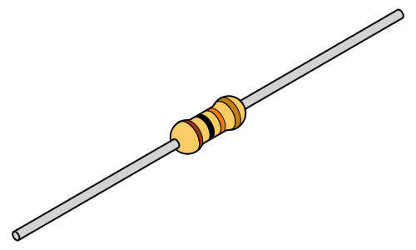 | 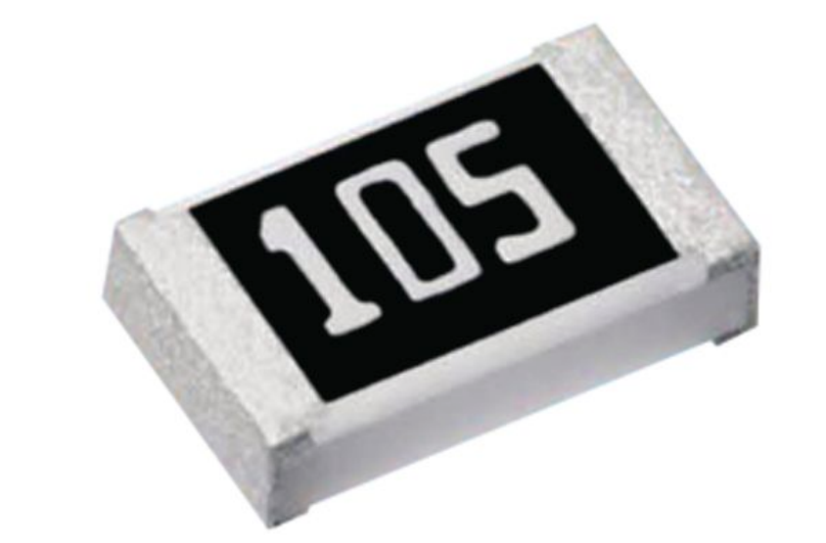 | 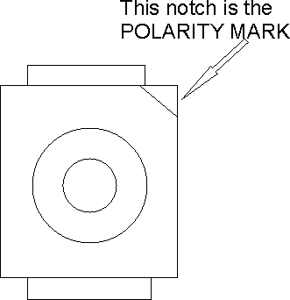 | 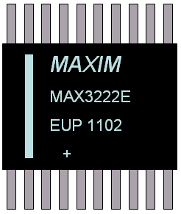 | 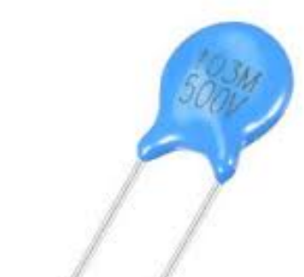
How to Solder:
- General Notes
  - If the iron you are using has temperature control you will want it set to 600-650F for leaded solder and 650-700F for lead-free

  - You will want to start with a clean tip (should be somewhat shiny) with a small amount of solder on it (about ½ a grain of rice worth). This ensures good thermal contact to the components
  - Don’t put a large amount of solder on the tip and then try to get it on the component. As you are melting the solder you will see smoke coming off. This is flux and it is only effective at cleaning the joint the moment it turns into smoke, so keep it at the component where it is effective.
  - If you have access to flux please use it. You can never have too much flux on your joint.
  - As you are soldering remember, HEAT-SOLDER-SOLDER-HEAT.
    - Apply heat; Apply solder; Remove solder; Remove heat
  - Apply solder to the leg/pad of the component and not to the iron when applying solder
- THT resistors
  - Installation:
    - Pinch the body of the component between two fingers and slide your fingers to bend the legs as they exit the resistor.
    - Place the component in the board (I recommend one at a time for the first few, then one row at a time)
    - Once installed, bend the legs out a bit to keep them in place
  - You will want to touch the iron to both the pad and the component to get them hot at the same time
  - Ideally the solder joint will look like a Hershey’s Kiss when you are done.
    - If the joint looks bad try adding more flux and put the iron back on the joint
  - Use side cutters to cut the legs off fairly close to the board. The sharp points can be dulled by adding flux and re-heating with the iron
- SMD resistors
  - Place a very small amount of solder on one pad before adding component
  - Place component on footprint and hold it in place with a fingernail or tweezers or something
  - Reheat the pad you placed the solder on. You should feel the component flatten to the board
  - Add solder to the other side of the component
  - Touch up the first side of the component
- ICs
  - Place a small amount of solder on a corner pad
  - Paying attention to the polarity dots, place the component on the footprint and keep it as aligned as you can while keeping pressure on the component to keep it from moving
  - Heat the leg with the pad with the solder
  - Ensure chip is properly aligned and solder the opposite corner down
  - Add flux to all legs/pads and solder the rest of the legs down
- Back Pin
  - This is hard to solder down
  - Add flux all along the pad and the pin
  - Place pin down and apply heat right next to the center hole
  - Touch the center hole every now and then with solder to see if its hot enough to allow solder to flow in
    - Once solder does flow in add a fair bit, but you don’t need to get it on the top of the component
  - Add more solder to the other two holes in the pin, these should go much faster

Troubleshooting:
- Some LEDs don’t turn on
  - Check the direction of the LED (is the notch facing the polarity mark?)
  - Check all of the resistors inline with the LED and make sure they have a good connection
  - Check legs of the U2 IC to make sure they look good
- No LEDs turn on
  - Check the polarity and legs of the U1 and U2 ICs to make sure they all look good
  - Check the direction of the LED (is the notch facing the polarity mark?)
- Bridge (multiple pads are soldered together)
  - Add flux to joint and drag solder away with a clean iron. If this doesn’t work after a couple of tries use Solder Wick to remove excess solder

