Beginner soldering level

The document describes in easy to read format, steps to correctly solder the garagedoor circuit. See <http://seeimadeit.wordpress.com>

Table of Contents

About the board 2

Tools required 3

Optionally 3

The Build 4

Crystal 4

Resistors 4

Diodes 6

Cleanup – time for a break 6

Capacitors 7

Transistor 7

LED – turn on the lights 9

Buttons – human interface 9

Chip and sockets 10

Headers 10

Power Jack 11

Relay 11

Terminal block – interface to the external world 11

Finished - What it should look like 12

# About the board

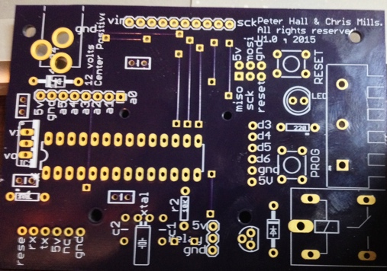This is the side to place the components.

Figure 1 Component Side

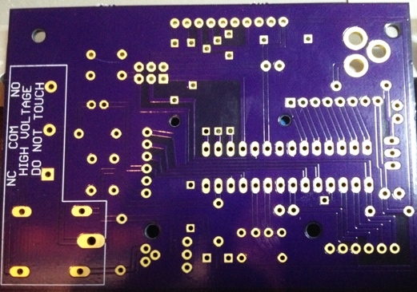This is where we will solder the components to the board

Figure 2 Solder Side

1. Crystal (1)
2. 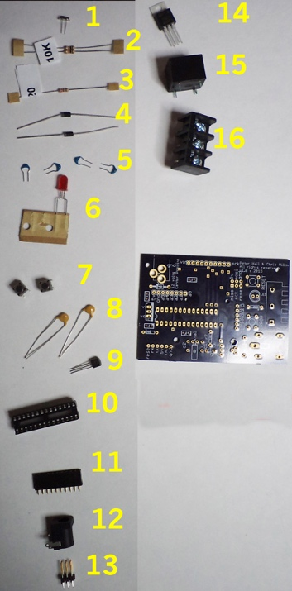10K resistor (2)
3. 220 resistor (1)
4. 1n4004 diode (2)
5. 0.33uF Cap (4)
6. 5mm LED (1)
7. micro switch (2)
8. 20pF Cap (2)
9. NPN BJT (1)
10. IC Socket (1)
11. 10 pin header (1)
12. Power Jack (1)
13. 6 pin header (1)
14. 5V regulator (1)
15. relay (1)
16. terminal block (1)

Figure 3 Solder component sequence

# Tools required

Soldering iron with a reasonable size chisel type tip, recommended 2mm to 3mm wide, a conical type tip will not work well.

Solder – 0.5mm or less diameter, rosin core solder

Side cutters

## Optionally

solder wick (to clean up your mess)

rosin flux – if you find the solder doesn’t want to flow easy

sticky tape – to hold components in place

third hand device – to hold the circuit board while you solder

Headband magnifier – if your eyes aren’t the best

Rubbing alcohol & tooth brush – to clean off rosin

Pliers – to bend component legs

# The Build

## Crystal

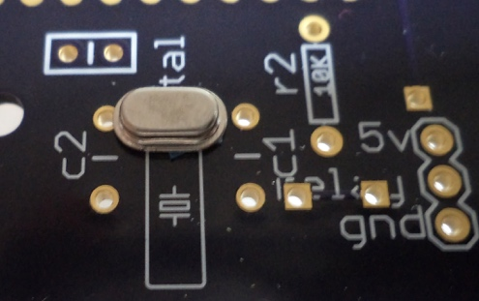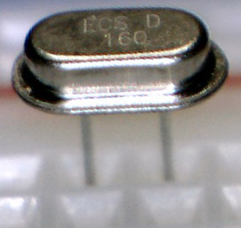Start by inserting the crystal, it’s the smallest part of the circuit. Its best to work from smallest component to largest component, because larger components can get in the way. This crystal is very small and the pins are easy to break off. The circuit legend is actually showing a watch style crystal. It also has the word “xtal”.

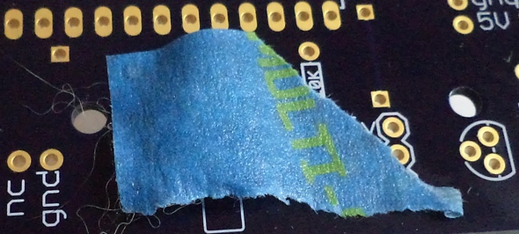

To hold the component in place I used tape to hold it whilst I flipped it over to solder. I also find chewing gum works in some cases.

## Resistors

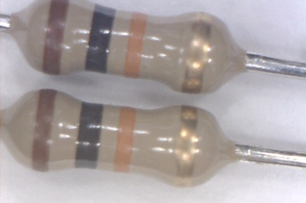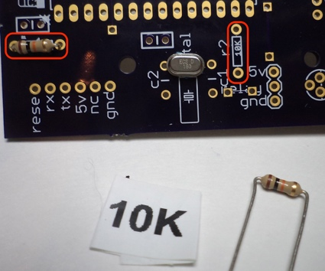Insert the 2 10K resistors. Bend the pins over to fit the holes. The image shows the 2 locations in red.

Note the color of the resistors (google a resistor color code to understand the colors).

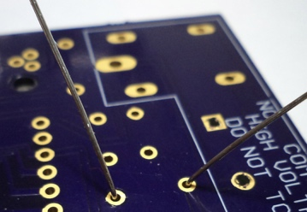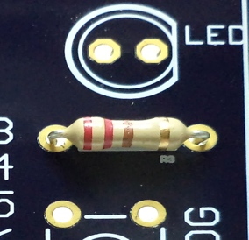

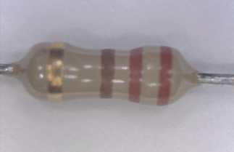Insert the single 220 resistor, again bend the pins over to fit the holes.

You can also bend the pins on the solder side to hold the component in place.

## Diodes

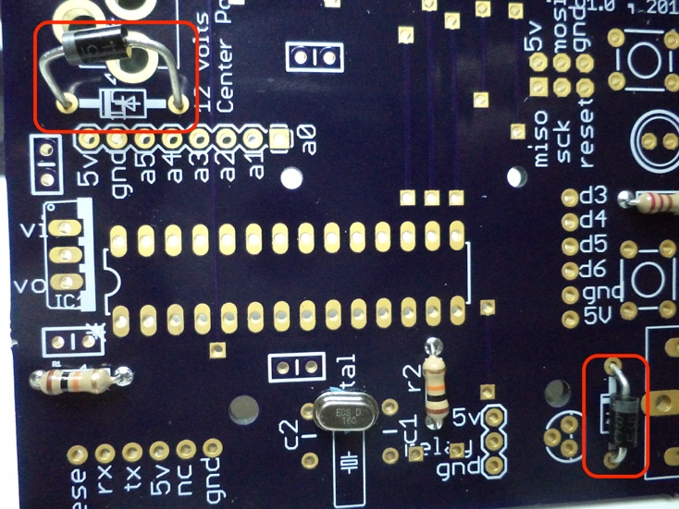

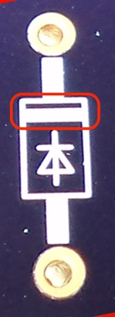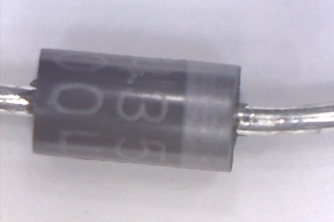There are 2 diodes in the circuit. They are outlined in red. Note this component needs to be oriented correctly to work. Look at the circuit symbol there is a white bar highlighted in red. This represents the same on the component.

## Cleanup – time for a break

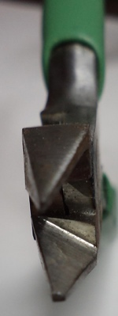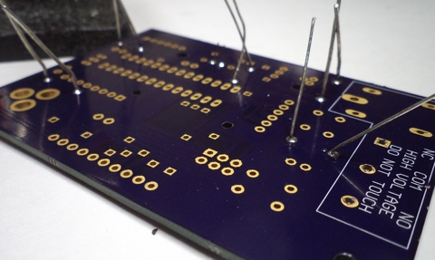Time for cleanup, the solder side is requiring a trim. You want to remove the legs nice and tight against the board. Ideally you want to cut the legs just above the solder.

Use some sharp side cutters. The cutters will allow you to get close to the board. Notice the cutters are almost flat on one side.

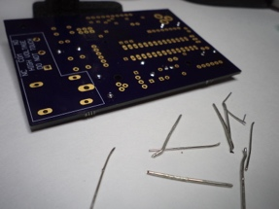

## Capacitors

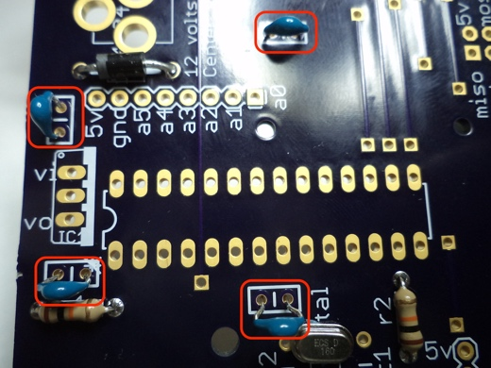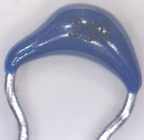These small capacitors are 0.33uF (micro Farad), they are so small I can’t read the label on them.

There are 4 on the circuit, the 2 on the left of the picture are used to stabilize the linear regulator. The other 2 are used to decouple the micro controller. These capacitors are not the the ideal type to use for the regulator, but it was a choice to reuse components that are already used for the circuit, therefore saving a small amount of money. Making decisions like that can help keep the costs down on a product.

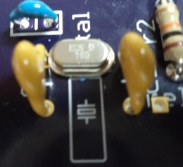

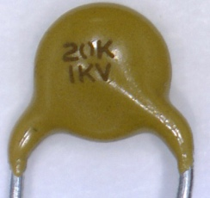2 capacitors are used to ‘load’ the crystal, without them the crystal will not work. These capacitors are 20pF (pico Farad).

## Transistor

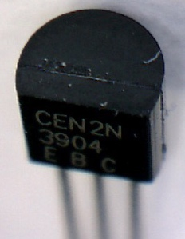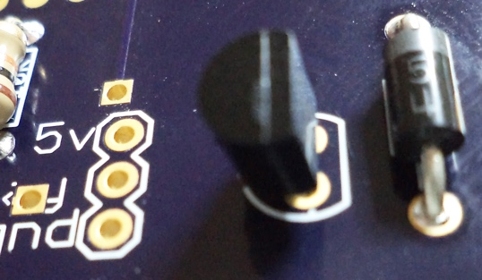A single transistor is used on this circuit as a switch, the microcontroller will toggle the transistor on and off. We do this to protect the microcontroller from excessive current draw, which would damage the microcontroller.

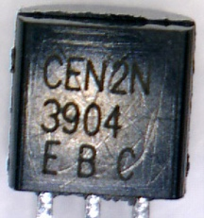Notice the shape of the transistor and the symbol on the circuit board. The component has 3 pins called E (emitter), B (base) and C (collector). It’s important the pins are correctly positioned on the circuit board for it to work.

## LED – turn on the lights

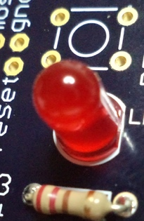This LED is used to give some visual feedback, in this device its used by the developer to indicate something in the firmware. When designing it’s important that you think about how it’s going to be tested.

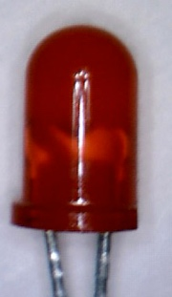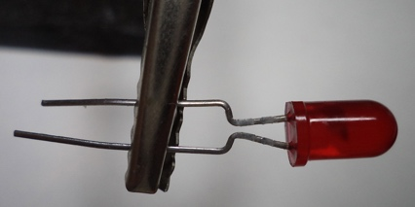The LED needs to be orientated correctly to work. There are 2 ways to identify the anode (+) and cathode (-), If your LED still has it legs intact the long leg is the anode, also the LED has a flat on the bottom of the bulb. See in the image only one side appears to have a ledge. Look at the circuit board and match the flat side of the LED to the symbol.

Notice on the circuit board, there is a resistor connected to the LED, this is called a current limiting resistor, its there to stop the LED drawing to much current from the micro controller.

## Buttons – human interface

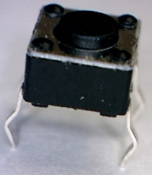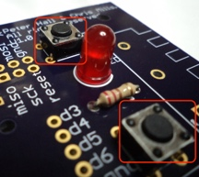The push button pins are bent to form a rectangle; this is because the buttons need to be installed in the correct orientation. Insert them and solder in place. There are 2 as shown in the red outline.

## Chip and sockets

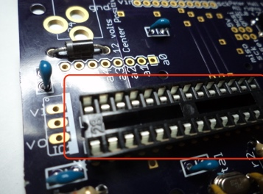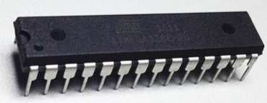 Moving to the larger components, the 28 pin IC socket, which is optional allows you to change out the chip, it’s a convenience feature I like to use for general purpose chips (if possible) because it allows me to reuse the chip for another project. If you choose not to install the socket you will need to solder the atmega328 ic. Notice the socket has a notch to indicate the first pin. The legend also has the same notch. Match the notches when you insert the component. The ic also has the notch and pin 1 is indicated with a dot above the pin. If you solder the ic directly make sure the notch matches the legend.

## Headers

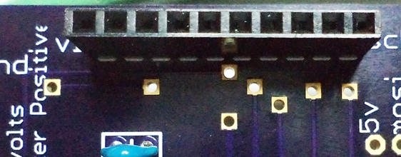Nearly there, the 10 pin female header is used to connect the bluetooth module. I found holding this component with tape helped with the soldering.

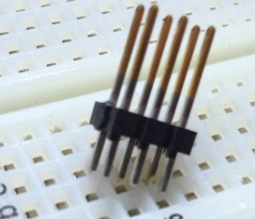

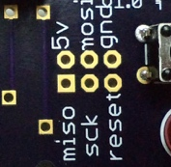Add the last header, this is a 6 pin male header, we will need this to reprogram the microcontroller. It’s called an ICSP header.

## Power Jack

To finish up the soldering add the remaining components:

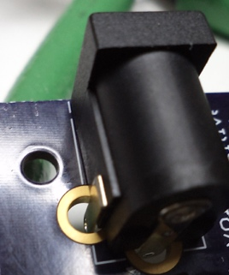Power Jack, note this requires a 9v-12v 2.1mm power supply with a center positive jack. Most 6v supplies will also work if it’s not a regulated supply. Note the circuitboard holes are large for the component legs, you want to try and fill the holes, but be careful not to burn the plastic. So don’t leave the iron on the board for too long.

## Relay

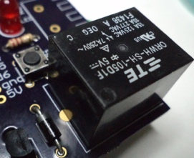 The relay is used to connect and disconnect the power to the externally connected device, for example a lamp or a garage door opener. Rated for 10A for 227vac or 15A or 125vac. There’s plenty of other things you can control.

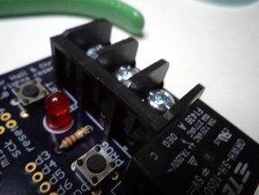

## Terminal block – interface to the external world

The terminal block is used to connect the external device you want to control.

It has 3 terminals

1. Normally open
2. Common
3. Normally closed

These states refer to the circuit, ie. Open circuit or closed circuit. In English if the state is normally open , it means the circuit is not complete so electricity will not flow. The word ‘normally’ means the state the device is in when no power to supplied to the actuator pin.

## Finished - What it should look like

Thats the soldering completed, plug in the bluetooth module and the microcontroller.

It should look like this.

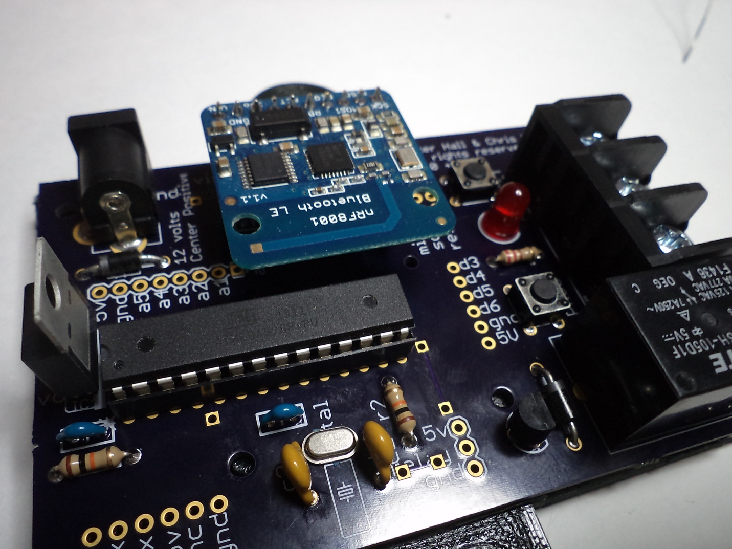

There are extra holes for headers, these holes can be used for experimenting. The legend references the pins as used by an Arduino.

Programming the device is covered in another article.

Your atmega328 microcontroller should already be programmed with the firmware, if you supply power to the unit you should see the LED glow momentarily, it will indicate its working.

Congratulations, you have made your device.