The microcontroller does not do anything without a program, in this document we show you how to program the device using a R3 Arduino.

We are going to use the ICSP or in circuit serial programing interface of the atmega328 controller.

The instructions and program for turning your Arduino into a ISP or in-system programmer are included in the Arduino IDE examples.

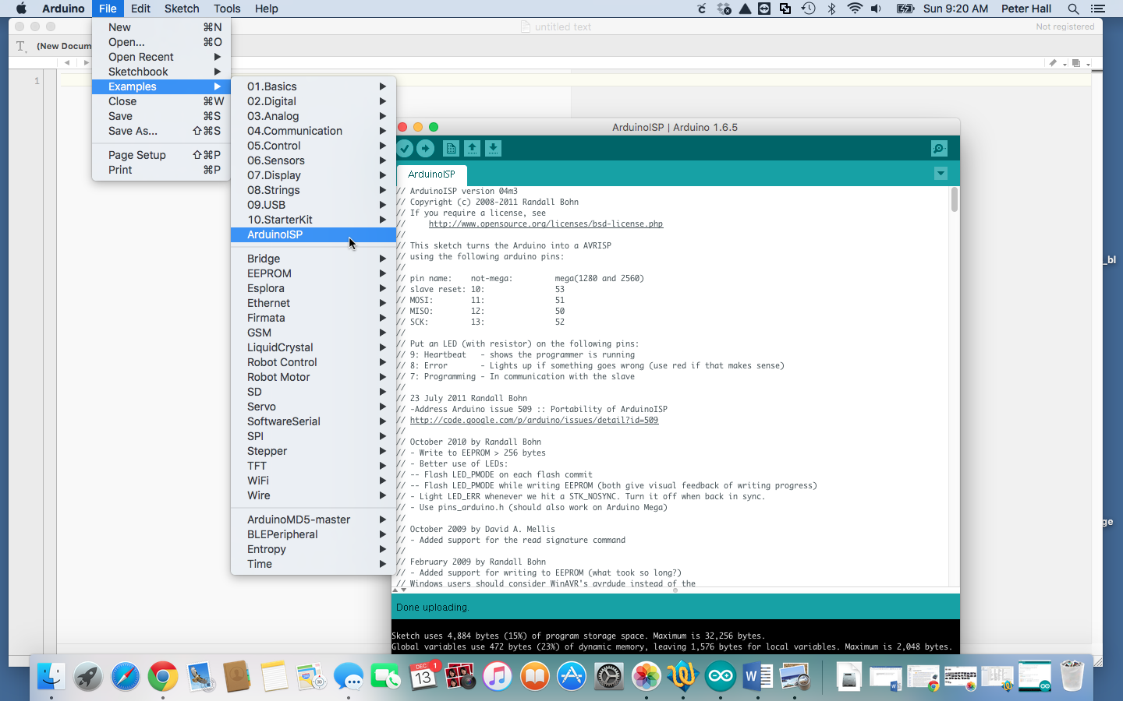

From the Menu choose File->Examples->ArduinoISP

You will need to make a minimum of 5 connections from the Arduino to the Garagedoor opener circuit.

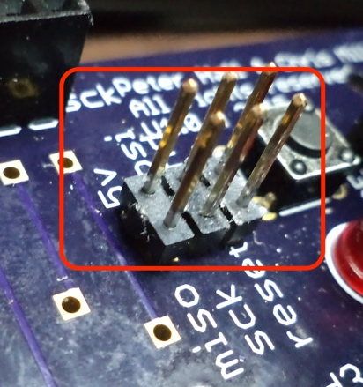

Connect the following using jumper leads.

|  |  |
| --- | --- |
| Arduino pin | Garagedoor header |
| 10 | Reset |
| 11 | Mosi |
| 12 | Miso |
| 13 | Sck |
| GND | Gnd |

After you have wired up the the connections. Consider making a permanent cable, it will make things more easy and you can reuse the cable for other projects. I glued the jumper cables with super glue, added some labels so I know how to plug it in and then to make it look good I added heat shrink tubing.

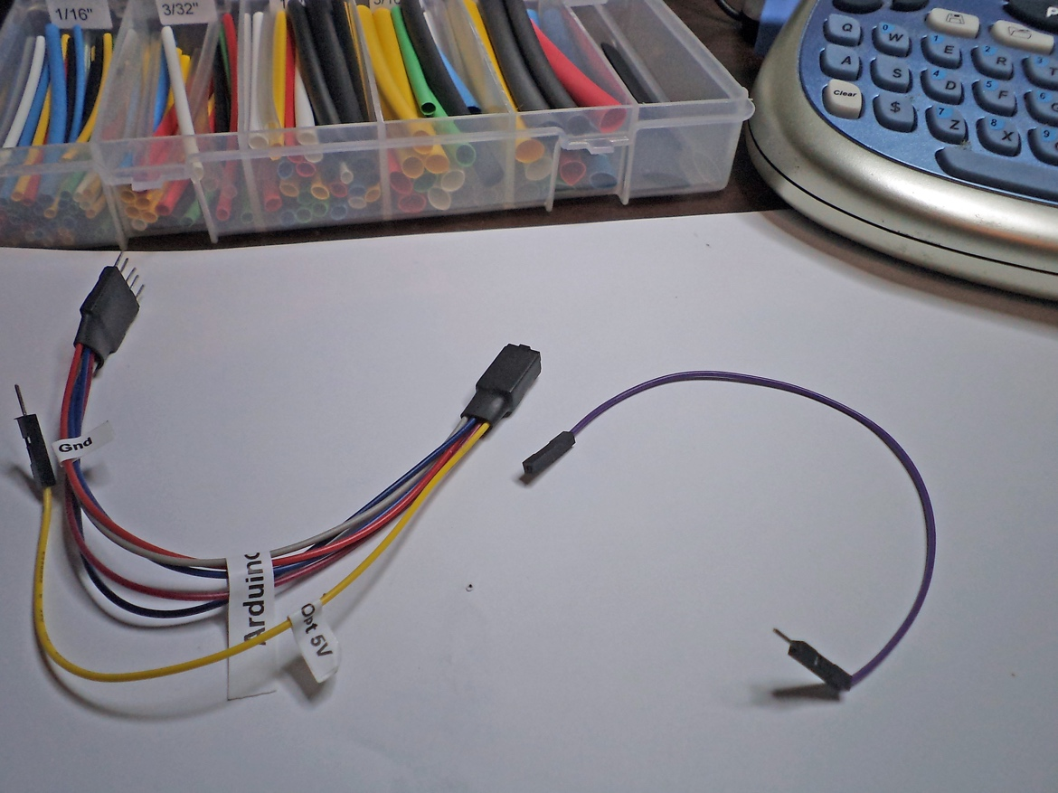I added an extra 5V optional cable so I ca use it for another project. You don’t need the 5V cable for this project as the board must be powered by an external power supply.

Be very careful with the superglue, or you might stick the cable to the header.

When it’s plugged in it should look something like this

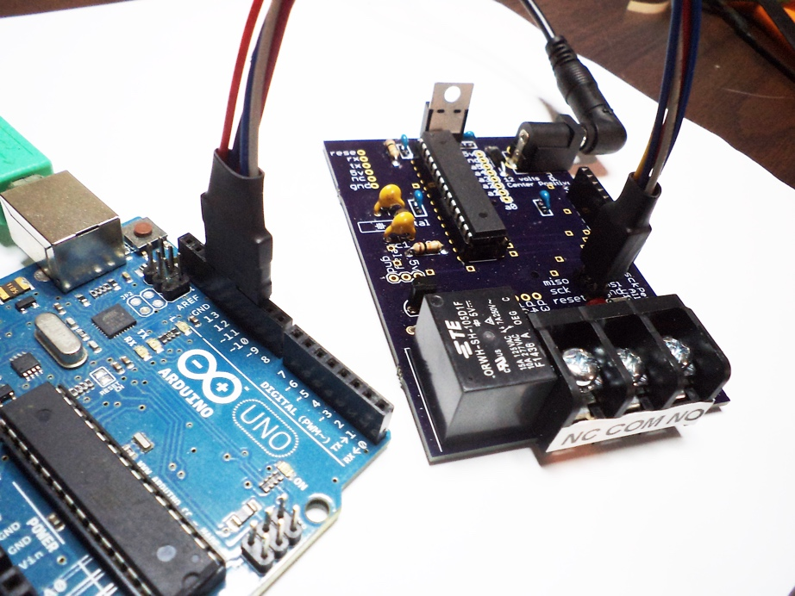

First we need to program the Arduino as an ISP.

Make sure your Arduino is plugged into the USB and your computer. You have already configured your Arduino software (If not consult the Arduino website if you need help)

In the window with ArduinoISP click on the arrow as in the image. You will notice when you mouse over the arrow the text Upload appears to the right.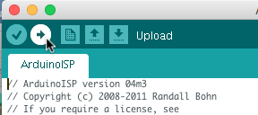

After the upload has completed it will say ‘Done’.

To program the garagedoor opener we need to change the software to use the Arduino as the programmer.

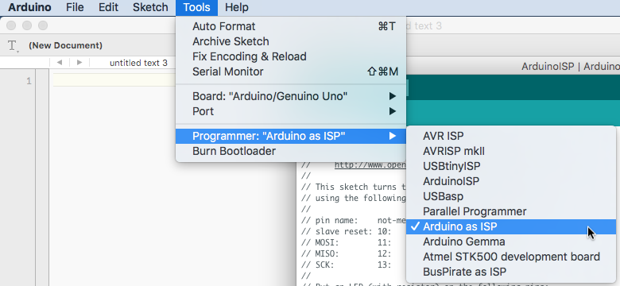

From the menu choose Tool->Programmer:->Arduino as ISP

The Arduino needs to be configured with some hardware fuses. We can’t do that directly with the Arduino software but we can program the garage door opener with the Arduino bootloader which will set the hardware fuses for us. This only needs to happen one time. If you bought your atmega328 chip directly it will not contain the settings. However if you got your chip with a kit it will already contain the settings so you won’t need to do this step.

To install the bootloader , first make sure the Arduino is plugged in to the USB, then make sure the Garagedoor opener is plugged into the Arduino.

From the tools Menu choose ‘Burn Boatloader’. When the boatloader has been written to the chip it will say its’ ‘Done’.

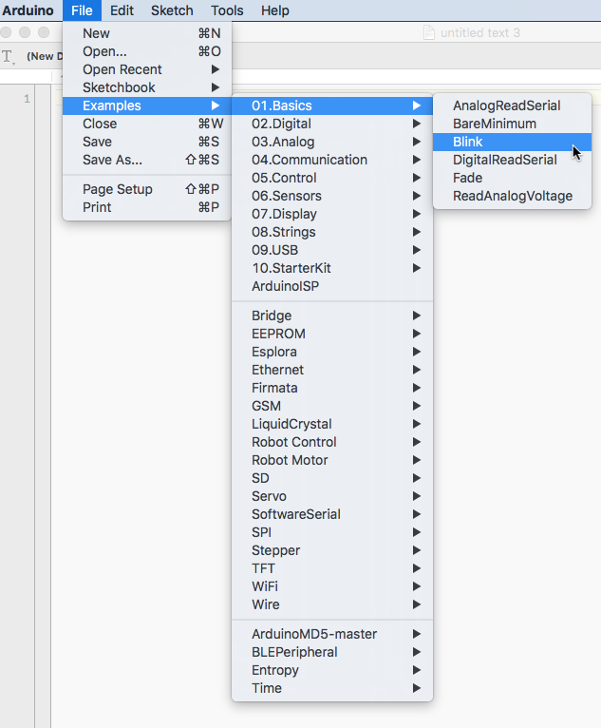Now we have an Arduino ready to install the Garage door opener software. But before we do that, lets run a simple test so see if the chip is working.

From the menus choose File->Examples->01.Basics->Blink

Change the program so it looks like this:

/*

Blink

Turns on an LED on for one second, then off for one second, repeatedly.

Most Arduinos have an on-board LED you can control. On the Uno and

Leonardo, it is attached to digital pin 13. If you're unsure what

pin the on-board LED is connected to on your Arduino model, check

the documentation at http://www.arduino.cc

This example code is in the public domain.

modified 8 May 2014

by Scott Fitzgerald

*/

#define PIN 6

// the setup function runs once when you press reset or power the board

void setup() {

// initialize digital pin as an output.

pinMode(PIN, OUTPUT);

}

// the loop function runs over and over again forever

void loop() {

digitalWrite(PIN, HIGH); // turn the LED on (HIGH is the voltage level)

delay(1000); // wait for a second

digitalWrite(PIN, LOW); // turn the LED off by making the voltage LOW

delay(1000); // wait for a second

}

The garage door opener has an LED on digital pin 6 not pin 13. Now we are ready to upload this to the garage door opener.

This time we will use the Arduino to program the garage door opener.

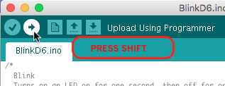

Press and hold down the shift key, then click on the arrow, make sure it says ‘Upload Using Programmer’ before you click or you will rewrite the Arduino with the blinking LED program.

If all goes well, the LED on the garage door opener will start to blink.

That’s all there is to it to program the device. Now let look at what you need to build the garage door opener.

Garage door opener firmware.

The garage door opener firmware relies of the work of others. In the case of the Arduino we need to install the libraries into the Arduino Libraries folder.

We need 2 libraries

1. BLEPeripheral v0.1.5
2. ArduinoMD5

The libraries need to be installed into the Libraries folder for you Arduino Sketchbook location. (see below for more information)

**Download Library**

**Arduino**

**Using the Arduino IDE Library Manager**

1. Choose Sketch -> Include Library -> Manage Libraries...
2. Type BLEPeripheral into the search box.
3. Click the row to select the library.
4. Click the Install button to install the library.

**Using Git**

cd ~/Documents/Arduino/libraries/

git clone https://github.com/sandeepmistry/arduino-BLEPeripheral BLEPeripheral

source code is available from here

https://github.com/sandeepmistry/arduino-BLEPeripheral

ArduinoMD5

<https://github.com/tzikis/ArduinoMD5>

Download a ZIP file from the above address.

Unzip the file and move into your Arduino sketchbook location.

Look for the “Sketchbook location” field in the Preferences dialog.

If you have not changed the default it will be in your Documents/Arduino folder.

To find your Sketchbook location for a mac.

Click on the Arduino application menu and choose Preferences.

To find your Sketchbook location for windows

Click on the File menu and choose Preferences.

Make sure you close the Arduino software and reload for the libraries to become available.

You will now be able to compile and install the Garage Door Opener firmware.