TASK 1
a) By running the code named gbm.py, you will get the following output.
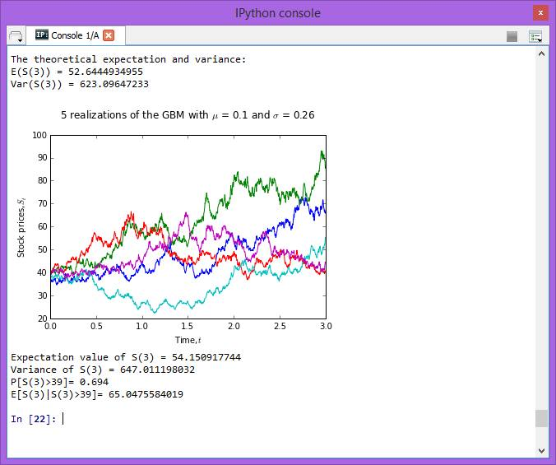
The theoretical expectation and variance is calculated by :
$$E[S\left(t\right)]=S\left(0\right)e^{\left(ut\right) }$$
$$E[S\left(3\right)]=39e^{\left(0.1(3)\right) }$$
= 52.6444935

$$Var\left[S\left(t\right)\right]={S\left(0\right)}^{2}e^{2ut}\left(e^{σ^{2}t}-1\right)$$
$$Var\left[S\left(3\right)\right]={39}^{2}e^{2(0.1)(3)}\left(e^{{(0.26)}^{2}(3)}-1\right)$$
= 623.0964723
We start off by define all the parameters needed such as mu, sigma and initial S0 and others. We simulate 1000 runs on each different path for 1000 paths. Then, we plot the 5 realizations of geometric Brownian Motion path and give proper labels.

1) Calculate the expectation value of S(3) based on the simulation. (Please explain how you obtained the values)
We generate a array of stock s(3) and extract the last column of stock prices by using S[:,-1]. Next, we use mean in the numpy function to find the average values stored in the array.

2) Calculate the variance of S(3).(Please explain how you obtained the values)
By using the same array, we find the variance of the value by using the var in the numpy function.
3) Calculate P[S(3)> 39]. (Please explain how you obtained the values)
First, we let variable ‘a’ be the position of values that are more than 39.0 from the array of s(3). True will be returned. Next, we find the P[S(3)> 39] by take the sum of variable ‘a’ divide by the length of variable ‘a’.
4) Calculate E[S(3) | S(3) > 39]. (Please explain how you obtained the values)
First, we let variable ‘c’ be the variable ‘a’ (position of values that are more than 39.0) multiple by the array s3. Then, we calculate the E[S(3) | S(3) > 39] by variable ‘d’ which is the sum of the variable ‘c’ divide by the sum of the variable ‘a’.

b)
By running the code named mr.py, you will get the following output.
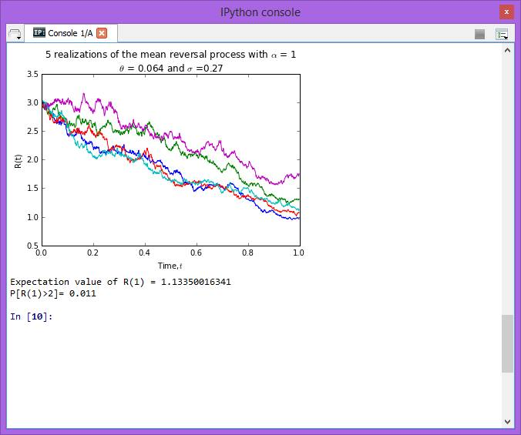
We start off by define all the parameters needed such as t, sigma, theta, n_path and others. Then, we plot the 5 realizations of mean reversal process and give all proper labels.
1) Calculate the expectation value of R(1) based on the simulation. (Please explain how you obtained the values.)
First, we take only the last row of the array ‘R’ and assign it to the variable ‘R1’. Next, we find the expectation value of R(1) by using the mean command in the function numpy.

2) Calculate P[R(1)> 2]. (Please explain how you obtained the values.)
First, we let variable ‘a’ be the position of values that are more than 2 from the R1. True will be returned. Next, we find the P[R(1)> 2] by take the sum of variable ‘a’ divide by the length of variable ‘a’.

TASK2
1) How many components stocks are there?
ANSWER: 30
2) Create a table list the following information for all the component stocks: Stock Name, Stock Code, Stock Sector, Weightage in FTSEKLCI, PE Ratio, Net Market Capital.
Stock Code | Stock Name | Stock  Sector | Weightage  (%) | PE  Ratio | Net Market Capital  (MYR in millions)
1295 | PUBLIC BANK BERHAD | Finance | 11.60 | 16.31 | 73682.979
1155 | MALAYAN BANKING BERHAD | Finance | 9.32 | 13.07 | 87750.513
1023 | CIMB GROUP HOLDINGS BERHAD | Finance | 5.76 | 14.97 | 46524.058
1082 | HONG LEONG FINANCIAL GROUP BERHAD | Finance | 0.64 | 11.20 | 16654.790
1015 | AMMB HOLDINGS BERHAD | Finance | 2.38 | 9.94 | 17723.408
5819 | HONG LEONG BANK BERHAD | Finance | 1.67 | 12.02 | 25265.977
1066 | RHB CAPITAL BERHAD | Finance | 1.06 | 9.67 | 19698.345
5347 | TENAGA NASIONAL BERHAD [S] | Trading/ Services | 9.28 | 10.79 | 69754.896
6888 | AXIATA GROUP BERHAD [S] | Trading /Services | 5.62 | 23.60 | 55544.741
4197 | SIME DARBY BERHAD [S] | Trading/ Services | 5.51 | 15.91 | 53354.208
5218 | SAPURAKENCANA PETROLEUM BERHAD [S] | Trading/ Services | 1.98 | 9.88 | 14153.159
3182 | GENTING BERHAD | Trading/ Services | 3.68 | 20.77 | 31068.523
5681 | PETRONAS DAGANGAN BERHAD [S] | Trading/ Services | 1.21 | 40.88 | 20504.891
5246 | WESTPORTS HOLDINGS BERHAD [S] | Trading/ Services | 0.93 | 32.98 | 14356.10
6012 | MAXIS BERHAD [S] | Trading/ Services | 3.45 | 28.46 | 48883.526
6399 | ASTRO MALAYSIA HOLDINGS BERHAD | Trading /Services | 1.22 | 30.45 | 15813.168
5225 | IHH HEALTHCARE BERHAD [S] | Trading /Services | 3.28 | 63.97 | 48251.265
4677 | YTL CORPORATION BERHAD | Trading /Services | 1.63 | 11.11 | 17270.384
4863 | TELEKOM MALAYSIA BERHAD [S] | Trading/ Services | 2.96 | 30.22 | 25140.584
4715 | GENTING MALAYSIA BERHAD | Trading/ Services | 2.50 | 20.18 | 23985.949
3816 | MISC BERHAD [S] | Trading/ Services | 2.45 | 16.28 | 35888.904
2445 | KUALA LUMPUR KEPONG BERHAD [S] | Plantation | 2.28 | 24.76 | 24552.615
1961 | IOI CORPORATION BERHAD | Plantation | 2.99 | 8.25 | 27837.135
4065 | PPB GROUP BERHAD [S] | Consumer | 1.80 | 19.45 | 17829.920
4162 | BRITISH AMERICAN TOBACCO (MALAYSIA) BERHAD | Consumer | 1.70 | 21.08 | 19016.298
4588 | UMW HOLDINGS BERHAD [S] | Consumer | 1.37 | 18.21 | 11869.867
5235SS | KLCC PROPERTY HOLDINGS BERHAD [S] | REITS | 0.63 | 15.31 | 12637.331
6947 | DIGI.COM BERHAD [S] | IPC | 4.16 | 20.71 | 42062.750
5183 | PETRONAS CHEMICALS GROUP BERHAD [S] | Industrial Products | 3.55 | 20.77 | 51200.000
6033 | PETRONAS GAS BERHAD [S] | Industrial Products | 3.40 | 22.91 | 42226.141

3) Plot a 5-day moving average plot for the downloaded data. Explain how you calculate the 5-day moving average.
RHB CAPITAL BERHAD, code 1066 is chosen in this task. The daily closing price from 1st Jan 2010 to 1st May 2015 is downloaded from Yahoo! Finance. Running the code named “download_data.py”, we obtained the following output:
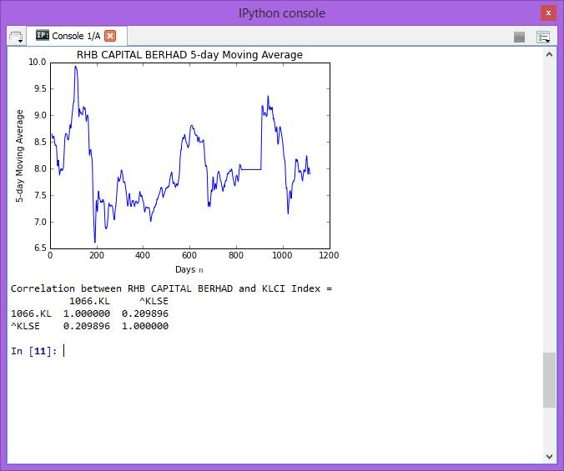
The 5-day moving average is calculated by adding the closing price of RHB CAPITAL BERHAD for 5 days, and then divides the total by 5. After each calculation, one number has been stored. All the moving average is stored by command rolling_mean by pandas function into variable named ‘moving_average’.
Next, we plot the moving average plot by giving all proper labels by using the matplotlib.pyplot function.

We also download the daily data of FTSEKLCI for same duration to find the correlation. Lastly, we find the correlation between the RHB CAPITAL BERHAD and the FTSEKLCI.

