AllLinks

Author | Riaz
Date | 6-18-2019
Version | 1.0
Status | Draft

Document Revision History
Date | Version | SLDC Phase / Revision Description | Author
<< 2015-06-19 >> | 0.1 | Initial draft | Riaz
<< YYYY-MM-DD >>
<< YYYY-MM-DD >>
<< YYYY-MM-DD >>
<< YYYY-MM-DD >>

Table of Contents
Table of Contents
1 INTRODUCTION 4
1.1 Overview 4
1.2 Scope of the document 4
1.3 Target Audience 4
2 vision/Scope Summary 5
3 Architecture 6
3.1 Conceptual architecture 6
3.2 Physical Architecture 6
Business process overview 8
3.3 admin Flow 8
3.4 End User 9
4 Modules and screens 10
4.1 User registration 10
4.2 User Login 10
4.3 Manage URL 10
4.4 URL Approved by admin 11
4.5 Browse URL 11
5 sECURITY 12
6 Entity relationship diagram 13
6.1 ER Diagram 13
6.2 Logical Model 13
6.3 Physical Model 14
7 Assumptions, Dependencies and Constraints 15
7.1 Assumptions 15
7.2 Dependencies 15
7.3 Constraints 15
8 Appendices 16
8.1 Conceptual Design Summary 16
8.2 Logical Design Summary 16
8.3 Physical Design Summary 16

INTRODUCTION

Overview

AllLinks is a web portal where a user can submit her/his portal URL under a specific category to be shared on link hub. Admin can approve or reject the URL submitted by the user and in each case an email is sent out to the user. Once the link is approved, it will be available on the link hub portal.

Scope of the document
The purpose of the document to provide detailed technical design information, Component implementation design and processes, product configuration, schema designs, data load process, the business process or scenario implementation as part of solution. The document does not cover business requirement, deployment process, operation and support procedures or user guide information.

Target Audience

The target audience for this document is-

- Technical Architect
- Business Architect
- Technical Manager
- Software Engineer or Development Resources
- System Testing Resources

vision/Scope Summary

The proposed system should enable a platform for users to submit their urls under a category and business should be able to analyze the url data for decision making.
- User Registration
- Login
- Manage URL’s
- URL Review by and approve by Admins
- Browse all Approved URL’s

Architecture

Conceptual architecture

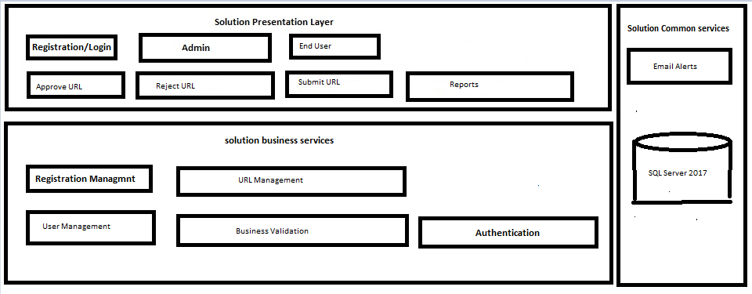

- Application will prompt login/password option for signing in. There will be no windows authentication supported.
- Application will contain following features
  - Home
  - View for Admin, End User
  - Tasks
  - Submit Browse URL
  - Approve Reject URL

- Following will be roles.
  - Admin
  - End-User

Physical Architecture
- Application shall be deployed on singleton architecture.
- Going forward based on business demand Distributed architecture will be proposed.
- Only one physical environment i.e. Development environment
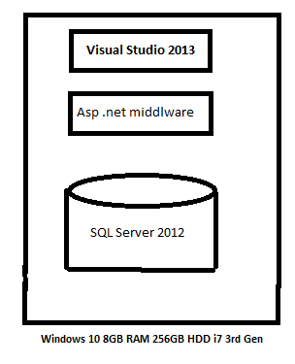

Business process overview
AllLinks is a web based application.
There will be different set of users who will be using the application.

List of users are below
- Admin
- End User

admin Flow
- Central admin is capable of approving user Urls
- Central admin is capable of rejecting URLs

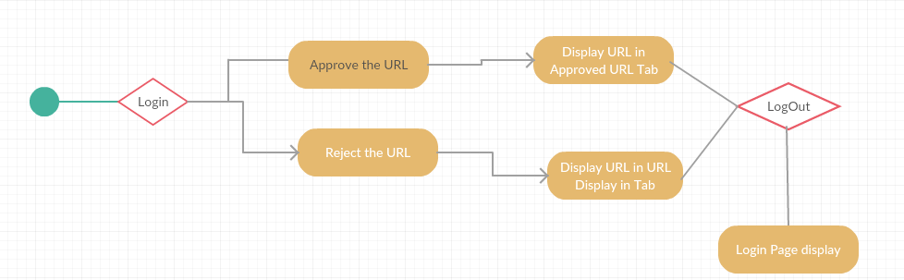

End User
HR will be able to add/remove an employee and generate offer and reliving letter.
Also HR can generate Salary revision document.
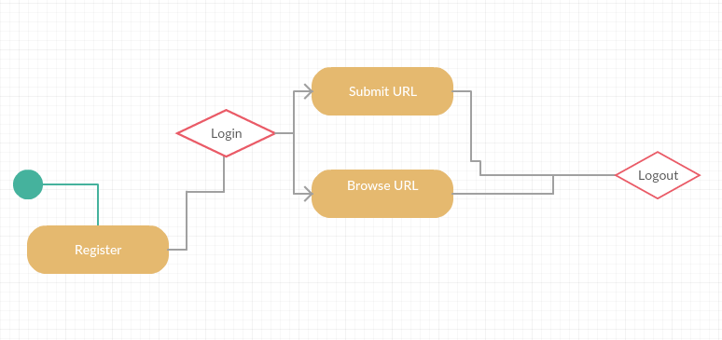

Modules and screens

User registration
User Registration form is below.

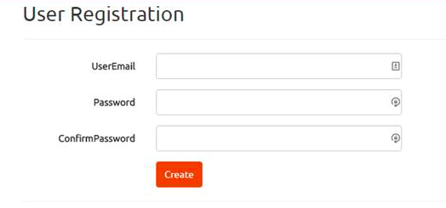

User Login
Login screen is below

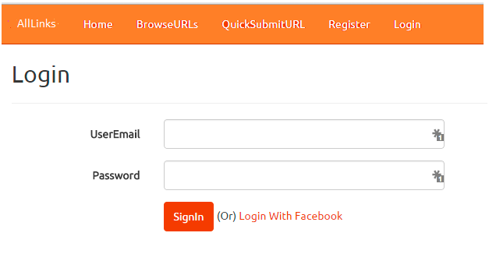

Manage URL
Login screen is below

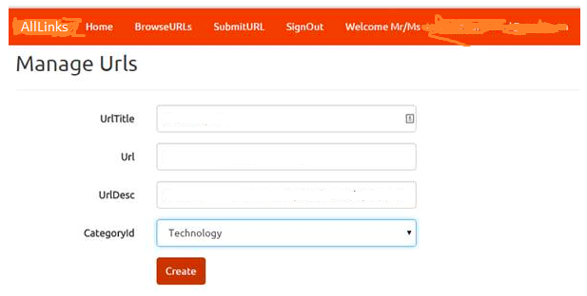

URL Approved by admin
This module depicts approvals of URL.
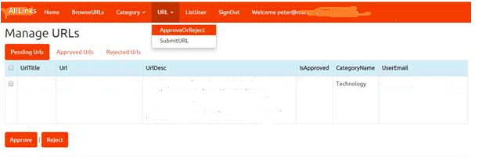

Browse URL
All approved URL’s can be viewed below.

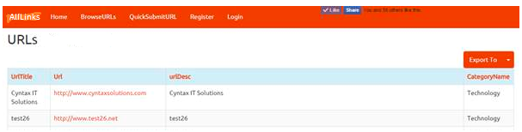

sECURITY

Entity relationship diagram

ER Diagram
From the requirement It is clear we have three objects which interacts with each other.
- User
- Category
- URL
Relationship
- Category -------->URL
(1:M)
- User---------------->URL
(1:M)

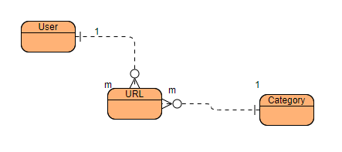

Logical Model
From the requirement It is clear we have three objects which interacts with each other.

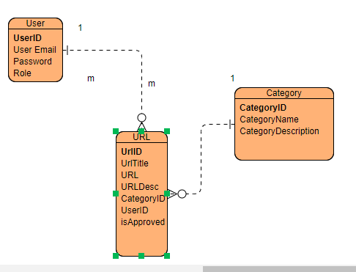

Physical Model
From the requirement It is clear we have three objects which interacts with each other.
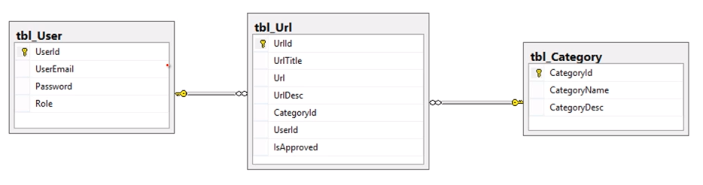

Assumptions, Dependencies and Constraints

Assumptions
Factors assumed for the completion of this document that are considered to be true, real, or certain without proof or demonstration are identified in the following table.

# | Assumptions
1 | Application will be deployed on local machine not on web server
2 | There will be no formal go-live on internet unless investments comes in
Table 1: Assumptions

Dependencies
External factors or events that are linked to the solution (in that one has an effect on the other) are identified in the following table.

# | Dependencies
1 | Employee monitoring will be done through external tool.

Constraints
Factors that limit or slow the successful development, deployment or adoption of the solution are identified in the following table.
# | Constraints
1 | Employee monitoring will be relied on third party tool as timelines for project very short.

Appendices

