Helm:
Solves this issue using a template approach. You just write all your Kubernetes resource definitions as usual. As soon as you realize that some specific part in them needs to be different in deployment A and B, you can add a placeholder and let Helm replace it with a user provided value at installation time. That’s all!
Kustomize:
Kustomize tries to achieve the same goal using a polymorphic inheritance approach, combined with a domain-specific language for post-processing (patches). This means that your file which specifies the staging deployment of your microservice will usually inherit from the ‘generic’ microservice description, and then add customization and patches to that using its custom configuration language.
Both are simply different solutions for bundling k8s/k3s resources(elements) such as deployment, services..
These both are different deployment engines.
Here are the few differences between both of them.
Helm Kustomize
1. helm has template engine functionality 1. overlay functionality
2. This is developed by 2. kustomize is already built in kubectl. we can use with thirdparty kubectl apply -k option
3. Helm3 is an imperative templating tool for managing Kubernetes packages called charts.
Charts are a templated version of your yaml manifests with a subset of Go Templating mixed throughout,
as well it is a package manager for kubernetes that can package, configure, and deploy/apply the helm charts onto kubernetes clusters.
4. kustomize, where the tool’s behavior is determined by declarative specifications expressed in a file called kustomization.yaml.
5. helm will have helm repository to place the helm charts
6. kustomize will not have any repo. create a kustomize.yaml file.
This file should declare the resources( deployment, services, pods), and any customization to apply to them, e.g. add a common label.

---------------------------------------------------------------------------------------------------------------

HELM

Overview:
- what is helm?
- what are the helm charts?
- how to use them?

1. what is helm ?
- helm is nothing but package manager for kubernetes like apt, yarn.
- This is used to package yaml files and distribute them in public/private repositories(helm hub)

2. What are the helm charts ?
- helm bundles the yaml files in the form of the helm charts.
- and these helm charts can be pushed to the helm repo
- Also it can be able to download the charts and use them in the cluster
example: common helm charts applications can be data base applications like mongoDB, monitoring apps like promotheous
usage: helm install <chart name>

3. How to use them ?
- The functionality of the helm is the templating engine
- If an application made of multiple micro services in the kubernetes cluster will have the same kind of yaml files except docker image file, label name, version tags.
- so without helm, we should have yaml files for every micro services which has the different application name and version defined.
- To avoid this , by using helm, we can define a common blueprint and the values can be given dynamically.
- Values can be defined in values.yaml file where the variables are declared in the template yaml files
- So these values can be dynamically applied using the yaml( custom-values.yaml which can be supplied through CLI) files or --set flag

Overview: Instead of having many yaml files for each micro service, we can have 1 yaml file as blueprint and variables declared in the template yaml file can be replaced with the values.yaml file or --set flag

- Another functionality of the helm is same applications can be deployed across different environments or different kubernetes cluster environments
ex: development staging production
we can package all the necessary yaml files as charts and can be redeploy wherever we want to deploy just with helm command.

- charts can be installed by the helm install <chartname>
- charts can be searched by the keywords helm search <chartname>
- These charts can be pushed to the helm repository just like (docker hub) how docker images will be pushed to the docker hub

helm chat structure:
mychart/ ------Top level mychart folder name of chart
chart.yaml ---- contains meta info about the chart
values.yaml ----values for the template files. Default values we can override.
charts/ --------charts folder, chart dependecies
templates/ -----templates folder, all the actual template files will be placed.
deployement.yaml -- actual files for deployment of the application
service.yaml ----actual files for service loadbalanceer of the application

-> deployment of the app can be done by the below command
$ helm install <chartname>
template values will be filled with the values from the values.yaml
values.yaml file will have all the key values with are defined in the template yaml files
once running the above command, all the values definations will be replaced with the template yaml files

- Value injection into the template files:
--------------------------
values.yaml
ImageName: myapp
port: 8080
version: 1.0.0
--------------------------
- These are the override values
--------------------------
custom-values.yaml
version: 2.0.0
---------------------------
during installtion of the chart, we can give the custom values yaml file
$helm install --values=custom-values.yaml <chartname>
to give individual value
helm install --set version=2.0.0

KUSTOMIZE

kustomize, where the tool’s behavior is determined by declarative specifications expressed in a file called kustomization.yaml
The kustomize program reads the file and the Kubernetes API resource files it references, then emits complete resources to standard output. This text output can be further processed by other tools, or streamed directly to kubectl for application to a cluster.

1) Make a kustomization file
In some directory containing your YAML resource files (deployments, services, configmaps, etc.), create a kustomization file.
This file should declare those resources, and any customization to apply to them, e.g. add a common label.
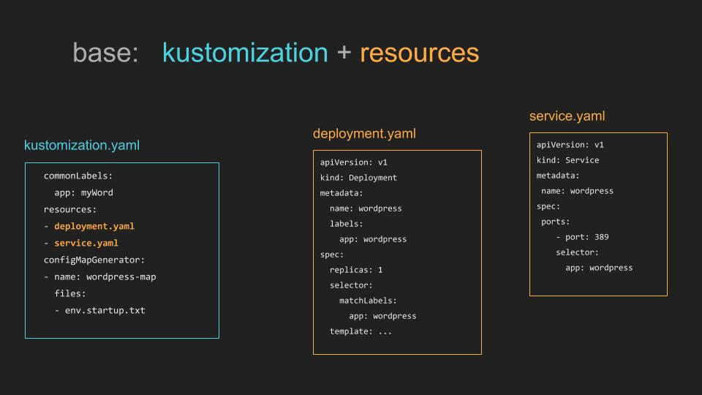
File structure:
~/someApp
├── deployment.yaml
├── kustomization.yaml
└── service.yaml
The resources in this directory could be a fork of someone else's configuration. If so, you can easily rebase from the source material to capture improvements, because you don't modify the resources directly.
Generate customized YAML with:
kustomize build ~/someApp
The YAML can be directly applied to a cluster:
kustomize build ~/someApp | kubectl apply -f -

