“Hand-written character recognition using deep-learning(CNN)”

End-Semester Report of
5th Semester Mini Project
for the degree Of

BachElOr OF TECHNOLOGY
In
INFORMATION TECHNOLOGY



BY

S.Sainath reddy (ISM2015006)
P.Vinay surya prakash (IHM2015004)
G.Naga nikhil (IRM2015501)

Under the supervision of
pavan chakraborthy
IIIT-ALLAHABAD

INDIAN INSTITUTE OF INFORMATION TECHNOLOGY, ALLAHABAD

April, 2017

Abstract

In order to recognize handwritten characters we used deep-learning technique (CNN) as classifier . We trained our network using NIST dataset.
We had done the statistical analysis of the white vs black pixel densities. And we binarised and cropped and used parse matrix method to decrease dataset size before we send that data to our network for training. We had done the justification on the layers of CNN . And finally we got an accuracy of __ with CNN .

CANDIDATE’S DECLARATION

We hereby declare that the work presented in this project report entitled “Hand-written character recognition using deep-learning(CNN)”, submitted end-semester report 5th Semester report of B.Tech. (IT) at Indian Institute of Information Technology, Allahabad, is an authenticated record of our original work carried out from august 2017 to november 2017 under the guidance of pavan chakraborthy. Due acknowledgements has been made in the text to all other material used. The project was done in full compliance with the requirements and constraints of the prescribed curriculum.

Place: Allahabad
Date: 19-11-2017
S.Sainath reddy (ISM2015006)
P.Vinay surya (IHM2015004)
G.Naga nikhil (IRM2015501)

CERTIFICATE

This is to certify that the above statement made by the candidate is correct to the best of my knowledge.

Date: 28-04-2017 Pavan Chakraborthy

Place: Allahabad IIIT-Allahabad

ii
Acknowledgement

This project was supported by the Indian Institute of Information Technology, Allahabad.

At First, we would like to thank our professor and mentor pavan chakraborthy for providing his guidance, support and mentoring us throughout the project, without which the project would not have been successful.

We would also like to thank Bibash goshal Sir, who has given us useful remarks and feedback regarding the working and implementation of the project.

iii
Table of Contents

- Introduction ………………………………………………………………………… 1
- Problem definition and Objectives …………………………………………………. 2
- Literature Survey …………………………………………………………………… 3
- Proposed Approach ………………………………………………………………… 5
- Hardware and Software requirements ……………………………………………… 15
- Activity Time Chart ………………………………………………………………... 16
- Experimental Setup and Results …………………………………………………… 16
- Conclusion …………………………………………………………………………. 23
- Future Scope ……………………………………………………………………….. 23
- References …………………………………………………………………………. 24

iv
- Introduction

hand-written charecter recognition is a difficult problem. But it has huge real world applications mainly.
1.postal automation (ex:)
2.inputing data of complex laguages.
3.digitalizing the documents.(ex: application sheets)
4.traffic controll (recognizing vehicle number of misbehaved)
5.automated road toll-booth paying system.
6.translation of text etc...

so the recognition efficiency of ML algorithms like k-nearest ,svm..
are not acceptable scince error in single chrecter may lead to big mistake. So a better approach like deep-learning is compulsary to address these real world applications.

Basic Terminology:
Low-Resolution(LR):
– It offers less details because of its small pixel density within an image.
High-Resolution(HR):
– It offers high details because of its high pixel density within an image.

1
SuperResolution(SR):
– It’s the technique of obtaining a HR image from one or multiple LR images. .
- Problem definition and Objectives
We are designing a model which segment the given input documet image to separate characters. And we send them to our trained convolutional neural network to recognize and we finally outputs the
final recognized characters in input ordered form.
Objectives:
- Collecting the dataset and pre-process it like binarizing, cropping and resizing and finally converting it to desired data format to train our convolutional network.
- Designing the CNN model like number of convolutional layers and number of feature extractors in each layers and number of hidden dense layers which gives better accuracy for our Dataset.
- To perform segmentation on input image to extract the individual characters by successive line , word, and character segmentation.
- Finally To integrate out segmentation part with our CNN model to recognize characters form the entire document and outputting in desired format.
- Literature Survey
- Table shows Literature Survey.

S. No. | Title | Year | Journal/  Conference | Objective | Method | Challenge(s) Dealt | Future Scope
1 | Super-resolution Reconstruction for License Plate Image in  Video Surveillance System | 2015 | IEEE-Conference  (Communications and Networking in China (ChinaCom)) | To improve the registration accuracy of license plate image and to reconstruct a HR image from low resolution images. | FMT, Vandewalle’s and POCS | Considered scaling, rotation and translation | NA
2 | Video Super resolution Reconstruction Using Iterative Back Projection with Critical-Point Filters Based  Image Matching | 2015 | ACM –Journal  (Department of Communication Engineering, Xiamen University, Xiamen, Fujian, China) | To improve the spatial resolution of reconstructed images/videos. | Sliding window. Critical Point Filters (CPF) based image matching. Iterative Back Projection (IBP) algorithm. | Blurring, noise are considered during registration.  Considered both rotation and translation. | NA
3 | POCS Super-Resolution Sequence Image Reconstruction Based on  Improvement Approach of Keren Registration Method | 2006 | Conference  (IEEE Transactions on Intelligent Transportation Systems) | To introduce the keren sub-pixel  registration method and point out its disadvantage and a new improvement  approach about keren method and its iterative method | Enhanced keren sub-pixel  registration method. POCS for image reconstruction. | Finding the disadvantage and improving the current method. | NA
4 | A super-resolution reconstruction algorithm for surveillance images | 2009 | Journal  (Elsevier, Signal Processing) | To enhance the resolution of region of interest from the low resolution images. | MAP estimation by using the weighted MRF regularization. Also used bilinear interpolation, GMRF, GWMRF, HMRF, HWMRF and compared the results. | Edge preserving methods. | NA
5 | Super-Resolution of License Plate Images using  Algebraic Reconstruction Technique | 2013 | Journal  (Journal of Image and Graphics-JOIG) | To increase the resolution to improve the readability of the license plate numbers. | Simultaneous algebraic  Reconstruction technique (SIRT).  Motion estimation, transformation parameters are initialized using cross power spectrum. | New method with new algorithm | NA
S. No. | Title | Year | Journal/  Conference | Objective | Method | Challenge(s) Dealt | Future Scope
6 | Superresolution of License Plates in Real Trafﬁc Videos | 2007 | Journal  (IEEE Transactions on Intelligent Transportation Systems) | To enhance license plate numbers of moving vehicles in real traffic videos. | Least squares (LS), GMRF, HMRF and DAMRF.  GNC (graduated non convexity) algorithm is used. | Preservation of edges in reconstructed images. | NA
7 | Real-time automatic license plate recognition for CCTV forensic applications | 2011 | Journal  (Springer, Journal of Real-Time Image Processing) | Efficient localization of license plates in video sequence. | For feature extraction and detection, used histogram of oriented gradients and nearest mean classifier. Character segmentation using MBR on binary maps. | Multiple vehicle license plates in a real-time scenario | Enhanced super-resolution techniques.
8 | Video Super Resolution using Duality Based TV-L1 Optical Flow | 2010 | Conference  (Springer, Joint Pattern Recognition Symposium) | To compute a superresolved image of a scene from an arbitrary input video | L1 and L2 error and compared the results. They used high accuracy optic flow estimation. | Demonstrated  good experimental performance on a variety of real-world examples | Simultaneously estimate the motion field and the  super resolved image
9 | Fast Super-resolution for License Plate Image Reconstruction | 2008 | Journal  (IEEE, Pattern Recognition) | A fast super-resolution reconstruction algorithm  for license plate recognition from LR images | Optical flow for computing motion parameters and used Fast map based sr reconstruction by minimizing cost function. | Computational cost is much lower compared  with other methods | NA
10 | Super-resolution Image Reconstruction | 2010 | Journal  (IEEE, Computer Application and System Modeling (ICCASM)) | To reconstruct high resolution image or video from a sequence  of low resolution images | The frequency domain method, non-uniform interpolation, POCS method, iterative back  projection method, Bayesian approach, regularization  method. | Robust to errors in  motion and blur estimation | NA

4
- Proposed Approach
Basic Idea:
Given:
An image of a document which hand written or printed charecters.
Required:

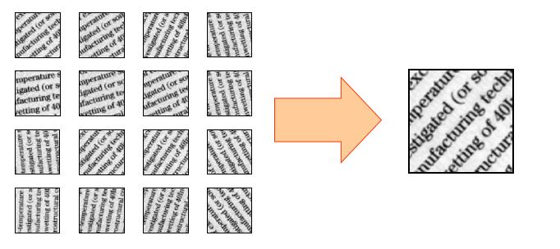
- (B)
Fig. 1 Image showing (a) Low Resolution Images (b) High Resolution Images (ImageSource:^{[14]} )

5
so before going a head baices of our CNN
like neurons,activation funtions ,back propogation,gradient decent,
baiscs on layes justification, previous effciencies,
2. Training
1.preprocessing ... black vs white desities
2. fitting and finding accuracies to find hyper parameters.
3.finally training our model of best accuracy we have found.
3. recognizing
1.preprocess image
2.segment
3. send to classifer
4.and send output.
Future scope.
conclusion.

When super resolution is possible?
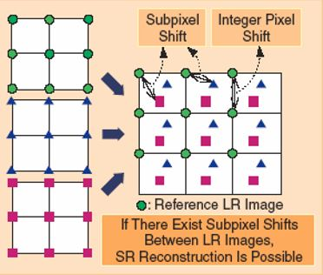
Fig. 2: Image showing when super resolution is possible. ImageSource:^{[14]}
Super resolution is only possible when there are only subpixel shifts between the low resolution images.

Super-Resolution methods involves two steps
1) Image Registration
2) Image Reconstruction

Image Registration: It is a technique used to align multiple images of the same scene with some differences in a single integrated image. It helps to overcome issues like scaling and rotation while overlying images.

6
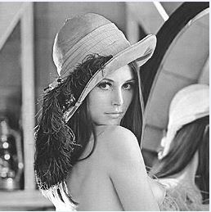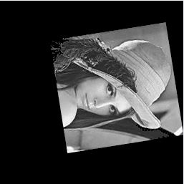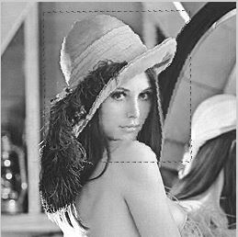
(a) (b) (c)
Fig. 3: Image showing (a) Original Image. (b) Image to be registered on original Image.
(c) After registration of image (b) on image (a). ImageSource:^{[14]}
Image Reconstruction: It is a technique used to reconstruct an image using the details obtained from the low resolution images.

Flow Chart of our proposed methodology:
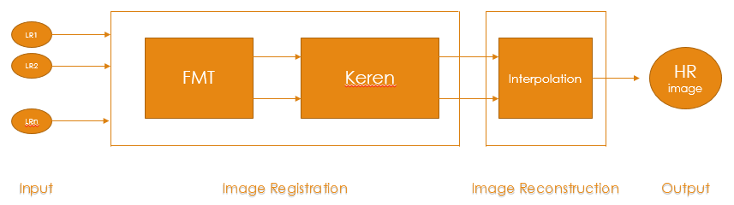
(a)
Fig. 4: Image showing (a) Figure shows the flow chart of proposed methodology
In image registration, several low resolution images which differ by rotation, scaling, translation are taken as input.
Fourier Mellin Transform (FMT) is used for scaling estimation between the
low resolution images and Keren method is used for rotation and translation
7
estimation. In keren method, there is no scaling estimation so we are considering FMT for scaling estimation. Keren is a better method when compared to FMT as keren method is able to find motion estimates even when there is subpixel shifts between the images.

Fourier Mellin Transform (FMT) Method [1][2]:
As rotation and translation parameters are found using keren algorithm, scaling parameter is found using FMT method as follows.
Let reference image be I1, and I2 be the image which is to be registered.
The relation between two images is given by the below function :
I₂ (x,y) = I₁ (xs cosα + ys sinα – t_{x} , – xs sinα + ys cosα – t_{y} ) (1)
Where (t_{x}, t_{y}) are shifts along x and y directions, α is the rotated angle, and s is the scaling factor.
By taking the Fourier Transform of the above equation, we get an equation in fourier domain as
FI₂ (u,v) = exp( – j2Π(u t_{x} + v t_{y})) *
FI₁ (us cosα + vs sinα , –us sinα + vs cosα) (2)
FI1 and FI2 denotes fourier transform of I1 and I2 respectively.
M₁ denotes spectral magnitude of FI1(u,v).
M₂ denotes spectral magnitude of FI2(u,v).
By transforming the above equation to its polar coordinates(r, θ),the relationship between Mag₁ and Mag₂ is given by
M₂ (r,θ) = M₁ (rs,θ – α) (3)
8
where M1 and M2 are translation invariant.
Scaling is converted to translation (i.e., multiplication to addition) by transforming radial coordinate to logarithmic scale.
Consider
ρ = log (r) , η = log (s) (4)
M₂ ( ρ , θ ) = M₁ ( ρ + η ,θ – α) (5)
By applying Fourier transformation to equation (5) , we get
F_{M2} (u’,v’) = exp( – j2Π( – u’η+v’α)) * F_{M1} (u’,v’) (6)
We can observe here scaling and rotation resembles as phase shifts. Finally calculating cross power spectrum of M1 and M2
A= F_{M1} (u’,v’)* F *_{M2} (u’,v’)
B= F_{M1} (u’,v’)* F *_{M2} (u’,v’)
(7)
A delta function (n,α) is obtained by computing the inverse Fourier transform of equation(7) and hence the value of n is obtained .
Now by substituting n in equation (4) we get value of s which is the desired scaling factor.

Keren Method^{[3]}:
Keren Image Registration algorithm is used to find translation and rotation parameters namely t_{x}, t_{y},.

9
t_{x} represents shift in X direction,
t_{y} represents shift in Y direction,
represents rotation angle.
(1)
Here g (x, y) is the reference image and f (x, y) is the image obtained by applying transformation function h (x, y) on g(x, y).
(2)

Substituting equation (2) in equation (1) we get :
(3)
Assuming to be small , sine and cosine are expanded to their first two terms in Taylor series.
Equation 3 after expansion becomes,
(4)
By applying Taylor series expansion to function f(x,y) , the above equation becomes,

Now error function (E (t_{x}, t_{y},) ) is obtained by taking the difference of reference image and transformed image

10

Where only overlapping part of two images is considered for summation in the above equation.
Now error function E has to be minimized, which can be done by taking the derivatives with respect to t_{x}, t_{y}, and equating them to zero, After that some non linear terms and small coefficients are neglected. Finally we get the following linear equations:

,

,
By multiplying both sides by in equation (7), we get:

11
Keren Algorithm^{[3]}:
Step 1: A 3 layer Gaussian pyramid is constructed for both reference and input image. Initial the layer variable n to 3.
Step 2: K denotes the no of iterations and initialise i to zero and the original four parameter variable X₀¹ = [0 0 0 0]^{T} .
Step 3: Calculate A_{i}^{n} ,B_{i}^{n} and then find X_{i}^{n} using the equation (8)
Step 4: if (i==K) , then jump to (7)
Step 5: Resample g_{n} ( x, y) according to X_{i}^{n} and the formula (10).
Step 6: increment k by 1, and jump to (3)
Step 7: if (n<3), in that case make X₀^{n+1} = X_{i}^{n} , and increment ‘n’ by 1 and go to (2). Otherwise, program ends.

After the parameters has been detected by the above algoritthms, we align all the images with respect to reference image. Now we need to perform image reconstruction to get a high resolution output.
Image reconstruction is done by Interpolation method which are used to enhance the image resolution.

IMAGE RECONSTRUCTION:
After Image Registration, we have rotation and shift parameters of every image with respect to reference image. Now we have to construct a new grid
12
image with new pixel values such that some of the pixels of the new image are found by applying their respective shift and rotation parameters to the old pixel values of every image. For example, consider an image for which we have shift and rotation parameters and the scaling factor(size of output image w.r.t input image), now for every pixel coordinate, a new pixel coordinate is found by using those parameters and mapping the pixel value to the found coordinates of respective pixel. By repeating this process for every image we get some pixel coordinates and its values and for finding pixel values of remaining coordinates bicubic interpolation is used.
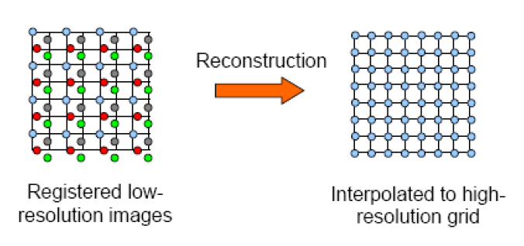
- (b)
Fig. 5: Image showing (a) Figure shows pixel representation of registered low resolution images. (b) It shows high resolution grid of Image after Interpolation. ImageSource:^{[13]}

INTERPOLATION:
It is a method of finding the unknown values by using some known values.
13
There are different types of interpolation linear interpolation, cubic
interpolation for single dimension and bilinear and bicubic interpolation for two dimensional data. But bicubic interpolation gives more accurate values when compared to bilinear. Hence we use bicubic interpolation for finding the pixel intensities of unknown pixel coordinates.
When we fill the pixel values of input image in scaled output image some pixel values are left unfilled, there we use interpolation to find the unknown pixel values.
BICUBIC INTERPOLATION:
It is an extension to cubic interpolation which is performed for single dimensional data. In bicubic interpolation also unknown values are found using cubic equation. In this 16 known points are considered around the unknown point which is to be calculated.
Equation for bicubic interpolation is given below:
p(x,y)=a₀₀x⁰y⁰ + a₀₁x⁰y¹+ a₀₂x⁰y²+ a₀₃x⁰y³+
a₁₀x¹y⁰ + a₁₁x¹y¹+ a₁₂x¹y²+ a₁₃x¹y³+
a₂₀x²y⁰ + a₂₁x²y¹+ a₂₂x²y²+ a₂₃x²y³+ (9)
a₃₀x³y⁰ + a₃₁x³y¹+ a₃₂x³y²+ a₃₃x³y³
In the above equation, we have 16 coefficients which are not known and we have 16 equations by putting each of the 16 points in that equation. So we have 16 unknowns and 16 equations which can be solved to get intensity of pixel at that particular point. Hence we can find pixel values at every missing coordinates.
After image reconstruction we are applying image enhancement techniques like image sharpening which enhances edges of the objects in the image.
14

5. Hardware and Software Requirements
Programming Tools:
python2
keras tensor-flow as back-end , open-CV

Dataset:
NIST special database of 800,000 characters of total 62 classes.
Dataset Link:
https://s3.amazonaws.com/nist-srd/SD19/by_class.zip

15
6. Activity Time Chart
 | Mid-Sem |  | End-Sem
 | Phase-I  15 Jan- 14 Feb | Phase-II  15 Feb- 14 March | Phase-III  15 March- 14 April | Phase-IV  15 April- 14 May
Literature Survey | Basics
Image Registration (Partial) | Keren Method and FMT  (Understanding)
Image Registration (Complete) |  | Keren Method  (Implementation)
Image Reconstruction |  |  | FMT implementation  Bicubic interpolation
Enhancing Results |  |  |  | Verification & Enhancement of  Model.

7. Experimental Setup and Results

We dealt with images that were differed by rotation and shifts. The method is used to deal with these parameters. We have generated a sample test data by taking an image and obtained different versions of the image by rotating and shifting the image with different values of rotation and shifts in horizontal and vertical direction. Then we applied keren algorithm on these images and results are shown below:

16
Keren method Validation:
Change in translation
- Table shows actual shifts and observed shifts after running our algorithm.
Sl.no | Actual shifts | Observed shifts
1 | (0.5,0.5) | (0.5645 ,0.5018)
2 | (2,2) | (1.9854 ,2.0001)
3 | (3,4) | (2.9107 ,3.9885)
4 | (6,7) | (5.5747 ,7.0021)
5 | (7,5) | (6.3840 ,4.9931)
Translation is not predicted above (23,15)
Change in rotation
(A)Table shows actual θ and observed θ values after running our algorithm.
Sl.no | Actual θ | Observed θ
1 | 2 | 1.8026
2 | 5 | 4.6868
3 | 14 | 13.1411
4 | 22 | 21.1930
5 | 33 | 32.2765
Rotation values are not predicted above 33.
17
Change in scaling

- Table shows actual scaling and observed scaling values after running our algorithm.

Sl.no | Actual value | Observed value
1 | 1.4 | 1.38
2 | 0.5 | 0.55
3 | 0.9 | 0.8
4 | 1.0 | 1.05
5 | 1.20 | 1.21

This is the Gui which we made :
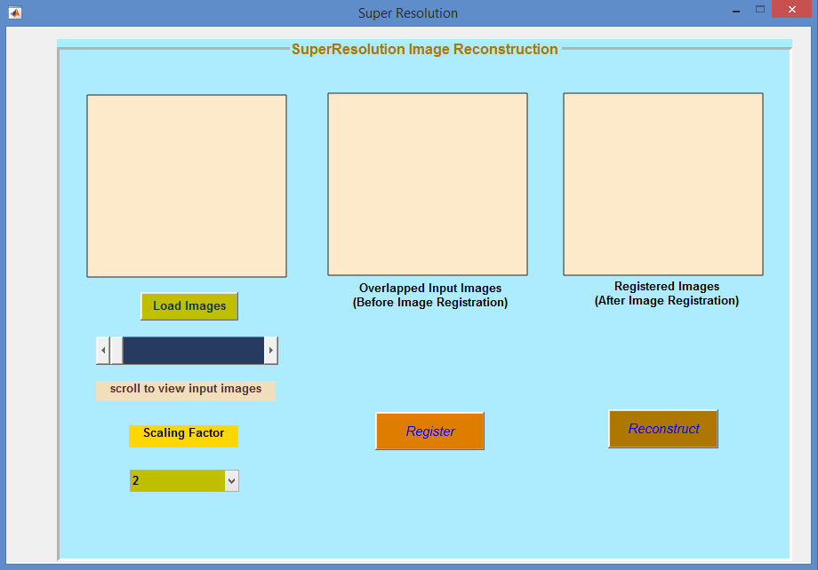
18
We give input and get results through this gui.

RESULTS AFTER IMAGE RECONSTRUCTION :

After finding the rotation and shift parameters, bicubic interpolation is
applied on input images along with their corresponding motion parameters.
The following are the results after applying interpolation on the input images.

OUTPUT 1:

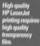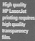
(a)
Input image sequences
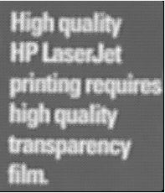
(b) (c)
Input image when zoomed Our output image
(blur value : 0.9063) (blur value : 0.3348)

Fig. 6: Image showing (a) Showing sequence of input images (b) Zoomed Input Image
(c) Output Image after Interpolation. ImageSource:^{[10]}

19
OUTPUT 2 :

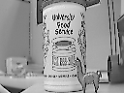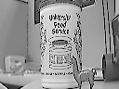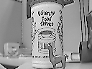
(a)
Input image sequences
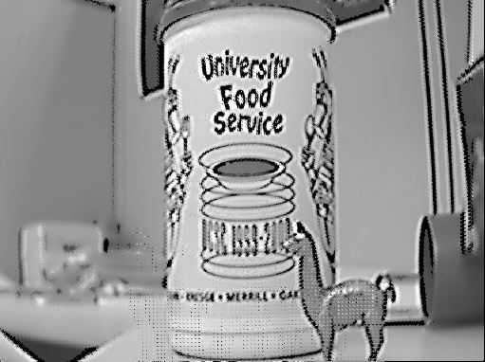
(b) (c)
Input image when zoomed Our output image
(blur value : 0.7578) (blur value : 0.2932)

Fig. 7: Image showing (a) Showing sequence of input images (b) Zoomed Input Image
(c) Output Image after Interpolation. ImageSource:^{[10]}

OUTPUT 3:

(a)
Input image sequences

20

(b) (c)
(blur value : 0.8711) (blur value : 0.3854)

Fig. 8: Image showing (a) Showing sequence of input images (b) Zoomed Input Image
(c) Output Image after Interpolation. ImageSource:^{[10]}
OUTPUT 4:

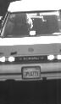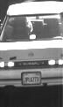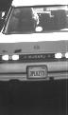
(a)
Input image sequences
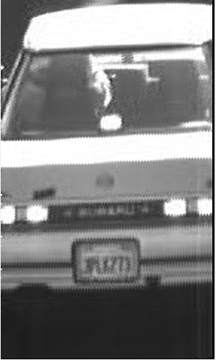
(b) (c)
Input image when zoomed Our output image
(blur value : 0.8274) (blur value : 0.5816)
Fig. 9: Image showing (a) Showing sequence of input images (b) Zoomed Input Image
(c) Output Image after Interpolation. ImageSource:^{[10]}
21
OUTPUT 5:


(a)
Input image sequences
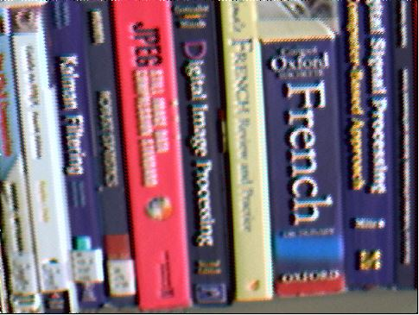
(b) (c)
Input image when zoomed Our output image
(blur value : 0.8031) (blur value : 0.3927)
Fig. 6: Image showing (a) Showing sequence of input images (b) Zoomed Input Image
(c) Output Image after Interpolation. ImageSource:^{[10]}

Validation:

For validation of our results, we have taken blur metric as one of the measure. As it can be easily perceived that more the blurriness in the image lesser the quality of that image. If the value of blur metric is high then that image has less details in it when compared to the image that has less blur metric value. For all the output images which we got, blur metric value is less when compared to its corresponding input images. So it is verified that output image of our algorithm has more details and clear than input images.

22
- Conclusion

In this project, we implemented an algorithm to increase the resolution of low resolution images. In Image Registration, we have used keren method for estimating rotation and translation parameters and FMT method for estimating scaling parameters. For Image Reconstruction, bicubic interpolation is used. The results in the validation also shows that we got better values of blur metric, PSNR and SSIM.

- Future Scope
Our algorithm takes an assumption that all the input images are differed by small changes (i.e., translation, rotation and scaling). If there are large changes between images then it would be better to take the region of interest in every image and apply this algorithm to those images to get better results.

23
- References

[1] Xiaole Yan, Qiu Shen, Xin Liu, “Super-resolution Reconstruction for
License Plate Image in Video Surveillance System” in 10th International Conference on Communications and Networking in China-2015.
[2] Yixiong Zhang, Mingliang Tao, Kewei Yang, and Zhenmiao Deng, “Video Superresolution Reconstruction Using Iterative Back Projection with Critical-Point Filters Based Image Matching,” Advances in Multimedia-2015.
[3] K. V. Suresh, G. Mahesh Kumar, and A. N. Rajagopalan, “Superresolution of License Plates in Real Traffic Videos”, IEEE Transactions on Intelligent Transportation Systems, Vol. 8, No. 2, June 2007.
[4] Liangpei Zhang, HongyanZhang, HuanfengShen, PingxiangLi, “A super-resolution reconstruction algorithm for surveillance images”, Elsevier-2009.
[5] K. Zarei Zefreh, W. van Aarle, K. J. Batenburg, and J. Sijbers, “Super-Resolution of License Plate Images using Algebraic Reconstruction Technique”, Journal of Image and Graphics Vol. 1, No. 2, June 2013.
[6] Dennis Mitzel, Thomas Pock, Thomas Schoeneman, Daniel Cremers, “Video Super Resolution using Duality Based TV-L1 Optical Flow”, Springer-2010.
[7] YUAN Jie, DU Si-dan, ZHU Xiang, “Fast Super-resolution for License Plate Image Reconstruction”, 2008 19th International Conference on Pattern Recognition.
[8] M. S. Sarfraz , A. Shahzad , Muhammad A. Elahi ,M. Fraz , I. Zafar , E. A. Edirisinghe, “Real-time automatic license plate recognition for CCTV forensic applications” , Journal of Real-Time Image Processing Springer-2011.
[9] Xue-fen Wan, Yi Yang, “Super-resolution Image Reconstruction”, 2010 International Conference on Computer Application and System Modeling (ICCASM 2010).
[10] Datasets : users.soe.ucsc.edu/~milanfar/software/sr-datasets.html

24
[11] Fr´ed´erique Cr´et´e-Roffet, Thierry Dolmiere, Patricia Ladret,
Marina Nicolas. The Blur Effect:Perception and Estimation with a
New No-Reference Perceptual Blur Metric. SPIE Electronic Imaging
Symposium Conf Human Vision and Electronic Imaging, Jan 2007,
San Jose, United States. XII, pp.EI 6492-16, 2007
[12] S. C. Park, M. K. Park, and M. G. Kang, “Super-resolution image
reconstruction: A technical review,” IEEE Signal Processing Mag., vol.
20, pp.21–36, May 2003
[13] Sung Cheol Park, Min Kyu Park and Moon Gi Kang, "Super-resolution
image reconstruction: a technical overview," in IEEE Signal Processing
Maga Magazine, vol. 20,no. 3,pp.2136, May2003.
[14] https://www.cse.buffalo.edu/courses/cse725/peter/Presentations/MApte.
ppt

25
Suggestions of Board Members

26

