React_NodeJs_MySql_Login_Signup

Open CMD

E:\React Project\React_NodeJs_MySql_Login_Signup>mkdir backend

E:\React Project\React_NodeJs_MySql_Login_Signup>cd backend

E:\React Project\React_NodeJs_MySql_Login_Signup\backend>npm init -y

Wrote to E:\React Project\React_NodeJs_MySql_Login_Signup\backend\package.json:

{

"name": "backend",

"version": "1.0.0",

"description": "",

"main": "index.js",

"scripts": {

"test": "echo \"Error: no test specified\" && exit 1"

},

"keywords": [],

"author": "",

"license": "ISC"

}

E:\React Project\React_NodeJs_MySql_Login_Signup\backend>npm i mysql express cors nodemon

added 109 packages, and audited 110 packages in 4s

14 packages are looking for funding

run `npm fund` for details

found 0 vulnerabilities

E:\React Project\React_NodeJs_MySql_Login_Signup\backend>code .

Now open in vs code and create bankend/server.js

E:\React Project\React_NodeJs_MySql_Login_Signup>npx create-react-app frontend

E:\React Project\React_NodeJs_MySql_Login_Signup>cd frontend

E:\React Project\React_NodeJs_MySql_Login_Signup\frontend>npm start

E:\React Project\React_NodeJs_MySql_Login_Signup\frontend>npm i bootstrap react-router-dom

Create login.js in src folder

Login.js

import React from 'react'

function Login() {

  return (

    <div className='d-flex justify-content-center align-items-center bg-primary vh-100' >

    <div className='bg-white p-3 rounded w-25' >

     <form action=''>

        <div className='mb-3'>

            <label htmlFor="email"><strong>Email</strong></label>

            <input type="email" id="email" name="email" placeholder='Enter Email' className='form-control rounded-0' />

        </div>

        <div className='mb-3'>

            <label htmlFor="password"><strong>Password</strong></label>

            <input type="password" id="password" name="password" placeholder='Enter Password' className='form-control rounded-0'/>

        </div>

        <button className='btn btn-success w-100 rounded-0' type='submit'><strong>Login</strong></button>

        <p>You are agree to our terms and condition? </p>

        <button className='btn btn-default border w-100 bg-light rounded-0' type='submit'><strong>Register</strong></button>

     </form>

     </div>

    </div>

  );

}

export default Login;

App.js

import Login from "./login";

function App() {

  return (

    <div className="App">

      <Login/>

    </div>

  );

}

export default App;

index.js

import 'bootstrap/dist/css/bootstrap.min.css';

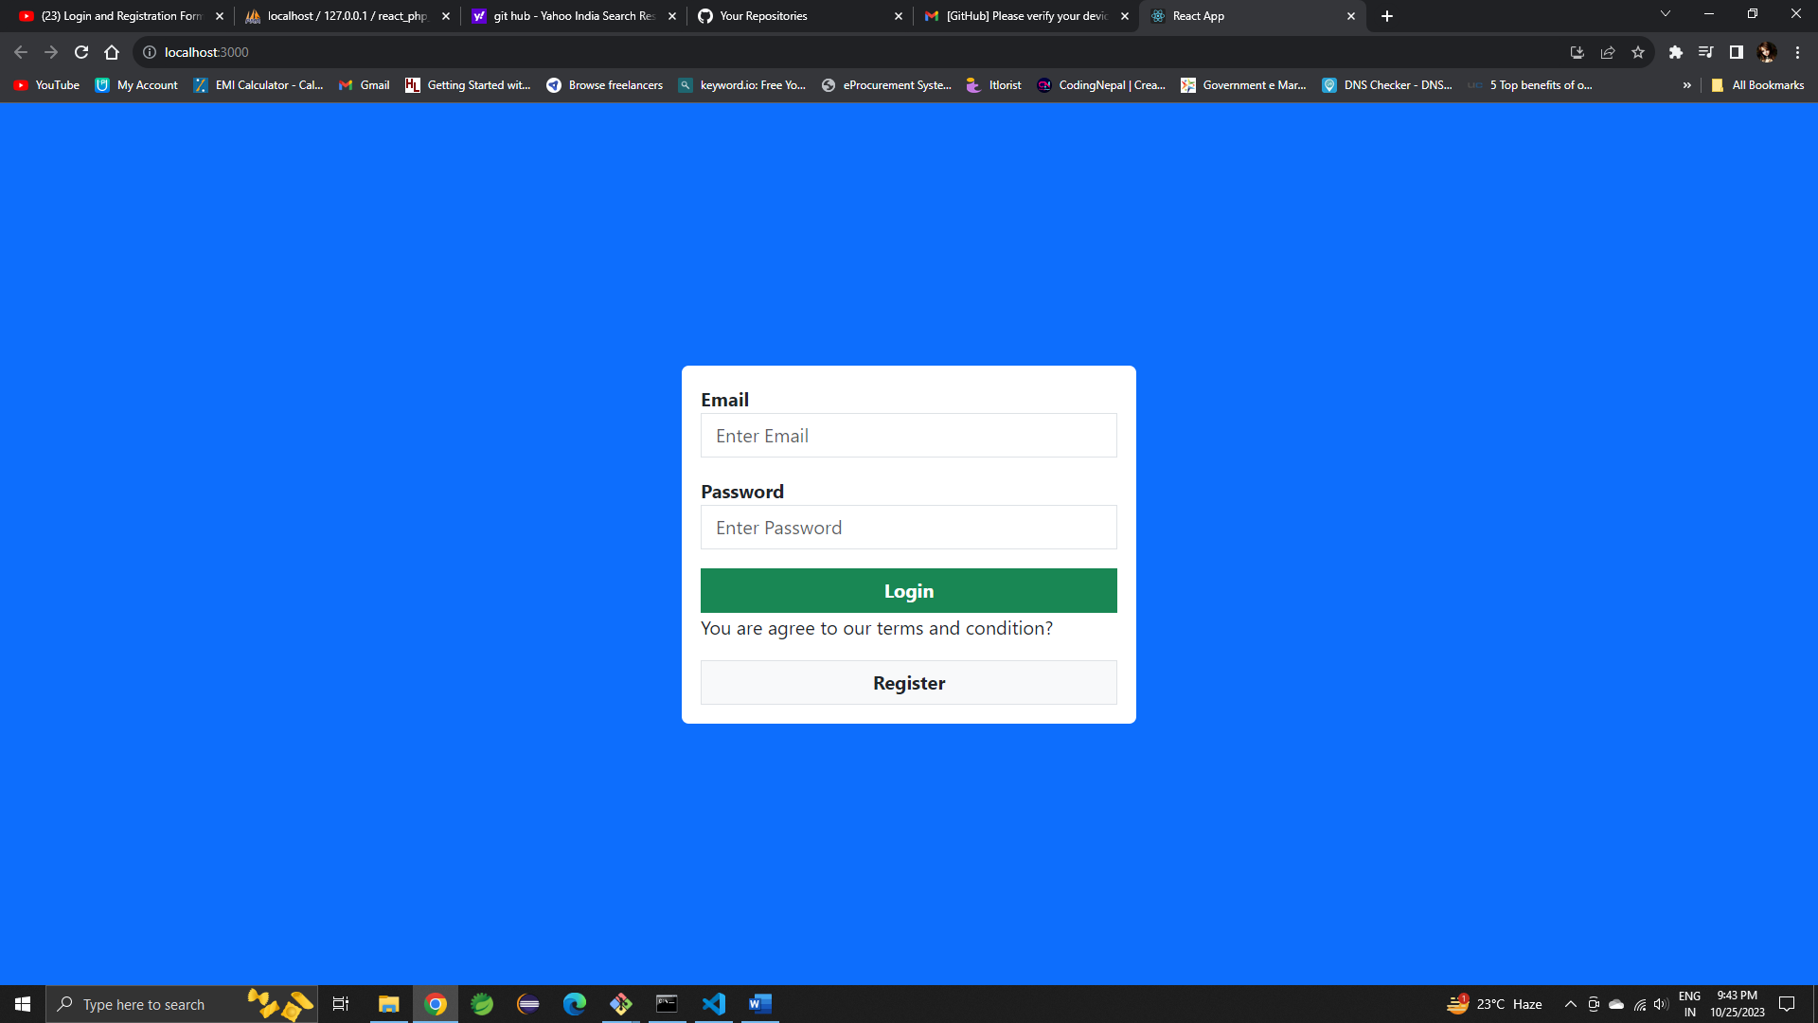

Creating Routes

App.js

import React from "react";

import Login from "./login";

import Login from "./Signup";

import {BrowserRouter, Router, Route, Routes} from 'react-router-dom';

function App() {

  return (

    <BrowserRouter>

    <Routes>

      <Route path="/" element={<Login/>}/>

      <Route path="/signup" element={<Signup/>}/>

    </Routes>

    </BrowserRouter>

  );

}

export default App;

Login.js

import React from 'react'

import { Link } from 'react-router-dom';

function Login() {

  return (

    <div className='d-flex justify-content-center align-items-center bg-primary vh-100' >

    <div className='bg-white p-3 rounded w-25' >

    <h2>Login</h2>

     <form action=''>

        <div className='mb-3'>

            <label htmlFor="email"><strong>Email</strong></label>

            <input type="email" id="email" name="email" placeholder='Enter Email' className='form-control rounded-0' />

        </div>

        <div className='mb-3'>

            <label htmlFor="password"><strong>Password</strong></label>

            <input type="password" id="password" name="password" placeholder='Enter Password' className='form-control rounded-0'/>

        </div>

        <button className='btn btn-success w-100 rounded-0' type='submit'><strong>Login</strong></button>

        <p>You are agree to our terms and condition? </p>

        <Link to='/Signup' className='btn btn-default border w-100 bg-light rounded-0 text-decoration-none' type='submit'><strong>Sign-Up</strong></Link>

     </form>

     </div>

    </div>

  );

}

export default Login;

CreateSignup.jsin src folder

Signup.js

import React from 'react'

import { Link } from 'react-router-dom';

function Signup() {

  return (

    <div className='d-flex justify-content-center align-items-center bg-primary vh-100' >

    <div className='bg-white p-3 rounded w-25' >

        <h2>Signup</h2>

     <form action=''>

        <div className='mb-3'>

            <label htmlFor="name"><strong>Name</strong></label>

            <input type="text" id="name" name="name" placeholder='Enter Name' className='form-control rounded-0' />

        </div>

        <div className='mb-3'>

            <label htmlFor="email"><strong>Email</strong></label>

            <input type="email" id="email" name="email" placeholder='Enter Email' className='form-control rounded-0' />

        </div>

        <div className='mb-3'>

            <label htmlFor="password"><strong>Password</strong></label>

            <input type="password" id="password" name="password" placeholder='Enter Password' className='form-control rounded-0'/>

        </div>

        <button className='btn btn-success w-100 rounded-0' type='submit'><strong>Sign-Up</strong></button>

        <p>You are agree to our terms and condition? </p>

        <Link to='/' className='btn btn-default border w-100 bg-light rounded-0 text-decoration-none' type='submit'><strong>Login</strong></Link>

     </form>

     </div>

    </div>

  );

}

export default Signup;

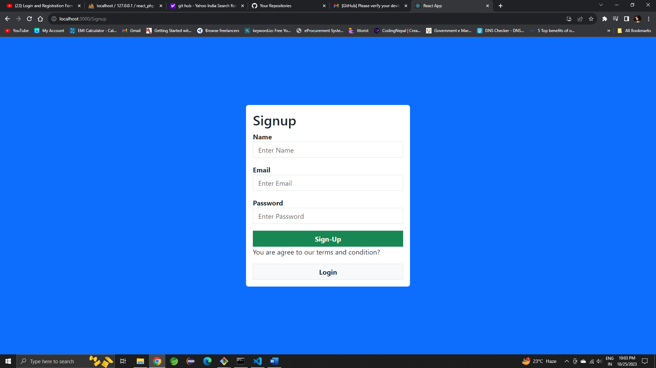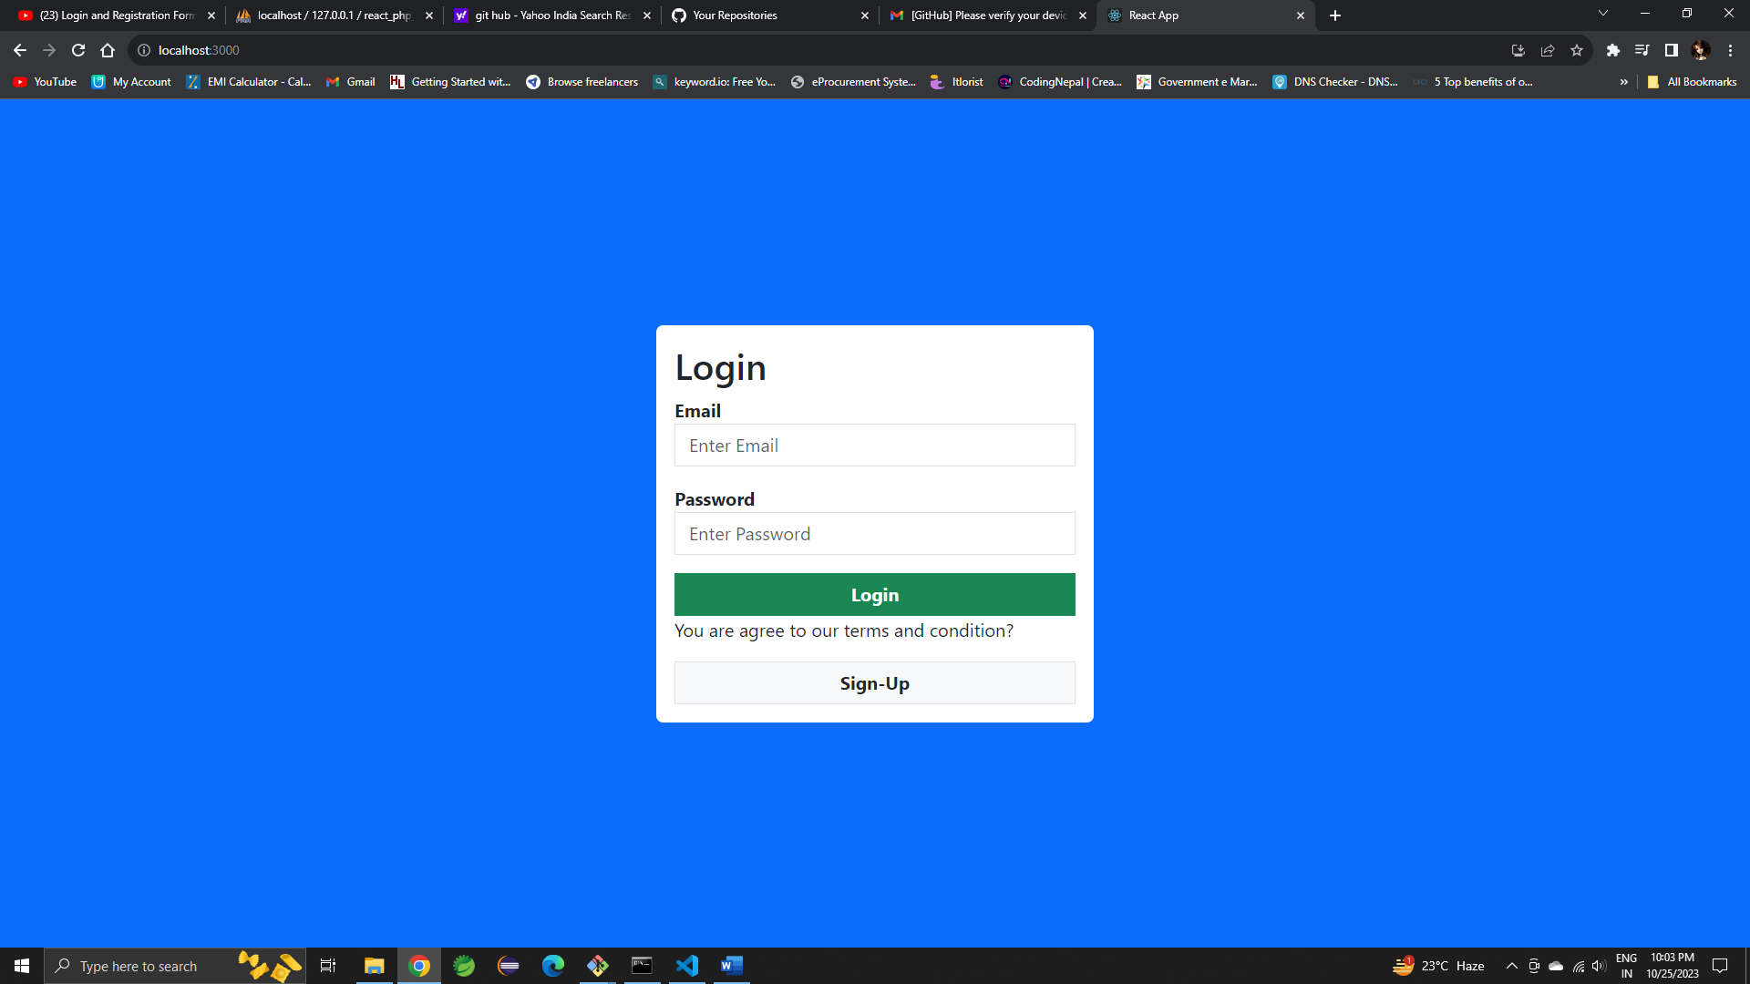

Creating Validation File

Login.js add this

import React from 'react'

import { Link } from 'react-router-dom';

import { useState } from 'react';

import Validation from './loginValidation';

function Login() {

    const[values, setValues] = useState({

        email:'',

        password:''

    })

    const [errors, setErrors] = useState({});

    const handleInput = (e) => {

        setValues(prev=>({...prev, [e.target.name]:[e.target.value]}))

    }

    const handleSubmit = (e) => {

        e.preventDefault();

        console.log(values);

        setErrors(Validation(values));

    }

  return (

    <div className='d-flex justify-content-center align-items-center bg-primary vh-100' >

    <div className='bg-white p-3 rounded w-25' >

    <h2>Login</h2>

     <form action=''onSubmit={handleSubmit}>

        <div className='mb-3'>

            <label htmlFor="email"><strong>Email</strong></label>

            <input type="email" id="email" name="email" placeholder='Enter Email' className='form-control rounded-0' onChange={handleInput} />

        </div>

        <div className='mb-3'>

            <label htmlFor="password"><strong>Password</strong></label>

            <input type="password" id="password" name="password" placeholder='Enter Password' className='form-control rounded-0' onChange={handleInput} />

        </div>

        <button className='btn btn-success w-100 rounded-0' type='submit'><strong>Login</strong></button>

        <p>You are agree to our terms and condition? </p>

        <Link to='/Signup' className='btn btn-default border w-100 bg-light rounded-0 text-decoration-none' type='submit'><strong>Sign-Up</strong></Link>

     </form>

     </div>

    </div>

  );

}

export default Login;

loginValidation.js

function Validation(values){

    let error={}

    const email_pattern = /^[a-zA-Z0-9._-]+@[a-zA-Z0-9.-]+\.[a-zA-Z]{2,4}$/

    const password_pattern = /^(?=.*[a-z])(?=.*[A-Z])(?=.*\d)(?=.*[@$!%*?&])[A-Za-z\d@$!%*?&]{8,}$/

    if(values.email === ""){

        error.email = "Email is required"

    }

    else if(!email_pattern.test(values.email)){

        error.email = "Email didn't match"

    }else{

        error.email = ""

    }

    if(values.password === ""){

        error.password = "Password is required"

    }

    else if(!password_pattern.test(values.password)){

        error.password = "Password didn't match"

    }else{

        error.password = ""

    }

    return error;

}

export default Validation;

Now set errors

Login.js add this code

<div className='mb-3'>

            <label htmlFor="email"><strong>Email</strong></label>

            <input type="email" id="email" name="email" placeholder='Enter Email' className='form-control rounded-0' onChange={handleInput} />

           {errors.email &&  <span className='text-danger'>{errors.email}</span>}

        </div>

        <div className='mb-3'>

            <label htmlFor="password"><strong>Password</strong></label>

            <input type="password" id="password" name="password" placeholder='Enter Password' className='form-control rounded-0' onChange={handleInput} />

            {errors.password &&  <span className='text-danger'>{errors.password}</span>}

        </div>

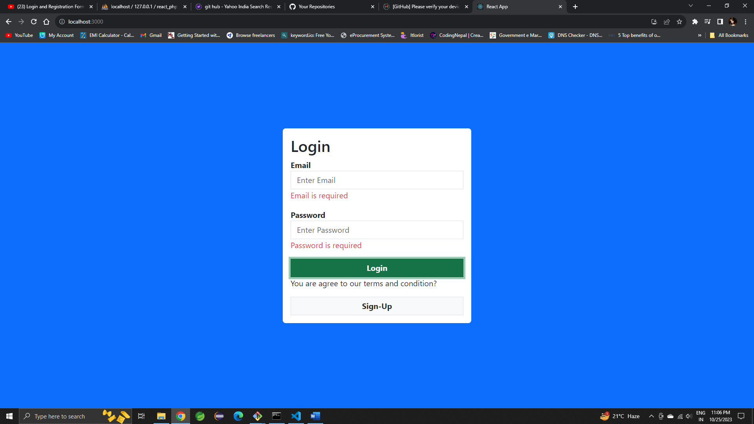

Validation for Signup.js

Create src/signupValidation.js

function Validation(values){

    let error={}

    const email_pattern = /^[a-zA-Z0-9._-]+@[a-zA-Z0-9.-]+\.[a-zA-Z]{2,4}$/

    const password_pattern = /^(?=.*[a-z])(?=.*[A-Z])(?=.*\d)(?=.*[@$!%*?&])[A-Za-z\d@$!%*?&]{8,}$/

    if(values.name === ""){

        error.name = "Name is required"

    }

    else{

        error.name = ""

    }

    if(values.email === ""){

        error.email = "Email is required"

    }

    else if(!email_pattern.test(values.email)){

        error.email = "Email didn't match"

    }else{

        error.email = ""

    }

    if(values.password === ""){

        error.password = "Password is required"

    }

    else if(!password_pattern.test(values.password)){

        error.password = "Password didn't match"

    }else{

        error.password = ""

    }

    return error;

}

export default Validation;

signup.js

import React,{useState} from 'react'

import { Link } from 'react-router-dom';

import Validation from './signupValidation';

function Signup() {

    const[values, setValues] = useState({

        name:'',

        email:'',

        password:''

    })

    const [errors, setErrors] = useState({});

    const handleInput = (e) => {

        setValues(prev=>({...prev, [e.target.name]:[e.target.value]}))

    }

    const handleSubmit = (e) => {

        e.preventDefault();

        console.log(values);

        setErrors(Validation(values));

    }

  return (

    <div className='d-flex justify-content-center align-items-center bg-primary vh-100' >

    <div className='bg-white p-3 rounded w-25' >

        <h2>Signup</h2>

     <form action='' onSubmit={handleSubmit}>

        <div className='mb-3'>

            <label htmlFor="name"><strong>Name</strong></label>

            <input type="text" id="name" name="name" placeholder='Enter Name' className='form-control rounded-0' onChange={handleInput} />

            {errors.name &&  <span className='text-danger'>{errors.name}</span>}

        </div>

        <div className='mb-3'>

            <label htmlFor="email"><strong>Email</strong></label>

            <input type="email" id="email" name="email" placeholder='Enter Email' className='form-control rounded-0' onChange={handleInput}/>

            {errors.email &&  <span className='text-danger'>{errors.email}</span>}

        </div>

        <div className='mb-3'>

            <label htmlFor="password"><strong>Password</strong></label>

            <input type="password" id="password" name="password" placeholder='Enter Password' className='form-control rounded-0' onChange={handleInput}/>

            {errors.password &&  <span className='text-danger'>{errors.password}</span>}

        </div>

        <button className='btn btn-success w-100 rounded-0' type='submit'><strong>Sign-Up</strong></button>

        <p>You are agree to our terms and condition? </p>

        <Link to='/' className='btn btn-default border w-100 bg-light rounded-0 text-decoration-none' type='submit'><strong>Login</strong></Link>

     </form>

     </div>

    </div>

  );

}

export default Signup;

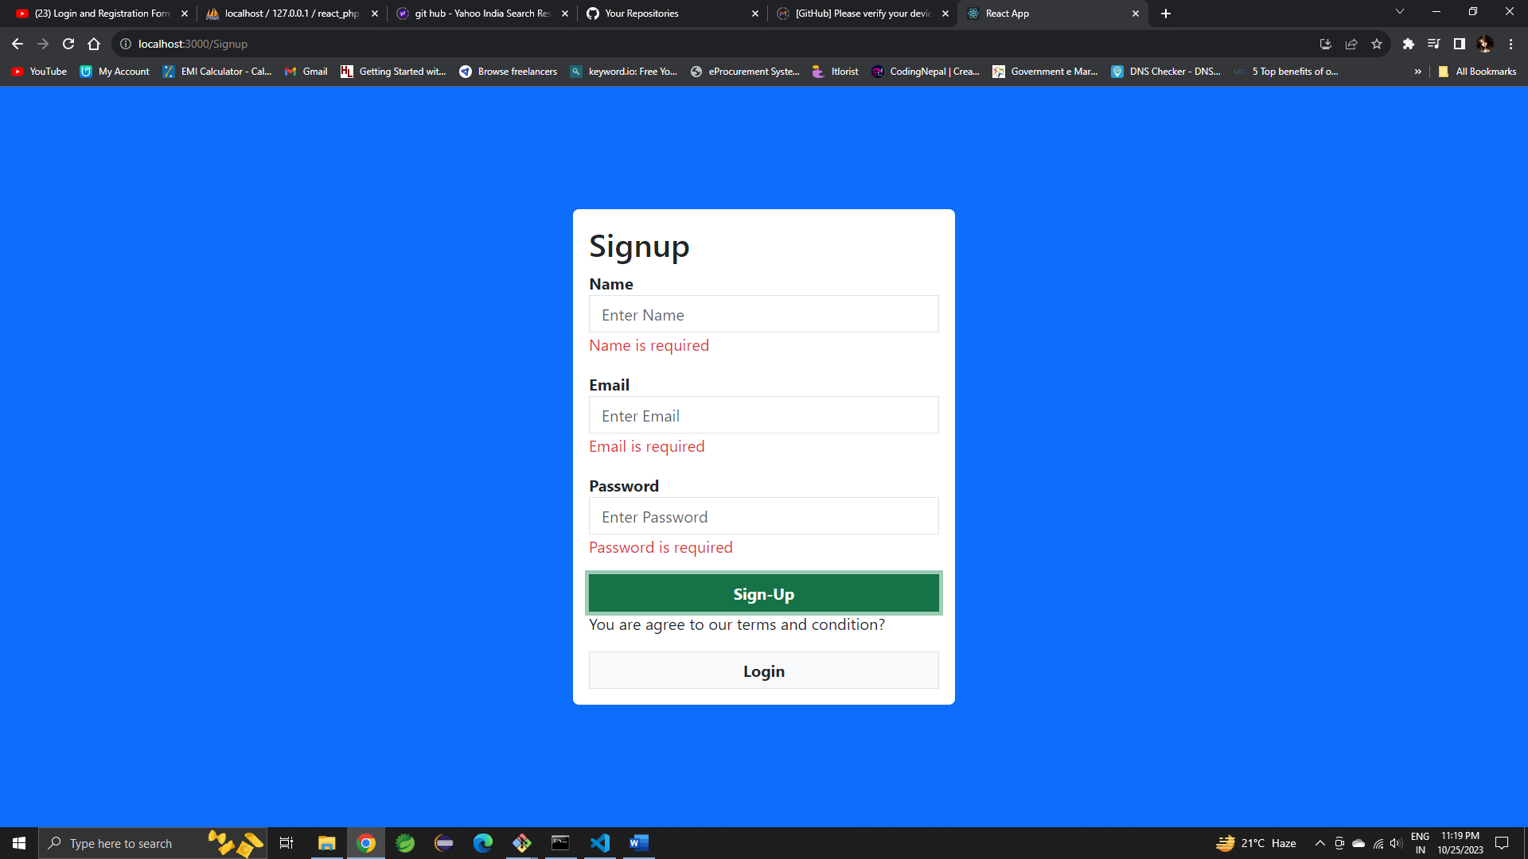

Backend Code

Server.js

const express = require("express");

const mysql = require("mysql");

const cors = require("cors");

const app = express();

app.use(cors());

app.use(express.json());

const db = mysql.createConnection({

    host: "localhost",

    user: "root",

    password: "",

    database: "react_nodejs",

})

app.post("/signup", (req, res) => {

  const sql = "INSERT INTO users (`name`, `email`,`password`) VALUES (?)";

  const values = [

   req.body.name,

   req.body.email,

   req.body.password

  ]

  db.query(sql, [values], (err, data) => {

    if(err) return res.json(err);

    return res.json(data);

  })

})

app.listen(8081, () => {

    console.log("Server is running on port 8081");

})

Package.json

"scripts": {

    "test": "echo \"Error: no test specified\" && exit 1",

    "start":"nodemon server.js"

  },

PS E:\React Project\React_NodeJs_MySql_Login_Signup\backend> npm install axios

PS E:\React Project\React_NodeJs_MySql_Login_Signup\backend>npm start

Signup.js

import React,{useState} from 'react'

import { Link } from 'react-router-dom';

import Validation from './signupValidation';

import axios from 'axios';

function Signup() {

    const[values, setValues] = useState({

        name:'',

        email:'',

        password:''

    })

    const [errors, setErrors] = useState({});

    const handleInput = (e) => {

        setValues(prev=>({...prev, [e.target.name]:[e.target.value]}))

    }

    const handleSubmit = (e) => {

        e.preventDefault();

        console.log(values);

        setErrors(Validation(values));

        if(errors.name === '' && errors.email === '' && errors.password === '') {

            axios.post('http://localhost:8081/signup', values)

            .then(res => console.log(res))

            .catch(err => console.log(err));

        }

    }

  return (

    <div className='d-flex justify-content-center align-items-center bg-primary vh-100' >

    <div className='bg-white p-3 rounded w-25' >

        <h2>Signup</h2>

     <form action='' onSubmit={handleSubmit}>

        <div className='mb-3'>

            <label htmlFor="name"><strong>Name</strong></label>

            <input type="text" id="name" name="name" placeholder='Enter Name' className='form-control rounded-0' onChange={handleInput} />

            {errors.name &&  <span className='text-danger'>{errors.name}</span>}

        </div>

        <div className='mb-3'>

            <label htmlFor="email"><strong>Email</strong></label>

            <input type="email" id="email" name="email" placeholder='Enter Email' className='form-control rounded-0' onChange={handleInput}/>

            {errors.email &&  <span className='text-danger'>{errors.email}</span>}

        </div>

        <div className='mb-3'>

            <label htmlFor="password"><strong>Password</strong></label>

            <input type="password" id="password" name="password" placeholder='Enter Password' className='form-control rounded-0' onChange={handleInput}/>

            {errors.password &&  <span className='text-danger'>{errors.password}</span>}

        </div>

        <button className='btn btn-success w-100 rounded-0' type='submit'><strong>Sign-Up</strong></button>

        <p>You are agree to our terms and condition? </p>

        <Link to='/' className='btn btn-default border w-100 bg-light rounded-0 text-decoration-none' type='submit'><strong>Login</strong></Link>

     </form>

     </div>

    </div>

  );

}

export default Signup;

server.js

const express = require("express");

const mysql = require("mysql");

const cors = require("cors");

const app = express();

app.use(cors());

app.use(express.json());

const db = mysql.createConnection({

    host: "localhost",

    user: "root",

    password: "",

    database: "react_nodejs",

})

app.post("/signup", (req, res) => {

  const sql = "INSERT INTO users (`name`, `email`,`password`) VALUES (?)";

  const values = [

   req.body.name,

   req.body.email,

   req.body.password

  ]

  db.query(sql, [values], (err, data) => {

    if(err) return res.json(err);

    return res.json(data);

  })

})

app.post("/login", (req, res) => {

    const sql = "SELECT * FROM login WHERE  `email`=? AND `password`=?";

    db.query(sql, [req.body.email, req.body.password ], (err, data) => {

      if(err) return res.json(err);

      if(data.length > 0){

        return res.json(data);

      }

      else{

        return res.json("Failed ...Invalid Email or Password");

      }

    })

  })

app.listen(8081, () => {

    console.log("Server is running on port 8081");

})