e-Journal

on

ADVANCED COMPUTER NETWORKS

SUBMITTED BY

**KALLIL RAHUL RAVIDNRAN**

ROLL NO:05

Submitted in partial fulfilment of the requirement for

Qualifying

M.Sc. Part I Semester II Examination

2018-19

Department of Information Technology

Ramniranjan Jhunjhunwala College

Station Road, Ghatkopar (w), Mumbai-86



**CERTIFICATE**

This is to certify that Mr. KALLIL RAHUL RAVINDRAN with Seat No. 05 has successfully completed the necessary course of experiments in the subject of **ADVANCED COMPUTER NETWORKS**  during the academic year **2018 – 2019** complying with the requirements of **RAMNIRANJAN JHUNJHUNWALA COLLEGE OF ARTS, SCIENCE AND COMMERCE**, for the course of **M.Sc. (IT)** semester -II.

Internal Examiner Date:

Head of Department College Seal External Examiner

**INDEX**

|  |  |  |  |
| --- | --- | --- | --- |
| **Sr. No** | **Practical** | **Date** | **Page No.** |
| 1 | Simulating RIP | 19-12-2018 | 3 |
| 2 | Simulating OSPF | 02-01-2019 | 18 |
| 3 | Simulating OSPF with Stub AREA, NSSA, Restricting LSAs | 09-01-2019 | 32 |
| 4 | Simulating BGP | 16-01-2019 | 43 |
| 5 | Simulating IBGP | 23-01-2019 | 54 |
| 6 | Simulating EBGP | 01-02-2019 | 59 |
| 7 | Configuring IP Multicasting Routing | 02-02-2019 | 47 |
| 8 | A. Simulating Routing Redistribution  B. Redistribution between EIGRP and OSPF | 06-02-2019 | 70 |
| 9 | Designing A Remote Access VPN | 08-02-2019 | 81 |

PRACTICAL NUMBER 1

Simulating RIP

Overview of Commands:

**Step 1:- Configure all routers.**

1) Right click each router and click configure

2) Select r1 and slots and select adapters for slots 0, 1, 2

3) Fill slot 0, slot1, slot 2 and click ok.

4) Do step 1 to 3 for all other routers.

**Step 2:- Configure network and RIP for all routers.**

# interface f0/0

# ip address 10.1.1.1 255.255.255.0

# no shut

**Step 3:- Displaying the interface brief:**

#show ip interface brief

**Displaying the details about neighbouring devices of all routers:**

#show cdp neighbors

**Step 4:- Configure RIP for all routers.**

# router rip

# network 10.1.1.0

# no auto-summary

**Step 5:- Displaying the current configuration of all routers:**

R1#show running

**Displaying the Routing Table:**

R1#show ip route

**Step 6:- Performing ping to check connectivity amongst routers:**

#ping 10.0.23.1

**Step 7:- Configuring RIP Authentication on the Routers:**

#key chain acn

#key 1

#key-string rippracts

**Configuring the RIP Authentication Mode (MD5) on the interface of routers:**

int s0/0

R1(config-if)#ip rip authentication key-chain acn

R1(config-if)#ip rip authentication mode md5

**Verifying RIP Authentication mode on the routers:**

#debug ip rip

**Enabling Split Horizon on the routers:**

# int s0/0

# R4(config-if)#ip split-horizon

**Disabling Split Horizon on the routers:**

# int s0/0

# no ip split-horizon

**Configuring Router to send and receive RIP version updates:**

int f0/0

R2(config-if)#ip rip receive version 1

R2(config-if)#ip rip send version 2

**Topology:-**

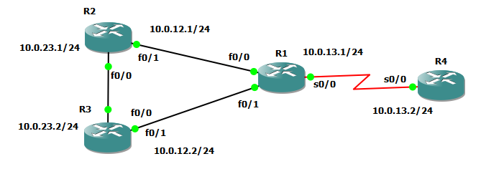

**Assigning IP addresses to R1:**

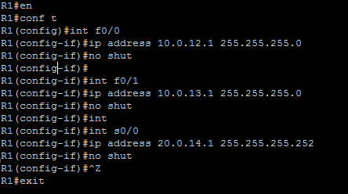

**Assigning IP addresses to R2:**

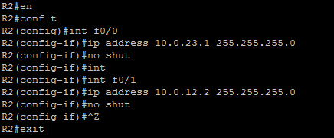

**Assigning IP addresses to R3:**

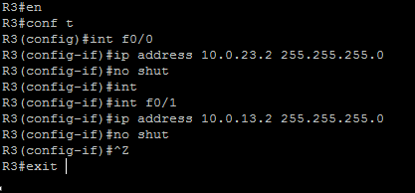

**Assigning IP addresses to R4:**

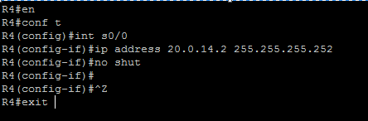

**OUTPUT:**

**For R1:** 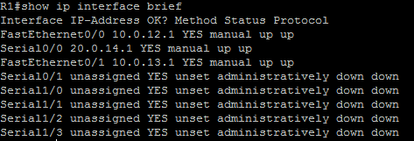

**For R2:** 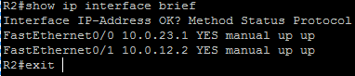

**For R3:** 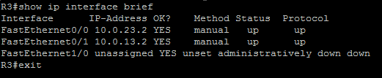

**For R4:** 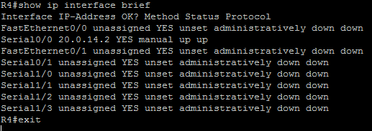

**Displaying the details about neighbouring devices of all routers:**

**For R1:** 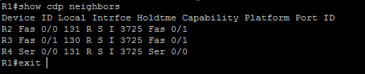

**For R2:** 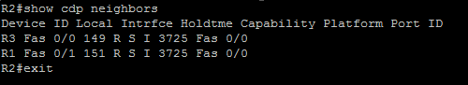

**For R3:** 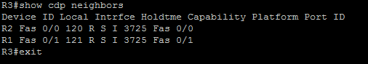

**For R4:** 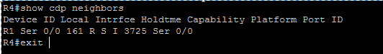

**Configuring RIP on the routers:**

**For R1:** 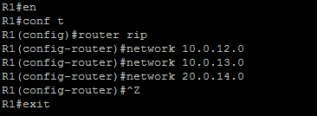

**For R2:** 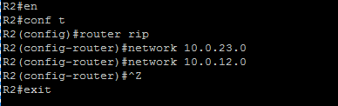

**For R3:** 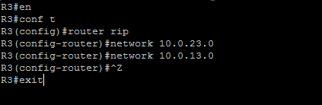

**For R4:** 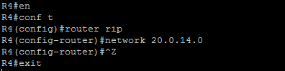

**Displaying the current configuration of all routers:**

**For R1:** 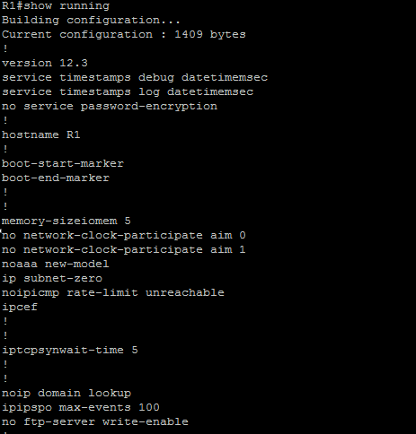

**For R2:** 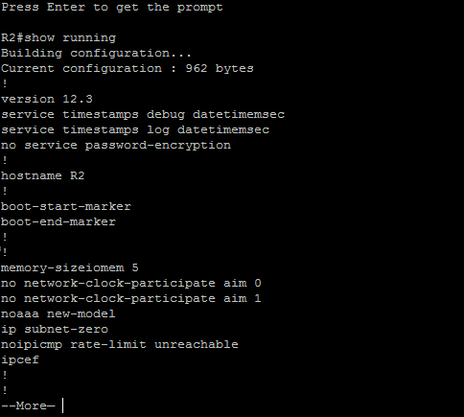

**For R3:** 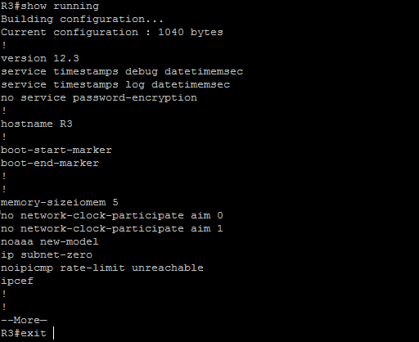

**For R4:** 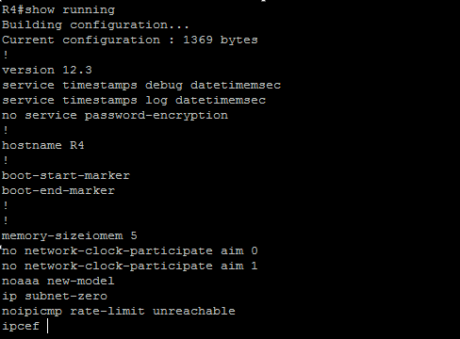

**Output Routing Tables:**

**For R1:** 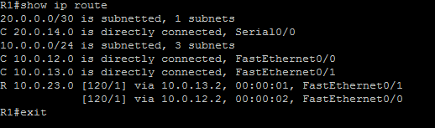

**For R2:** 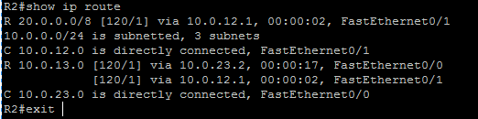

**For R3:** 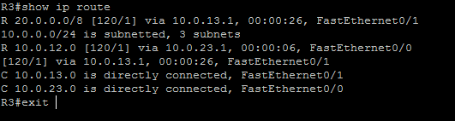

**For R4:** 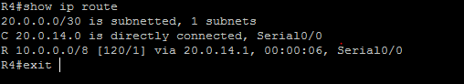

**Performing ping to check connectivity amongst routers:**

**For R1:** 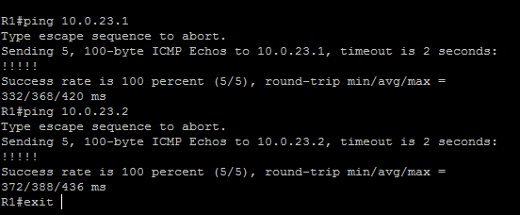

**For R2:** 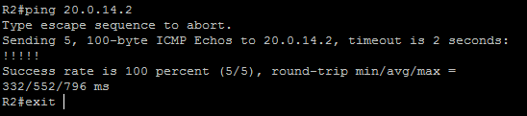

**For R3:** 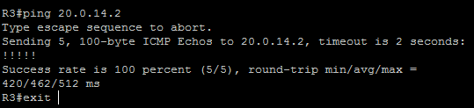

**For R4:** 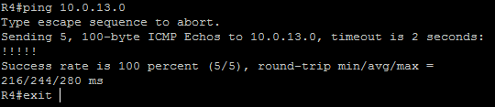

**Configuring the RIP Authentication Mode (MD5) on the interface of routers:**

**For R1:**

R1#en

R1#conf t

R1(config)#int s0/0

R1(config-if)#ip rip authentication key-chain acn

R1(config-if)#ip rip authentication mode md5

R1(config-if)#^Z

R1#exit

**For R4:**

R4#en

R4#conf t

R4(config)#int s0/0

R4(config-if)#ip rip authentication key-chain acn

R4(config-if)#ip rip authentication mode md5

R4(config-if)#^Z

R4#exit

**Configuring the RIP Authentication Mode (Text [default]) on the interface of routers:**

**For R2:**

R2#en

R2#conf t

R2(config)#int f0/0

R2(config-if)#ip rip authentication key-chain acn1

R2(config-if)#^Z

R2#exit

**For R3:**

R3#en

R3#conf t

R3(config)#int f0/0

R3(config-if)#ip rip authentication key-chain acn1

R3(config-if)#^Z

R3#exit

**Verifying RIP Authentication mode on the routers:**

For R2: 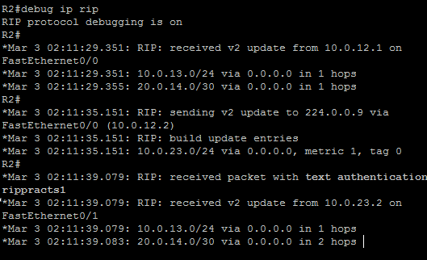

For R3: 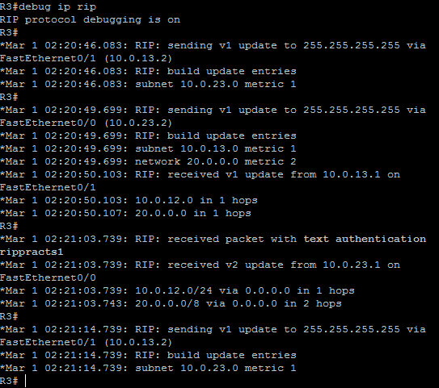

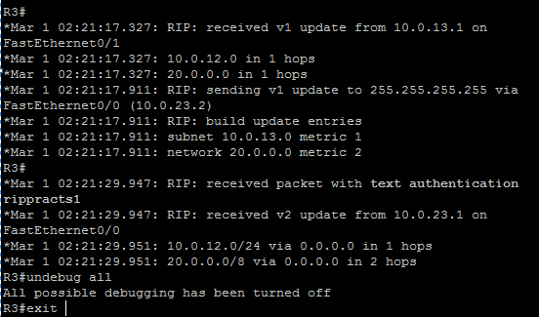

For R4: 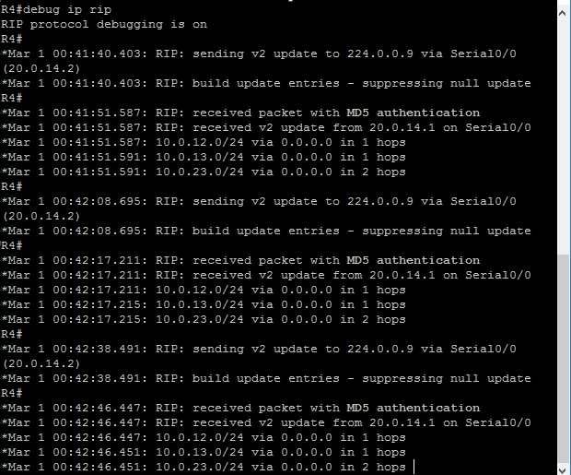

**Enabling Split Horizon on the routers:**

**For R4:**

R4#en

R4#conf t

R4(config)#int s0/0

R4(config-if)#ip split-horizon

R4(config-if)#^Z

R4#exit

**Disabling Split Horizon on the routers:**

**For R4:**

R4#en

R4#conf t

R4(config)#int s0/0

R4(config-if)#no ip split-horizon

R4(config-if)#^Z

R4#exit

**Configuring Router to send and receive RIP version updates:**

**For R2:**

R2#en

R2#conf t

R2(config)#int f0/0

R2(config-if)#ip rip receive version 1

R2(config-if)#ip rip send version 2

R2(config-if)#

R2(config-if)#^Z

R2#exit

PRACTICAL NUMBER 2

Simulating OSPF

Overview of Commands:

Practical 2A: Simulating OSPF in Broadcast Routers Using a topology of five routers as shown in the below picture.

OVERVIEW OF COMMANDS

**Step 1:- Assigning IP addresses to R1**

config)#int f0/0

R1(config-if)#ip address 10.0.12.1 255.255.255.0

R1(config-if)#no shut

**Configuring OSPF on the routers**

R1(config)#router ospf 1

R1(config-router)#network 10.0.12.0 0.0.0.255 area 0

R1(config-router)#network 10.0.13.0 0.0.0.255 area 0

R1(config-router)#^Z

**Displaying the details about neighbouring devices of all routers:**

R1#show ip ospf neighbor

**Routing Table of all routers:**

R1#show ip route

**Performing ping to check connectivity amongst routers:**

R1#ping 20.0.24.2

**Specifying Router Priority for DR and BDR Election (R1 is the DR for interface f0/1 with highest of priority 255):**

int f0/0

R1(config-if)#ip ospf priority 0

R1(config-if)#!

R1(config-if)#int f0/1

R1(config-if)#ip ospf priority 255

**Displaying Interface Data Structure of interface 0/1 of R2 and interface 0/1 of R3:**

R2#show ip ospf int f0/1

**Changing Hello and Dead Interval of the routers:**

interface fastethernet0/1

R2(config-if)#ip ospf hello-interval 9

**Displaying Interface Data Structure of interface 0/1 of R2 and interface 0/1 of R3 after changing the hello and dead intervals of interface 0/1 of R2 and interface 0/1 of R3.**

R2#show ip ospf int f0/1

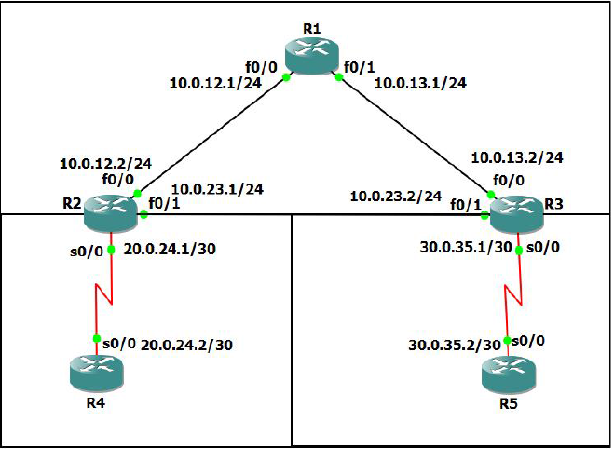

**Assigning IP addresses to R1:**

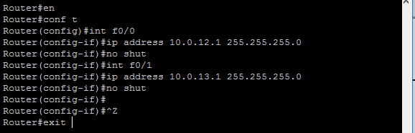

**Assigning IP addresses to R2:**

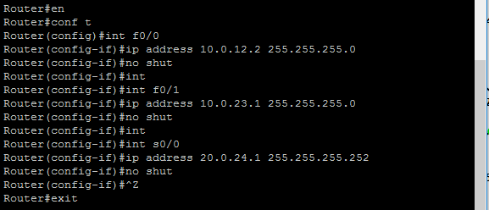

**Assigning IP addresses to R3:**

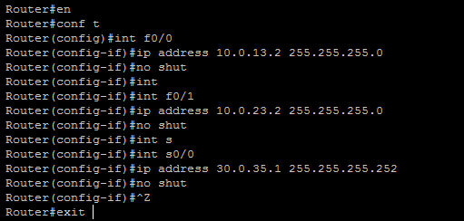

**Assigning IP addresses to R4:**

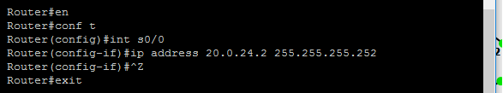

**Assigning IP addresses to R5:**

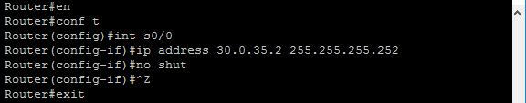

**Configuring OSPF on the routers:**

**For R1:** 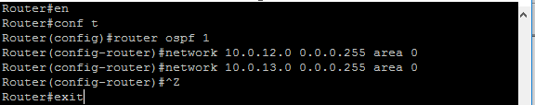

**For R2:** 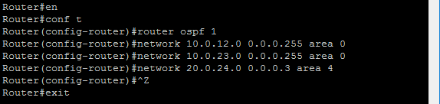

**For R3:** 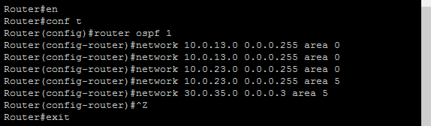

**For R4:** 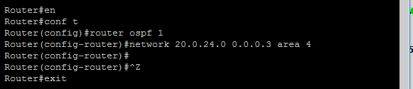

**For R5:** 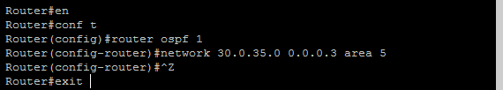

**Displaying the details about neighbouring devices of all routers:**

**For R1:**

Router#show ip ospf neighbor

Neighbor ID Pri State Dead Time Address Interface

30.0.35.1 1 FULL/BDR 00:00:32 10.0.13.2 FastEthernet0/1

20.0.24.1 1 FULL/BDR 00:00:31 10.0.12.2 FastEthernet0/0

**For R2:**

Router#show ip ospf neighbor

Neighbor ID Pri State Dead Time Address Interface

30.0.35.1 1 FULL/BDR 00:00:30 10.0.23.2 FastEthernet0/1

10.0.13.1 1 FULL/DR 00:00:39 10.0.12.1 FastEthernet0/0

20.0.24.2 0 FULL/ - 00:00:31 20.0.24.2 Serial0/0

**For R3:**

Router#show ip ospf neighbor

Neighbor ID Pri State Dead Time Address Interface

20.0.24.1 1 FULL/DR 00:00:37 10.0.23.1 FastEthernet0/1

10.0.13.1 1 FULL/DR 00:00:37 10.0.13.1 FastEthernet0/0

30.0.35.2 0 FULL/ - 00:00:37 30.0.35.2 Serial0/0

**For R4:**

Router#show ip ospf neighbor

Neighbor ID Pri State Dead Time Address Interface

20.0.24.1 0 FULL/ - 00:00:36 20.0.24.1 Serial0/0

**For R5:**

Router#show ip ospf neighbor

Neighbor ID Pri State Dead Time Address Interface

30.0.35.1 0 FULL/ - 00:00:31 30.0.35.1 Serial0/0

OUTPUT:

**Routing Table of all routers:**

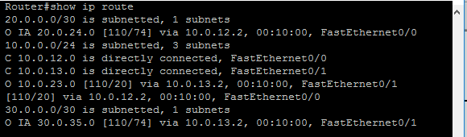

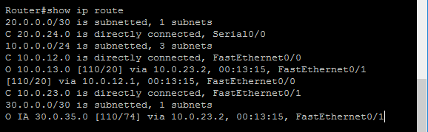

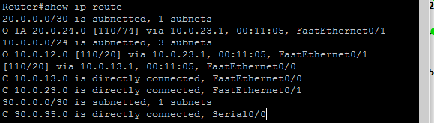

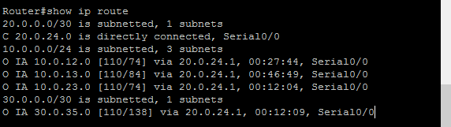

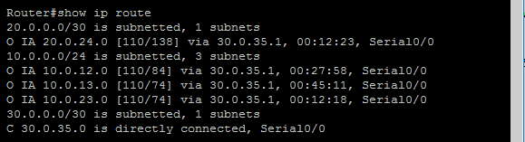

**Performing ping to check connectivity amongst routers:**

For R1: 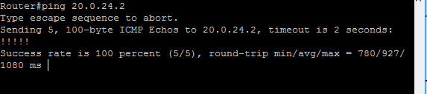

For R2: 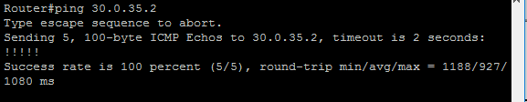

For R3: 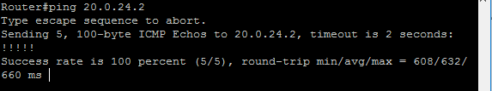

For R4: 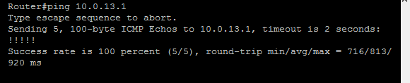

For R5: 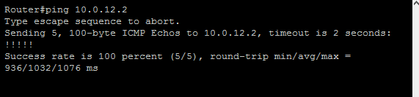

**Specifying Router Priority for DR and BDR Election (R1 is the DR for interface f0/1 with highest of priority 255):**

**For R1:**

Router#en

Router#conf t

Router(config)#int f0/0

Router(config-if)#ip ospf priority 0

Router(config-if)#!

Router(config-if)#int f0/1

Router(config-if)#ip ospf priority 255

Router(config-if)#^Z

Router#exit

**Displaying Interface Data Structure of interface 0/1 of R2 and interface 0/1 of R3:**

**For R2:**

Router#show ip ospf int f0/1

FastEthernet0/1 is up, line protocol is up

Internet Address 10.0.23.1/24, Area 0

Process ID 2, Router ID 20.0.24.1, Network Type BROADCAST, Cost: 10

Transmit Delay is 1 sec, State DR, Priority 1

Designated Router (ID) 20.0.24.1, Interface address 10.0.23.1

Backup Designated router (ID) 30.0.35.1, Interface address 10.0.23.2

Timer intervals configured, **Hello 10, Dead 40**, Wait 40, Retransmit 5

oob-resync timeout 40

Hello due in 00:00:05

Supports Link-local Signaling (LLS)

Index 2/2, flood queue length 0

Next 0x0(0)/0x0(0)

Last flood scan length is 1, maximum is 1

Last flood scan time is 0 msec, maximum is 0 msec

Adjacent with neighbor 30.0.35.1 (Backup Designated Router)

Suppress hello for 0 neighbor(s)

**For R3:**

Router#show ip ospf int f0/1

FastEthernet0/1 is up, line protocol is up

Internet Address 10.0.23.2/24, Area 0

Process ID 1, Router ID 30.0.35.1, Network Type BROADCAST, Cost: 10

Transmit Delay is 1 sec, State BDR, Priority 1

Designated Router (ID) 20.0.24.1, Interface address 10.0.23.1

Backup Designated router (ID) 30.0.35.1, Interface address 10.0.23.2

Timer intervals configured, **Hello 10, Dead 40**, Wait 40, Retransmit 5

oob-resync timeout 40

Hello due in 00:00:08

Supports Link-local Signaling (LLS)

Index 2/2, flood queue length 0

Next 0x0(0)/0x0(0)

Last flood scan length is 1, maximum is 1

Last flood scan time is 0 msec, maximum is 0 msec

Neighbor Count is 1, Adjacent neighbor count is 1

Adjacent with neighbor 20.0.24.1 (Designated Router)

Suppress hello for 0 neighbor(s)

**Changing Hello and Dead Interval of the routers:**

**For R2:**

Router#en

Router#conf t

Router(config)#interface fastethernet0/1

Router(config-if)#ip ospf hello-interval 9

Router(config-if)#^Z

Router#exit

**For R3:**

Router#en

Router#conf t

Router(config)#interface fastethernet0/1

Router(config-if)#ip ospf hello-interval 9

Router(config-if)#^Z

Router#exit

**Displaying Interface Data Structure of interface 0/1 of R2 and interface 0/1 of R3 after changing the hello and dead intervals of interface 0/1 of R2 and interface 0/1 of R3.**

**For R2:**

Router#show ip ospf int f0/1

FastEthernet0/1 is up, line protocol is up

Internet Address 10.0.23.1/24, Area 0

Process ID 2, Router ID 20.0.24.1, Network Type BROADCAST, Cost: 10

Transmit Delay is 1 sec, State BDR, Priority 1

Designated Router (ID) 30.0.35.1, Interface address 10.0.23.2

Backup Designated router (ID) 20.0.24.1, Interface address 10.0.23.1

Flush timer for old DR LSA due in 00:02:49

Timer intervals configured, **Hello 9, Dead 36**, Wait 36, Retransmit 5

Hello due in 00:00:05

Supports Link-local Signaling (LLS)

Index 2/2, flood queue length 0

Next 0x0(0)/0x0(0)

Last flood scan length is 1, maximum is 1

Last flood scan time is 0 msec, maximum is 4 msec

Neighbor Count is 1, Adjacent neighbor count is 1

Adjacent with neighbor 30.0.35.1 (Designated Router)

Suppress hello for 0 neighbor(s)

**For R3:**

Router#show ip ospf int f0/1

FastEthernet0/1 is up, line protocol is up

Internet Address 10.0.23.2/24, Area 0

Process ID 1, Router ID 30.0.35.1, Network Type BROADCAST, Cost: 10

Transmit Delay is 1 sec, State DR, Priority 1

Designated Router (ID) 30.0.35.1, Interface address 10.0.23.2

Backup Designated router (ID) 20.0.24.1, Interface address 10.0.23.1

Timer intervals configured, **Hello 9, Dead 36**, Wait 36, Retransmit 5

oob-resync timeout 40

Hello due in 00:00:08

Supports Link-local Signaling (LLS)

Index 2/2, flood queue length 0

Next 0x0(0)/0x0(0)

Last flood scan length is 1, maximum is 1

Last flood scan time is 0 msec, maximum is 0 msec

Neighbor Count is 1, Adjacent neighbor count is 1

Adjacent with neighbor 20.0.24.1 (Backup Designated Router)

Suppress hello for 0 neighbor(s

**Practical 2B: Simulating OSPF in Non-Broadcast Routers**

* Drag and drop a ***“Frame Relay switch”*** on a new project window in GNS3.
* It asks for configuration for the FR1 node (Frame Relay switch).
* Here, router R1 is connected to all the other 3 routers (R2, R3 & R4) via the FR1 switch.
* First Mapping can be seen in the following window.
* Click on ***“Add”*** button after giving the “Port” and “DLCI” values to add the mapping to the list.

Topology:

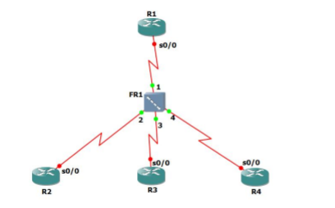

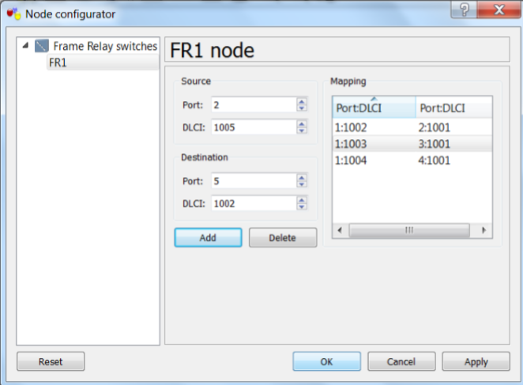

**Configuring OSPF on all the routers**

#int s0/0

#ip address 10.0.0.1 255.255.255.248

#encapsulation frame-relay

#ip ospf network non-broadcast

#ip ospf priority 100

#frame-relay map ip 10.0.0.2 1002

#no shut

#exit

#router ospf 1

#network 10.0.0.0 0.0.0.7 area 0

#neighbor 10.0.0.2

#^Z

**Displaying the details about neighbouring devices of all routers:**

R1#show ip ospf neighbor

**Performing ping to check connectivity amongst routers:**

#ping 10.0.0.2

**Configuring OSPF on all the routers:**

**For R1:**

Router#en

Router#conf t

Router(config)#int s0/0

Router(config-if)#ip address 10.0.0.1 255.255.255.248

Router(config-if)#encapsulation frame-relay

Router(config-if)#ip ospf network non-broadcast

Router(config-if)#ip ospf priority 100

Router(config-if)#frame-relay map ip 10.0.0.2 1002

Router(config-if)#frame-relay map ip 10.0.0.3 1003

Router(config-if)#frame-relay map ip 10.0.0.4 1004

Router(config-if)#no shut

Router(config-if)#exit

Router(config)#router ospf 1

Router(config-router)#network 10.0.0.0 0.0.0.7 area 0

Router(config-router)#neighbor 10.0.0.2

Router(config-router)#neighbor 10.0.0.3

Router(config-router)#neighbor 10.0.0.4

Router(config-router)#^Z

Router#exit

**For R2:**

Router#en

Router#conf t

Router(config)#int s0/0

Router(config-if)#ip address 10.0.0.2 255.255.255.248

Router(config-if)#encapsulation frame-relay

Router(config-if)#ip ospf network non-broadcast

Router(config-if)#ip ospf priority 0

Router(config-if)#frame-relay map ip 10.0.0.1 1001

Router(config-if)#no shut

Router(config-if)#exit

Router(config)#router ospf 1

Router(config-router)#network

Router(config-router)#network 10.0.0.0 0.0.0.7 area 0

Router(config-router)#neighbor 10.0.0.1

Router(config-router)#^Z

Router#exit

**For R3:**

Router#en

Router#conf t

Router(config)#int s0/0

Router(config-if)#ip address 10.0.0.3 255.255.255.248

Router(config-if)#encapsulation frame-relay

Router(config-if)#ipospf network non-broadcast

Router(config-if)#ipospf priority 0

Router(config-if)#frame-relay map ip 10.0.0.1 1001

Router(config-if)#no shut

Router(config-if)#exit

Router(config)#router ospf 1

Router(config-router)#network 10.0.0.0 0.0.0.7 area 0

Router(config-router)#neighbor 10.0.0.1

Router(config-router)#^Z

Router#exit

**For R4:**

Router#en

Router#conf t

Router(config)#int s0/0

Router(config-if)#ip address 10.0.0.4 255.255.255.248

Router(config-if)#encapsulation frame-relay

Router(config-if)#ip ospf network non-broadcast

Router(config-if)#ip ospf priority 0

Router(config-if)#frame-relay map ip 10.0.0.1 1001

Router(config-if)#no shut

Router(config-if)#exit

Router(config)#router ospf 1

Router(config-router)#network 10.0.0.0 0.0.0.7 area 0

Router(config-router)#neighbor 10.0.01

Router(config-router)#neighbor 10.0.0.1

Router(config-router)#^Z

Router#exit

**Displaying the details about neighbouring devices of all routers:**

**For R1:**

Router#show ip ospf neighbor

Neighbor ID Pri State Dead Time Address Interface

10.0.0.2 0 FULL/DROTHER 00:01:48 10.0.0.2 Serial0/0

10.0.0.3 0 FULL/DROTHER 00:01:55 10.0.0.3 Serial0/0

10.0.0.4 0 FULL/DROTHER 00:01:46 10.0.0.4 Serial0/0

**For R2:**

Router#show ip ospf neighbor

Neighbor ID Pri State Dead Time Address Interface

10.0.0.1 100 FULL/DR 00:01:51 10.0.0.1 Serial0/0

**For R3:**

Router#show ipospf neighbor

Neighbor ID Pri State Dead Time Address Interface

10.0.0.1 100 FULL/DR 00:01:54 10.0.0.1 Serial0/0

**For R4:**

Router#show ip ospf neighbor

Neighbor ID Pri State Dead Time Address Interface

10.0.0.1 100 FULL/DR 00:01:43 10.0.0.1 Serial0/0

**Performing ping to check connectivity amongst routers:**

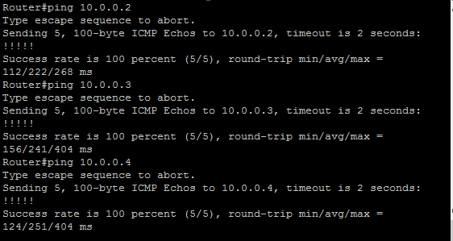

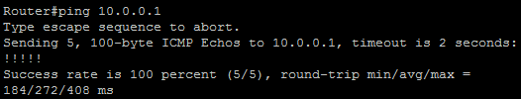

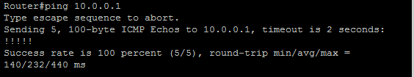

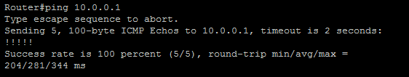

PRACTICAL NUMBER 3

Simulating OSPF with STUB AREA, NSSA, Restricting LSA’s

**OVERVIEW OF COMMANDS:**

**Assigning IP address and Loopback Interfaces to router R1:**

R1(config)#int s0/0

R1(config-if)#ip address 10.1.1.1 255.255.255.0

R1(config-if)#no shut

R1(config-if)#int loopback0

R1(config-if)#ip address 10.1.2.1 255.255.255.0

R1(config-if)#ip address 10.1.2.1 255.255.255.0

R1(config-if)#no shut

**Configuring OSPF on routers R1, R2, R4 and R5:**

R1#en

R1#conf t

R1(config)#router ospf 1

R1(config-router)#network 10.1.1.0 0.0.0.255 area 1

R1(config-router)#^Z

R1#exit

**Configuring RIP and OSPF on R3:**

R3(config)#router rip

R3(config-router)#network 99.9.1.0

R3(config-router)#network 99.9.2.0

R3(config-router)#network 99.9.3.0

R3(config-router)#network 99.9.4.0

R3(config-router)#network 99.9.5.0

R3(config-router)#exit

**Displaying Routing tables of all routers:**

R1#show ip route

**Displaying OSPF neighbors of all routers:**

R1#show ip ospf neighbor

**Displaying OSPF Interface details of all routers:**

R1#show ip ospf interface brief

**Configure Area 1 as stub area:**

R1(config)#router ospf 1

R1(config-router)#area 1 stub

R1(config-router)#^Z

R1#exit

**Displaying Routing Table of R1 to verify Area1 as Stub Area:**

R1#show ip route

**Displaying global OSPF Configuration of the R1:**

R1#show ip ospf

**Configure Area2 as NSSA on R4:**

R4(config)#router ospf 1

R4(config-router)#no area 2 stub

R4(config-router)#area 2 nssa

R4(config-router)#^Z

**Configure R4 to advertise default routes for NSSA:**

R4(config)#router ospf 1

R4(config-router)#area 2 nssa default-information-originate

R4(config-router)#^Z

**Topology:**

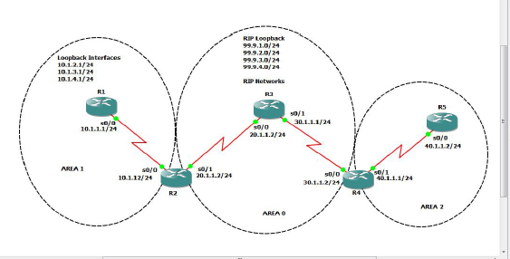

**Assigning IP address and Loopback Interfaces to router R1:**

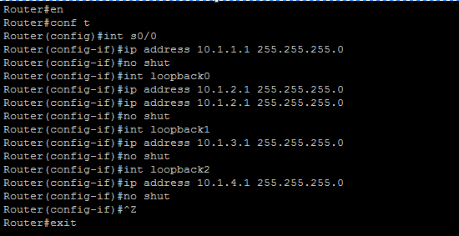

**Assigning IP addresses to router R2:**

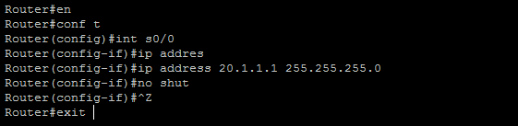

**Assigning IP address and Loopback Interfaces to router R3:**

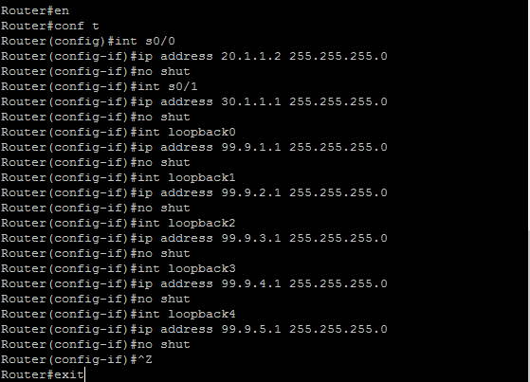

**Assigning IP addresses to router R4:**

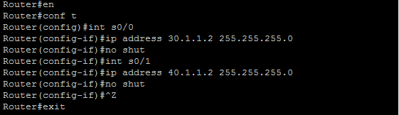

**Assigning IP addresses to router R5:**

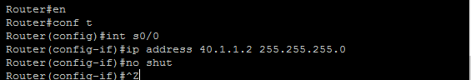

**Configuring OSPF on routers R1, R2, R4 and R5:**

For R1: 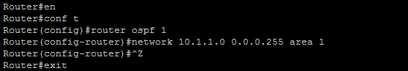

For R2: 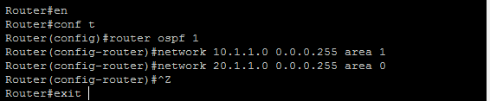

**Configuring RIP and OSPF on R3:**

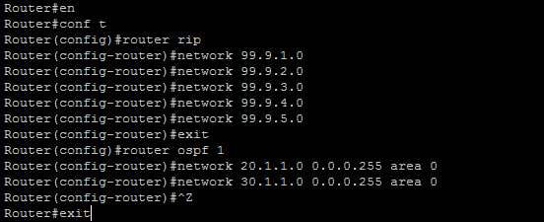

For R4: 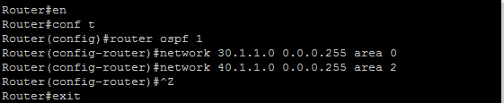

For R5: 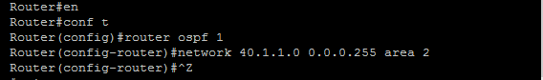

**Displaying Routing tables of all routers:**

**For R1:**

Router#show ip route

20.0.0.0/24 is subnetted, 1 subnets

O IA 20.1.1.0 [110/128] via 10.1.1.2, 00:02:23, Serial0/0

40.0.0.0/24 is subnetted, 1 subnets

O IA 40.1.1.0 [110/256] via 10.1.1.2, 00:00:15, Serial0/0

10.0.0.0/24 is subnetted, 4 subnets

C 10.1.3.0 is directly connected, Loopback2

C 10.1.2.0 is directly connected, Loopback1

C 10.1.1.0 is directly connected, Serial0/0

C 10.1.4.0 is directly connected, Loopback3

30.0.0.0/24 is subnetted, 1 subnets

O IA 30.1.1.0 [110/192] via 10.1.1.2, 00:00:51, Serial0/0

**For R2:**

Router#show ip route

20.0.0.0/24 is subnetted, 1 subnets

C 20.1.1.0 is directly connected, Serial0/1

40.0.0.0/24 is subnetted, 1 subnets

O IA 40.1.1.0 [110/192] via 20.1.1.2, 00:04:24, Serial0/1

10.0.0.0/24 is subnetted, 1 subnets

C 10.1.1.0 is directly connected, Serial0/0

30.0.0.0/24 is subnetted, 1 subnets

O 30.1.1.0 [110/128] via 20.1.1.2, 00:04:24, Serial0/1

**For R3:**

Router#show ip route

99.0.0.0/24 is subnetted, 5 subnets

C 99.9.2.0 is directly connected, Loopback1

C 99.9.3.0 is directly connected, Loopback2

C 99.9.1.0 is directly connected, Loopback0

C 99.9.4.0 is directly connected, Loopback3

C 99.9.5.0 is directly connected, Loopback4

20.0.0.0/24 is subnetted, 1 subnets

C 20.1.1.0 is directly connected, Serial0/0

40.0.0.0/24 is subnetted, 1 subnets

O IA 40.1.1.0 [110/128] via 30.1.1.2, 00:04:30, Serial0/1

10.0.0.0/24 is subnetted, 1 subnets

O IA 10.1.1.0 [110/128] via 20.1.1.1, 00:04:54, Serial0/0

30.0.0.0/24 is subnetted, 1 subnets

C 30.1.1.0 is directly connected, Serial0/1

**For R4:**

Router#show ip route

20.0.0.0/24 is subnetted, 1 subnets

O 20.1.1.0 [110/128] via 30.1.1.1, 00:04:31, Serial0/0

40.0.0.0/24 is subnetted, 1 subnets

C 40.1.1.0 is directly connected, Serial0/1

10.0.0.0/24 is subnetted, 1 subnets

O IA 10.1.1.0 [110/192] via 30.1.1.1, 00:04:31, Serial0/0

30.0.0.0/24 is subnetted, 1 subnets

C 30.1.1.0 is directly connected, Serial0/0

**For R5:**

Router#show ip route

40.0.0.0/24 is subnetted, 1 subnets

C 40.1.1.0 is directly connected, Serial0/0

**Displaying OSPF neighbors of all routers:**

**For R1:**

Router#show ip ospf neighbor

Neighbor ID Pri State Dead Time Address Interface

20.1.1.1 0 FULL/ - 00:00:35 10.1.1.2 Serial0/0

**For R2:**

Router#show ip ospf neighbor

Neighbor ID Pri State Dead Time Address Interface

99.9.5.1 0 FULL/ - 00:00:38 20.1.1.2 Serial0/1

10.1.4.1 0 FULL/ - 00:00:37 10.1.1.1 Serial0/0

**For R3:**

Router#show ip ospf neighbor

Neighbor ID Pri State Dead Time Address Interface

40.1.1.2 0 FULL/ - 00:00:38 30.1.1.2 Serial0/1

20.1.1.1 0 FULL/ - 00:00:32 20.1.1.1 Serial0/0

**For R4:**

Router#show ip ospf neighbor

Neighbor ID Pri State Dead Time Address Interface

99.9.5.1 0 FULL/ - 00:00:35 30.1.1.1 Serial0/0

40.1.1.2 0 FULL/ - 00:00:34 40.1.1.2 Serial0/1

**For R5:**

Router#show ip ospf neighbor

Neighbor ID Pri State Dead Time Address Interface

40.1.1.1 0 FULL/ - 00:00:31 40.1.1.1 Serial0/0

**Displaying OSPF Interface details of all routers:**

**For R1:**

Router#show ip ospf interface brief

Interface PID Area IP Address/Mask Cost State Nbrs F/C

Se0/0 1 1 10.1.1.1/24 64 P2P 1/1

**For R2:**

Router#show ip ospf interface brief

Interface PID Area IP Address/Mask Cost State Nbrs F/C

Se0/1 1 0 20.1.1.1/24 64 P2P 1/1

Se0/0 1 1 10.1.1.2/24 64 P2P 1/1

**For R3:**

Router#show ip ospf interface brief

Interface PID Area IP Address/Mask Cost State Nbrs F/C

Se0/1 1 0 30.1.1.1/24 64 P2P 1/1

Se0/0 1 0 20.1.1.2/24 64 P2P 1/1

**For R4:**

Router#show ip ospf interface brief

Interface PID Area IP Address/Mask Cost State Nbrs F/C

Se0/0 1 0 30.1.1.2/24 64 P2P 1/1

Se0/1 1 2 40.1.1.1/24 64 P2P 0/0

**For R5:**

Router#show ip ospf interface brief

Interface PID Area IP Address/Mask Cost State Nbrs F/C

Se0/0 1 2 40.1.1.2/24 64 P2P 0/0

**Configure Area 1 as stub area:**

**For R1:**

Router#en

Router#conf t

Router(config)#router ospf 1

Router(config-router)#area 1 stub

Router(config-router)#^Z

Router#exit

**For R2:**

Router#en

Router#conf t

Router(config)#router ospf 1

Router(config-router)#area 1 stub

Router(config-router)#^Z

Router#exit

**Displaying Routing Table of R1 to verify Area1 as Stub Area:**

**For R1:** 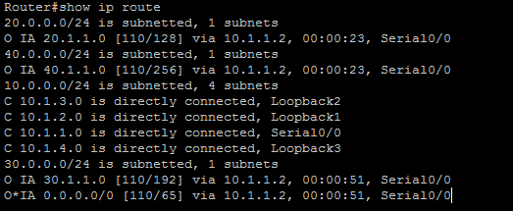

**Displaying global OSPF Configuration of the R1:**

**For R1:** 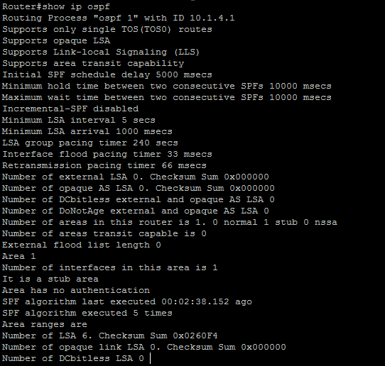

**Configure Area2 as Totally Stubby Area:**

**For R5:**

Router#en

Router#conf t

Router(config)#router ospf 1

Router(config-router)#area 2 stub

Router(config-router)#^Z

Router#exit

**For R4:**

Router#en

Router#conf t

Router(config)#router ospf 1

Router(config-router)#area 2 stub no-summary

Router(config-router)#^Z

Router#exit

**Displaying Routing Table of R5 to verify Area2 as Totally Stubby Area:**

For R4: 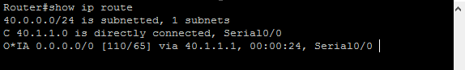

**Configure Area2 as NSSA on R4:**

**For R4:**

Router#en

Router#conf t

Router(config)#router ospf 1

Router(config-router)#no area 2 stub

Router(config-router)#area 2 nssa

Router(config-router)#^Z

Router#exit

**For R5:**

Router#en

Router#conf t

Router(config)#router ospf 1

Router(config-router)#no area 2 stub

Router(config-router)#area 2 nssa

Router(config-router)#^Z

Router#exit

**Configure R4 to advertise default routes for NSSA:**

**For R4:**

Router#en

Router#conf t

Router(config)#router ospf 1

Router(config-router)#area 2 nssa default-information-originate

Router(config-router)#^Z

Router#exit

**Displaying routing table of R5 to verify Area2 as a NSSA**

**For R5:** 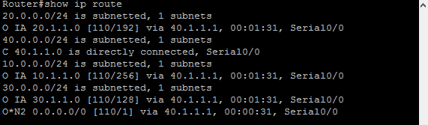

PRACTICAL NUMBER 4

Simulating BGP

Topology:-

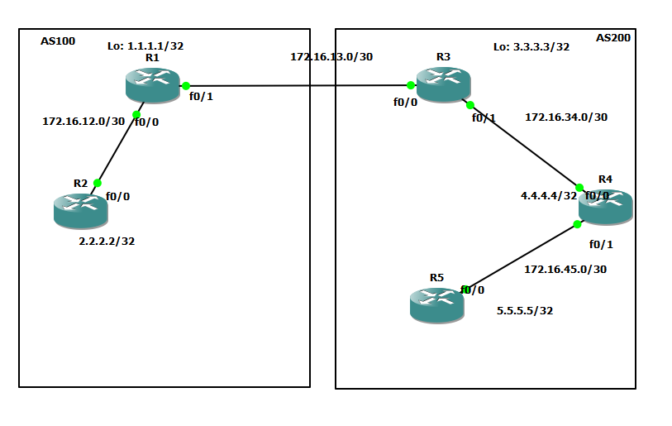

STEPS Overview:

1. Assigning IP Addresses and Loopback Address R1:
2. Configuring OSPF on all routers:
3. Configure Static Routes on R1 and R3:
4. Configure BGP Network on R1 and R3
5. Displaying routing tables of all routers:
6. Performing Ping on all routers to check Connectivity:

**Assigning IP Addresses and Loopback Address R1:**

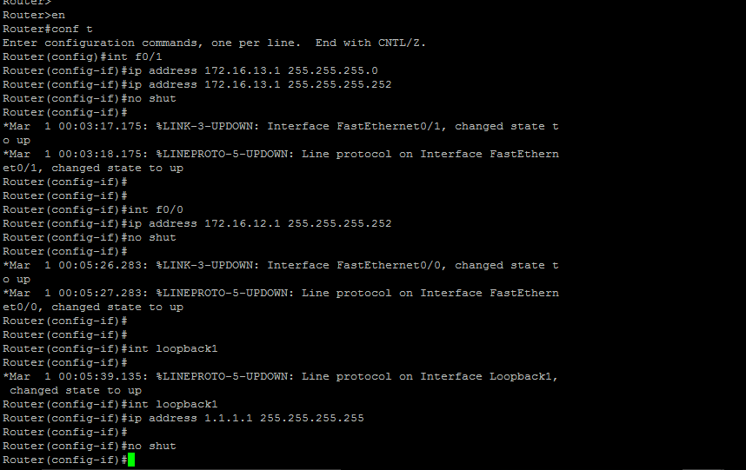





**Assigning IP Addresses and Loopback Address R2:**

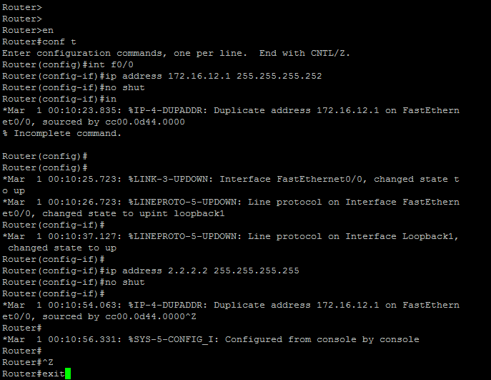



**Assigning IP Addresses and Loopback Address R3:**

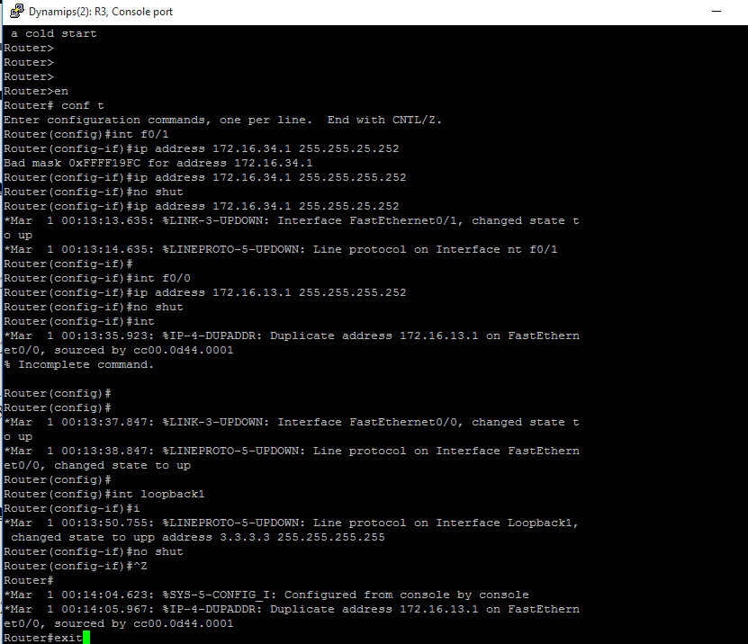





**Assigning IP Addresses and Loopback Address R4:**

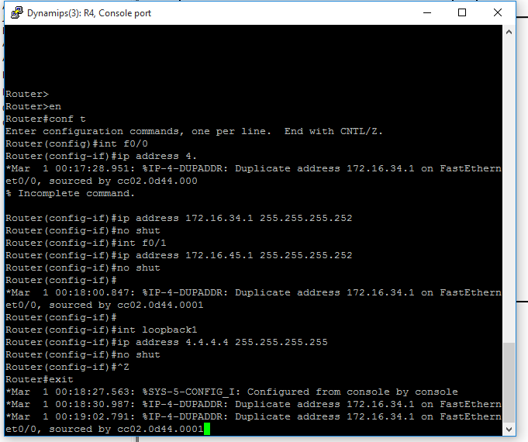



**Assigning IP Addresses and Loopback Address R5:**

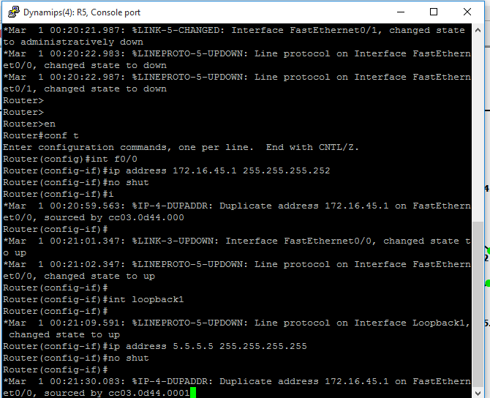



**Configuring OSPF on all routers:**

**For R1:**

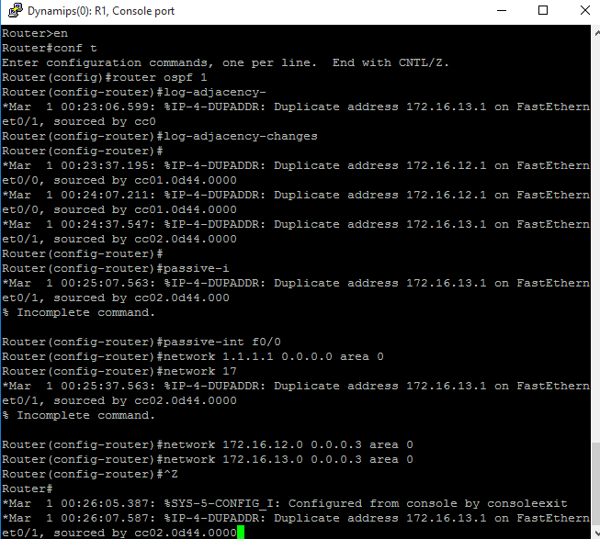





**For R2:**

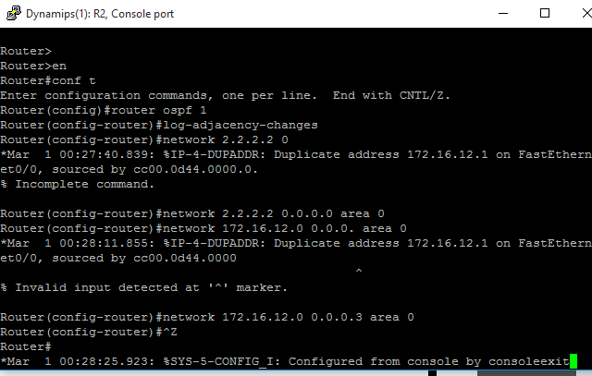





**For R3:** 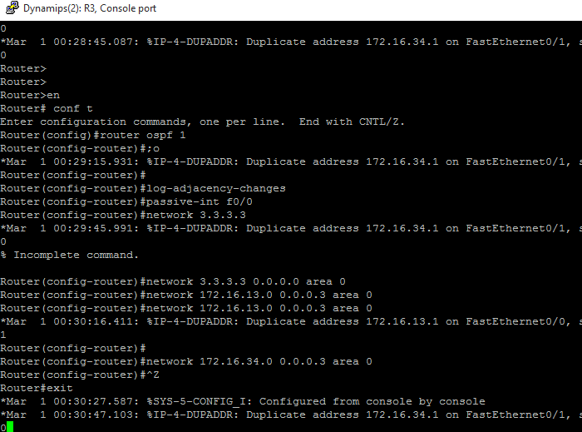





**For R4:** 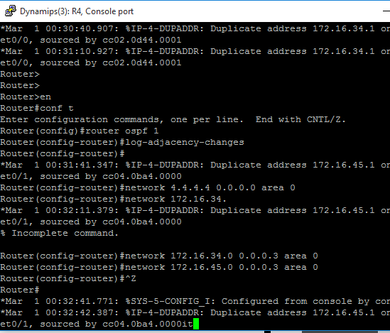



**For R5:**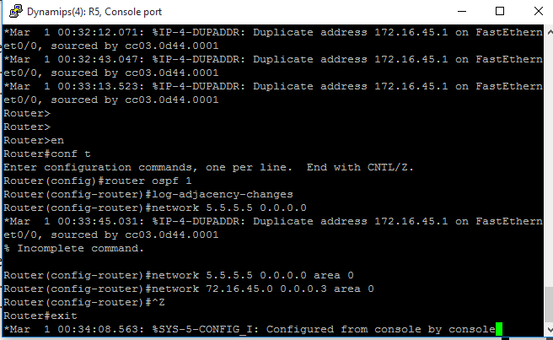

**Configure Static Routes on R1 and R3:**

**For R1:**

Router#en

Router#conf t

Router(config)#ip route 100.100.100.0 255.255.255.0 null0

Router(config)#ip route 100.100.101.0 255.255.255.0 null0

Router(config)#ip route 100.100.102.0 255.255.255.0 null0

Router(config)#ip route 100.100.103.0 255.255.255.0 null0

Router(config)#^Z

Router#exit

**For R3:**

Router#en

Router#conf t

Router(config)#ip route 200.200.200.0 255.255.255.0 null0

Router(config)#ip route 200.200.201.0 255.255.255.0 null0

Router(config)#ip route 200.200.202.0 255.255.255.0 null0

Router(config)#ip route 200.200.203.0 255.255.255.0 null0

Router(config)#^Z

Router#exit

**Configure BGP Network on R1 and R3:**

**For R1:**

Router#en

Router#conf t

Router(config)#router bgp 100

Router(config-router)#network 100.100.100.0 mask 255.255.255.0

Router(config-router)#network 100.100.101.0 mask 255.255.255.0

Router(config-router)#network 100.100.102.0 mask 255.255.255.0

Router(config-router)#network 100.100.103.0 mask 255.255.255.0

Router(config-router)#network 1.1.1.1 mask 255.255.255.255

Router(config-router)#network 2.2.2.2 mask 255.255.255.255

Router(config-router)#network 172.16.12.0 mask 255.255.255.252

Router(config-router)#^Z

Router#exit

**For R3:**

Router#en

Router#conf t

Router(config)#router bgp 200

Router(config-router)#network 200.200.200.0 mask 255.255.255.0

Router(config-router)#network 200.200.201.0 mask 255.255.255.0

Router(config-router)#network 200.200.202.0 mask 255.255.255.0

Router(config-router)#network 200.200.203.0 mask 255.255.255.0

Router(config-router)#network 3.3.3.3 mask 255.255.255.255

Router(config-router)#network 4.4.4.4 mask 255.255.255.255

Router(config-router)#network 5.5.5.5 mask 255.255.255.255

Router(config-router)#network 172.16.34.0 mask 255.255.255.252

Router(config-router)#network 172.16.45.0 mask 255.255.255.252

Router(config-router)#^Z

Router#exit

**Displaying routing tables of all routers:**

**For R1:**

Router#show ip route

B 200.200.200.0/24 [20/0] via 172.16.13.2, 00:03:42

1.0.0.0/32 is subnetted, 1 subnets

C 1.1.1.1 is directly connected, Loopback1

B 200.200.201.0/24 [20/0] via 172.16.13.2, 00:02:42

2.0.0.0/32 is subnetted, 1 subnets

O 2.2.2.2 [110/11] via 172.16.12.2, 01:55:15, FastEthernet0/1

100.0.0.0/24 is subnetted, 4 subnets

S 100.100.100.0 is directly connected, Null0

S 100.100.101.0 is directly connected, Null0

S 100.100.102.0 is directly connected, Null0

S 100.100.103.0 is directly connected, Null0

B 200.200.202.0/24 [20/0] via 172.16.13.2, 00:02:51

3.0.0.0/32 is subnetted, 1 subnets

B 3.3.3.3 [20/0] via 172.16.13.2, 00:02:49

B 200.200.203.0/24 [20/0] via 172.16.13.2, 00:03:58

4.0.0.0/32 is subnetted, 1 subnets

B 4.4.4.4 [20/11] via 172.16.13.2, 00:02:58

5.0.0.0/32 is subnetted, 1 subnets

B 5.5.5.5 [20/21] via 172.16.13.2, 00:02:59

172.16.0.0/30 is subnetted, 4 subnets

B 172.16.45.0 [20/20] via 172.16.13.2, 00:01:59

B 172.16.34.0 [20/0] via 172.16.13.2, 00:02:24

C 172.16.12.0 is directly connected, FastEthernet0/1

C 172.16.13.0 is directly connected, FastEthernet0/0

**For R2:**

Router#show ip route

B 200.200.200.0/24 [200/0] via 172.16.13.2, 00:03:55

1.0.0.0/32 is subnetted, 1 subnets

O 1.1.1.1 [110/11] via 172.16.12.1, 01:55:30, FastEthernet0/0

B 200.200.201.0/24 [200/0] via 172.16.13.2, 00:02:55

2.0.0.0/32 is subnetted, 1 subnets

C 2.2.2.2 is directly connected, Loopback1

100.0.0.0/24 is subnetted, 4 subnets

B 100.100.100.0 [200/0] via 172.16.12.1, 00:07:09

B 100.100.101.0 [200/0] via 172.16.12.1, 00:07:09

B 100.100.102.0 [200/0] via 172.16.12.1, 00:06:09

B 100.100.103.0 [200/0] via 172.16.12.1, 00:06:23

B 200.200.202.0/24 [200/0] via 172.16.13.2, 00:03:10

3.0.0.0/32 is subnetted, 1 subnets

B 3.3.3.3 [200/0] via 172.16.13.2, 00:03:03

B 200.200.203.0/24 [200/0] via 172.16.13.2, 00:04:03

4.0.0.0/32 is subnetted, 1 subnets

B 4.4.4.4 [200/11] via 172.16.13.2, 00:04:24

5.0.0.0/32 is subnetted, 1 subnets

B 5.5.5.5 [200/21] via 172.16.13.2, 00:04:24

172.16.0.0/30 is subnetted, 4 subnets

B 172.16.45.0 [200/20] via 172.16.13.2, 00:03:25

B 172.16.34.0 [200/0] via 172.16.13.2, 00:03:25

C 172.16.12.0 is directly connected, FastEthernet0/0

O 172.16.13.0 [110/20] via 172.16.12.1, 01:58:53, FastEthernet0/0

**For R3:**

Router#show ip route

S 200.200.200.0/24 is directly connected, Null0

1.0.0.0/32 is subnetted, 1 subnets

B 1.1.1.1 [20/0] via 172.16.13.1, 00:06:27

S 200.200.201.0/24 is directly connected, Null0

2.0.0.0/32 is subnetted, 1 subnets

B 2.2.2.2 [20/11] via 172.16.13.1, 00:05:27

100.0.0.0/24 is subnetted, 4 subnets

B 100.100.100.0 [20/0] via 172.16.13.1, 00:07:28

B 100.100.101.0 [20/0] via 172.16.13.1, 00:07:28

B 100.100.102.0 [20/0] via 172.16.13.1, 00:06:27

B 100.100.103.0 [20/0] via 172.16.13.1, 00:06:45

S 200.200.202.0/24 is directly connected, Null0

3.0.0.0/32 is subnetted, 1 subnets

C 3.3.3.3 is directly connected, Loopback1

S 200.200.203.0/24 is directly connected, Null0

4.0.0.0/32 is subnetted, 1 subnets

O 4.4.4.4 [110/11] via 172.16.34.2, 01:50:38, FastEthernet0/1

5.0.0.0/32 is subnetted, 1 subnets

O 5.5.5.5 [110/21] via 172.16.34.2, 01:50:38, FastEthernet0/1

172.16.0.0/30 is subnetted, 4 subnets

O 172.16.45.0 [110/20] via 172.16.34.2, 01:50:49, FastEthernet0/1

C 172.16.34.0 is directly connected, FastEthernet0/1

B 172.16.12.0 [20/0] via 172.16.13.1, 00:05:47

C 172.16.13.0 is directly connected, FastEthernet0/0

**For R4:**

Router#show ip route

B 200.200.200.0/24 [200/0] via 172.16.34.1, 00:04:03

1.0.0.0/32 is subnetted, 1 subnets

B 1.1.1.1 [200/0] via 172.16.13.1, 00:06:17

B 200.200.201.0/24 [200/0] via 172.16.34.1, 00:03:03

2.0.0.0/32 is subnetted, 1 subnets

B 2.2.2.2 [200/11] via 172.16.13.1, 00:05:16

100.0.0.0/24 is subnetted, 4 subnets

B 100.100.100.0 [200/0] via 172.16.13.1, 00:07:17

B 100.100.101.0 [200/0] via 172.16.13.1, 00:07:17

B 100.100.102.0 [200/0] via 172.16.13.1, 00:06:17

B 100.100.103.0 [200/0] via 172.16.13.1, 00:06:39

B 200.200.202.0/24 [200/0] via 172.16.34.1, 00:03:26

3.0.0.0/32 is subnetted, 1 subnets

O 3.3.3.3 [110/11] via 172.16.34.1, 01:50:32, FastEthernet0/0

B 200.200.203.0/24 [200/0] via 172.16.34.1, 00:04:16

4.0.0.0/32 is subnetted, 1 subnets

C 4.4.4.4 is directly connected, Loopback1

5.0.0.0/32 is subnetted, 1 subnets

O 5.5.5.5 [110/11] via 172.16.45.2, 01:52:26, FastEthernet0/1

172.16.0.0/30 is subnetted, 4 subnets

C 172.16.45.0 is directly connected, FastEthernet0/1

C 172.16.34.0 is directly connected, FastEthernet0/0

B 172.16.12.0 [200/0] via 172.16.13.1, 00:07:24

O 172.16.13.0 [110/20] via 172.16.34.1, 01:52:39, FastEthernet0/0

**For R5:**

Router#show ip route

B 200.200.200.0/24 [200/0] via 172.16.34.1, 00:04:30

1.0.0.0/32 is subnetted, 1 subnets

B 1.1.1.1 [200/0] via 172.16.13.1, 00:06:43

B 200.200.201.0/24 [200/0] via 172.16.34.1, 00:03:30

2.0.0.0/32 is subnetted, 1 subnets

B 2.2.2.2 [200/11] via 172.16.13.1, 00:05:43

100.0.0.0/24 is subnetted, 4 subnets

B 100.100.100.0 [200/0] via 172.16.13.1, 00:07:43

B 100.100.101.0 [200/0] via 172.16.13.1, 00:07:43

B 100.100.102.0 [200/0] via 172.16.13.1, 00:06:43

B 100.100.103.0 [200/0] via 172.16.13.1, 00:07:06

B 200.200.202.0/24 [200/0] via 172.16.34.1, 00:03:53

3.0.0.0/32 is subnetted, 1 subnets

O 3.3.3.3 [110/21] via 172.16.45.1, 01:50:43, FastEthernet0/0

B 200.200.203.0/24 [200/0] via 172.16.34.1, 00:04:20

4.0.0.0/32 is subnetted, 1 subnets

O 4.4.4.4 [110/11] via 172.16.45.1, 01:50:43, FastEthernet0/0

5.0.0.0/32 is subnetted, 1 subnets

C 5.5.5.5 is directly connected, Loopback1

172.16.0.0/30 is subnetted, 4 subnets

C 172.16.45.0 is directly connected, FastEthernet0/0

O 172.16.34.0 [110/20] via 172.16.45.1, 01:52:36, FastEthernet0/0

B 172.16.12.0 [200/0] via 172.16.13.1, 00:07:26

O 172.16.13.0 [110/30] via 172.16.45.1, 01:52:36, FastEthernet0

**Performing Ping on all routers to check Connectivity:**

**For R1:** 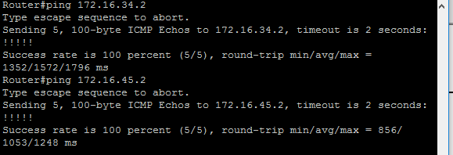

**For R2:** 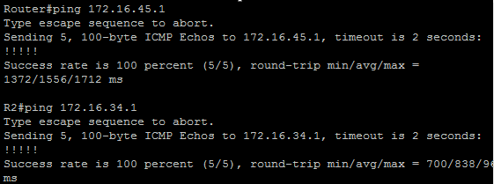

**For R3:** 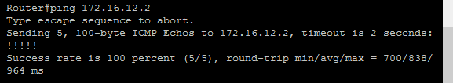

**For R4:** 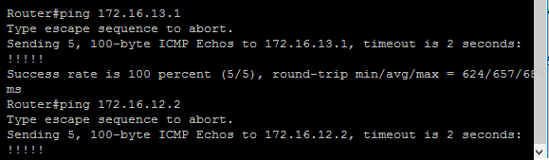

**For R5:** 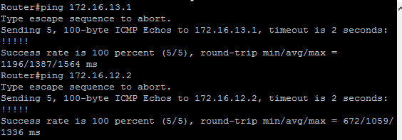

PRACTICAL NUMBER 5

Simulating IBGP

STEPS OVERVEW:

1. Configure I-BGP between R1 and R2 (AS100):
2. Configure I-BGP between R3 and R4 (AS200):
3. Configure I-BGP between R3 and R5 (AS200):
4. Displaying I-BGP summary of the routers:
5. Configure R3 as Route Reflector for R4 and R5:
6. Performing ping to check the working of I-BGP Connectivity:

Topology:



**Configure I-BGP between R1 and R2 (AS100):**

**For R1:**

Router#en

Router#conf t

Router(config)#router bgp 100

Router(config-router)#neighbor 2.2.2.2 remote-as 100

Router(config-router)#neighbor 2.2.2.2 update-source loopback1

Router(config-router)#neighbor 172.16.12.2 remote-as 100

Router(config-router)#^Z

Router#exit

**For R2:**

Router#en

Router#conf t

Router(config)#router bgp 100

Router(config-router)#neighbor 1.1.1.1 remote-as 100

Router(config-router)#neighbor 1.1.1.1 update-source loopback1

Router(config-router)#neighbor 172.16.12.1 remote-as 100

Router(config-router)#^Z

Router#exit

**Configure I-BGP between R3 and R4 (AS200):**

**For R3:**

Router#en

Router#conf t

Router(config)#

Router(config)#router bgp 200

Router(config-router)#neighbor 4.4.4.4 remote-as 200

Router(config-router)#neighbor 4.4.4.4 update-source loopback1

Router(config-router)#neighbor 172.16.34.2 remote-as 200

Router(config-router)#^Z

Router#exit

**For R4:**

Router#en

Router#conf t

Router(config)#router bgp 200

Router(config-router)#neighbor 3.3.3.3 remote-as 200

Router(config-router)#neighbor 3.3.3.3 update-source loopback1

Router(config-router)#neighbor 172.16.34.1 remote-as 200

Router(config-router)#^Z

Router#exit

**Configure I-BGP between R3 and R5 (AS200):**

**For R3:**

Router#en

Router#conf t

Router(config)#router bgp 200

Router(config-router)#neighbor 5.5.5.5 remote-as 200

Router(config-router)#neighbor 5.5.5.5 update-source loopback1

Router(config-router)#neighbor 172.16.45.2 remote-as 200

Router(config-router)#^Z

Router#exit

**For R5:**

Router#en

Router#conf t

Router(config)#router bgp 200

Router(config-router)#neighbor 3.3.3.3 remote-as 200

Router(config-router)#neighbor 3.3.3.3 update-source loopback1

Router(config-router)#neighbor 172.16.34.1 remote-as 200

Router(config-router)#^Z

Router#exit

**Displaying I-BGP summary of the routers:**

**For R1:** 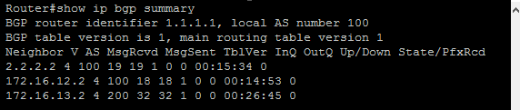

**For R2:** 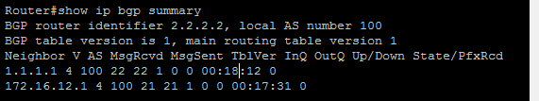

**For R3:** 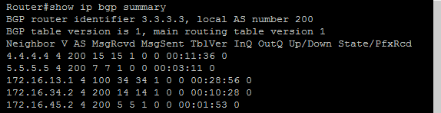

**For R4:** 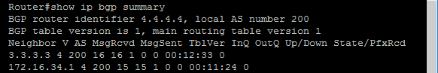

**For R5:** 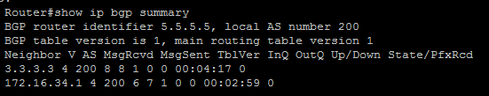

**Configure R3 as Route Reflector for R4 and R5:**

**For R3:**

Router#en

Router#conf t

Router(config)#router bgp 200

Router(config-router)#neighbor 4.4.4.4 route-reflector-client

Router(config-router)#neighbor 5.5.5.5 route-reflector-client

Router(config-router)#^Z

Router#exit

**Performing ping to check the working of I-BGP Connectivity:**

**For R1:** 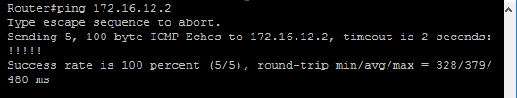

**For R2:** 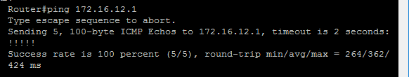

**For R3:** 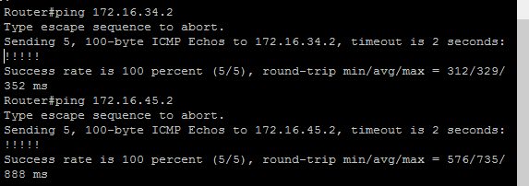

**For R4:** 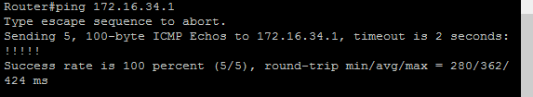

**For R5:** 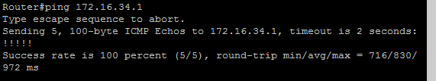

PRACTICAL NUMBER 6

Simulating EBGP

STEPS OVERVIEW:

1. Configure E-BGP between R1 and R3 (AS100 and AS200):
2. Displaying E-BGP Summary of R1 and R3:
3. Performing Ping to check the working of E-BGP Connectivity:

Topology:

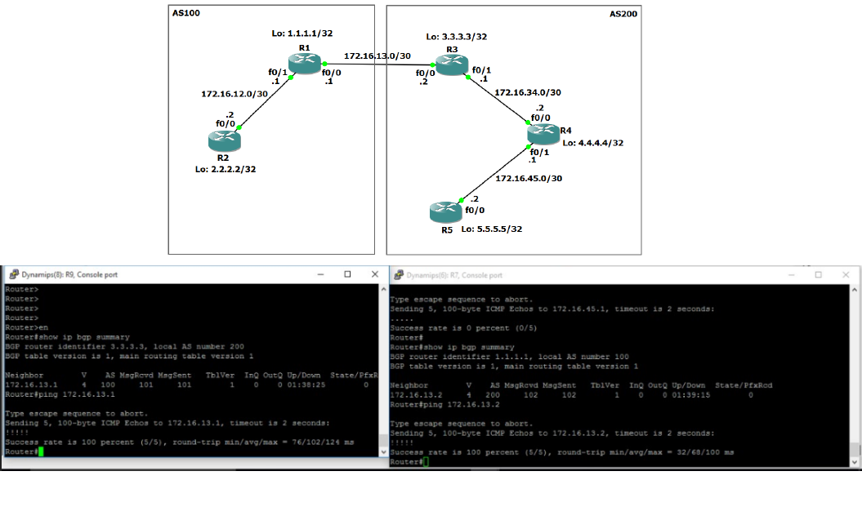

**Configure E-BGP between R1 and R3 (AS100 and AS200):**

**For R1:**

Router#en

Router#conf t

Router(config)#router bgp 100

Router(config-router)#no synchronization

Router(config-router)#neighbor 172.16.13.2 remote-as 200

Router(config-router)#^Z

Router#exit

**For R3:**

Router#en

Router#conf t

Router(config)#router bgp 200

Router(config-router)#no synchronization

Router(config-router)#neighbor 172.16.13.1 remote-as 100

Router(config-router)#^Z

Router#exit

**Displaying E-BGP Summary of R1 and R3:**

For R1: 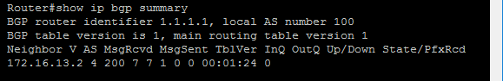

For R3: 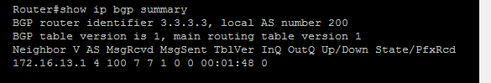

**Performing Ping to check the working of E-BGP Connectivity:**

For R1: 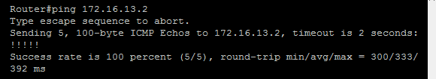

For R3: 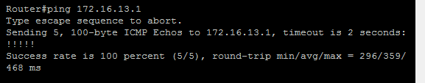

PRACTICAL NUMBER 7

Configuring IP Multicast Routing

STEPS OVERVIEW;

1. **Assigning IP Addresses and Loopback Address R**
2. **Configuring OSPF on all routers:**
3. **Displaying routing tables of all routers:**
4. **Configuring IP Multicasting (PIM Sparse Dense mode) on all the routers:**
5. **Configure RP on all the routers:**
6. **Configure RP on all the routers:**
7. **Performing ping from R1 to generate multicast traffic:**
8. **Displaying IGMP groups of all the routers:**
9. **Displaying PIM Neighbor of all routers:**
10. **Displaying RP Mapping of all the routers:**
11. **Displaying Multicast Routing Table of all the routers:**

Topology:

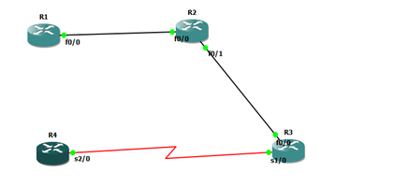

**Assigning IP Addresses and Loopback Address R1:**

Router#en

Router#conf t

Router(config)#int f0/0

Router(config-if)#ip address 192.168.12.1 255.255.255.0

Router(config-if)#no shut

Router(config-if)#int loopback1

Router(config-if)#ip address 1.1.1.1 255.255.255.0

Router(config-if)#no shut

Router(config-if)#^Z

Router#exit

**Assigning IP Addresses and Loopback Address R2:**

Router#en

Router#conf t

Router(config)#int f0/0

Router(config-if)#ip address 192.168.12.2 255.255.255.0

Router(config-if)#no shut

Router(config)#int s0/0

Router(config-if)#ip address 192.168.23.1 255.255.255.0

Router(config-if)#no shut

Router(config-if)#int loopback1

Router(config-if)#ip address 2.2.2.2 255.255.255.0

Router(config-if)#no shut

Router(config-if)#^Z

Router#exit

**Assigning IP Addresses and Loopback Address R3:**

Router#en

Router#conf t

Router(config)#int f0/0

Router(config-if)#ip address 192.168.34.2 255.255.255.0

Router(config-if)#no shut

Router(config)#int s0/0

Router(config-if)#ip address 192.168.23.2 255.255.255.0

Router(config-if)#no shut

Router(config-if)#int loopback1

Router(config-if)#ip address 3.3.3.3 255.255.255.0

Router(config-if)#no shut

Router(config-if)#^Z

Router#exit

**Assigning IP Addresses and Loopback Address R4:**

Router#en

Router#conf t

Router(config)#int f0/0

Router(config-if)#ip address 192.168.34.1 255.255.255.0

Router(config-if)#no shut

Router(config-if)#int loopback1

Router(config-if)#ip address 4.4.4.4 255.255.255.0

Router(config-if)#no shut

Router(config-if)#^Z

Router#exit

**Configuring OSPF on all routers:**

**R1:**

Router#en

Router#conf t

Router(config)#router ospf 1

Router(config-router)#network 192.168.12.0 0.0.0.255 area 0

Router(config-router)#^Z

Router#exit

**R2:**

Router#en

Router#conf t

Router(config)#router ospf 1

Router(config-router)#network 192.168.12.0 0.0.0.255 area 0

Router(config-router)#network 192.168.23.0 0.0.0.255 area 0

Router(config-router)#^Z

Router#exit

**R3:**

Router#en

Router#conf t

Router(config)#router ospf 1

Router(config-router)#network 192.168.23.0 0.0.0.255 area 0

Router(config-router)#network 192.168.34.0 0.0.0.255 area 0

Router(config-router)#^Z

Router#exit

**R4:**

Router#en

Router#conf t

Router(config)#router ospf 1

Router(config-router)#network 192.168.34.0 0.0.0.255 area 0

Router(config-router)#^Z

Router#exit

**Displaying routing tables of all routers:**

**R1:** 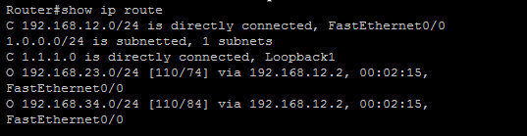

**R2:** 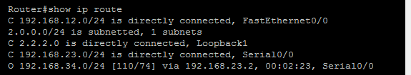

**R3:** 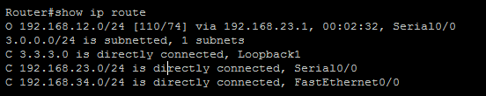

**R4:** 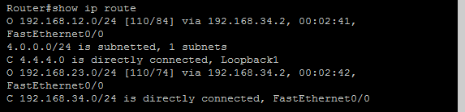

**Configuring IP Multicasting (PIM Sparse Dense mode) on all the routers:**

**R1:**

Router#en

Router#conf t

Router(config)#ip multicast-routing

Router(config)#int f0/0

Router(config-if)#ip pim sparse-dense-mode

Router(config-if)#^Z

Router#exit

**R2:**

Router#en

Router#conf t

Router(config)#ip multicast-routing

Router(config)#int f0/0

Router(config-if)#ip pim sparse-dense-mode

Router(config-if)#int s0/0

Router(config-if)#ip pim sparse-dense-mode

Router(config-if)#^Z

Router#exit

**R3:**

Router#en

Router#conf t

Router(config)#ip multicast-routing

Router(config)#int f0/0

Router(config-if)#ip pim sparse-dense-mode

Router(config-if)#int s0/0

Router(config-if)#ip pim sparse-dense-mode

Router(config-if)#^Z

Router#exit

**R4:**

Router#en

Router#conf t

Router(config)#ip multicast-routing

Router(config)#int f0/0

Router(config-if)#ip pim sparse-dense-mode

Router(config-if)#^Z

Router#exit

**Configure RP on all the routers:**

**R1:**

Router#en

Router#conf t

Router(config)#ip pim rp-address 3.3.3.3 1

Router(config)#access-list 1 permit 224.4.4.4

Router(config)#^Z

Router#exit

**R2:**

Router#en

Router#conf t

Router(config)#ip pim rp-address 3.3.3.3 1

Router(config)#access-list 1 permit 224.4.4.4

Router(config)#^Z

Router#exit

**R3:**

Router#en

Router#conf t

Router(config)#ip pim rp-address 3.3.3.3 1

Router(config)#access-list 1 permit 224.4.4.4

Router(config)#^Z

Router#exit

**R4:**

Router#en

Router#conf t

Router(config)#ip pim rp-address 3.3.3.3 1

Router(config)#access-list 1 permit 224.4.4.4

Router(config)#^Z

Router#exit

**Configure R4 to join the multicast group:**

Router#en

Router#conf t

Router(config)#int f0/0

Router(config-if)#ip igmp join-group 224.4.4.4

Router(config-if)#^Z

Router#exit

**Performing ping from R1 to generate multicast traffic:**

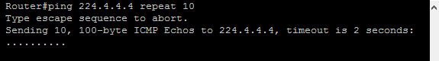

**Displaying IGMP groups of all the routers:**

For R1: 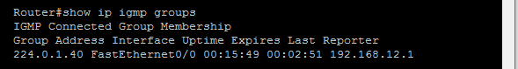

For R2: 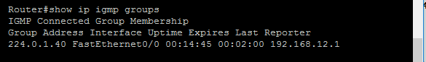

For R3: 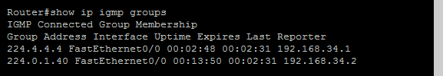

For R4: 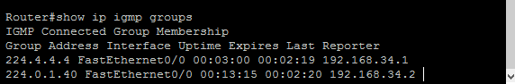

**Displaying PIM Neighbor of all routers:**

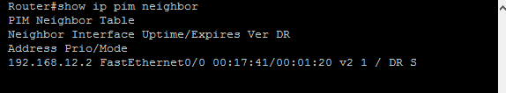

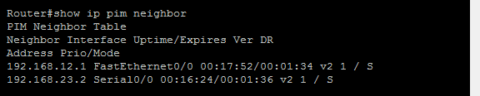

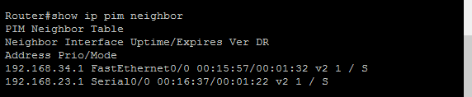

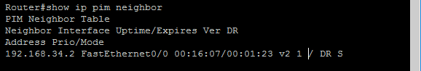

**Displaying RP Mapping of all the routers:**

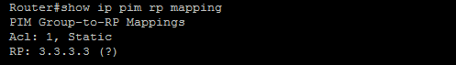

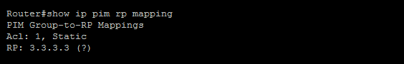

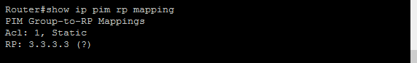

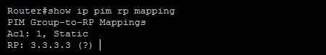

**Displaying Multicast Routing Table of all the routers:**

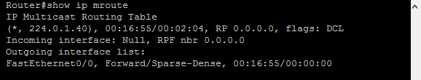

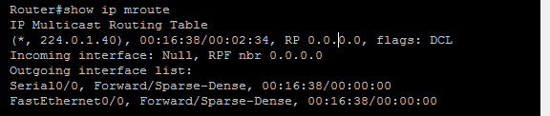

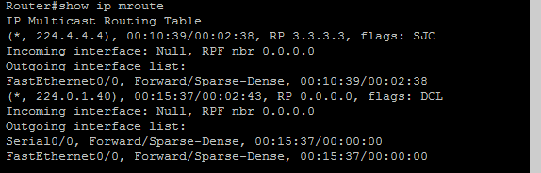

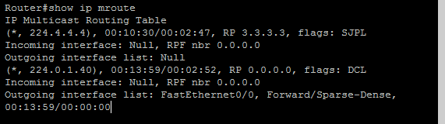

PRACTICAL NUMBER 8A

Simulating Routing Redistribution

**STEPS OVERVIEW**

1. Assigning IP address and Loopback addresses to R1:
2. Configuring RIP on router R1:
3. Configuring rip and ospf on router R2:
4. Configuring OSPF on routers:
5. Displaying the routing tables before Redistribution:
6. Redistributing OSPF routes in RIP Domain and RIP in OSPF Domain in R2:
7. Displaying the routing tables after Redistribution:
8. Using Ping command:

**Aim-**Simulating routing redistribution

Topology:

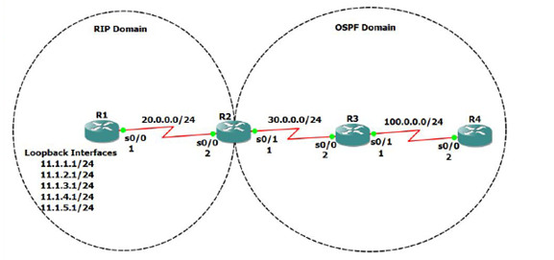

**Assigning IP address and Loopback addresses to R1:**

Router#en

Router#conf t

Router(config)#int s0/0

Router(config-if)#ip address 20.0.0.1 255.255.255.0

Router(config-if)#no shut

Router(config-if)#^Z

Router#exit

Router#en

Router#conf t

Router(config)#int loopback1

Router(config-if)#ip address 11.1.1.1 255.255.255.0

Router(config-if)#no shut

Router(config-if)#int loopback2

Router(config-if)#ip address 11.1.2.1 255.255.255.0

Router(config-if)#no shut

Router(config-if)#int loopback3

Router(config-if)#ip address 11.1.3.1 255.255.255.0

Router(config-if)#no shut

Router(config-if)#int loopback4

Router(config-if)#ip address 11.1.4.1 255.255.255.0

Router(config-if)#no shut

Router(config-if)#int loopback5

Router(config-if)#ip address 11.1.5.1 255.255.255.0

Router(config-if)#no shut

Router(config-if)#^Z

Router#exit

**Assigning IP addresses to R2:**

Router#en

Router#conf t

Router(config)#int s0/0

Router(config-if)#ip address 20.0.0.2 255.255.255.0

Router(config-if)#no shut

Router(config-if)#int s0/1

Router(config-if)#ip address 30.0.0.1 255.255.255.0

Router(config-if)#no shut

Router(config-if)#^Z

Router#exit

**Assigning IP addresses to R3:**

Router#en

Router#conf t

Router(config)#int s0/0

Router(config-if)#ip address 30.0.0.2 255.255.255.0

Router(config-if)#no shut

Router(config-if)#int s0/1

Router(config-if)#int s0/1

Router(config-if)#ip address 100.0.0.1 255.255.255.0

Router(config-if)#no shut

Router(config-if)#^Z

Router#exit

**Assigning IP addresses to R4:**

Router#en

Router#conf t

Router(config)#int s0/1

Router(config-if)#int s0/0

Router(config-if)#ip address 100.0.0.2 255.255.255.0

Router(config-if)#no shut

Router(config-if)#^Z

Router#exit

**Configuring RIP on router R1:**

Router#en

Router#conf t

Router(config)#router rip

Router(config-router)#network 20.0.0.0

Router(config-router)#network 11.1.1.0

Router(config-router)#network 11.1.2.0

Router(config-router)#network 11.1.3.0

Router(config-router)#network 11.1.4.0

Router(config-router)#network 11.1.5.0

Router(config-router)#no auto-summary

Router(config-router)#^Z

Router#exit

**Configuring rip and ospf on router R2:**

Router#en

Router#conf t

Router(config)#router rip

Router(config-router)#network 20.0.0.0

Router(config-router)#no auto-summary

Router(config-router)#exit

Router(config)#router ospf 1

Router(config-router)#network 30.0.0.0 0.0.0.255 area 0

Router(config-router)#^Z

Router#exit

**Configuring OSPF on routers:**

**For R3**

Router#en

Router#conf t

Router(config)#router ospf 1

Router(config-router)#network 30.0.0.0 0.0.0.255 area 0

Router(config-router)#network 30.0.0.0 0.0.0.255 area 0

Router(config-router)#network 100.0.0.0 0.0.0.255 area 0

Router(config-router)#^Z

Router#exit

**For R4**

Router#en

Router#conf t

Router(config)#router ospf 1

Router(config-router)#network 100.0.0.0 0.0.0.255 area 0

Router(config-router)#^Z

Router#exit

**Displaying the routing tables before Redistribution:**

**For R1:**

Router#show ip route

20.0.0.0/24 is subnetted, 1 subnets

C 20.0.0.0 is directly connected, Serial0/0

11.0.0.0/24 is subnetted, 5 subnets

C 11.1.2.0 is directly connected, Loopback2

C 11.1.3.0 is directly connected, Loopback3

C 11.1.1.0 is directly connected, Loopback1

C 11.1.4.0 is directly connected, Loopback4

C 11.1.5.0 is directly connected, Loopback5

**For R2:**

Router#show ip route

100.0.0.0/24 is subnetted, 1 subnets

O 100.0.0.0 [110/128] via 30.0.0.2, 00:04:54, Serial0/1

20.0.0.0/24 is subnetted, 1 subnets

C 20.0.0.0 is directly connected, Serial0/0

R 11.0.0.0/8 [120/1] via 20.0.0.1, 00:00:16, Serial0/0

30.0.0.0/24 is subnetted, 1 subnets

C 30.0.0.0 is directly connected, Serial0/1

**For R3:**

Router#show ip route

100.0.0.0/24 is subnetted, 1 subnets

C 100.0.0.0 is directly connected, Serial0/1

30.0.0.0/24 is subnetted, 1 subnets

C 30.0.0.0 is directly connected, Serial0/0

**For R4:**

Router#show ip route

100.0.0.0/24 is subnetted, 1 subnets

C 100.0.0.0 is directly connected, Serial0/0

30.0.0.0/24 is subnetted, 1 subnets

O 30.0.0.0 [110/128] via 100.0.0.1, 00:05:17, Serial0/0

**Redistributing OSPF routes in RIP Domain and RIP in OSPF Domain in R2:**

Router#en

Router#conf t

Router(config)#router ospf 1

Router(config-router)#redistribute rip subnets metric 5

Router(config-router)#exit

Router(config)#router rip

Router(config-router)#redistribute ospf 1 metric 10

Router(config-router)#^Z

Router#exit

**Displaying the routing tables after Redistribution:**

**For R1:**

Router#show ip route

R 100.0.0.0/8 [120/10] via 20.0.0.2, 00:00:15, Serial0/0

20.0.0.0/24 is subnetted, 1 subnets

C 20.0.0.0 is directly connected, Serial0/0

11.0.0.0/24 is subnetted, 5 subnets

C 11.1.2.0 is directly connected, Loopback2

C 11.1.3.0 is directly connected, Loopback3

C 11.1.1.0 is directly connected, Loopback1

C 11.1.4.0 is directly connected, Loopback4

C 11.1.5.0 is directly connected, Loopback5

R 30.0.0.0/8 [120/10] via 20.0.0.2, 00:00:15, Serial0/0

**For R2:**

Router#show ip route

100.0.0.0/24 is subnetted, 1 subnets

O 100.0.0.0 [110/128] via 30.0.0.2, 00:05:36, Serial0/1

20.0.0.0/24 is subnetted, 1 subnets

C 20.0.0.0 is directly connected, Serial0/0

R 11.0.0.0/8 [120/1] via 20.0.0.1, 00:00:07, Serial0/0

30.0.0.0/24 is subnetted, 1 subnets

C 30.0.0.0 is directly connected, Serial0/1

**For R3:**

Router#show ip route

100.0.0.0/24 is subnetted, 1 subnets

C 100.0.0.0 is directly connected, Serial0/1

20.0.0.0/24 is subnetted, 1 subnets

O E2 20.0.0.0 [110/5] via 30.0.0.1, 00:05:45, Serial0/0

O E2 11.0.0.0/8 [110/5] via 30.0.0.1, 00:05:45, Serial0/0

30.0.0.0/24 is subnetted, 1 subnets

C 30.0.0.0 is directly connected, Serial0/0

**For R4:**

Router#show ip route

100.0.0.0/24 is subnetted, 1 subnets

C 100.0.0.0 is directly connected, Serial0/0

20.0.0.0/24 is subnetted, 1 subnets

O E2 20.0.0.0 [110/5] via 100.0.0.1, 00:06:36, Serial0/0

O E2 11.0.0.0/8 [110/5] via 100.0.0.1, 00:06:36, Serial0/0

30.0.0.0/24 is subnetted, 1 subnets

O 30.0.0.0 [110/128] via 100.0.0.1, 00:06:36, Serial0/0

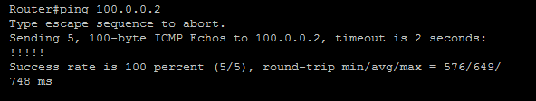

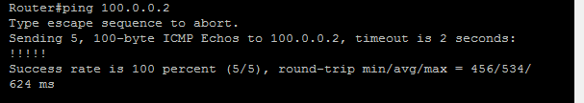

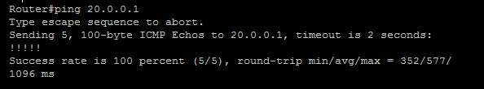

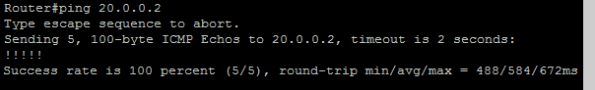

PRACTICAL 8B

Redistribution between EIGRP and OSPF

STEPS OVERVIEW:

1. Assigning IP addresses to R1:
2. Configuring OSPF and EIGRP on router R1:
3. Configuring EIGRP on router R2:
4. Configuring OSPF on router R3:
5. Displaying OSPF and EIGRP neighbors of R1:
6. Displaying OSPF neighbors of R2:
7. Displaying EIGRP neighbors of R3:
8. Displaying Routing Tables of all routers before Redistribution:
9. Redistributing OSPF and EIGRP
10. Displaying route tables of all routers after redistributing:
11. Performing Ping to check connectivity:

Topology:

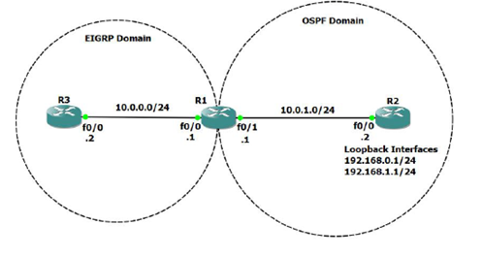

**Assigning IP addresses to R1:**

Router#en

Router#conf t

Router(config)#int f0/0

Router(config-if)#ip address 10.0.0.1 255.255.255.0

Router(config-if)#no shut

Router(config-if)#i

Router(config-if)#int f0/1

Router(config-if)#ip address 10.0.1.1 255.255.255.0

Router(config-if)#no shut

Router(config-if)#^Z

Router#exit

**Assigning IP address and loopback addresses to R2:**

Router#en

Router#conf t

Router(config)#int f0/0

Router(config-if)#ip address 10.0.1.2 255.255.255.0

Router(config-if)#no shut

Router(config-if)#int loopback0

Router(config-if)#ip address 192.168.0.1 255.255.255.0

Router(config-if)#no shut

Router(config-if)#int loopback1

Router(config-if)#ip address 192.168.1.1 255.255.255.0

Router(config-if)#no shut

Router(config-if)#^Z

Router#exit

**Assigning IP addresses to R3:**

Router#en

Router#conf t

Router(config)#int f0/0

Router(config-if)#ip address 10.0.0.2 255.255.255.0

Router(config-if)#no shut

Router(config-if)#^Z

Router#exit

**Configuring OSPF and EIGRP on router R1:**

Router#en

Router#conf t

Router(config)#router ospf 1

Router(config-router)#network 10.0.1.0 0.0.0.255 area 0

Router(config-router)#exit

Router(config)#router eigrp 10

Router(config-router)#network 10.0.0.0

Router(config-router)#no auto-summary

Router(config-router)#^Z

Router#exit

**Configuring EIGRP on router R2:**

Router#en

Router#conf t

Router(config)#router ospf 1

Router(config-router)#network 10.0.1.0 0.0.0.255 area 0

Router(config-router)#network 192.168.0.0 0.0.0

Router(config-router)#network 192.168.0.0 0.0.0.255 area 0

Router(config-router)#network 192.168.1.0 0.0.0.255 area 0

Router(config-router)#^Z

Router#exit

**Configuring OSPF on router R3:**

Router#en

Router#conf t

Router(config)#router eigrp 10

Router(config-router)#network 10.0.0.0

Router(config-router)#no auto-summary

Router(config-router)#^Z

Router#exit

**Displaying OSPF and EIGRP neighbors of R1:**

Router#show ip eigrp neighbor

IP-EIGRP neighbors for process 10

H Address Interface Hold Uptime SRTT RTO Q Seq

(sec) (ms) Cnt Num

0 10.0.0.2 Fa0/0 14 00:00:59 1020 5000 0 4

Router#show ip ospf neighbor

Neighbor ID Pri State Dead Time Address Interface

192.168.1.1 1 FULL/BDR 00:00:36 10.0.1.2 FastEthernet0/1

**Displaying OSPF neighbors of R2:**

Router#show ip ospf neighbor

Neighbor ID Pri State Dead Time Address Interface

10.0.1.1 1 FULL/DR 00:00:34 10.0.1.1 FastEthernet0/0

**Displaying EIGRP neighbors of R3:**

Router#show ip eigrp neighbor

IP-EIGRP neighbors for process 10

H Address Interface Hold Uptime SRTT RTO Q Seq

(sec) (ms) Cnt Num

0 10.0.0.1 Fa0/0 11 00:08:29 368 2208 0 2

**Displaying Routing Tables of all routers before Redistribution:**

**For R1:**

Router#show ip route

10.0.0.0/24 is subnetted, 2 subnets

C 10.0.0.0 is directly connected, FastEthernet0/0

C 10.0.1.0 is directly connected, FastEthernet0/1

192.168.0.0/32 is subnetted, 1 subnets

O 192.168.0.1 [110/11] via 10.0.1.2, 00:12:59, FastEthernet0/1

192.168.1.0/32 is subnetted, 1 subnets

O 192.168.1.1 [110/11] via 10.0.1.2, 00:12:59, FastEthernet0/1

**For R2:**

Router#show ip route

10.0.0.0/24 is subnetted, 1 subnets

C 10.0.1.0 is directly connected, FastEthernet0/0

C 192.168.0.0/24 is directly connected, Loopback0

C 192.168.1.0/24 is directly connected, Loopback1

**For R3:**

Router#show ip route

10.0.0.0/24 is subnetted, 2 subnets

C 10.0.0.0 is directly connected, FastEthernet0/0

D 10.0.1.0 [90/307200] via 10.0.0.1, 00:10:13, FastEthernet0/0

**Redistributing OSPF and EIGRP**

Router#en

Router#conf t

Router(config)#router ospf 1

Router(config-router)#redistribute eigrp 10 metric 100 metric-type 1 subnets

Router(config-router)#exit

Router(config)#router eigrp 10

Router(config-router)#redistribute ospf 1 metric 10000 10 255 5 1500

Router(config-router)#^Z

Router#exit

**Displaying route tables of all routers after redistributing:**

**For R1:**

Router#show ip route

10.0.0.0/24 is subnetted, 2 subnets

C 10.0.0.0 is directly connected, FastEthernet0/0

C 10.0.1.0 is directly connected, FastEthernet0/1

192.168.0.0/32 is subnetted, 1 subnets

O 192.168.0.1 [110/11] via 10.0.1.2, 00:03:57, FastEthernet0/1

192.168.1.0/32 is subnetted, 1 subnets

O 192.168.1.1 [110/11] via 10.0.1.2, 00:03:57, FastEthernet0/1

**For R2:**

Router#show ip route

10.0.0.0/24 is subnetted, 2 subnets

O E1 10.0.0.0 [110/110] via 10.0.1.1, 00:04:05, FastEthernet0/0

C 10.0.1.0 is directly connected, FastEthernet0/0

C 192.168.0.0/24 is directly connected, Loopback0

C 192.168.1.0/24 is directly connected, Loopback1

**For R3:**

Router#show ip route

10.0.0.0/24 is subnetted, 2 subnets

C 10.0.0.0 is directly connected, FastEthernet0/0

D 10.0.1.0 [90/307200] via 10.0.0.1, 00:19:45, FastEthernet0/0

192.168.0.0/32 is subnetted, 1 subnets

D EX 192.168.0.1 [170/284160] via 10.0.0.1, 00:02:49, FastEthernet0/0

192.168.1.0/32 is subnetted, 1 subnets

D EX 192.168.1.1 [170/284160] via 10.0.0.1, 00:02:49, FastEthernet0/0

**Performing Ping to check connectivity:**

For R2: 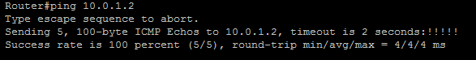

For R3: 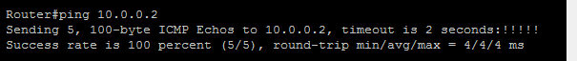

PRACTICAL NUMBER 9

Designing a Remote Access VPN

Topology:

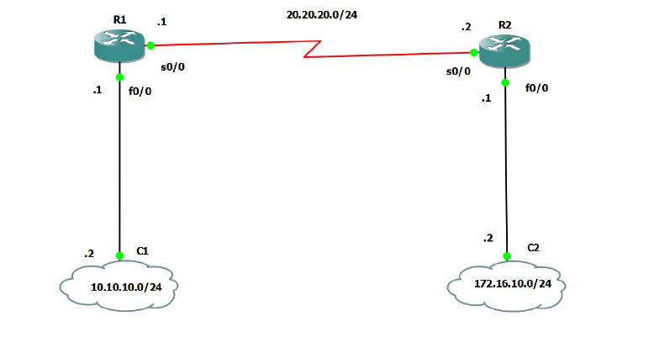

For R1:

R1(config)#int s1/0

R1(config-if)#ip address 20.20.20.1 255.255.255.252

R1(config-if)#no shut

R1(config-if)#router rip

R1(config-router)#version 2

R1(config-router)#no auto-summary

R1(config-router)#network 20.20.20.0

R1(config-router)#exit

R1(config)#int f0/0

R1(config-if)#ip address 192.168.42.243 255.255.255.0

R1(config-if)#no shut

R1(config-if)#exit

R1(config)#exit

R1(config)#router rip

R1(config-router)#version 2

R1(config-router)#no auto-summary

R1(config-router)#network 192.168.42.0

R1(config-router)#

R1(config-router)#exit

R1(config)#exit

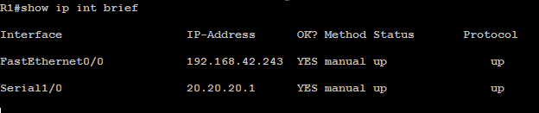

R1(config)#crypto isakmp policy 1

R1(config-isakmp)#authentication pre-share

R1(config-isakmp)#hash sha

R1(config-isakmp)#exit

R1(config)#crypto isakmp key cisco address 20.20.20.2

R1(config)#crypto ipsec transform-set myset esp-sha-hmac esp-aes

R1(cfg-crypto-trans)#exit

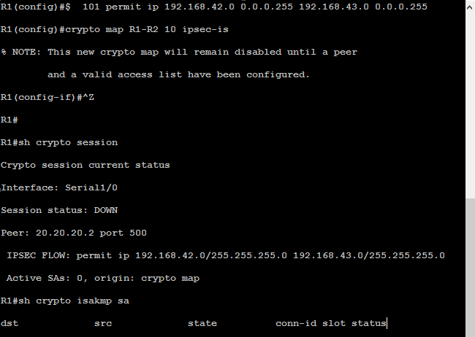

**For Router R2**

R2(config)#int s1/0

R2(config-if)#ip address 20.20.20.2 255.255.255.252

R2(config-if)#no shut

R2(config-if)#router rip

R2(config-router)#version 2

R2(config-router)#no auto-summary

R2(config-router)#network 20.20.20.0

R2(config-router)#exit

R2(config)#exit

R2#

*Mar 1 00:22:51.827: %SYS-5-CONFIG_I: Configured from console by console

R2#conf t

Enter configuration commands, one per line. End with CNTL/Z.

R2(config)#int f0/0

R2(config-if)#ip address 192.168.42.154

% Incomplete command.

R2(config-if)#ip address 192.168.42.154 255.255.255.0

R2(config-if)#no shut

R2(config-if)#exit

R2(config)#router rip

R2(config-router)#version 2

R2(config-router)#no auto-summary

R2(config-router)#network 192.168.42.0

R2(config-router)#exit

R2(config)#exit

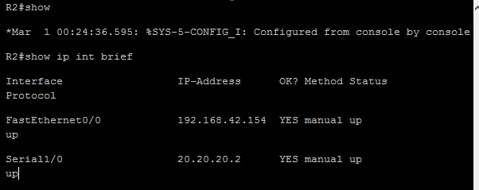

R2(config)#crypto isakmp policy 1

R2(config-isakmp)#authentication pre-share

R2(config-isakmp)#hash sha

R2(config-isakmp)#exit

R2(config)#crypto isakmp key cisco address 20.20.20.1

R2(config)#crypto ipsec transform-set myset esp-sha-hmac esp-aes

R2(cfg-crypto-trans)#exit

R2(config)#$ 101 permit ip 192.168.43.0 0.0.0.255 192.168.42.0 0.0.0.255

R2(config)#crypto map R1-R2 10 ipsec-is

% NOTE: This new crypto map will remain disabled until a peer

and a valid access list have been configured.

R2(config-if)#^Z

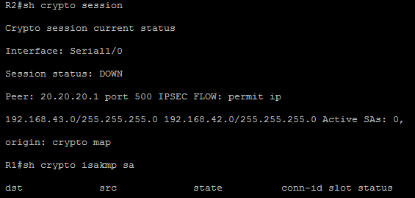

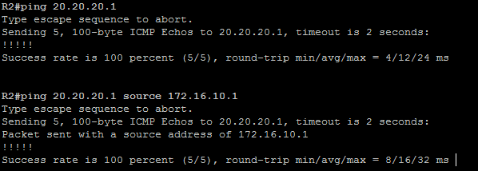

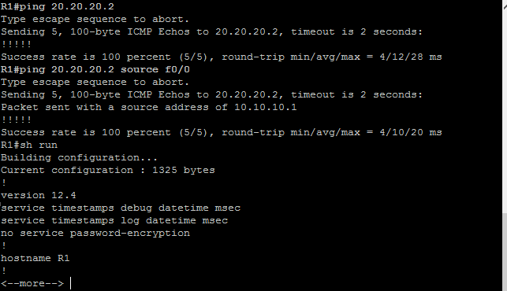

**Third Step**

* Open your cmd prompt of windows on which your GNS3 install and ping the ipaddress of Routers
* R1 and R2 simultaneously.
* It should be reply from both IP.

