PRACTICAL e-Journal

MSCIT (PART I) SEMESTER - II

2018-19

SUBJECT

ADVANCED COMPUTER NETWORKS

SUBMITTED BY

Shaikh Seema Abdul Rashid

Seat No. 13

Submitted in partial fulfillment of the requirement for

Qualifying

M.Sc. Part I Semester II Examination

2018-19

Department of Information Technology

Ramniranjan Jhunjhunwala College

Station Road, Ghatkopar (w), Mumbai-86



CERTIFICATE

This is to certify that Miss SHAIKH SEEMA ABDUL RASHID with Seat No. 13 has successfully completed the necessary course of experiments in the subject of ADVANCED COMPUTER NETWORKS during the academic year 2018 – 2019 complying with the requirements of RAMNIRANJAN JHUNJHUNWALA COLLEGE OF ARTS, SCIENCE AND COMMERCE, for the course of M.Sc. (IT) semester -II.

Internal Examiner Date:

Head of Department College Seal External Examiner

**INDEX**

|  |  |  |  |
| --- | --- | --- | --- |
| **Sr. No** | **Practical** | **Date** | **Page No.** |
| 1 | Simulating RIP | 19-12-2018 | 3 |
| 2 | Simulating OSPF | 02-01-2019 | 18 |
| 3 | Simulating OSPF with Stub AREA, NSSA, Restricting LSAs | 09-01-2019 | 32 |
| 4 | Simulating BGP | 16-01-2019 | 43 |
| 5 | Simulating IBGP | 23-01-2019 | 54 |
| 6 | Simulating EBGP | 01-02-2019 | 59 |
| 7 | Configuring IP Multicasting Routing | 02-02-2019 | 47 |
| 8 | A. Simulating Routing Redistribution  B. Redistribution between EIGRP and OSPF | 06-02-2019 | 70 |
| 9 | Designing A Remote Access VPN | 08-02-2019 | 81 |

PRACTICAL NUMBER 1

Simulating RIP

Overview of Commands:

**Step 1:- Configure all routers.**

1) Right click each router and click configure

2) Select r1 and slots and select adapters for slots 0, 1, 2

3) Fill slot 0, slot1, slot 2 and click ok.

4) Do step 1 to 3 for all other routers.

**Step 2:- Configure network and RIP for all routers.**

# interface f0/0

# ip address 10.1.1.1 255.255.255.0

# no shut

**Step 3:- Displaying the interface brief:**

#show ip interface brief

**Displaying the details about neighbouring devices of all routers:**

#show cdp neighbors

**Step 4:- Configure RIP for all routers.**

# router rip

# network 10.1.1.0

# no auto-summary

**Step 5:- Displaying the current configuration of all routers:**

R1#show running

**Displaying the Routing Table:**

R1#show ip route

**Step 6:- Performing ping to check connectivity amongst routers:**

#ping 10.0.23.1

**Step 7:- Configuring RIP Authentication on the Routers:**

#key chain acn

#key 1

#key-string rippracts

**Configuring the RIP Authentication Mode (MD5) on the interface of routers:**

int s0/0

R1(config-if)#ip rip authentication key-chain acn

R1(config-if)#ip rip authentication mode md5

**Verifying RIP Authentication mode on the routers:**

#debug ip rip

**Enabling Split Horizon on the routers:**

# int s0/0

# R4(config-if)#ip split-horizon

**Disabling Split Horizon on the routers:**

# int s0/0

# no ip split-horizon

**Configuring Router to send and receive RIP version updates:**

int f0/0

R2(config-if)#ip rip receive version 1

R2(config-if)#ip rip send version 2

**Topology:-**

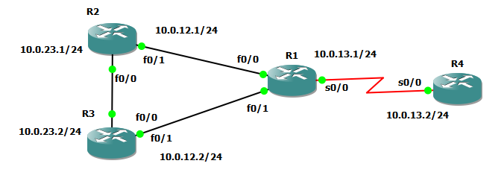

**Assigning IP addresses to R1:**

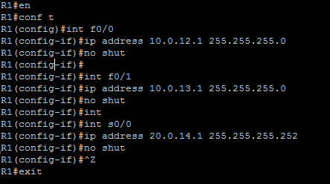

**Assigning IP addresses to R2:**

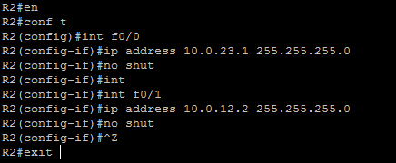

**Assigning IP addresses to R3:**

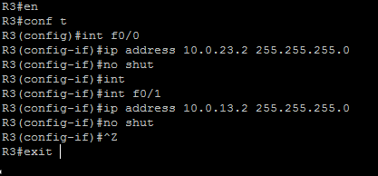

**Assigning IP addresses to R4:**

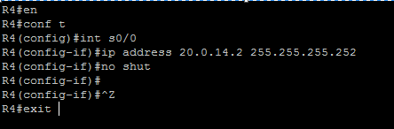

**OUTPUT:**

**For R1:** 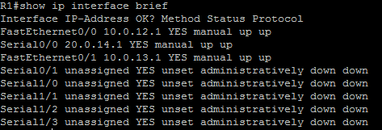

**For R2:** 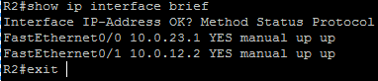

**For R3:** 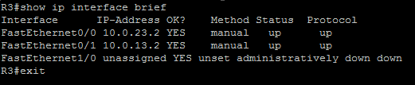

**For R4:** 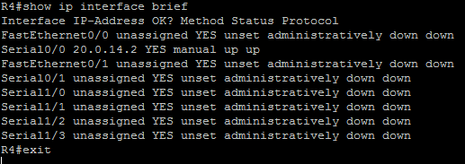

**Displaying the details about neighbouring devices of all routers:**

**For R1:** 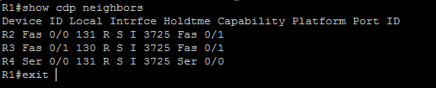

**For R2:** 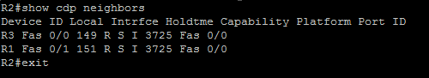

**For R3:** 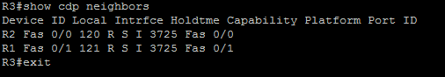

**For R4:** 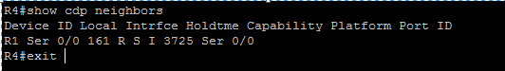

**Configuring RIP on the routers:**

**For R1:** 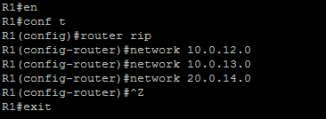

**For R2:** 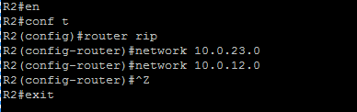

**For R3:** 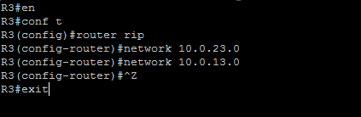

**For R4:** 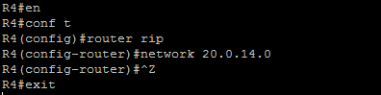

**Displaying the current configuration of all routers:**

**For R1:** 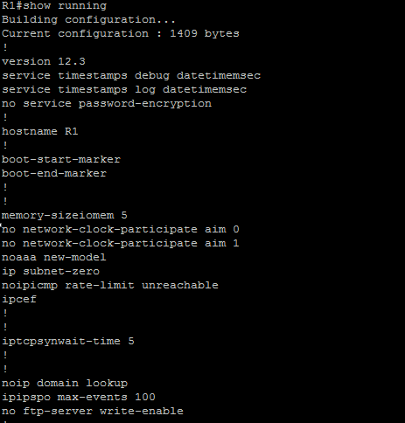

**For R2:** 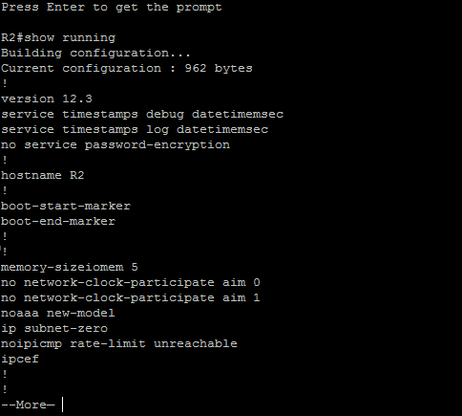

**For R3:** 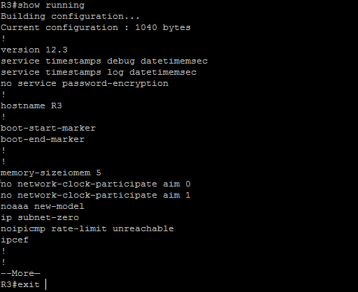

**For R4:** 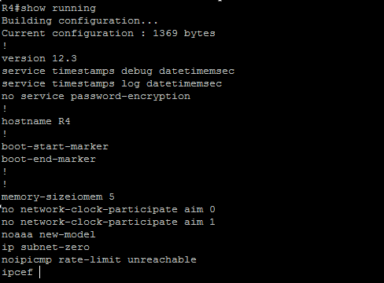

**Output Routing Tables:**

**For R1:** 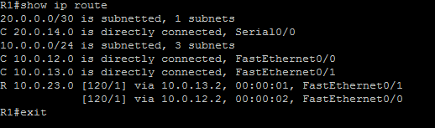

**For R2:** 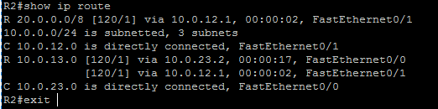

**For R3:** 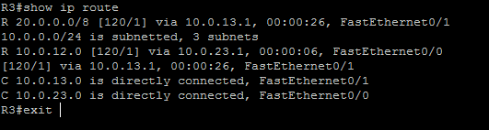

**For R4:** 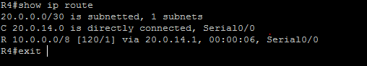

**Performing ping to check connectivity amongst routers:**

**For R1:** 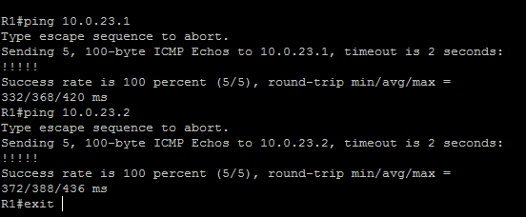

**For R2:** 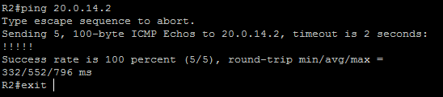

**For R3:** 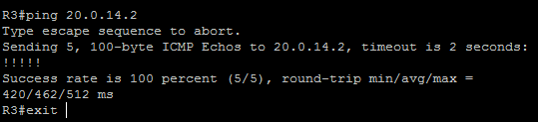

**For R4:** 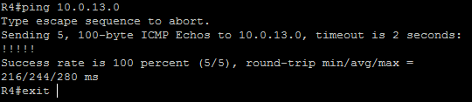

**Configuring the RIP Authentication Mode (MD5) on the interface of routers:**

**For R1:**

R1#en

R1#conf t

R1(config)#int s0/0

R1(config-if)#ip rip authentication key-chain acn

R1(config-if)#ip rip authentication mode md5

R1(config-if)#^Z

R1#exit

**For R4:**

R4#en

R4#conf t

R4(config)#int s0/0

R4(config-if)#ip rip authentication key-chain acn

R4(config-if)#ip rip authentication mode md5

R4(config-if)#^Z

R4#exit

**Configuring the RIP Authentication Mode (Text [default]) on the interface of routers:**

**For R2:**

R2#en

R2#conf t

R2(config)#int f0/0

R2(config-if)#ip rip authentication key-chain acn1

R2(config-if)#^Z

R2#exit

**For R3:**

R3#en

R3#conf t

R3(config)#int f0/0

R3(config-if)#ip rip authentication key-chain acn1

R3(config-if)#^Z

R3#exit

**Verifying RIP Authentication mode on the routers:**

For R2: 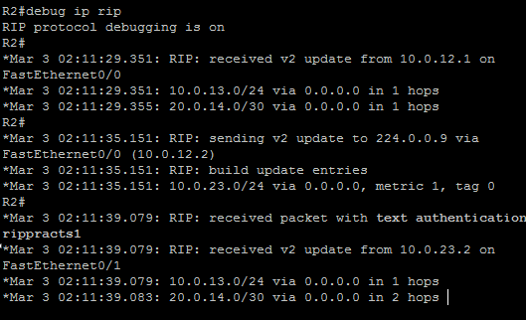

For R3: 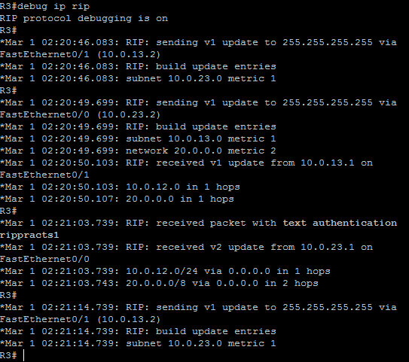

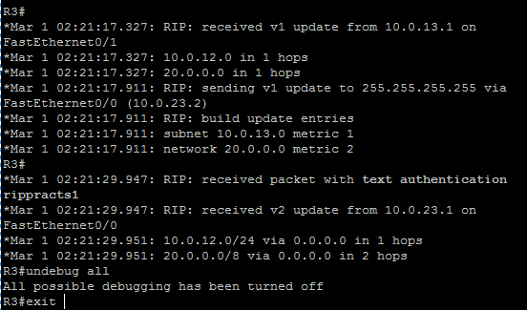

For R4: 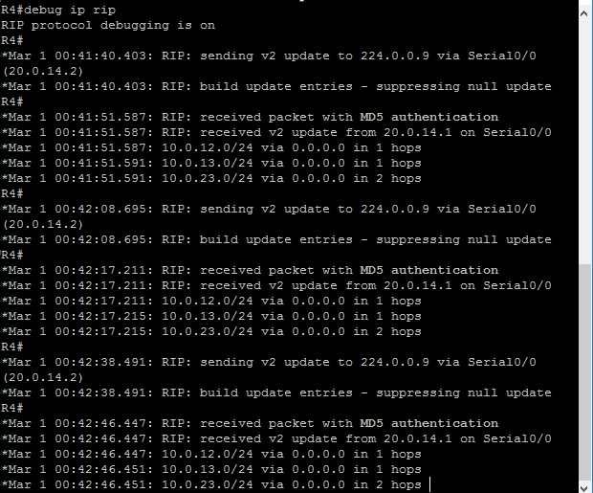

**Enabling Split Horizon on the routers:**

**For R4:**

R4#en

R4#conf t

R4(config)#int s0/0

R4(config-if)#ip split-horizon

R4(config-if)#^Z

R4#exit

**Disabling Split Horizon on the routers:**

**For R4:**

R4#en

R4#conf t

R4(config)#int s0/0

R4(config-if)#no ip split-horizon

R4(config-if)#^Z

R4#exit

**Configuring Router to send and receive RIP version updates:**

**For R2:**

R2#en

R2#conf t

R2(config)#int f0/0

R2(config-if)#ip rip receive version 1

R2(config-if)#ip rip send version 2

R2(config-if)#

R2(config-if)#^Z

R2#exit

PRACTICAL NUMBER 2

Simulating OSPF

Practical 2A: Simulating OSPF in Broadcast Routers Using a topology of five routers as shown in the below picture.

OVERVIEW OF COMMANDS

**Step 1:- Assigning IP addresses to R1**

config)#int f0/0

R1(config-if)#ip address 10.0.12.1 255.255.255.0

R1(config-if)#no shut

**Configuring OSPF on the routers**

R1(config)#router ospf 1

R1(config-router)#network 10.0.12.0 0.0.0.255 area 0

R1(config-router)#network 10.0.13.0 0.0.0.255 area 0

R1(config-router)#^Z

**Displaying the details about neighbouring devices of all routers:**

R1#show ip ospf neighbor

**Routing Table of all routers:**

R1#show ip route

**Performing ping to check connectivity amongst routers:**

R1#ping 20.0.24.2

**Specifying Router Priority for DR and BDR Election (R1 is the DR for interface f0/1 with highest of priority 255):**

int f0/0

R1(config-if)#ip ospf priority 0

R1(config-if)#!

R1(config-if)#int f0/1

R1(config-if)#ip ospf priority 255

**Displaying Interface Data Structure of interface 0/1 of R2 and interface 0/1 of R3:**

R2#show ip ospf int f0/1

**Changing Hello and Dead Interval of the routers:**

interface fastethernet0/1

R2(config-if)#ip ospf hello-interval 9

**Displaying Interface Data Structure of interface 0/1 of R2 and interface 0/1 of R3 after changing the hello and dead intervals of interface 0/1 of R2 and interface 0/1 of R3.**

R2#show ip ospf int f0/1

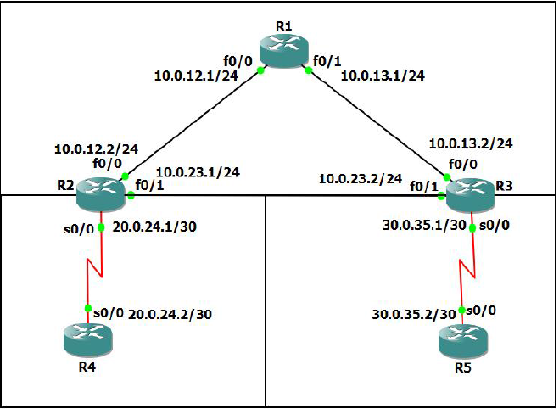

**Assigning IP addresses to R1:**

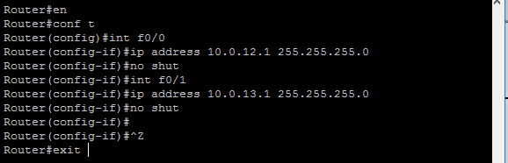

**Assigning IP addresses to R2:**

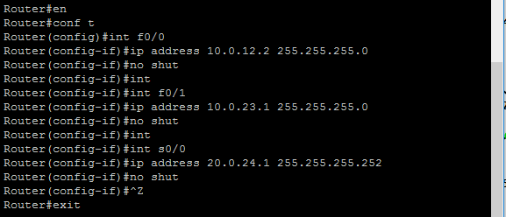

**Assigning IP addresses to R3:**

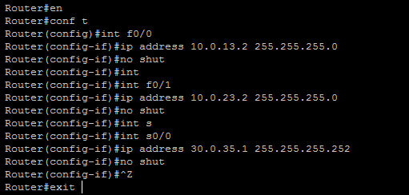

**Assigning IP addresses to R4:**

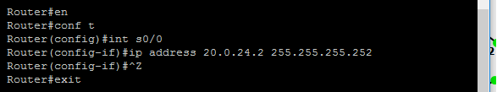

**Assigning IP addresses to R5:**

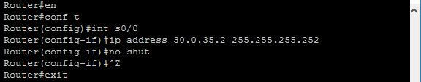

**Configuring OSPF on the routers:**

**For R1:** 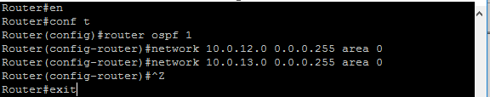

**For R2:** 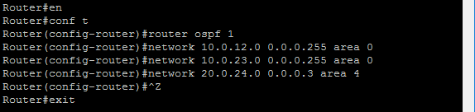

**For R3:** 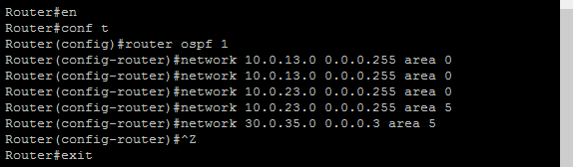

**For R4:** 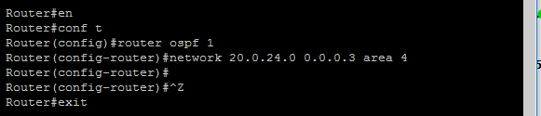

**For R5:** 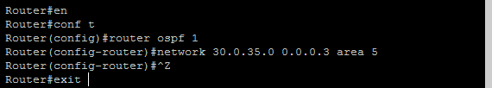

**Displaying the details about neighbouring devices of all routers:**

**For R1:**

Router #show ip ospf neighbor

Neighbor ID Pri State Dead Time Address Interface

30.0.35.1 1 FULL/BDR 00:00:32 10.0.13.2 FastEthernet0/1

20.0.24.1 1 FULL/BDR 00:00:31 10.0.12.2 FastEthernet0/0

**For R2:**

Router#show ip ospf neighbor

Neighbor ID Pri State Dead Time Address Interface

30.0.35.1 1 FULL/BDR 00:00:30 10.0.23.2 FastEthernet0/1

10.0.13.1 1 FULL/DR 00:00:39 10.0.12.1 FastEthernet0/0

20.0.24.2 0 FULL/ - 00:00:31 20.0.24.2 Serial0/0

**For R3:**

Router#show ip ospf neighbor

Neighbor ID Pri State Dead Time Address Interface

20.0.24.1 1 FULL/DR 00:00:37 10.0.23.1 FastEthernet0/1

10.0.13.1 1 FULL/DR 00:00:37 10.0.13.1 FastEthernet0/0

30.0.35.2 0 FULL/ - 00:00:37 30.0.35.2 Serial0/0

**For R4:**

Router#show ip ospf neighbor

Neighbor ID Pri State Dead Time Address Interface

20.0.24.1 0 FULL/ - 00:00:36 20.0.24.1 Serial0/0

**For R5:**

Router#show ip ospf neighbor

Neighbor ID Pri State Dead Time Address Interface

30.0.35.1 0 FULL/ - 00:00:31 30.0.35.1 Serial0/0

OUTPUT:

**Routing Table of all routers:**

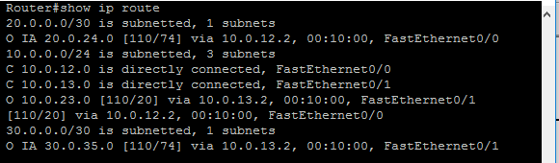

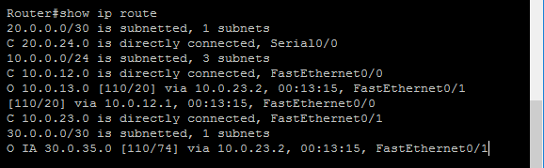

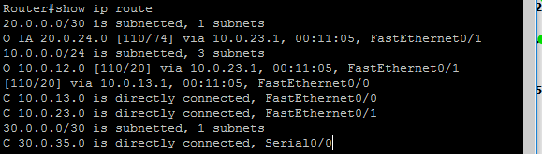

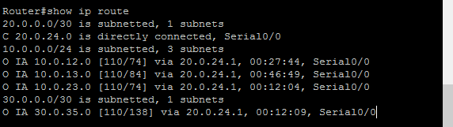

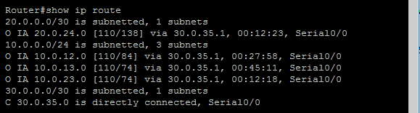

**Performing ping to check connectivity amongst routers:**

For R1: 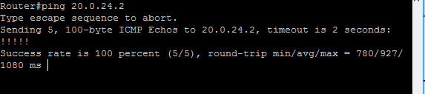

For R2: 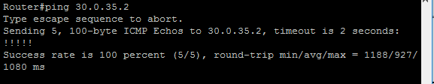

For R3: 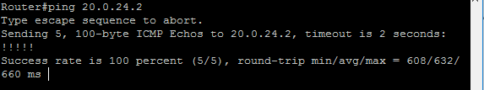

For R4: 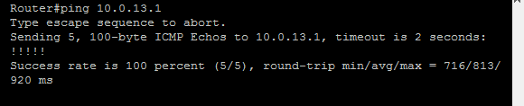

For R5: 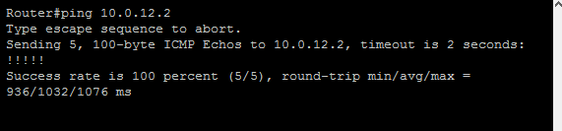

**Specifying Router Priority for DR and BDR Election (R1 is the DR for interface f0/1 with highest of priority 255):**

**For R1:**

Router#en

Router#conf t

Router(config)#int f0/0

Router(config-if)#ip ospf priority 0

Router(config-if)#!

Router(config-if)#int f0/1

Router(config-if)#ip ospf priority 255

Router(config-if)#^Z

Router#exit

**Displaying Interface Data Structure of interface 0/1 of R2 and interface 0/1 of R3:**

**For R2:**

Router#show ip ospf int f0/1

FastEthernet0/1 is up, line protocol is up

Internet Address 10.0.23.1/24, Area 0

Process ID 2, Router ID 20.0.24.1, Network Type BROADCAST, Cost: 10

Transmit Delay is 1 sec, State DR, Priority 1

Designated Router (ID) 20.0.24.1, Interface address 10.0.23.1

Backup Designated router (ID) 30.0.35.1, Interface address 10.0.23.2

Timer intervals configured, **Hello 10, Dead 40**, Wait 40, Retransmit 5

oob-resync timeout 40

Hello due in 00:00:05

Supports Link-local Signaling (LLS)

Index 2/2, flood queue length 0

Next 0x0(0)/0x0(0)

Last flood scan length is 1, maximum is 1

Last flood scan time is 0 msec, maximum is 0 msec

Adjacent with neighbor 30.0.35.1 (Backup Designated Router)

Suppress hello for 0 neighbor(s)

**For R3:**

Router#show ip ospf int f0/1

FastEthernet0/1 is up, line protocol is up

Internet Address 10.0.23.2/24, Area 0

Process ID 1, Router ID 30.0.35.1, Network Type BROADCAST, Cost: 10

Transmit Delay is 1 sec, State BDR, Priority 1

Designated Router (ID) 20.0.24.1, Interface address 10.0.23.1

Backup Designated router (ID) 30.0.35.1, Interface address 10.0.23.2

Timer intervals configured, **Hello 10, Dead 40**, Wait 40, Retransmit 5

oob-resync timeout 40

Hello due in 00:00:08

Supports Link-local Signaling (LLS)

Index 2/2, flood queue length 0

Next 0x0(0)/0x0(0)

Last flood scan length is 1, maximum is 1

Last flood scan time is 0 msec, maximum is 0 msec

Neighbor Count is 1, Adjacent neighbor count is 1

Adjacent with neighbor 20.0.24.1 (Designated Router)

Suppress hello for 0 neighbor(s)

**Changing Hello and Dead Interval of the routers:**

**For R2:**

Router#en

Router#conf t

Router(config)#interface fastethernet0/1

Router(config-if)#ip ospf hello-interval 9

Router(config-if)#^Z

Router#exit

**For R3:**

Router#en

Router#conf t

Router(config)#interface fastethernet0/1

Router(config-if)#ip ospf hello-interval 9

Router(config-if)#^Z

Router#exit

**Displaying Interface Data Structure of interface 0/1 of R2 and interface 0/1 of R3 after changing the hello and dead intervals of interface 0/1 of R2 and interface 0/1 of R3.**

**For R2:**

Router#show ip ospf int f0/1

FastEthernet0/1 is up, line protocol is up

Internet Address 10.0.23.1/24, Area 0

Process ID 2, Router ID 20.0.24.1, Network Type BROADCAST, Cost: 10

Transmit Delay is 1 sec, State BDR, Priority 1

Designated Router (ID) 30.0.35.1, Interface address 10.0.23.2

Backup Designated router (ID) 20.0.24.1, Interface address 10.0.23.1

Flush timer for old DR LSA due in 00:02:49

Timer intervals configured, **Hello 9, Dead 36**, Wait 36, Retransmit 5

Hello due in 00:00:05

Supports Link-local Signaling (LLS)

Index 2/2, flood queue length 0

Next 0x0(0)/0x0(0)

Last flood scan length is 1, maximum is 1

Last flood scan time is 0 msec, maximum is 4 msec

Neighbor Count is 1, Adjacent neighbor count is 1

Adjacent with neighbor 30.0.35.1 (Designated Router)

Suppress hello for 0 neighbor(s)

**For R3:**

Router#show ip ospf int f0/1

FastEthernet0/1 is up, line protocol is up

Internet Address 10.0.23.2/24, Area 0

Process ID 1, Router ID 30.0.35.1, Network Type BROADCAST, Cost: 10

Transmit Delay is 1 sec, State DR, Priority 1

Designated Router (ID) 30.0.35.1, Interface address 10.0.23.2

Backup Designated router (ID) 20.0.24.1, Interface address 10.0.23.1

Timer intervals configured, **Hello 9, Dead 36**, Wait 36, Retransmit 5

oob-resync timeout 40

Hello due in 00:00:08

Supports Link-local Signaling (LLS)

Index 2/2, flood queue length 0

Next 0x0(0)/0x0(0)

Last flood scan length is 1, maximum is 1

Last flood scan time is 0 msec, maximum is 0 msec

Neighbor Count is 1, Adjacent neighbor count is 1

Adjacent with neighbor 20.0.24.1 (Backup Designated Router)

Suppress hello for 0 neighbor(s

**Practical 2B: Simulating OSPF in Non-Broadcast Routers**

* Drag and drop a ***“Frame Relay switch”*** on a new project window in GNS3.
* It asks for configuration for the FR1 node (Frame Relay switch).
* Here, router R1 is connected to all the other 3 routers (R2, R3 & R4) via the FR1 switch.
* First Mapping can be seen in the following window.
* Click on ***“Add”*** button after giving the “Port” and “DLCI” values to add the mapping to the list.

Topology:

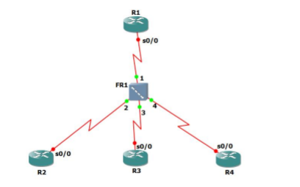

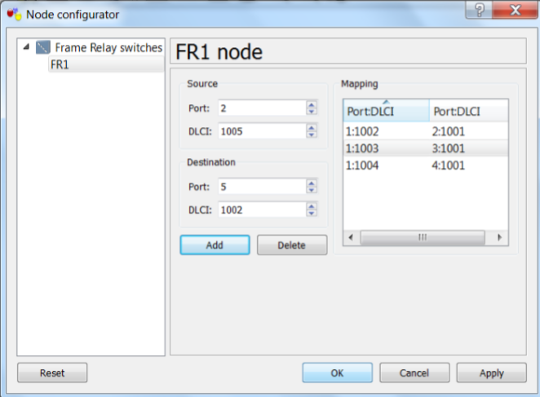

**Configuring OSPF on all the routers**

#int s0/0

#ip address 10.0.0.1 255.255.255.248

#encapsulation frame-relay

#ip ospf network non-broadcast

#ip ospf priority 100

#frame-relay map ip 10.0.0.2 1002

#no shut

#exit

#router ospf 1

#network 10.0.0.0 0.0.0.7 area 0

#neighbor 10.0.0.2

#^Z

**Displaying the details about neighbouring devices of all routers:**

R1#show ip ospf neighbor

**Performing ping to check connectivity amongst routers:**

#ping 10.0.0.2

**Configuring OSPF on all the routers:**

**For R1:**

Router#en

Router#conf t

Router(config)#int s0/0

Router(config-if)#ip address 10.0.0.1 255.255.255.248

Router(config-if)#encapsulation frame-relay

Router(config-if)#ip ospf network non-broadcast

Router(config-if)#ip ospf priority 100

Router(config-if)#frame-relay map ip 10.0.0.2 1002

Router(config-if)#frame-relay map ip 10.0.0.3 1003

Router(config-if)#frame-relay map ip 10.0.0.4 1004

Router(config-if)#no shut

Router(config-if)#exit

Router(config)#router ospf 1

Router(config-router)#network 10.0.0.0 0.0.0.7 area 0

Router(config-router)#neighbor 10.0.0.2

Router(config-router)#neighbor 10.0.0.3

Router(config-router)#neighbor 10.0.0.4

Router(config-router)#^Z

Router#exit

**For R2:**

Router#en

Router#conf t

Router(config)#int s0/0

Router(config-if)#ip address 10.0.0.2 255.255.255.248

Router(config-if)#encapsulation frame-relay

Router(config-if)#ip ospf network non-broadcast

Router(config-if)#ip ospf priority 0

Router(config-if)#frame-relay map ip 10.0.0.1 1001

Router(config-if)#no shut

Router(config-if)#exit

Router(config)#router ospf 1

Router(config-router)#network

Router(config-router)#network 10.0.0.0 0.0.0.7 area 0

Router(config-router)#neighbor 10.0.0.1

Router(config-router)#^Z

Router#exit

**For R3:**

Router#en

Router#conf t

Router(config)#int s0/0

Router(config-if)#ip address 10.0.0.3 255.255.255.248

Router(config-if)#encapsulation frame-relay

Router(config-if)#ipospf network non-broadcast

Router(config-if)#ipospf priority 0

Router(config-if)#frame-relay map ip 10.0.0.1 1001

Router(config-if)#no shut

Router(config-if)#exit

Router(config)#router ospf 1

Router(config-router)#network 10.0.0.0 0.0.0.7 area 0

Router(config-router)#neighbor 10.0.0.1

Router(config-router)#^Z

Router#exit

**For R4:**

Router#en

Router#conf t

Router(config)#int s0/0

Router(config-if)#ip address 10.0.0.4 255.255.255.248

Router(config-if)#encapsulation frame-relay

Router(config-if)#ip ospf network non-broadcast

Router(config-if)#ip ospf priority 0

Router(config-if)#frame-relay map ip 10.0.0.1 1001

Router(config-if)#no shut

Router(config-if)#exit

Router(config)#router ospf 1

Router(config-router)#network 10.0.0.0 0.0.0.7 area 0

Router(config-router)#neighbor 10.0.01

Router(config-router)#neighbor 10.0.0.1

Router(config-router)#^Z

Router#exit

**Displaying the details about neighbouring devices of all routers:**

**For R1:**

Router#show ip ospf neighbor

Neighbor ID Pri State Dead Time Address Interface

10.0.0.2 0 FULL/DROTHER 00:01:48 10.0.0.2 Serial0/0

10.0.0.3 0 FULL/DROTHER 00:01:55 10.0.0.3 Serial0/0

10.0.0.4 0 FULL/DROTHER 00:01:46 10.0.0.4 Serial0/0

**For R2:**

Router#show ip ospf neighbor

Neighbor ID Pri State Dead Time Address Interface

10.0.0.1 100 FULL/DR 00:01:51 10.0.0.1 Serial0/0

**For R3:**

Router#show ipospf neighbor

Neighbor ID Pri State Dead Time Address Interface

10.0.0.1 100 FULL/DR 00:01:54 10.0.0.1 Serial0/0

**For R4:**

Router#show ip ospf neighbor

Neighbor ID Pri State Dead Time Address Interface

10.0.0.1 100 FULL/DR 00:01:43 10.0.0.1 Serial0/0

**Performing ping to check connectivity amongst routers:**

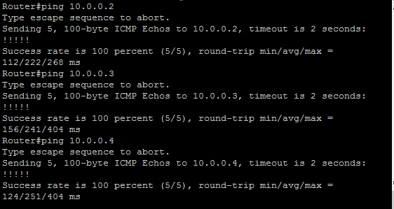

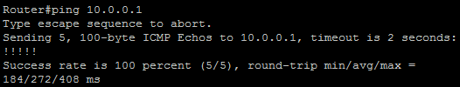

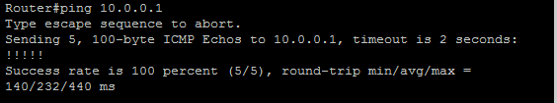

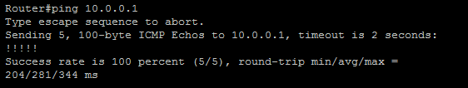

PRACTICAL NUMBER 3

Simulating OSPF with STUB AREA, NSSA, Restricting LSA’s

**OVERVIEW OF COMMANDS:**

**Assigning IP address and Loopback Interfaces to router R1:**

R1(config)#int s0/0

R1(config-if)#ip address 10.1.1.1 255.255.255.0

R1(config-if)#no shut

R1(config-if)#int loopback0

R1(config-if)#ip address 10.1.2.1 255.255.255.0

R1(config-if)#ip address 10.1.2.1 255.255.255.0

R1(config-if)#no shut

**Configuring OSPF on routers R1, R2, R4 and R5:**

R1#en

R1#conf t

R1(config)#router ospf 1

R1(config-router)#network 10.1.1.0 0.0.0.255 area 1

R1(config-router)#^Z

R1#exit

**Configuring RIP and OSPF on R3:**

R3(config)#router rip

R3(config-router)#network 99.9.1.0

R3(config-router)#network 99.9.2.0

R3(config-router)#network 99.9.3.0

R3(config-router)#network 99.9.4.0

R3(config-router)#network 99.9.5.0

R3(config-router)#exit

**Displaying Routing tables of all routers:**

R1#show ip route

**Displaying OSPF neighbors of all routers:**

R1#show ip ospf neighbor

**Displaying OSPF Interface details of all routers:**

R1#show ip ospf interface brief

**Configure Area 1 as stub area:**

R1(config)#router ospf 1

R1(config-router)#area 1 stub

R1(config-router)#^Z

R1#exit

**Displaying Routing Table of R1 to verify Area1 as Stub Area:**

R1#show ip route

**Displaying global OSPF Configuration of the R1:**

R1#show ip ospf

**Configure Area2 as NSSA on R4:**

R4(config)#router ospf 1

R4(config-router)#no area 2 stub

R4(config-router)#area 2 nssa

R4(config-router)#^Z

**Configure R4 to advertise default routes for NSSA:**

R4(config)#router ospf 1

R4(config-router)#area 2 nssa default-information-originate

R4(config-router)#^Z

**Topology:**

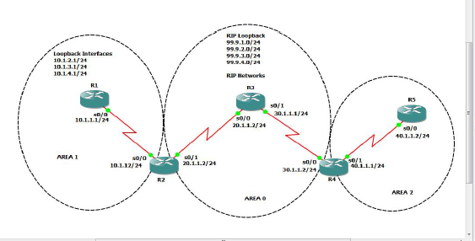

**Assigning IP address and Loopback Interfaces to router R1:**

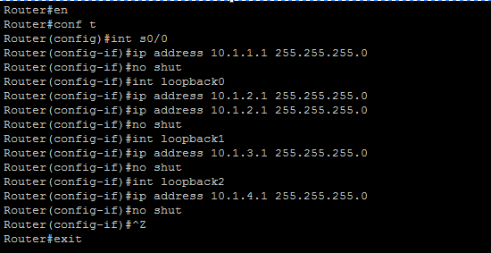

**Assigning IP addresses to router R2:**

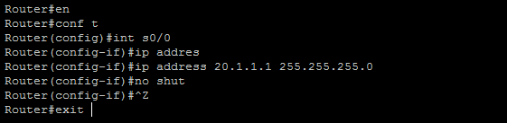

**Assigning IP address and Loopback Interfaces to router R3:**

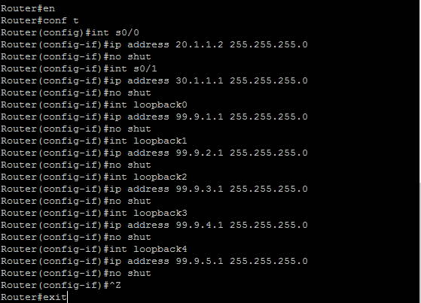

**Assigning IP addresses to router R4:**

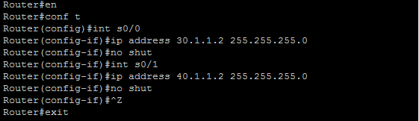

**Assigning IP addresses to router R5:**

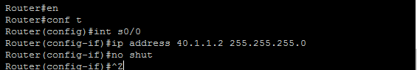

**Configuring OSPF on routers R1, R2, R4 and R5:**

For R1: 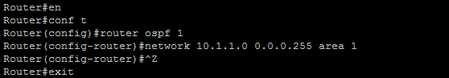

For R2: * 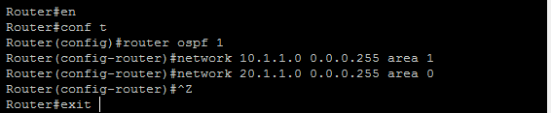

**Configuring RIP and OSPF on R3:**

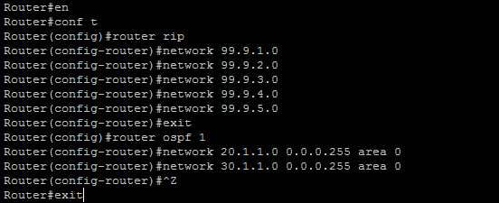

For R4: 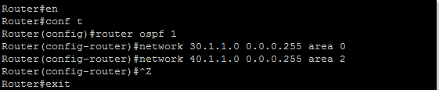

For R5: 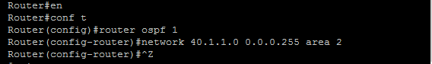

**Displaying Routing tables of all routers:**

**For R1:**

Router#show ip route

20.0.0.0/24 is subnetted, 1 subnets

O IA 20.1.1.0 [110/128] via 10.1.1.2, 00:02:23, Serial0/0

40.0.0.0/24 is subnetted, 1 subnets

O IA 40.1.1.0 [110/256] via 10.1.1.2, 00:00:15, Serial0/0

10.0.0.0/24 is subnetted, 4 subnets

C 10.1.3.0 is directly connected, Loopback2

C 10.1.2.0 is directly connected, Loopback1

C 10.1.1.0 is directly connected, Serial0/0

C 10.1.4.0 is directly connected, Loopback3

30.0.0.0/24 is subnetted, 1 subnets

O IA 30.1.1.0 [110/192] via 10.1.1.2, 00:00:51, Serial0/0

**For R2:**

Router#show ip route

20.0.0.0/24 is subnetted, 1 subnets

C 20.1.1.0 is directly connected, Serial0/1

40.0.0.0/24 is subnetted, 1 subnets

O IA 40.1.1.0 [110/192] via 20.1.1.2, 00:04:24, Serial0/1

10.0.0.0/24 is subnetted, 1 subnets

C 10.1.1.0 is directly connected, Serial0/0

30.0.0.0/24 is subnetted, 1 subnets

O 30.1.1.0 [110/128] via 20.1.1.2, 00:04:24, Serial0/1

**For R3:**

Router#show ip route

99.0.0.0/24 is subnetted, 5 subnets

C 99.9.2.0 is directly connected, Loopback1

C 99.9.3.0 is directly connected, Loopback2

C 99.9.1.0 is directly connected, Loopback0

C 99.9.4.0 is directly connected, Loopback3

C 99.9.5.0 is directly connected, Loopback4

20.0.0.0/24 is subnetted, 1 subnets

C 20.1.1.0 is directly connected, Serial0/0

40.0.0.0/24 is subnetted, 1 subnets

O IA 40.1.1.0 [110/128] via 30.1.1.2, 00:04:30, Serial0/1

10.0.0.0/24 is subnetted, 1 subnets

O IA 10.1.1.0 [110/128] via 20.1.1.1, 00:04:54, Serial0/0

30.0.0.0/24 is subnetted, 1 subnets

C 30.1.1.0 is directly connected, Serial0/1

**For R4:**

Router#show ip route

20.0.0.0/24 is subnetted, 1 subnets

O 20.1.1.0 [110/128] via 30.1.1.1, 00:04:31, Serial0/0

40.0.0.0/24 is subnetted, 1 subnets

C 40.1.1.0 is directly connected, Serial0/1

10.0.0.0/24 is subnetted, 1 subnets

O IA 10.1.1.0 [110/192] via 30.1.1.1, 00:04:31, Serial0/0

30.0.0.0/24 is subnetted, 1 subnets

C 30.1.1.0 is directly connected, Serial0/0

**For R5:**

Router#show ip route

40.0.0.0/24 is subnetted, 1 subnets

C 40.1.1.0 is directly connected, Serial0/0

**Displaying OSPF neighbors of all routers:**

**For R1:**

Router#show ip ospf neighbor

Neighbor ID Pri State Dead Time Address Interface

20.1.1.1 0 FULL/ - 00:00:35 10.1.1.2 Serial0/0

**For R2:**

Router#show ip ospf neighbor

Neighbor ID Pri State Dead Time Address Interface

99.9.5.1 0 FULL/ - 00:00:38 20.1.1.2 Serial0/1

10.1.4.1 0 FULL/ - 00:00:37 10.1.1.1 Serial0/0

**For R3:**

Router#show ip ospf neighbor

Neighbor ID Pri State Dead Time Address Interface

40.1.1.2 0 FULL/ - 00:00:38 30.1.1.2 Serial0/1

20.1.1.1 0 FULL/ - 00:00:32 20.1.1.1 Serial0/0

**For R4:**

Router#show ip ospf neighbor

Neighbor ID Pri State Dead Time Address Interface

99.9.5.1 0 FULL/ - 00:00:35 30.1.1.1 Serial0/0

40.1.1.2 0 FULL/ - 00:00:34 40.1.1.2 Serial0/1

**For R5:**

Router#show ip ospf neighbor

Neighbor ID Pri State Dead Time Address Interface

40.1.1.1 0 FULL/ - 00:00:31 40.1.1.1 Serial0/0

**Displaying OSPF Interface details of all routers:**

**For R1:**

Router#show ip ospf interface brief

Interface PID Area IP Address/Mask Cost State Nbrs F/C

Se0/0 1 1 10.1.1.1/24 64 P2P 1/1

**For R2:**

Router#show ip ospf interface brief

Interface PID Area IP Address/Mask Cost State Nbrs F/C

Se0/1 1 0 20.1.1.1/24 64 P2P 1/1

Se0/0 1 1 10.1.1.2/24 64 P2P 1/1

**For R3:**

Router#show ip ospf interface brief

Interface PID Area IP Address/Mask Cost State Nbrs F/C

Se0/1 1 0 30.1.1.1/24 64 P2P 1/1

Se0/0 1 0 20.1.1.2/24 64 P2P 1/1

**For R4:**

Router#show ip ospf interface brief

Interface PID Area IP Address/Mask Cost State Nbrs F/C

Se0/0 1 0 30.1.1.2/24 64 P2P 1/1

Se0/1 1 2 40.1.1.1/24 64 P2P 0/0

**For R5:**

Router#show ip ospf interface brief

Interface PID Area IP Address/Mask Cost State Nbrs F/C

Se0/0 1 2 40.1.1.2/24 64 P2P 0/0

**Configure Area 1 as stub area:**

**For R1:**

Router#en

Router#conf t

Router(config)#router ospf 1

Router(config-router)#area 1 stub

Router(config-router)#^Z

Router#exit

**For R2:**

Router#en

Router#conf t

Router(config)#router ospf 1

Router(config-router)#area 1 stub

Router(config-router)#^Z

Router#exit

**Displaying Routing Table of R1 to verify Area1 as Stub Area:**

**For R1:** 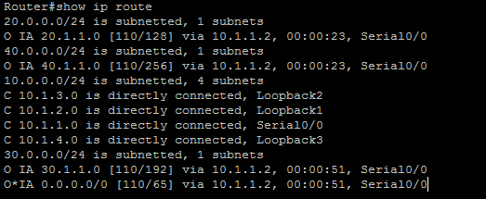

**Displaying global OSPF Configuration of the R1:**

**For R1:** 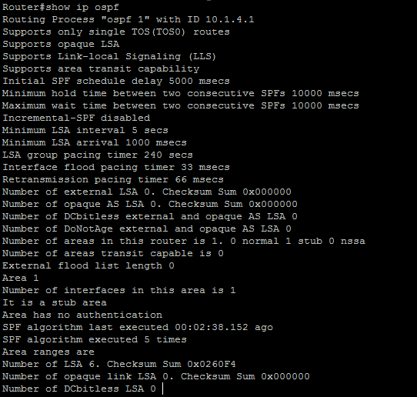

**Configure Area2 as Totally Stubby Area:**

**For R5:**

Router#en

Router#conf t

Router(config)#router ospf 1

Router(config-router)#area 2 stub

Router(config-router)#^Z

Router#exit

**For R4:**

Router#en

Router#conf t

Router(config)#router ospf 1

Router(config-router)#area 2 stub no-summary

Router(config-router)#^Z

Router#exit

**Displaying Routing Table of R5 to verify Area2 as Totally Stubby Area:**

For R4: 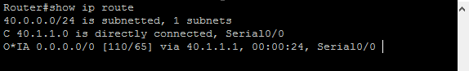

**Configure Area2 as NSSA on R4:**

**For R4:**

Router#en

Router#conf t

Router(config)#router ospf 1

Router(config-router)#no area 2 stub

Router(config-router)#area 2 nssa

Router(config-router)#^Z

Router#exit

**For R5:**

Router#en

Router#conf t

Router(config)#router ospf 1

Router(config-router)#no area 2 stub

Router(config-router)#area 2 nssa

Router(config-router)#^Z

Router#exit

**Configure R4 to advertise default routes for NSSA:**

**For R4:**

Router#en

Router#conf t

Router(config)#router ospf 1

Router(config-router)#area 2 nssa default-information-originate

Router(config-router)#^Z

Router#exit

**Displaying routing table of R5 to verify Area2 as a NSSA**

**For R5:** 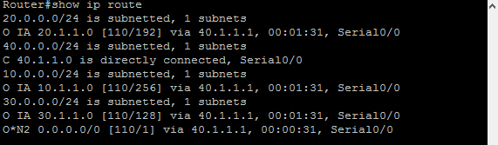

PRACTICAL NUMBER 4

Simulating BGP

Topology:-

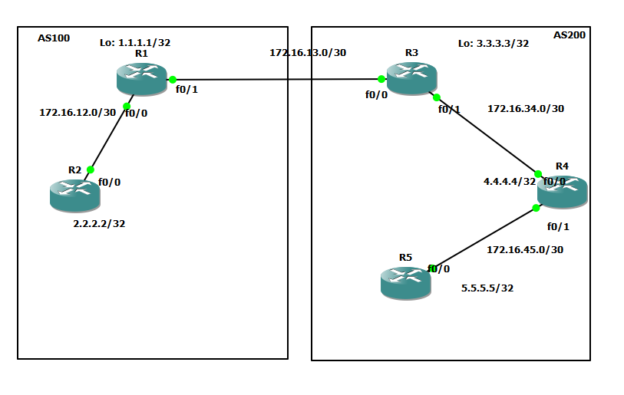

STEPS Overview:

1. Assigning IP Addresses and Loopback Address R1:
2. Configuring OSPF on all routers:
3. Configure Static Routes on R1 and R3:
4. Configure BGP Network on R1 and R3
5. Displaying routing tables of all routers:
6. Performing Ping on all routers to check Connectivity:

**Assigning IP Addresses and Loopback Address R1:**

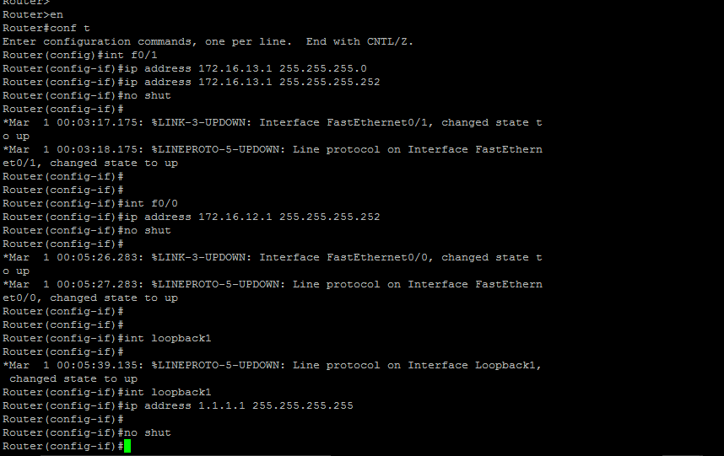





**Assigning IP Addresses and Loopback Address R2:**

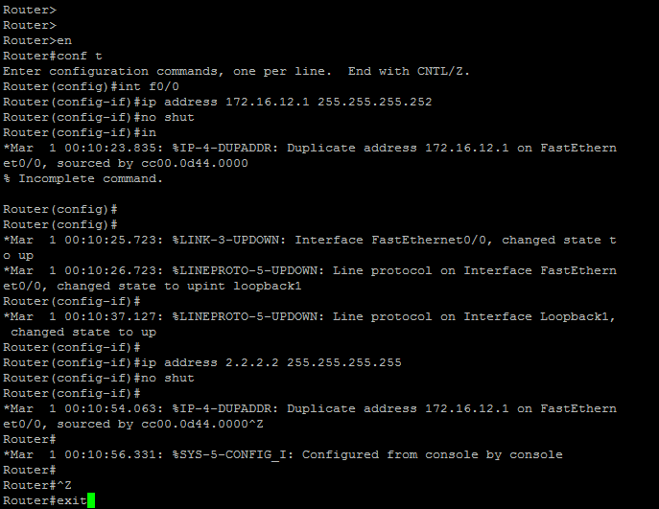



**Assigning IP Addresses and Loopback Address R3:**

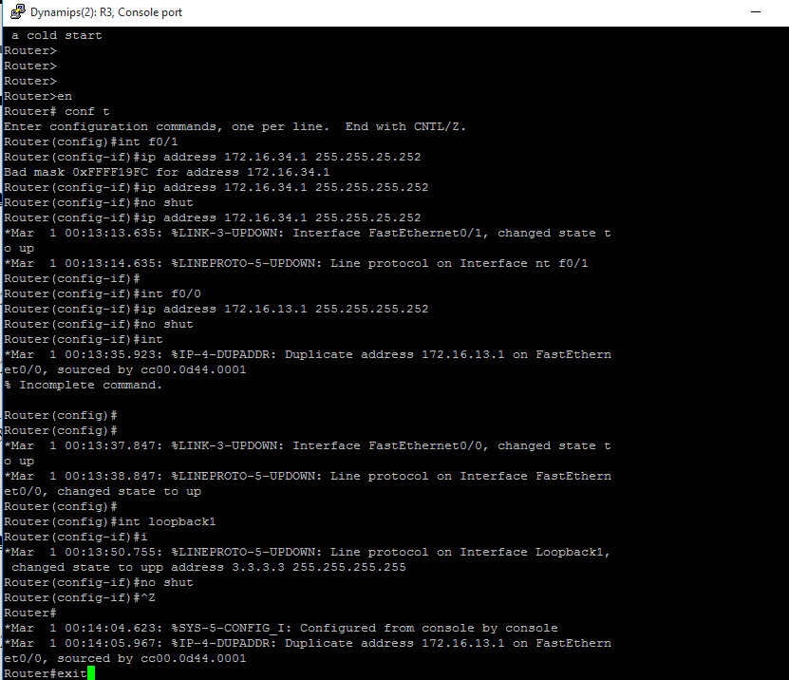





**Assigning IP Addresses and Loopback Address R4:**

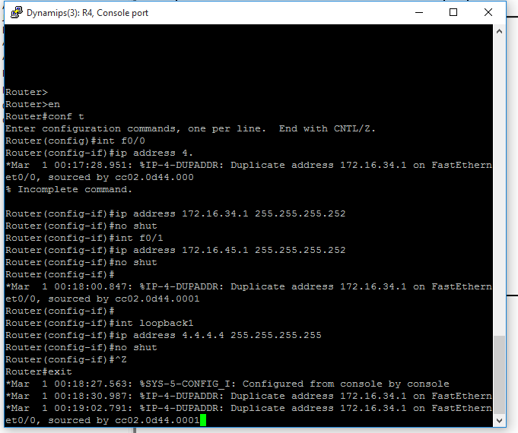



**Assigning IP Addresses and Loopback Address R5:**

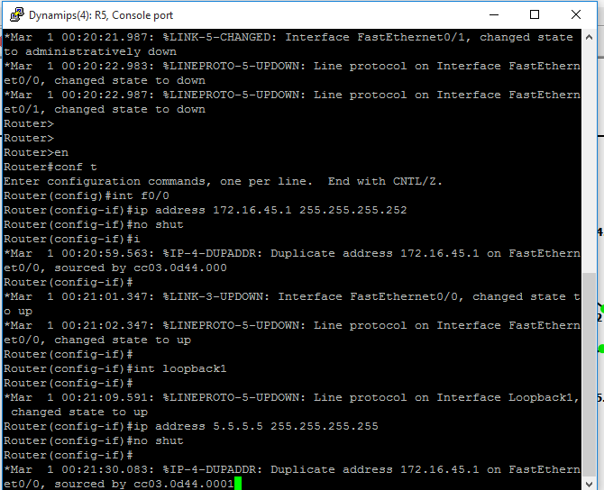



**Configuring OSPF on all routers:**

**For R1:**

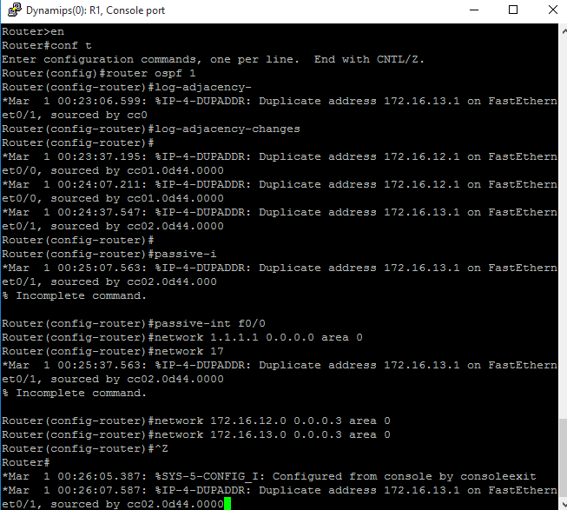





**For R2:**

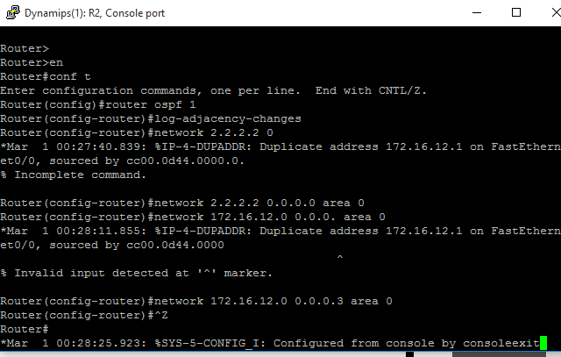





**For R3:** 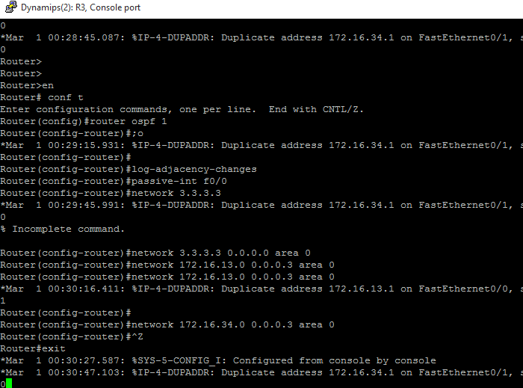





**For R4:** 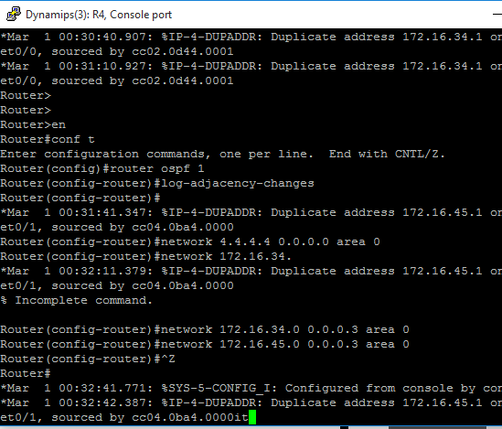



**For R5:**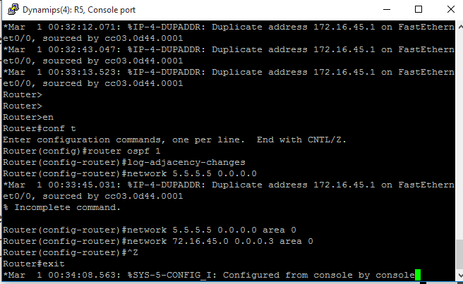

**Configure Static Routes on R1 and R3:**

**For R1:**

Router#en

Router#conf t

Router(config)#ip route 100.100.100.0 255.255.255.0 null0

Router(config)#ip route 100.100.101.0 255.255.255.0 null0

Router(config)#ip route 100.100.102.0 255.255.255.0 null0

Router(config)#ip route 100.100.103.0 255.255.255.0 null0

Router(config)#^Z

Router#exit

**For R3:**

Router#en

Router#conf t

Router(config)#ip route 200.200.200.0 255.255.255.0 null0

Router(config)#ip route 200.200.201.0 255.255.255.0 null0

Router(config)#ip route 200.200.202.0 255.255.255.0 null0

Router(config)#ip route 200.200.203.0 255.255.255.0 null0

Router(config)#^Z

Router#exit

**Configure BGP Network on R1 and R3:**

**For R1:**

Router#en

Router#conf t

Router(config)#router bgp 100

Router(config-router)#network 100.100.100.0 mask 255.255.255.0

Router(config-router)#network 100.100.101.0 mask 255.255.255.0

Router(config-router)#network 100.100.102.0 mask 255.255.255.0

Router(config-router)#network 100.100.103.0 mask 255.255.255.0

Router(config-router)#network 1.1.1.1 mask 255.255.255.255

Router(config-router)#network 2.2.2.2 mask 255.255.255.255

Router(config-router)#network 172.16.12.0 mask 255.255.255.252

Router(config-router)#^Z

Router#exit

**For R3:**

Router#en

Router#conf t

Router(config)#router bgp 200

Router(config-router)#network 200.200.200.0 mask 255.255.255.0

Router(config-router)#network 200.200.201.0 mask 255.255.255.0

Router(config-router)#network 200.200.202.0 mask 255.255.255.0

Router(config-router)#network 200.200.203.0 mask 255.255.255.0

Router(config-router)#network 3.3.3.3 mask 255.255.255.255

Router(config-router)#network 4.4.4.4 mask 255.255.255.255

Router(config-router)#network 5.5.5.5 mask 255.255.255.255

Router(config-router)#network 172.16.34.0 mask 255.255.255.252

Router(config-router)#network 172.16.45.0 mask 255.255.255.252

Router(config-router)#^Z

Router#exit

**Displaying routing tables of all routers:**

**For R1:**

Router#show ip route

B 200.200.200.0/24 [20/0] via 172.16.13.2, 00:03:42

1.0.0.0/32 is subnetted, 1 subnets

C 1.1.1.1 is directly connected, Loopback1

B 200.200.201.0/24 [20/0] via 172.16.13.2, 00:02:42

2.0.0.0/32 is subnetted, 1 subnets

O 2.2.2.2 [110/11] via 172.16.12.2, 01:55:15, FastEthernet0/1

100.0.0.0/24 is subnetted, 4 subnets

S 100.100.100.0 is directly connected, Null0

S 100.100.101.0 is directly connected, Null0

S 100.100.102.0 is directly connected, Null0

S 100.100.103.0 is directly connected, Null0

B 200.200.202.0/24 [20/0] via 172.16.13.2, 00:02:51

3.0.0.0/32 is subnetted, 1 subnets

B 3.3.3.3 [20/0] via 172.16.13.2, 00:02:49

B 200.200.203.0/24 [20/0] via 172.16.13.2, 00:03:58

4.0.0.0/32 is subnetted, 1 subnets

B 4.4.4.4 [20/11] via 172.16.13.2, 00:02:58

5.0.0.0/32 is subnetted, 1 subnets

B 5.5.5.5 [20/21] via 172.16.13.2, 00:02:59

172.16.0.0/30 is subnetted, 4 subnets

B 172.16.45.0 [20/20] via 172.16.13.2, 00:01:59

B 172.16.34.0 [20/0] via 172.16.13.2, 00:02:24

C 172.16.12.0 is directly connected, FastEthernet0/1

C 172.16.13.0 is directly connected, FastEthernet0/0

**For R2:**

Router#show ip route

B 200.200.200.0/24 [200/0] via 172.16.13.2, 00:03:55

1.0.0.0/32 is subnetted, 1 subnets

O 1.1.1.1 [110/11] via 172.16.12.1, 01:55:30, FastEthernet0/0

B 200.200.201.0/24 [200/0] via 172.16.13.2, 00:02:55

2.0.0.0/32 is subnetted, 1 subnets

C 2.2.2.2 is directly connected, Loopback1

100.0.0.0/24 is subnetted, 4 subnets

B 100.100.100.0 [200/0] via 172.16.12.1, 00:07:09

B 100.100.101.0 [200/0] via 172.16.12.1, 00:07:09

B 100.100.102.0 [200/0] via 172.16.12.1, 00:06:09

B 100.100.103.0 [200/0] via 172.16.12.1, 00:06:23

B 200.200.202.0/24 [200/0] via 172.16.13.2, 00:03:10

3.0.0.0/32 is subnetted, 1 subnets

B 3.3.3.3 [200/0] via 172.16.13.2, 00:03:03

B 200.200.203.0/24 [200/0] via 172.16.13.2, 00:04:03

4.0.0.0/32 is subnetted, 1 subnets

B 4.4.4.4 [200/11] via 172.16.13.2, 00:04:24

5.0.0.0/32 is subnetted, 1 subnets

B 5.5.5.5 [200/21] via 172.16.13.2, 00:04:24

172.16.0.0/30 is subnetted, 4 subnets

B 172.16.45.0 [200/20] via 172.16.13.2, 00:03:25

B 172.16.34.0 [200/0] via 172.16.13.2, 00:03:25

C 172.16.12.0 is directly connected, FastEthernet0/0

O 172.16.13.0 [110/20] via 172.16.12.1, 01:58:53, FastEthernet0/0

**For R3:**

Router#show ip route

S 200.200.200.0/24 is directly connected, Null0

1.0.0.0/32 is subnetted, 1 subnets

B 1.1.1.1 [20/0] via 172.16.13.1, 00:06:27

S 200.200.201.0/24 is directly connected, Null0

2.0.0.0/32 is subnetted, 1 subnets

B 2.2.2.2 [20/11] via 172.16.13.1, 00:05:27

100.0.0.0/24 is subnetted, 4 subnets

B 100.100.100.0 [20/0] via 172.16.13.1, 00:07:28

B 100.100.101.0 [20/0] via 172.16.13.1, 00:07:28

B 100.100.102.0 [20/0] via 172.16.13.1, 00:06:27

B 100.100.103.0 [20/0] via 172.16.13.1, 00:06:45

S 200.200.202.0/24 is directly connected, Null0

3.0.0.0/32 is subnetted, 1 subnets

C 3.3.3.3 is directly connected, Loopback1

S 200.200.203.0/24 is directly connected, Null0

4.0.0.0/32 is subnetted, 1 subnets

O 4.4.4.4 [110/11] via 172.16.34.2, 01:50:38, FastEthernet0/1

5.0.0.0/32 is subnetted, 1 subnets

O 5.5.5.5 [110/21] via 172.16.34.2, 01:50:38, FastEthernet0/1

172.16.0.0/30 is subnetted, 4 subnets

O 172.16.45.0 [110/20] via 172.16.34.2, 01:50:49, FastEthernet0/1

C 172.16.34.0 is directly connected, FastEthernet0/1

B 172.16.12.0 [20/0] via 172.16.13.1, 00:05:47

C 172.16.13.0 is directly connected, FastEthernet0/0

**For R4:**

Router#show ip route

B 200.200.200.0/24 [200/0] via 172.16.34.1, 00:04:03

1.0.0.0/32 is subnetted, 1 subnets

B 1.1.1.1 [200/0] via 172.16.13.1, 00:06:17

B 200.200.201.0/24 [200/0] via 172.16.34.1, 00:03:03

2.0.0.0/32 is subnetted, 1 subnets

B 2.2.2.2 [200/11] via 172.16.13.1, 00:05:16

100.0.0.0/24 is subnetted, 4 subnets

B 100.100.100.0 [200/0] via 172.16.13.1, 00:07:17

B 100.100.101.0 [200/0] via 172.16.13.1, 00:07:17

B 100.100.102.0 [200/0] via 172.16.13.1, 00:06:17

B 100.100.103.0 [200/0] via 172.16.13.1, 00:06:39

B 200.200.202.0/24 [200/0] via 172.16.34.1, 00:03:26

3.0.0.0/32 is subnetted, 1 subnets

O 3.3.3.3 [110/11] via 172.16.34.1, 01:50:32, FastEthernet0/0

B 200.200.203.0/24 [200/0] via 172.16.34.1, 00:04:16

4.0.0.0/32 is subnetted, 1 subnets

C 4.4.4.4 is directly connected, Loopback1

5.0.0.0/32 is subnetted, 1 subnets

O 5.5.5.5 [110/11] via 172.16.45.2, 01:52:26, FastEthernet0/1

172.16.0.0/30 is subnetted, 4 subnets

C 172.16.45.0 is directly connected, FastEthernet0/1

C 172.16.34.0 is directly connected, FastEthernet0/0

B 172.16.12.0 [200/0] via 172.16.13.1, 00:07:24

O 172.16.13.0 [110/20] via 172.16.34.1, 01:52:39, FastEthernet0/0

**For R5:**

Router#show ip route

B 200.200.200.0/24 [200/0] via 172.16.34.1, 00:04:30

1.0.0.0/32 is subnetted, 1 subnets

B 1.1.1.1 [200/0] via 172.16.13.1, 00:06:43

B 200.200.201.0/24 [200/0] via 172.16.34.1, 00:03:30

2.0.0.0/32 is subnetted, 1 subnets

B 2.2.2.2 [200/11] via 172.16.13.1, 00:05:43

100.0.0.0/24 is subnetted, 4 subnets

B 100.100.100.0 [200/0] via 172.16.13.1, 00:07:43

B 100.100.101.0 [200/0] via 172.16.13.1, 00:07:43

B 100.100.102.0 [200/0] via 172.16.13.1, 00:06:43

B 100.100.103.0 [200/0] via 172.16.13.1, 00:07:06

B 200.200.202.0/24 [200/0] via 172.16.34.1, 00:03:53

3.0.0.0/32 is subnetted, 1 subnets

O 3.3.3.3 [110/21] via 172.16.45.1, 01:50:43, FastEthernet0/0

B 200.200.203.0/24 [200/0] via 172.16.34.1, 00:04:20

4.0.0.0/32 is subnetted, 1 subnets

O 4.4.4.4 [110/11] via 172.16.45.1, 01:50:43, FastEthernet0/0

5.0.0.0/32 is subnetted, 1 subnets

C 5.5.5.5 is directly connected, Loopback1

172.16.0.0/30 is subnetted, 4 subnets

C 172.16.45.0 is directly connected, FastEthernet0/0

O 172.16.34.0 [110/20] via 172.16.45.1, 01:52:36, FastEthernet0/0

B 172.16.12.0 [200/0] via 172.16.13.1, 00:07:26

O 172.16.13.0 [110/30] via 172.16.45.1, 01:52:36, FastEthernet0

**Performing Ping on all routers to check Connectivity:**

**For R1:** 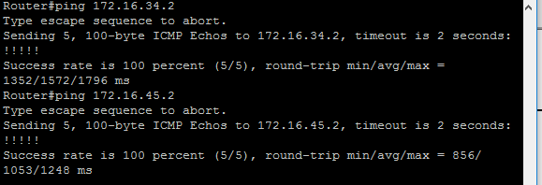

**For R2:** 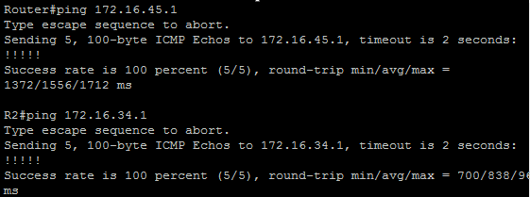

**For R3:** 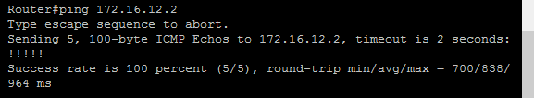

**For R4:** 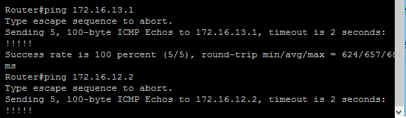

**For R5:** 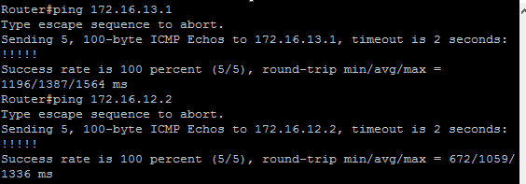

PRACTICAL NUMBER 5

Simulating IBGP

STEPS OVERVEW:

1. Configure I-BGP between R1 and R2 (AS100):
2. Configure I-BGP between R3 and R4 (AS200):
3. Configure I-BGP between R3 and R5 (AS200):
4. Displaying I-BGP summary of the routers:
5. Configure R3 as Route Reflector for R4 and R5:
6. Performing ping to check the working of I-BGP Connectivity:

Topology:



**Configure I-BGP between R1 and R2 (AS100):**

**For R1:**

Router#en

Router#conf t

Router(config)#router bgp 100

Router(config-router)#neighbor 2.2.2.2 remote-as 100

Router(config-router)#neighbor 2.2.2.2 update-source loopback1

Router(config-router)#neighbor 172.16.12.2 remote-as 100

Router(config-router)#^Z

Router#exit

**For R2:**

Router#en

Router#conf t

Router(config)#router bgp 100

Router(config-router)#neighbor 1.1.1.1 remote-as 100

Router(config-router)#neighbor 1.1.1.1 update-source loopback1

Router(config-router)#neighbor 172.16.12.1 remote-as 100

Router(config-router)#^Z

Router#exit

**Configure I-BGP between R3 and R4 (AS200):**

**For R3:**

Router#en

Router#conf t

Router(config)#

Router(config)#router bgp 200

Router(config-router)#neighbor 4.4.4.4 remote-as 200

Router(config-router)#neighbor 4.4.4.4 update-source loopback1

Router(config-router)#neighbor 172.16.34.2 remote-as 200

Router(config-router)#^Z

Router#exit

**For R4:**

Router#en

Router#conf t

Router(config)#router bgp 200

Router(config-router)#neighbor 3.3.3.3 remote-as 200

Router(config-router)#neighbor 3.3.3.3 update-source loopback1

Router(config-router)#neighbor 172.16.34.1 remote-as 200

Router(config-router)#^Z

Router#exit

**Configure I-BGP between R3 and R5 (AS200):**

**For R3:**

Router#en

Router#conf t

Router(config)#router bgp 200

Router(config-router)#neighbor 5.5.5.5 remote-as 200

Router(config-router)#neighbor 5.5.5.5 update-source loopback1

Router(config-router)#neighbor 172.16.45.2 remote-as 200

Router(config-router)#^Z

Router#exit

**For R5:**

Router#en

Router#conf t

Router(config)#router bgp 200

Router(config-router)#neighbor 3.3.3.3 remote-as 200

Router(config-router)#neighbor 3.3.3.3 update-source loopback1

Router(config-router)#neighbor 172.16.34.1 remote-as 200

Router(config-router)#^Z

Router#exit

**Displaying I-BGP summary of the routers:**

**For R1:** 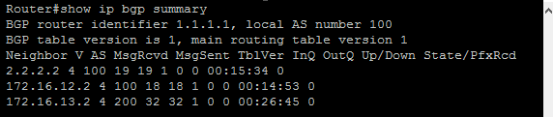

**For R2:** 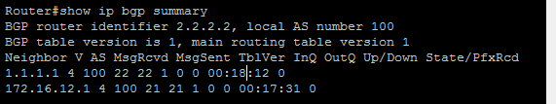

**For R3:** 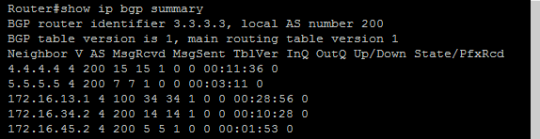

**For R4:** 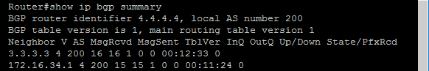

**For R5:** 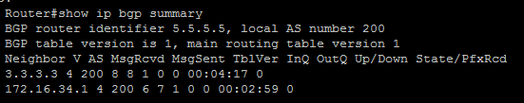

**Configure R3 as Route Reflector for R4 and R5:**

**For R3:**

Router#en

Router#conf t

Router(config)#router bgp 200

Router(config-router)#neighbor 4.4.4.4 route-reflector-client

Router(config-router)#neighbor 5.5.5.5 route-reflector-client

Router(config-router)#^Z

Router#exit

**Performing ping to check the working of I-BGP Connectivity:**

**For R1:** 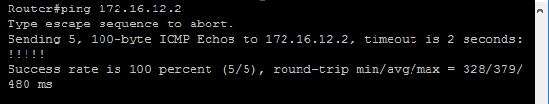

**For R2:** 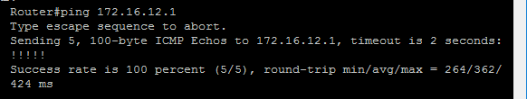

**For R3:** 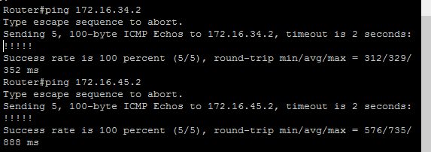

**For R4:** 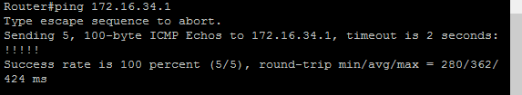

**For R5:** 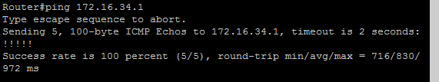

PRACTICAL NUMBER 6

Simulating EBGP

STEPS OVERVIEW:

1. Configure E-BGP between R1 and R3 (AS100 and AS200):
2. Displaying E-BGP Summary of R1 and R3:
3. Performing Ping to check the working of E-BGP Connectivity:

Topology:

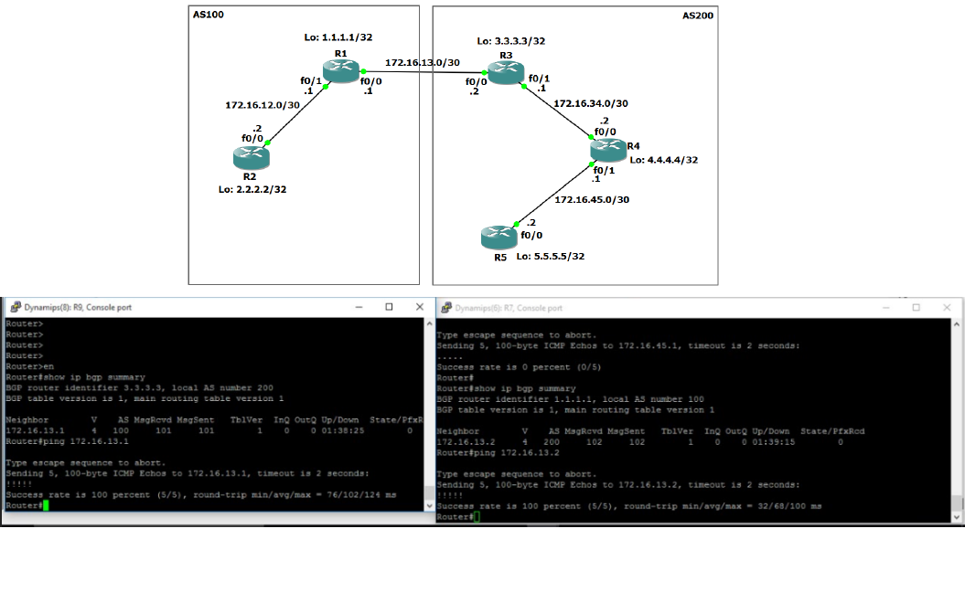

**Configure E-BGP between R1 and R3 (AS100 and AS200):**

**For R1:**

Router#en

Router#conf t

Router(config)#router bgp 100

Router(config-router)#no synchronization

Router(config-router)#neighbor 172.16.13.2 remote-as 200

Router(config-router)#^Z

Router#exit

**For R3:**

Router#en

Router#conf t

Router(config)#router bgp 200

Router(config-router)#no synchronization

Router(config-router)#neighbor 172.16.13.1 remote-as 100

Router(config-router)#^Z

Router#exit

**Displaying E-BGP Summary of R1 and R3:**

For R1: 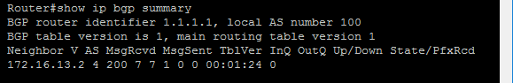

For R3: 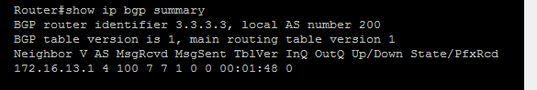

**Performing Ping to check the working of E-BGP Connectivity:**

For R1: 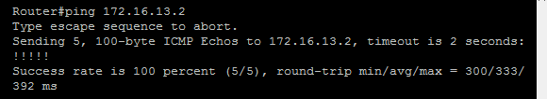

For R3: 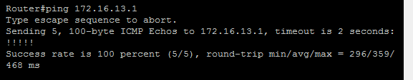

PRACTICAL NUMBER 7

Configuring IP Multicast Routing

STEPS OVERVIEW;

1. **Assigning IP Addresses and Loopback Address R**
2. **Configuring OSPF on all routers:**
3. **Displaying routing tables of all routers:**
4. **Configuring IP Multicasting (PIM Sparse Dense mode) on all the routers:**
5. **Configure RP on all the routers:**
6. **Configure RP on all the routers:**
7. **Performing ping from R1 to generate multicast traffic:**
8. **Displaying IGMP groups of all the routers:**
9. **Displaying PIM Neighbor of all routers:**
10. **Displaying RP Mapping of all the routers:**
11. **Displaying Multicast Routing Table of all the routers:**

Topology:

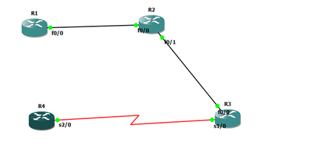

**Assigning IP Addresses and Loopback Address R1:**

Router#en

Router#conf t

Router(config)#int f0/0

Router(config-if)#ip address 192.168.12.1 255.255.255.0

Router(config-if)#no shut

Router(config-if)#int loopback1

Router(config-if)#ip address 1.1.1.1 255.255.255.0

Router(config-if)#no shut

Router(config-if)#^Z

Router#exit

**Assigning IP Addresses and Loopback Address R2:**

Router#en

Router#conf t

Router(config)#int f0/0

Router(config-if)#ip address 192.168.12.2 255.255.255.0

Router(config-if)#no shut

Router(config)#int s0/0

Router(config-if)#ip address 192.168.23.1 255.255.255.0

Router(config-if)#no shut

Router(config-if)#int loopback1

Router(config-if)#ip address 2.2.2.2 255.255.255.0

Router(config-if)#no shut

Router(config-if)#^Z

Router#exit

**Assigning IP Addresses and Loopback Address R3:**

Router#en

Router#conf t

Router(config)#int f0/0

Router(config-if)#ip address 192.168.34.2 255.255.255.0

Router(config-if)#no shut

Router(config)#int s0/0

Router(config-if)#ip address 192.168.23.2 255.255.255.0

Router(config-if)#no shut

Router(config-if)#int loopback1

Router(config-if)#ip address 3.3.3.3 255.255.255.0

Router(config-if)#no shut

Router(config-if)#^Z

Router#exit

**Assigning IP Addresses and Loopback Address R4:**

Router#en

Router#conf t

Router(config)#int f0/0

Router(config-if)#ip address 192.168.34.1 255.255.255.0

Router(config-if)#no shut

Router(config-if)#int loopback1

Router(config-if)#ip address 4.4.4.4 255.255.255.0

Router(config-if)#no shut

Router(config-if)#^Z

Router#exit

**Configuring OSPF on all routers:**

**R1:**

Router#en

Router#conf t

Router(config)#router ospf 1

Router(config-router)#network 192.168.12.0 0.0.0.255 area 0

Router(config-router)#^Z

Router#exit

**R2:**

Router#en

Router#conf t

Router(config)#router ospf 1

Router(config-router)#network 192.168.12.0 0.0.0.255 area 0

Router(config-router)#network 192.168.23.0 0.0.0.255 area 0

Router(config-router)#^Z

Router#exit

**R3:**

Router#en

Router#conf t

Router(config)#router ospf 1

Router(config-router)#network 192.168.23.0 0.0.0.255 area 0

Router(config-router)#network 192.168.34.0 0.0.0.255 area 0

Router(config-router)#^Z

Router#exit

**R4:**

Router#en

Router#conf t

Router(config)#router ospf 1

Router(config-router)#network 192.168.34.0 0.0.0.255 area 0

Router(config-router)#^Z

Router#exit

**Displaying routing tables of all routers:**

**R1:** 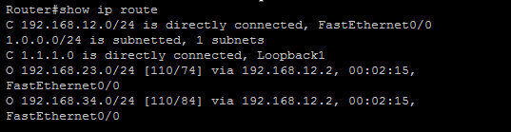

**R2:** 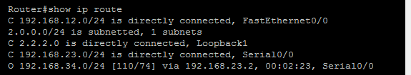

**R3:** 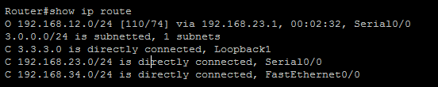

**R4:** 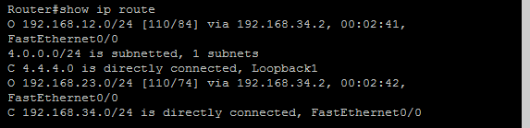

**Configuring IP Multicasting (PIM Sparse Dense mode) on all the routers:**

**R1:**

Router#en

Router#conf t

Router(config)#ip multicast-routing

Router(config)#int f0/0

Router(config-if)#ip pim sparse-dense-mode

Router(config-if)#^Z

Router#exit

**R2:**

Router#en

Router#conf t

Router(config)#ip multicast-routing

Router(config)#int f0/0

Router(config-if)#ip pim sparse-dense-mode

Router(config-if)#int s0/0

Router(config-if)#ip pim sparse-dense-mode

Router(config-if)#^Z

Router#exit

**R3:**

Router#en

Router#conf t

Router(config)#ip multicast-routing

Router(config)#int f0/0

Router(config-if)#ip pim sparse-dense-mode

Router(config-if)#int s0/0

Router(config-if)#ip pim sparse-dense-mode

Router(config-if)#^Z

Router#exit

**R4:**

Router#en

Router#conf t

Router(config)#ip multicast-routing

Router(config)#int f0/0

Router(config-if)#ip pim sparse-dense-mode

Router(config-if)#^Z

Router#exit

**Configure RP on all the routers:**

**R1:**

Router#en

Router#conf t

Router(config)#ip pim rp-address 3.3.3.3 1

Router(config)#access-list 1 permit 224.4.4.4

Router(config)#^Z

Router#exit

**R2:**

Router#en

Router#conf t

Router(config)#ip pim rp-address 3.3.3.3 1

Router(config)#access-list 1 permit 224.4.4.4

Router(config)#^Z

Router#exit

**R3:**

Router#en

Router#conf t

Router(config)#ip pim rp-address 3.3.3.3 1

Router(config)#access-list 1 permit 224.4.4.4

Router(config)#^Z

Router#exit

**R4:**

Router#en

Router#conf t

Router(config)#ip pim rp-address 3.3.3.3 1

Router(config)#access-list 1 permit 224.4.4.4

Router(config)#^Z

Router#exit

**Configure R4 to join the multicast group:**

Router#en

Router#conf t

Router(config)#int f0/0

Router(config-if)#ip igmp join-group 224.4.4.4

Router(config-if)#^Z

Router#exit

**Performing ping from R1 to generate multicast traffic:**

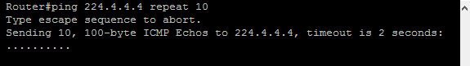

**Displaying IGMP groups of all the routers:**

For R1: 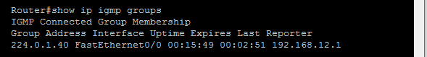

For R2: 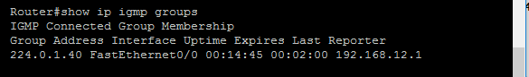

For R3: 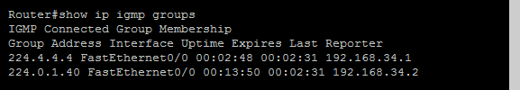

For R4: 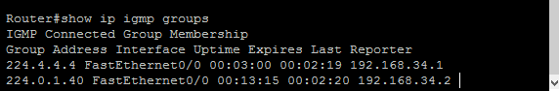

**Displaying PIM Neighbor of all routers:**

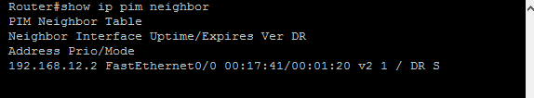

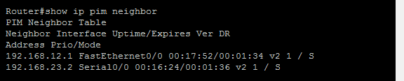

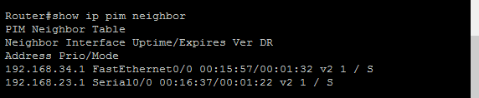

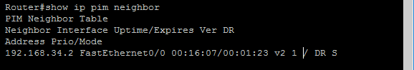

**Displaying RP Mapping of all the routers:**

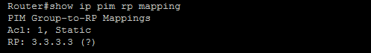

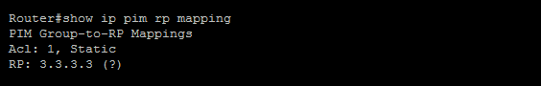

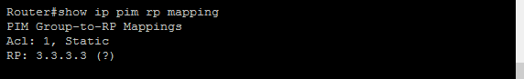

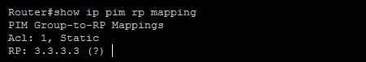

**Displaying Multicast Routing Table of all the routers:**

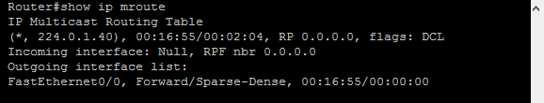

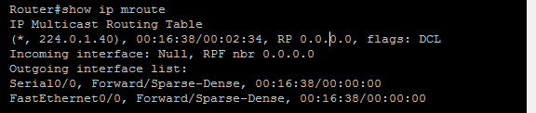

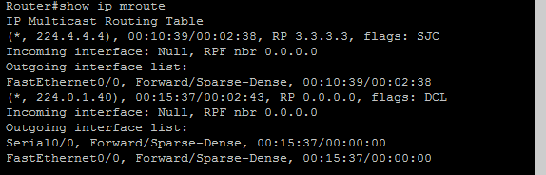

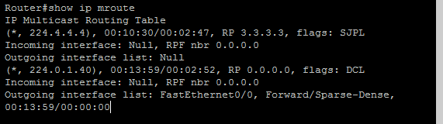

PRACTICAL NUMBER 8A

Simulating Routing Redistribution

**STEPS OVERVIEW**

1. Assigning IP address and Loopback addresses to R1:
2. Configuring RIP on router R1:
3. Configuring rip and ospf on router R2:
4. Configuring OSPF on routers:
5. Displaying the routing tables before Redistribution:
6. Redistributing OSPF routes in RIP Domain and RIP in OSPF Domain in R2:
7. Displaying the routing tables after Redistribution:
8. Using Ping command:

**Aim-**Simulating routing redistribution

Topology:

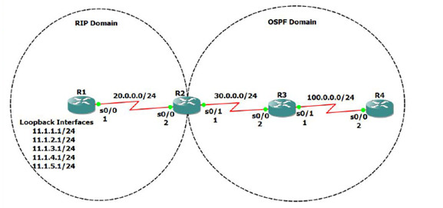

**Assigning IP address and Loopback addresses to R1:**

Router#en

Router#conf t

Router(config)#int s0/0

Router(config-if)#ip address 20.0.0.1 255.255.255.0

Router(config-if)#no shut

Router(config-if)#^Z

Router#exit

Router#en

Router#conf t

Router(config)#int loopback1

Router(config-if)#ip address 11.1.1.1 255.255.255.0

Router(config-if)#no shut

Router(config-if)#int loopback2

Router(config-if)#ip address 11.1.2.1 255.255.255.0

Router(config-if)#no shut

Router(config-if)#int loopback3

Router(config-if)#ip address 11.1.3.1 255.255.255.0

Router(config-if)#no shut

Router(config-if)#int loopback4

Router(config-if)#ip address 11.1.4.1 255.255.255.0

Router(config-if)#no shut

Router(config-if)#int loopback5

Router(config-if)#ip address 11.1.5.1 255.255.255.0

Router(config-if)#no shut

Router(config-if)#^Z

Router#exit

**Assigning IP addresses to R2:**

Router#en

Router#conf t

Router(config)#int s0/0

Router(config-if)#ip address 20.0.0.2 255.255.255.0

Router(config-if)#no shut

Router(config-if)#int s0/1

Router(config-if)#ip address 30.0.0.1 255.255.255.0

Router(config-if)#no shut

Router(config-if)#^Z

Router#exit

**Assigning IP addresses to R3:**

Router#en

Router#conf t

Router(config)#int s0/0

Router(config-if)#ip address 30.0.0.2 255.255.255.0

Router(config-if)#no shut

Router(config-if)#int s0/1

Router(config-if)#int s0/1

Router(config-if)#ip address 100.0.0.1 255.255.255.0

Router(config-if)#no shut

Router(config-if)#^Z

Router#exit

**Assigning IP addresses to R4:**

Router#en

Router#conf t

Router(config)#int s0/1

Router(config-if)#int s0/0

Router(config-if)#ip address 100.0.0.2 255.255.255.0

Router(config-if)#no shut

Router(config-if)#^Z

Router#exit

**Configuring RIP on router R1:**

Router#en

Router#conf t

Router(config)#router rip

Router(config-router)#network 20.0.0.0

Router(config-router)#network 11.1.1.0

Router(config-router)#network 11.1.2.0

Router(config-router)#network 11.1.3.0

Router(config-router)#network 11.1.4.0

Router(config-router)#network 11.1.5.0

Router(config-router)#no auto-summary

Router(config-router)#^Z

Router#exit

**Configuring rip and ospf on router R2:**

Router#en

Router#conf t

Router(config)#router rip

Router(config-router)#network 20.0.0.0

Router(config-router)#no auto-summary

Router(config-router)#exit

Router(config)#router ospf 1

Router(config-router)#network 30.0.0.0 0.0.0.255 area 0

Router(config-router)#^Z

Router#exit

**Configuring OSPF on routers:**

**For R3**

Router#en

Router#conf t

Router(config)#router ospf 1

Router(config-router)#network 30.0.0.0 0.0.0.255 area 0

Router(config-router)#network 30.0.0.0 0.0.0.255 area 0

Router(config-router)#network 100.0.0.0 0.0.0.255 area 0

Router(config-router)#^Z

Router#exit

**For R4**

Router#en

Router#conf t

Router(config)#router ospf 1

Router(config-router)#network 100.0.0.0 0.0.0.255 area 0

Router(config-router)#^Z

Router#exit

**Displaying the routing tables before Redistribution:**

**For R1:**

Router#show ip route

20.0.0.0/24 is subnetted, 1 subnets

C 20.0.0.0 is directly connected, Serial0/0

11.0.0.0/24 is subnetted, 5 subnets

C 11.1.2.0 is directly connected, Loopback2

C 11.1.3.0 is directly connected, Loopback3

C 11.1.1.0 is directly connected, Loopback1

C 11.1.4.0 is directly connected, Loopback4

C 11.1.5.0 is directly connected, Loopback5

**For R2:**

Router#show ip route

100.0.0.0/24 is subnetted, 1 subnets

O 100.0.0.0 [110/128] via 30.0.0.2, 00:04:54, Serial0/1

20.0.0.0/24 is subnetted, 1 subnets

C 20.0.0.0 is directly connected, Serial0/0

R 11.0.0.0/8 [120/1] via 20.0.0.1, 00:00:16, Serial0/0

30.0.0.0/24 is subnetted, 1 subnets

C 30.0.0.0 is directly connected, Serial0/1

**For R3:**

Router#show ip route

100.0.0.0/24 is subnetted, 1 subnets

C 100.0.0.0 is directly connected, Serial0/1

30.0.0.0/24 is subnetted, 1 subnets

C 30.0.0.0 is directly connected, Serial0/0

**For R4:**

Router#show ip route

100.0.0.0/24 is subnetted, 1 subnets

C 100.0.0.0 is directly connected, Serial0/0

30.0.0.0/24 is subnetted, 1 subnets

O 30.0.0.0 [110/128] via 100.0.0.1, 00:05:17, Serial0/0

**Redistributing OSPF routes in RIP Domain and RIP in OSPF Domain in R2:**

Router#en

Router#conf t

Router(config)#router ospf 1

Router(config-router)#redistribute rip subnets metric 5

Router(config-router)#exit

Router(config)#router rip

Router(config-router)#redistribute ospf 1 metric 10

Router(config-router)#^Z

Router#exit

**Displaying the routing tables after Redistribution:**

**For R1:**

Router#show ip route

R 100.0.0.0/8 [120/10] via 20.0.0.2, 00:00:15, Serial0/0

20.0.0.0/24 is subnetted, 1 subnets

C 20.0.0.0 is directly connected, Serial0/0

11.0.0.0/24 is subnetted, 5 subnets

C 11.1.2.0 is directly connected, Loopback2

C 11.1.3.0 is directly connected, Loopback3

C 11.1.1.0 is directly connected, Loopback1

C 11.1.4.0 is directly connected, Loopback4

C 11.1.5.0 is directly connected, Loopback5

R 30.0.0.0/8 [120/10] via 20.0.0.2, 00:00:15, Serial0/0

**For R2:**

Router#show ip route

100.0.0.0/24 is subnetted, 1 subnets

O 100.0.0.0 [110/128] via 30.0.0.2, 00:05:36, Serial0/1

20.0.0.0/24 is subnetted, 1 subnets

C 20.0.0.0 is directly connected, Serial0/0

R 11.0.0.0/8 [120/1] via 20.0.0.1, 00:00:07, Serial0/0

30.0.0.0/24 is subnetted, 1 subnets

C 30.0.0.0 is directly connected, Serial0/1

**For R3:**

Router#show ip route

100.0.0.0/24 is subnetted, 1 subnets

C 100.0.0.0 is directly connected, Serial0/1

20.0.0.0/24 is subnetted, 1 subnets

O E2 20.0.0.0 [110/5] via 30.0.0.1, 00:05:45, Serial0/0

O E2 11.0.0.0/8 [110/5] via 30.0.0.1, 00:05:45, Serial0/0

30.0.0.0/24 is subnetted, 1 subnets

C 30.0.0.0 is directly connected, Serial0/0

**For R4:**

Router#show ip route

100.0.0.0/24 is subnetted, 1 subnets

C 100.0.0.0 is directly connected, Serial0/0

20.0.0.0/24 is subnetted, 1 subnets

O E2 20.0.0.0 [110/5] via 100.0.0.1, 00:06:36, Serial0/0

O E2 11.0.0.0/8 [110/5] via 100.0.0.1, 00:06:36, Serial0/0

30.0.0.0/24 is subnetted, 1 subnets

O 30.0.0.0 [110/128] via 100.0.0.1, 00:06:36, Serial0/0

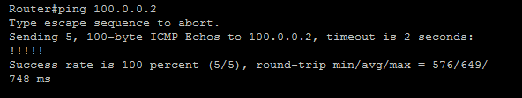

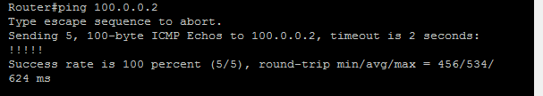

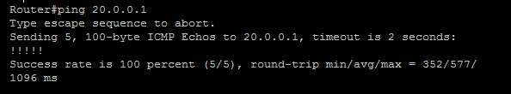

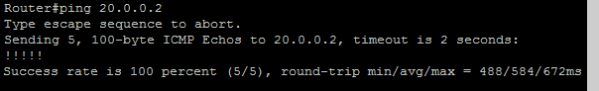

PRACTICAL 8B

Redistribution between EIGRP and OSPF

STEPS OVERVIEW:

1. Assigning IP addresses to R1:
2. Configuring OSPF and EIGRP on router R1:
3. Configuring EIGRP on router R2:
4. Configuring OSPF on router R3:
5. Displaying OSPF and EIGRP neighbors of R1:
6. Displaying OSPF neighbors of R2:
7. Displaying EIGRP neighbors of R3:
8. Displaying Routing Tables of all routers before Redistribution:
9. Redistributing OSPF and EIGRP
10. Displaying route tables of all routers after redistributing:
11. Performing Ping to check connectivity:

Topology:

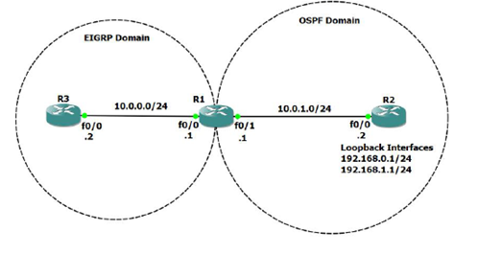

**Assigning IP addresses to R1:**

Router#en

Router#conf t

Router(config)#int f0/0

Router(config-if)#ip address 10.0.0.1 255.255.255.0

Router(config-if)#no shut

Router(config-if)#i

Router(config-if)#int f0/1

Router(config-if)#ip address 10.0.1.1 255.255.255.0

Router(config-if)#no shut

Router(config-if)#^Z

Router#exit

**Assigning IP address and loopback addresses to R2:**

Router#en

Router#conf t

Router(config)#int f0/0

Router(config-if)#ip address 10.0.1.2 255.255.255.0

Router(config-if)#no shut

Router(config-if)#int loopback0

Router(config-if)#ip address 192.168.0.1 255.255.255.0

Router(config-if)#no shut

Router(config-if)#int loopback1

Router(config-if)#ip address 192.168.1.1 255.255.255.0

Router(config-if)#no shut

Router(config-if)#^Z

Router#exit

**Assigning IP addresses to R3:**

Router#en

Router#conf t

Router(config)#int f0/0

Router(config-if)#ip address 10.0.0.2 255.255.255.0

Router(config-if)#no shut

Router(config-if)#^Z

Router#exit

**Configuring OSPF and EIGRP on router R1:**

Router#en

Router#conf t

Router(config)#router ospf 1

Router(config-router)#network 10.0.1.0 0.0.0.255 area 0

Router(config-router)#exit

Router(config)#router eigrp 10

Router(config-router)#network 10.0.0.0

Router(config-router)#no auto-summary

Router(config-router)#^Z

Router#exit

**Configuring EIGRP on router R2:**

Router#en

Router#conf t

Router(config)#router ospf 1

Router(config-router)#network 10.0.1.0 0.0.0.255 area 0

Router(config-router)#network 192.168.0.0 0.0.0

Router(config-router)#network 192.168.0.0 0.0.0.255 area 0

Router(config-router)#network 192.168.1.0 0.0.0.255 area 0

Router(config-router)#^Z

Router#exit

**Configuring OSPF on router R3:**

Router#en

Router#conf t

Router(config)#router eigrp 10

Router(config-router)#network 10.0.0.0

Router(config-router)#no auto-summary

Router(config-router)#^Z

Router#exit

**Displaying OSPF and EIGRP neighbors of R1:**

Router#show ip eigrp neighbor

IP-EIGRP neighbors for process 10

H Address Interface Hold Uptime SRTT RTO Q Seq

(sec) (ms) Cnt Num

0 10.0.0.2 Fa0/0 14 00:00:59 1020 5000 0 4

Router#show ip ospf neighbor

Neighbor ID Pri State Dead Time Address Interface

192.168.1.1 1 FULL/BDR 00:00:36 10.0.1.2 FastEthernet0/1

**Displaying OSPF neighbors of R2:**

Router#show ip ospf neighbor

Neighbor ID Pri State Dead Time Address Interface

10.0.1.1 1 FULL/DR 00:00:34 10.0.1.1 FastEthernet0/0

**Displaying EIGRP neighbors of R3:**

Router#show ip eigrp neighbor

IP-EIGRP neighbors for process 10

H Address Interface Hold Uptime SRTT RTO Q Seq

(sec) (ms) Cnt Num

0 10.0.0.1 Fa0/0 11 00:08:29 368 2208 0 2

**Displaying Routing Tables of all routers before Redistribution:**

**For R1:**

Router#show ip route

10.0.0.0/24 is subnetted, 2 subnets

C 10.0.0.0 is directly connected, FastEthernet0/0

C 10.0.1.0 is directly connected, FastEthernet0/1

192.168.0.0/32 is subnetted, 1 subnets

O 192.168.0.1 [110/11] via 10.0.1.2, 00:12:59, FastEthernet0/1

192.168.1.0/32 is subnetted, 1 subnets

O 192.168.1.1 [110/11] via 10.0.1.2, 00:12:59, FastEthernet0/1

**For R2:**

Router#show ip route

10.0.0.0/24 is subnetted, 1 subnets

C 10.0.1.0 is directly connected, FastEthernet0/0

C 192.168.0.0/24 is directly connected, Loopback0

C 192.168.1.0/24 is directly connected, Loopback1

**For R3:**

Router#show ip route

10.0.0.0/24 is subnetted, 2 subnets

C 10.0.0.0 is directly connected, FastEthernet0/0

D 10.0.1.0 [90/307200] via 10.0.0.1, 00:10:13, FastEthernet0/0

**Redistributing OSPF and EIGRP**

Router#en

Router#conf t

Router(config)#router ospf 1

Router(config-router)#redistribute eigrp 10 metric 100 metric-type 1 subnets

Router(config-router)#exit

Router(config)#router eigrp 10

Router(config-router)#redistribute ospf 1 metric 10000 10 255 5 1500

Router(config-router)#^Z

Router#exit

**Displaying route tables of all routers after redistributing:**

**For R1:**

Router#show ip route

10.0.0.0/24 is subnetted, 2 subnets

C 10.0.0.0 is directly connected, FastEthernet0/0

C 10.0.1.0 is directly connected, FastEthernet0/1

192.168.0.0/32 is subnetted, 1 subnets

O 192.168.0.1 [110/11] via 10.0.1.2, 00:03:57, FastEthernet0/1

192.168.1.0/32 is subnetted, 1 subnets

O 192.168.1.1 [110/11] via 10.0.1.2, 00:03:57, FastEthernet0/1

**For R2:**

Router#show ip route

10.0.0.0/24 is subnetted, 2 subnets

O E1 10.0.0.0 [110/110] via 10.0.1.1, 00:04:05, FastEthernet0/0

C 10.0.1.0 is directly connected, FastEthernet0/0

C 192.168.0.0/24 is directly connected, Loopback0

C 192.168.1.0/24 is directly connected, Loopback1

**For R3:**

Router#show ip route

10.0.0.0/24 is subnetted, 2 subnets

C 10.0.0.0 is directly connected, FastEthernet0/0

D 10.0.1.0 [90/307200] via 10.0.0.1, 00:19:45, FastEthernet0/0

192.168.0.0/32 is subnetted, 1 subnets

D EX 192.168.0.1 [170/284160] via 10.0.0.1, 00:02:49, FastEthernet0/0

192.168.1.0/32 is subnetted, 1 subnets

D EX 192.168.1.1 [170/284160] via 10.0.0.1, 00:02:49, FastEthernet0/0

**Performing Ping to check connectivity:**

For R2: 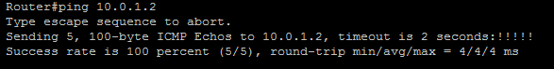

For R3: 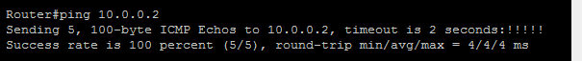

PRACTICAL NUMBER 9

Designing a Remote Access VPN

Topology:

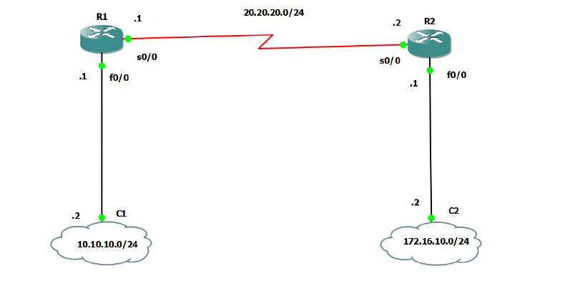

For R1:

R1(config)#int s1/0

R1(config-if)#ip address 20.20.20.1 255.255.255.252

R1(config-if)#no shut

R1(config-if)#router rip

R1(config-router)#version 2

R1(config-router)#no auto-summary

R1(config-router)#network 20.20.20.0

R1(config-router)#exit

R1(config)#int f0/0

R1(config-if)#ip address 192.168.42.243 255.255.255.0

R1(config-if)#no shut

R1(config-if)#exit

R1(config)#exit

R1(config)#router rip

R1(config-router)#version 2

R1(config-router)#no auto-summary

R1(config-router)#network 192.168.42.0

R1(config-router)#

R1(config-router)#exit

R1(config)#exit

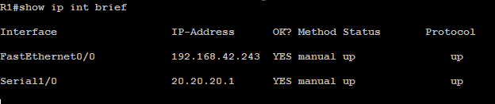

R1(config)#crypto isakmp policy 1

R1(config-isakmp)#authentication pre-share

R1(config-isakmp)#hash sha

R1(config-isakmp)#exit

R1(config)#crypto isakmp key cisco address 20.20.20.2

R1(config)#crypto ipsec transform-set myset esp-sha-hmac esp-aes

R1(cfg-crypto-trans)#exit

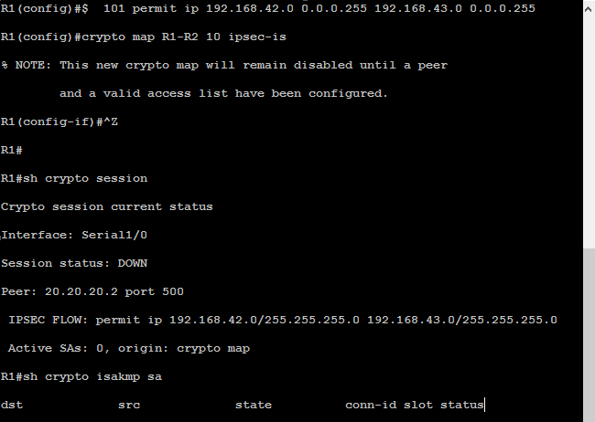

**For Router R2**

R2(config)#int s1/0

R2(config-if)#ip address 20.20.20.2 255.255.255.252

R2(config-if)#no shut

R2(config-if)#router rip

R2(config-router)#version 2

R2(config-router)#no auto-summary

R2(config-router)#network 20.20.20.0

R2(config-router)#exit

R2(config)#exit

R2#

*Mar 1 00:22:51.827: %SYS-5-CONFIG_I: Configured from console by console

R2#conf t

Enter configuration commands, one per line. End with CNTL/Z.

R2(config)#int f0/0

R2(config-if)#ip address 192.168.42.154

% Incomplete command.

R2(config-if)#ip address 192.168.42.154 255.255.255.0

R2(config-if)#no shut

R2(config-if)#exit

R2(config)#router rip

R2(config-router)#version 2

R2(config-router)#no auto-summary

R2(config-router)#network 192.168.42.0

R2(config-router)#exit

R2(config)#exit

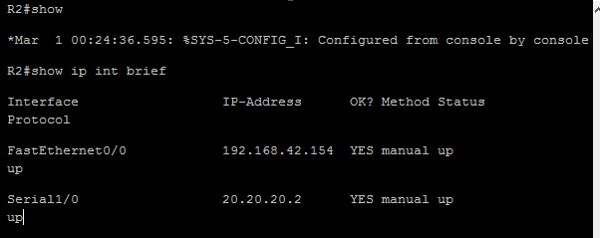

R2(config)#crypto isakmp policy 1

R2(config-isakmp)#authentication pre-share

R2(config-isakmp)#hash sha

R2(config-isakmp)#exit

R2(config)#crypto isakmp key cisco address 20.20.20.1

R2(config)#crypto ipsec transform-set myset esp-sha-hmac esp-aes

R2(cfg-crypto-trans)#exit

R2(config)#$ 101 permit ip 192.168.43.0 0.0.0.255 192.168.42.0 0.0.0.255

R2(config)#crypto map R1-R2 10 ipsec-is

% NOTE: This new crypto map will remain disabled until a peer

and a valid access list have been configured.

R2(config-if)#^Z

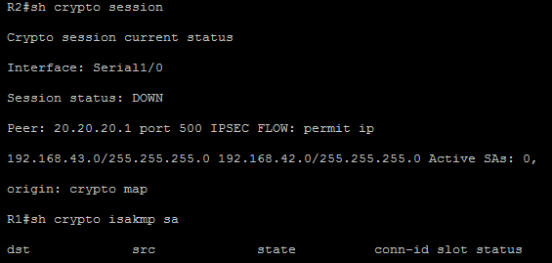

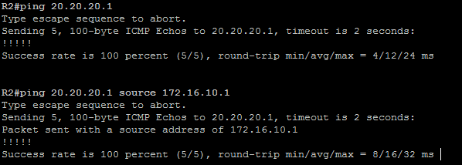

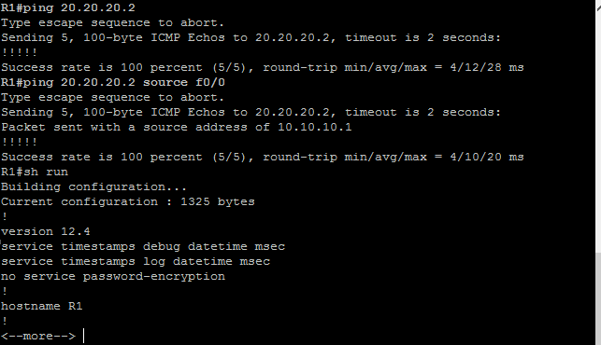

**Third Step**

* Open your cmd prompt of windows on which your GNS3 install and ping the ipaddress of Routers
* R1 and R2 simultaneously.
* It should be reply from both IP.

