**EFFECTIVE PROMPTING:**

**What is ChatGPT?**

Language is essential for communication. Recent advances in the field of natural language processing (NLP) with advanced deep-learning concepts make it possible for machines to understand and generate human-like responses. Among the growing numbers of popular LLMs, one of the most employed language models is ChatGPT, developed by OpenAI. It is specifically designed to generate human-like responses to text-based conversations/prompts.

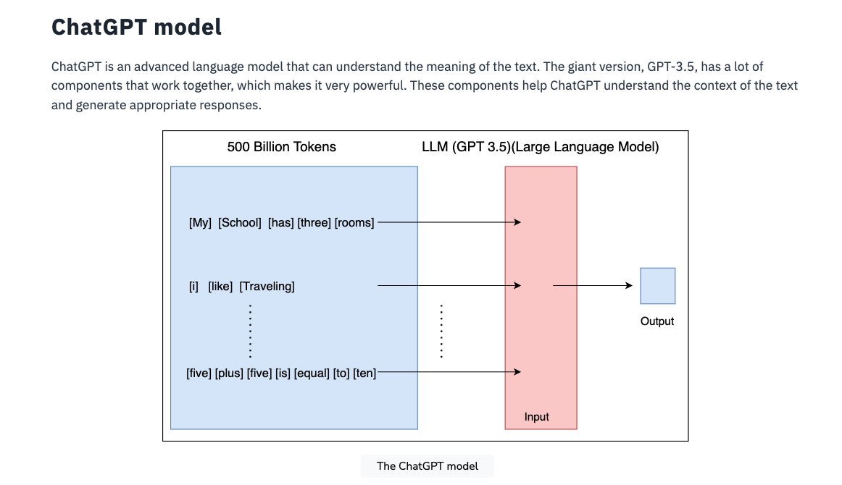

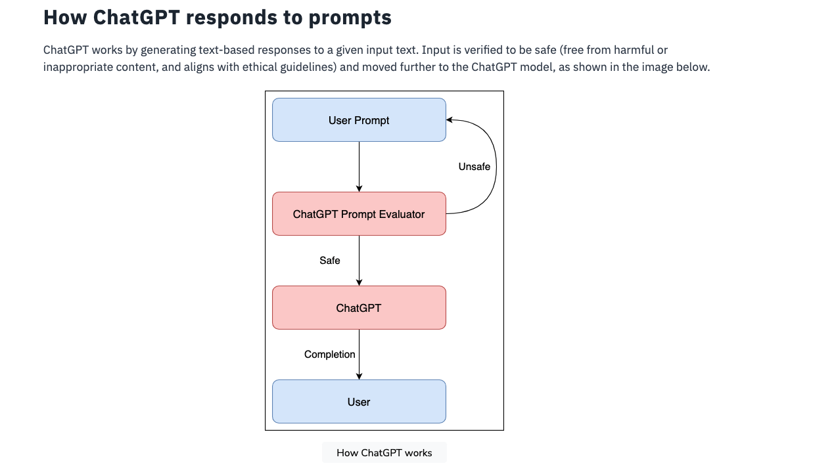

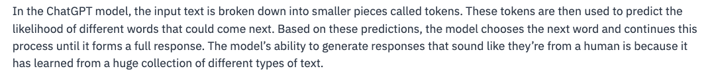

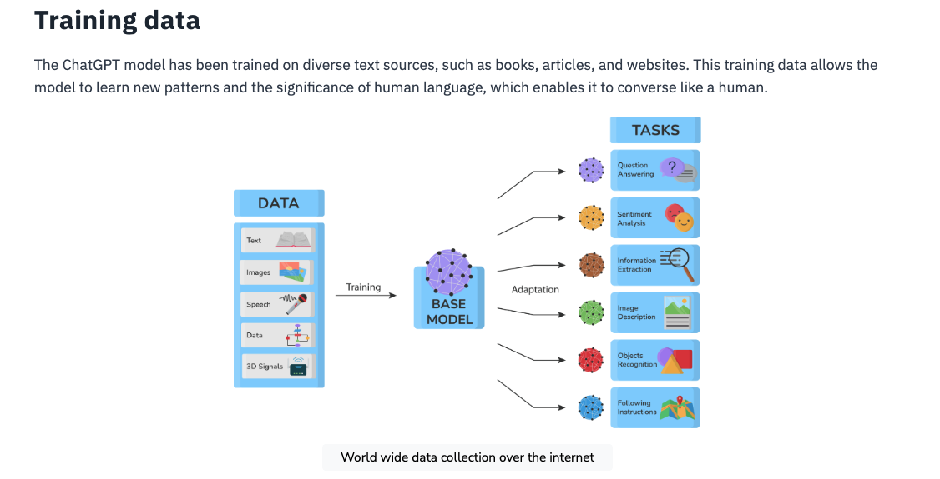

The training data used for ChatGPT includes over 45 terabytes of text. The data was collected from various sources, including publicly available books, articles from the internet, and text from online forums. The data was carefully selected to include texts from different genres, languages, and periods to ensure that the training data was diverse and representative of human language. This allowed the model to learn and create contextually appropriate responses following almost all rules of human language.

## ChatGPT features

Here are some of the notable features of ChatGPT:

* **Versatility:** ChatGPT is a versatile language model used for various NLP tasks, including language translation, summarization, and text generation. The model can also be fine-tuned for domain-specific requirements, making it a popular choice for many NLP applications.
* **Accuracy:** ChatGPT has achieved state-of-the-art performance on several NLP benchmarks, indicating its high accuracy. The model has been shown to generate human-like responses with relatively high accuracy and has outperformed many other NLP models in terms of language understanding and generation.
* **Human-like responses:** ChatGPT’s ability to generate human-like responses makes it an ideal model for chatbot development and other conversational AI applications. The model can learn the inner context of a conversation and create appropriate responses similar to human-like responses, making it an excellent tool for building chatbots that can converse with humans.
* **Large model size:** ChatGPT’s large model size, with over 6 billion parameters, allows it to understand the context of a text accurately and generate appropriate responses. The model’s large size has also enabled it to perform well.

## ChatGPT 3.5 vs. ChatGPT 4.0

While both ChatGPT 3.5 Turbo and ChatGPT 4 are advanced language models with impressive capabilities, the two have some key differences. ChatGPT 3.5 Turbo is faster and more efficient than ChatGPT 3, while ChatGPT 4 is better suited for generating long-form text and features improved accuracy and naturalness in its responses. Ultimately, the choice between ChatGPT 3.5 Turbo and ChatGPT 4 will depend on the project’s specific use case and requirements. For applications that require real-time responses, ChatGPT 3.5 Turbo may be the better choice, while for applications that require the generation of longer-sequence-form text, ChatGPT 4 may be more suitable.

ChatGPT is a powerful, large language model designed for creating and responding to text-based conversations. It uses advanced deep-learning architecture and is trained on a massive corpus of diverse text sources—making it an ideal choice for chatbot development and other conversational AI applications.

## ChatGPT Usage:

## 

## 

## 

## 

## 

## 

## Generating structured output

We can prompt the model to produce responses that adhere to a specific format or template.

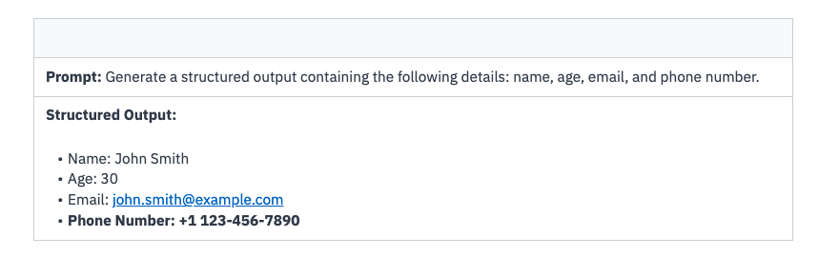

## Creative writing

ChatGPT can also be used for creative writing. We can engage the model in creative storytelling, generate poetry, or even collaborate with it to generate ideas for creative projects.



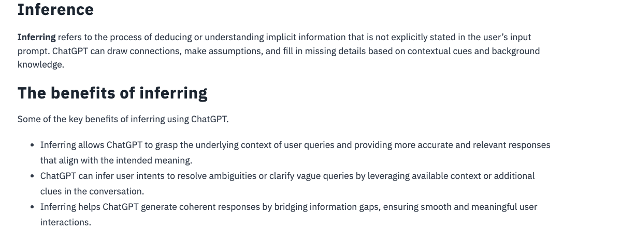

**Use cases of inference**

Here are some of the use cases in which ChatGPT can be used for inference:

* Enhancing responses by considering conversation history and contextual cues.
* Understanding user intents even when explicit details are missing.
* Offering tailored suggestions based on inferred preferences.
* Adapting responses to maintain coherence and relevance within a conversation.
* Interpreting implicit clues to provide clarification and resolve uncertainty.
* Engaging in more contextually appropriate conversations.

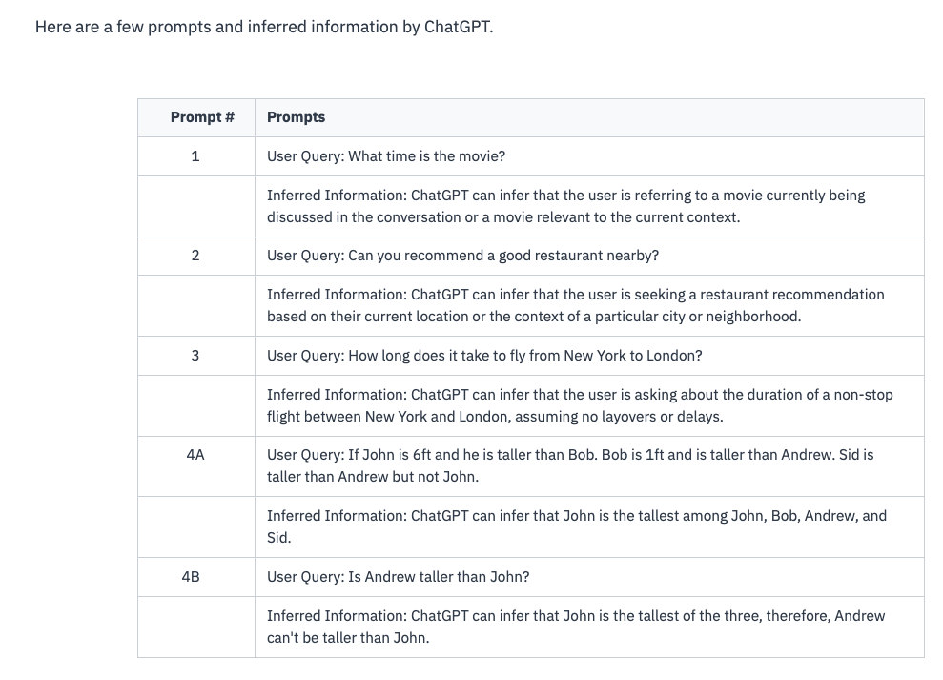

## Strategies for leveraging inferring

**Context awareness:** Provide relevant context or refer back to previous statements to help ChatGPT infer implicit information and understand user queries in the appropriate context.

**Clarity in prompts:** Craft prompts that provide clear cues or hints to aid ChatGPT in inferring missing details or intentions.

**Test and iterate:** Evaluate the responses generated by ChatGPT to identify any misinferences and iteratively refine prompts or provide additional context for better results.

# Transforming with ChatGPT

ChatGPT’s ability to transform data is powerful. In this lesson, we explore how to harness ChatGPT to transform text. Through examples, we showcase how ChatGPT rewrites text, reframes ideas, summarizes information, translates languages, and even generates new content.

**Significance of transforming**

Here are some key benefits of transforming:

* Transforming empowers users to explore different perspectives, reframe ideas, and generate unique text variations, fostering creativity and providing new insights.
* By transforming text, ChatGPT can adapt its responses to suit specific contexts, target different audiences, or meet formatting requirements, enhancing its versatility and utility in various scenarios.

## Applications and examples of transforming in ChatGPT

1. **Text rewriting**

2. **Idea reframing:** ChatGPT can help reframe ideas or express them from different perspectives, enabling users to explore alternative viewpoints or communicate concepts more compellingly.

3. **Summarization**

4. **Language translation**

5. **Content generation:** ChatGPT’s transforming ability extends to generating new content, such as story continuations, creative writing prompts, or product descriptions. One example is transforming an initial story snippet into a full-fledged narrative and expanding on the characters, plot, and setting.

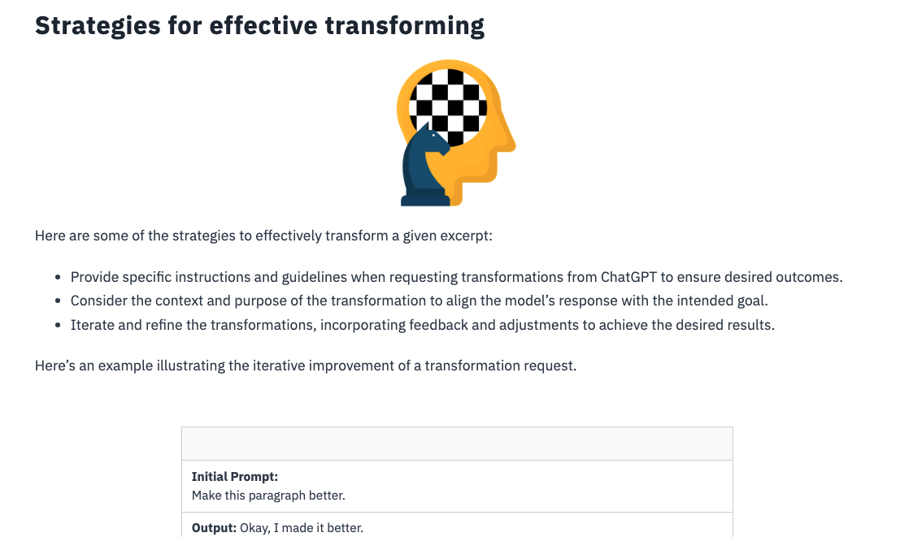

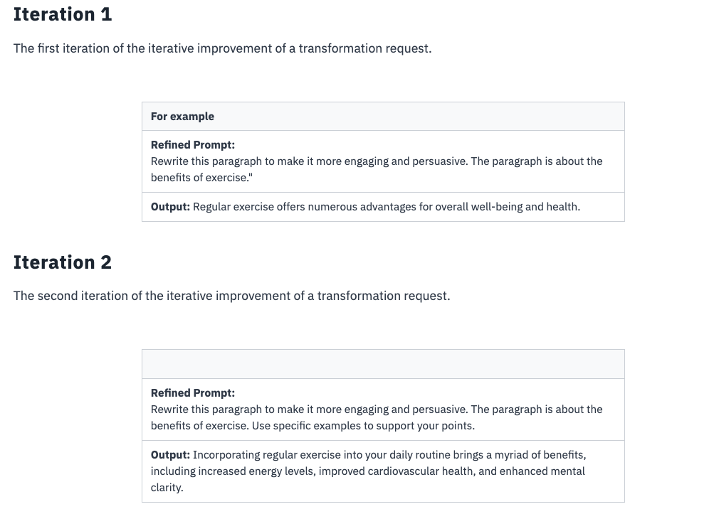

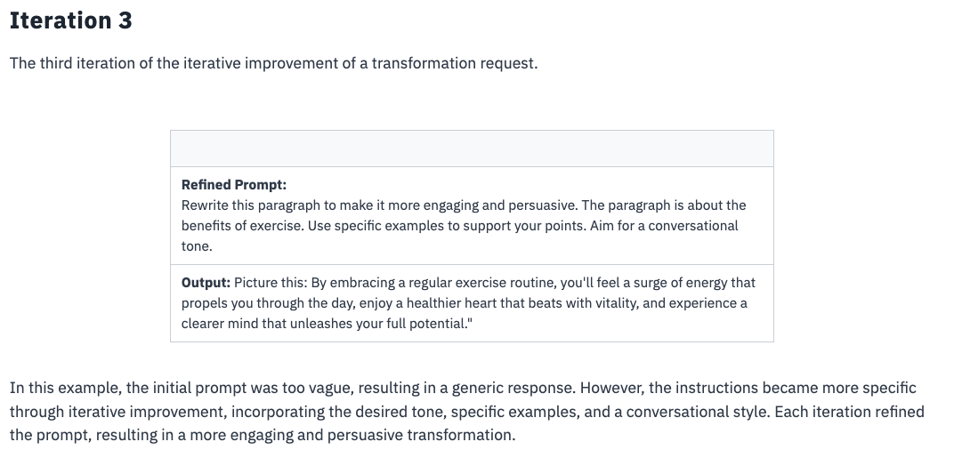

# Expanding with ChatGPT

Expanding with ChatGPT refers to elaborating on ideas, adding more details, and providing comprehensive responses.

**Importance of expanding**

* It allows for a more thorough exploration of concepts, enabling ChatGPT to provide detailed explanations and engage in meaningful discussions.
* It ensures that ChatGPT’s responses are well-rounded, offering background information, examples, and supporting details.
* Expanded responses provide a more informative and satisfying conversational experience, as users receive comprehensive and thoughtful answers.

**Use cases and examples of expanding in ChatGPT**

**1. Detailed explanations:** ChatGPT can expand on complex concepts by breaking them down into simpler terms, providing step-by-step explanations, or offering relevant examples.

**Example:** Expanding on the concept of neural networks, describing their layers, activation functions, and training process.

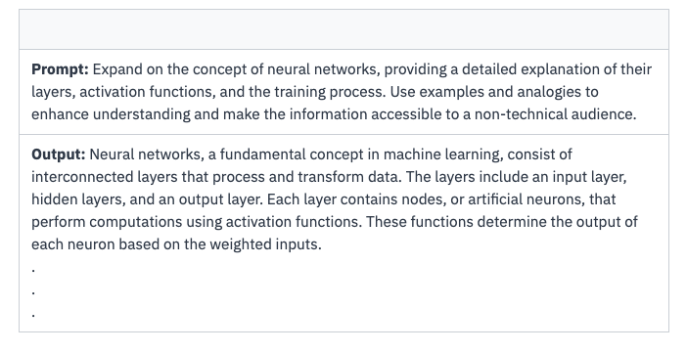

2. **Supporting evidence**: ChatGPT can present additional evidence or facts to support its responses, strengthening the credibility and reliability of the information provided.

**Example:**Expanding on a statement about climate change by citing scientific studies, statistics, or expert opinions.

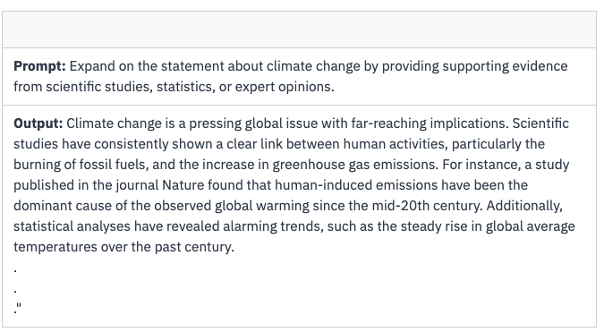

3. **Elaborating on examples:** ChatGPT can expand on provided examples by offering more details, analyzing implications, or discussing related scenarios.

**Example:** Expanding on an example of a self-driving car by describing its sensor technologies, navigation algorithms, and safety measures.

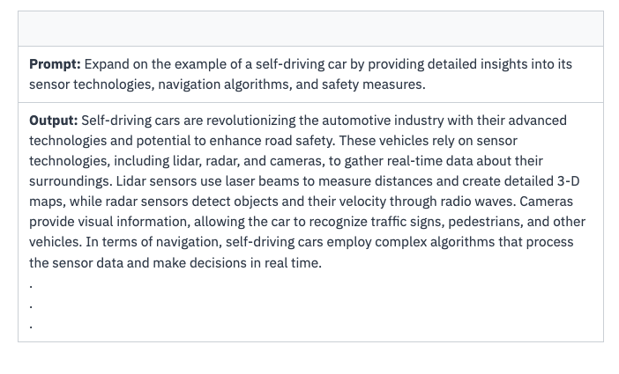

4. **Providing historical context:** ChatGPT can offer historical background or context to understand a topic or event comprehensively.

**Example:**Expanding on a question about a historical figure by discussing their contributions, historical context, and impact on society.

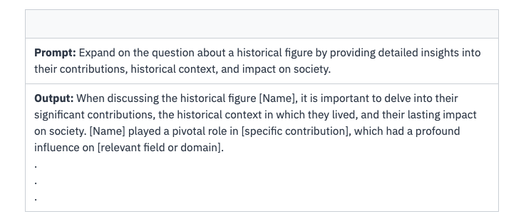

**Strategies for effective expansion**

* Provide specific prompts that request expanded responses or encourage ChatGPT to provide more details.
* Consider the context and purpose of the expansion, ensuring that ChatGPT’s responses align with the desired level of elaboration.
* Iterate and refine prompts and instructions to guide ChatGPT toward more comprehensive and accurate expansions.

# Formatting Output with ChatGPT

**Understanding format and sequence requirements**

## 1. Adapting output to tabular formats

## 

## 2. Handling sequential output

## 

## 3. Incorporating headers or titles

## 

## 

## 4. Formatting lists or bullet points

## 

## 5. Incorporating emphasis or styling

If the prompt requires certain elements to be emphasized, use formatting techniques like bold, italics, or underline to highlight those portions within the generated output.

## 

BEST PRACTICES FOR EFFECTIVE PROMPTING:

## 1.Provide detailed description

## 

**2. Contextual understanding in ChatGPT interactions:** Providing necessary background information with contextual details helps ChatGPT understand the specific domain, topic, or situation, allowing them to generate coherent responses that align with the given context.

## 

## 3. Incorporating specific examples

## 

## 4. Using rich language and providing sensory details

**Prompt:** Suggest a recipe to cook potatoes.

**Rich Description:** Suggest a recipe to cook jacket potato. I like them crispier and properly cooked.

## 5. Iterative prompt refinement

## 

# For Effective Human Resource Management

**Email communication and professional etiquette:**

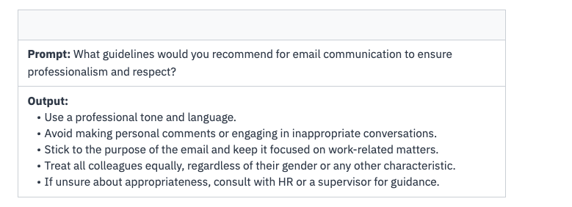

**Conflict resolution:**

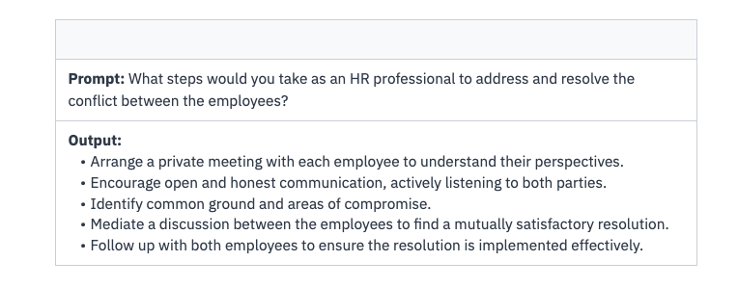

**Employee engagement and recognition:**

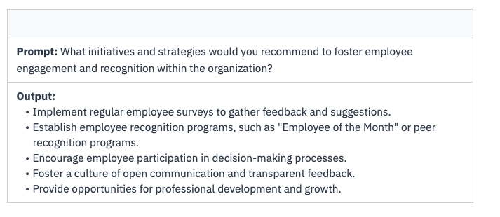

**Talent acquisition and onboarding:**



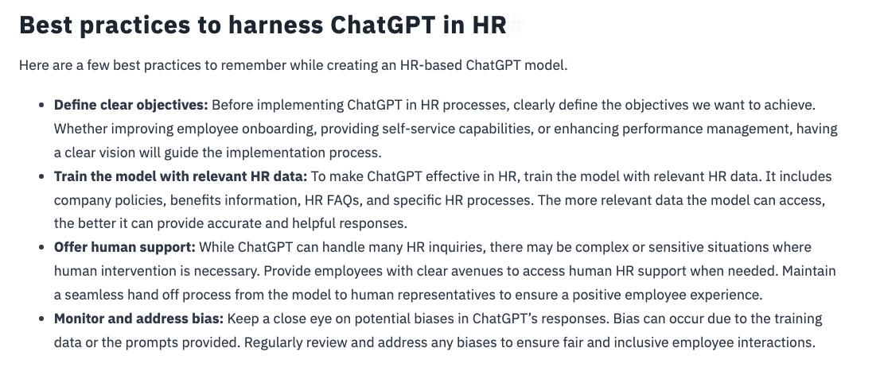

## Practice prompt

Use ChatGPT to generate a response to a candidate’s interview question about handling conflict in the workplace. Provide practical advice and examples based on your experience.

Generate a response to a candidate’s interview question about handling conflict in the workplace.

# Usage in Academia:

## 1. Writing research papers

## 2. Drafting discussion and conclusion

## 3. Creating presentation slides

## 4. Enhancing language and style

## 5. Generating citations and references

## 

## 

## Practice prompt

You are assigned a research paper on renewable energy sources. Highlight the main findings and their implications for sustainable energy solutions.

## Solution:

Summarize a research paper on renewable energy sources in 3-4 concise sentences. Highlight the main findings and their implications for sustainable energy solutions.

# AutoPrompt:

**AutoPrompt** is a powerful technique that automates generating prompts for language models like ChatGPT.

- AutoPrompt is a method of automatically generating prompts using predefined templates or rules. These templates contain instructions and placeholders that are dynamically filled with specific information, allowing users to generate prompts on-the-fly.

- With AutoPrompt, users can define their prompts’ structure, format, and context, ensuring relevant and accurate responses from ChatGPT.

-  AutoPrompt templates can be as simple as providing a context or as complex as including multiple variables and instructions.

- The templates act as a blueprint for constructing prompts, enabling users to specify the desired input format for ChatGPT.

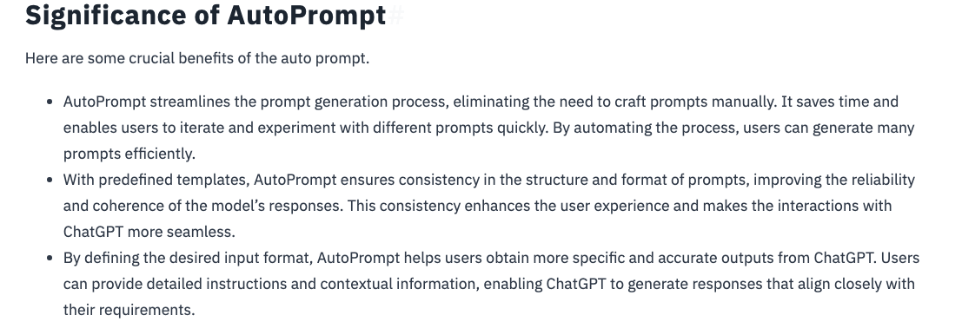

## Examples of AutoPrompt

## 