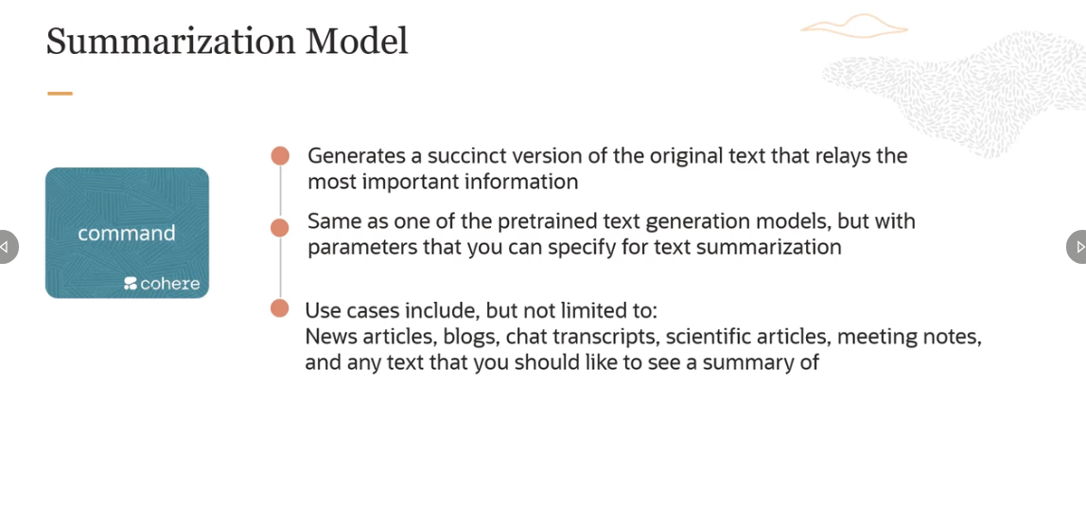

So the summarization model, which is available in the OCI Generative AI service is the Cohere command model, which is the same model which is used for generation purposes also. This model generates a succinct version of the original text that relays the most important information.

