-- 1. Show how many medal counts present for entire data

select medal, count(medal) as medalcount

from olympics1

where medal <> 'Nomedal'

group by medal;

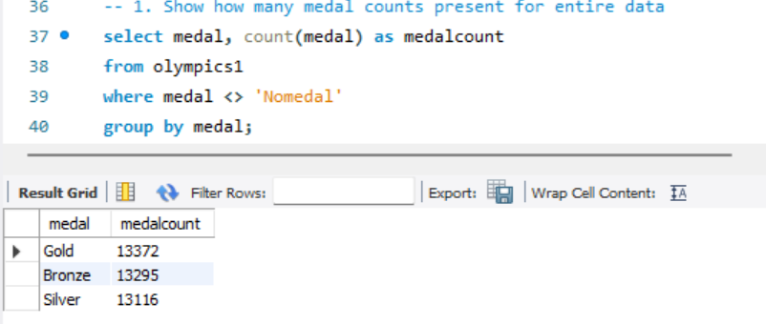

-- 2. Show count of unique sports present in Olympics1

select Sport, count(distinct(Sport)) from olympics1

group by Sport;

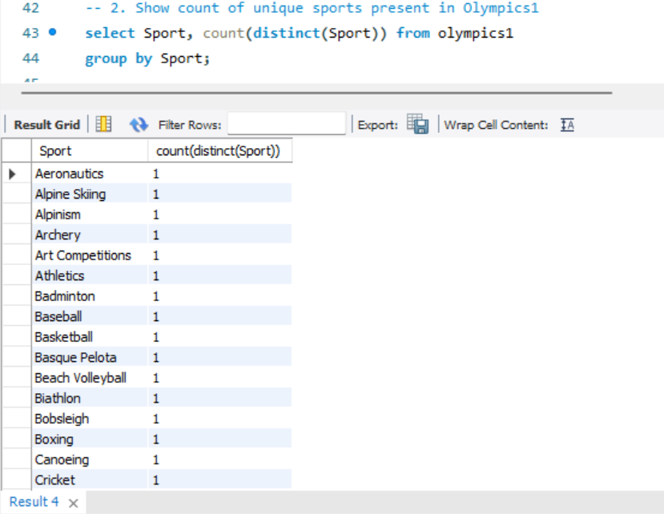

-- 3. Show how many different medals won by team India

select Team, medal, count(medal) as medalcount

from olympics1

where Team= 'India' AND medal <> 'Nomedal'

group by Team, medal;

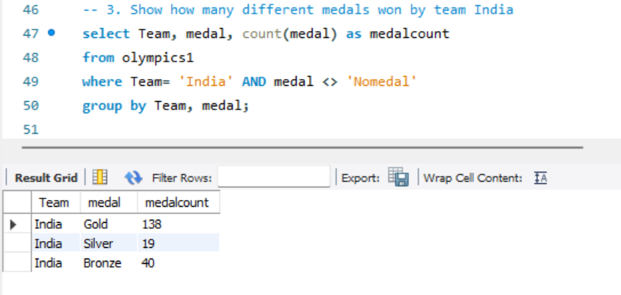

-- 4. Show event wise medals won by India show from highest to lowest medals won in order

select Team, Event, medal, count(medal) as medalcount

from olympics1

where Team = 'India' AND medal <> 'Nomedal'

group by Team, Event, medal

order by medalcount desc;

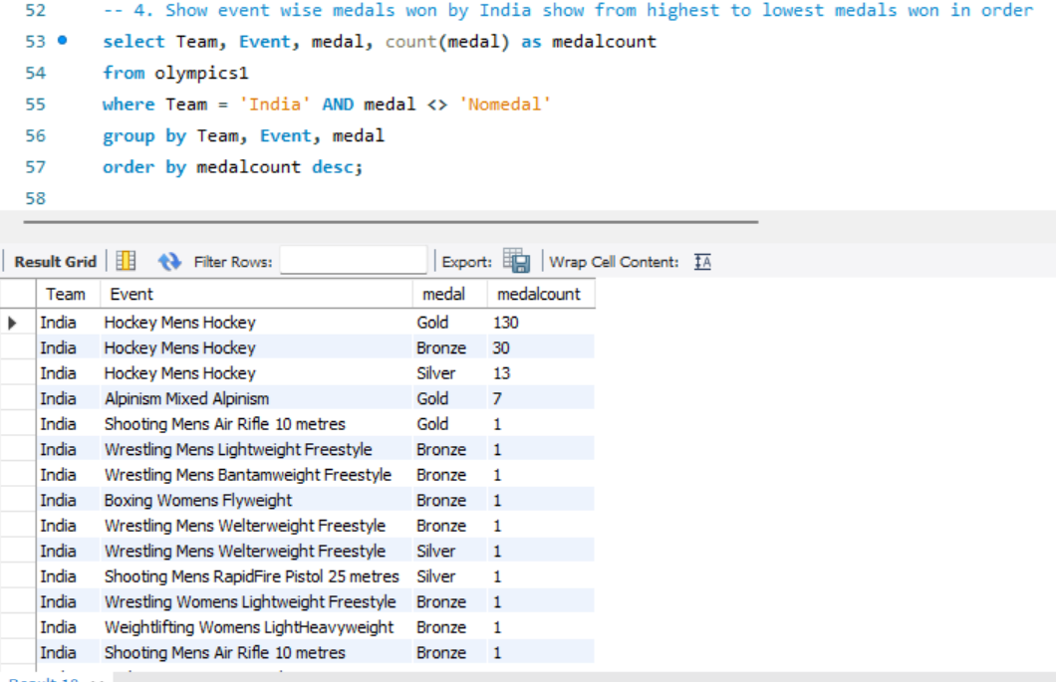

-- 5. Show event wise medals won by India in order of year

select event, year,medal, Team from olympics1

where Team='India' AND Medal <> 'Nomedal'

group by event, year, medal

order by Year;

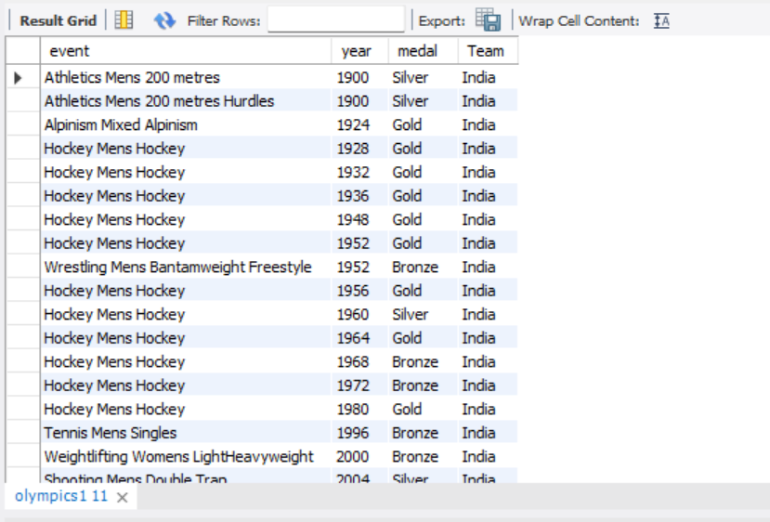

-- 6. show country who won maximum medals.

select Team, medal, count(medal) as medalcount

from olympics1

where medal <> 'Nomedal'

group by Team,medal

order by medalcount desc;

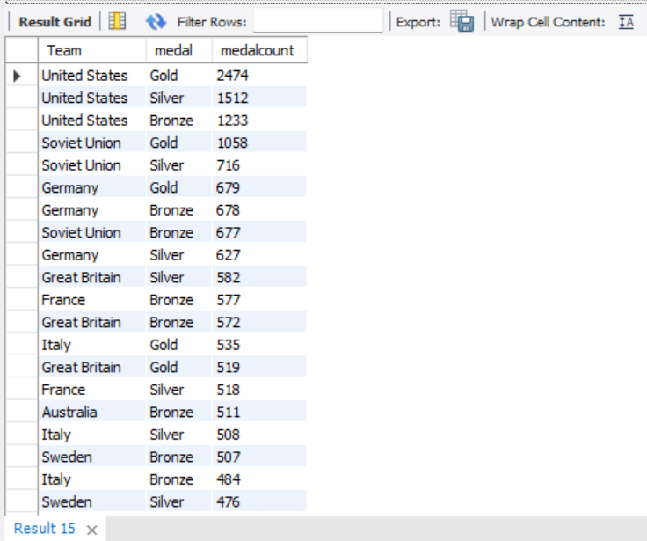

-- 7.show top 10 countries whowon gold

select Team, medal, count(medal) as medalcount

from olympics1

where medal = 'Gold'

group by Team, medal

order by medalcount desc

limit 10;

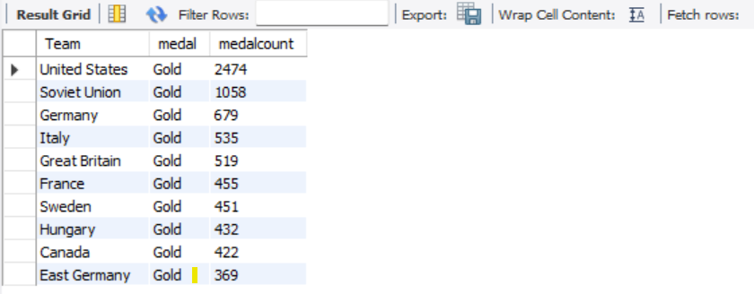

-- 8. show in which year did United states won most gold medal

select Team, year, medal, count(medal) as medalcount from olympics1

where Team='United States' AND medal = 'Gold'

group by year, medal

order by medalcount desc;

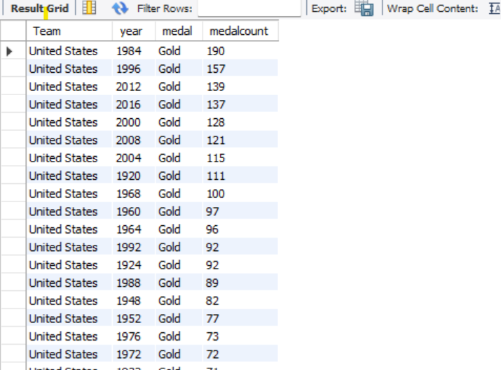

-- 9. In which sports United States has most medals.

select Team,Sport,Medal, count(medal) as medalcount from olympics1

where Team='United States' AND Medal <> 'Nomedal'

group by Team, Sport, Medal

order by medalcount desc;

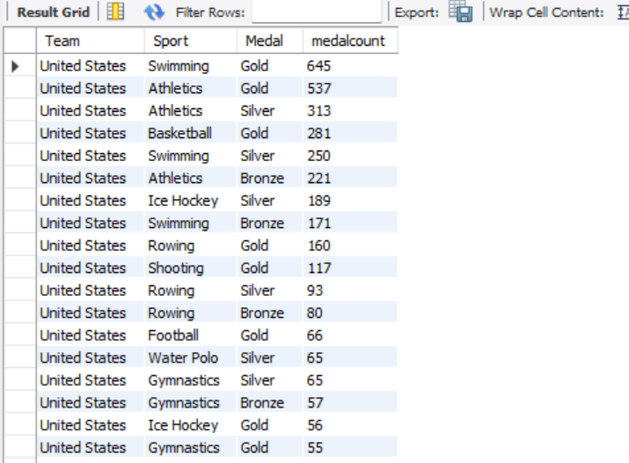

-- 10. Find top three players who won most medals along with their sports and country

select name,sport,team, count(medal) as medalcount from olympics1

where Medal <> 'Nomedal'

group by name,sport,medal,team

order by medalcount desc

limit 3;

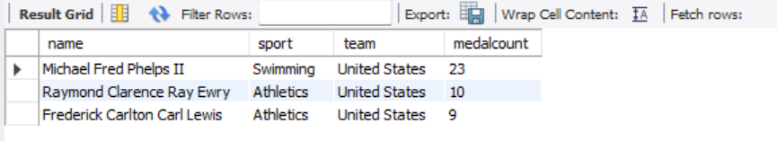

-- 11. Find player with most gold medals in cycling along with his country.

select name, medal ,sport,Team, count(medal) as medalcount from olympics1

where sport='Cycling' AND medal = 'Gold'

group by name, medal ,sport,Team

order by medalcount desc

limit 1;

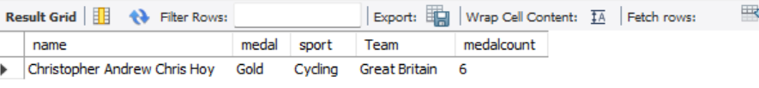

-- 12.Find player with most medals (Gold+Silver+Bronze) in Basketball also show his country.

select Team,name, sport,medal, count(medal) as medalcount from olympics1

where sport= 'basketball' and medal <> 'Nomedal'

group by Team,name, sport,medal

order by medalcount desc;

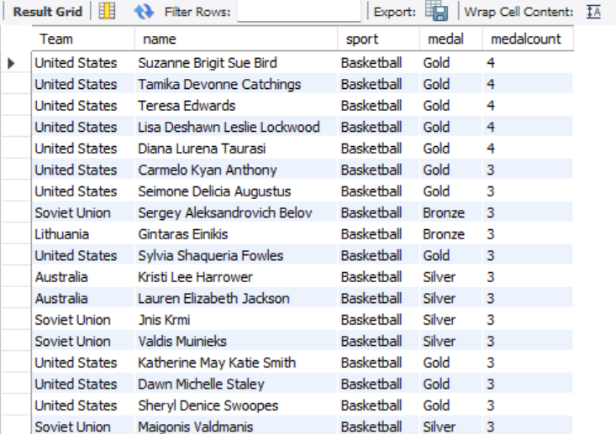

-- 13. Find out the count of different medals of the top basketball player Teresa Edwards

select name, sport,medal, count(medal) from olympics1

where sport= 'basketball' and name='Teresa Edwards'

group by name, sport,medal;

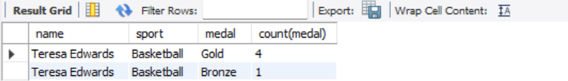

-- 14. Find out medals won by male,female each year , Export this data and plot graph in excel

select Sex, year, medal, count(medal) from olympics1

where Medal <> 'Nomedal'

group by sex, year, medal

order by sex, year, medal;

