**Assignment – week 2**

How to create a hidden file and how to display it using ls command

Files starting with dot followed by name are by default hidden and ls -a is used to display all hidden files.

Touch .”name”.

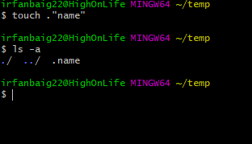

How to create multiple nested directories with one “mkdir” command?

mkdir -p parent/child1/child2/child3

Here “parent” is the directory name and child1,2,3 are the sub directories.

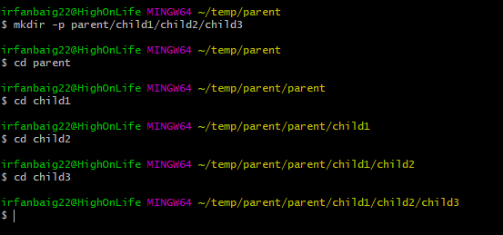

Execute following commands terminal:

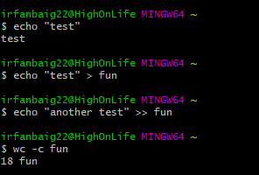

wc -c : displays number of characters in the file.

Research how to append something in the file without a newline character.

Command:- sed -I ‘$ s/$/another test/’ fun

