PDF_RAG_Llama32
Open Windows PowerShell
PS C:\Users\SEJAL> cd d:
PS D:\> cd PDF_RAG_Llama32
PS D:\PDF_RAG_Llama32> dir
Directory: D:\PDF_RAG_Llama32
Mode LastWriteTime Length Name
---- ------------- ------ ----
d----- 19-09-2026 21:01 .ipynb_checkpoints
d----- 19-09-2026 22:21 chroma_db
d----- 19-09-2026 22:04 huggingface_cache
d----- 19-09-2026 20:47 pdfs
d----- 19-09-2026 15:15 rag_env
-a---- 20-09-2026 03:42 PDF_RAG_Llama32.ipynb

PS D:\PDF_RAG_Llama32> .\rag_env\Scripts\Activate.ps1
(rag_env) PS D:\PDF_RAG_Llama32> jupyter notebook
Opening the Project -
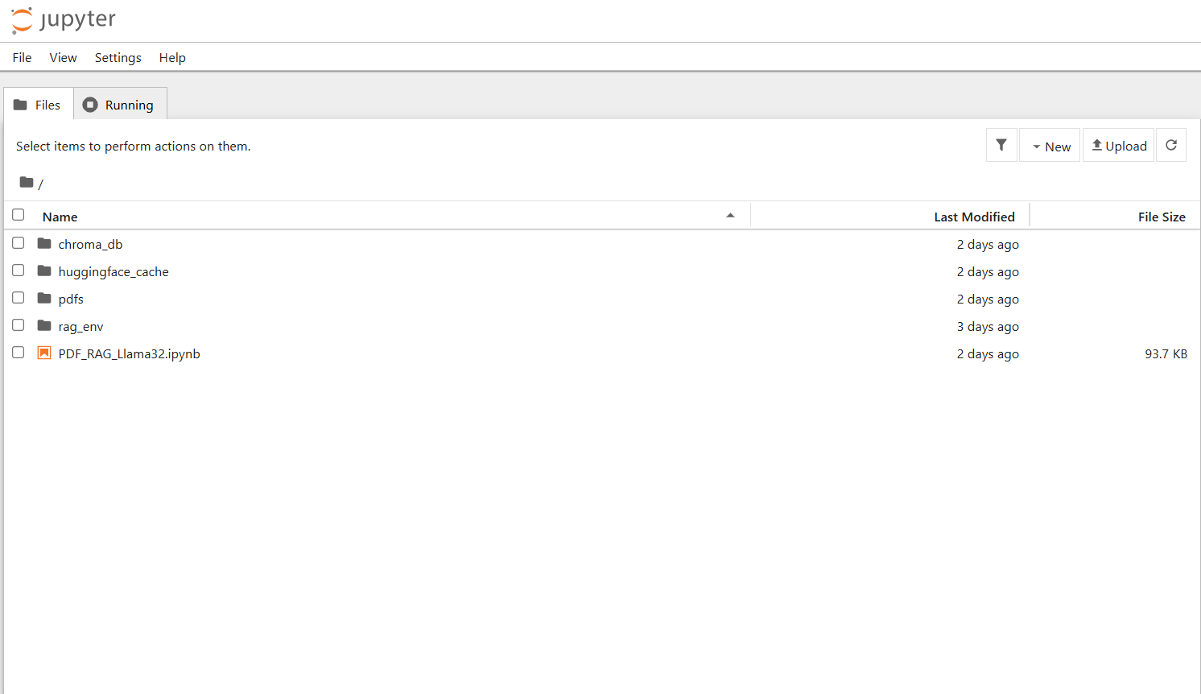

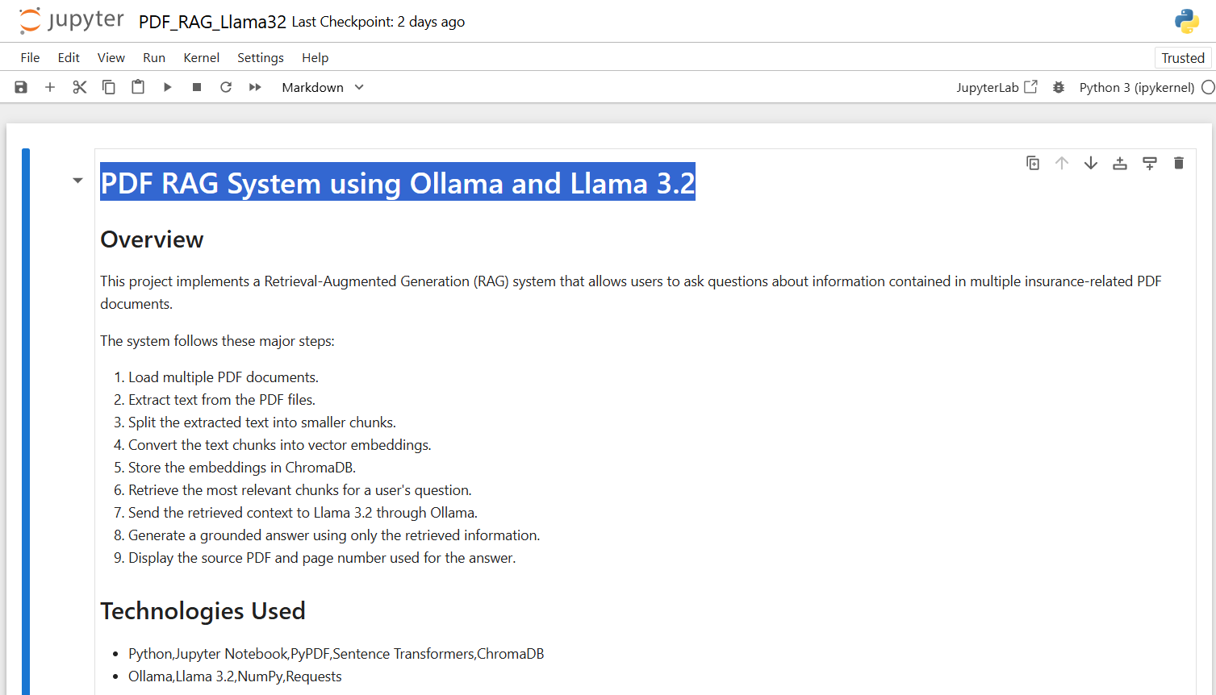

Open another Powershell to run Llama3.2


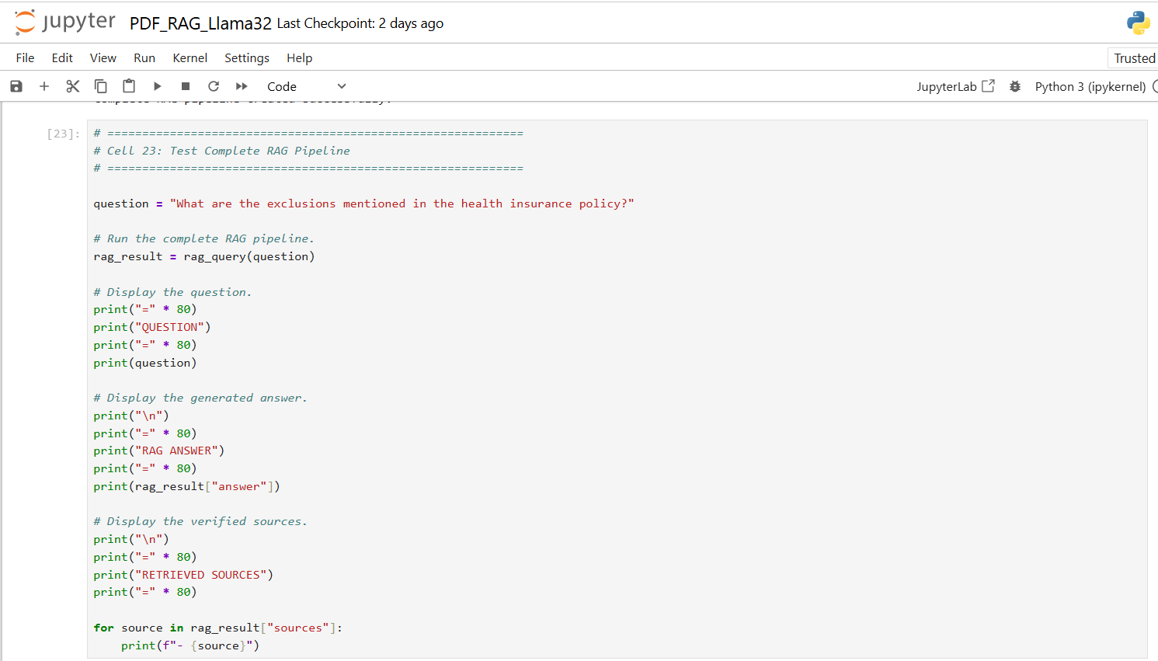

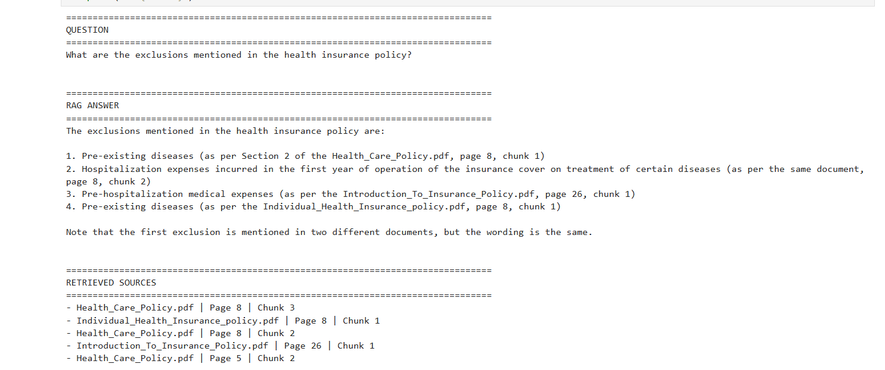

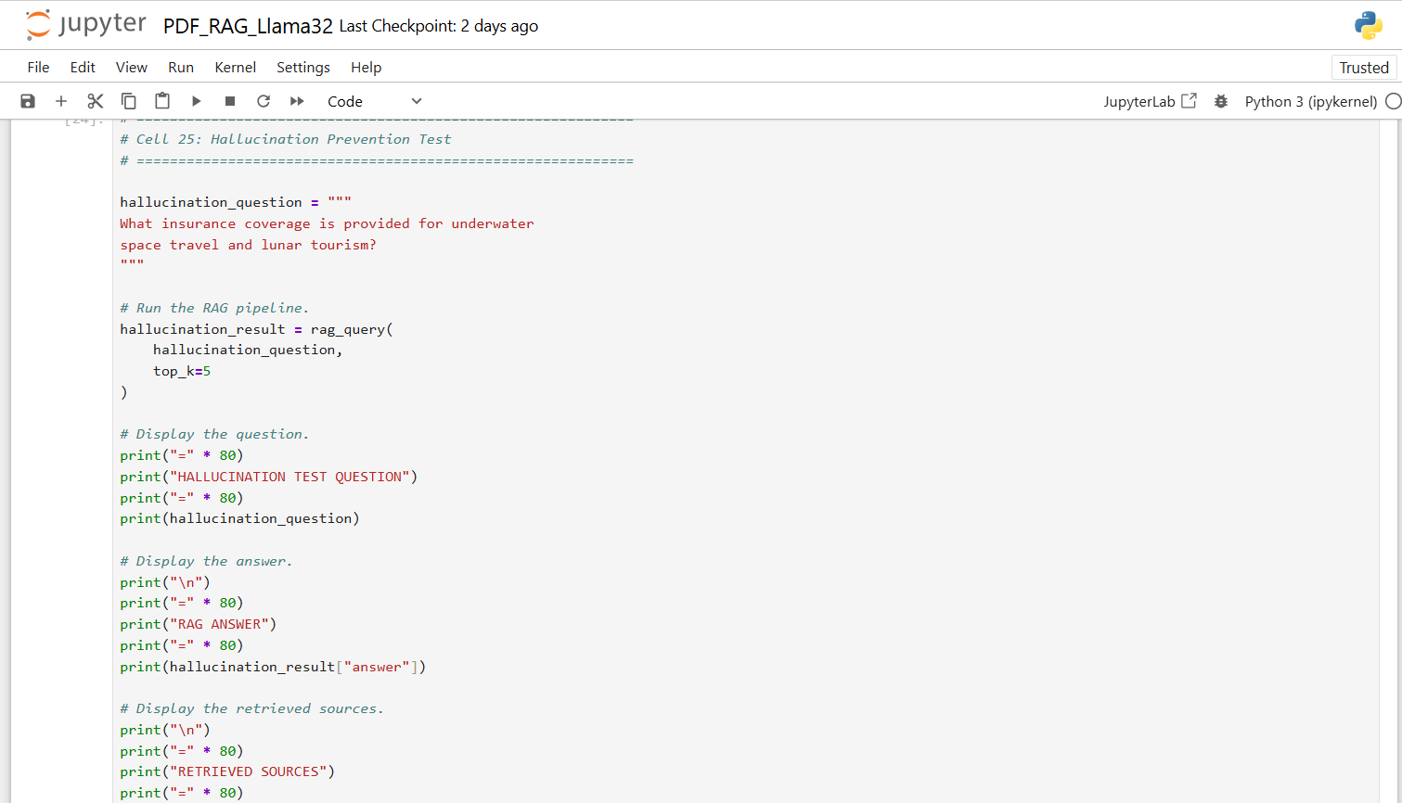

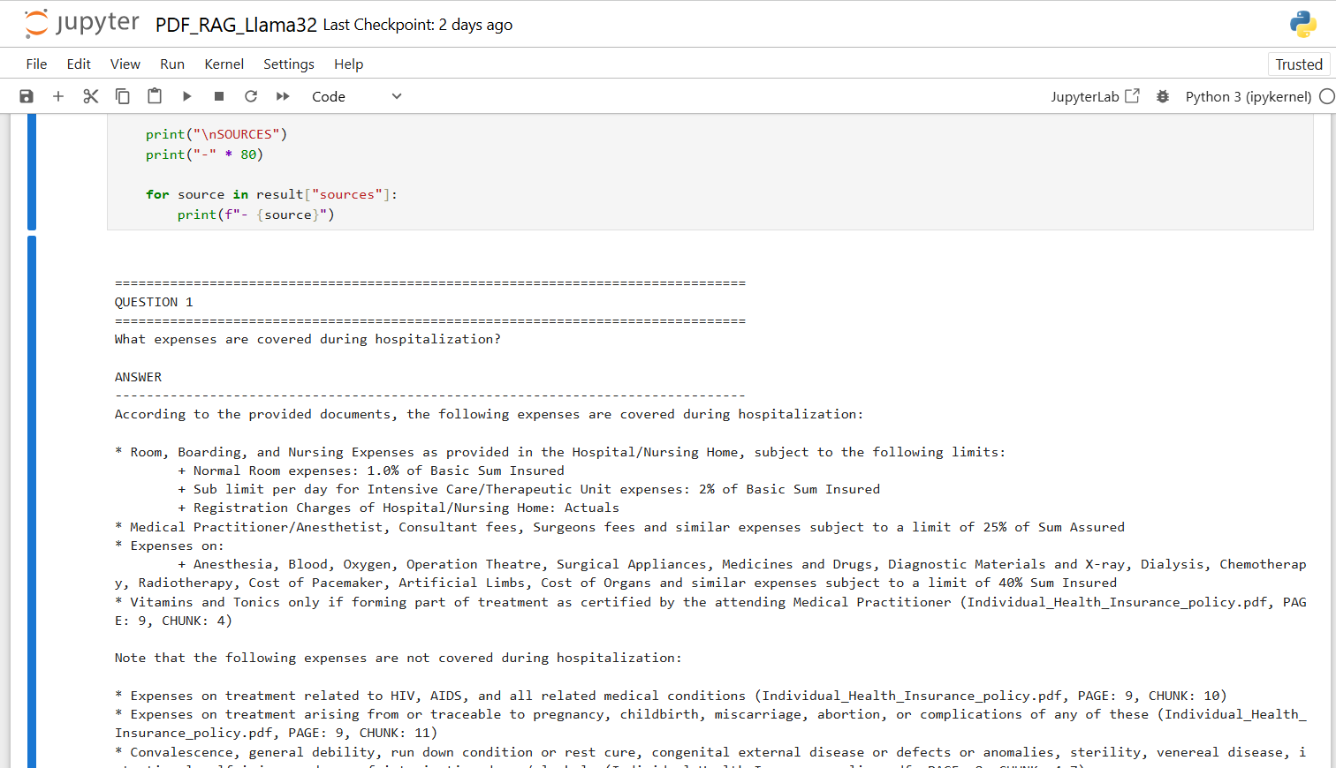

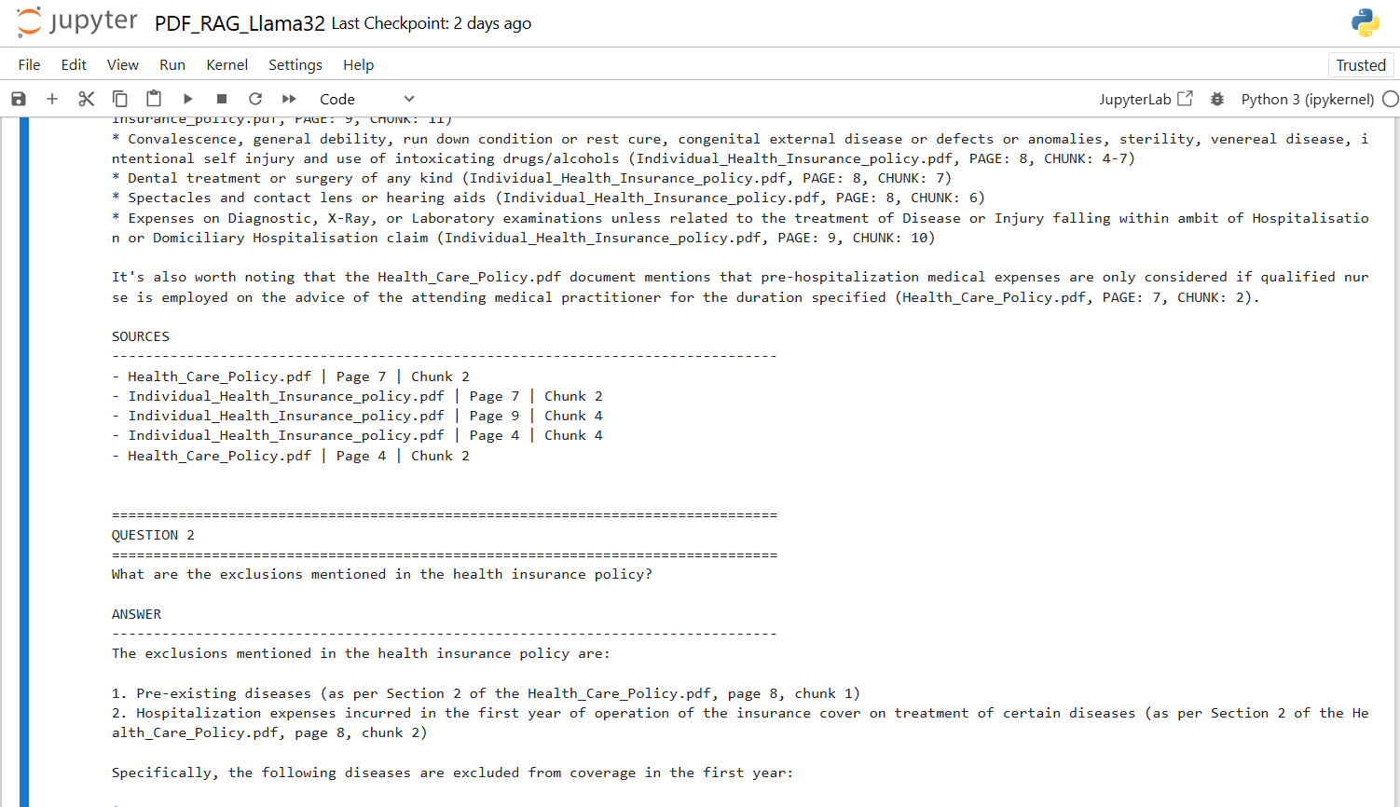

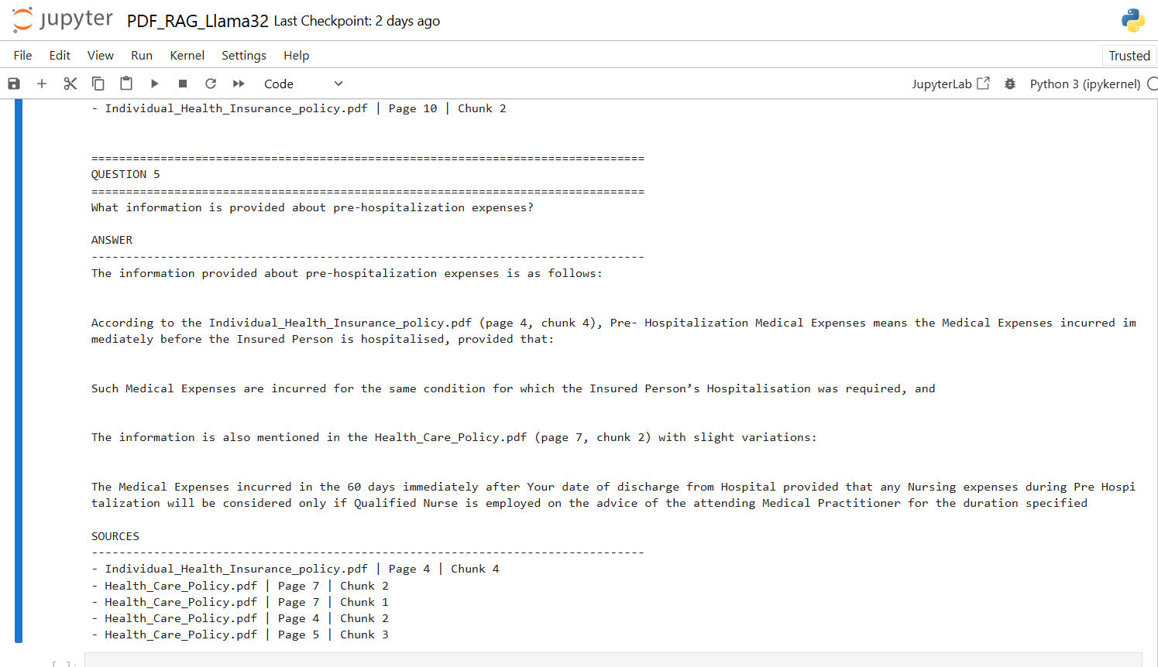

Multiple RAG questions output

================================================================================
QUESTION 1
================================================================================
What expenses are covered during hospitalization?

ANSWER
--------------------------------------------------------------------------------
According to the provided documents, the following expenses are covered during hospitalization:

* Room, Boarding, and Nursing Expenses as provided in the Hospital/Nursing Home, subject to the following limits:
+ Normal Room expenses: 1.0% of Basic Sum Insured
+ Sub limit per day for Intensive Care/Therapeutic Unit expenses: 2% of Basic Sum Insured
+ Registration Charges of Hospital/Nursing Home: Actuals
* Medical Practitioner/Anesthetist, Consultant fees, Surgeons fees and similar expenses subject to a limit of 25% of Sum Assured
* Expenses on:
+ Anesthesia, Blood, Oxygen, Operation Theatre, Surgical Appliances, Medicines and Drugs, Diagnostic Materials and X-ray, Dialysis, Chemotherapy, Radiotherapy, Cost of Pacemaker, Artificial Limbs, Cost of Organs and similar expenses subject to a limit of 40% Sum Insured
* Vitamins and Tonics only if forming part of treatment as certified by the attending Medical Practitioner (Individual_Health_Insurance_policy.pdf, PAGE: 9, CHUNK: 4)

Note that the following expenses are not covered during hospitalization:

* Expenses on treatment related to HIV, AIDS, and all related medical conditions (Individual_Health_Insurance_policy.pdf, PAGE: 9, CHUNK: 10)
* Expenses on treatment arising from or traceable to pregnancy, childbirth, miscarriage, abortion, or complications of any of these (Individual_Health_Insurance_policy.pdf, PAGE: 9, CHUNK: 11)
* Convalescence, general debility, run down condition or rest cure, congenital external disease or defects or anomalies, sterility, venereal disease, intentional self injury and use of intoxicating drugs/alcohols (Individual_Health_Insurance_policy.pdf, PAGE: 8, CHUNK: 4-7)
* Dental treatment or surgery of any kind (Individual_Health_Insurance_policy.pdf, PAGE: 8, CHUNK: 7)
* Spectacles and contact lens or hearing aids (Individual_Health_Insurance_policy.pdf, PAGE: 8, CHUNK: 6)
* Expenses on Diagnostic, X-Ray, or Laboratory examinations unless related to the treatment of Disease or Injury falling within ambit of Hospitalisation or Domiciliary Hospitalisation claim (Individual_Health_Insurance_policy.pdf, PAGE: 9, CHUNK: 10)

It's also worth noting that the Health_Care_Policy.pdf document mentions that pre-hospitalization medical expenses are only considered if qualified nurse is employed on the advice of the attending medical practitioner for the duration specified (Health_Care_Policy.pdf, PAGE: 7, CHUNK: 2).

SOURCES
--------------------------------------------------------------------------------
- Health_Care_Policy.pdf | Page 7 | Chunk 2
- Individual_Health_Insurance_policy.pdf | Page 7 | Chunk 2
- Individual_Health_Insurance_policy.pdf | Page 9 | Chunk 4
- Individual_Health_Insurance_policy.pdf | Page 4 | Chunk 4
- Health_Care_Policy.pdf | Page 4 | Chunk 2

================================================================================
QUESTION 2
================================================================================
What are the exclusions mentioned in the health insurance policy?

ANSWER
--------------------------------------------------------------------------------
The exclusions mentioned in the health insurance policy are:

1. Pre-existing diseases (as per Section 2 of the Health_Care_Policy.pdf, page 8, chunk 1)
2. Hospitalization expenses incurred in the first year of operation of the insurance cover on treatment of certain diseases (as per Section 2 of the Health_Care_Policy.pdf, page 8, chunk 2)

Specifically, the following diseases are excluded from coverage in the first year:

* Cataract
* Benign Prostatic Hypertrophy
* Myomectomy, Hysterectomy
* Hernia, Hydrocele
* Fistula in anus, Piles

Additionally, pre-existing diseases are excluded unless the policyholder has been continuously covered without any break under an individual health insurance plan with an Indian insurer or any other similar health insurance plan from the same insurer, as per Section 2 of the Individual_Health_Insurance_policy.pdf, page 8, chunk 1.

SOURCES
--------------------------------------------------------------------------------
- Health_Care_Policy.pdf | Page 8 | Chunk 3
- Individual_Health_Insurance_policy.pdf | Page 8 | Chunk 1
- Health_Care_Policy.pdf | Page 8 | Chunk 2
- Introduction_To_Insurance_Policy.pdf | Page 26 | Chunk 1
- Health_Care_Policy.pdf | Page 5 | Chunk 2

================================================================================
QUESTION 3
================================================================================
What is domiciliary hospitalization?

ANSWER
--------------------------------------------------------------------------------
According to the provided documents, Domiciliary Treatment means medical treatment for an Illness/disease/Injury which in the normal course would require care and treatment at a Hospital but is actually taken while confined at home under any of the following circumstances:

1. The condition of the patient is such that he/she is not in a condition to be removed to a Hospital.
2. The patient takes treatment at home on account of non-availability of room in a Hospital.

This definition is found in both the Individual_Health_Insurance_policy.pdf (page 2, chunk 3) and the Health_Care_Policy.pdf (page 3, chunk 3).

SOURCES
--------------------------------------------------------------------------------
- Individual_Health_Insurance_policy.pdf | Page 2 | Chunk 3
- Health_Care_Policy.pdf | Page 3 | Chunk 1
- Health_Care_Policy.pdf | Page 1 | Chunk 2
- Health_Care_Policy.pdf | Page 3 | Chunk 3
- Health_Care_Policy.pdf | Page 3 | Chunk 2

================================================================================
QUESTION 4
================================================================================
What conditions are mentioned for hospitalization?

ANSWER
--------------------------------------------------------------------------------
The conditions mentioned for hospitalization are:

* Illness means a sickness or a disease or pathological condition leading to the impairment of normal physiological function which manifests itself during the Policy Period (Individual_Health_Insurance_policy.pdf, page 3, CHUNK 2)
* Medical Practitioner, hospitalization for medical/surgical treatment in any Nursing Home/ Hospital in India as defined in the policy (Health_Care_Policy.pdf, page 1, CHUNK 2)
* Hospital means any institution established for in-patient care and Day Care Treatment of Illness and/or Injuries and which has been registered as a Hospital with the local authorities under the Clinical Establishments (Registration and Regulation) Act, 2010 or under the enactments specified under the Schedule of Section 56(1) of the said Act (Individual_Health_Insurance_policy.pdf, page 3, CHUNK 2)

These conditions are further specified in the Health Care Policy document, which defines hospitalization as the treatment of an illness or disease that requires in-patient care.

SOURCES
--------------------------------------------------------------------------------
- Individual_Health_Insurance_policy.pdf | Page 3 | Chunk 2
- Health_Care_Policy.pdf | Page 1 | Chunk 2
- Health_Care_Policy.pdf | Page 5 | Chunk 2
- Health_Care_Policy.pdf | Page 5 | Chunk 3
- Individual_Health_Insurance_policy.pdf | Page 10 | Chunk 2

================================================================================
QUESTION 5
================================================================================
What information is provided about pre-hospitalization expenses?

ANSWER
--------------------------------------------------------------------------------
The information provided about pre-hospitalization expenses is as follows:

According to the Individual_Health_Insurance_policy.pdf (page 4, chunk 4), Pre- Hospitalization Medical Expenses means the Medical Expenses incurred immediately before the Insured Person is hospitalised, provided that:

Such Medical Expenses are incurred for the same condition for which the Insured Person’s Hospitalisation was required, and

The information is also mentioned in the Health_Care_Policy.pdf (page 7, chunk 2) with slight variations:

The Medical Expenses incurred in the 60 days immediately after Your date of discharge from Hospital provided that any Nursing expenses during Pre Hospitalization will be considered only if Qualified Nurse is employed on the advice of the attending Medical Practitioner for the duration specified

SOURCES
--------------------------------------------------------------------------------
- Individual_Health_Insurance_policy.pdf | Page 4 | Chunk 4
- Health_Care_Policy.pdf | Page 7 | Chunk 2
- Health_Care_Policy.pdf | Page 7 | Chunk 1
- Health_Care_Policy.pdf | Page 4 | Chunk 2
- Health_Care_Policy.pdf | Page 5 | Chunk 3

